Combined State Plan for Nebraska’s Workforce System

July 1, 2016 – June 30, 2020

2-year modification

Draft released – January 26, 2018

# Public Comments

The Nebraska Departments of Education, Health and Human Services, and Labor and the Nebraska Commission for the Blind and Visually Impaired:

* release this modification Combined State Plan for Nebraska’s Workforce System in compliance with the Workforce Innovation and Opportunity Act; and
* seek public comment on this modification during a 30-day period beginning January 26, 2018 and ending February 25, 2018.

In addition, a public hearing will be held on February 7, 2018 from 2p to 3p. The hearing will be available simultaneously at the following ten (10) Nebraska Vocational Rehabilitation locations across the state through interactive video conferencing technology:

* Columbus - 3100 23rd Street, Suite 5
* Fremont - 827 North D Street
* Grand Island - 203 East Stolley Park Road, Suite B
* Kearney - 315 West 60th Street, Suite 400
* Lincoln - 3901 North 27th Street, Suite 6
* Norfolk - 1212 Benjamin Avenue
* North Platte - 200 South Silber, Building 2
* Omaha - 1313 Farnam on the Mall
* Omaha - 12011 Q Street
* Scottsbluff - 505A Broadway, Suite 500

The summary of the public comments and plan partner responses will be accessible online following the conclusion of the public comment period.

# Preface

**How this Combined State Plan Modification is organized**

The major content areas of this modification of Nebraska’s Combined State Plan include strategic and operational planning elements. WIOA separates the strategic and operational elements to facilitate cross-program strategic planning.

The *Strategic Planning Elements* section includes analyses of the Nebraska’s economic conditions, workforce characteristics, and workforce development activities. These analyses drive the vision and goals for the Nebraska’s workforce system and alignment strategies for workforce development programs to support economic growth.

The *Operational Planning Elements* section identifies strategies for implementation of the vision and goals and describes the infrastructure, policies, and workforce development activities to be implemented by the plan partners.

**Technical Assistance**

If you experience issues with this document, please requesting technical assistance by sending an email to ndol.wioa_policy@nebraska.gov.

Contents

Public Comments 2

Preface 3

I. Overview 9

II. Strategic Elements 9

a. Economic, Workforce, and Workforce Development Activities Analysis 9

1. Economic and Workforce Analysis 9

2. Workforce Development, Education and Training Activities Analysis 48

b. State Strategic Vision and Goals 56

1. Vision 56

2. Goals 57

3. Performance Goals 58

4. Assessment 58

c. State Strategy 59

1. State Strategies for In-demand Industry Sectors and Occupations and Career Pathways 59

2. State Strategies to Align Core Programs 62

III. Operational Planning Elements 65

a. State Strategy Implementation 65

1. State Board Functions 65

2. Implementation of State Strategy 67

b. State Operating Systems and Policies 79

1. State operating systems supporting implementation of the State’s strategies. 79

2. State policies that will support the implementation of the State’s strategies 81

3. State Program and State Board Overview 82

4. Assessment and Evaluation of Programs and One-Stop Program Partners 86

5. Distribution of Funds for Core Programs 88

6. Program Data 92

7. Priority of Service for Veterans 96

8. One-Stop Delivery System Accessibility for Individuals with Disabilities 97

9. One-Stop Delivery System Accessibility for English Language Learners 99

IV. Coordination with State Plan Programs 100

V. Common Assurances (for all core programs) 100

VI. Program-Specific Requirements for Core Programs 101

Program-Specific Requirements for Adult, Dislocated Worker, and Youth Activities under Title I-B 101

1. General Requirements 101

2. Adult and Dislocated Workers Program Requirements 114

4. Youth Program Requirements 123

5. Single-area State Requirements 128

6. Waiver Requests (optional) 128

Title I-B Assurances 136

Program-Specific Requirements for Wagner-Peyser Program (Employment Services) 139

a. Employment Service Professional Staff Development. 139

b. Provision of UI Information and Meaningful Assistance 142

c. Reemployment Assistance 142

d. Support of UI Claimants 148

e. Agricultural Outreach Plan (AOP). 151

f. Wagner-Peyser Assurances 159

Program-Specific Requirements for Adult Education and Family Literacy Act Programs 160

a. Aligning of Content Standards 160

b. Local Activities 160

c. Corrections Education and other Education of Institutionalized Individuals 163

d. Integrated English Literacy and Civics Education Program 164

e. Assessing Quality 169

Certifications 170

Certification Regarding Lobbying 171

Statement for Loan Guarantees and Loan Insurance 171

Assurances 172

Program-Specific Requirements for Vocational Rehabilitation (Nebraska VR) 172

a. Input of State Rehabilitation Council (Nebraska VR) 173

b. Request for Waiver of Statewideness (Nebraska VR) 176

c. Cooperative Agreements with Agencies not carrying out Activities under the Statewide Workforce Development System. (Nebraska VR) 177

d. Coordination with Education Officials (Nebraska VR) 178

e. Cooperative Agreements with Private Nonprofit Organizations (Nebraska VR) 181

f. Arrangements and Cooperative Agreements for the Provision of Supported Employment Services (Nebraska VR) 181

g. Coordination with Employers (Nebraska VR) 182

h. Interagency Cooperation (Nebraska VR) 185

i. Comprehensive System of Personnel Development; Data System on Personnel and Personnel Development (Nebraska VR) 187

j. Statewide Assessment (Nebraska VR) 198

k. Annual Estimates (Nebraska VR) 202

l. State Goals and Priorities (Nebraska VR) 204

m. Order of Selection (Nebraska VR) 209

n. Goals and Plans for Distribution of title VI Funds. (Nebraska VR) 217

o. State's Strategies (Nebraska VR) 219

p. Evaluation and Reports of Progress: VR and Supported Employment Goals (Nebraska VR) 222

q. Quality, Scope, and Extent of Supported Employment Services. (Nebraska VR) 226

Certifications (Nebraska VR) 229

Certification Regarding Lobbying — Vocational Rehabilitation (Nebraska VR) 230

Certification Regarding Lobbying — Supported Employment (Nebraska VR) 232

Assurances (Nebraska VR) 233

Program-Specific Requirements for Vocational Rehabilitation (Nebraska Commission for the Blind and Visually Impaired [NCBVI]) 237

a. Input of State Rehabilitation Council (NCBVI) 237

b. Request for Waiver of Statewideness (NCBVI) 237

c. Cooperative Agreements with Agencies not carrying out Activities under the Statewide Workforce Development System. (NCBVI) 238

d. Coordination with Education Officials (NCBVI) 239

e. Cooperative Agreements with Private Nonprofit Organizations (NCBVI) 241

f. Arrangements and Cooperative Agreements for the Provision of Supported Employment Services (NCBVI) 242

g. Coordination with Employers (NCBVI) 242

h. Interagency Cooperation (NCBVI) 243

i. Comprehensive System of Personnel Development; Data System on Personnel and Personnel Development (NCBVI) 244

j. Statewide Assessment (NCBVI) 250

k. Annual Estimates (NCBVI) 255

l. State Goals and Priorities (NCBVI) 256

m. Order of Selection (NCBVI) 257

n. Goals and Plans for Distribution of title VI Funds. (NCBVI) 258

o. State's Strategies (NCBVI) 259

p. Evaluation and Reports of Progress: VR and Supported Employment Goals (NCBVI) 262

q. Quality, Scope, and Extent of Supported Employment Services. (NCBVI) 270

Certifications (NCBVI) 272

Certification Regarding Lobbying — Vocational Rehabilitation (NCBVI) 274

Certification Regarding Lobbying — Supported Employment (NCBVI) 275

Assurances (NCBVI) 276

VII. Program-Specific Requirements for Combined State Plan Partner Programs 280

Temporary Assistance for Needy Families (TANF) 280

(a) Service in all Political Subdivisions 280

(b) Employment First 281

(c) Orientation Assessment; Self-Sufficiency Contract 281

(d) Privacy 283

(e) Pregnancies 284

(f) Statutory Rape Education Program 285

(g) EBT and Access to Cash Assistance 285

(h) Nebraska ReliaCard 286

(i) Services for Relocating Families 286

(j) Services for Non-Citizens 286

(k) Eligibility and Benefits 287

(l) Elder Care 292

(m) MOE-funded Services 293

TANF Certifications 298

Trade Adjustment Assistance (TAA) 299

*TAA Program* 299

Trade Adjustment Assistance (TAA) Program Assurances 301

Jobs for Veterans’ State Grants 301

(a) Employment, Training, and Job Placement Services 301

(b) DVOP Specialists and LVER Staff Roles and Responsibilities 303

(c) Integration of DVOP Specialists and LVER Staff 308

(d) Incentive Award Program 309

(e) Populations of Veterans to be Served 310

(f) Priority of Service to Covered Persons 314

(g) Provision and Measurement of Services 315

(h) Hire Dates and Mandatory Training Completion Dates 316

(i) Additional Information 317

Unemployment Insurance (UI) 317

(a) Contents of a complete UI SQSP package 317

(b) Requirements for States electing to include UI in the Combined State Plan 356

Senior Community Service Employment Program (SCSEP) 357

(a) Economic Projections and Impact 357

(b) Service Delivery and Coordination 359

(c) Location and Population Served, including Equitable Distribution 366

SCSEP Assurances 376

Appendix 1. Performance Goals for the Core Programs 377

Table 1. Employment (Second Quarter after Exit) 377

Table 2. Employment (Fourth Quarter after Exit) 377

Table 3. Median Earnings (Second Quarter after Exit) 378

Table 4. Credential Attainment Rate 378

Table 5. Measurable Skill Gains 378

Table 6. Effectiveness in Serving Employers 379

Table 7. Combined Federal Partner Measures 379

Appendix 2. Other State Attachments (Optional) 380

Limited English Proficiency (LEP) Plan 380

# Overview

The State of Nebraska elected to implement a combined state plan for its workforce system. This plan represents the collective planning, resources, and vision of the plan partners:

* WIOA Title I Adult, Dislocated Worker, and Youth programs;
* WIOA Title II Adult Education and Family Literacy Act program;
* WIOA Title III Wagner-Peyser Employment Service program;
* WIOA Title IV Vocational Rehabilitation programs:
  + Nebraska Vocational Rehabilitation Program; and
  + Nebraska Commission for the Blind and Visually Impaired programs;
* Jobs for Veterans State Grant;
* Migrant Seasonal Farmworker Program.
* Senior Community Service Employment Program;
* Trade Assistance Act program;
* Temporary Assistance for Needy Families program; and
* Unemployment Insurance.

Each partner actively participated during the planning process and is fully committed to implementation of the plan.

# Strategic Elements

The Unified or Combined State Plan must include a Strategic Planning Elements section that analyzes the State’s current economic environment and identifies the State’s overall vision for its workforce development system. The required elements in this section allow the State to develop data-driven goals for preparing an educated and skilled workforce and to identify successful strategies for aligning workforce development programs. Unless otherwise noted, all Strategic Planning Elements apply to Combined State Plan partner programs included in the plan as well as to core programs.

## Economic, Workforce, and Workforce Development Activities Analysis

The Unified or Combined State Plan must include an analysis of the economic conditions, economic development strategies, and labor market in which the State’s workforce system and programs will operate.

### Economic and Workforce Analysis

#### *Economic Analysis*

The Unified or Combined State Plan must include an analysis of the economic conditions and trends in the State, including sub-State regions and any specific economic areas identified by the State. This must include;

##### Existing Demand Industry Sectors and Occupations

Provide an analysis of the industries and occupations for which there is existing demand.

##### Emerging Industry Sectors and Occupation

Provide an analysis of the industries and occupations for which demand is emerging.

##### Employers’ Employment Needs

With regard to the industry sectors and occupations identified in 1 and 2 above, provide an assessment of the employment needs of employers, including a description of the knowledge, skills, and abilities required, including credentials and licenses.

###### Introduction

The State of Nebraska covers 77,358 square miles, making it the 16th largest state in terms of geographic area.[1] In 2017, Nebraska’s population was estimated at 1,920,076, with 55 percent of the state’s population concentrated in Douglas, Lancaster, and Sarpy Counties (Omaha and Lincoln areas), as illustrated in Map 1.[2]

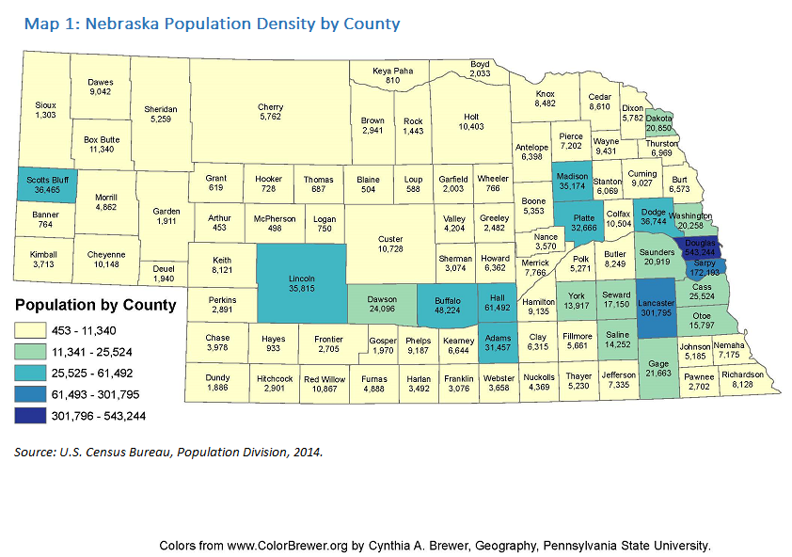

Nebraska offers a variety of demand industry sectors and occupations that provide family-sustaining wages; a 92.3 cost of living index that ranked 13th in the nation during the third quarter of 2017;[3] and appealing tax incentives for new and existing businesses.

Gross Domestic Product

Table 1 provides a comparison of the growth of Nebraska’s gross domestic product (GDP) to the growth of the national GDP and shows that the percent change in growth of Nebraska’s current-dollar[4] and real GDP (in chained 2009 dollars)[5] from year to year for 2013 and 2014 increased at a rate greater than that of the national GDP growth rate. The opposite holds true for 2015 and 2016.

*Table 1. Gross Domestic Product – All Industries: Nebraska/US Comparison*

| Year | **Nebraska**  *Current-dollar* GDP  (millions of current dollars) | **Nebraska**  *Current-dollar* GDP  % change from previous year | **US**  *Current-dollar* GDP (millions of current dollars) | **US**  *Current-dollar* GDP  % change from previous year | **Nebraska**  *Real* GDP  (millions of chained 2009 dollars) | **Nebraska**  *Real* GDP  % change from previous year | **US**  *Real* GDP  (millions of chained 2009 dollars) | **US**  *Real* GDP % change from previous year |
| --- | --- | --- | --- | --- | --- | --- | --- | --- |
| 2013 | 106,765 | 4.7 | 16,576,738 | 3.3 | 96,352 | 2.5 | 15,348,034 | 1.5 |
| 2014 | 112,167 | 5.1 | 17,312,381 | 4.4 | 99,891 | 3.7 | 15,717,536 | 2.4 |
| 2015 | 115,720 | 3.2 | 18,007,085 | 4.0 | 101,996 | 2.1 | 16,148,378 | 2.7 |
| 2016 | 117,446 | 1.5 | 18,511,499 | 2.8 | 102,888 | 0.9 | 16,385,170 | 1.5 |

*Source: United States Department of Commerce, Bureau of Economic Analysis, “GDP & Personal Income, Regional Data,” https://www.bea.gov/iTable/index_regional.cfm [accessed December 19, 2017]*

Tables 2, 3, and 4 provide comparisons of GDP growth for the Grand Island, Lincoln, and Omaha-Council Bluffs metropolitan statistical areas (MSAs) against the Nebraska GDP growth rate.

* The percent change for the Grand Island MSA GDP, current-dollar and real (refer to Table 2):
  + lagged behind the state significantly in 2013, 2014, and 2015; and
  + exceeded the state significantly in 2016.
* The percent change for the Lincoln MSA GDP, current-dollar and real (refer to Table 3):
  + tracked with the state in 2013 and 2014;
  + lagged behind the state in 2015; and
  + exceeded the state in 2016.
* The percent change for the Omaha-Council Bluffs MSA GDP, current-dollar and real (refer to Table 4):
  + lagged behind the state significantly in 2013;
  + exceeded the state significantly in 2014 and 2016; and
  + tracked with the state in 2015.

*Table 2. Gross Domestic Product – All Industries: Grand Island MSA/Nebraska Comparison*

| Year | **Grand Island MSA**  *Current-dollar* GDP  (millions of current dollars) | **Grand Island MSA**  *Current-dollar* GDP  percent change from previous year | **Nebraska**  *Current-dollar* GDP  (millions of current dollars) | **Nebraska**  *Current-dollar* GDP  percent change from previous year | **Grand Island MSA**  *Real* GDP  (millions of chained 2009 dollars) | **Grand Island MSA**  *Real* GDP  percent change from previous year | **Nebraska**  *Real* GDP  (millions of chained 2009 dollars) | **Nebraska**  *Real* GDP  percent change from previous year |
| --- | --- | --- | --- | --- | --- | --- | --- | --- |
| 2013 | 4,041 | 2.3 | 106,765 | 4.7 | 3,625 | 0.0 | 96,352 | 2.5 |
| 2014 | 4,031 | (0.2) | 112,167 | 5.1 | 3,568 | (1.6) | 99,891 | 3.7 |
| 2015 | 4,099 | 1.7 | 115,720 | 3.2 | 3,582 | 0.4 | 101,996 | 2.1 |
| 2016 | 4,238 | 3.4 | 117,446 | 1.5 | 3,669 | 2.4 | 102,888 | 0.9 |

*Source: United States Department of Commerce, Bureau of Economic Analysis, “GDP & Personal Income, Regional Data,” https://www.bea.gov/iTable/index_regional.cfm [accessed December 19, 2017]*

*Table 3. Gross Domestic Product (GDP) - All Industries: Lincoln MSA/Nebraska Comparison*

| Year | **Lincoln** **MSA**  *Current-dollar* GDP  (millions of current dollars) | **Lincoln MSA**  *Current-dollar* GDP  percent change from previous year | **Nebraska**  *Current-dollar* GDP  (millions of current dollars) | **Nebraska**  *Current-dollar* GDP  percent change from previous year | **Lincoln MSA**  *Real* GDP  (millions of chained 2009 dollars) | **Lincoln MSA**  *Real* GDP  percent change from previous year | **Nebraska**  *Real* GDP  (millions of chained 2009 dollars) | **Nebraska**  *Real* GDP  percent change from previous year |
| --- | --- | --- | --- | --- | --- | --- | --- | --- |
| 2013 | 17,332 | 4.3 | 106,765 | 4.7 | 16,028 | 2.2 | 96,352 | 2.5 |
| 2014 | 18,180 | 4.9 | 112,167 | 5.1 | 16,476 | 2.8 | 99,891 | 3.7 |
| 2015 | 18,588 | 2.2 | 115,720 | 3.2 | 16,431 | (0.3) | 101,996 | 2.1 |
| 2016 | 19,203 | 3.3 | 117,446 | 1.5 | 16,677 | 1.5 | 102,888 | 0.9 |

*Source: United States Department of Commerce, Bureau of Economic Analysis, “GDP & Personal Income, Regional Data,” https://www.bea.gov/iTable/index_regional.cfm [accessed December 19, 2017]*

*Table 4. Gross Domestic Product – All Industries: Omaha-Council Bluffs MSA/Nebraska Comparison*

| Year | **Omaha-CB MSA**  *Current-dollar* GDP  (millions of current dollars) | **Omaha-CB MSA**  *Current-dollar* GDP  percent change from previous year | **Nebraska**  *Current-dollar* GDP  (millions of current dollars) | **Nebraska**  *Current-dollar* GDP  percent change from previous year | **Omaha-CB MSA**  *Real* GDP  (millions of chained 2009 dollars) | **Omaha-CB MSA**  *Real* GDP  percent change from previous year | **Nebraska**  *Real* GDP  (millions of chained 2009 dollars) | **Nebraska**  *Real* GDP  percent change from previous year |
| --- | --- | --- | --- | --- | --- | --- | --- | --- |
| 2013 | 53,631 | 2.2 | 106,765 | 4.7 | 49,900 | 0.1 | 96,352 | 2.5 |
| 2014 | 57,413 | 7.1 | 112,167 | 5.1 | 52,287 | 4.8 | 99,891 | 3.7 |
| 2015 | 59,673 | 3.9 | 115,720 | 3.2 | 53,054 | 1.5 | 101,996 | 2.1 |
| 2016 | 61,289 | 2.7 | 117,446 | 1.5 | 53,621 | 1.1 | 102,888 | 0.9 |

*Source: United States Department of Commerce, Bureau of Economic Analysis, “GDP & Personal Income, Regional Data,” https://www.bea.gov/iTable/index_regional.cfm [accessed December 19, 2017]*

Personal Income

Table 5 provides a comparison of the growth of Nebraska’s personal income (all sources) against the growth rate for national personal income (all sources) and shows the percent change in growth for Nebraska for 2013 and 2015 lagged behind the national growth rate significantly, exceeded the national rate in 2014, and tracked with the national rate in 2016.

*Table 5. Personal Income – All Sources: Nebraska/US Comparison*

| Year | **Nebraska**  Personal Income  (thousands of dollars) | **Nebraska**  Personal Income  percent change from previous year | **US**  Personal Income  (thousands of dollars) | **US**  Personal Income  percent change from previous year |
| --- | --- | --- | --- | --- |
| 2013 | 85,722,866 | 0.3 | 14,068,960,000 | 1.2 |
| 2014 | 91,082,845 | 6.3 | 14,811,388,000 | 5.3 |
| 2015 | 93,868,240 | 3.1 | 15,547,661,000 | 5.0 |
| 2016 | 95,411,344 | 1.6 | 15,912,777,000 | 2.3 |

*Source: United States Department of Commerce, Bureau of Economic Analysis, “GDP & Personal Income, Regional Data,” https://www.bea.gov/iTable/index_regional.cfm [accessed December 19, 2017]*

Tables 6, 7, and 8 provide comparisons of the growth rate of personal income for the Grand Island, Lincoln, and Omaha-Council Bluffs metropolitan statistical areas (MSAs) against Nebraska’s overall growth rate of personal income.

* The percent change for Grand Island MSA personal income (refer to Table 6):
  + lagged behind the state significantly in 2013 and 2014; and
  + exceeded the state in 2015 and 2016.
* The percent change for Lincoln MSA personal income (refer to Table 7):
  + tracked with the state in 2013;
  + lagged behind the state in 2014; and
  + exceeded the state in 2015 and 2016.
* The percent change for Omaha-Council Bluffs personal income (refer to Table 8):
  + lagged behind the state significantly in 2013;
  + exceeded the state significantly in 2014;
  + tracked with the state in 2015; and
  + exceeded the state significantly in 2016.

*Table 6. Personal Income – All Sources: Grand Island MSA/Nebraska Comparison*

| Year | **Grand Island MSA**  Personal Income  (thousands of dollars) | **Grand Island MSA**  Personal Income  percent change from previous year | **Nebraska**  Personal Income  (thousands of dollars) | **Nebraska**  Personal Income  percent change from previous year |
| --- | --- | --- | --- | --- |
| 2013 | 3,315,156 | (0.4) | 85,722,866 | 0.3 |
| 2014 | 3,416,138 | 3.0 | 91,082,845 | 6.3 |
| 2015 | 3,556,187 | 4.1 | 93,868,240 | 3.1 |
| 2016 | 3,636,790 | 2.3 | 95,411,344 | 1.6 |

*Source: United States Department of Commerce, Bureau of Economic Analysis, “GDP & Personal Income, Regional Data,” https://www.bea.gov/iTable/index_regional.cfm [accessed December 19, 2017]*

*Table 7. Personal Income – All Sources: Lincoln MSA/Nebraska Comparison*

| Year | **Lincoln MSA**  Personal Income  (thousands of dollars) | **Lincoln MSA**  Personal Income  percent change from previous year | **Nebraska**  Personal Income  (thousands of dollars) | **Nebraska**  Personal Income  percent change from previous year |
| --- | --- | --- | --- | --- |
| 2013 | 13,148,732 | 0.4 | 85,722,866 | 0.3 |
| 2014 | 13,823,543 | 5.1 | 91,082,845 | 6.3 |
| 2015 | 14,478,448 | 4.7 | 93,868,240 | 3.1 |
| 2016 | 14,878,513 | 2.8 | 95,411,344 | 1.6 |

*Source: United States Department of Commerce, Bureau of Economic Analysis, “GDP & Personal Income, Regional Data,” https://www.bea.gov/iTable/index_regional.cfm [accessed December 19, 2017]*

*Table 8. Personal Income – All Sources: Omaha-Council Bluffs MSA/Nebraska Comparison*

| Year | **Omaha-CB MSA**  Personal Income  (thousands of dollars) | **Omaha-CB MSA**  Personal Income  percent change from previous year | **Nebraska**  Personal Income  (thousands of dollars) | **Nebraska**  Personal Income  percent change from previous year |
| --- | --- | --- | --- | --- |
| 2013 | 42,984,202 | (1.8) | 85,722,866 | 0.3 |
| 2014 | 46,495,856 | 8.2 | 91,082,845 | 6.3 |
| 2015 | 48,218,073 | 3.7 | 93,868,240 | 3.1 |
| 2016 | 49,545,167 | 2.8 | 95,411,344 | 1.6 |

*Source: United States Department of Commerce, Bureau of Economic Analysis, “GDP & Personal Income, Regional Data,” https://www.bea.gov/iTable/index_regional.cfm [accessed December 19, 2017]*

Summary

Nebraska’s current and real dollar GDP growth rate was statistically stronger than national GDP growth rate in 2013 and 2014 but weaker than the national rate in 2015 and 2016. Current and real dollar GDP growth for the Grand Island and Lincoln MSAs was weaker than the state’s growth rate in 2013, 2014, and 2015 but stronger in 2016. Current and real dollar GDP growth rate for the Omaha-Council Bluffs MSA was weaker than the state’s in 2013 and 2015 but stronger in 2014 and 2015.

Nebraska’s personal income growth rate was weaker than the national personal income growth rate in 2013, 2015, and 2016 but stronger in 2014. The personal income growth rate for the Grand Island MSA was weaker than the state’s growth rate in 2013 and 2014 and stronger than the state’s in 2015 and 2016. The personal income growth rate for the Lincoln MSA was stronger than the state’s rate in 2013, 2015, and 2016 and weaker in 2014. The personal income growth rate for the Omaha-Council Bluffs MSA was stronger than the state’s in 2013 but weaker in 2014, 2015, and 2016.

###### Economic Analysis

Existing and Emerging Demand Industry Sectors and Occupations

*Industry Sectors*

Tables 9 and 10 provide data on Nebraska’s 22 industry sectors.[6] Table 9 ranks emerging industry sectors based on projected numeric changes in employment levels, from 2014 to 2024. Based solely on projected numeric changes, the top five emerging industry sectors in Nebraska are:

1. Services-Providing, with a projected increase of 78,254;
2. Health Care and Social Assistance, with a projected increase of 20,546;
3. Goods-Producing, with a projected increase of 12,789;
4. Professional, Scientific, and Technical Services, with a projected increase of 9,095; and
5. Construction, with projected increase of 7,490.

Table 10 ranks emerging industry sectors based on percent changes in employment levels, from 2014 to 2024. Based solely on projected percent changes, the top five emerging industry sectors in Nebraska are:

1. Professional, Scientific, and Technical Services, with a projected increase of 20.86 percent;
2. Arts, Entertainment, and Recreation, with a projected increase of 16.35 percent;
3. Construction, with a projected increase of 16.25 percent;
4. Health Care and Social Assistance, with a projected increase of 15.21 percent; and
5. Management of Companies and Enterprises, with a projected increase of 14.73 percent.

Table 9. Emerging Demand Industry Sectors based on Numeric Change in Employment Levels from 2014 to 2024

| Ranking | Industry Title | 2014 Annual Employment | 2024 Projected Employment | Numeric Change in Employment 2014-2024 |
| --- | --- | --- | --- | --- |
| **---** | **Total** | **1,129,802** | **1,227,362** | **97,560** |
| --- | Self-Employed Workers | 87,006 | 93,523 | 6,517 |
| --- | Wage and Salary Employment - Summary Level | --- | --- | --- |
| **---** | **Total Wage and Salary Employment** | **1,042,796** | **1,133,839** | **91,043** |
| 1 | Services-Providing | 841,872 | 920,126 | 78,254 |
| 2 | Health Care and Social Assistance | 135,042 | 155,588 | 20,546 |
| 3 | Goods-Producing | 200,924 | 213,713 | 12,789 |
| 4 | Professional, Scientific, and Technical Services | 43,981 | 53,076 | 9,095 |
| 5 | Construction | 46,081 | 53,571 | 7,490 |
| 6 | Accommodation and Food Services | 73,435 | 80,592 | 7,157 |
| 7 | Manufacturing | 97,442 | 104,036 | 6,594 |
| 8 | Educational Services (including state and local government) | 99,975 | 106,551 | 6,576 |
| 9 | Retail Trade | 108,049 | 114,528 | 6,479 |
| 10 | Transportation and Warehousing | 52,170 | 57,856 | 5,686 |
| 11 | Finance and Insurance | 62,738 | 67,904 | 5,166 |
| 12 | Administrative and Support and Waste Management and Remediation Services | 48,586 | 52,368 | 3,782 |
| 13 | Government | 68,795 | 72,207 | 3,412 |
| 14 | Management of Companies and Enterprises | 21,307 | 24,446 | 3,139 |
| 15 | Wholesale Trade | 42,526 | 44,832 | 2,306 |
| 16 | Arts, Entertainment, and Recreation | 13,545 | 15,760 | 2,215 |
| 17 | Other Services (except Government) | 36,811 | 38,486 | 1,675 |
| 18 | Real Estate and Rental and Leasing | 9,145 | 10,000 | 855 |
| 19 | Information | 17,319 | 17,744 | 425 |
| 20 | Mining | 1,136 | 1,255 | 119 |
| 21 | Utilities (private, state, and local) | 8,448 | 8,188 | (260) |
| 22 | Agriculture, Forestry, and Fishing | 56,265 | 54,851 | (1,414) |

*Source: Nebraska Department of Labor, NEworks, Labor Market Data, Data Download Center, “Long-term Industry Employment Projections, Nebraska Statewide,” https://neworks.nebraska.gov/admin/gsipub/htmlarea/uploads/Nebraska%20LTOP.xlsx, [accessed December 18, 2017]*

Table 10. Emerging Demand Industry Sectors based on Percent Change in Employment Levels from 2014 to 2024

| Ranking | Industry Title | 2014 Annual Employment | 2024 Projected Employment | Percent Change in Employment 2014-2024 |
| --- | --- | --- | --- | --- |
| **---** | **Total** | **1,129,802** | **1,227,362** | **8.64%** |
| --- | Self-Employed Workers | 87,006 | 93,523 | 7.49% |
| --- | Wage and Salary Employment - Summary Level | --- | --- | --- |
| **---** | **Total Wage and Salary Employment** | **1,042,796** | **1,133,839** | **8.73%** |
| 1 | Professional, Scientific, and Technical Services | 43,981 | 53,076 | 20.68% |
| 2 | Arts, Entertainment, and Recreation | 13,545 | 15,760 | 16.35% |
| 3 | Construction | 46,081 | 53,571 | 16.25% |
| 4 | Health Care and Social Assistance | 135,042 | 155,588 | 15.21% |
| 5 | Management of Companies and Enterprises | 21,307 | 24,446 | 14.73% |
| 6 | Transportation and Warehousing | 52,170 | 57,856 | 10.90% |
| 7 | Mining | 1,136 | 1,255 | 10.48% |
| 8 | Accommodation and Food Services | 73,435 | 80,592 | 9.75% |
| 9 | Real Estate and Rental and Leasing | 9,145 | 10,000 | 9.35% |
| 10 | Services-Providing | 841,872 | 920,126 | 9.30% |
| 11 | Finance and Insurance | 62,738 | 67,904 | 8.23% |
| 12 | Administrative and Support and Waste Management and Remediation Services | 48,586 | 52,368 | 7.78% |
| 13 | Manufacturing | 97,442 | 104,036 | 6.77% |
| 14 | Educational Services (including state and local government) | 99,975 | 106,551 | 6.58% |
| 15 | Goods-Producing | 200,924 | 213,713 | 6.37% |
| 16 | Retail Trade | 108,049 | 114,528 | 6.00% |
| 17 | Wholesale Trade | 42,526 | 44,832 | 5.42% |
| 18 | Government | 68,795 | 72,207 | 4.96% |
| 19 | Other Services (except Government) | 36,811 | 38,486 | 4.55% |
| 20 | Information | 17,319 | 17,744 | 2.45% |
| 21 | Agriculture, Forestry, and Fishing | 56,265 | 54,851 | -2.51% |
| 22 | Utilities (private, state, and local) | 8,448 | 8,188 | -3.08% |

*Source: Nebraska Department of Labor, NEworks, Labor Market Data, Data Download Center, “Long-term Industry Employment Projections, Nebraska Statewide,” https://neworks.nebraska.gov/admin/gsipub/htmlarea/uploads/Nebraska%20LTOP.xlsx, [accessed December 18, 2017]*

*Occupations*

Tables 11 and 12 provide data on Nebraska’s top 20 emerging demand occupations. Table 11 ranks emerging demand occupations based on projected numeric changes in employment levels, from 2014 to 2024. Based solely on projected numeric changes, the top five emerging demand occupations in Nebraska are:

1. Heavy and Tractor-Trailer Truck Drivers, with a projected increase of 4,041;
2. Combined Food Preparation and Serving Workers, Including Fast Food, with a projected increase of 3,174;
3. Registered Nurses, with a projected increase of 3,057;
4. Retail Salespersons, with a projected increase of 2,602; and
5. Customer Service Representatives, with a projected increase of 2,313.

Table 12 ranks emerging demand occupations based on percent changes in employment levels, from 2014 to 2024. Based solely on projected percent changes, the top five emerging demand occupations in Nebraska are:

1. Occupational Therapy Assistants, with a projected increase of 45.2 percent;
2. Statisticians, with a projected increase of 36.1 percent;
3. Physical Therapist Assistants, with a projected increase of 33.7 percent;
4. Home Health Aides, with a projected increase of 32.7 percent; and
5. Web Developers, with a projected increase of 32.5 percent.

Table 11. Top 20 Emerging Demand Occupations based on Numeric Change in Employment Levels, 2014 – 2024

| Ranking | SOC | SOC Title | 2014 Estimated Employment | 2024 Projected Employment | Numeric Change |
| --- | --- | --- | --- | --- | --- |
| 1 | 53-3032 | Heavy and Tractor-Trailer Truck Drivers | 28,501 | 32,542 | 4,041 |
| 2 | 35-3021 | Combined Food Preparation and Serving Workers, Including Fast Food | 21,244 | 24,418 | 3,174 |
| 3 | 29-1141 | Registered Nurses | 22,621 | 25,678 | 3,057 |
| 4 | 41-2031 | Retail Salespersons | 29,229 | 31,831 | 2,602 |
| 5 | 43-4051 | Customer Service Representatives | 18,764 | 21,077 | 2,313 |
| 6 | 31-1014 | Nursing Assistants | 13,848 | 15,460 | 1,612 |
| 7 | 39-9011 | Childcare Workers | 11,159 | 12,687 | 1,528 |
| 8 | 13-2011 | Accountants and Auditors | 9,992 | 11,511 | 1,519 |
| 9 | 53-7062 | Laborers and Freight, Stock, and Material Movers, Hand | 17,871 | 19,383 | 1,512 |
| 10 | 47-2031 | Carpenters | 10,379 | 11,745 | 1,366 |
| 11 | 11-1021 | General and Operations Managers | 12,458 | 13,770 | 1,312 |
| 12 | 43-1011 | First-Line Supervisors of Office and Administrative Support Workers | 11,117 | 12,386 | 1,269 |
| 13 | 39-9021 | Personal Care Aides | 6,372 | 7,598 | 1,226 |
| 14 | 41-2011 | Cashiers | 24,597 | 25,728 | 1,131 |
| 15 | 35-3031 | Waiters and Waitresses | 15,253 | 16,356 | 1,103 |
| 16 | 37-2011 | Janitors and Cleaners, Except Maids and Housekeeping Cleaners | 15,714 | 16,770 | 1,056 |
| 17 | 49-9041 | Industrial Machinery Mechanics | 3,598 | 4,628 | 1,030 |
| 18 | 15-1132 | Software Developers, Applications | 4,164 | 5,184 | 1,020 |
| 19 | 43-9061 | Office Clerks, General | 17,699 | 18,701 | 1,002 |
| 20 | 47-2111 | Electricians | 4,850 | 5,780 | 930 |

*Source: Nebraska Department of Labor, NEworks, Labor Market Data, Download Center, “High Wage, High Skill, High Demand (H3) Occupations,” https://neworks.nebraska.gov/gsipub/index.asp?docid=1165 [accessed December 20, 2017]*

Table 12. Top 20 Emerging Demand Occupations based on Percent Change in Employment Levels, 2014 – 2024

| Ranking | SOC | SOC Title | 2014 Estimated Employment | 2024 Projected Employment | Percent Change |
| --- | --- | --- | --- | --- | --- |
| 1 | 31-2011 | Occupational Therapy Assistants | 115 | 167 | 45.2% |
| 2 | 15-2041 | Statisticians | 191 | 260 | 36.1% |
| 3 | 31-2021 | Physical Therapist Assistants | 635 | 849 | 33.7% |
| 4 | 31-1011 | Home Health Aides | 1,446 | 1,919 | 32.7% |
| 5 | 15-1134 | Web Developers | 1,171 | 1,551 | 32.5% |
| 6 | 51-4011 | Computer-Controlled Machine Tool Operators, Metal and Plastic | 1,321 | 1,742 | 31.9% |
| 7 | 15-2031 | Operations Research Analysts | 383 | 505 | 31.9% |
| 8 | 31-2022 | Physical Therapist Aides | 770 | 1,009 | 31.0% |
| 9 | 51-9081 | Dental Laboratory Technicians | 248 | 322 | 29.8% |
| 10 | 51-4012 | Computer Numerically Controlled Machine Tool Programmers, Metal and Plastic | 106 | 137 | 29.3% |
| 11 | 49-9041 | Industrial Machinery Mechanics | 3,598 | 4,628 | 28.6% |
| 12 | 17-1021 | Cartographers and Photogrammetrists | 105 | 135 | 28.6% |
| 13 | 29-2056 | Veterinary Technologists and Technicians | 631 | 811 | 28.5% |
| 14 | 15-1122 | Information Security Analysts | 610 | 783 | 28.4% |
| 15 | 29-1123 | Physical Therapists | 1,482 | 1,901 | 28.3% |
| 16 | 47-2171 | Reinforcing Iron and Rebar Workers | 192 | 245 | 27.6% |
| 17 | 47-3011 | Helpers--Brickmasons, Blockmasons, Stonemasons, and Tile and Marble Setters | 165 | 209 | 26.7% |
| 18 | 49-9044 | Millwrights | 272 | 344 | 26.5% |
| 19 | 47-4071 | Septic Tank Servicers and Sewer Pipe Cleaners | 126 | 159 | 26.2% |
| 20 | 15-1121 | Computer Systems Analysts | 3,330 | 4,164 | 25.1% |

*Source: Nebraska Department of Labor, NEworks, Labor Market Data, Download Center, “High Wage, High Skill, High Demand (H3) Occupations,” https://neworks.nebraska.gov/gsipub/index.asp?docid=1165 [accessed December 20, 2017]*

*Summary*

Analysis of Nebraska’s 22 industry sectors based on projected numeric and percent changes in employment levels from 2014 to 2024 revealed three industry sectors as the strongest emerging sectors based on both numeric and percent changes:

1. Health Care and Social Assistance, with a projected numeric increase of 20,546 and percent increase of 15.21; and
2. Professional, Scientific, and Technical Services, with a projected numeric increase of 9,095 and percent increase of 20.86; and
3. Construction, with a projected numeric increase of 7,490 positions and percent increase of 16.25;

Analysis of Nebraska’s top 20 emerging demand occupations based on projected numeric and percent changes in employment levels from 2014 to 2024 revealed career-pathway connections for the top 10 emerging demand occupations to all of the three strongest emerging industry sectors and one additional emerging industry sector (Services-Providing), as described in Table 13.

Table 13. Career-pathway Connections between Emerging Demand Occupations and Industry Sectors

| Emerging Demand Occupation | Emerging Demand Industry Sector |
| --- | --- |
| 1. Combined  Food Preparation and Serving Workers, Including Fast Food | Services-providing |
| 1. Customer  Service Representatives | Services-providing |
| 1. Heavy  and Tractor-Trailer Truck Drivers | Construction |
| 1. Home  Health Aides | Health Care and Social Assistance |
| 1. Occupational  Therapy Assistants | Health Care and Social Assistance |
| 1. Physical  Therapist Assistants | Health Care and Social Assistance |
| 1. Registered  Nurses | Health Care and Social Assistance |
| 1. Retail  Salespersons | Services-providing |
| 1. Statisticians | Professional, Scientific, and Technical Services |
| 1. Web  Developers | Professional, Scientific, and Technical Services |

*Source: Refer to the narrative preceding Tables 9 and 10 in the earlier section on Industry Sectors and the narrative preceding Tables 11 and 12 in the earlier section on Occupations.*

Employers’ Employment Needs

Tables 14 and 15 provide data on education and job-training requirements for emerging demand occupations in Nebraska (refer to Tables 11 and 12). Table 14 identifies education and job training requirements for the top 20 emerging demand occupations based on projected numeric changes in employment levels from 2014 through 2024.

* Seven occupations require no formal educational credential but do require short-term on-the-job training, with entry hourly wages ranging from $9.25 to $10.30 and median hourly wages ranging from $9.13 to $13.22.
* Seven require a high school diploma or its equivalent and short- or long-term on-the-job training or apprenticeship training or no job-related training, with entry hourly wages ranging from $9.30 to $16.30 and median hourly wages ranging from $9.71 to $23.57.
* Two require a postsecondary non-degree award and short-term on-the-job training or no job-related training, with entry hourly wages ranging from $10.65 to $14.75 and median hourly wages ranging from $11.94 to $19.61.
* Four require a Bachelor’s degree but no job-related training, with entry hourly wages ranging from $19.85 to $29.25 and median wages ranging from $28.40 to $44.59.

Table 15 identifies education and job-training requirements for the top 20 emerging demand occupations based on projected percent changes in employment levels from 2014 through 2024.

* Three occupations require no formal educational credential but do require short- or moderate-term on-the-job training, with entry hourly wages ranging from $10.50 to $13.30 and median hourly wages ranging from $11.59 to $15.14.
* Seven require a high school diploma or its equivalent and short-, moderate-, or long-term on-the-job training or apprenticeship training, with entry hourly wages ranging from $9.95 to $19.50 and median hourly wages ranging from $11.01 to $23.99.
* Four require an Associate’s degree but no job-related training, with entry hourly wages ranging from $11.25 to $18.80 and median hourly wages ranging from $14.41 to $27.32.
* Four require a Bachelor’s degree but no job-related training, with entry hourly wages ranging from $20.35 to $24.05 and median wages ranging from $27.06 to $36.49.
* One requires a Master’s degree but no job-related training, with an entry hourly wage of $19.70 and a median wage of $24.75.
* One requires a Doctoral or professional degree but no job-related training, with an entry hourly wage of $24.95 and a median wage of $36.06

*Table 14. Education and Job Training Requirements for the Top 20 Emerging Demand Occupations (based on Numeric Change in Employment Levels, 2014 – 2024)*

| Ranking | SOC | SOC Title | Education | Job Training | Median Hourly Wage | Entry Wage |
| --- | --- | --- | --- | --- | --- | --- |
| 1 | 53-3032 | Heavy and Tractor-Trailer Truck Drivers | Postsecondary non-degree award | Short-term on-the-job training | $19.61 | $14.75 |
| 2 | 35-3021 | Combined Food Preparation and Serving Workers, Including Fast Food | No formal educational credential | Short-term on-the-job training | $9.21 | $9.30 |
| 3 | 29-1141 | Registered Nurses | Bachelor's degree | None | $28.40 | $22.80 |
| 4 | 41-2031 | Retail Salespersons | No formal educational credential | Short-term on-the-job training | $10.78 | $9.35 |
| 5 | 43-4051 | Customer Service Representatives | High school diploma or equivalent | Short-term on-the-job training | $14.84 | $11.10 |
| 6 | 31-1014 | Nursing Assistants | Postsecondary non-degree award | None | $11.94 | $10.65 |
| 7 | 39-9011 | Childcare Workers | High school diploma or equivalent | Short-term on-the-job training | $9.71 | $9.30 |
| 8 | 13-2011 | Accountants and Auditors | Bachelor's degree | None | $28.98 | $19.85 |
| 9 | 53-7062 | Laborers and Freight, Stock, and Material Movers, Hand | No formal educational credential | Short-term on-the-job training | $13.22 | $10.15 |
| 10 | 47-2031 | Carpenters | High school diploma or equivalent | Apprenticeship | $16.66 | $12.55 |
| 11 | 11-1021 | General and Operations Managers | Bachelor's degree | None | $44.59 | $22.10 |
| 12 | 43-1011 | First-Line Supervisors of Office and Administrative Support Workers | High school diploma or equivalent | None | $23.57 | $16.00 |
| 13 | 39-9021 | Personal Care Aides | No formal educational credential | Short-term on-the-job training | $11.18 | $10.30 |
| 14 | 41-2011 | Cashiers | No formal educational credential | Short-term on-the-job training | $9.37 | $9.30 |
| 15 | 35-3031 | Waiters and Waitresses | No formal educational credential | Short-term on-the-job training | $9.13 | $9.25 |
| 16 | 37-2011 | Janitors and Cleaners, Except Maids and Housekeeping Cleaners | No formal educational credential | Short-term on-the-job training | $11.32 | $9.75 |
| 17 | 49-9041 | Industrial Machinery Mechanics | High school diploma or equivalent | Long-term on-the-job training | $21.76 | $16.30 |
| 18 | 15-1132 | Software Developers, Applications | Bachelor's degree | None | $38.69 | $29.25 |
| 19 | 43-9061 | Office Clerks, General | High school diploma or equivalent | Short-term on-the-job training | $12.27 | $9.75 |
| 20 | 47-2111 | Electricians | High school diploma or equivalent | Apprenticeship | $21.83 | $15.10 |

*Source: Nebraska Department of Labor, NEworks, Labor Market Data, Download Center, “High Wage, High Skill, High Demand (H3) Occupations,” https://neworks.nebraska.gov/gsipub/index.asp?docid=1165 [accessed December 20, 2017]*

*Table 15. Education and Job Training Requirements for the Top 20 Emerging Demand Occupations (based on Percent Change in Employment Levels, 2014 – 2024)*

| Ranking | SOC | SOC Title | Education | Job Training | Median Hourly Wage | Entry Wage |
| --- | --- | --- | --- | --- | --- | --- |
| 1 | 31-2011 | Occupational Therapy Assistants | Associate's degree | None | $26.85 | $18.80 |
| 2 | 15-2041 | Statisticians | Master's degree | None | $24.75 | $19.70 |
| 3 | 31-2021 | Physical Therapist Assistants | Associate's degree | None | $24.70 | $16.05 |
| 4 | 31-1011 | Home Health Aides | No formal educational credential | Short-term on-the-job training | $11.59 | $10.50 |
| 5 | 15-1134 | Web Developers | Associate's degree | None | $27.32 | $16.90 |
| 6 | 51-4011 | Computer-Controlled Machine Tool Operators, Metal and Plastic | High school diploma or equivalent | Moderate-term on-the-job training | $17.19 | $12.50 |
| 7 | 15-2031 | Operations Research Analysts | Bachelor's degree | None | $32.12 | $23.15 |
| 8 | 31-2022 | Physical Therapist Aides | High school diploma or equivalent | Short-term on-the-job training | $11.01 | $9.95 |
| 9 | 51-9081 | Dental Laboratory Technicians | High school diploma or equivalent | Moderate-term on-the-job training | $21.01 | $14.00 |
| 10 | 51-4012 | Computer Numerically Controlled Machine Tool Programmers, Metal and Plastic | High school diploma or equivalent | Long-term on-the-job training | $23.99 | $19.50 |
| 11 | 49-9041 | Industrial Machinery Mechanics | High school diploma or equivalent | Long-term on-the-job training | $21.76 | $16.30 |
| 12 | 17-1021 | Cartographers and Photogrammetrists | Bachelor's degree | None | $27.06 | $20.35 |
| 13 | 29-2056 | Veterinary Technologists and Technicians | Associate's degree | None | $14.41 | $11.25 |
| 14 | 15-1122 | Information Security Analysts | Bachelor's degree | None | $36.49 | $23.70 |
| 15 | 29-1123 | Physical Therapists | Doctoral or professional degree | None | $36.03 | $24.95 |
| 16 | 47-2171 | Reinforcing Iron and Rebar Workers | High school diploma or equivalent | Apprenticeship | $20.59 | $18.20 |
| 17 | 47-3011 | Helpers--Brickmasons, Blockmasons, Stonemasons, and Tile and Marble Setters | No formal educational credential | Short-term on-the-job training | $15.14 | $12.55 |
| 18 | 49-9044 | Millwrights | High school diploma or equivalent | Apprenticeship | $23.72 | $15.60 |
| 19 | 47-4071 | Septic Tank Servicers and Sewer Pipe Cleaners | No formal educational credential | Moderate-term on-the-job training | $14.77 | $13.30 |
| 20 | 15-1121 | Computer Systems Analysts | Bachelor's degree | None | $35.98 | $24.05 |

*Source: Nebraska Department of Labor, NEworks, Labor Market Data, Download Center, “High Wage, High Skill, High Demand (H3) Occupations,” https://neworks.nebraska.gov/gsipub/index.asp?docid=1165 [accessed December 20, 2017]*

#### *Workforce Analysis*

The Unified or Combined State Plan must include an analysis of the current workforce, including individuals with barriers to employment, as defined in section 3 of WIOA.* This population must include individuals with disabilities among other groups** in the State and across regions identified by the State. This includes: Individuals with barriers to employment include displaced homemakers; low-income individuals; Indians, Alaska Natives, and Native Hawaiians; individuals with disabilities, including youth who are individuals with disabilities; older individuals; ex-offenders; homeless individuals, or homeless children and youths; youth who are in or have aged out of the foster care system; individuals who are English language learners, individuals who have low levels of literacy, and individuals facing substantial cultural barriers; farmworkers (as defined at section 167(i) of WIOA and Training and Employment Guidance Letter No. 35-14); individuals within 2 years of exhausting lifetime eligibility under the Temporary Assistance for Needy Families program; single parents (including single pregnant women); and long-term unemployed individuals.   ** Veterans, unemployed workers, and youth, and others that the State may identify.

##### Employment and Unemployment

Provide an analysis of current employment and unemployment data, including labor force participation rates, and trends in the State.

##### Labor Market Trends

Provide an analysis of key labor market trends, including across existing industries and occupations.

##### Education and Skill Levels of the Workforce

Provide an analysis of the educational and skill levels of the workforce.

##### Skills Gaps

Describe apparent skill gaps.

###### Employment and Unemployment

Since 2013, has experienced a net reduction in its civilian labor force of 7,255 workers, while maintaining a low, relatively stable statewide rate of unemployment.

Table 16. Total Civilian Labor Force in Nebraska, 2013 – 2016

| Time Period | Labor Force | Employed | Unemployed | Unemployment Rate |
| --- | --- | --- | --- | --- |
| 2013 | 1,018,435 | 979,379 | 39,057 | 3.8% |
| 2014 | 1,011,918 | 978,208 | 33,710 | 3.3% |
| 2015 | 1,008,616 | 977,465 | 31,151 | 3.1% |
| 2016 | 1,011,180 | 978,261 | 32,919 | 3.3% |

*Source: Nebraska Department of Labor, Labor Market Information, Local Area Unemployment Statistics, https://neworks.nebraska.gov/vosnet/analyzer/results.aspx?session=labforce [accessed December 27, 2018)*

Percentage unemployment rates for 2016 for each of Nebraska’s 93 counties, ranked by county from lowest to highest, are listed in Table 17. County unemployment rates vary from 2.1 percent in Keya Paha County to 6.2 percent in Arthur County.

Table 17. Unemployment Rates by County in Nebraska, 2016

| Rank | County | Percentage Unemployment Rate |
| --- | --- | --- |
| 1 | Keya Paha County | 2.1% |
| 2 | Chase County | 2.2% |
| 3 | Dundy County | 2.3% |
| 5 | Wheeler County | 2.3% |
| 4 | Perkins County | 2.3% |
| 6 | Cherry County | 2.4% |
| 8 | McPherson County | 2.4% |
| 7 | Grant County | 2.4% |
| 9 | Pawnee County | 2.4% |
| 10 | Custer County | 2.5% |
| 11 | Hayes County | 2.5% |
| 13 | Kearney County | 2.5% |
| 12 | Jefferson County | 2.5% |
| 14 | Buffalo County | 2.6% |
| 17 | Phelps County | 2.6% |
| 16 | Holt County | 2.6% |
| 18 | Thayer County | 2.6% |
| 15 | Harlan County | 2.6% |
| 19 | Antelope County | 2.7% |
| 21 | Gosper County | 2.7% |
| 23 | Stanton County | 2.7% |
| 22 | Rock County | 2.7% |
| 20 | Cedar County | 2.7% |
| 24 | Boone County | 2.8% |
| 32 | York County | 2.8% |
| 29 | Polk County | 2.8% |
| 31 | Wayne County | 2.8% |
| 27 | Nance County | 2.8% |
| 26 | Garfield County | 2.8% |
| 25 | Deuel County | 2.8% |
| 28 | Pierce County | 2.8% |
| 30 | Sioux County | 2.8% |
| 33 | Fillmore County | 2.9% |
| 35 | Hamilton County | 2.9% |
| 37 | Logan County | 2.9% |
| 36 | Lancaster County | 2.9% |
| 34 | Furnas County | 2.9% |
| 38 | Madison County | 2.9% |
| 39 | Cheyenne County | 3.0% |
| 44 | Sarpy County | 3.0% |
| 40 | Colfax County | 3.0% |
| 42 | Frontier County | 3.0% |
| 43 | Red Willow County | 3.0% |
| 47 | Valley County | 3.0% |
| 41 | Cuming County | 3.0% |
| 46 | Sheridan County | 3.0% |
| 45 | Seward County | 3.0% |
| 48 | Dawes County | 3.1% |
| 51 | Keith County | 3.1% |
| 49 | Dawson County | 3.1% |
| 52 | Nuckolls County | 3.1% |
| 50 | Franklin County | 3.1% |
| 53 | Boyd County | 3.2% |
| 56 | Lincoln County | 3.2% |
| 57 | Saline County | 3.2% |
| 58 | Saunders County | 3.2% |
| 54 | Dodge County | 3.2% |
| 55 | Knox County | 3.2% |
| 59 | Adams County | 3.3% |
| 65 | Washington County | 3.3% |
| 66 | Webster County | 3.3% |
| 64 | Sherman County | 3.3% |
| 61 | Clay County | 3.3% |
| 62 | Greeley County | 3.3% |
| 60 | Butler County | 3.3% |
| 63 | Johnson County | 3.3% |
| 67 | Garden County | 3.4% |
| 70 | Thomas County | 3.4% |
| 69 | Richardson County | 3.4% |
| 68 | Morrill County | 3.4% |
| 71 | Cass County | 3.5% |
| 73 | Douglas County | 3.5% |
| 75 | Howard County | 3.5% |
| 74 | Gage County | 3.5% |
| 76 | Otoe County | 3.5% |
| 72 | Dixon County | 3.5% |
| 77 | Loup County | 3.6% |
| 78 | Scotts Bluff County | 3.6% |
| 79 | Platte County | 3.7% |
| 80 | Banner County | 3.8% |
| 85 | Hooker County | 3.8% |
| 81 | Box Butte County | 3.8% |
| 82 | Burt County | 3.8% |
| 86 | Merrick County | 3.8% |
| 83 | Hall County | 3.8% |
| 84 | Hitchcock County | 3.8% |
| 87 | Nemaha County | 3.8% |
| 88 | Brown County | 3.9% |
| 89 | Dakota County | 4.3% |
| 90 | Kimball County | 4.3% |
| 91 | Blaine County | 4.5% |
| 92 | Thurston County | 5.0% |
| 93 | Arthur County | 6.2% |

*Source: Nebraska Department of Labor, Labor Market Information, Local Area Unemployment Statistics, https://neworks.nebraska.gov/vosnet/analyzer/results.aspx?session=labforce [accessed December 27, 2018)*

The two largest counties in Nebraska, Douglas and Lancaster, reported employment gains from December 2015 to December 2016.[7]

* Employment rose 0.7 percent in Douglas County and 0.1 percent in Lancaster County. (Refer to Table 18.)
* Among the two largest counties in Nebraska, employment was higher in Douglas (340,700) in December 2016. (Refer to Table 18.)
* Lancaster County recorded an employment level of 169,500. (Refer to Table 18.)
* Collectively, Nebraska’s two large counties accounted for 52.5 percent of the state's employment. (Refer to Table 18.)
* The average weekly wage in Douglas was $986 in the fourth quarter of 2016, a decrease of 0.8 percent from the fourth quarter of 2015. (Refer to Table 19.)
* Average weekly wages in Lancaster were $853, unchanged over the year. (Refer to Table 19.)

Employment and wage levels (but not over-the-year changes) are also available for the 91 counties in Nebraska with employment levels below 75,000. (Refer to Table 19.) Two of these smaller counties, Nemaha and Stanton, had average weekly wages above the national average of $1,067.

Table 18. Covered employment and wages in the United States and the 2 largest counties in Nebraska, fourth quarter 2016

| Area | **Employment**  –  December 2016 (thousands) | **Employment**  –  Percent change, December 2015-16  (1) | **Employment**  –  National ranking by percent change  (2) | **Average** **weekly** **wage**  (3) | **Average weekly wage**  –  National ranking by level  (2) | **Average weekly wage**  –  Percent change, fourth quarter 2015-16  (1) | **Average weekly wage**  –  National ranking by percent change  (2) |
| --- | --- | --- | --- | --- | --- | --- | --- |
| United States (4) | 143,750 | 1.2% | -- | $1,067.00 | -- | -1.5% | -- |
| Nebraska | 972 | 0.0% | -- | $876.00 | 40 | -0.5% | 10 |
| Douglas | 341 | 0.7% | 223 | $986.00 | 162 | -0.8% | 104 |
| Lancaster | 170 | 0.1% | 268 | $853.00 | 291 | 0.0% | 49 |

*Footnotes:*

*(1) Percent changes were computed from quarterly employment and pay data adjusted for noneconomic county reclassifications*

*(3) Ranking does not include data for Puerto Rico or the Virgin Islands*

*(3) Average weekly wages were calculated using unrounded data*

*(4) Totals for the United States do not include data for Puerto Rico or the Virgin Islands*

*Note: Data are preliminary. Covered employment and wages includes workers covered by Unemployment Insurance (UI) and Unemployment Compensation for Federal Employees (UCFE) programs.*

*Source: United States Department of Labor, Bureau of Labor Statistics, County Employment and Wages in Nebraska – Fourth Quarter 2016, https://www.bls.gov/regions/midwest/news-release/countyemploymentandwages_nebraska.htm [accessed December 27, 2017]*

Table 19. Covered employment and wages in the United States and all counties in Nebraska, fourth quarter 2016

| Area | Employment December 2016 | Average weekly wage(1) |
| --- | --- | --- |
| United States(2) | 143,749,910 | $1,067 |
| Nebraska | 972,400 | $876 |
| Adams | 15,280 | $750 |
| Antelope | 2,046 | $694 |
| Arthur | 85 | $606 |
| Banner | 125 | $708 |
| Blaine | 133 | $683 |
| Boone | 2,352 | $699 |
| Box Butte | 3,772 | $694 |
| Boyd | 610 | $586 |
| Brown | 1,208 | $695 |
| Buffalo | 27,134 | $768 |
| Burt | 1,806 | $704 |
| Butler | 2,505 | $755 |
| Cass | 5,547 | $738 |
| Cedar | 2,648 | $710 |
| Chase | 1,833 | $730 |
| Cherry | 2,307 | $594 |
| Cheyenne | 5,342 | $919 |
| Clay | 2,424 | $830 |
| Colfax | 5,253 | $957 |
| Cuming | 3,698 | $819 |
| Custer | 4,538 | $729 |
| Dakota | 12,667 | $840 |
| Dawes | 3,298 | $616 |
| Dawson | 11,384 | $733 |
| Deuel | 578 | $619 |
| Dixon | 1,707 | $731 |
| Dodge | 17,248 | $754 |
| Douglas | 340,676 | $986 |
| Dundy | 571 | $745 |
| Fillmore | 2,229 | $779 |
| Franklin | 749 | $736 |
| Frontier | 807 | $690 |
| Furnas | 2,032 | $727 |
| Gage | 9,151 | $686 |
| Garden | 565 | $629 |
| Garfield | 796 | $583 |
| Gosper | 386 | $730 |
| Grant | 281 | $600 |
| Greeley | 600 | $629 |
| Hall | 34,625 | $772 |
| Hamilton | 3,572 | $879 |
| Harlan | 823 | $633 |
| Hayes | 215 | $631 |
| Hitchcock | 657 | $712 |
| Holt | 4,546 | $695 |
| Hooker | 258 | $486 |
| Howard | 1,426 | $634 |
| Jefferson | 3,286 | $670 |
| Johnson | 1,589 | $734 |
| Kearney | 2,172 | $718 |
| Keith | 3,306 | $661 |
| Keya Paha | 151 | $548 |
| Kimball | 1,356 | $737 |
| Knox | 2,998 | $621 |
| Lancaster | 169,450 | $853 |
| Lincoln | 14,894 | $743 |
| Logan | 193 | $619 |
| Loup | 130 | $420 |
| Madison | 21,677 | $783 |
| McPherson | 83 | $585 |
| Merrick | 2,303 | $754 |
| Morrill | 1,516 | $706 |
| Nance | 1,054 | $691 |
| Nemaha | 3,055 | $1,090 |
| Nuckolls | 1,441 | $599 |
| Otoe | 6,132 | $716 |
| Pawnee | 861 | $652 |
| Perkins | 1,151 | $842 |
| Phelps | 4,789 | $828 |
| Pierce | 1,994 | $726 |
| Platte | 18,551 | $825 |
| Polk | 1,479 | $716 |
| Red Willow | 5,201 | $687 |
| Richardson | 2,508 | $632 |
| Rock | 475 | $635 |
| Saline | 7,235 | $803 |
| Sarpy | 70,627 | $877 |
| Saunders | 5,237 | $713 |
| Scotts Bluff | 16,917 | $756 |
| Seward | 6,074 | $789 |
| Sheridan | 1,753 | $590 |
| Sherman | 816 | $577 |
| Sioux | 164 | $661 |
| Stanton | 1,295 | $1,076 |
| Thayer | 2,400 | $753 |
| Thomas | 260 | $549 |
| Thurston | 2,977 | $849 |
| Valley | 1,793 | $654 |
| Washington | 7,912 | $1,033 |
| Wayne | 4,241 | $684 |
| Webster | 1,077 | $579 |
| Wheeler | 323 | $694 |
| York | 7,583 | $771 |

*Footnotes*

*(1) Average weekly wages were calculated using unrounded data.*

*(2) Totals for the United States do not include data for Puerto Rico or the Virgin Islands.*

*NOTE: Includes workers covered by Unemployment Insurance (UI) and Unemployment Compensation for Federal Employees (UCFE) programs. Data are preliminary.*

*Source: United States Department of Labor, Bureau of Labor Statistics, County Employment and Wages in Nebraska – Fourth Quarter 2016, https://www.bls.gov/regions/midwest/news-release/countyemploymentandwages_nebraska.htm [accessed December 27, 2017]*

Labor availability[8]

The term *labor availability* refers to the number of people within a given area who are available and willing to take a new job. Labor availability has two components: geographical and human. The geographical component narrows down the labor pool to those who are located near or able to travel to a specific location to work. The human component of labor availability depends upon the characteristics of the potential workforce in the area. People take, keep, and change jobs for a variety of reasons. Compensation—salary and benefits—is important, but other factors, including convenience, security, family obligations, personal fulfillment, age, sex, education, and training, contribute to workers’ employment decisions. These motivations and demographic characteristics determine labor availability within a region.

The Nebraska Department of Labor (NDOL) frequently collects many types of data on Nebraska workers for the US Bureau of Labor Statistics (BLS). BLS then measures how many people work in different industries and occupations. In addition, BLS measures how many people work or do not work. While BLS and NDOL produce a rich data catalog, neither agency regularly measures the reasons workers choose to work where they do, or choose not to work. Labor availability studies aim to supplement BLS and NDOL data with information about those motivations. Understanding why people take a job helps stakeholders understand how an employer might attract new workers. In addition, understanding the characteristics of the current labor force and the incentives required for residents to change jobs could shed light on how communities might improve the local labor force.

In 2013, NDOL and the Nebraska Department of Economic Development (NDED), with support from the University of Nebraska – Lincoln, Bureau of Sociological Research (BOSR) began a series of studies to measure labor availability in six Nebraska regions:

* Central Nebraska;
* Lincoln and Omaha metro regions;
* Northeast Nebraska;
* Panhandle area of Nebraska (Scottsbluff);
* Southeast Nebraska; and
* Southwest Nebraska.

*Central Nebraska*

Results of the Central Nebraska Labor Availability Survey, which included all or parts of Hall, Hamilton, Howard, and Merrick counties, among others, revealed that there were an estimated 11,698 potential jobseekers, over the age of 18, in the city of Grand Island during the fall of 2016. The majority of these potential jobseekers were currently employed (85.9 percent). Others were out of work or seeking to reenter the workforce after time spent in retirement or homemaking. These potential jobseekers indicated that they were willing to take new work or change jobs in the next year if a suitable job presented itself. The median minimum pay that potential jobseekers required to improve their employment situation was $60,000 in annual salary, or $18 per hour (salaried and hourly paid employees were calculated separately). The median tenure of employed potential jobseekers at their current job was 45 months, or just under four years. Over 36 percent of potential jobseekers reported they held a bachelor’s degree or higher. Potential jobseekers identified salary, health insurance, and a work schedule that would fit their needs as the most important factors in improving their employment situation. Potential jobseekers named lack of job opportunities in the area, inadequate pay offered at area employers, and inadequate benefits offered by area employers as the most common barriers to improving their employment situation.

*Lincoln and Omaha Metro Regions*

Results of the Metro Area Labor Availability Survey, which included all or parts of Douglas, Gage, Lancaster, Sarpy, Saunders, and Washington counties, among others, revealed that there are an estimated 247,692 potential jobseekers in the Lincoln survey area. The majority of these potential jobseekers are currently employed. Others are out of work or seeking to reenter the workforce after time spent in retirement or homemaking. These potential jobseekers indicated that they are willing to take new work or change jobs in the next year if a suitable job presents itself. The median wage sought by this group is a minimum of $40,560 annually, or $19.50 per hour, for full-time, year-round work. Nearly all (97 percent) potential jobseekers stated that they are willing to commute 15 minutes or more each way for suitable work. The median tenure of employed potential jobseekers at their current job is three years. More than half said they have at least a bachelor’s degree. Potential jobseekers identified salary, use of skills they already possessed, and a schedule that fit their needs as the most important factors in improving their employment situation. They named inadequate pay offered by area employers, lack of job opportunities in the area, and inadequate benefits offered by area employers as the most common barriers to improving their employment situation.

Results of the survey also revealed that there are an estimated 300,043 potential jobseekers in the Omaha survey area. The majority of these potential jobseekers are currently employed. Others are out of work or seeking to reenter the workforce after time spent in retirement or homemaking. These potential jobseekers indicated that they are willing to take new work or change jobs in the next year if a suitable job presents itself. The median wage sought by this group is a minimum of $41,600 annually, or $20.00 per hour, for full-time, year-round work. Nearly all (97 percent) potential jobseekers stated that they are willing to commute 15 minutes or more each way for suitable work. The median tenure of employed potential jobseekers at their current job is five years. More than half said they have at least a bachelor’s degree. Potential jobseekers identified salary, use of skills they already possessed, and a schedule that fit their needs as the most important factors in improving their employment situation. They named inadequate pay offered by area employers, lack of job opportunities in the area, and inadequate benefits offered by area employers as the most common barriers to improving their employment situation.

*Northeast Nebraska*

Respondents provided information about their current employment status and their perspective on future employment changes. Six communities in the region were highlighted: Columbus, Fremont, Norfolk, South Sioux City, Wayne, and West Point.

A survey of northeast Nebraska revealed that there are an estimated 116,550 potential jobseekers in the region. The majority of these people are employed; others may be out of work or seeking to reenter the workforce from time spent in retirement or homemaking. These potential jobseekers indicated that they would be willing to take new work in the next year if a suitable job were to present itself. The median wage sought by this group was a minimum of $35,360 annually, or $17 per hour for full-time year-round work. Four out of five potential jobseekers stated that they are willing to commute 15 minutes or more each way for suitable work. The median tenure of employed potential jobseekers at their current job is over five and one-half years. Half of these people have an associate’s degree or higher education. In general, those who were less likely to reenter the workforce or change jobs earned more and had been with their employers longer if they were employed. Potential jobseekers identified salary, use of skills they already possessed, and a schedule that fit their needs as the most important factors in improving their employment situation. They named lack of job opportunities in the area, inadequate pay offered by area employers, and inadequate benefits offered by area employers as the most common barriers to improving their employment situation.

*Panhandle Area of Nebraska (Scottsbluff)*

Results of the Panhandle Labor Availability Survey, which included areas in western Nebraska such as Scottsbluff, Alliance, and Sidney, as well as Goshen County, Wyoming, revealed that there were an estimated 23,543 potential jobseekers in the Panhandle survey area during the summer of 2015. The majority of these potential jobseekers are currently employed (81.4 percent). Others are out of work or seeking to reenter the workforce after time spent in retirement or homemaking. These potential jobseekers indicated that they were willing to take new work or change jobs in the next year if a suitable job presents itself. The median wage sought by this group was a minimum of $40,000 annually, or $19.23 per hour for full-time, year-round work. Nearly all (93 percent) potential jobseekers stated that they were willing to commute 15 minutes or more each way for suitable work. The median tenure of employed potential jobseekers at their current job was four and one-half years. Over a third of potential jobseekers (36.4 percent) said they had at least a bachelor’s degree. Potential jobseekers identified salary, work schedule, and using skills they have as the most important factors in improving their employment situation. They named lack of job opportunities in the area, inadequate pay offered at area employers, and inadequate benefits offered by area employers as the most common barriers to improving their employment situation.

*Southeast Nebraska*

Results of the Southeast Nebraska Labor Availability Survey, which included all or parts of eight counties in the southeast region of Nebraska and southwest Iowa, including Johnson, Nemaha, Pawnee, Otoe, and Richardson counties in Nebraska, revealed that there were an estimated 11,403 potential jobseekers, over the age of 18, in the survey area during the fall of 2016 (29 percent of all potential respondents). The majority of potential jobseekers in the survey area were currently employed (80 percent). Others were out of work or seeking to reenter the workforce after time spent in retirement or homemaking. These potential jobseekers indicated that they were willing to take new work or change jobs in the next year if a suitable job presented itself. The median minimum pay that potential jobseekers required to improve their employment situation was $55,000 in annual salary, or $16 per hour (salaried and hourly paid employees were calculated separately). The median tenure of employed potential jobseekers at their current job was 85 months, or just over seven years. Over 37 percent of potential jobseekers reported they held a bachelor’s degree or higher. Potential jobseekers indicated salary, a work schedule that would fit their needs and health insurance as the most important factors in improving their employment situation. Potential jobseekers indicated lack of job opportunities in the area, inadequate pay offered at area employers, and inadequate benefits offered by area employers as the most common obstacles to improving their employment situation.

*Southwest Nebraska*

Results of the Southwest Nebraska Labor Availability Survey, which included all or parts of 11 counties in southwest Nebraska, including Chase, Dundy, Frontier, Hayes, Hitchcock, Keith, Lincoln, Logan, Perkins, and Red Willow. The survey revealed that there were an estimated 5,007 potential jobseekers, over the age of 18, in the city of North Platte during the fall of 2016. The majority of these potential jobseekers were currently employed (82.8 percent). Others were out of work or seeking to reenter the workforce after time spent in retirement or homemaking. These potential jobseekers indicated that they were willing to take new work or change jobs in the next year if a suitable job presented itself. The median minimum pay that potential jobseekers required to improve their employment situation was $50,000 in annual salary, or $15 per hour (salaried and hourly paid employees were calculated separately). The median tenure of employed potential jobseekers at their current job was 43 months, or just over 3 and a half years. Over 28 percent of potential jobseekers reported they held a bachelor’s degree or higher. Potential jobseekers identified salary, health insurance, and a work schedule that would fit their needs as the most important factors in improving their employment situation. Potential jobseekers indicated a lack of job opportunities in the area, inadequate pay offered at area employers, and inadequate benefits offered by area employers as the most common obstacles to improving their employment situation.

Underutilization[9]

In 2016, the broadest measure of labor underutilization, which includes the unemployed, workers employed part time for economic reasons, and those marginally attached to the labor force), was 6.2 percent in Nebraska, significantly lower than the 9.6 percent rate for the nation. The six alternative measures of labor underutilization in Nebraska in 2016 were not statistically different from the rates recorded in 2015. Nationally, all six measures declined significantly over the year.

The official concept of unemployment includes all jobless persons who are available to take a job and have actively sought work during the four weeks preceding the data collection for the Current Population Survey (CPS).[10] In Nebraska, 3.4 percent of the labor force was unemployed, significantly lower than the 4.9 percent rate for the nation.

Nebraska had 34,000 unemployed residents in 2016 according to the CPS. In addition, 22,300 workers were employed part-time for economic reasons (also known as involuntary part-time). These individuals were working part time because of slack work or business conditions, or because they were unable to find a full-time job. Nationwide, there were 5.9 million individuals working part time for economic reasons in 2016.

In 2016, the number of individuals considered marginally attached to the labor force in Nebraska was 6,700. People marginally attached to the labor force are not working but indicate that they would like to work, are available to work, and have looked for work at some time during the past 12 months even though they had not searched for work in the 4 weeks preceding the survey. In the United States, the number marginally attached totaled 1.8 million in 2016.

Discouraged workers, a subset of the marginally attached, are persons who are not currently looking for work because they believe no jobs are available for them. In 2016, there were 900 discouraged workers in Nebraska, accounting for about 13 percent of all marginally attached workers in the state. The combined 2016 unemployment rate for unemployed workers and discouraged-workers was 3.4 percent in Nebraska in 2016, significantly lower than the national rate of 5.2 percent.

###### Labor Market Trends[11]

*Industry Projections*

NDOL calculates industry employment projections using historical employment data and current economic indicators. Statewide, employment in all industries is projected to increase by 8.7 percent from 2014 to 2024. The projected compound annual growth rate or year-over-year growth rate for all Nebraska industries is 0.8 percent. Statewide, the health care and social assistance industry is projected to add the most jobs by 2024 (approximately 20,500 or 15 percent). Professional, scientific, and technical services is projected to see the highest percentage of employment growth at 21 percent, representing an increase of 9,100 jobs. Arts, entertainment, and recreation, as well as construction, are projected to see growth of 16 percent. The agriculture, forestry, and fishing and utilities (private, state, and local) industries are the only Nebraska industries projected to see a decrease in employment of 2.5 percent and 3.1 percent, respectively. (Refer to Tables 9 and 10 in Section II.a.1.A for additional information on industry trends.)

Occupational Projections

NDOL calculates occupational projections by combining industry projections with staffing patterns from the Bureau of Labor Statistics’ Occupational Employment Statistics program. This combination reveals the occupational employment ratios within industries and forms the basis for occupational projections. Statewide occupational employment is projected to increase by 8.6 percent from 2014 to 2024. Healthcare support occupations, computer and mathematical occupations, and healthcare practitioner and technical occupations are projected to have the greatest employment growth of 14.2 to 17.5 percent, followed by construction and extraction occupations at 13.6 percent. Farming, fishing, and forestry is the only occupational group projected to decrease (by 2.2 percent) in employment from 2014 to 2024. (Refer to Tables 11 and 12 in Section II.a.1.A for additional information on industry trends.)

Job Growth by Region

Table 20 shows projected employment growth by economic region from 2014 to 2024. The data also gives estimates of the number of job openings due to new job creation (jobs due to growth), and the number of job openings due to workers leaving their positions (jobs due to replacements). The statewide projected job-growth rate of 8.6 percent is slightly higher than the national projected growth rate of 6.5 percent. The Omaha Consortium (Cass, Dodge, Sarpy, Saunders, and Washington Counties) and the state MSAs (Lincoln and Grand Island) are expected to grow at a much faster rate than the rest of the state. Jobs in the Omaha Consortium and the state MSAs are projected to increase by around 9 to 11 percent, compared to around 4 to 5 percent in almost all other economic regions. The Lincoln MSA has the high projected job growth in the state at 11.1 percent, and the Sandhills economic region has the lowest at 2.7 percent.

*Table 20. Job Growth by Region, 2014 – 2024*

|  |  |  |  |
| --- | --- | --- | --- |
| Region | Job Growth % | Jobs due to Growth | Jobs due to Replacements |
| Panhandle | 3.9 | 2,470 | 11,820 |
| Sandhills | 2.7 | 720 | 3,925 |
| Grand Island MSA | 9.7 | 5,176 | 11,970 |
| Northeast | 5.2 | 8,110 | 31,959 |
| Lincoln MSA | 11.1 | 21,358 | 43,496 |
| Omaha Consortium | 10.8 | 53,264 | 109,275 |
| Southeast | 5.1 | 3,624 | 14,463 |
| Central | 5.2 | 4,964 | 19,430 |
| Mid Plains | 4.1 | 2,917 | 13,878 |

*Source: Nebraska Department of Labor, NEworks, Office of Labor Market Information, Publications, “Nebraska Economic Insight and Outlook,” https://neworks.nebraska.gov/admin/gsipub/htmlarea/uploads/EconInsight_Outlook.pdf [accessed December 28, 2017]*

###### Education and Skill Levels of the Workforce

*Educational Attainment*

As described in Table 21, Nebraskans are generally well educated, with 90.9 percent of Nebraskans ages 25 and older possessing, at minimum, a high school diploma or GED, and 64.5 percent of Nebraskans possess at least some postsecondary education. In addition, Nebraskans are better educated than United States residents are in general. While, United States residents, as a whole, are 1.6 percent more likely than Nebraskans to report having a graduate or professional degree, Nebraskans are 5.8 percent more likely to report having all other forms of postsecondary education.

Table 21. Educational Attainment in Nebraska compared to US, 2016

| Population Group and Educational Attainment Level | US Estimated Number | US Estimated Percentage | Nebraska Estimated Number | Nebraska Estimated  Percentage | NE Compared to US |
| --- | --- | --- | --- | --- | --- |
| **Population 18 to 24 years** | **31,014,292** | **100.0%** | **189,211** | **100.0%** | **0.0%** |
| Less than high school graduate | 4,078,282 | 13.1% | 19,623 | 10.4% | -2.8% |
| High school graduate (includes equivalency) | 9,611,552 | 31.0% | 54,416 | 28.8% | -2.2% |
| Some college or associate's degree | 13,973,145 | 45.1% | 96,079 | 50.8% | 5.7% |
| Bachelor's degree or higher | 3,351,313 | 10.8% | 19,093 | 10.1% | -0.7% |
| **Population 25 years and over** | **218,475,480** | **100.0%** | **1,243,820** | **100.0%** | **0.0%** |
| Less than 9th grade | 11,692,904 | 5.4% | 51,410 | 4.1% | -1.2% |
| 9th to 12th grade, no diploma | 15,719,330 | 7.2% | 61,935 | 5.0% | -2.2% |
| High school graduate (includes equivalency) | 59,373,780 | 27.2% | 328,348 | 26.4% | -0.8% |
| Some college, no degree | 45,095,348 | 20.6% | 281,360 | 22.6% | 2.0% |
| Associate's degree | 18,259,841 | 8.4% | 129,795 | 10.4% | 2.1% |
| Bachelor's degree | 42,242,395 | 19.3% | 261,931 | 21.1% | 1.7% |
| Graduate or professional degree | 26,091,882 | 11.9% | 129,041 | 10.4% | -1.6% |

*Source: United States Census Bureau, “EDUCATIONAL ATTAINMENT 2016 American Community Survey 1-year Estimates,” https://factfinder.census.gov/faces/tableservices/jsf/pages/productview.xhtml?pid=ACS_16_1YR_S1501&prodType=table [accessed December 28, 2017]*

As described in Table 22, a significant segment of Nebraska’s population lacks a basic education. According to 2016 American Community Survey 1-year Estimates, there are 1,433,031 adults (age 18 and older) in Nebraska. Of this number, 9.3 percent, or 132,968 adults, have less than a high school diploma. Education is an indicator of economic prosperity. As described in Table 23, nearly one in every four adults in Nebraska age 25 and older without a high school diploma (24.1 percent) live in poverty; and the average median wage in Nebraska for an adult with less than a high school diploma is $25,292.

Table 22. Poverty Rate for Nebraska adults (25 years and over) for whom poverty status is determined by educational attainment level, 2016

| Population Group and Educational Attainment Level | Nebraska Estimated Percent | Nebraska Estimated Percent - Males | Nebraska Estimated Percent - Females |
| --- | --- | --- | --- |
| Less than high school graduate | 24.1% | 20.2% | 28.7% |
| High school graduate (includes equivalency) | 10.9% | 9.2% | 12.8% |
| Some college or associate's degree | 8.0% | 5.9% | 10.0% |
| Bachelor's degree or higher | 3.4% | 3.0% | 3.7% |

*Source: United States Census Bureau, “EDUCATIONAL ATTAINMENT 2016 American Community Survey 1-year Estimates,” https://factfinder.census.gov/faces/tableservices/jsf/pages/productview.xhtml?pid=ACS_16_1YR_S1501&prodType=table [accessed December 28, 2017]*

Table 23. Median earnings in the past 12 months (in 2016 inflation-adjusted dollars) for Nebraska adults (25 years and over), 2016

| Population Group and Educational Attainment Level | Nebraska Estimated Number | Nebraska Estimated Number - Males | Nebraska Estimated Number - Females |
| --- | --- | --- | --- |
| Population 25 years and over with earnings | $37,002 | $43,890 | $31,112 |
| Less than high school graduate | $25,292 | $27,452 | $19,804 |
| High school graduate (includes equivalency) | $30,482 | $36,600 | $23,311 |
| Some college or associate's degree | $35,209 | $42,893 | $28,883 |
| Bachelor's degree | $46,260 | $56,765 | $40,542 |
| Graduate or professional degree | $61,459 | $73,844 | $52,636 |

*Source: United States Census Bureau, “EDUCATIONAL ATTAINMENT 2016 American Community Survey 1-year Estimates,” https://factfinder.census.gov/faces/tableservices/jsf/pages/productview.xhtml?pid=ACS_16_1YR_S1501&prodType=table [accessed December 28, 2017]*

Rates of educational attainment vary significantly within racial and ethnic groups compared to the overall rate for Nebraska as a whole, as detailed in Table 24. In general, as described in Table 21, 90.9 percent of Nebraskans ages 25 and older have achieved at least a high school diploma (or its equivalent). In contrast, among individuals identifying as:

* Hispanic or Latino, 44.4 percent have less than a high school diploma (or its equivalent);
* Asian alone, 26.1 percent have achieved less than a high school diploma (or its equivalent);
* American Indian or Alaska Native alone, 18.0 percent have achieved less than a high school diploma (or its equivalent); and
* Black alone, 13.6 percent have achieved less than a high school diploma (or its equivalent).

Table 24. Adult (18 and older) Educational Attainment in Nebraska by Race or Ethnicity, 2016

| Population Group and Educational Attainment Level | Nebraska Estimated Number | Nebraska Estimated Percent | Nebraska Estimated Number - Males | Nebraska Estimated Percent - Males | Nebraska Estimated Number - Females | Nebraska Estimated Percent - Females |
| --- | --- | --- | --- | --- | --- | --- |
| **White alone** | **1,124,773** | **100%** | **552,528** | **100%** | **572,245** | **100%** |
| Less than high school (or equivalent)* | 86,760 | 7.7% | 49,089 | 8.9% | 37,671 | 6.6% |
| High school graduate or higher | 1,038,013 | 92.3% | 503,439 | 91.1% | 534,574 | 93.4% |
| Bachelor's degree or higher | 361,383 | 32.1% | 165,942 | 30.0% | 195,441 | 34.2% |
| **White alone, not Hispanic or Latino** | **1,048,188** | **100%** | **511,220** | **100%** | **536,968** | **100%** |
| Less than high school (or equivalent)* | 53,165 | 5.1% | 29,228 | 5.7% | 23,937 | 4.5% |
| High school graduate or higher | 995,023 | 94.9% | 481,992 | 94.3% | 513,031 | 95.5% |
| Bachelor's degree or higher | 352,431 | 33.6% | 161,577 | 31.6% | 190,854 | 35.5% |
| **Black alone** | **50,875** | **100%** | **25,655** | **100%** | **25,220** | **100%** |
| Less than high school (or equivalent)* | 6,915 | 13.6% | 3,259 | 12.7% | 3,656 | 14.5% |
| High school graduate or higher | 43,960 | 86.4% | 22,396 | 87.3% | 21,564 | 85.5% |
| Bachelor's degree or higher | 11,840 | 23.3% | 5,328 | 20.8% | 6,512 | 25.8% |
| **American Indian or Alaska Native alone** | **8,453** | **100%** | **4,221** | **100%** | **4,232** | **100%** |
| Less than high school (or equivalent)* | 1,520 | 18.0% | 814 | 19.3% | 706 | 16.7% |
| High school graduate or higher | 6,933 | 82.0% | 3,407 | 80.7% | 3,526 | 83.3% |
| Bachelor's degree or higher | 1,265 | 15.0% | 599 | 14.2% | 666 | 15.7% |
| **Asian alone** | **23,787** | **100%** | **11,214** | **100%** | **12,573** | **100%** |
| Less than high school (or equivalent)* | 6,219 | 26.1% | 2,843 | 25.4% | 3,376 | 26.9% |
| High school graduate or higher | 17,568 | 73.9% | 8,371 | 74.6% | 9,197 | 73.1% |
| Bachelor's degree or higher | 10,091 | 42.4% | 5,127 | 45.7% | 4,964 | 39.5% |
| ***Native Hawaiian and Other Pacific Islander alone*** | ***NA*** | ***NA*** | ***NA*** | ***NA*** | ***NA*** | ***NA*** |
| *Less than high school (or equivalent)\** | *NA* | *NA* | *NA* | *NA* | *NA* | *NA* |
| *High school graduate or higher* | *NA* | *NA* | *NA* | *NA* | *NA* | *NA* |
| *Bachelor's degree or higher* | *NA* | *NA* | *NA* | *NA* | *NA* | *NA* |
| **Some other race alone** | **19,454** | **100%** | **9,764** | **100%** | **9,690** | **100%** |
| Less than high school (or equivalent)* | 9,797 | 50.4% | 4,848 | 49.7% | 4,949 | 51.1% |
| High school graduate or higher | 9,657 | 49.6% | 4,916 | 50.3% | 4,741 | 48.9% |
| Bachelor's degree or higher | 1,425 | 7.3% | 702 | 7.2% | 723 | 7.5% |
| **Two or more races** | **15,954** | **100%** | **8,543** | **100%** | **7,411** | **100%** |
| Less than high school (or equivalent)* | 2,134 | 13.4% | 1,048 | 12.3% | 1,086 | 14.7% |
| High school graduate or higher | 13,820 | 86.6% | 7,495 | 87.7% | 6,325 | 85.3% |
| Bachelor's degree or higher | 4,968 | 31.1% | 2,385 | 27.9% | 2,583 | 34.9% |
| **Hispanic or Latino Origin** | **98,476** | **100%** | **52,074** | **100%** | **46,402** | **100%** |
| Less than high school (or equivalent)* | 43,771 | 44.4% | 24,854 | 47.7% | 18,917 | 40.8% |
| High school graduate or higher | 54,705 | 55.6% | 27,220 | 52.3% | 27,485 | 59.2% |
| Bachelor's degree or higher | 10,661 | 10.8% | 5,186 | 10.0% | 5,475 | 11.8% |

*\* Calculated based on ACS data provided for high school graduate or higher and Bachelor's degree or higher.*

*Source: United States Census Bureau, “EDUCATIONAL ATTAINMENT 2016 American Community Survey 1-year Estimates,” https://factfinder.census.gov/faces/tableservices/jsf/pages/productview.xhtml?pid=ACS_16_1YR_S1501&prodType=table [accessed December 28, 2017]*

Since 2005 – 2006, the number of students graduating from Nebraska’s high schools has increased 8.3%.[12] The cohort four-year graduation rate has increased from 86 percent in 2010 – 2011 to 89 percent in 2015 – 2016. However, many students continue to drop out of high school before they earn diplomas, lessening their likelihood of financial and other successes and reducing the pool of students who could go on to postsecondary education.

Table 25 compares Nebraska public school fall membership for 7th through 12th graders to the number of students in the 7th through 12th grades who dropped out in 2015 – 2016.

* White non-Hispanics accounted for 69.2 percent of fall membership for 7th to 12th graders but only 43.2 percent of dropouts.
* Meanwhile, compared to their white non-Hispanic classmates, all other racial/ethnic groups accounted for disproportionately higher percentages of the students who dropped out of school relative to the percentages of students included in fall membership counts for 7th to 12th graders in 2015 – 2016.
* While fall membership increased 1.6 percent from 2014 – 2015 to 2015 – 2016 (134,691 v. 136,837), the number of dropouts increased 11.7 percent (1,468 v. 1,640).

Table 25. Distributions of Nebraska Public School Fall Membership and Total Dropouts from the 7th through 12th Grades by Race or Ethnicity 2015 – 2016

| Race/Ethnicity | Fall Membership  7th - 12th Grade Students | % of Fall Membership | Number of  7th - 12th Grade Dropouts | % of Dropouts |
| --- | --- | --- | --- | --- |
| White non-Hispanic | 94,752 | 69.2% | 709 | 43.2% |
| Asian/Pacific Islander | 3,529 | 2.6% | 75 | 4.6% |
| Hispanic | 23,641 | 17.3% | 517 | 31.5% |
| Native American | 1,819 | 1.3% | 59 | 3.6% |
| Black non-Hispanic | 8,888 | 6.5% | 203 | 12.4% |
| Two or more races | 4,208 | 3.1% | 77 | 4.7% |
| Total | 136,837 | 100.0% | 1,640 | 100.0% |

*Source: Nebraska Department of Education, “2017 Nebraska Higher Education Progress Report,” https://nebraskalegislature.gov/FloorDocs/105/PDF/Agencies/Coordinating_Commission_for_Postsecondary_Education/474_20170317-141944.pdf [accessed 28 Dec 2017]*

Language[13]

Table 26 provides information on Nebraskans who speak English and Spanish at home. Of the 1,774,959 Nebraskans age five years and older, 88.5 percent speak English only at home. Among the 203,828 (11.5 percent) who speak a language other than English at home:

* the majority (67.2 percent) speak Spanish; and
* nearly half (95,848) speak English less than “very well.”

*Table 26. Language Spoken at Home and Ability to Speak English, 2016*

| Language and Population Group | Nebraska Total Estimated Numbers | Nebraska Total Estimated  Percent | Nebraska Estimated Numbers of specified language speakers  -  Speak English only or speak English "very well" | Nebraska Percent of specified language speakers  -  Speak English only or speak English "very well" | Nebraska Estimated Numbers of specified language speakers  -  Speak English less than "very well" | Nebraska Percent of specified language speakers  -  Speak English less than "very well" |
| --- | --- | --- | --- | --- | --- | --- |
| **Population 5 years and over** | **1,774,959** | **(X)** | **1,679,331** | **94.6%** | **95,628** | **5.4%** |
| **Speak only English** | **1,571,131** | **88.5%** | **(X)** | **(X)** | **(X)** | **(X)** |
| **Speak a language other than English** | **203,828** | **11.5%** | **108,200** | **53.1%** | **95,628** | **46.9%** |
| **SPEAK A LANGUAGE OTHER THAN ENGLISH** | **(X)** | **(X)** | **(X)** | **(X)** | **(X)** | **(X)** |
| **Spanish** | **136,925** | **7.7%** | **70,664** | **51.6%** | **66,261** | **48.4%** |
| 5 to 17 years old | 36,790 | 2.1% | 25,750 | 70.0% | 11,040 | 30.0% |
| 18 to 64 years old | 93,921 | 5.3% | 41,324 | 44.0% | 52,597 | 56.0% |
| 65 years old and over | 6,214 | 0.4% | 3,590 | 57.8% | 2,624 | 42.2% |
| **Other Indo-European languages** | **23,874** | **1.3%** | **17,403** | **72.9%** | **6,471** | **27.1%** |
| 5 to 17 years old | 3,064 | 0.2% | 2,509 | 81.9% | 555 | 18.1% |
| 18 to 64 years old | 16,992 | 1.0% | 12,059 | 71.0% | 4,933 | 29.0% |
| 65 years old and over | 3,818 | 0.2% | 2,835 | 74.3% | 983 | 25.7% |
| **Asian and Pacific Island languages** | **27,486** | **1.5%** | **10,829** | **39.4%** | **16,657** | **60.6%** |
| 5 to 17 years old | 5,197 | 0.3% | 2,062 | 39.7% | 3,135 | 60.3% |
| 18 to 64 years old | 20,235 | 1.1% | 8,222 | 40.6% | 12,013 | 59.4% |
| 65 years old and over | 2,054 | 0.1% | 545 | 26.5% | 1,509 | 73.5% |
| **Other languages** | **15,543** | **0.9%** | **9,304** | **59.9%** | **6,239** | **40.1%** |
| 5 to 17 years old | 3,106 | 0.2% | 1,979 | 63.7% | 1,127 | 36.3% |
| 18 to 64 years old | 12,099 | 0.7% | 7,151 | 59.1% | 4,948 | 40.9% |
| 65 years old and over | 338 | 0.0% | 174 | 51.5% | 164 | 48.5% |

*Source: United States Census Bureau, “LANGUAGE SPOKEN AT HOME 2016 American Community Survey 1-year Estimates,” https://factfinder.census.gov/faces/tableservices/jsf/pages/productview.xhtml?src=bkmk [accessed December 28, 2017]*

###### Skills Gaps

A skills gap is present if it is difficult for a large share of employers to hire in a particular occupation and there is a persistent gap between the demand for new workers and the number of individuals entering that occupation. In the following studies of skills gaps, two key questions were asked.

* In what part of the labor force, if any, is a skills gap present?
* Is the skills gap the result of a lack of education and training opportunities or are other factors at work?

Central Nebraska Area

In 2016, the NDOL and NDED conducted two surveys regarding the skills of workers and skill needs of employers in the Central Nebraska area, which includes the Grand Island Metropolitan Statistical Area (MSA) and the Kearney and Hastings areas. The two surveys were the *Central Nebraska Labor Availability Survey* and the *Central Nebraska Survey of Hiring and Training Needs*.

*Grand Island Area*[14]

The study utilized the results of both surveys as well as secondary data about the Grand Island MSA economy to summarize information about job skills and whether skills gaps exist. The Grand Island MSA includes Hall, Hamilton, Howard, and Merrick counties.

Results of the skills gap study suggest that the annual flow of individuals into the Grand Island workforce is likely less than the projected annual needs of businesses. The annual needs of businesses are measured through job openings, which are due to both net job growth and the replacement of workers. These annual deficits of workers are found primarily in blue collar and service occupations. Annual deficits are most severe in select blue collar and service occupations, including production workers, office and administrative workers, sales and related workers and food preparation and services workers. Among service and blue-collar occupations, these annual deficits are further magnified because a significant share workers are difficult to hire due to a “poor work history” (which typically means frequent job changes) or an inability to pass a background check.

For the more highly skilled occupations with a deficit of workers, potential employees can be prepared through enhanced training, education, internship and (in some cases) apprenticeship opportunities developed through collaboration between employers, training entities and other education institutions. These enhanced learning opportunities should be combined with additional efforts to inform secondary school students, and their parents, about the earnings and other opportunities afforded by these occupations. Grand Island MSA businesses also must work hard to attract and retain workers in these occupations. Specific occupations are listed below, along with the standard occupation code from the U.S. Bureau of Labor Statistics:

* Registered Nurses (SOC CODE 29-1141);
* Automotive Service Technicians and Mechanics (SOC CODE 49-3023);
* Maintenance and Repair Workers, General (SOC CODE 49-9071);
* Computer Controlled Machine Tool Operators, Metal and Plastic (SOC 51-4011);
* Welders, Cutters, Solderers and Brazers (SOC CODE 51-4121); and
* Heavy and Tractor-Trailer Truck Drivers (SOC CODE 53-3032).

*Hastings Area*[15]

The study utilized the results of both surveys as well as secondary data about the Hastings area economy to evaluate job skills and whether skills gaps exist. The Hastings are includes all or part of Adams, Clay, Fillmore, Nuckolls, and Webster counties.

Results of the study suggest that the annual flow of individuals into the workforce in the Hastings area will be less than the projected annual needs of businesses due to net job growth and the replacement of workers. These annual deficits of workers are found throughout the workforce but especially among blue-collar and service occupations. Annual deficits are most severe in service occupations, especially sales and related workers and food preparation and services workers. Among service and blue-collar occupations, these annual deficits are further magnified because a significant share of workers are difficult to hire due to a “poor work history” (which typically means frequent job changes) or an inability to pass a background check.

For the more highly skilled occupations with a deficit of workers, potential employees can be prepared through enhanced training, education, internship and (in some cases) apprenticeship opportunities developed through collaboration between employers, training entities and other education institutions. These enhanced learning opportunities should be combined with additional efforts to inform secondary school students, and their parents, about the earnings and other opportunities afforded by these occupations. A list of specific occupations is provided below, along with the standard occupation code from the US Bureau of Labor Statistics:

* Registered Nurses (SOC CODE 29-1141);
* Automotive Service Technicians and Mechanics (SOC CODE 49-3023);
* Maintenance and Repair Workers, General (SOC CODE 49-9071);
* Machinists (SOC CODE 51-4041);
* Welders, Cutters, Solderers and Brazers (SOC CODE 51-4121); and
* Heavy and Tractor-Trailer Truck Drivers (SOC CODE 53-3032).

*Kearney Area*[16]

The study utilized the results of both surveys as well as secondary data about the Kearney area economy to summarize information about job skills and whether skills gaps exist. The Kearney area includes all or part of Buffalo, Dawson, Franklin, Gosper, Harlan, Kearney, and Phelps counties.

Results of the study suggest that the annual flow of individuals into the workforce in the Kearney area will be less than the projected annual needs of businesses due to net job growth and worker replacement. These annual deficits are found throughout the workforce but especially among blue-collar and service occupations. Annual deficits are largest in service occupations, especially sales and related workers and food preparation and serving related workers. Among service and blue-collar occupations, these annual deficits are further magnified because a significant share workers are difficult to hire due to a “poor work history” (which typically means frequent job changes) or an inability to pass a background check.

For the more highly skilled occupations with a deficit of workers, potential employees can be prepared through enhanced training, education, internship and (in some cases) apprenticeship opportunities developed through collaboration between employers, training entities and other education institutions. These enhanced learning opportunities should be combined with additional efforts to inform secondary school students, and their parents, about the earnings and other opportunities afforded by these occupations. A list of specific occupations is below, along with the standard occupation code from the US Bureau of Labor Statistics:

* Registered Nurses (SOC CODE 29-1141);
* Automotive Service Technicians and Mechanics (SOC CODE 49-3023);
* Maintenance and Repair Workers, General (SOC CODE 49-9071);
* Multiple Machine Tool Setters, Operators and Tenders, Metal and Plastic (SOC 51-4081);
* Welders, Cutters, Solderers and Brazers (SOC CODE 51-4121); and
* Heavy and Tractor-Trailer Truck Drivers (SOC CODE 53-3032).

Lincoln Area[17]

In 2014, NDOL and NDED conducted two surveys regarding the skills of workers and skill needs of employers: the *Nebraska Metro Area Labor Availability Survey* and the *Make It Work for Lincoln Survey*. The Association for Talent Development – Lincoln Chapter also contributed to the *Make It Work for Lincoln Survey*.

The surveys further asked about training requirements and needs. The study utilized the results of both surveys as well as secondary data about the Lincoln economy, to summarize information about job skills in the Lincoln area and whether skills gaps exist.

Results of the study suggested the aggregate annual flow of individuals into the workforce in the Lincoln area is sufficient to meet annual needs of businesses due to net job growth and exits from the workforce. However, there are annual deficits of workers in many skilled blue-collar occupations and lower skill service occupations, in part because a large share of entrants to the Lincoln labor force are college graduates. These annual deficits are only magnified by concerns employers expressed about job applicants in both segments of the work force. In particular, employers argue that a significant share of workers develop a work or personal history which makes them difficult to hire even when they have some of the requisite skills for an occupation. Problems include an inability to pass a background check or a poor work history (which typically means frequent job changes). Such problems imply even lower growth in the number of “hirable” skilled blue-collar workers each year, and an even greater deficit with the annual number of new workers needed. Finally, there are also annual deficits in select technically oriented professional fields, which require a college degree, such as computer and mathematical and workers.

As suggested by the above, results indicate a need to prepare more Lincoln workers to enter careers in skilled, blue-collar occupations, as well as additional select occupations. Through the study, a group of specific, high demand occupations was for which enhanced training, education, internship and (in some cases) apprenticeship opportunities are needed. These enhanced learning opportunities should be combined with additional efforts to inform secondary school students, and their parents, about the earnings and other opportunities afforded by these high demand occupations. The specific occupations are listed below, along with the standard occupation code from the US Bureau of Labor Statistics:

* Computer Systems Analysts (SOC CODE 15-1121);
* Computer Programmers and Software Developers (SOC Code 15-1131, 15-1132, 15-1133);
* Network and Computer Systems Administrators (SOC Code 15-1142);
* Computer User Support Specialists (SOC CODES 15-1151);
* Carpenters (SOC Code 47-2031);
* Electricians (SOC Code 47-2111);
* Industrial Machinery Mechanics (SOC Code 49-9041);
* Maintenance and Repair Workers, General (SOC Code 49-9071);
* Machinists (SOC Code 51-4041); and
* Welders, Cutters, Solderers and Brazers (SOC Code 51-4121).

Given this list, the study report clearly supports Lincoln’s recent Career Academy initiative, a partnership of the Lincoln Public Schools, Southeast Community College and the community at large. The Career Academy develops a pipeline of students pursuing career and technical programs in order to address directly the gap between demand for qualified workers in technical fields and the availability of professionally trained workers. While the exact pattern of job placement after high school, community college, or further postsecondary education is not yet known, graduates of the Career Academy should help mitigate some of the shortages noted in this report for the occupations listed above.

Naturally, other steps also should be taken. A complementary expansion of training, certificate programs, degree programs, internships and, where appropriate, apprenticeship opportunities are needed in these occupations. This will require even further collaboration between employers, training entities, and other education institutions.

Omaha Area[18]

In 2014 and 2015, NDOL and NDED conducted two surveys regarding the skills of workers and skill needs of employers in the Omaha area: the *Nebraska Metro Area Labor Availability Survey* and the *Greater Omaha Survey of Workforce Needs*. The surveys also asked about training requirements and needs.

The study utilized the results of both surveys as well as secondary data about the Omaha area economy to summarize information about job skills and whether skills gaps exist. For the analysis, the Omaha area is defined as the Omaha Metropolitan Statistical Area.

Results of the study suggest that the aggregate annual flow of individuals into the workforce in the Omaha area is slightly less than the projected annual needs of businesses due to net job growth and turnover (i.e., exits from the workforce). These annual deficits of workers are found for select white-collar occupations such as business and financial operations workers and computer and mathematical workers, and are more widespread in skilled blue-collar occupations. Annual deficits are most severe in service occupations, especially sales and related workers, food preparation service related workers and office and administrative workers. These annual deficits are further magnified because a significant share workers in service and skilled blue collar occupations are difficult to hire due to a “poor work history” (which typically means frequent job changes) or an inability to pass a background check.

For the more highly skilled occupations with a deficit of workers, potential employees can be prepared through enhanced training, education, internship and (in some cases) apprenticeship opportunities developed through collaboration between employers, training entities and other education institutions. These enhanced learning opportunities should be combined with additional efforts to inform secondary school students, and their parents, about the earnings and other opportunities afforded by these occupations. The specific occupations are listed below, along with the standard occupation code from the US Bureau of Labor Statistics:

* Computer Systems Analysts (SOC CODE 15-1121);
* Computer Programmers and Software Developers (SOC Code 15-1131, 15-1132, 15-1133);
* Network and Computer Systems Administrators (SOC Code 15-1142);
* Computer User Support Specialists (SOC CODES 15-1151);
* Carpenters (SOC Code 47-2031) Electricians (SOC Code 47-2111)
* Plumber, Pipefitters and Steamfitters (SOC Code 47-2152);
* Industrial Machinery Mechanics (SOC Code 49-9041);
* Maintenance and Repair Workers, General (SOC Code 49-9071);
* Machinist (SOC Code 51-4041); and
* Welders, Cutters, Solderers and Brazers (SOC Code 51-4121).

Scottsbluff Area[19]

NDOL and NDED conduct two surveys in 2015 regarding the skills of workers and skill needs of employers in the Scottsbluff area: the *Panhandle Labor Availability Survey* and the *Scottsbluff Survey of Hiring and Training Needs*. The surveys also asked about training requirements and needs.

The study utilized the results of both surveys as well as secondary data about the Scottsbluff area economy to summarize information about job skills and whether skills gaps exist. For the analysis, the Scottsbluff area is defined to include significant portions of the Nebraska Panhandle including Banner, Box Butte, Cheyenne, Dawes, Kimball, Morrill, Scotts Bluff, Sheridan and Sioux counties.

Results of the study suggest that the aggregate annual flow of individuals into the workforce in the Scottsbluff area is less than the projected annual needs of businesses due to net job growth and turnover (i.e., exits from the workforce). These annual deficits of workers are found for select white-collar occupations such as business and financial operations workers, and are more widespread in skilled blue-collar occupations. Annual deficits are most severe in service occupations, especially office and administrative workers, health support occupations, personal care and service workers, sales and related workers, and food preparation and services workers. These annual deficits are further magnified because a significant share workers in service and skilled blue collar occupations are difficult to hire due to a “poor work history” (which typically means frequent job changes) or an inability to pass a background check.

For the more highly skilled occupations with a deficit of workers, potential employees can be prepared through enhanced training, education, internship and (in some cases) apprenticeship opportunities developed through collaboration between employers, training entities and other education institutions. These enhanced learning opportunities should be combined with additional efforts to inform secondary school students, and their parents, about the earnings and other opportunities afforded by these occupations. The specific occupations are listed below, along with the standard occupation code from the US Bureau of Labor Statistics:

* Management Analysts (SOC Code 13-1111);
* Accountants and Auditors (SOC Code 13-2011);
* Loan Officers (SOC Code 13-2072);
* Computer Systems Analysts (SOC CODE 15-1121);
* Computer Programmers and Software Developers (SOC Code 15-1131, 15-1132, 15-1133);
* Network and Computer Systems Administrators (SOC Code 15-1142);
* Computer User Support Specialists (SOC CODES 15-1151);
* Registered Nurses (SOC Code 29-1141);
* Licensed Practical Nurses (SOC Code 29-2061);
* Industrial Machinery Mechanics (SOC Code 49-9041); and
* Maintenance and Repair Workers, General (SOC Code 49-9071).

Southeast Nebraska[20]

In 2016, NDOL and NDED conducted two surveys regarding the skills of workers and skill needs of employers in Southeast Nebraska, which includes Nebraska City and nearby areas. The two surveys were the *Southeast Nebraska Labor Availability Survey* and the *Southeast Nebraska Survey of Hiring and Training Needs*.

The study utilized the results of both surveys as well as secondary data about the Southeast Nebraska economy to summarize information about job skills and whether skills gaps exist. Southeast Nebraska includes all or most of Johnson, Nemaha, Otoe, Pawnee, and Richardson counties in Nebraska and Fremont County in Iowa.

Results of the skills gap study suggest that the annual entrants into the Southeast Nebraska workforce are less than the projected job openings among blue collar and service occupations. Job openings result from both net job growth and the replacement of workers. Annual deficits are most severe in select blue collar and service occupation groups, including production workers, transportation and material moving workers, sales and related workers and food preparation and serving related workers. Among service and blue-collar occupations, these annual deficits are further magnified because a significant share workers are difficult to hire due to a “poor work history” (which typically means frequent job changes) or an inability to pass a background check.

For the more highly skilled occupations with a deficit of workers, potential employees can be prepared through enhanced training, education, internship and (in some cases) apprenticeship opportunities developed through collaboration between employers, training entities and other education institutions. These enhanced learning opportunities should be combined with additional efforts to inform secondary school students, and their parents, about the earnings and other opportunities afforded by these occupations. Southeast Nebraska businesses also must work hard to attract and retain workers in these occupations. Specific occupations are listed below, along with the standard occupation code from the US Bureau of Labor Statistics:

* Loan Officers (SOC CODE 13-2072)
* Registered Nurses (SOC CODE 29-1141)
* Licensed Practical and Licensed Vocational Nurses (SOC CODE 29-2061)
* Bookkeeping, Accounting and Auditing Clerks (SOC CODE 43-3031)
* Carpenters (SOC CODE 47-2031)
* Farm Equipment Mechanics and Service Technicians (SOC 49-3041)
* Welders, Cutters, Solderers and Brazers (SOC CODE 51-4121)
* Heavy and Tractor-Trailer Truck Drivers (SOC CODE 53-3032)

Southwest Nebraska[21]

NDOL and NDED conduct two surveys in 2016 regarding the skills of workers and skill needs of employers in Southwest Nebraska, which includes the North Platte Micropolitan Statistical Area and nearby counties. The two surveys were the *Southwest Nebraska Labor Availability Survey* and the *Southwest Nebraska Survey of Hiring and Training Needs*.

The current study utilizes the results of both surveys as well as secondary data about the Southwest Nebraska economy to summarize information about job skills and whether skills gaps exist. Southwest Nebraska includes all or most of Chase, Dundy, Frontier, Hayes, Hitchcock, Keith, Logan, Lincoln, Perkins, and Red Willow Counties, and a portion of Southwest Dawson County.

Results of the skills gap study suggest that the annual flow of individuals into Southwest Nebraska workforce is half of the projected annual job openings of regional businesses. Job openings are due to both net job growth and the replacement of workers. A major contributor to this deficit is that annual outmigration of workers from the region. Annual outmigration of 200 workers accounts for 36 percent of the gap between annual job openings and workforce entrants.

Annual deficits of workers are found in most blue collar and service occupations and in select white-collar occupations. White-collar occupations with a large annual deficit between job openings and new entrants include teachers and business and financial operations workers. Among blue-collar workers, large annual deficits are found for construction and extraction workers, production workers, installation, maintenance and repair workers and transportation and material moving workers. Among service workers, the largest annual deficits are found for office and administrative workers, sales and related workers and food preparation and serving related workers. Among both service and blue-collar occupations, annual deficits are further magnified because a significant share workers are difficult to hire due to a “poor work history” (which typically means frequent job changes) or an inability to pass a background check.

For the more highly skilled occupations, potential employees can be prepared through enhanced training, education, internship and (in some cases) apprenticeship opportunities developed through collaboration between employers, training entities, and other education institutions. These enhanced learning opportunities should be combined with additional efforts to inform secondary school students, and their parents, about the earnings and other opportunities afforded by these occupations. Southwest Nebraska businesses also must work hard to attract and retain workers in these occupations. Further, for blue-collar occupations in particular there may be a benefit to attracting more legal immigrants to Southwest Nebraska. Specific occupations are listed below, along with the standard occupation code from the US Bureau of Labor Statistics:

* Loan Officers (SOC CODE 13-2072);
* Registered Nurses (SOC CODE 29-1141);
* Carpenters (SOC CODE 47-2031);
* Automotive Service Technicians and Mechanics (SOC CODE 49-3023);
* Maintenance and Repair Workers, General (SOC CODE 49-9071);
* Machinists (SOC CODE 51-4041);
* Welders, Cutters, Solderers and Brazers (SOC CODE 51-4121); and
* Heavy and Tractor-Trailer Truck Drivers (SOC CODE 53-3032).

### Workforce Development, Education and Training Activities Analysis

The Unified or Combined State Plan must include an analysis of the workforce development activities, including education and training in the State, to address the education and skill needs of the workforce, as identified in *Education and Skill Levels of the Workforce* above, and the employment needs of employers, as identified in *Employers' Employment Needs* above. This must include an analysis of –

#### *The State’s Workforce Development Activities*

Provide an analysis of the State’s workforce development activities, including education and training activities of the core programs, Combined State Plan partner programs included in this plan, and required and optional one-stop delivery system partners.*

__________

* Required one-stop partners: In addition to the core programs, the following partner programs are required to provide access through the one-stops: Career and Technical Education (Perkins), Community Services Block Grant, Indian and Native American programs, HUD Employment and Training programs, Job Corps, Local Veterans’ Employment Representatives and Disabled Veterans’ Outreach Program, National Farmworker Jobs program, Senior Community Service Employment program, Temporary Assistance for Needy Families (TANF) (unless the Governor determines TANF will not be a required partner), Trade Adjustment Assistance programs, Unemployment Compensation programs, and YouthBuild.

##### Overview

Nebraska’s workforce system relies upon the collaborative efforts of the American Job Center required one-stop partners, other one-stop delivery system partners and programs, and other public and private agencies across the state. Collectively, these partners and programs seek to ensure a comprehensive network of interrelated services addressing a wide spectrum of jobseeker and employer needs. Categorically, these entail seven major service areas: assessment, classroom training, work-based training and instruction, education, industry credentialing and certification, supportive services, employment services, and business services. These services are itemized in Tables 27.1 and 27.2 and described below.

###### *Table 27.1 Jobseeker and Employer Services – Core Partners*

| Workforce Development Activities Delivered by Nebraska’s Core Programs | Adult, Dislocated Worker, and Youth programs (WIOA Title I) | Adult Education and Family Literacy Act programs  (WIOA Title II) | Wagner-Peyser Employment Service programs (WIOA Title III) | Vocational Rehabilitation Program (WIOA Title IV) | Nebraska Commission for the Blind & Visually Impaired programs (WIOA Title IV) |
| --- | --- | --- | --- | --- | --- |
| Career Interest Assessment | Yes | Yes | Yes | Yes | Yes |
| Basic Skills Assessment | Yes | Yes | No | Yes | Yes |
| Community- and Job-Based Evaluations | No | No | No | Yes | Yes |
| English-as-a-Second Language (ESL) Assessment | No | Yes | No | No | No |
| Functional Skills Assessment | No | No | No | Yes | Yes |
| On-the-Job Training | Yes | No | No | Yes | Yes |
| Work Experience | Yes | No | No | Yes | Yes |
| Work-Based Training | Yes | Yes | No | Yes | Yes |
| Job Readiness Training | Yes | Yes | Yes | Yes | Yes |
| Incumbent Worker Training | Yes | No | No | Yes | Yes |
| Disability Skills Training | No | No | No | Yes | Yes |
| Customized Job Training | Yes | Yes | No | Yes | Yes |
| Academic/Foundation Skills Education | No | Yes | No | Yes | Yes |
| Preparation for Postsecondary Education | Yes | Yes | No | Yes | Yes |
| Distance Education | No | Yes | No | No | No |
| Career Pathways/Work Readiness Skills Education | Yes | Yes | Yes | Yes | Yes |
| Computer Literacy Education | No | Yes | No | No | Yes |
| English-as-a- Second Language Education | Yes | Yes | No | Yes | Yes |
| General Educational Development (GED) Credential | No | Yes | No | No | No |
| Postsecondary Credentialing | Yes | Yes | No | Yes | Yes |
| Licensure | No | No | No | Yes | No |
| Transportation, child care, personal care assistance, relocation assistance, emergency financial assistance (rent deposits, utilities, care repairs), application fees, benefits planning, etc. | Yes | No | No | Yes | Yes |
| Career Planning and Career Counseling Services | Yes | Yes | Yes | Yes | Yes |
| Labor Exchange and Placement Services | Yes | No | Yes | Yes | Yes |
| Job Seeking/Job Readiness Skills Services | Yes | Yes | Yes | Yes | Yes |
| Networking/Peer Counseling (Job Clubs) Services | Yes | No | No | Yes | Yes |
| Self-Employment Services | No | No | No | Yes | Yes |
| Job Fairs/Hiring Events/Networks | No | No | Yes | No | No |
| Regulatory Compliance (ADA, 503, Federal Contracting) | No | No | Yes | Yes | Yes |
| Employer Incentives | No | No | Yes | Yes | Yes |
| Worksite Modification | No | No | No | Yes | Yes |

###### *Table 27.2. Jobseeker and Employer Services - Additional Plan Partners*

| Workforce Development Activities Delivered by Nebraska’s Core Programs | Jobs for Veterans’ State Grants (JVSG) | Senior Community Service Employment Program (SCSEP) | Temporary Assistance for Needy Families (TANF) | Trade Adjustment Assistance (TAA) | Unemployment Insurance (UI) |
| --- | --- | --- | --- | --- | --- |
| Career Interest Assessment | Yes | Yes | Yes | Yes | Yes |
| Basic Skills Assessment | Yes | No | Yes | Yes | No |
| Community- and Job-Based Evaluations | Yes | No | No | No | No |
| English-as-a-Second Language (ESL) Assessment | No | No | No | No | No |
| Functional Skills Assessment | Yes | No | No | No | No |
| On-the-Job Training | No | Yes | Yes | Yes | No |
| Work Experience | No | Yes | Yes | No | No |
| Work-Based Training | No | Yes | Yes | No | No |
| Job Readiness Training | Yes | Yes | Yes | No | No |
| Incumbent Worker Training | No | No | No | Yes | No |
| Disability Skills Training | No | No | No | No | No |
| Customized Job Training | Yes | Yes | Yes | No | No |
| Academic/Foundation Skills Education | No | No | No | No | No |
| Preparation for Postsecondary Education | No | No | No | Yes | No |
| Distance Education | No | No | No | No | No |
| Career Pathways/Work Readiness Skills Education | Yes | Yes | Yes | Yes | Yes |
| Computer Literacy Education | Yes | Yes | Yes | Yes | No |
| English-as-a- Second Language Education | No | Yes | Yes | Yes | No |
| General Educational Development (GED) Credential | No | Yes | No | Yes | No |
| Postsecondary Credentialing | No | Yes | No | Yes | No |
| Licensure | No | Yes | No | No | No |
| Transportation, child care, personal care assistance, relocation assistance, emergency financial assistance (rent deposits, utilities, care repairs), application fees, benefits planning, etc. | No | Yes | Yes | Yes | Yes |
| Career Planning and Career Counseling Services | Yes | Yes | Yes | Yes | No |
| Labor Exchange and Placement Services | Yes | Yes | Yes | Yes | No |
| Job Seeking/Job Readiness Skills Services | Yes | Yes | Yes | Yes | Yes |
| Networking/Peer Counseling (Job Clubs) Services | Yes | Yes | Yes | No | No |
| Self-Employment Services | No | Yes | No | No | No |
| Job Fairs/Hiring Events/Networks | Yes | No | Yes | No | No |
| Regulatory Compliance (ADA, 503, Federal Contracting) | No | No | No | No | No |
| Employer Incentives | No | Yes | Yes | No | No |
| Worksite Modification | No | No | No | No | No |

###### Assessments

Assessments are administered by WIOA core partners according to the needs of their clients in order to gauge career interests, measure basic skills, identify specific job competencies, assess English and basic education literacy (*i.e.*, ABE, ESL/GED), evaluate specific functional skills, and determine eligibility for public assistance. Collectively, these assessments are designed to help the partnering programs understand the individualized needs of each individual in order to provide appropriate services and supports. Developing a talent pipeline in high demand industries is essential to serving the needs of the workforce system’s two primary customers, jobseekers and employers.

###### Classroom training and work-based training and instruction

Classroom training and work-based training and instruction entail both short- and long-term options to ensure jobseekers are equipped with the work readiness and technical skills necessary to succeed in the workplace. This includes occupational skills training, short-term on-the-job training, customized job training, job readiness training, work experience, incumbent worker training, and disability skills training. Connecting its clients with an array of occupation-specific training and instructional options to meet industry and occupational requirements is an essential component of the state’s workforce strategy.

###### Education

Education is available throughout the one-stop delivery system to provide foundational education and subject matter knowledge. This includes academic and foundation skills, corrections education, high school equivalency education, postsecondary preparation, career pathways foundations, work readiness skills, basic literacy, computer literacy, and English-as-a-Second Language instruction. The core partners work with K-12, public and private postsecondary institutions, and other education and training providers to connect jobseekers with education opportunities aligned to their specific needs and the needs of employers.

###### Industry credential and certification

Industry credential and certification includes continuing education, occupational licensure, and industry certifications to provide industry-recognized credentials for entry and advancement within specific industries and occupations, particularly those in in-demand industries and occupations that are essential to Nebraska’s economy, with a secondary focus on high wage and high skill occupations.

###### Supportive services

Supportive services are designed to address barriers to employment. This includes the provision of such services as childcare, transportation, relocation assistance, clothing, coaching, scribes, insurance coverage, utility and rent deposits, emergency financial assistance, and other supports. Cognizant of the imposing barriers to employment facing disadvantaged populations within Nebraska, the one-stop delivery system offers a wide network of supports that mitigate these challenges in order to maximize workforce participation rates among individuals experiencing barriers to employment.

###### Employment services

Employment services include career planning and career counseling, labor exchange and placement services, job seeking support, job readiness training and workshops, networking and peer counseling, as well as assistance for the self-employed. These services are delivered at all stages of the employment process to the unemployed, new workers, as well as incumbent workers.

###### Business services

Business services address:

* employers’ needs through job fairs, hiring events, and industry networks;
* compliance with the requirements of the Americans with Disabilities Act, Section 503, and other workplace requirements;
* employer incentives; and
* worksite modifications to accommodate the needs of individuals with special workforce needs.

Business services are designed to support business growth and meet employer needs.

##### Analysis

Collectively, the plan partners provide a comprehensive set of 31 distinct one-stop delivery system services for jobseekers and employers. However, of those 31 services, not all are provided globally, with 16 of the services provided by 6 or more plan partners and 15 are provided by 5 or fewer plan partners. All plan partners provide:

* career interest assessment services,
* career pathways and work-readiness training, and
* job-seeking and job-readiness skills services.

The services described in Tables 27.1 and 27.2 are elements of a one-stop delivery system that presents an opportunity for plan partners to align those services, minimize or eliminate duplication, and develop efficiencies that result in proportionate cost savings and an increased level of effectiveness among plan partners and across the one-stop delivery system.

###### Assessments

All plan partners provide some form of employment-related assessment. Overall, the assessment services, as a whole, represent a strength among plan partners and an opportunity for collaboration. Streamlining the provision of assessment services among plan partners creates efficiency and improves the overall effectiveness of assessment services among plan partners and across the one-stop delivery system. The majority of the plan partners provide career-interest and basic-skills assessment. However, three or fewer plan partners provide community- and job-based evaluations, functional skills assessments, and ESL assessments, which are services typically provided to two target populations under WIOA: individuals with disabilities and individuals who are English language learners.

* 10 of 10 provide career interest assessments
* 7 of 10 provide basic skills assessments
* 3 of 10 provide community- and job-based evaluations
* 3 of 10 provide functional skills assessments
* 1 of 10 provides ESL assessments

###### Classroom training and work-based training and instruction

Eight of ten plan partners provide services relating to classroom training and workforce-based training and instruction. This category of services is a strength among plan partners, with the exception of the provision of disability skills training. In this category, there are important opportunities for plan partners to improve the provision of disability-skills training and further develop the provision of work-based training services.

* 8 of 10 provide job-readiness training
* 7 of 10 provide customized job training
* 6 of 10 provide on-the-job training
* 6 of 10 provide work-based training
* 6 of 10 provide incumbent worker training
* 2 of 10 provide disability skills training

###### Education

All plan partners provide educational services. In this category, plan partners are strongest in the provision of services relating to career pathways and developing work-readiness skills. For the remaining types of services, the plan partners recognize opportunities to improve educational services and further develop efficiencies in and the effectiveness of the workforce system.

* 10 of 10 provide career pathways/work-readiness skills services
* 7 of 10 provide ESL services
* 6 of 10 provide computer literacy services
* 5 of 10 provide preparation services for postsecondary education
* 3 of 10 provide academic/foundational skills services
* 1 of 10 provides distance education services

###### Industry credential and certification

Six of ten plan partners provide access to industry credential and certification services. This category of services is a weakness and a tremendous opportunity for growth. Credentialing and certifications are a key focus of WIOA. Development of this category of services is essential to the success of the one-stop delivery system.

* 6 of 10 provide access to postsecondary credentialing services
* 3 of 10 provide access to GED credentialing services
* 2 of 10 provide access to licensure services

###### Supportive services

Seven of ten plan partners provide some form of supportive service. Supportive services are key to the success of individuals with barriers to employment. Coordination and collaboration among the plan partners will maximize the ability of plan partners to provide supportive services.

###### Employment services

All plan partners provide employment services. This category of assessments is strength among plan partners and, again, an opportunity for collaboration. Streamlining the provision of employment services among plan partners will mean a proportionate cost saving through increased level of effectiveness among plan partners and across the one-stop delivery system.

* 10 of 10 provide job-seeking/job-readiness skills services
* 9 of 10 provide career planning and career counseling services
* 8 of 10 provide labor exchange and placement services
* 6 of 10 provide networking/peer counseling (job clubs) services
* 3 of 10 provide self-employment services

###### Business services

Nine of ten plan partners provide business services for employers. While the majority of plan partners provide business services, this category of services represents a weakness due to the limited types of services currently available to employers. Again, as a weakness, this category of services presents great opportunities for growth.

* + 5 of 10 provide employer incentives
  + 3 of 10 provide job fairs/hiring events/networking services
  + 3 of 10 provide regulatory compliance services (ADA, 503, Federal contracting)
  + 2 of 10 provide worksite modification services

#### *The Strengths and Weaknesses of Workforce Development Activities*

Provide an analysis of the strengths and weaknesses of the workforce development activities identified in (A) above.

Nebraska’s workforce system partners have established and maintain a broad network of services as part of the overall strategy to create a strong one-stop delivery system. The system has strengths and weaknesses, which are identified below.

##### Key Strengths

*NEworks, Nebraska’s management information system.*NEworksis a technological tool that offers a wealth of workforce data as well as resources for both employers and jobseekers. Beyond its present use, this technology can serve to potentially improve coordination of program services, enhance communication between partners, and track relevant participant outcomes.

*High-quality workforce development services.* From initial assessment to job placement, the plan partner programs offer an array of high quality, services geared toward the needs of the state’s employers and jobseekers.

*Cost-efficiency in the delivery of services.* Despite geographic, financial, programmatic, and other constraints, the plan partners have cost-efficiently delivered their services to jobseekers and workers throughout the state. The extent to which these entities have continually maximized the quality and reach of their services is a strength that is capitalized upon across the one-stop delivery system.

*Partnerships between plan partners.*Strong partnerships among plan partners, as well as public and private partners, are a key strength, which is evident in their contributions to the design and execution of this plan and ongoing collaboration among partners.

*Technology infrastructure.* Nebraska has a technology infrastructure capable of supporting the business growth and expansion targeted through the combined plan. A 2014 report by the Nebraska Information Technology Commission found that broadband service, with download speeds of greater than 10Mbps, is available to 99.5% of the state’s population (*Broadband in Nebraska, 2014*). In 2017, funding was approved for the construction of 11 mobile wireless towers in rural areas of Nebraska as part of the Nebraska Universal Service Fund Broadband Program, adding to the 145 towers constructed in rural Nebraska since 2009.[22] Widespread access to broadband, given the geographic challenges in an expansive state with numerous rural areas, is a tremendous strength that will be leveraged throughout the implementation of the combined plan.

##### Key Weaknesses

*Geographic distribution of target populations within the state.* The geographic distribution of Nebraskans who face barriers to employment (e.g., low-income individuals; individuals with disabilities; ex-offenders; homeless individuals; youth who have aged out of the foster care system; English language learners; individuals with low levels of literacy; single parents; farmworkers; those within two years of exhausting lifetime TANF eligibility; and the long-term unemployed) present unique challenges in communicating and coordinating services in areas where these populations reside. This includes remote rural areas, areas with capacity issues, and those affected by other factors that complicate service delivery.

*Limited industry sector involvement in the workforce system.* There is a strong willingness between both industry and the public sector to work collaboratively in promoting workforce development within the state. While Nebraska’s Next Generation Industry Sector Partnership initiative is well underway, more needs to be done to formalize and leverage the contributions of the industry sector to further develop Nebraska’s one-stop delivery system.

*Collaborative efforts among workforce system partners, programs, and organizations.* In order to further develop Nebraska’s one-stop delivery system, the plan partners need to increase collaborative efforts in a meaningful way, avoid *turfism*, and look to a collective design of service delivery.

*Communication among workforce system partners.* Despite the availability of high quality programs and a willingness to collaborate, the partner programs struggle at times to communicate in a timely fashion in order to coordinate programming and avoid duplication of effort. This is especially true at the front-line service-delivery level.

*Common intake procedures.* The lack of common intake procedures results in duplication of effort and is indicative of the previously mentioned lack of communication that currently exists between programs.

*Common terminology.*Another weakness that disrupts communication and the understanding necessary for an effective, efficient statewide workforce strategy is the lack of common terminology across one-stop delivery system partners and programs.

#### *State Workforce Development Capacity*

Provide an analysis of the capacity of State entities to provide the workforce development activities identified in (A) above.

Each of the plan partners possesses a modernized technology infrastructure, committed staff, and a strong willingness to strengthen workforce development within the state. The capacity for increased communication between Nebraska’s workforce development programs is extremely strong. Technologically, Nebraska has the tools necessary to foster increased communication, including data sharing and a willingness among plan partners to improve workforce development capacity across programs.

## State Strategic Vision and Goals

The Unified or Combined State Plan must include the State’s strategic vision and goals for developing its workforce and meeting employer needs in order to support economic growth and economic self-sufficiency. This must include—

### Vision

Describe the State’s strategic vision for its workforce development system.

Nebraska’s workforce system delivers coordinated, proactive, responsive and adaptable services for jobseekers and employers to maximize opportunities for earning, learning, and living. Primary to this vision are three guiding principles.

1. Coordinated. Nebraska’s workforce development system is coordinated, with partners working collaboratively across programs to ensure efficiency and enhanced access.
2. Proactive. Nebraska’s workforce development system is proactive, anticipating future needs and opportunities.
3. Responsive and Adaptable. Nebraska’s workforce development system is responsive and adaptable, continuously improving to meet the changing needs of jobseekers and employers.

Meeting the challenges facing Nebraska’s workforce development system is essential to ensuring Nebraska’s jobseekers and employers are provided an environment that meets their unique workforce needs. Embedded within these challenges are opportunities to enhance Nebraska’s strong record of accomplishment in providing employers and jobseekers an environment that supports business growth and family-sustaining wages.

### Goals

Describe the goals for achieving this vision based on the above analysis of the State’s economic conditions, workforce, and workforce development activities. This must include—

* Goals for preparing an educated and skilled workforce, including preparing youth and individuals with barriers of employment* and other populations.**
* Goals for meeting the skilled workforce needs of employers.

* Individuals with barriers to employment include displaced homemakers; low-income individuals; Indians, Alaska Natives, and Native Hawaiians; individuals with disabilities, including youth who are individuals with disabilities; older individuals; ex-offenders; homeless individuals, or homeless children and youths; youth who are in or have aged out of the foster care system; individuals who are English language learners, individuals who have low levels of literacy, and individuals facing substantial cultural barriers; eligible migrant and seasonal farmworkers (as defined at section 167(i) of WIOA and Training and Employment Guidance Letter No. 35-14); individuals within 2 years of exhausting lifetime eligibility under the Temporary Assistance for Needy Families Program; single parents (including single pregnant women); and long-term unemployed individuals.

** Veterans, unemployed workers, and youth and any other populations identified by the State.

Four goals have been identified for preparing an educated and skilled workforce that meets the needs of employers. These four goals:

* articulate a coordinated approach and seek to establish an economic climate that serves employers, jobseekers, and the communities where they operate and work;
* respond to the identified capacity gaps and weaknesses within Nebraska’s workforce development system as described;
* build upon the strengths of the partnering programs;
* meet present and anticipated challenges and labor needs; and
* account for the unique workforce characteristics within Nebraska.

1. Enhance coordination between plan partners and other key workforce development system stakeholders to:
   * ensure jobseekers and employers are provided coordinated and seamless services;
   * reduce duplication of effort; and
   * maximize the resources among the state’s workforce development system partners
2. Increase workforce participation by:
   * expanding access to assessment, education, training, and employment services and other workforce development activities; and
   * preparing jobseekers, including individuals in Nebraska who are experiencing barriers to employment and other populations,[23] for occupations that provide family-sustaining wages
3. Enhance employer engagement through industry sector partnership initiatives, informed by workforce and industry data to support identification of:
   * future industry needs;
   * opportunities for collaboration among industry sector employers;
   * potential workforce disruptions
4. Promoting economic self-sufficiency among Nebraska’s jobseekers and reducing welfare dependency by increasing postsecondary credential attainment, employment, retention, and earnings to:
   * meet the skill requirements of employers; and
   * enhance productivity and competitiveness of Nebraska

### Performance Goals

Using the table provided in Appendix 1, include the State's expected levels of performance relating to the performance accountability measures based on primary indicators of performance described in section 116(b)(2)(A) of WIOA. (This Strategic Planning element only applies to core programs.)

Nebraska’s proposed performance goals for the 2018 and 2019 program years are detailed in Appendix 1 and will be negotiated with the Secretary of Labor, in conjunction with the Secretary of Education, in accordance with Federal laws, rules, regulations, and guidance.

### Assessment

Describe how the State will assess the overall effectiveness of the workforce development system in the State in relation to the strategic vision and goals stated above in sections (b)(1), (2), and (3) and how it will use the results of this assessment and other feedback to make continuous or quality improvements.

Assessment of the overall effectiveness of Nebraska’s workforce development system in relation to the state’s vision and goals will involve the collaborative efforts of plan partners. Data will be collected and analyzed by plan partners, including employment rates, median earnings, credential attainment rates, measurable skills gains, employer services, and other data. Data analysis will allow plan partners to identify trends in system performance and initiate necessary program refinements as part of a continuous improvement approach.

## State Strategy

The Unified or Combined State Plan must include the State's strategies to achieve its strategic vision and goals. These strategies must take into account the State’s economic, workforce, and workforce development, education and training activities and analysis provided in Section (a) above. Include discussion of specific strategies to address the needs of populations provided in Section (a).

### State Strategies for In-demand Industry Sectors and Occupations and Career Pathways

Describe the strategies the State will implement, including industry or sector partnerships related to in-demand industry sectors and occupations and career pathways,  as required by WIOA Sec. 101(d)(3)(B), (D).  “Career pathway” is defined at WIOA Sec. 3(7).  “In-demand industry sector or occupation” is defined at WIOA Sec. 3(23).

In consultation with the Nebraska Workforce Development Board, Nebraska’s plan partners are simultaneously implementing strategies to support the use of career pathways for the purpose of providing individuals with workforce investment activities, education, and supportive services to enter or retain employment. The strategies include:

* two primary sector partnership strategies, industry sector partnerships and public sector partnerships; and
* multiple secondary strategies that complement the sector partnership strategies.

#### Industry Sector Partnerships Strategy

In 2016, the Nebraska Workforce Development Board launched its *Next Generation Industry Partnerships* initiative: regional industry sector partnerships working closely with government, education, economic development, labor, and community-based organizations (partners from the public sector partnerships, described below) that focus on the needs of the industry sector partnerships. Through this initiative:

* regional industry sector partnerships advise education and training providers of the talent needs and credential requirements of the individual regional partnerships; and
* education and training providers supply job-relevant training based on career pathways organized according to the Nebraska Career Education (NCE) Model, which is described below.

#### Public Sector Partnerships Strategy

The Nebraska Partner Council was established as a public sector partnership for the purpose of convening and strengthening cross-agency partnerships that focus on workforce solutions to ensure subpopulations are being afforded quality work opportunities and employers have a diverse and ready workforce. In 2016, the Council refined its purpose to align with the key purposes of WIOA, focusing on:

* increasing access to, and opportunities for the individuals we serve to receive, the employment, education, training, and support services necessary to succeed in the labor market;
* enhancing Nebraska’s workforce system by increasing flexibility to tailor services to meet employer and jobseeker needs;
* supporting the alignment of the workforce, education, and economic development systems in support of a comprehensive, accessible, and high-quality workforce development system at state, regional, and local levels; and
* improving the quality and labor-market relevance of workforce investment, education, and economic development efforts by promoting the use of industry sector partnerships, career pathways, and regional service delivery strategies in order to provide Nebraska’s:
  + jobseekers with skills and credentials that will enable them to secure and advance in employment with family-sustaining wages, and
  + employers with the skilled workers they need to succeed in a global economy.

The Council supports the Nebraska Workforce Development Board in its implementation of this plan and:

* serves as a recommending body regarding the vision, goals, and strategies defined in the plan, as well as workforce development initiatives; and
* provides state-level leadership regarding:
  + coordination of programs and activities provided by required and optional one-stop partners, focusing on efficiency of service delivery and elimination of duplicated services across partner programs; and
  + technical assistance and cross training for state, regional, and local level administrative staff and required and optional one-stop partner programs regarding:
    - policies;
    - partner programs, including terminology;
    - workforce system initiatives;
    - technology;
    - program performance;
    - best practices; and
    - other key workforce development activities.

#### Career Pathways Advancement Project (CPAP)

Nebraska VR was one of four state VR programs to receive a Career Pathways for Individuals with Disabilities Model Demonstration Grant from Rehabilitation Services Administration. The Career Pathways Advancement Project (CPAP) uses an Upskill/Backfill model with a focused outreach to Nebraska VR clients successfully employed in the last four years in order to assist in career advancement options within the high demand industries of Information Technology, Manufacturing, Healthcare, Construction, and Transportation, and Distribution and Logistics.

#### Connecting SNAP Clients to Better Job Opportunities

Plan partners are working to implement regional initiatives that connect in-demand industry sectors and occupations with career pathways by collaborating programmatically to provide resources for program participants that lead to occupations providing family-sustaining wages. An example of this collaboration is the Connecting SNAP Clients to Better Job Opportunities initiative. In the Tri-Cities planning region, two one-stop system partners, WIOA Title IB and SNAP, began a pilot program in 2016 that connects families who receive SNAP benefits with better paying jobs. The program has been expanded to two additional communities within the planning region in 2017 and further expansion is planned for 2018. The program’s joint team shares a common vision, effectively serving program participants and preparing them for higher-paying jobs with health insurance and work hours that help to stabilize their personal lives. In general, the program’s design is based on joint service delivery. WIOA Title IB and SNAP staff meet with program participants to identify and provide assistance needed to overcome barriers to success. For each program participant, a plan is developed and the SNAP case manager coaches the participant on methods for overcoming barriers that keep them from obtaining higher-paying jobs. WIOA Title IB career planners provide access to career and training services to prepare program participants for employment.

#### Secondary Strategies

In addition to the industry sector and public sector partnership strategies, Nebraska’s plan partners are working to implement the following secondary strategies to support the use of career pathways for the purpose of providing individuals, including low-skilled adults, youth, and individuals with barriers to employment (including individuals with disabilities), with workforce investment activities, education, and supportive services to enter or retain employment:

* promoting career pathways, including career readiness;
* focusing on in-demand industry sectors and occupations during the provision of career services, with a secondary focus on high-wage, high-skill occupations;
* increasing co-enrollment of program participants and coordinating funding across partner programs;
* expanding work-based learning opportunities, including apprenticeship; and
* implementing joint partner initiatives, such as Nebraska’s WIOA/SNAP initiative.

#### Nebraska Career Education (NCE) Model

The Nebraska Career Education (NCE) Model is an organizational structure of courses designed to prepare students for specific career areas through career pathways. These courses are offered at middle schools, high schools, and two- and four-year colleges and universities in Nebraska. The NCE Model has five distinct levels, each with specific sets of knowledge and skill statements, which are depicted in Illustration 1.

1. *College and Career Readiness* are a set of knowledge and skills common to all 16 Career Clusters.
2. *Career Fields* are six broad groupings of 16 Career Clusters based on commonalities among Career Clus­ters:
   1. Business, Marketing & Management;
   2. Agriculture, Food, and Natural Resources;
   3. Communication and Information Systems;
   4. Human Services and Education;
   5. Health Sciences and
   6. Skilled and Technical Sciences.
3. *Career Clusters* are a grouping of careers with similar skills or common themes based on in­dustry groupings at all educational levels.
4. *Career Pathways* further define the types of ca­reer opportunities within the Career Cluster.
5. *Career Specialties* (not shown) are specific job titles within a Career Pathway within a Career Cluster.

##### *Illustration 1. Nebraska Career Education (NCE) Model*

The NCE Model has five distinct levels, each with specific sets of knowledge and skill statements.
1. College and Career Readiness are a set of knowledge and skills common to all 16 Career Clusters. 
2. Career Fields are six broad groupings of 16 Career Clusters based on commonalities among Career Clusters:
a. Business, Marketing & Management; 
b. Agriculture, Food, and Natural Resources; 
c. Communication and Information Systems; 
d. Human Services and Education; 
e. Health Sciences and 
f. Skilled and Technical Sciences. 
3. Career Clusters are a grouping of careers with similar skills or common themes based on industry groupings at all educational levels. 
4. Career Pathways further define the types of career opportunities within the Career Cluster. The pathways are listed below and grouped according to Career Fields and Clusters
a. Business, Marketing & Management:
i. Marketing;
(a) Marketing communications
(b) Marketing management
(c) Marketing research
(d) Merchandising
(e) Professional selling
ii. Hospitality and Tourism
(a) Lodging
(b) Recreation, amusements, and attractions
(c) Restaurants and food and beverage services
(d) Travel and tourism
iii. Business Management and Administration
(a) Administrative services
(b) Business information management
(c) Operations management
(d) Human resources management
(e) Management 
iv. Finance
(a) Accounting
(b) Banking services
(c) Business finance
(d) Securities and investments
(e) Insurance 
b. Agriculture, Food, and Natural Resources; 
i. Agriculture, Food, and Natural Resources
(a) Agribusiness systems
(b) Animal systems
(c) Environmental service systems
(d) Food products and processing systems
(e) Natural resources systems
(f) Plant systems
(g) Power, structural, and technical systems
c. Communication and Information Systems; 
i. Arts, A/V Technology, and Communications
(a) Audio/video technology and film
(b) Journalism and broadcasting
(c) Performing arts
(d) Printing technology
(e) Telecommunications
(f) Visual arts
ii. Information technology
(a) Information support and services
(b) Network systems
(c) Programming and software development
(d) Web and digital communications
d. Human Services and Education; 
i. Government and public administration
(a) Foreign service
(b) Governance
(c) National security
(d) Planning
(e) Public management and administration
(f) Regulation
(g) Revenue and taxation
ii. Human services
(a) Consumer services
(b) Counseling and mental health services
(c) Early childhood development and services
(d) Family and community services
(e) Personal care services
iii. Law, public safety, corrections, and security
(a) Correction services
(b) Emergency and fire management services
(c) Law enforcement services
(d) Legal services
(e) Security and protective services
iv. Education and training
(a) Administration and administrative support
(b) Professional support services
(c) Teaching/training
e. Health Sciences
i. Health sciences
(a) Biotechnology research and development
(b) Diagnostic services
(c) Health informatics
(d) Supportive services
(e) Therapeutic services 
f. Skilled and Technical Sciences
i. Science, technology, engineering, and mathematics
(a) Engineering and technology
(b) Science and math
ii. Manufacturing
(a) Health, safety, and environmental assurance
(b) Logistics and inventory control
(c) Manufacturing production process development
(d) Maintenance, installation, and repair
(e) Production
(f) Quality assurance
iii. Architecture and construction
(a) Construction
(b) Design and preconstruction
(c) Maintenance and operations
(d) Facility and mobile equipment maintenance
(e) Health, safety, and environmental management
(f) Logistics planning and management services
(g) Sales and services
(h) Transportation operations
(i) Transportation/systems infrastructure planning, management, and regulations
(j) Warehousing and distribution center operations
iv. Transportation, distribution, and logistics
5. Career Specialties (not shown) are specific job titles within a Career Pathway within a Career Cluster.


To support the NCE Model, Nebraska has established Career Readiness Standards, which describe varieties of expertise that educators at all levels, should seek to develop in their students. The Nebraska Career Readiness Standards were derived from extensive input from business and industry representatives expressing the most critical skills needed for employees to be successful on the job. Career Readiness Standards are often referred to as work readiness skills or soft skills. These standards rest on important practices and proficiencies in career education. The standards and related practices are not limited to formal career technical education programs or middle- or high-school levels. Instead, these standards and practices are reinforced, with increasing complexity and relevance, as students progress along career pathways. Schools, colleges, and service providers implement teaching and assessment of these standards.

### State Strategies to Align Core Programs

Describe the strategies the State will use to align the core programs, any Combined State Plan partner programs included in this Plan, required and optional one-stop partner programs, and any other resources available to the State to achieve fully integrated customer services consistent with the strategic vision and goals described above. Also describe strategies to strengthen workforce development activities in regard to weaknesses identified in section II(a)(2).

#### Program Alignment Strategies

Nebraska identified five strategies for alignment of plan partner programs, required and optional one-stop partner programs, and other state resources. Implementation of the following strategies will occur at the state level.

1. Integrated technology
2. Strategic policy development
3. Online resources
4. Technical assistance and cross-training
5. Continuous improvement

##### *Integrated Technology*

Plan partners will work to integrate technology to improve data sharing in order to provide the real-time data necessary to initiate services among partner programs, assess service delivery, and complete WIOA common reporting requirements. Integrating technology will also support program refinements necessary for continuous improvement across the workforce development system, including development of common intake procedures. Plan partners will develop and refine common intake procedures and work to integrate the intake process across plan partner programs and required and optional one-stop partner programs.

##### *Strategic Policy Development*

Plan partners will work individually and collectively to develop state-level policies that support program alignment and partner collaboration at state, regional, and local levels, including policies regarding:

* memorandums of understanding and funding agreements;
* certification of American Job Centers;
* co-enrollment and coordination of funding across programs; and
* priority populations and priority of service.

##### *Online Resources*

In consultation with required and optional one-stop partners, plan partners will work to develop and disseminate online resources and essential workforce-related information for employers and jobseekers, including individuals facing barriers to employment, in English and other languages as appropriate.

##### *Technical Assistance and Cross Training*

Plan partners will work individually and collectively to develop state-level technical assistance and cross training for state, regional, and local level administrative staff and required and optional one-stop partner programs regarding:

* policies;
* partner programs, including terminology;
* workforce system initiatives;
* technology;
* program performance;
* best practices; and
* other key workforce development activities.

This will include the development of materials and online resources that can be used by plan partners and required and optional one-stop partners during new-hire orientation.

##### *Continuous Improvement of Workforce Development Strategies*

Plan partners will meet regularly for planning purposes, information sharing, resource coordination, and continuous improvement. Using data generated by the plan partners’ and required and optional one-stop partners’ respective data systems, the plan partners will assess progress, identify trends, and determine if additional strategies or actions are warranted.

#### Strengthening Workforce Development Activities

Implementation of strategies described in Sections II.c.1. and II.c.2. will strengthen workforce development activities across Nebraska in relation to the key weaknesses identified in Section II.a.2.B.

##### *Geographic distribution of target populations within the state and communication among workforce system partners*

Implementation of the integrated technology strategy will strengthen and streamline communication among workforce system partners and enhance the provision of services to target populations, including those in remote rural areas experiencing capacity issues.

##### *Limited industry sector involvement in the workforce system*

Implementation of the industry sector partnerships strategy will be facilitated through funding provided under Nebraska’s Sector Partnership Program Act which focuses on developing a replicable framework for aligning employment programs, resources, and planning efforts regionally around industry sectors that drive regional employment and connect services and training directly to jobs.

##### *Collaborative efforts among workforce system partners, programs, and organizations*

Implementation of the public sector partnerships strategy and program alignment strategies will strengthen communication; increase collaboration among workforce system partners, programs, and organizations; and result in maximization of resources over time.

##### *Common intake procedures and terminology*

Implementation of the integrated technology strategy and the technical assistance and cross training strategy will support the development of common intake procedures and strengthen communication among workforce system partners through training on partner programs and related terminology.

# Operational Planning Elements

The Unified or Combined State Plan must include an Operational Planning Elements section that support the State’s strategy and the system-wide vision described in Section II(c) above. Unless otherwise noted, all Operational Planning Elements apply to Combined State Plan partner programs included in the plan as well as to core programs. This section must include—

## State Strategy Implementation

The Unified or Combined State Plan must include—

### State Board Functions

Describe how the State board will implement its functions under section 101(d) of WIOA (i.e. provide a description of Board operational structures and decision making processes to ensure such functions are carried out).

#### Board Functions

The Nebraska Workforce Development Board is responsible for maintaining a dynamic, demand-driven workforce system focusing on demand industries and occupations within a regional development context. This includes the integration of services to employers and jobseekers through a network of public and private partners. The Board also works to meet the changing long- and short-term needs of employers and jobseekers through a coordinated and efficient workforce system that provides Nebraska residents with the knowledge, skills and resources for learning, earning, and living in the state. Specific functions performed by the Nebraska Workforce Development Board pursuant to WIOA Sec. 101(d) include:

1. developing and implementing the state plan;
2. providing recommendations to help align the workforce system in the state;
3. increasing activity in developing career pathways;
4. unifying workforce investment activities with education and supportive services in the development of career pathways;
5. improving outreach and access to programs;
6. developing strategies for meeting the needs of employers and jobseekers through sector partnerships (with an emphasis on in-demand industry sectors and occupations);
7. developing and implementing the one-stop delivery system, including continuous improvement of the system;
8. providing assistance to local boards, one-stop operators, and their partners;
9. assisting with planning, including training and supportive services to workers, jobseekers, and employers;
10. identifying planning regions in consultation with local boards and CEOs;
11. providing consultation to the Governor on the designation of local areas;
12. assisting the Governor in the development and updating of comprehensive state performance accountability measures, including state-adjusted levels of performance, to assess the effectiveness of the core programs under 101(d)(4);
13. developing policies to coordinate services;
14. developing criteria and procedures for local board to use in assessing core programs;
15. developing guidance for local boards on infrastructure costs and defining what required and additional one-stop partners must do to contribute to the services delivered through the one-stop delivery system
16. defining the role and contributions of required one-stop partners, including methods for equitable and efficient cost allocation;
17. developing strategies to improve technology for digital literacy and accelerating learning, accessibility, and professional development;
18. reviewing the state plan at the end of the first two-year period of each four-year plan to submit modifications relating to labor market information, economic conditions, or other factors affecting the plan; and
19. helping in designing evaluations of state programs under section 116(e).

Implementation of the Nebraska Workforce Development Board’s functions is achieved through the Board’s structure of standing committees and subcommittees. This structure includes the Executive Committee (standing committee), the Strategic Direction Committee, and the System Alignment Committee (both subcommittees). Each member of the Board participates in at least one committee or subcommittee as described below. The subcommittees provide:

* functional oversight of planning in relation to the Board’s functions; and
* recommendations to the full Board on implementation of its functions.

The decisions of the Board are made according to the requirements and procedures established in Sections 4.5 – 4.8, 5.4, and 5.8 of the Board’s bylaws.

##### Executive Committee

The Executive Committee has the authority to act on behalf of the Nebraska Workforce Development Board on issues that require action between scheduled Board meetings. As permitted under the bylaws of the Board, the Governor designates the members of the Executive Committee of the Board. Section 5.3 of the bylaws requires that the membership of the Executive Committee include:

* Chair of the Board;
* Vice Chair of the Board;
* Chair of each subcommittee of the Board (2);
* Representative from the labor category of Board membership;
* Representative from the youth category of Board membership;
* Commissioner of the Nebraska Department of Labor;
* Commissioner of the Nebraska Department of Education; and
* Three representatives from the general membership of the Board.

##### Subcommittees

###### *Strategic Direction Committee*

The Strategic Direction Committee is responsible for functional oversight of planning relating to:

* identifying planning regions in consultation with local boards and CEOs ;
* providing consultation to the Governor on the designation of local areas;
* increasing activity in developing career pathways;
* unifying workforce investment activities with education and supportive services in the development of career pathways; and
* developing strategies for meeting the needs of employers and jobseekers through sector partnerships (with an emphasis on in-demand industry sectors and occupations)

###### *System Alignment Committee*

The System Alignment Committee is responsible for functional oversight of planning relating to:

* developing and implementing the state plan;
* providing recommendations to help align the workforce system in the state;
* improving outreach and access to programs;
* developing and implementing the one-stop delivery system, including continuous improvement of the system;
* providing assistance to local boards, one-stop operators, and their partners
* assisting with planning, including training and supportive services to workers, jobseekers, and employers;
* assisting the Governor in the development and updating of comprehensive state performance accountability measures, including state-adjusted levels of performance, to assess the effectiveness of the core programs;
* developing policies to coordinate services;
* developing criteria and procedures for local board to use in assessing core programs;
* developing guidance for local boards on infrastructure costs and defining what required one-stop partners must do to contribute to the services delivered through the one-stop delivery system;
* defining the role and contributions of required one-stop partners, including equitable and efficient cost allocation;
* developing strategies to improve technology for digital literacy, accelerating learning, accessibility, and professional development;
* reviewing the state plan at the end of the first two-year period of any four-year plan to submit modifications relating to labor market information, economic conditions, or other factors affecting the plan;
* helping in designing the evaluations of state programs.

### Implementation of State Strategy

Describe how the lead State agency with responsibility for the administration of each core program or a Combined Plan partner program included in this plan will implement the State’s Strategies identified in Section II(c) above. This must include a description of—

#### *Core Program Activities to Implement the State’s Strategy*

Describe the activities the entities carrying out the respective core programs will fund to implement the State’s strategies. Also, describe how such activities will be aligned across the core programs and Combined State Plan partner programs included in this plan and among the entities administering the programs, including using co-enrollment and other strategies.

Core programs will fund the activities and services described below to implement the state’s strategies and will be aligned across plan partner programs through:

* co-enrollment strategies;
* coordination of funding across partner programs; and
* technical assistance and cross training for state, regional, and local level administrative staff and required and optional one-stop partner programs regarding partner program activities and services.

##### Title IB, Adult, Dislocated Worker, and Youth

* career interest assessment
* basic skills assessment
* on-the-job training
* work experience
* work-based training
* job readiness training
* incumbent worker training
* customized job training
* preparation for postsecondary education
* career pathways/work readiness skills education
* English-as-a- second language (ESL) education
* postsecondary credentialing
* supportive services
* career planning and career counseling services
* labor exchange and placement services
* job seeking/job readiness skills services
* networking/peer counseling (job clubs) services

##### Title II, Adult Education and Family Literacy Act

* career interest assessment
* basic skills assessment
* ESL assessment
* work-based training
* job readiness training
* customized job training
* academic/foundation skills education
* preparation for postsecondary education
* distance education
* career pathways/work readiness skills education
* computer literacy education
* ESL education
* general educational development (GED) credential
* postsecondary credentialing
* career planning and career counseling services
* job seeking/job readiness skills services

##### Title III, Wagner-Peyser Act Employment Service

* career interest assessment
* job readiness training
* career pathways/work readiness skills education
* career planning and career counseling services
* labor exchange and placement services
* job seeking/job readiness skills services
* job fairs/hiring events/networks
* regulatory compliance (ADA, 503, Federal contracting)
* employer incentives

##### Title IV, Nebraska Vocational Rehabilitation Program

* career interest assessment
* basic skills assessment
* community- and job-based evaluations
* functional skills assessment
* on-the-job training
* work experience
* work-based training
* job readiness training
* incumbent worker training
* disability skills training
* customized job training
* academic/foundation skills education
* preparation for postsecondary education
* career pathways/work readiness skills education
* ESL education
* postsecondary credentialing
* licensure
* supportive services
* career planning and career counseling services
* labor exchange and placement services
* job seeking/job readiness skills services
* networking/peer counseling (job clubs) services
* self-employment services
* regulatory compliance (ADA, 503, federal contracting)
* employer incentives
* worksite modification

##### Title IV, Nebraska Commission for the Blind and Visually Impaired

* career interest assessment
* basic skills assessment
* community- and job-based evaluations
* functional skills assessment
* on-the-job training
* work experience
* work-based training
* job readiness training
* incumbent worker training
* disability skills training
* customized job training
* academic/foundation skills education
* preparation for postsecondary education
* career pathways/work readiness skills education
* computer literacy education
* ESL education
* postsecondary credentialing
* supportive services
* career planning and career counseling services
* labor exchange and placement services
* job seeking/job readiness skills services
* networking/peer counseling (job clubs) services
* self-employment services
* regulatory compliance (ADA, 503, Federal contracting)
* employer incentives
* worksite modification

#### *Alignment with Activities outside the Plan*

Describe how the activities identified in (A) will be aligned with programs and activities provided by required one-stop partners and other optional one-stop partners and activities provided under employment, training (including Registered Apprenticeships), education (including career and technical education), human services and other programs not covered by the plan, as appropriate, assuring coordination of, and avoiding duplication among these activities.

As discussed in Section II.c.1., Nebraska established a state-level public sector partnership, the Nebraska Partner Council. Member agencies and programs include the plan partners, as well as:

* CHP International, Inc./Job Corps (recruitment contractor);
* Indian Center, Inc. (INA grantee); and
* Nebraska Community College Association;
* Nebraska Department of Education Career Education programs;
* Nebraska Department of Health and Human Services SNAP program;
* Nebraska Department of Economic Development;
* Nebraska Department of Labor Apprenticeship Program (ApprenticeshipUSA Accelerator Grant); and
* Proteus, Inc. (NFJP grantee).

As discussed in Section II.c.1., the Council supports the Nebraska Workforce Development Board in its implementation of this plan and:

* serves as a recommending body regarding the vision, goals, and strategies defined in the plan, as well as workforce development initiatives; and
* provides state-level leadership entity regarding:
  + coordination of programs and activities provided by required and optional one-stop partners, focusing on efficiency of service delivery and elimination of duplicated services across partner programs; and
  + technical assistance and cross training for state, regional, and local level administrative staff and required and optional one-stop partner programs regarding:
    - policies;
    - partner programs, including terminology;
    - workforce system initiatives;
    - technology;
    - program performance;
    - best practices; and
    - Other key workforce development activities.

The Council has established workgroups to coordinate system alignment at the state level for WIOA required one-stop partners, as well other non-WIOA programs that serve common customers. The workgroups are chaired by Council members and include workforce program representatives as well as other stakeholders for each area of focus for the workgroups. Council workgroups and purposes are:

* Continuous Improvement: Coordinating services, maximizing resources, reducing duplication of effort
* Business Services: Focus on employer issues: identify primary workforce needs common to industry sectors; identify opportunities to measure and collect data
* Funding Resources: Identify existing resources and gaps in services; identify recommendations for grant and other funding opportunities
* Policies and Systems: Develop a framework for local level service delivery, leveraging resources and maximizing impact
* Cross Training: Identify and align resources to allow partners to access training and expand awareness of other partners’ roles and responsibilities
* Targeted Outreach: Increase system referrals from targeted populations
* Career Pathways: Develop a model that can be incorporated and leveraged by partners and programs in the workforce system, including educators, trainers, training programs, and community based organizations

The state’s ApprenticeshipUSA Accelerator Grant program coordinates with core partners, as well as state and local economic development organizations and the Nebraska Department of Education Career Education Program to develop outreach and training on work-based learning (WBL) initiatives. Core partners and required one-stop partner staff and local educators will be trained in WBL tools and resources for Nebraska’s workforce system. (Refer to Section VI, Program-Specific Requirements for Adult, Dislocated Worker, and Youth Activities under Title IB, section 2.2. for additional information on the state’s ApprenticeshipUSA Accelerator Grant program.)

Core partners also coordinate with economic development organizations, community colleges, Career Education, and Nebraska Department of Health and Human Services programs to leverage staff training tools and resources and expand workforce program training from training of individual program staff to comprehensive system trainings. Workforce programs and partners are aligning strategies, services and expectations regarding career pathways, assessments, WBL opportunities, and other career services in order to create a streamlined experience for workforce customers and to increase access to services for workforce system customers.

#### *Coordination, Alignment and Provision of Services to Individuals*

Describe how the entities carrying out the respective core programs, Combined State Plan partner programs included in this plan, and required and optional one-stop partner programs will coordinate activities and resources to provide comprehensive, high-quality, customer-centered services, including supportive services to individuals including those populations identified in section II(a)(1)(B). The activities described shall conform to the statutory requirements of each program.

Plan partners and required and optional one-stop partner programs coordinate activities and resources to provide comprehensive, high-quality, customer-centered services, including supportive services, to jobseekers including those populations identified in Section II.a.1.B. of this plan. Central to this effort is collaboration among partners on methods for improving regional and local service delivery:

* through regional and local assessment and analysis of:
  + needs of jobseekers and employers; and
  + labor market information;
* based on guidelines for:
  + one-stop certification; and
  + memorandums of understanding and funding agreements;
* through co-enrollment and coordination of funding and supportive services.

##### Regional and Local Assessment and Analysis

During 2016 and 2017, core partners sponsored regional planning events in and for each of Nebraska’s three planning regions to support of development of regional and local plans required under 20 CFR Part 679 Subpart D. Regional planning events included representatives from local workforce development boards, plan partners, and required and optional one-stop partners and focused, in part, on best practices for the development and implementation of regional and local strategies for assessing and analyzing needs of jobseekers and employers and labor market information.

Regional teams examined and evaluated methods for leveraging program services and resources needed to:

* connect jobseekers with career services and career opportunities in in-demand industries and occupations; and
* meet the labor needs of regional and local employers.

The planning process also included:

* analyses of methods regional and local partners use to address the specific needs of the target populations;
* an asset mapping process to inventory career, education, training, and supportive services available in each planning region and local workforce development area; and
* developing methods for accessing and analyzing labor market information to support data-driven decision-making.

##### Guidelines

The Nebraska Workforce Development Board, in collaboration with the Nebraska Department of Labor (designated state workforce agency) and consultation with plan partners, developed and issued guidance regarding requirements for:

* certification of one-stop centers; and
* development of memorandums of understanding (MOUs) with required and optional one-stop partners.

The state’s guidance on certification of one-stop centers establishes:

* criteria and procedures for evaluating one-stop centers for:
  + effectiveness, including customer satisfaction;
  + physical and programmatic accessibility; and
  + continuous improvement;
* procedures for certification.

The state’s guidance on MOUs requires that MOUs:

* describe the career services that will be provided by required and optional one-stop partners to jobseekers;
* identify which career services will be provided by each one-stop partner;
* how the provision of career services will be coordinated by the one-stop partners;
* how services will be delivered by one-stop partners (at the AJC, through direct linkage, etc.);
* how referrals among one-stop partners will be coordinated and tracked by the one-stop operator; and
* include funding agreements that describe how one-stop partners fund the provision career services through the one-stop delivery system.

##### Co-enrollment and Coordination of Funding and Supportive Services

Title IB (Adult, Dislocated Worker, and Youth) programs are required to co-enroll participants, pursuant to the state’s Title IB co-enrollment policy, when eligibility permits and co-enrollment benefits the participant and the participant agrees to co-enrollment. The state’s Title IB co-enrollment policy also requires coordination of services and funding with partner programs. In addition, the state’s Title IB policy on supportive services requires local boards establish local policies on supportive services that ensure resource and service coordination with partner programs, including how supportive services are funded when they are not otherwise available from other sources, such as partner programs.

Plan partners will work with required and optional one-stop partners on the establishment of related policies on co-enrollment and coordination of funding and supportive services.

#### *Coordination, Alignment and Provision of Services to Employers*

Describe how the entities carrying out the respective core programs, any Combined State Plan partner program included in this plan, required and optional one-stop partner programs will coordinate activities and resources to provide comprehensive, high-quality services to employers to meet their current and projected workforce needs. The activities described shall conform to the statutory requirements of each program.

During 2016 and 2017, core partners sponsored regional planning events in and for each of Nebraska’s three planning regions to support of development of regional and local plans required under 20 CFR Part 679 Subpart D. Regional planning events included representatives from local workforce development boards, plan partners, and required and optional one-stop partners and focused, in part, on best practices for the development and implementation of regional and local strategies for providing comprehensive, high-quality services to employers to meet their current and projected workforce needs.

Regional teams examined and evaluated methods for:

* identifying needed employer services;
* aligning employer services across programs to create comprehensive service-delivery; and
* identifying strategies for coordination of employer services.

Currently, Nebraska has two local areas implementing a Business Services Representative (BSR) team concept. The BSR teams are made up of representatives from multiple plan partners who work collaboratively to address employers’ workforce needs, including:

* talent recruitment across programs;
* packaging of hiring incentives; and
* offering placement and follow up services.

Plan partners will continue to build upon and expand the BSR team concept during the next two-year plan period.

Nearly all plan partners and required and optional one-stop partner programs have an employer or placement component. Pursuant to the state’s policy on regional and local plans, local boards are required to include in regional and local plans a description of:

* employer services to be coordinated among required and optional one-stop partners; and
* methods for alignment and coordination of employer services across one-stop partners.

Plan partners will continue promote and provide access to tools that assist regional and optional one-stop partners in providing quality services to employers, including:

* labor market information;
* education and training programs, including incumbent worker and customized;
* human resources information;
* equal employment opportunity information;
* Rapid Response services; and
* opportunities to develop industry sector partnerships.

#### *Partner Engagement with Educational Institutions*

Describe how the State’s Strategies will engage the State’s community colleges and area career and technical education schools, as partners in the workforce development system to create a job-driven education and training system.  WIOA Sec. 102(b)(2)(B)(iv).

Nebraska is served by six community colleges serving the central, mid-plains, northeast, southeast, western, and metropolitan regions of the state. These institutions are tremendous partners in the workforce development efforts occurring within their respective regions:

* providing high-quality and affordable education and training programs along career pathways;
* coordinating programming with four-year institutions;
* developing and maintaining relationships with regional and local employers to align curriculum with industry and occupational needs;
* coordinating bridge and other programs to increase access; and
* supporting placement of students in employment that provides family-sustaining wages.

All of Nebraska’s community colleges are included on Nebraska’s Eligible Training Provider List, offering more than 400 programs collectively. In addition, Title II (Adult Education and Family Literacy Act) services are provided through community colleges as Title II service providers.

#### *Partner Engagement with Other Education and Training Providers.*

Describe how the State’s Strategies will engage the State’s other education and training providers, including providers on the state’s eligible training provider list, as partners in the workforce development system to create a job-driven education and training system.

Plan partners engage with Nebraska’s four-year institutions, private postsecondary career schools, public schools, and other partners in the workforce as follows:

* Nebraska’s Eligible Training Provider List includes programs offered by the state’s university system, as well as Registered Apprenticeship programs and private postsecondary career schools.
* The Nebraska Department of Education reVISION program provides Nebraska public schools with the opportunity to analyze and transform their current career education systems in order to improve their ability to educate a qualified workforce that meets industry needs within an ever-changing economy. Working in collaboration with postsecondary education and regional workforce and economic development leaders, the reVISION process links career educators, school administrators, school counselors, and industry professionals. Under the leadership of the Nebraska Department of Education and in partnership with the Nebraska Departments of Labor and Economic Development, the reVISION process is a strategic approach for schools to analyze their current career education system and make plans, as needed, for adjustments.
* Nebraska VR has established certificate training programs that are business driven partnerships with local community colleges, Nebraska VR, and businesses within targeted in demand occupations. With a dual customer focus, the goal is to offer a short-term training and internship program that will meet the needs of businesses in high demand sectors and result in long-term employment for the individuals who participate.
* The *Next Generation Industry Partnerships* initiative, as described in Section II.c.1, includes education and training providers that supply job-relevant training based on career pathways organized according to the Nebraska Career Education (NCE) Model. The Nebraska Career Education (NCE) Model is an organizational structure of courses designed to prepare students for specific career areas through career pathways. These courses are offered at middle schools, high schools, and two- and four-year colleges and universities in Nebraska.

#### *Leveraging Resources to Increase Educational Access*

Describe how the State’s strategies will enable the State to leverage other Federal, State, and local investments that have enhanced access to workforce development programs at the above institutions, described in section (E).

Through and with the Nebraska Partner Council (discussed in Section II.c.1.), plan partners disseminate information about other Federal, state, and local investments that have enhanced access to workforce development programs provided at or through the state’s community colleges and private postsecondary career schools.

* The Nebraska Department of Labor Apprenticeship Program increases educational access by supporting development of Registered Apprenticeship programs in Nebraska. Nebraska’s Apprenticeship Program coordinates with Nebraska’s Eligible Training Provider Program to promote the benefits of inclusion on the Eligible Training Provider List.
* Nebraska’s conNEct Program is a Federally funded Ready-to-Work H1B grant program that funds IT training for long-term unemployed individuals and Veterans. conNEct Program staff coordinate with program staff from Title IB, Title IV, JVSG, and TANF programs on co-enrollment of program participants and coordination of funding.
* Nebraska’s Community College Gap Assistance Program offers financial aid to community college students taking non-credit courses that could lead to jobs in in demand occupations. Financial aid is provided for low-income students who would not be eligible for Federal financial aid because, although they are enrolled in college, they are not enrolled in courses for credit that lead directly to a degree. Gap Program funds are distributed to the state’s six community colleges, which recruit and select eligible low-income students in eligible programs to receive grants. Eligible students must have a family income at or below 250 percent of Federal poverty guidelines. Student grants can be used for tuition, direct training costs, required books and equipment, and fees, including those for industry testing services and background check services.
* EducationQuest has college planning offices in Kearney, Lincoln, and Omaha where they provide resources that help students and parents:
  + research colleges;
  + explore career options;
  + look for scholarships;
  + complete and file the FAFSA; and
  + learn about student loans.

All services are *free* and most are by appointment to provide families with one-on-one assistance. Students and parents also learn about college planning and financial aid through EducationQuest’s statewide college fairs, educational planning programs, and financial aid programs. EducationQuest also creates college planning handbooks, newsletters, and brochures and distributes them to students and parents across the state.

* The EducationQuest Scholarship Program provides $1.54 million in scholarship funding each year to Nebraska’s nonprofit public and private colleges. The colleges then award the funds to eligible students who demonstrate financial need, which may include middle-income as well as low-income students.
* Students who face significant obstacles to higher education are the target of The Reaching Your Potential Scholarship Program, a need-based, renewable scholarship program that provides approximately $100,000 in scholarships each year. Applicants are referred to the program by Nebraska’s community agencies and colleges.
* EducationQuest College Access Grants provide funding for Nebraska high schools that seek to develop or enhance college access activities within their school. The program’s goal is to increase the number of Nebraska students going to college. Every two years, EducationQuest provides grants to approximately 15 high schools and commits funding to each school for four years. Funding amounts depend on the school’s enrollment.
* EducationQuest’s KnowHow2GO program provides four steps 8th, 9th, and 10th grade students should follow to prepare for college. EducationQuest provides free KnowHow2GO materials for students, parents, counselors, and agencies and coordinates statewide activities and events to promote the program.
* The Susan T. Buffett Foundation offers scholarships to college students in Nebraska. Scholarships are awarded on a competitive basis to first-time, entering freshmen who are residents of Nebraska, graduates of a Nebraska high school with plans to attend a Nebraska public institution, and who have demonstrated financial need.
* The Nebraska Opportunity Grant (NOG) program provides financial aid to students who are residents of Nebraska, have not earned a bachelor’s, graduate or professional degree, have high financial need, and who are attending eligible Nebraska postsecondary schools to earn a degree or credential. Scholarships are given based on financial need and can be renewed as long as academic and financial need requirements are met.
* Federal Supplemental Educational Opportunity Grant Program (FSEOG) awards grants to students that can demonstrate a great financial need to attend college. Like the Federal Pell grant, the FSEOG is renewable.
* The Nebraska Rural Schools Scholarship is geared toward students in Nebraska that graduated from what is considered a rural high school. Rural is defined as a city or town with 10,000 or fewer residents. To qualify for the scholarship, students must have graduated in the top 10 percent of their graduating class or be currently enrolled in college with at least a 3.5 grade point average. They must also be attending a community college, four-year college, or university within Nebraska.

#### *Improving Access to Postsecondary Credentials*

Describe how the State’s strategies will improve access to activities leading to recognized postsecondary credentials, including Registered Apprenticeship certificates. This includes credentials that are industry-recognized certificates, licenses or certifications, and that are portable and stackable.

Through the state’s education-related strategies, plan partners improve access to activities leading to recognized postsecondary credentials, including Registered Apprenticeship certificates, industry-recognized certificates, licenses, certifications, and credentials that are portable and stackable, including:

* Nebraska’s industry sector partnership strategy, the *Next Generation Industry Partnerships* initiative, which includes a focus on education and training leading to postsecondary credentials that are portable and stackable;
* regional initiatives that connect in-demand industry sectors and occupations with career pathways, will continued focus on activities leading to recognized postsecondary credentials, such as Nebraska’s Connecting SNAP Clients to Better Job Opportunities initiative (described in Section II.c.1. of this plan);
* certificate training programs that are business driven partnerships with local community colleges, Nebraska VR, and businesses within targeted in demand occupations;
* promotion of career pathways, including career readiness, throughout the one-stop delivery system;
* expanded work-based learning opportunities, including Registered Apprenticeship programs;
* Nebraska’s Eligible Training Provider List includes programs offered by training providers that supply job-relevant training that supply job-relevant training leading to Registered Apprenticeship certificates, industry-recognized certificates, licenses, certifications, and credentials that are portable and stackable; and
* Collaboration with workforce system partners that offer programs and initiatives that that provide access to as described in Section III.a.2.G.

#### *Coordinating with Economic Development Strategies*

Describe how the activities identified in (A) will be coordinated with economic development entities, strategies, and activities in the State.

Core partners are coordinating the activities identified in (A) with economic development entities, strategies, and activities in the state through support of industry sector partnerships. In 2017, core partners, members of the state board, and representatives of the Nebraska Departments of Economic Development and Education attended the National Next Gen Academy to learn how to build industry-led industry sector partnerships, after which the *Next Generation Industry Partnerships* initiative was developed and implementation begun. Initial implementation activities include:

* training for public sector partners that will support partnerships;
* funding of labor availability and skills gap studies through Nebraska’s Sector Partnership Program Act (Neb. Rev. Stat. §§ 48-3401 – 48-3407) identify work-based training opportunities to ensure that the state’s workforce and economic development activities align with the needs of employers; and
* identification of in demand industry sectors and occupations and projections for their growth in the state.

In general, the purpose of the *Next Generation Industry Partnerships* initiative is to establish an industry-led mechanism for promoting economic and workforce development throughout Nebraska, supported by core partners, members of the state board, and representatives of the Nebraska Departments of Economic Development and Education, that:

* provides an effective blueprint for future regional and local efforts around workforce and economic development;
* strengthens the coordination of state, regional, and local workforce system partners around common goals;
* informs the alignment of state, regional, and local resources; and
* furnishes data that support additional investment in industry sector partnership strategies within the state.

The current framework of the *Next Generation Industry Partnerships* initiative includes:

* working with regional public sector partners, employers, and consultants:
  + to launch business councils; and
  + regarding progress and assessments of the work in setting up regional launches;
* regional convener trainings, involving training on planning, launching, organizing, and sustain partnerships;
* providing technical assistance regarding planning, launching, organizing, and sustain partnerships; and
* cross-regional peer sharing network that includes facilitated peer sharing calls/web events to enable all regions to share challenges and successes of planning, launching, and supporting partnerships.

## State Operating Systems and Policies

The Unified or Combined State Plan must include a description of the State operating systems and policies that will support the implementation of the State strategy described in Section II Strategic Elements. This includes—

### State operating systems supporting implementation of the State’s strategies.

This must include a description of–

#### *Coordinated implementation of State strategies*

State operating systems that support coordinated implementation of State strategies (e.g., labor market information systems, data systems, communication systems, case-management systems, job banks, etc.).

The following sections outline operating systems that support coordinated implementation of state strategies. Additional systems and system modifications will occur as needed to address challenges and further the work of the partners.

##### NEworks

NEworks is a comprehensive web-based case management and reporting system used by the Nebraska Department of Labor (NDOL) for the delivery of Wagner-Peyser, WIOA, Trade Assistance Act, and Jobs for Veterans Act. The management of multiple programs within a single system allows for integrated service delivery and common performance reporting data. NEworks also functions as a self-service labor exchange for jobseekers and employers, the front-end of Unemployment Insurance, and a Labor Market Information module for public users. Additional resources include a resume builder, assessments, communication tools, the eligible training provider list, and online learning.

**OnBase Enterprise Content Management**

OnBase is a content management solution used in conjunction with NEworks to store supporting eligibility documentation, which allows for complete electronic case files. The electronic format leads to increased efficiency with data storage, retrieval, documentation sharing across programs, and off-site monitoring.

##### QE2

QE2 is a web-based case management and fiscal reporting system. The application was written in Ruby on Rails, an open source object oriented web framework, with a MySQL backend. End-user authentication utilizes the Nebraska Directory Services (NDS) framework. Development, hosting, and support are provided by Nebraska VR application developers and network administrators.

##### AWARE

AWARE is a client database management system utilized by the Nebraska Commission for the Blind and Visually Impaired that establishes:

* electronic reminders of service deadlines;
* ways for staff to communicate with each other about client needs and case service activities;
* mechanisms for administrators to review work that is done, accomplishments made, and assess gaps in either the data management system itself or the agency’s service delivery system.

##### National Reporting System

The National Reporting System (NRS) is an updated accountability system for the federally funded, State-administered adult education program. The Workforce Investment Act of 1998 (WIA) required a computerized student data system. The purpose of the NRS is to have an accountability system for adult education programs by identifying measures for national reporting and their definitions, establishing methodologies for data collection, developing standards for reporting to the U.S. Department of Education, and developing training materials and activities on NRS requirements and procedures. Nebraska’s Adult Education data system, the Adult Information Management System (AIMS), is utilized to report required information and data required by the NRS. AIMS was created by the Nebraska Department of Education and is routinely updated to comply with the United States Department of Education guidance and reporting. In addition, enhancements are made to assist local programs in utilizing the data for local program evaluation, improvement, and management. Uses of NRS data at the federal level include meeting agency accountability requirements (GPRA) and demonstrating program effectiveness to Congress. Uses of NRS data at the state level include meeting state and federal reporting requirements for funding, one factor in determining local funding, and understanding local programs and identify technical assistance (TA) needs. Uses of NRS data at the local level include program improvement efforts and program management (i.e. understanding students and classes).

##### H3

The H3 (High Wage, High Skill, High Demand) website utilizes job posting data from NEworks with statistical occupation projections to educate end users on labor market trends. This website was developed for use by educators, workforce professionals, economic developers, parents, students, and jobseekers. The H3 website is the result of a collaboration between the Departments of Employment and Training, Labor Market Information, Career Technical Education and Economic Development.

#### *Data-collection and reporting processes*

Data-collection and reporting processes used for all programs and activities, including those present in one-stop centers*.

Plan partners utilize various methods for data-collection and reporting processes regarding program performance indicators described in WIOA Sec. 116(b)(2). Data collection methods at the local level, including one-stop centers are the same as those used at the state level.

* NEworks is a comprehensive web-based case management and reporting system used by the Nebraska Department of Labor (NDOL) for data-collection and reporting for Title IB, Title III, Trade Assistance Act, and Jobs for Veterans State Grant programs.
* OnBase is a content management solution used in conjunction with NEworks to store supporting eligibility documentation, which allows for complete electronic case files.
* QE2 is a web-based case management and fiscal reporting system. The application was written in Ruby on Rails, an open source object oriented web framework, with a MySQL backend. End-user authentication utilizes the Nebraska Directory Services (NDS) framework. Development, hosting, and support are provided by Nebraska VR application developers and network administrators.
* AWARE allows fully accessible client data tracking, entering, and reporting.
* The National Reporting System (NRS) is an updated accountability system for the federally funded, State-administered adult education program. Nebraska’s Adult Education data system, the Adult Information Management System (AIMS), is utilized to report required information and data required by the NRS. AIMS was created by the Nebraska Department of Education and is routinely updated to comply with the United States Department of Education guidance and reporting. Uses of NRS data at the federal level include meeting agency accountability requirements (GPRA) and demonstrating program effectiveness to Congress. Uses of NRS data at the state level include meeting state and federal reporting requirements for funding, one factor in determining local funding, and understanding local programs and identify technical assistance (TA) needs. Uses of NRS data at the local level include program improvement efforts and program management (i.e. understanding students and classes).

* For the PY 2016 state plan, descriptions of data collection and reporting processes need only include currently known indicators.

### State policies that will support the implementation of the State’s strategies

The State policies that will support the implementation of the State’s strategies (e.g., co-enrollment policies and universal intake processes where appropriate).  In addition, describe the State’s process for developing guidelines for State-administered one-stop partner programs’ contributions to a one-stop delivery system, including benchmarks, and its guidance to assist local boards, chief elected officials, and local one-stop partners in determining equitable and stable methods of funding infrastructure in accordance with sec. 121(h)(1)(B). Beginning with the state plan modification in 2018 and for subsequent state plans and state plan modifications, the State must also include such guidelines.

The state has established policies that support the implementation of the state’s strategies, which are provided in Section VI.2.A. of this plan.

The state’s process for developing (a) guidelines for contributions by state-administered one-stop partner programs to a one-stop delivery system and (b) guidance to assist local board, chief elected officials, and local one-stop partners in determining equitable and stable methods of funding infrastructure costs included:

* consultation with local workforce development areas and required and optional one-stop partners by:
  + the Nebraska Department of Labor, as the Governor’s designee, on equitable and stable methods of funding infrastructure costs;
  + the System Alignment Committee of the Nebraska Workforce Development Board on factors to be considered in the development of a formula for budget creation under the state funding mechanism;
* development of the state’s policy based on feedback received during consultation;
* a recommendation by the System Alignment Committee to the Nebraska Workforce Development Board on a proposed formula for budget creation under the state funding mechanism;
* approval of the formula for budget creation under the state funding mechanism by the Nebraska Workforce Development Board;
* publication of the state’s policy for comment by plan partners and required and optional one-stop partners;
* revision of the state’s policy based on comments received; and
* implementation of the state’s policy.

The guidelines are provided in Section VI.2.A. as the state’s policy on memorandums and funding agreements.

### State Program and State Board Overview

#### *State Agency Organization*

Describe the organization and delivery systems at the State and local levels for the programs covered in the plan, including the organizational structure. Include an organizational chart.

The organization and delivery systems at the state and local levels for plan partner programs is shown in Illustration 4 and described below.

*Illustration 4. Organization and delivery systems at the state and local levels*

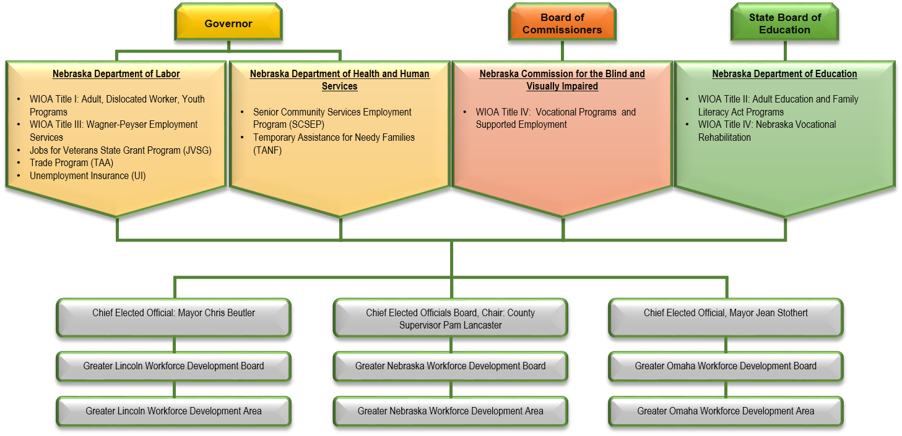

Plan partner programs are organized under three (3) leadership structures for the following plan partner agencies:

* The Governor provides leadership for and oversight of the Nebraska Departments of Labor and Health and Human Services;
* The Board of Commissioners provides leadership for and oversight of the Nebraska Commission for the Blind and Visually Impaired; and
* The State Board of Education provides leadership for and oversight of the Nebraska Department of Education.

Under the Nebraska Department of Labor are:

* Title I: Adult, Dislocated Worker, Youth Programs
* Title III: Wagner-Peyser Employment Services
* Jobs for Veterans State Grant Program (JVSG)
* Trade Program (TAA)
* Unemployment Insurance (UI)

Under the Nebraska Department of Health and Human Services are:

* Senior Community Services Employment Program (SCSEP)
* Temporary Assistance for Needy Families (TANF)

Under the Nebraska Commission for the Blind and Visually Impaired are Title IV: Vocational Programs and Supported Employment.

Under the Nebraska Department of Education are:

* Title II: Adult Education and Family Literacy Act Programs
* Title IV: Nebraska Vocational Rehabilitation

Local delivery of services for plan partner programs occurs in Nebraska’s three local workforce development areas:

* Greater Lincoln Workforce Development Area:
  + Chief Elected Official: Mayor Chris Beutler
  + Greater Lincoln Workforce Development Board
* Greater Nebraska Workforce Development Area:
  + Chief Elected Officials Board, Chair: County Supervisor Pam Lancaster
  + Greater Nebraska Workforce Development Board
* Greater Omaha Workforce Development Area:
  + Chief Elected Official: Mayor Jean Stothert
  + Greater Omaha Workforce Development Board

#### *State Board*

Provide a description of the State Board, including—

The Nebraska Workforce Development Board (NWDB) is currently comprised of and the Governor, one legislative representative, and 23 members who represent business, labor, workforce, community-based organizations, education, and government:

* 12 business representatives;
* 5 workforce and labor representatives
* 2 individuals representing Titles I, II, and III;
* 2 local governance representatives;
* 1 individual representing state-level economic development; and
* 1 individual representing a state-level one-stop partner program.

(Note: Nebraska’s legislature is a unicameral, having only one chamber.)

##### Membership roster

Provide a membership roster for the State Board, including members’ organizational affiliations.

The Nebraska Workforce Development Board membership roster, including organization affiliations, is provided in Table 28.

###### *Table 28. Nebraska Workforce Development Board Membership Roster*

| Name | Title | Organization | Category of Representation |
| --- | --- | --- | --- |
| Pete Ricketts | Governor | State of Nebraska | Governor |
| Joni Albrecht | Senator | Nebraska State Legislature | Legislative |
| Tammie Beck | HR Senior Business Partner | Cabela’s | Business |
| Brian Deakin | HR Manager | BD Medical | Business |
| Michael Geary | Vice President, Human Resources | Kiewit Corporation | Business |
| James Hanson, Jr. | Owner/Founder | InTouch Communications | Business |
| Mark Moravec (Chair) | Business Development Manager | Chief Industries, Inc. | Business |
| Don Nordell | Director | Black Hills Energy | Business |
| Terri Ridder | HR Director | Franciscan Care Services, Inc. | Business |
| Bradley Schroeder (Vice-Chair) | Director of Total Rewards | Children's Hospital & Medical Center | Business |
| Jennifer Sedlacek | Director of Strategic Planning | Union Pacific Railroad | Business |
| Becky Stitt | Regional Human Resources Manager | Western Sugar Cooperative | Business |
| Carol Swigart | Owner/President | Hillaero Modification Center | Business, Small |
| Lisa Wilson | Plant HR Manager | Case New Holland Industrial | Business |
| Bradley Bird | Union Representative | Steamfitters and Plumbers Local 464 | Labor Organization |
| Jason Feldhaus | Vice President of Connected Youth Initiatives | Nebraska Child and Families Foundation | Workforce organization serving Youth |
| Allan Hale | Executive Director | National Electrical Contractors Assoc. | Labor Organization |
| Susan Martin | President/Secretary-Treasurer | Nebraska State AFL-CIO | Labor Organization |
| Michelle Olson* | Project Director, Job Corps-Nebraska | CHP International Inc./Job Corps | Workforce organization serving Youth |
| John Albin | Commissioner | Nebraska Department of Labor | Lead state official with primary responsibility for Titles I and III |
| Matthew Blomstedt | Commissioner | Nebraska Department of Education | Lead state official with primary responsibility for Title II |
| John Fagot* | Mayor | City of Lexington | CEO representing city government |
| Courtney Phillips | CEO | Nebraska Department of Health and Human Services | Lead state official representing a one-stop partner program |
| Vern Powers* | Mayor | City of Hastings | CEO representing city government |
| Dave Rippe | Director | Nebraska Department of Economic Development | Lead state official representing economic development |

*\* Resigned: Governor’s office is in the process of a new appointment.*

*NOTE: Nebraska’s state legislature is a unicameral having only one chamber. For that reason, the Nebraska Workforce Development Board includes only one legislative representative.*

##### Board Activities

Provide a description of the activities that will assist State Board members and staff in carrying out State Board functions effectively.

All newly appointed members are given an orientation that includes overviews of:

* responsibilities of being a Nebraska Workforce Development Board member;
* all board functions;
* purposes and requirements of the Workforce Innovation and Opportunity Act; and
* strategies that the state is currently implementing to achieve determined workforce goals.

Additionally, all NWDB members have access to the Nebraska Department of Labor websites, which include:

* WIOA policies;
* employment data and program statistics;
* labor market information publications;
* statutes and regulations; and
* other workforce- and labor-related information.

To assist Board members with execution of Board responsibilities, the Board receives administrative support from the Nebraska Department of Labor’s Office of Employment and Training regarding:

* planning, coordination, and development of:
* state plans and modifications;
* policies; and
* annual WIOA reports.

The Board also utilizes an executive committee and two subcommittees to drive and focus member efforts and enable board members to achieve objectives within specific timeframes.

### Assessment and Evaluation of Programs and One-Stop Program Partners

#### *Assessment of Core Programs*

Describe how the core programs will be assessed each year based on State performance accountability measures described in section 116(b) of WIOA.  This State assessment must include the quality, effectiveness, and improvement of programs broken down by local area or provider.  Such state assessments should take into account local and regional planning goals.

Assessment of core partner programs occurs annually during the third quarter of each program year, concurrently with the assessment of one-stop delivery system partner program and other plan partner programs (refer to Section III.b.4.B. below).

In addition to the assessment criteria described in Section III.b.4.B., assessment of core program performance is based on performance indicators defined in WIOA Sec. 116(b), as they apply to individual core programs:

* employment rates at the second and fourth quarters;
* median earnings at the second quarter after program exit;
* credential attainment rate;
* measurable skills gains; and
* effectiveness in serving employers.

Core program performance will be assessed at the local-area level based on the following standards:

* The standard of *exceeded*, in relation to local area program performance, means the local area exceeded negotiated performance levels when actual performance on an individual performance measure is in excess of one hundred (100) percent of the negotiated level of performance.
* The standard of *met*, in relation to local area program performance, means the local area met negotiated performance levels when actual performance on an individual performance measure falls within the eighty (80) percent to one hundred (100) percent range of the negotiated level of performance.
* The standard of *failed*, in relation to local area program performance, means the local area failed to meet negotiated performance measures when actual performance on an individual performance measure is less than eighty (80) percent of the negotiated level of performance.

Assessment of the performance of core programs authorized under Titles II and IV based on the standards described above will occur once levels of performance have been negotiated and local-level performance data is available.

#### *Assessment of One-Stop Partner Programs*

Describe how other one-stop delivery system partner program services and Combined State Plan partner programs included in the plan will be assessed each year. Such state assessments should take into account local and regional planning goals.

Assessment of one-stop delivery system partner programs, including plan partner programs, occurs annually during the third quarter of each program year. Programs are assessed for:

* quality, effectiveness, and improvement; and
* progress on achievement of local and regional planning goals established in regional and local plans, as they apply to individual programs.

Assessments are performed on-site by representatives of plan partner programs using:

* program-related criteria established in the state’s current policy on certification of American Job Centers; and
* local and regional planning goals as they are defined in the applicable regional and local plan, as they apply to individual programs.

#### *Previous Assessment Results*

Beginning with the state plan modification in 2018 and for subsequent state plans and state plan modifications, provide the results of an assessment of the effectiveness of the core programs and other one-stop partner programs and Combined State Plan partner programs included in the Unified or Combined State plan during the preceding 2-year period (i.e. the 2-year period of the plan modification cycle). Describe how the State is adapting its strategies based on these assessments.

Regarding the assessment described in Section III.b.4.A., local area core program performance data is not yet available in the Workforce Integrated Performance System. Once the data is available, assessment results for core programs will be provided.

Regarding the assessment described in Section III.b.4.B., assessment of one-stop delivery system partner programs, including plan partner programs, underway. Assessment results are forthcoming.

#### *Evaluation*

Describe how the state will conduct evaluations and research projects on activities under WIOA core programs; how such projects will be coordinated with, and designed in conjunction with, State and local boards and with State agencies responsible for the administration of all respective core programs; and, further, how the projects will be coordinated with the evaluations provided for by the Secretary of Labor and the Secretary of Education under WIOA.

Evaluations and research projects conducted regarding core programs may be done through a third party. Core partners will solicit ideas from the Nebraska Workforce Development Board, local boards, and state agencies responsible for core program administration on subject matter to be evaluated and related criteria. Development of the format, timeline, and product of the evaluations and research projects will be the responsibility of core partners and shared with Nebraska Workforce Development Board, local boards, and state agencies responsible for core program administration. Results of evaluations and research projects will be made available publicly. As the state plans evaluations and research projects, it will review current and recent evaluations conducted by the US Departments of Education and Labor to avoid duplicative efforts.

### Distribution of Funds for Core Programs

Describe the methods and factors the State will use in distributing funds under the core programs in accordance with the provisions authorizing such distributions.

#### *For Title I programs*

For Title I programs, provide a description of the written policies that establish the State's methods and factors used to distribute funds to local areas for—

##### Youth activities in accordance with WIOA Sec. 128(b)(2) or (b)(3)

The state’s current policy on allocation planning for WIOA Title IB adult, dislocated worker, and youth funds describes the methods and factors used to distribute funds to local areas for youth activities.

The state uses the formula defined in WIOA Sec. 128 (b)(2)(A)(i) for allocation of Youth funds to local areas, subject to the minimum-percentage requirement defined in WIOA Sec. 128 (b)(2)(A)(ii). The discretionary allocation method described in WIOA Sec. 128 (b)(3) will not be used.

Youth funds are available for obligation by local areas beginning April 1 for the program year that begins the following July 1, subject to the requirements and limitations of the applicable fiscal year appropriation. Funds allotted and allocated for Youth activities are available for expenditure by:

* the state during the program year of allotment and two succeeding program years; and
* local areas during the program year of allocation and one succeeding program year.

##### Adult and training activities in accordance with WIOA Sec. 133(b)(2) or (b)(3)

The state’s current policy on allocation planning for WIOA Title IB adult, dislocated worker, and youth funds describes the methods and factors used to distribute funds to local areas for adult activities.

The state uses the formula defined in WIOA Sec. 133 (b)(2)(A)(i) for allocation of adult funds to local areas, subject to the minimum-percentage requirement defined in WIOA Sec. 133 (b)(2)(A)(ii).

Adult funds are available for obligation by local areas on a program year and fiscal year basis, subject to the requirements and limitations of the applicable fiscal year appropriation. Program year funds are available for obligation beginning July 1 of the program year and fiscal year funds are available for obligation on October 1 of the program year. Funds allotted and allocated for adult and training activities are available for expenditure by:

* the state during the program year of allotment and two succeeding program years; and
* local areas during the program year of allocation and one succeeding program year.

##### Dislocated worker employment and training activities in accordance with WIOA Sec. 133(b)(2) and based on data and weights assigned.

The state’s current policy on allocation planning for WIOA Title IB adult, dislocated worker, and youth funds describes the methods and factors used to distribute funds to local areas for dislocated worker activities.

Allocation of dislocated worker funds to local areas is calculated by the state in two (2) steps based on the allocation factors listed in Table 29, which are prescribed by the Governor as required under WIOA Sec. 133(b)(2)(B)(i) and subject to the minimum-percentage requirement defined in WIOA Sec. 133 (b)(2)(A)(iii).

###### *Table 29. Dislocated Worker Allocation Factors*

| Allocation Factor | Weight |
| --- | --- |
| UI | 15% |
| Excess UI | 15% |
| Long Term | 20% |
| Dislocated Workers | 20% |
| Declining Industries | 5% |
| Farmer-Rancher Hardship | 5% |
| Enrollments in Dislocated Worker programs | 20% |
| Total | 100% |

1. The state determines the portion of the state’s allotment for the dislocated worker program to be assigned to each allocation factor described in Table 29 (the assigned portion).
2. The state determines, for each allocation factor, the percentage amount of the assigned portion to be apportioned to each local area.

Dislocated worker funds are available for obligation by local areas on a program year and fiscal year basis, subject to the requirements and limitations of the applicable fiscal year appropriation. Program year funds are available for obligation beginning July 1 of the program year and fiscal year funds are available for obligation on October 1 of the program year. Funds allotted and allocated for adult and training activities are available for expenditure by:

* the state during the program year of allotment and two succeeding program years; and
* local areas during the program year of allocation and one succeeding program year.

#### *For Title II:*

##### Multi-year grants or contracts

Describe how the eligible agency will award multi-year grants or contracts on a competitive basis to eligible providers in the State, including how eligible agencies will establish that eligible providers are organizations of demonstrated effectiveness.

Nebraska will distribute multi-year grants to eligible providers within designated service area to maximize services across the State. All eligible providers will have direct and equitable access to apply and compete for grants or contracts under WIOA Title II. The same grant or contract announcement and application processes will be used for all eligible providers.

Eligible providers for Title II, as defined in Section 203(5), means an organization that has demonstrated effectiveness in providing adult education and literacy activities that my include –

1. a local educational agency;
2. a community-based organization or faith-based organization;
3. a volunteer literacy organization;
4. an institution of higher education;
5. a public or private nonprofit agency;
6. a library;
7. a public housing authority;
8. a nonprofit institution that is not described in
9. any of subparagraphs (A) through (G) and has the ability to provide adult education and literacy activities to eligible individuals;
10. a consortium or coalition of the agencies, organizations, institutions, libraries, or authorities described in any of subparagraphs (A) through (H); and
11. a partnership between an employer and an entity described in any of subparagraphs (A) through (I).

An eligible provider must demonstrate past effectiveness by providing performance data on its record of improving the skills of eligible individuals, particularly individuals who have low levels of literacy, in the content domains of reading, writing, and mathematics, English language acquisition, and other subject areas relevant to the services contained in the State’s application for funds.

An eligible provider must also provide information regarding its outcomes for participants related to employment, attainment of secondary school diploma or its recognized equivalent, and transition to postsecondary education and training.

The local application process will include information required by Nebraska Adult Education and may include items in Section 232 of WIOA, including:

1. a description of how funds awarded under this title will be spent consistent with the requirements of this title;
2. a description of any cooperative arrangements the eligible provider has with other agencies, institutions, or organizations for the delivery of adult education and literacy activities;
3. a description of how the eligible provider will provide services in alignment with the local plan under section 108, including how such provider will promote concurrent enrollment in programs and activities under Title I, as appropriate;
4. a description of how the eligible provider will meet the State adjusted levels of performance described in section 116(b)(3), including how such provider will collect data to report on such performance indicators;
5. a description of how the eligible provider will fulfill one-stop partner responsibilities as described in section 121(b)(1)(A), as appropriate;
6. a description of how the eligible provider will provide services in a manner that meets the needs of eligible individuals; and
7. information that addresses the considerations described under section 231(e), as applicable.

##### Ensure direct and equitable access

Describe how the eligible agency will ensure direct and equitable access to all eligible providers to apply and compete for funds and how the eligible agency will ensure that it is using the same grant or contract announcement and application procedure for all eligible providers.

Title II of WIOA, Section 231(c) requires that each eligible agency receiving funds under this title shall ensure that all eligible providers have direct and equitable access to apply for grants or contracts under this section; and the same grant or contract announcement process and application process is used for all eligible providers in the State or outlying area. The Nebraska Department of Education ensures that all eligible providers have direct and equitable access to apply for grants under the Adult Education and Family Literacy Act (Title II) of the Workforce Investment and Opportunity Act.

The same grant announcement and application process is used for all eligible providers in the state. All applicants follow a detailed request for proposal, and each proposal is evaluated by a team of evaluators and state Adult Education staff. The considerations for funding will follow Section 231(e) of WIOA; other considerations identified in the local plan under section 108 as determined by the regional Workforce Boards; and other considerations as determined by Nebraska Adult Education in accomplishing the intent of WIOA.

Applicants must guarantee that persons served in the local Adult Education program receiving grant funding are eligible to receive services under Title II of WIOA and the applicant will comply with all the federal and state requirements of the Nebraska Adult Education program.

In those programs that provide family literacy services, Adult Education funds can be used only for those activities specifically offered for the adult parent(s) who are eligible for Adult Education services. Other sources of funding will be required to fund activities involving children. (Pertains to Special Rule directly below.)

**Special Rule**

Each eligible agency awarding a grant or contract under this section shall not use any funds made available under this title for adult education and literacy activities for the purpose of supporting or providing programs, services, or activities for individuals who are under the age of 16 and are enrolled or required to be enrolled in secondary school under State law, except that such agency may use such funds for such purpose if such programs, services, or activities are related to family literacy activities. In providing family literacy activities under this title, an eligible provider shall attempt to coordinate with programs and services that are not assisted under this title prior to using funds for adult education and literacy activities under this title for activities other than activities for eligible individuals.

#### *Title IV Vocational Rehabilitation*

In the case of a State that, under section 101(a)(2)(A)(i) of the Rehabilitation Act designates a State agency to administer the part of the Vocational Rehabilitation (VR) services portion of the Unified or Combined State Plan under which VR services are provided for individuals who are blind, describe the process and the factors used by the State to determine the distribution of funds among the two VR agencies in the State.

As per longstanding agreement, the Federal allotment of total dollars to Nebraska is divided as follows: 15.5 percent to the Nebraska Commission for the Blind and Visually Impaired and 84.5 percent to the Nebraska Vocational Rehabilitation Program.

### Program Data

#### *Data Alignment and Integration*

Describe the plans of the lead State agencies with responsibility for the administration of the core programs, along with the State Board, to align and integrate available workforce and education data systems for the core programs, unemployment insurance programs, and education through postsecondary education, and to the extent possible, the Combined State Plan partner programs included in this plan. The description of the State’s plan for integrating data systems should include the State’s goals for achieving integration and any progress to date.

##### Interoperability of Management Information Systems for Core Programs

Describe the State’s plans to make the management information systems for the core programs interoperable to maximize the efficient exchange of common data elements to support assessment and evaluation.

Core partners are working to make the management information systems for the core programs interoperable to maximize the efficient exchange of common data elements to support assessment and evaluation through technical reforms regarding procedures, policies, and systems, and privacy safeguards. For that reason, the plan partners established the work group described in section 2 below.

##### Integrated Data Systems

Describe the State’s plans to integrate data systems to facilitate streamlined intake and service delivery to track participation across all programs included in this plan.

Core partners have established a work group to address the integration of data systems to facilitate streamlined intake and service delivery to track participation across all programs included in this plan. The work group includes representatives of each plan partner, including those with the requisite technical expertise necessary to understand the architectural potential and adaptability of the core partners’ current data systems. The work group will also coordinate and collaborate with the state board as described in section 3 below regarding alignment of technology and data systems.

##### Alignment of technology and data systems

Explain how the State board will assist the governor in aligning technology and data systems across required one-stop partner programs (including design and implementation of common intake, data collection, etc.) and how such alignment will improve service delivery to individuals, including unemployed individuals.

The state board has established a subcommittee that addresses alignment of technology and data systems across required one-stop partner programs, including design and implementation of common intake and data collection. The subcommittee will:

* consider alignment strategies that focus on improvement of service delivery to individuals, including unemployed individuals;
* make fact-based decisions to implement strategies that create efficiencies and positively affect performance outcomes;
* coordinate with the core partners in their efforts to integrate data systems to facilitate streamlined intake and service delivery to track participation across all programs included in this plan; and
* make recommendations to the state board regarding strategies for alignment of technology and data systems.

##### Reporting

Describe the State’s plans to develop and produce the reports required under section 116, performance accountability system. (WIOA Sec. 116(d)(2)).

The plan partners are working to modify their individual management information systems in order to collect WIOA data elements and generate performance reports required under WIOA Sec. 116(d)(2). Additional development will occur as future guidance is released regarding performance reporting.

In 2015, Nebraska was awarded its second Workforce Data Quality Initiative Grant through US Department of Labor. The grant funds the establishment of a warehouse of workforce data (Nebraska Longitudinal Data System (NELDS)), including:

* NDOL employment and training records;
* records for:
  + all community and state colleges; and the state university system;
  + Adult Basic Education; and
  + Carl Perkins;
* Nebraska VR records.

The data warehouse initiative is designed to produce the information the plan partners need to monitor performance and initiate programmatic improvements. NDOL has extended data sharing agreements to include records of the following workforce system partners and programs:

* INA programs;
* Nebraska Veterans Affairs;
* Nebraska Department of Education;
* Office of Apprenticeship (RAPIDS);
* Nebraska Department of Corrections; and
* Nebraska Department of Motor Vehicles.

To increase the potential impact of this initiative, additional training providers and Temporary Assistance to Needy Families (TANF) has also been invited to participate.

*Planning Note: States should be aware that Section 116(i)(1) requires the core programs, local boards, and chief elected officials to establish and operate a fiscal and management accountability information system based on guidelines established by the Secretaries of Labor and Education. Separately, the Departments of Labor and Education anticipate working with States to inform future guidance and possible information collection(s) on these accountability systems. States should begin laying the groundwork for these fiscal and management accountability requirements, recognizing that adjustments to meet the elements above may provide opportunity or have impact on such a fiscal and management accountability system.*

#### *Assessment of Participants’ Post-Program Success*

Describe how lead State agencies will use the workforce development system to assess the progress of participants who are exiting from core programs in entering, persisting in, and completing postsecondary education, or entering or remaining in employment. States may choose to set additional indicators of performance.

Nebraska Longitudinal Data System (NELDS) provides the data necessary to assess the progress of participants who are exiting from core programs in entering, persisting in, and completing postsecondary education, or entering or remaining in employment. Data from each program’s management information system is populated in NELDS, including data from WIOA Titles I – IV, TAA, UI benefit claims, UI Tax, FEDES, WRIS and WRIS2, CTE postsecondary, and the Nebraska Department of Motor Vehicles.

NELDS establishes linkage processes to the Nebraska Department of Education Student and Staff Record System, using a combination of data elements to identify students (the participant’s social security number, unique student identification number or name, gender, age and other identifiers). This identification method was established to meet the requirements of Family Education Rights and Privacy Act (FERPA) regulations and provide for the collection of a variety of data, such as test scores, names of teachers, graduation rates, and transcripts, all of which are cross-referenced to postsecondary and workforce outcomes. Through wage matching in relation to the core programs and other programs and services described above, program managers and policymakers can determine:

* employment status;
* earnings, if employed;
* workforce and training services received;
* credential attainment; and
* use of UI benefits.

#### *Use of Unemployment Insurance (UI) Wage Record Data*

Explain how the State will meet the requirements to utilize quarterly UI wage records for performance accountability, evaluations, and as a source for workforce and labor market information, consistent with Federal and State law. (This Operational Planning element applies to core programs.)

Through data sharing agreements with NDOL, core programs use UI wage records to assess workforce performance, as part of an overall strategy for performance accountability, evaluations, and as a source for workforce and labor market information.

WRIS 2 is designed to extend the WRIS data sharing model to required AJC partner programs that do not fall under the jurisdiction of the Department of Labor, and it also extends the data sharing model to programs defined by the Act as "additional" partners (i.e., those entities who are not mandatory partners in the American Job Center delivery system but are appropriate given the services provided through their agencies.) WRIS 2 is specifically designed to help facilitate the generation of aggregate statistical reports and subsequent analysis in satisfaction of Federal and state performance.

#### *Privacy Safeguards*

Describe the privacy safeguards incorporated in the State’s workforce development system, including safeguards required by section 444 of the General Education Provisions Act (20 U.S.C. 1232g) and other applicable Federal laws.

The state is committed to ensuring the privacy of all its workforce participants. Plan partners recognize that information shared between the parties is subject section 444 of the General Education Provisions Act (20 USC 1232g) and other applicable Federal privacy laws. Plan partners work with their respective legal counsels to review all interagency agreements involving data sharing and ensure the inclusion of provisions regarding:

* privacy safeguards;
* use of available data security protocols; and
* assurances to protect the privacy of data shared, manipulated, and extracted.

Plan partner staff who access and utilize protected data are subject to the privacy provisions of interagency agreements as well as the data usage policies of their respective agencies, all of which define the purpose and proper use of protected data.

WIOA authorizes the collection of eligibility, enrollment, and participant data. Only the minimum number of data elements will be maintained and shared between plan partners to meet WIOA performance reporting requirements. Any data released or shared between or among plan partners will be in aggregate form and not reveal personally identifiable information. Shared wage and education data will be used solely for:

* program administration;
* Federal and state reporting; and
* statistical research.

All necessary steps will be taken to protect shared data from unauthorized disclosure and personally identifiable information will be destroyed when no longer needed for the purposes of performance reporting.

### Priority of Service for Veterans

Describe how the State will implement and monitor the priority of service provisions for Veterans in accordance with the requirements of the Jobs for Veterans Act, codified at section 4215 of 38 U.S.C., which applies to all employment and training programs funded in whole or in part by the Department of Labor. States should also describe the referral process for Veterans determined to have a significant barrier to employment to receive services from the Jobs for Veterans State Grants (JVSG) program’s Disabled Veterans’ Outreach Program (DVOP) specialist.

The state implements and monitors the priority of service provisions for Veterans in accordance with the requirements of the Jobs for Veterans Act regarding all employment and training programs funded in whole or in part by the US Department of Labor (USDOL), as follows:

* Priority of service requirements are established in the state’s current policy on priority populations and priority of service, including directives regarding local area:
  + policies and procedures on implementation of priority of service; and
  + monitoring of priority of service.
* The state’s WIOA monitor assesses local area compliance with priority of service requirements established in the state’s policy and in Federal law, rules, regulations, and guidance.

When a Veteran or eligible person is determined to have a Significant Barrier to Employment (SBE), they are referred to DVOP staff for individualized career services. DVOPs serve as case managers for Veterans having SBEs. All Nebraska AJCs have integrated the JVSG program into their one-stop delivery system. At least one DVOP and/or LVER staff member is located in each region of the state along with at least one Employment Service staff member trained and certified in Veterans programs by the National Veterans Training Institute (NVTI).

If a Veteran or eligible person does not have an SBE, the individual still receives priority of service in programs funded in whole or in part by USDOL. If the individual is referred to a partner administering a USDOL-funded program, the individual’s status as a Veteran or eligible person is communicated to the partner to ensure priority of service.

### One-Stop Delivery System Accessibility for Individuals with Disabilities

Describe how the one-stop delivery system (including one-stop center operators and the one-stop delivery system partners), will comply with section 188 of WIOA (if applicable) and applicable provisions of the Americans with Disabilities Act of 1990 (42 U.S.C. 12101 et seq.) with regard to the physical and programmatic accessibility of facilities, programs, services, technology, and materials for individuals with disabilities. This also must include a description of compliance through providing staff training and support for addressing the needs of individuals with disabilities. Describe the State’s one-stop center certification policy, particularly the accessibility criteria.

The state’s compliance with the requirements of WIOA Sec. 188 and the American with Disabilities Act regarding physical and programmatic accessibility is addressed under Nebraska’s Nondiscrimination Plan, which includes provisions for EO reviews of the one-stop delivery system. A recent EO review of resource rooms in one-stop centers across the state revealed a need for new assistive technology for individuals with disabilities. In 2016, the state submitted an Unemployment Insurance Supplemental Budget Request (SBR) to fund assistive technology upgrades in 11 one-stop centers. Following approval of the request, the state worked with Assistive Technology Partnership (ATP) to identify components required to provide state-of-the art hardware and software to one-stop centers across the state. Based on the outcome of the consultation with ATP and available funding through the SBR, the state is able to upgrade assistive technology in 12 one-stop centers, as described in Table 30.

#### *Table 30. Assistive Technology Upgrades*

| Item | Quantity |
| --- | --- |
| Acrobat Reader | 13 |
| XY Tables | 13 |
| Merlin Smart Reader | 13 |
| Flex Station adjustable table | 13 |
| Kensington Privacy Monitor Screens | 27 |
| Contour Keyboard | 14 |
| Contour Mouse | 14 |
| Hearing Devices: Clearsounds Headset | 13 |
| Hearing Devices: Clearsounds Neck loop | 13 |
| Zoom Text Software Enterprise License | 15 |
| Dell Optiplex 5050 SFF XCTO PC’s | 14 |
| Ultra Sharp 24” Monitors | 27 |
| Amplified Phone Clearsounds CSC 600 | 15 |

Following installation of the new assistive technology during January and February 2018, training and support will be provided for one-stop center staff to ensure appropriate use and application of assistive technology. One-stop center staff will also receive training and support on addressing the needs of individuals with disabilities.

The state’s current policy on nondiscrimination describes requirements under WIOA Sec. 188 and 29 CFR Part 38 regarding physical and programmatic accessibility. In addition, the state’s current policy on one-stop center certification includes criteria for assessment of physical and programmatic accessibility, including the use of accessible technology to increase access to high quality workforce services for individuals with disabilities. The criteria by which local boards are required to assess a one-stop center’s physical and programmatic accessibility is listed in Tables 31 and 32.

#### *Table 31. Physical Accessibility Criteria*

| Minimum Requirements | Minimum Certification Criteria |
| --- | --- |
| 1. Physical layout: The location and physical layout of the one-stop center eliminates structural barriers and is accessible to individuals of all capabilities. | * 1. The layout of the one-stop center supports a culture of inclusiveness, guided by laws and regulations including WIOA Sec. 188 and 29 CFR part 38, as well as all applicable state and local laws. |
| 1. Equal opportunity access: Staff of the one-stop center and required one-stop partners provide access to the local workforce delivery system in compliance with the requirements established in WIOA Sec. 188 and 29 CFR Part 38 regarding disability and non-discrimination. | * 1. Staff of the one-stop center and required one-stop partners:  1. provide reasonable accommodations for persons with disabilities; 2. administer programs in the most appropriate integrated setting; and 3. communicate with persons with disabilities as effectively as with others. |
| *(2. Equal opportunity access – continued)* | * 1. Required one-stop partners reasonably modify policies, practices, and procedures to avoid discrimination and to meet individual needs. |
| 1. Location: The location of the one-stop center is accessible by public transportation, driving, or walking. | * 1. Local workforce delivery system customers who take public transportation can access the one-stop center within a reasonable walking distance. |
| *(3. Location – continued)* | * 1. Adequate parking is available and accessible for one-stop center customers who drive to the facility. |
| *(3. Location – continued)* | * 1. The location of the one-stop center is recognizable in a high-traffic area. |
| 1. Signage and logos: One-stop center signage and logos are in use, making the physical location of the facility simple to find and identify with easy-to-see signage on the exterior and interior of the facility. | * 1. Signage and logos reflect the “*American Job Center*” or “*a proud partner of the American Job Center network*” identifier. |

#### *Table 32. Programmatic Accessibility Criteria*

| Minimum Requirements | Minimum Certification Criteria |
| --- | --- |
| 1. Career services: Customers have equal access at or through the one-stop center to the 23 required career services for adults or dislocated workers. | * 1. Services available at the one-stop center are provided in accordance with the Local Workforce Delivery System Service Matrix. |
| 1. Program services: Customers have access at or through the one-stop center to training services, education services, employment services, supportive services, and business services in accordance with the applicable sections of WIOA and the applicable regulations and laws governing the required programs. | * 1. Access to training services is provided at or through one-stop center. |
| *(2. Program services – continued)* | * 1. Access to employment services and activities through WIOA Title III Wagner-Peyser Employment Service is provided at or through the one-stop center. |
| *(2. Program services – continued)* | * 1. Business services, including labor force and labor market information, are provided at or through the one-stop center. |
| 1. Direct linkage: Customers have access to on-demand, real-time services in person and via technology at or through the one-stop center in compliance with WIOA’s “direct linkage” requirement and definition of “access” | * 1. All services are available on demand through a direct connection with the one-stop center within a reasonable time, either through onsite staff or via technology in real time, consistent with the “direct linkage” requirement. |
| *(3. Direct linkage – continued)* | * 1. To ensure that not all services provided are virtual, at least one (1) WIOA Title IB (Adult, Dislocated Worker, and Youth programs) staff member is physically present at the facility at all times or is covered by other required one-stop partner program staff during shift transitions or breaks. |
| *(3. Direct linkage – continued)* | * 1. Staff members who are physically present at the one-stop center are appropriately trained to provide information about all required one-stop partner programs, services, and activities available at or through the one-stop center. |
| 1. Equal access: Each required one-stop partner program, service, and activity is made available to persons with disabilities in the most integrated setting appropriate to meet their unique needs. | * 1. All required one-stop partner program services, not just those through provided by or available through the Nebraska Vocational Rehabilitation Program or the Nebraska Commission for the Blind and Visually Impaired, are made available to persons with disabilities. |
| *(4. Equal access– continued)* | * 1. If persons with disabilities receive separate or different services than those provided to other customers of the one-stop center who do not have disabilities, staff can demonstrate why the provision of different services are necessary. |
| 1. Accommodations: The one-stop center provides reasonable accommodations for persons with disabilities or language barriers to fully access services. | * 1. The one-stop center has the capacity to accommodate persons with disabilities through available equipment, policies, procedures, and other resources, including bilingual staff, materials, or translation services. |
| 1. Common identifier: The one-stop center displays the “*American Job Center*” or “*a proud partner of the American Job Center network*” identifier as the location for required programs, services, and activities under WIOA. | * 1. Signage, logos, marketing material, and products reflect the “*American Job Center*” or “*a proud partner of the American Job Center network*” identifier to be easily recognizable as the location where programs, services, and activities are available. |

### One-Stop Delivery System Accessibility for English Language Learners

Describe how the one-stop delivery system (including one-stop center operators and the one-stop delivery system partners) will ensure that each one-stop center is able to meet the needs of English language learners, such as through established procedures, staff training, resources, and other materials.

Nebraska has established a Limited English Proficiency (LEP) Plan (refer to Appendix 2), which ensures that individuals with limited English proficiency are able to access programs and services provided through the one-stop delivery system on an equitable basis. Key features of the LEP Plan include:

* establishment of an LEP planning committee to provide guidance and leadership around the equitable provision of services to individuals with limited English proficiency;
* thorough assessment of the language needs of the populations served by attempting to identify LEP individuals;
* availability of specific resources at one-stop centers, include bilingual staff, LanguageLine or International Communications translation services, referral to ESL resources and the availability of materials in Spanish; and
* training staff on serving individuals with LEP needs.

The Nebraska Department of Labor (NDOL) public website (dol.nebraska.gov) provides information for workers and employers, including information about job searching, training, the Workforce Innovation and Opportunity Act, and many additional programs and services. The website includes an option for translation services provided via Google Language Tools. The translation through Google utilizes an automated translation process that provides an approximation of the site’s original content. NDOL provides a Translation Disclaimer Statement on the website, indicating the possibility of potential issues with the automated translation process. Languages available through the automated translation process include Spanish, Chinese, French, German, Italian, Korean, Russian, Polish, Arabic, Portuguese, Japanese, and Norwegian. The website provides information on how to contact local field staff for additional assistance. In addition, NEworks, which includes the state’s labor-exchange system, is available in Spanish.

English-as-a-second Language (ESL) instruction is available throughout the state to provide populations with low levels of English literacy with the instruction they need to improve fluency. Referral to providers of ESL education and the provision of transportation and other forms of assistance necessary to access these courses will continue to occur through one-stop centers.

# Coordination with State Plan Programs

Describe the methods used for joint planning and coordination among the core programs, and with the required one-stop partner programs and other programs and activities included in the Unified or Combined State Plan.

Joint planning and coordination among the plan partner programs, required one-stop partner programs, and other programs and activities included in this plan occurs through the Nebraska Partner Council. The Council meets on a regular basis for the purposes described in Section II.c.1.

# Common Assurances (for all core programs)

The Unified or Combined State Plan must include assurances that—

1. The State has established a policy identifying circumstances that may present a conflict of interest for a State Board or local board member, or the entity or class of officials that the member represents, and procedures to resolve such conflicts; **Yes**
2. The State has established a policy to provide to the public (including individuals with disabilities) access to meetings of State Boards and local boards, and information regarding activities of State boards and local boards, such as data on board membership and minutes; **Yes**
3. The lead State agencies with optimal policy-making authority and responsibility for the administration of core programs reviewed and commented on the appropriate operational  planning elements of the Unified or Combined State Plan, and approved the elements as serving the needs of the populations served by such programs; **Yes**
4. (a) The State obtained input into the development of the Unified or Combined State Plan and provided an opportunity for comment  on  the  plan  by  representatives of local boards and chief elected officials, businesses, labor organizations, institutions of higher education, the entities responsible for planning or administrating the core programs, required one-stop partners and the other Combined Plan programs (if included in the State Plan), other  primary  stakeholders, including other organizations that provide services to individuals with barriers to employment,  and  the  general  public,  and that the Unified or Combined State Plan is available and accessible to the general public; (b) The State provided an opportunity for review and comment on the plan by the State Board, including State agency official(s) for the Unemployment Insurance Agency if such official(s) is a member of the State Board; **Yes**
5. The State has established, in accordance with WIOA Sec. 116(i), fiscal control and fund accounting procedures that may be necessary to ensure the proper disbursement of, and accounting for, funds  paid  to the State through allotments made for the core programs to carry out workforce development activities; **Yes**
6. The State has taken appropriate action to secure compliance with uniform administrative requirements in this Act, including that the State will annually monitor local areas to ensure compliance and otherwise take appropriate action to secure compliance with the uniform administrative requirements under WIOA Sec. 184(a)(3); **Yes**
7. The State has taken the appropriate action to be in compliance with WIOA Sec. 188, Nondiscrimination, as applicable; **Yes**
8. The Federal funds received to carry out a core program will not be expended for any purpose other than for activities authorized with respect to such funds under that core program; **Yes**
9. The State will pay an appropriate share (as defined by the State board) of the costs of carrying out section 116, from funds made available through each of the core programs; **Yes**
10. The State has a One-Stop certification policy that ensures the physical and programmatic accessibility of all One-Stop centers with the Americans with Disabilities Act of 1990 (ADA); **Yes**
11. Service providers have a referral process in place for directing Veterans with Significant Barriers to Employment (SBE) to DVOP services, when appropriate; and **Yes**
12. Priority of service for Veterans and eligible spouses is provided in accordance with 38 USC 4215 in all workforce preparation, development or delivery of programs or services funded directly, in whole or in part, by the Department of Labor. **Yes**

# Program-Specific Requirements for Core Programs

The State must address all program-specific requirements in this section for the WIOA core programs regardless of whether the State submits either a Unified or Combined State Plan.

## Program-Specific Requirements for Adult, Dislocated Worker, and Youth Activities under Title I-B

The Unified or Combined State Plan must include the following with respect to activities carried out under subtitle B--

### General Requirements

#### *Regions and Local Workforce Development Areas*

##### Designated Regions and Local Workforce Development Areas

Identify the regions and the local workforce development areas designated in the State.

Nebraska’s regional structure includes three regions as shown in Map 3 and outlined below:

1. Metro Region - covers Cass, Dodge, Douglas, Sarpy, Saunders, and Washington Counties, with Douglas County being the target area of economic concentration. Preliminary contact has been made with the state of Iowa to explore the possibility of a future expansion of the Metro Region to include Iowa counties that are economically tied to the Metro Region;
2. Southeast Region - covers Fillmore, Gage, Jefferson, Johnson, Lancaster, Nemaha, Otoe, Pawnee, Richardson, Saline, Seward, Thayer, and York Counties, with Lancaster County being the target area of economic concentration; and
3. Greater Nebraska Region - covers the remaining 74 counties in Nebraska.

Nebraska’s Governor has designated three local areas:

1. Greater Omaha Local Workforce Development Area, serving Douglas, Sarpy, and Washington counties;
2. Greater Lincoln Local Workforce Development Area, serving Lancaster and Saunders counties; and
3. Greater Nebraska Local Workforce Development Area, serving the remaining 88 Nebraska counties.

Nebraska’s local area structure has not changed from that under WIA, pursuant to WIOA Sec. 106(b)(2) and the state’s current policy on local workforce development areas.

##### Designation Process for Regions and Local Workforce Development Areas

Describe the process used for designating local areas, including procedures for determining whether the local area met the criteria for “performed successfully” and “sustained fiscal integrity” in accordance with 106(b)(2) and (3) of WIOA. Describe the process used for identifying regions and planning regions under section 106(a) of WIOA. This must include a description of how the State consulted with the local boards and chief elected officials in identifying the regions.

###### Local area designation

Designation of local workforce development areas in Nebraska has been performed in accordance with the state’s current policy on local workforce development areas, which is consistent with WIOA Sec. 106(b). The policy establishes requirements, criteria, and procedures for local area designation, including initial and subsequent designation.

Criteria for “performed successfully” and “sustained fiscal integrity”

Under the state’s current policy on local workforce development areas, the procedures for determining whether a local area met the criteria for performed successfully and sustained fiscal integrity are consistent with WIOA Sec. 106(b)(2) and (3) and 20 CFR § 679.260(a) and (b). The standard of *performed successfully* varies in meaning in relation to the applicable program year.

*For initial designation*

For purposes of initial designation of local areas for Program Years 2016 and 2017, the term *performed successfully* means the local area:[24]

* *met* or *exceeded* all negotiated performance levels under WIA Sec. 136(c) for the two full program years prior to the enactment of WIOA (Program Years 2012 and 2013); and
* has not failed to meet any individual measure during the two consecutive program years prior to the enactment of WIOA (Program Years 2012 and 2013).

*For subsequent designation after PY 2017*

For purposes of subsequent designation of local areas after the conclusion of Program Year 2017, the term *performed successfully* means the local area *met* or *exceeded* negotiated levels of performance for Program Years 2016 and 2017 for the following performance indicators:[25]

* employment rate second quarter after program exit; and
* median earnings second quarter after program exit.

*For subsequent designation after the conclusion of PY 2018 and later*

For purposes of subsequent designation of local areas after the conclusion of Program Year 2018, or any point thereafter, the term *performed successfully* means the local area *met* or *exceeded* negotiated levels of performance for the two most recently completed program years for the following performance indicators:[26]

* employment rate second quarter after program exit;
* employment rate fourth quarter after program exit;
* median earnings second quarter after program exit;
* effectiveness in serving employers;
* credential attainment rate; and
* measurable skills attainment rate.

*Performance standards*

The standard of *exceeded*, in relation to local area performance, means the local area exceeded negotiated performance levels when actual performance on an individual performance measure is in excess of 100 percent of the negotiated level of performance.[27]

The standard of *met*, in relation to local area performance, means the local area met negotiated performance levels when actual performance on an individual performance measure falls within the 80 percent to 100 percent range of the negotiated level of performance.[28]

The standard of *failed*, in relation to local area performance, means the local area failed to meet negotiated performance levels when actual performance on an individual performance measure is less than 80 percent of the negotiated level of performance.[29]

*Fiscal integrity*

For purposes of initial and subsequent designation as a local area, the term *sustained fiscal integrity* means the Secretary of the US Department of Labor has not made a formal determination that either the grant recipient or the administrative entity for the local area, for the two year period preceding the date of a request for designation as a local area, misexpended funds due to:[30]

* willful disregard of the requirements of applicable regulations;
* gross negligence; or
* failure to comply with accepted standards of administration.

Designation procedure

The procedure established for any entity seeking designation as a local area, whether an initial designation or otherwise, is provided to CEOs and local boards through an Employment and Training Notice issued by NDOL and includes instructions regarding the requirements and procedure for requesting designation. The procedure includes the following steps:

1. The CEO and local board submit a written request for local area designation that includes documentation indicating the local area has performed successfully and sustained fiscal integrity.
2. The Governor reviews the request to ensure the local area meets the requirements and criteria established under WIOA Sec. 106(b)(1)(B) and the state’s current policy on local workforce development areas.
3. The Governor forwards the request to Nebraska Workforce Development Board and other CEOs and local boards in Nebraska for review and comment and makes the request available to the public for comment through Nebraska’s public comment process.
4. Upon receipt of a recommendation from Nebraska Workforce Development Board and following consideration of comments from the public and other CEOs and local boards in Nebraska, the Governor approves or denies the request and notifies the Nebraska Workforce Development Board, CEOs, and local boards in Nebraska, and all other entities seeking designation as a local area.

###### Planning region identification

Identification of Nebraska’s planning regions was performed in accordance with the state’s current policy on planning regions, which is consistent with the requirements of WIOA Secs. 102 and 106 and 20 CFR § 679.210.

At the request of the Governor, NDOL evaluated labor market structure and distribution, designated economic development areas, distribution of educational and training resources, location of population centers, workforce commuting patterns, labor force conditions, and geographic boundaries. The outcome of NDOL’s evaluation revealed a substantive relationship between concentrations of economic activity and statewide workforce commuting patterns.

Following the evaluation, NDOL consulted with the following individuals and groups regarding identification of planning regions:

* Nebraska Workforce Development Board in October 2015;
* CEOs and local area boards in July and August 2015; and
* core partners in July and August 2015.

NDOL provided the individuals and groups with a summary of the evaluation for review and comment as part of the consultations.

NDOL also held focus groups during the months of July and August 2015. NDOL met with over 250 workforce system representatives from across Nebraska. The focus groups were held at three Nebraska locations: Lincoln, Grand Island, and Omaha. The focus group discussions were co-sponsored by the core partners. Focus group topics included the identification of planning regions to promote regional alignment with the labor market and economic development activities through:

* identification of key elements of an economic region;
* examination of the usefulness of defining economic regions based on commuting patterns; and
* establishing factors the Governor should consider when identifying planning regions.

Subsequent to the consultations and focus groups, the Nebraska Workforce Development Board, CEOs, and local boards recommended establishing planning regions based on the relationship between areas of economic concentration and workforce commuting patterns. In January 2016, based on these recommendations, the Governor established an in-state regional structure that includes three regions based on economic concentrations and workforce commuting patterns.

##### Appeals Process relating to Designated Local Workforce Development Areas

Provide the appeals process referred to in section 106(b)(5) of WIOA relating to designation of local areas.

A local board and CEO may appeal a denied request for designation as a local area. The appeal must be made first to the state board. If a decision on the appeal is not rendered within a reasonable amount of time *or* if the appeal does not result in designation, the local board and CEO may request review by the Secretary of the US Department of Labor (the Secretary).

###### Appeal to the state board

The local board and CEO must submit a written request for a hearing to the chair of the state board within fifteen calendar days of the date of notification of denial of the request for designation. The written request must include a description of the basis for the appeal and must be submitted by certified mail, return receipt requested, to:

Chair, Nebraska Workforce Development Board

Attention: Director, Office of Employment and Training

Nebraska Department of Labor

550 South 16th Street

Lincoln, NE 68508

In addition, a copy of the appeal must be submitted by email to NDOL at ndol.wioa_policy@nebraska.gov.

Absent extenuating circumstances, the chair will assign a hearing officer and a hearing will take place within fifteen calendar days of the chair’s receipt of the written request for a hearing. The hearing will include:

* a statement of the reason(s) for denial of the request for designation; and
* an appeal by the local board and CEO describing why the decision should be reversed or a compromise established.

The chair will render a decision within fifteen calendar days of the date of the hearing.

###### Appeal to the Secretary

As stated above, if a decision on the appeal is not rendered by the state board within a reasonable amount of time *or* if the appeal does not result in designation, the local board and CEO may request review by the Secretary of the US Department of Labor (the Secretary).

If appealing to the Secretary, the local board and CEO must file the appeal no later than thirty calendar days after receipt of written notification of denial from the state board. In its appeal to the Secretary, the local board and CEO must establish that:

* procedural rights under the appeal process set forth in this policy were not afforded; or
* the local area meets the requirements for local area designation provided under WIOA Sec. 106(b)(2) or 106(b)(3) and 20 CFR § 679.250.

The appeal to the Secretary must be submitted by certified mail, return receipt requested, to:

Secretary

US Department of Labor

200 Constitution Avenue NW

Washington, DC 20210

Attention: ASET

In addition, a copy of the appeal to the Secretary must be submitted simultaneously by certified mail, return receipt requested, to:

Chair, Nebraska Workforce Development Board

Attention: Director, Office of Employment and Training

Nebraska Department of Labor

550 South 16th Street

Lincoln, NE 68508

In addition, a copy of the appeal to the Secretary must be submitted by email to NDOL at ndol.wioa_policy@nebraska.gov.

In making a determination, the Secretary may consider any comments submitted by the state board in response to the appeal. The Secretary must issue a written decision to the Governor and the appellant.

##### Appeals Process relating to Infrastructure Funding

Provide the appeals process referred to in section 121(h)(2)(E) of WIOA relating to determinations for infrastructure funding.

Under the state funding mechanism, a required one-stop partner may appeal the determination of its required contribution to funding of infrastructure costs. The appeal may be made based on a claim that the determination is inconsistent with the proportionate share requirements or cost contribution caps.

###### How and when to appeal

The required one-stop partner must follow the appeal process described in this section and:

* submit the appeal in writing within fifteen calendar days of the notification to the partner on the required contribution; and
* provide the following documentation with the written appeal:
  + description of the partner’s basis for appeal; and
  + rationale for reversing the determination or establishing a compromise.

###### Submission of an appeal

The appeal must be submitted in writing to:

Commissioner of Labor

Nebraska Department of Labor

PO Box 94600

Lincoln, NE 68509-4600

A copy of the appeal and supporting documentation must also be sent simultaneously and electronically to:

* the CEO and chair of the local board;
* all other required one-stop partners operating in the local area;
* Stan Odenthal, Director, Office of Employment and Training, Nebraska Department of Labor at [stan.odenthal@nebraska.gov](mailto:stan.odenthal@nebraska.gov); and
* the WIOA policy mailbox at [ndol.wioa_policy@nebraska.gov](mailto:ndol.wioa_policy@nebraska.gov).

###### Timeline for determination of an appeal

Absent extenuating circumstances, the Commissioner of Labor will assign a hearing officer and a hearing will take place and a determination made within thirty calendar days of the receipt of the written request for a hearing. The hearing will include a:

* statement of the reason(s) for the determination of the required one-stop partner’s required contribution;
* statement by the required one-stop partner, describing why the decision should be reversed or a compromise established; and
* final judgment that will include an explanation of the reasons for:
  + retention of the determination; or
  + reversal of the determination; or
  + establishment of a compromise.

#### *Statewide Activities*

##### State Policies and Guidance

Provide State policies or guidance for the statewide workforce development system and for use of State funds for workforce investment activities.

The Nebraska Workforce Development Board and the Nebraska Department of Labor (NDOL) acting on the Governor’s behalf pursuant to the Governor’s Executive Order No. 15-03, develop and issue WIOA policies.

Policies are released in draft form to local area administrative leaders and technical assistance is provided via WebEx on each policy, providing local area administrative staff an opportunity for comments and questions. Following technical assistance, the policies are finalized and published at https://dol.nebraska.gov/EmploymentAndTraining/LCRWP/WIOA/Policies.

Local area administrative leaders disseminate the state’s policies to their respective local workforce development boards and service staff and are responsible for implementation of the requirements established under the state’s policies.

NDOL provides on-going technical assistance regarding policies through:

* quarterly technical assistance meetings with local area administrative leaders;
* on-site local area staff training; and
* written communications.

The state has issued policies on the implementation and administrative of the following WIOA activities:

* governance;
* one-stop delivery system;
* administrative requirements;
* youth, adult, and dislocated worker programs;
* Rapid Response; and
* Trade Adjustment Assistance.

The state’s current policies are listed in Table A, with descriptions of primary topics covered in the policies.

###### *Table A. Nebraska’s WIOA policies*

| Category | Title | Topics |
| --- | --- | --- |
| Governance | Workforce Development Boards and Chief Elected Officials | * State board membership, functions, and conflict of interest requirements * Local board membership, functions, conflict of interest requirements, certification criteria and procedures, decertification criteria and procedures * CEO functions and conflict of interest requirements |
| Governance | Local Areas and Planning Regions | * Local area designation, redesignation, and appeal procedures regarding denial of designation * Requirements for identification of planning regions |
| Governance | Regional and Local Plans, Change 3 | * Requirements for development of regional and local plans, including required planning activities and content, public comment and accessibility requirements, and technical assistance requirements * Criteria for modification and revision of regional and local plans * Submission procedures for regional and local plans * Approval process for regional and local plans |
| Governance | Memorandums of Understanding and Funding Agreements | * Purpose, scope, and development of MOUs and funding agreements * Reporting outcomes of negotiations on MOUs and funding agreements * State funding mechanism appeal process for required one-stop partners |
| One-stop Delivery System | American Job Center Certification and Local Workforce Delivery System Evaluation, Change 2 | * One-stop center and delivery system evaluation requirements and procedures * Reporting on certification outcomes |
| One-stop Delivery System | One-stop Operator Competitive Selection | * Competitive selection requirements * Eligible entities * One-stop operator responsibilities and prohibited functions * Uniform Guidance and procurement standards * Essential contract elements * Monitoring of one-stop operators |
| One-stop Delivery System | Priority Populations and Priority of Service | * Priority of service * Priority requirements for use of Title I, Title III, and JVSG funds * Local area compliance and monitoring of priority of service |
| One-stop Delivery System | Co-enrollment and Common Exit | * Co-enrollment requirement * Coordination of services and funding * Common exit requirement |
| Administrative Requirements | Allocation Planning - WIOA Title IB Adult, Dislocated Worker, and Youth Funds, Change 1 | * Formulas for determining state allotments and local area allocations * Funding distribution and availability * Return and reallocation of unexpended local are allocations * Recapture and reallocation of unobligated local area allocations * Recapture and reallotment of unobligated state allotments |
| Administrative Requirements | Records Management | * General requirements for management of records for programs administered by NDOL, including Title I, Title III, JVSG, TAA, and discretionary grant programs * Requirements regarding records management systems, electronic case files, and records correction, retention, and access |
| Administrative Requirements | Quarterly Reporting and the Financial Request and Reporting System, Change 1 | * Financial reporting requirements * Requesting Title I funds * Corrective action, sanctions, and repayment * Appeals and administrative hearings |
| Administrative Requirements | Nondiscrimination and Equal Opportunity, Change 1 | * Obligation to ensure nondiscrimination and equal opportunity * Requirements and procedures * Consequences regarding noncompliance |
| Administrative Requirements | Grievances and Complaints | * Noncriminal grievance and complaint requirements and procedures, including state and Federal appeal procedures * Criminal complaint requirements and procedures |
| Youth, Adult, and Dislocated Worker | Program Eligibility for Youth, Adults, and Dislocated Workers, Change 1 | * General eligibility requirements * Specific eligibility requirements for youth, adult, and dislocated worker programs |
| Youth, Adult, and Dislocated Worker | Youth Program | * Program design, including service provider selection and procurement, pay-for-performance contract strategies and contracts, community involvement, framework, and expenditures * Program services [elements], including occupation skills training and follow-up services |
| Youth, Adult, and Dislocated Worker | Eligible Training Provider Program | * Eligibility criteria and process * Individual training accounts * Performance reporting * Denial or termination of eligibility * Roles and responsibilities of NDOL and local boards |
| Youth, Adult, and Dislocated Worker | On-the-job Training | * OJT requirements and use of funds for OJT * Appeal and grievance procedures |
| Rapid Response | Rapid Response | * Required activities, including coordination with TAA * Additional assistance to local areas * Layoff aversion |
| Trade Adjustment Assistance (TAA) | Trade Adjustment Assistance Program, Change 1 | * Applicable program directives and guidance * Co-enrollment of TAA-certified workers * Expenditure limitations for training services |

The state’s policies are based on the state’s reading of the applicable statutes, regulations, rules, and guidance released by the U.S. Government and the State of Nebraska and are subject to change as revised or additional statutes, regulations, rules and guidance are issued.

##### Governor’s set aside funding

Describe how the State intends to use Governor’s set aside funding. Describe how the State will utilize Rapid Response funds to respond to layoffs and plant closings and coordinate services to quickly aid companies and their affected workers. States also should describe any layoff aversion strategies they have implemented to address at risk companies and workers

Nebraska will utilize Governor’s set-aside funding for the purpose of delivering Rapid Response services to businesses and employees experiencing a dislocation event to quickly maximize public and private resources and to minimize the disruptions on companies, affected workers, and communities. Rapid Response activities are coordinated by the Nebraska Department of Labor’s (NDOL) state-level Rapid Response team and are delivered at the local-area level by workforce and community partners. The Rapid Response team of workforce professionals includes:

* Unemployment Insurance representatives;
* Trade Program representatives
* Wagner Peyser Program representatives
* WIOA Program representatives
* Other community partners including healthcare, financial planning, and community assistance

Other partners that NDOL works in collaboration with include:

* Local boards and chief elected officials
* Economic Development
* Educational institutions
* Local community organizations

Local Rapid Response team members provide customized activities onsite at an affected company or alternate location, to assist companies and workers through the transitions associated with job loss.

Rapid Response activities are provided for any dislocation, regardless of company size and number laid off. An onsite response will be offered to all companies facing a downsizing or closing and on-site responses will be tailored to the needs and schedules of the affected employees.

The topics presented at Rapid Response events regularly include but are not limited to:

* American Job Center (AJC) resources
* Workforce Innovation and Opportunity Act- Training/Education
* Unemployment Insurance Benefits
* Trade Adjustment Assistance (if Trade certified)
* Employment Services
* Labor Market Information
* Financial counseling programs
* Resume and interview guidance
* Veterans Program assistance
* Local Health and Human Services programs
* Health Insurance Options

A questionnaire is distributed at each event and used to identify dislocated workers’ needs and interests for future workforce services. Rapid Response events are used to directly connect affected workers to the workforce system and follow-up outreach is conducted for additional partner program service referrals. Rapid Response survey data will also be used with the submission of a Dislocated Worker Grant in situations that warrant additional funding to address increased need for employment and training services.

In addition to assisting employers who are in the final stages of closing or laying off individuals, Nebraska also provides layoff aversion services to assist employers who are in the early stages of laying off or closing. Identification of these situations comes from partnerships with Economic Development, chambers of commerce, industry associations, and local area business service representatives of the core partner programs. Employers will be provided information related to opportunities to receive assistance with skills upgrade and incumbent worker training, customized training, English as a Second Language (ESL) classes, and basic skills training.

The Rapid Response team will closely partner with and leverage existing relationships between employers and business service representatives to identify opportunities for layoff aversion assistance. A successful strategy will incorporate utilizing funds from multiple sources including state Worker Training Board grants, WIOA Title 1B, Dislocated Worker Grant opportunities along with other core partner programs.

##### State Rapid Response Policies and Procedures

In addition, describe the State policies and procedures to provide Rapid Responses in cases of natural disasters including coordination with FEMA and other entities.

In response to a layoff or closure as the result of a natural disaster, the Rapid Response team will quickly organize an event in coordination with FEMA and NEMA representatives:

* FEMA: Region VII contact is 816-283-7061 or FEMARegion7info@fema.dhs.gov.
* NEMA: Emergency Management Program Specialist at 471-7426.

Essential planning topics will include:

* If an individual assistance declaration has been requested/approved
* If a Disaster Recovery Center (DRC) is available in the area
* What services will be available to workers through FEMA
* The logistics of internet availability, space and capacity limitations, etc.

The Rapid Response team will also closely coordinate with Unemployment Insurance (UI) especially in the event of a Presidential declaration for Disaster Unemployment Assistance (DUA).

Options for meeting places across the state will depend on the type and severity of the natural disaster along with the location of the affected workers. If the President declares an Individual Assistance (IA), FEMA will open Disaster Recovery Centers (DRCs) and these centers may be used for Rapid Response events along with Red Cross Stations, and community centers.

A Rapid Response event for a natural disaster will include more than the traditional mandated partners in order to coordinate and inform local and national disaster relief efforts. Information will be exchanged with agencies and contacts that can meet the needs of the impacted individuals, based on the type and severity of the natural disaster, to include emergency housing, clothing and nutritional needs. The list of invited additional partners may include, but is not limited to:

* Federal Emergency Management Agency (FEMA)
* Nebraska Emergency Management Agency (NEMA)
* Red Cross
* Faith-based organizations
* Community-based organizations

The Rapid Response team will play a key role in recommending the request of disaster Dislocated Worker Grant funding if it is determined that there is an opportunity to support clean-up and recovery efforts in the impacted area.

##### Rapid Response Earlier Intervention

Describe how the State provides early intervention (e.g., Rapid Response) to worker groups on whose behalf a Trade Adjustment Assistance (TAA) petition has been filed. (Section 134(a)(2)(A).) This description must include how the State disseminates benefit information to provide trade-affected workers in the groups identified in the TAA petitions with an accurate understanding of the provision of TAA benefits and services in such a way that they are transparent to the trade-affected dislocated worker applying for them (Trade Act Sec. 221(a)(2)(A) and Sec. 225; Governor-Secretary Agreement). Describe how the State will use funds that have been reserved for Rapid Response to provide services for every worker group that files a TAA petition.

Nebraska provides early intervention services including Rapid Response to all worker groups when notified of a possible layoff or closure including those identified in a TAA petition filing.

All layoffs and closures identified by the Rapid Response team are investigated by the state TAA Program Coordinator to determine if conditions indicate that a TAA petition should be filed on behalf of the workers. A Trade petition is filed if research demonstrates that foreign trade may have contributed to the downsizing or closure.

Once a petition is certified, a Rapid Response event is hosted and content is presented specific to the identified Trade affected workers, which includes information related to all TAA and TRA benefits available to them. Additional agenda topics include an orientation to Nebraska’s workforce system and services available from partner programs including WIOA Dislocated Worker and Wagner-Peyser.

Rapid Response activities related to the Trade Program must include:

1. The provision of information and access to unemployment compensation benefits and programs, such as short-term compensation, comprehensive one-stop system services, and employment and training activities, including information on the TAA program;
2. Delivery of services to worker groups for which a petition for TAA has been filed;

Upon receipt of a certified Trade petition, a notice will be sent from the state TAA Program Coordinator to all eligible workers to notify them of their TAA eligibility; a public notice is also published in the local-area newspaper and social media is utilized to increase visibility of the notice. The mailed notifications contain information on Trade Program benefits along with details of the related Rapid Response event including location, date, time, and contact information for the local Trade Program representative. Follow-up outreach is conducted to members of the eligible worker group who do not attend offering an individualized orientation of TAA benefits.

### Adult and Dislocated Workers Program Requirements

#### *Work-based training*

If the State is utilizing work-based training models (e.g. On-the-job training, Incumbent Worker training, Transitional Jobs, and Customized Training) as part of its training strategy and these strategies are not already discussed in other sections of the plan, describe the State’s strategies for how these models ensure high quality training for both the participant and the employer.

Work-based training in Nebraska’s one-stop delivery system is employer driven with education as a supporting component. Work-based training activities provide access to training services aligned with in demand industry sectors and occupations, including occupational skills training, on-the-job training, incumbent worker training, internships, and Registered Apprenticeships that ensure quality training for employers and participants.

Additionally, in April 2016, Nebraska’s State Legislature passed the Sector Partnership Program Act (Neb. Rev. Stat. §§ 48-3401 – 48-3407). The purpose of the Act is to support local sector partnerships that will close skill gaps in high-demand sectors of business and industry. By conducting labor availability and skills gap studies, the Sector Partnership Program will identify work-based training opportunities to ensure that the state’s workforce and economic development activities align with the needs of employers in the state’s key industries.

#### *Registered Apprenticeship*

Describe how the State will incorporate Registered Apprenticeship into its strategy and services.

Following the award of an ApprenticeshipUSA Accelerator grant, Nebraska took assertive steps to promote and expand Registered Apprenticeship in the state. Expansion activities include:

* + 1. hiring a full-time Program Coordinator to support the ApprenticeshipUSA State Accelerator Grant;
    2. building the framework for the Nebraska Department of Labor (NDOL) Registered Apprenticeship program;
    3. carrying out partnership planning sessions with state and local workforce system partners, including in demand industry sector employers;
    4. creating printed reports and resources to facilitate outreach to employers and jobseekers;
    5. establishing a website that will focus on work-based training opportunities throughout Nebraska, highlighting career pathways involving Registered Apprenticeships;
    6. creating technical assistance materials, including videos aimed at informing jobseekers of the benefits of apprenticeships and directing jobseekers to additional information about existing apprenticeships;
    7. participating in the ApprenticeshipUSA Action Planning program and providing a response to the Action Planning Tool;
    8. collecting Registered Apprenticeship data elements related to Registered Apprenticeship programs and Registered Apprentices;
    9. leveraging existing resources through connections with programs funded under WIOA, Federal Financial Aid, and Federal Work Study Programs;
    10. partnering with industry sector initiatives, community colleges, and other appropriate educational entities, and one-stop centers and required one-stop partners;
    11. working with employers and educational institutions to build a training pathway within non-traditional industries to support transitioning of well-trained and highly-skilled professionals with credentials less than a bachelor’s degree many into middle- to high-skilled positions;
    12. connecting eligible employers with other potential funding sources supporting work-based training, such as the Nebraska Worker Training Program, InternNE, and conNEct Program (H-1B Ready to Work Partnership grant); and
    13. submitting interim narrative progress and financial reports, final plan for apprenticeship innovation, and final narrative and financial reports.

The Accelerator grant concludes in May 2018, at which time Nebraska’s state-level Registered Apprenticeship activities and initiatives will be funded and driven by NDOL, including:

* + 1. maintaining expansion efforts through employer engagement in order to develop Registered Apprenticeship programs in healthcare, information technology, energy, skilled trades, and transportation;
    2. supporting the creation of Youth Registered Apprenticeships through collaboration with Nebraska high schools, community colleges, and the Nebraska Department of Education Career Education and other forms of work-based training; and
    3. Apprenticeship Program Coordinator, as a subject matter expert, providing continued assistance to required one-stop partners regarding navigation of the US Department of Labor Office of Apprenticeship’s programmatic standards for Registered Apprenticeship.

#### *Eligible Training Provider Program*

Provide the procedure, eligibility criteria, and information requirements for determining training provider initial and continued eligibility, including Registered Apprenticeship programs (WIOA Sec. 122).

##### Provider Eligibility

A training provider must meet all criteria listed in Table B to be included and maintained on the Eligible Training Provider List.

*Table B. Training provider eligibility criteria*

| Criteria |
| --- |
| 1. A training provider must provide information about its organization and for its primary representative.[31] |
| 1. A training provider must be 1 of the following:[32] 2. Registered Apprenticeship program; 3. postsecondary education institution; or 4. other public or private provider of training, such as a:    1. community-based organization;    2. joint labor-management organization; or    3. provider of WIOA adult education and literacy activities (Title II activities), provided the activities occur in combination with work-based training. |
| 1. A training provider must have been in operation at least 12 months at the time of application. |
| 1. A training provider must be authorized by an accrediting or governing authority to provide training services in Nebraska or to Nebraska residents.[33] |
| 1. A training provider must provide information on its participation (or non-participation) in the Federal Pell Grant Program. |
| 1. A training provider must provide written assurances[34] that it: 2. complies with the requirements of:[35]    1. WIOA Sec. 188 and 29 CFR Part 38, which prohibit discrimination on the basis of age, disability, sex, race, color, national origin, political affiliation or belief, or student status; discrimination against certain noncitizens; and assistance for facilities used for religious instruction or worship; and    2. the Americans with Disabilities Act; 3. will submit program performance reports as required under the state’s policy; and 4. will retain documentation verifying the accuracy of its submitted program performance reports and provide access to the documentation as required under 2 CFR § 200.333 and described under the state’s policy. |
| 1. A training provider must not be debarred, suspended, or otherwise excluded from or ineligible for participation in Federal programs or activities.[36] |

##### Program Eligibility

Two (2) requirements must be met for a program to be considered for eligibility. The training provider must provide the program information described in Table C; and the program must meet the criteria described in Table D.

*Table C. Program Information Requirements[37]*

| Criteria |
| --- |
| 1. The training provider must submit a complete program application in NEworks, including information on: 2. its business partnerships relating to the program; 3. how the program is linked to employment opportunities in in-demand occupations in Nebraska (*i.e.*, provide at least 1 Standard Occupational Classification (SOC) code relating to the program); 4. programs costs; 5. location(s) where the program is offered; and 6. occupational skills participants will acquire through participation in the program. |
| 1. The training provider must provide program performance reports as described in the state’s policy. |

*Table D. Program Eligibility Requirements[38]*

| Criteria |
| --- |
| 1. A program must provide 1 or more courses or classes leading to 1 or more of the following: 2. certificate of completion for a Registered Apprenticeship program; 3. industry-recognized certificate or certification; 4. license recognized by the Federal government, State of Nebraska, another state with which Nebraska has a reciprocal agreement; 5. postsecondary diploma; 6. associate or baccalaureate degree; 7. secondary-school diploma (or its equivalent) earned in conjunction with:    1. occupational skills training;    2. on-the-job training;    3. incumbent worker training; or    4. workplace training; 8. employment; or 9. measurable skills gains toward:    1. employment; or    2. any of the credentials described above. |
| 1. A program must be linked to employment opportunities in one (1) or more in-demand occupations in Nebraska.[39] |

IMPORTANT. The following types of programs are not eligible for inclusion on the Eligible Training Provider List:

* + - programs associated solely with self-employment or occupations resulting in commission-only earnings;
    - programs that are not linked to employment opportunities in in-demand occupations in Nebraska; and
    - programs resulting in graduate or post-graduate degrees.

##### Additional Eligibility Criteria

In addition to the criteria described in Tables B, C, and D, NDOL may consider the criteria described in Table E when determining training provider and program eligibility.

*Table E. Additional training provider and program eligibility criteria[40]*

| Criteria |
| --- |
| 1. Training provider program performance reports |
| 1. NDOL’s obligation to ensure access to training services throughout Nebraska and through the use of technology |
| 1. Information reported to state agencies on Federal and state training programs other than programs authorized under WIOA Title IB (youth, adult, and dislocated worker programs) |
| 1. Encouraging the use of industry-recognized certificates and credentials |
| 1. The quality of the program and ability of the training provider to offer programs leading to postsecondary credentials |
| 1. The ability of the training provider to provide the program for employed individuals and individuals with barriers to employment |
| 1. Whether the training provider submits program performance reports as required under the state’s policy |
| 1. Other factors NDOL may determine are appropriate |

##### Registered Apprenticeship Programs

Registered Apprenticeship programs are automatically eligible for inclusion on the Eligible Training Provider List.[41] On an annual basis, NDOL notifies Nebraska sponsors of Registered Apprenticeship programs by email of their programs’ automatic eligibility for inclusion on the Eligible Training Provider List. If interested in participating in the Eligible Training Provider Program, the sponsor must provide basic sponsor and program information to NDOL by email at ndol.wioa_policy@nebraska.gov.[42] Once included on the Eligible Training Provider List, a Registered Apprenticeship program is maintained on the list:[43]

* for as long as the program remains registered with the US Department of Labor Office of Apprenticeship;
* until the sponsor contacts NDOL by email at ndol.wioa_policy@nebraska.gov and requests the program be removed from the list; or
* unless the sponsor’s or program’s eligibility is denied or terminated for the reasons described in the state’s policy.

For each Registered Apprenticeship program on the Eligible Training Provider List, NDOL verifies the sponsor’s and program’s registration status at least once every two (2) years with the Nebraska State Office of Apprenticeship.[44] Programs that are no longer registered will be removed from the Eligible Training Provider List and notified in writing of the removal.

##### Procedures

###### Application submission

To be considered for inclusion on the Eligible Training Provider List, a training provider must:

1. set up a training provider account in NEworks;
2. provide written assurances[45] that it:
   1. complies with the requirements of:
      1. WIOA Sec. 188 and 29 CFR Part 38, which prohibit discrimination on the basis of age, disability, sex, race, color, national origin, political affiliation or belief, or student status; discrimination against certain noncitizens; and assistance for facilities used for religious instruction or worship;[46] and
      2. the Americans with Disabilities Act;[47]
   2. will submit program performance reports as required under the state’s policy; and
   3. will retain documentation verifying the accuracy of its submitted program performance reports and provide access to the documentation as required under 2 CFR § 200.333 and described under the state’s policy;
3. complete an online application for the training program in NEworks and submit it for review.

###### Application review

Applications are reviewed by NDOL based on the eligibility criteria described in the state’s policy. During the application review process, NDOL:

* confirms that the training provider:
  + confirms that the provider is not debarred, suspended, or otherwise excluded from or ineligible for participation in Federal programs or activities;
  + is authorized by applicable accrediting or governing authorities to provide training services in Nebraska or to Nebraska residents;
  + has provided written assurances as described in the state’s policy; and
  + has submitted all information required under the state’s policy;
* considers the additional eligibility criteria described in the state’s policy.

NDOL issues a notice of determination by email to the training provider no later than the sixty-first (61st) calendar day after the date of submission of a complete application and written assurances as described in the state’s policy.

###### Initial eligibility

If determined eligible, new programs receive initial eligibility. Initial eligibility is limited to a period of one (1) year.[48]

###### Continued eligibility[49]

Before initial eligibility ends and in order to remain on the Eligible Training Provider List, the training provider must apply for and establish continued eligibility as a training provider and for the program. Continued eligibility is limited to a period of two (2) years.

If a training provider fails to establish continued eligibility before the period of initial eligibility ends, the training provider may still apply for eligibility and, if determined eligible, the provider and program will receive initial eligibility.

#### *Priority Populations*

Describe how the State will implement and monitor the priority for public assistance recipients, other low-income individuals, and individuals who are basic skills deficient in accordance with the requirements of WIOA sec. 134(c)(3)(E), which applies to individualized career services and training services funding by the Adult Formula program.

Nebraska’s plan partners have worked closely to develop policies, procedures, and system designs to ensure this access to individuals receiving public assistance recipients, other low-income individuals, or individuals who are basic skills deficient.

The state’s current policy on priority populations and priority of service requires that one-stop partner staff must give priority for career services, training, and employment services to Veterans, eligible spouses of Veterans, and non-Veterans who are:[50]

* recipients of public assistance;
* other low-income individuals; or
* individuals who are basic-skills deficient.

Services to eligible adult program participants must be provided in the following order:[51]

1. First, to Veterans and eligible spouses of Veterans who are:
   1. recipients of public assistance;
   2. low-income; or
   3. basic-skills deficient;
2. Second, to individuals who are not Veterans and eligible spouses of Veterans but are:
   1. recipients of public assistance;
   2. low- income; or
   3. basic-skills deficient;
3. Third, to Veterans and eligible spouses of Veterans who are not:
   1. recipients of public assistance;
   2. low- income; or
   3. basic-skills deficient
4. Last, to persons who are not:
   1. recipients of public assistance;
   2. low- income; or
   3. basic-skills deficient.

The policy also requires that local boards establish policies that address priority populations and priority of service.[52] The policies must, at a minimum:

* describe how the local board and one-stop center staff will perform outreach to the priority population groups to ensure that the groups are aware of their entitlement to priority of service;
* describe how individuals from the priority population groups are:
  + identified at the point of entry into the local workforce delivery system, including one-stops, to ensure the provision of timely and useful information on priority of service, including individuals who:
    - physically access service delivery points; and
    - access service delivery through technology;
  + given an opportunity to take full advantage of priority of service;
* be clear on the process or “steps” the local board and one-stop partner staff must take to ensure priority of service for individuals from the priority population groups; and
* describe the review and analysis process the local board will conduct to ensure priority of service.

In addition, local boards:

* must ensure local plans address the requirements of the state’s current policy on priority populations and priority of service;
* should maintain local priority of service policies at all workforce service delivery points; and
* should make local priority of service policies easily accessible to the public (posted on the website, identified in published materials, *etc*.).

Monitoring priority of service

NDOL will provide technical assistance to the local areas for the implementation of priority of service requirements. Additionally, the implementation of priority of service for priority populations in the adult program will be monitored through the state’s WIOA monitoring process.

#### *Transfer Authority*

Describe the State’s criteria regarding local area transfer of funds between the adult and dislocated worker programs.

The state’s criteria regarding transfer of funds between local area adult and dislocated worker programs are established under the state’s current policy on regional and local plans The policy permits a local board to transfer funds between the programs based on a local plan modification submitted and approved according to established processes.

##### Submission requirements

Each submission must include:

1. a cover letter providing:
   1. the reason for the modification;
   2. an explanation of how the modification benefits the regional and/or local workforce system;
   3. the proposed effective date of the modification;
   4. a description of the modified sections of the local plan;
   5. a description of any deletions from the original local plan; and
   6. identification of the applicable program year and fiscal year;
2. dated and signed plan signature page indicating submission and approval by the CEO and the chair of the local board;
3. newly prepared local plan assurances;
4. all modified or revised sections and attachments;
5. all public comments that express disagreement with the modification; and
6. an assurance that hard copies of the complete modification package, including the signature page, will be:
   1. kept on file at the lead local board’s administrative office; and
   2. promptly available to the public through electronic means, including websites, and in written form and through whatever other means the local board and one-stop partners use to disseminate information to the public.

##### Approval process

The Nebraska Workforce Development Board and NDOL[53] must review proposed local plan modifications for transfer of adult and dislocated worker funds. NDOL will notify the local board, or its designee, of any known issues related to the modification and require clarification or correction. Modifications of local plans are not approved until NDOL notifies the lead local board in writing that the modification is approved.

##### Public comment and accessibility

The local board must:[54]

1. make copies of the proposed plan modification available to the public through electronic and other means, such as public hearings and local news media;
2. provide an opportunity for public comment on the plan modification before submitting the plan, allowing no more than a thirty day period for comment before its submission, beginning on the date on which the proposed plan modification is made available; and
3. provide a summary of all comments received that express disagreement with the plan through electronic and other means; and
4. make information about the local plan modification available to the public on a regular basis through electronic means and open meetings;
5. ensure that all open meetings are held in compliance with the Nebraska Open Meetings Act;[55] and
6. make the local plan easily accessible to the public, including people with disabilities.

### Youth Program Requirements

With respect to youth workforce investment activities authorized in section 129 of WIOA,—

#### *Grants for youth workforce investment activities and provider accountability*

Identify the state-developed criteria to be used by local boards in awarding grants for youth workforce investment activities and describe how the local boards will take into consideration the ability of the providers to meet performance accountability measures based on primary indicators of performance for the youth program as described in section 116(b)(2)(A)(ii) of WIOA in awarding such grants.*

* Sec. 102(b)(2)(D)(i)(V)

##### General requirements

Each local board has the option of directly providing some or all of the required youth employment and training activities. If a local board chooses to award grants or contracts to service providers to carry out some or all of the employment and training activities, including occupational skills training, the local board:[56]

* must identify providers based on criteria established in Section I(a) of the state’s current youth program policy;
* must take into consideration the ability of providers to meet performance accountability measures based on the primary indicators of performance for youth programs as described in WIOA Sec. 116(b)(2)(A)(ii);
* must procure providers in accordance with the Uniform Guidance at 2 CFR Parts 200 and 2900, in addition to applicable state and local procurement laws;
* must award grants and contracts on a competitive basis, subject to the exception described below; and
* if it has established a standing youth committee according to the requirements of 20 CFR § 681.100 and the State’s current policy on workforce development boards and chief elected officials, may assign the committee the function of selecting providers to which grants and contracts are awarded.

If a local board determines there are an insufficient number of youth providers in the local area, including providers of occupational skills training, the local board may award grants or contracts to providers on a sole-source basis.[57] This determination must be based on the criteria and methods established in local policy as described in the state’s current youth program policy.

Performance accountability requirements

Local boards are expected to consider the following criteria during the competitive (and sole-source) selection process when evaluating the ability of youth providers to meet performance accountability measures as described in Sec. 116(b)(2)(A)(ii):[58]

* ability to provide one or more of the required youth program elements;
* ability to adhere to the requirements for youth programs established in WIOA, its implementing regulations, 2 CFR Parts 200 and 2900, and 29 CFR Part 38;
* ability to provide accommodations for special needs populations;
* connections to in demand industry sectors and occupations;
* participant success rates based on:
  + retention in unsubsidized employment at the second and fourth quarters after program exit;
  + median earnings at the second quarter after program exit;
  + attainment of recognized postsecondary credentials; and
  + measurable skills gains.

##### Referral requirements

In addition to the performance accountability requirements described above, the local board must ensure that youth service providers:[59]

* meet the referral requirements described in WIOA Sec. 129(c)(3)(A) for all youth participants, which involve:
  + providing all participants with information about the full array of applicable or appropriate services available through the local one-stop delivery system; and
  + referring participants to appropriate training and educational programs that have the capacity to serve them either on a sequential or concurrent basis;
* if an individual applies for enrollment in the program and either does not meet enrollment requirements or cannot be served by program, refer the individual for further assessment, if necessary, or to appropriate programs to meet the skills and training needs of the individual.

##### Local procurement standards

Prior to selecting youth service providers, the state requires that each local board establish a local policy on procurement, which includes provisions that:

1. comply with the procurement requirements described under 2 CFR §§ 200.318 through 200.326, applicable state and local procurement laws, and this policy; and
2. address requirements regarding sole-source procurement when the local area has an insufficient number of youth providers, including providers of occupational skills gains, and:
   1. define what constitutes an insufficient number of youth providers; and
   2. establish methods for determining there are an insufficient number of youth providers;
3. require written documentation be prepared and maintained concerning the entire process of selecting each youth provider, including providers of occupational skills training.

#### *Improved outcomes for out-of-school youth*

Describe the strategies the State will use to achieve improved outcomes for out-of-school youth as described in 129(a)(1)(B), including how it will leverage and align the core programs, and Combined State Plan partner programs included in this Plan, required and optional one-stop partner programs, and any other resources available.

Development of collaborative relationships among local workforce development boards, plan partners, required and optional one-stop partners, and other service providers is essential to achieve improved outcomes for out-of-school youth (OSY). Plan partners will leverage the resources of Nebraska’s workforce system in the implementation of the youth workforce investment activities.

Nebraska will improve outcomes for OSY by ensuring the 14 required program elements are accessible throughout the state’s one-stop delivery system. The program elements will be funded with WIOA Title I youth funds or provided through leveraged partner resources. Local boards are required to:

* establish an agreement with the youth provider or partner that provides a program element; and
* ensure that the program element is connected and coordinated with the youth program and part of the youth’s individual service strategy.

In addition, Title I youth program providers must co-enroll youth program participants when eligibility permits and co-enrollment benefits the participant and the participant agrees to co-enrollment. Partner programs in which participants may be co-enrolled include, but are not limited to, the:

* Adult, Dislocated Worker, and Youth programs (WIOA Title IB);
* Adult Education and Family Literacy Act (AEFLA) program (WIOA Title II);
* Wagner-Peyser Employment Service (ES) programs (WIOA Title III);
* Nebraska Commission for the Blind and Visually Impaired (NCBVI) programs (WIOA Title IV);
* Nebraska Vocational Rehabilitation Program (VR) (WIOA Title IV);
* Jobs for Veterans State Grant (JVSG) program;
* Migrant and Seasonal Farmworker (MSFW) program;
* Temporary Assistance for Needy Families (TANF); and
* Trade Adjustment Assistance (TAA) program.

#### *Youth Program Elements*

Describe how the State will ensure that all 14 program elements described in WIOA Sec. 129(c)(2) are made available and effectively implemented.*

* Sec. 102(b)(2)(D)(i)(I)

Nebraska ensures the 14 required youth program elements are available to all eligible youth participants through the state’s current youth program policy. The policy requires that local boards:

* include in their local plan a description of the design framework of their local youth programs, including how the 14 program elements required under 20 CFR § 681.460 are made available within that framework;
* establish agreements with youth providers to ensure that the program elements:
  + will be offered; and
  + are connected and coordinated with the youth program.

Consistent with WIOA Sec. 129(c)(5), the policy does not require that each local youth program provider must provide all 14 required program elements. Instead, the policy requires that the local youth program provider provide *access* to all of the required elements.

Annually, through the state’s monitoring process, the availability of the required program elements in each local area will be reviewed.

#### *Additional Assistance for Out-of-School Youth*

Provide the language contained in the State policy for “requiring additional assistance to enter or complete an educational program, or to secure and hold employment” criterion for out-of-school youth specified in WIOA Sec. 129(a)(1)(B)(iii)(VIII) and for “requiring additional assistance to complete an education program, or to secure and hold employment” criterion for in-school youth specified in WIOA Sec. 129(a)(1)(C)(iv)(VII).

Definitions and eligibility documentation requirements regarding these criteria must be established at the local level pursuant to the state’s current policy on program eligibility for youth, adults, and dislocated workers.

#### *Definitions for Attending School and Not Attending School*

Include the State definition, as defined in law, for not attending school and attending school as specified in WIOA Sec. 129(a)(1)(B)(i) and Section 129(a)(1)(C)(i). If state law does not define “not attending school” or “attending school” indicate that is the case.

Neb. Rev. Stat. § 79-201. Compulsory education; attendance required; exceptions; reports required.

1. For purposes of this section, a child is of mandatory attendance age if the child (a) will reach six years of age prior to January 1 of the then-current school year and (b) has not reached eighteen years of age.
2. Except as provided in subsection (3) of this section, every person residing in a school district within the State of Nebraska who has legal or actual charge or control of any child who is of mandatory attendance age or is enrolled in a public school shall cause such child to enroll in, if such child is not enrolled, and attend regularly a public, private, denominational, or parochial day school which meets the requirements for legal operation prescribed in Chapter 79, or a school which elects pursuant to section 79-1601 not to meet accreditation or approval requirements, each day that such school is open and in session, except when excused by school authorities or when illness or severe weather conditions make attendance impossible or impracticable.
3. Subsection (2) of this section does not apply in the case of any child who:
   1. Has obtained a high school diploma by meeting the graduation requirements established in section 79-729;
   2. Has completed the program of instruction offered by a school which elects pursuant to section 79-1601 not to meet accreditation or approval requirements;
   3. Has reached sixteen years of age and has been withdrawn from school pursuant to section 79-202;
   4. (i) Will reach six years of age prior to January 1 of the then-current school year, but will not reach seven years of age prior to January 1 of such school year,

(ii) such child’s parent or guardian has signed an affidavit stating that the child is participating in an education program that the parent or guardian believes will prepare the child to enter grade one for the following school year, and (iii) such affidavit has been filed by the parent or guardian with the school district in which the child resides;

* 1. (i) Will reach six years of age prior to January 1 of the then-current school year but has not reached seven years of age,

(ii) such child’s parent or guardian has signed an affidavit stating that the parent or guardian intends for the child to participate in a school which has elected or will elect pursuant to section 79-1601 not to meet accreditation or approval requirements and the parent or guardian intends to provide the Commissioner of Education with a statement pursuant to subsection (3) of section 79-1601 on or before the child’s seventh birthday, and

(iii) such affidavit has been filed by the parent or guardian with the school district in which the child resides; or

* 1. Will not reach six years of age prior to January 1 of the then-current school year and such child was enrolled in a public school and has discontinued the enrollment according to the policy of the school board adopted pursuant to subsection (4) of this section.

1. The board shall adopt policies allowing discontinuation of the enrollment of students who will not reach six years of age prior to January 1 of the then-current school year and specifying the procedures therefor.
2. Each school district that is a member of a learning community shall report to the learning community coordinating council on or before September 1 of each year for the immediately preceding school year the following information:
3. All reports of violations of this section made to the attendance officer of any school in the district pursuant to section 79-209;
4. The results of all investigations conducted pursuant to section 79-209, including the attendance record that is the subject of the investigation and a list of services rendered in the case;
5. The district’s policy on excessive absenteeism; and
6. Records of all notices served and reports filed pursuant to section 79-209 and the district’s policy on habitual truancy.

#### *Basic Skills Deficient*

If not using the basic skills deficient definition contained in WIOA Sec. 3(5)(B), include the specific State definition.

The state defines basic skills deficient, according to WIOA Sec. 3(5)), as an individual:

* who is a youth that has English reading, writing, or computing skills at or below the 8th grade level on a generally accepted standardized test; or
* who is a youth or adult that is unable to compute or solve problems, or read, write, or speak English, at a level necessary to function on the job, in the individual’s family, or in society.

### Single-area State Requirements

In States where there is only one local workforce investment area, the governor serves as both the State and local chief elected official. In such cases, the State must submit any information required in the local plan (WIOA Sec. 106(d)(2)). States with a single workforce area must also include:

Nebraska is not a single-area state.

### Waiver Requests (optional)

States wanting to request waivers as part of their Title I-B Operational Plan must include a waiver plan that includes the following information for each waiver requested:

#### Planning Regions

##### *Statutory requirements to be waived*

Nebraska requests that the ETA waive its required reconfiguration of Nebraska’s designated regions and local areas, as requested in the ETA’s June 29, 2016 letter to Governor Ricketts and in the September 26, 2016 email to Commissioner Albin, because:

* Nebraska’s designated planning regions meet the criteria established under WIOA Sec. 106(a)(2) and 20 CFR § 679.210; and
* the Governor is permitted to reconfigure a designated local area only in the event that the local area:
  + fails to perform successfully and sustain fiscal integrity according to the requirements of WIOA Sec. 106(e)(1) – (2) and 20 CFR §§ 679.250 and 679.260; or
  + agrees to reconfiguration.

##### *Background*

In its letter dated June 29, 2016 regarding requested revisions to this plan, the US Department of Labor Employment and Training Administration (ETA) states that Nebraska must reconfigure its regions so that the two counties that comprise the Greater Lincoln Local Workforce Development Area are not split between two regions.

Based on its responses in the final WIOA Labor-only rules to comments on 20 CFR § 679.210, the ETA interprets WIOA Sec. 106(a)(2) and 20 CFR § 679.210 to say that a local area cannot be split across two planning regions. Neither WIOA Sec. 106(a)(2) nor 20 CFR § 679.210 states that a local area cannot be split across two planning regions. Rather, WIOA Sec. 106(a)(2) and 20 CFR § 679.210 say that a region must consist of one local area or two or more contiguous local areas. Assignment of Nebraska’s initially-designated local areas to the planning regions designated by the Governor meets the criteria established under WIOA Sec. 106(a)(2) and 20 CFR § 679.210 in that all three of Nebraska’s local areas are contiguous.

The designated planning regions identified in this plan include contiguous counties from two of the state’s three local areas. If one or more contiguous counties from a local area cannot be a part of a planning region, then Nebraska finds itself with planning region boundaries that mirror those of Nebraska’s local areas, which were established more than 30 years ago. The local areas then become *de facto* planning regions.

On September 26, 2016, Commissioner John Albin was notified by email that Nebraska must reconfigure its local areas so that no local area is split between two regions. Under WIOA Sec. 106(b)(2), 20 CFR § 679.250(a), and TEGL 27-14, the Governor is required to approve a request for initial designation as a local area from any local area that was designated as a local area for purposes of the Workforce Investment Act of 1998 (WIA) for the 2-year period preceding the date of enactment of WIOA; provided the local area had performed successfully and sustained fiscal integrity during that 2-year period. Because each of Nebraska’s local areas met these criteria and one local area requested its initial designation as a local area continues under WIOA as it had under WIA, Nebraska’s local area boundaries remain unchanged. Based on the requirements of WIOA Sec. 106(b)(2) and 20 CFR § 679.250(a), the Governor is not permitted to reconfigure Nebraska’s initially-designated local areas.

Prior to subsequent designation of any local area, the Governor will again consult with local area chief elected officials and local workforce development boards and attempt realignment of local area boundaries. Implementing the planning regions as originally designated will greatly facilitate the alignment of the local area and regional boundaries.

##### *Actions undertaken to remove state or local barriers*

In July and August of 2015, the Governor held focus groups across the state, including the communities of Omaha, Lincoln, Grand Island, Norfolk, Scottsbluff, and North Platte. These public focus groups were attended by more than 250 workforce system representatives, including employers, state and local workforce development board members, community college representatives, one-stop partners, representatives of economic development entities, elected officials, and other interested parties.

Nebraska’s then-proposed planning regions were determined based on analysis of empirical regional economic and labor market data, performed by the Nebraska Department of Labor Office of Labor Market Information. The analysis was a main topic of discussion at the focus group events. Data analyzed included:

* commuting patterns;
* numbers of employers and jobs supported regionally;
* projections of regional job growth, particularly in H3 occupations (“H3” refers to high wage, high skill, high demand);
* locations of training facilities;
* targeted industry growth patterns; and
* workforce system service delivery patterns.

Based on the empirical data and related input from the focus groups in August 2015, the Governor took the proposed planning regions to each local area’s Chief Elected Official and Workforce Development Board with the idea of aligning local area boundaries with the proposed planning regions. Two of Nebraska’s three local areas agreed with the realignment of local area boundaries; one did not. However, *all three local areas agreed that the then-proposed planning regions were appropriate* and supported the submission of this plan with the designated planning regions identified in the Program-specific Requirements for Adult, Dislocated Worker, and Youth Activities under Title I-B, Section 1.1.A. There is *no objection by any of Nebraska’s three local areas* to being “split” for the purpose of establishing planning regions.

When contacted about this waiver request, all three local area Chief Elected Officials and Local Workforce Development Board Chairs, in addition to the Chair of the Nebraska Workforce Development Board and the Commissioner of the Nebraska Department of Labor, expressed continued support of the planning region designation.

Nebraska’s large land mass (77,358 square miles) supports only three WIOA local workforce development areas. The ability to consolidate two or more total local workforce development areas is practically non-existent without going to a two local area or single-area state design. While this might make sense in the future, the chief elected officials and local workforce development boards are not ready. However, designating planning regions does provide the vehicle to align workforce services and delivery with regional economies. The current local area configuration has been in place since 1983, established under the Job Training Partnership Act (JTPA). This configuration, particularly in the eastern, most populated portion of Nebraska, has not represented economic or service patterns for a number of years.

As stated above, under WIOA Sec. 106(b)(2), 20 CFR § 679.250(a), and TEGL 27-14, the Governor is required to approve a request for initial designation as a local area from any local area that was designated as a local area for purposes of WIA for the 2-year period preceding the date of enactment of WIOA; provided the local area performed successfully and sustained fiscal integrity during that 2-year period. Again, because each local area met these criteria and one local area requested its initial designation as a local area continues under WIOA as it had under WIA, Nebraska’s local area boundaries remain unchanged.

Designating planning regions in Nebraska that align with outdated local area boundaries *does not* meet with the spirit of 20 CFR § 679.200, which defines the purpose of identifying planning regions as alignment of workforce development activities and resources with larger regional economic development areas and available resources to provide coordinated and efficient services to both jobseekers and employers. Aligning workforce development services and programs with the designated planning regions that reflect current economic conditions, workforce patterns, and employment projections is critical in creating Nebraska’s workforce system.

If Nebraska’s current local area boundaries, which are over 30 years old, become Nebraska’s planning region boundaries, alignment of the workforce development activities and resources of the local areas with larger regional economic areas and resources through the planning activities required under 20 CFR § 679.510 *will not* occur.

##### *Waiver Goals and Outcomes*

Waiver of the ETA’s requested reconfigurations will allow Nebraska to not only comply with the requirements of WIOA Section 106(a) and 20 CFR Part 679 Subpart D but also ensure that Nebraska’s workforce system is aligned and based on the development of employment and training systems tailored specifically to regional economies.

In this plan, Nebraska identifies four goals, which are aligned with and supported by the structure of Nebraska’s planning regions as identified in this waiver request:

1. Enhance coordination between plan partners and other key workforce development system stakeholders to:
   * ensure jobseekers and employers are provided coordinated and seamless services;
   * reduce duplication of effort; and
   * maximize the resources among the state’s workforce development system partners
2. Increase workforce participation by:
   * expanding access to assessment, education, training, and employment services and other workforce development activities; and
   * preparing jobseekers, including individuals in Nebraska who are experiencing barriers to employment and other populations, for occupations that provide family-sustaining wages
3. Enhance employer engagement through industry sector partnership initiatives, informed by workforce and industry data to support identification of:
   * future industry needs;
   * opportunities for collaboration among industry sector employers;
   * potential workforce disruptions
4. Promoting economic self-sufficiency among Nebraska’s jobseekers and reducing welfare dependency by increasing postsecondary credential attainment, employment, retention, and earnings to:
   * meet the skill requirements of employers; and
   * enhance productivity and competitiveness of Nebraska

The plan partners developed each of these goals based on the practical reality of the data analyzed by the Nebraska Department of Labor Office of Labor Market Information *and* the formation of planning regions based on that data. Retaining the original boundaries of Nebraska’s designated planning regions will ensure collaboration across local area boundaries in support of the goals established in this plan. Without this waiver, the goals are compromised due to the misalignment of education and training programs and partner services.

##### *Alignment with US Department of Labor policy priorities*

Under 20 CFR § 675.100, four of the eight identified purposes of Title I of WIOA include priorities involving activities at the regional level:

* enhancing the strategic role for states and elected officials, and local workforce development boards in the public workforce system by increasing flexibility to tailor services to meet employer and worker needs at state, regional, and local levels;
* supporting the alignment of the workforce investment, education, and economic development systems in support of a comprehensive, accessible, and high-quality workforce development system at the Federal, state, and local and regional levels;
* improving the quality and labor market relevance of workforce investment, education, and economic development efforts by promoting the use of industry and sector partnerships, career pathways, and regional service delivery strategies in order to both provide America's workers with the skills and credentials that will enable them to secure and advance in employment with family-sustaining wages, and to provide America's employers with the skilled workers the employers need to succeed in a global economy; and
* increasing the prosperity and economic growth of workers, employers, communities, regions, and states.

These four priorities are the very basis of Nebraska’s workforce system stakeholders’ support for the designated planning regions. Designing and implementing Nebraska’s workforce system based on current economic and labor market data will result in a service delivery system that makes sense to employers and jobseekers and greatly improves alignment with Nebraska’s community colleges and the service delivery areas of the one-stop partners. The stakeholders fully support the development of comprehensive regional partnerships and alignment of workforce development activities with regional economic development activities, as well as the execution and implementation of sector strategies and career pathways.

##### *Individuals impacted by the waiver*

First and foremost, employers and jobseekers are impacted by the misalignment of local area boundaries serving as the boundaries of planning regions.

Beneficiary of the establishment of this waiver is the entirety of Nebraska’s workforce system, including:

1. employers;
2. jobseekers, including WIOA priority population groups;
3. local area one-stop partners and delivery systems;
4. local workforce development boards;
5. economic development entities; and
6. the state board.

Designing and implementing regional plans that align with the economic, labor market, and service-delivery patterns will provide increased access to workforce services for employers and jobseekers, which truly aligns with the full intent of WIOA.

##### *Monitoring progress and implementation*

The process for monitoring the implementation of the Governor’s designated planning regions will be done through the state board. Each local workforce development board responsible for their region has submitted a regional plan that aligns jobseeker and employer services with regional economies. The Board will monitor progress by:

* measuring partnerships developed, participants served regionally (including co-enrollments), and employers served; and
* gathering feedback from the local workforce development boards on the alignment of jobseeker and employer services from a regional perspective.

Nebraska has three designated planning regions, which are outlined below and depicted under the Program-specific Requirements for Adult, Dislocated Worker, and Youth Activities under Title I-B, Section 1.1.A.:[60]

1. Metro Region - covers Dodge, Douglas, Cass, Sarpy, Saunders, and Washington counties, with Douglas County being the focal county;
2. Southeast Region - covers Fillmore, Gage, Jefferson, Johnson, Lancaster, Nemaha, Otoe, Pawnee, Richardson, Saline, Seward, Thayer, and York counties, with Lancaster County being the focal county; and
3. Greater Nebraska Region - covers the remaining seventy-four (74) counties in Nebraska and includes 10 focal counties: Adams, Buffalo, Cheyenne, Hall, Holt, Lincoln, Madison, Platte, Red Willow, and Scotts Bluff counties.

Under Nebraska’s regional configuration, local areas are assigned to the planning regions as described below. For each planning region, one local board is designated as the “lead local board.”

1. Metro Region
2. Greater Omaha Workforce Development Board is assigned to the Metro Region and is the lead local board for the planning region.
3. Greater Omaha Workforce Development Board is responsible for:
   1. coordinating the Metro regional planning activities, including collaborating with the:
      1. one-stop and workforce system partners, which must include representatives from the Greater Nebraska and Greater Lincoln Workforce Development Area WIOA Title I (Adult, Dislocated Worker, and Youth programs) service providers in Cass, Dodge, and Saunders counties; and
      2. Greater Lincoln and Greater Nebraska Workforce Development Boards, which have oversight of Cass, Dodge, and Saunders counties; and
   2. preparing and submitting the Metro Region regional plan and the Greater Omaha local area plan.
4. Southeast Region
5. Greater Lincoln Workforce Development Board is assigned to the Southeast Region and is the lead local board for the planning region.
6. Greater Lincoln Workforce Development Board is responsible for:
7. coordinating the Southeast regional planning activities, including collaborating with the:
   * 1. one-stop and workforce system partners, which must include representatives from the Greater Nebraska Workforce Development Area WIOA Title I (Adult, Dislocated Worker, and Youth programs) service providers in Fillmore, Gage, Jefferson, Johnson, Nemaha, Otoe, Pawnee, Richardson, Saline, Seward, Thayer, and York counties; and
     2. Greater Nebraska Workforce Development Board, which has oversight of Fillmore, Gage, Jefferson, Johnson, Nemaha, Otoe, Pawnee, Richardson, Saline, Seward, Thayer, and York counties; and
8. preparing and submitting the Southeast Region regional plan and the Greater Lincoln local area plan.
9. Greater Nebraska Region
10. Greater Nebraska Workforce Development Board is assigned to the Greater Nebraska Region.
11. Greater Nebraska Workforce Development Board is responsible for:
12. coordinating the Greater Nebraska in regional planning activities, including collaborating with the:
13. WIOA Title I (Adult, Dislocated Worker, and Youth programs) service providers in the remaining 74 counties in Nebraska; and
14. Workforce system representatives in each of the 10 focal counties; and
15. preparing and submitting the Greater Nebraska Region regional plan and the Greater Nebraska local area plan.

##### *Notice to local workforce development boards and public comment*

The Nebraska Department of Labor notified local area chief elected officials and workforce development boards of its intent to submit this waiver request on January 26, 2018 through the publication of this 2-year modification of this plan.

Local area chief elected officials, local workforce development boards, and the public have the opportunity to comment on this waiver request during the public comment period for this 2-year modification of this plan, which includes a public hearing on February 7, 2018 as described in the Public Comments section at the front of this plan.

#### Stand-alone Wagner-Peyser Employment Service offices

##### *Statutory requirements to be waived*

Nebraska requests a waiver of the statutory requirements under 20 CFR §§ 652.202 and 678.315:

* prohibiting the existence of Wagner-Peyser Employment Service offices as stand-alone affiliate sites; and
* requiring the physical presence of one or more required one-stop partners more than 50 percent of the time an affiliate site is open.

##### *Background*

Nebraska has 93 counties covering 77,358 square miles. Nebraska’s 93 counties are served by four comprehensive one-stop centers in three local workforce development areas. Jobseekers and employers in 31 of the 93 counties are within a one-hour drive of the comprehensive one-stop center(s) in their respective local areas. Jobseekers and employers in the remaining 62 counties, all of which are part of the Greater Nebraska Workforce Development area, are underserved due to:

* restrictions regarding stand-alone Wagner-Peyser offices;
* budget limitations among required one-stop partners affecting their ability to provide a physical presence in the rural areas of the local area; and
* geographic isolation based on:
  + the distance to the nearest comprehensive one-stop center, and
  + limited or no access to public transportation in rural areas.

While access to virtual services are an option in addressing this need, delivery of virtual services is contingent upon the customer’s ability to access technology, which may be limited based on:

* income;
* educational attainment;
* disability;
* English proficiency; or
* homelessness.

##### *Actions undertaken to remove state or local barriers*

During the development of memorandums of understanding and funding agreements among required one-stop partners in the Greater Nebraska Workforce Development Area, the Greater Nebraska Workforce Development Board sought to establish affiliate sites in underserved rural communities in the local area. Because of budget limitations, required one-stop partners in the Greater Nebraska local area were and remain unable to provide a physical presence in those rural areas in addition to their required physical presence or presence through direct linkage in the comprehensive one-stop centers in the local area.

The Nebraska Department of Labor, as the Wagner-Peyser grantee for the State of Nebraska, has the capacity to provide staffing for affiliate sites in rural Nebraska but is prohibited from doing so because of the:

* restrictions regarding stand-alone Wagner-Peyser offices; and
* inability of required one-stop partners to provide staffing at least 50 percent of the time the proposed affiliate sites would be open.

##### *Waiver Goals and Outcomes*

Goals and outcomes of this waiver request include:

* increased access to one-stop delivery system services in the Greater Nebraska Workforce Development Area for jobseekers and employers through:
  + establishment of stand-alone Wagner-Peyser offices in underserved rural communities located more than 45 miles from the nearest comprehensive one-stop center in the local area; and
  + direct linkage to required one-stop partners that do not have a physical presence in rural Greater Nebraska;
* enhanced ability of required one-stop partners in the Greater Nebraska Workforce Development Area to provide services to underserved populations in geographically isolated rural areas, including individuals with barriers to employment.

##### *Alignment with US Department of Labor policy priorities*

Ensuring the provision of services to individuals with barriers to employment is a required function of the state workforce development board and local workforce development boards.[61] In the context of this waiver request, geographic isolation is a barrier to employment. Implementation of this waiver will align with this required function of the boards as a strategy for better meeting the needs of individuals with barriers to employment through leveraging resources and capacity within the local workforce development system.

##### *Individuals impacted by the waiver*

Individuals in the Greater Nebraska Workforce Development Area impacted by this waiver include:

* individuals with barriers to employment residing in geographically isolated rural areas;
* employers operating in geographically isolated rural areas;
* required one-stop partners that do not have a physical presence in rural Greater Nebraska;
* the local workforce development board and its ability to effectively serve employers and jobseekers, including individuals with barriers to employment, in geographically isolated rural areas; and
* the state workforce development board and its ability to ensure the provision of services to employers and jobseekers, including individuals with barriers to employment, in geographically isolated rural areas.

##### *Monitoring progress and implementation*

NDOL will monitor progress and implementation of this waiver in the Greater Nebraska Workforce Development Area by:

* collaborating with the local workforce development board on the development and implementation of an action plan for establishment of stand-alone Wagner-Peyser offices in key regions of the local area;
* coordinating with the local workforce development board and required one-stop partners to establish a mechanism for use of established stand-alone Wagner-Peyser offices on an as-needed basis, based on a reasonable cost allocation methodology; and
* monitoring of local area performance in key regions of the local area where stand-alone Wagner-Peyser offices have been established.

##### *Notice to local workforce development boards and public comment*

The Nebraska Department of Labor notified local area chief elected officials and workforce development boards of its intent to submit this waiver request on January 26, 2018 through the publication of this 2-year modification of this plan.

Local area chief elected officials, local workforce development boards, and the public have the opportunity to comment on this waiver request during the public comment period for this 2-year modification of this plan, which includes a public hearing on February 7, 2018 as described in the Public Comments section at the front of this plan.

#### Initial RESEA meetings

##### *Statutory requirements to be waived*

The Nebraska Department of Labor (NDOL) requests a permanent waiver of the mandate under UIPL 3-17 requiring UI claimants profiled into the RESEA claimant pool to report in person to an AJC for an initial RESEA meeting to receive staff-assisted services. This permanent waiver would apply only to RESEA claimants living more than 75 miles from an AJC.

##### *Background*

Nebraska is a large, rural state, and requiring individuals to report for in-person services can cause transportation-related hardships. During the initial RESEA meeting, the claimant and Employment Services (ES) staff are required to collaboratively create a reemployment plan. Requiring claimants, who are already experiencing a loss of income, to drive as much as 200 miles to appear in-person for a reemployment meeting, can slow or completely restrict, the collaborative process of developing a reemployment plan. Claimants who are frustrated are less likely to view the RESEA as an opportunity for assistance, and instead, view the RESEA meeting and Employment Services staff as a roadblock or hurdle they must overcome.

Given this information, NDOL requests permission to conduct the initial RESEA meeting with RESEA claimants who live more than 75 miles from an AJC via videoconference or teleconference. Currently, Nebraska requires all unattached UI claimants to participate in NEres, Nebraska’s reemployment services program. Claimants are profiled into two pools: RESEA and All UI Claimant. The RESEA pool is funded by the RESEA grant, while the All UI Claimant pool is funded through Wagner-Peyser.

For individuals profiled into the All UI Claimant pool, Nebraska ES staff frequently provide reemployment services via videoconference and teleconference. During these meetings, the claimant and ES staff member can access and view the claimant’s individual employment plan via NEworks, NDOL’s management information system. Nebraska requests permission to conduct similar meetings via teleconference and videoconference with RESEA claimants who live more than 75 miles from an AJC.

##### *Actions undertaken to remove state or local barriers*

Under UIPL 3-17, NDOL is restricted from taking actions to remove this barrier to claimant participation in RESEA.

##### *Waiver Goals and Outcomes*

Goals and outcomes of this waiver request include:

* increased participation of RESEA claimants who live more than 75 miles from an AJC;
* decrease in the number of RESEA claimants who fail to report for an initial RESEA meeting; and
* decrease in the state’s no-show costs.

##### *Alignment with US Department of Labor policy priorities*

Under UIPL 3-17, the Department encourages states to:

* consider how to most effectively leverage AJC partner program resources and services as well as RESEA resources; and
* address no-show levels and costs.

NDOL’s proposed distance waiver allows Nebraska to:

* leverage resources while providing reemployment services to claimants selected for RESEA participation who reside in geographically isolated areas of Nebraska; and
* address no-show levels and costs; and
* meet the reemployment needs of RESEA claimants.

##### *Individuals impacted by the waiver*

Individuals in Nebraska impacted by this waiver include:

* RESEA claimants living more than 75 miles from an AJC; and
* Employment Services staff.

##### *Monitoring progress and implementation*

NDOL will monitor progress and implementation of this waiver by monitoring participation rates among RESEA claimants living more than 75 miles from an AJC.

##### *Notice to local workforce development boards and public comment*

The Nebraska Department of Labor notified local area chief elected officials and workforce development boards of its intent to submit this waiver request on January 26, 2018 through the publication of this 2-year modification of this plan.

Local area chief elected officials, local workforce development boards, and the public have the opportunity to comment on this waiver request during the public comment period for this 2-year modification of this plan, which includes a public hearing on February 7, 2018 as described in the Public Comments section at the front of this plan.

### Title I-B Assurances

The State Plan must include assurances that:

1. The State has implemented a policy to ensure Adult program funds provide a priority in the delivery of training services and individualized career services to individuals who are low income, public assistance recipients and basic skills deficient; **Yes**
2. The state has implemented a policy to ensure local areas have a process in place for referring Veterans with significant barriers to employment to career services provided by the JVSG program’s Disabled Veterans’ Outreach Program (DVOP) specialist; **Yes**
3. The state established a written policy and procedure that set forth criteria to be used by chief elected officials for the appointment of local workforce investment board members. **Yes**
4. The state established written policy and procedures to ensure local workforce investment boards are certified by the governor every two years in accordance with WIOA Sec. 107(c)(2). **Yes**
5. Where an alternative entity takes the place of a State Board, the State has written policy and procedures to ensure the alternative entity meets the definition under WIOA Sec. 101(e) and the legal requirements for membership. **Yes**
6. The State established a written policy and procedure for how the individuals and entities represented on the State Workforce Development Board help to determine the methods and factors of distribution, and how the state consults with chief elected officials in local areas throughout the state in determining the distributions. **Yes**
7. The State will not use funds received under WIOA Title I to assist, promote, or deter union organizing in accordance with WIOA Sec. 181(b)(7). **Yes**
8. The State distributes adult and youth funds received under WIOA equitably throughout the State, and no local area suffers significant shifts in funding from year-to-year during the period covered by this plan. **Yes**
9. If a State Workforce Development Board, department, or agency administers state laws for vocational rehabilitation of persons with disabilities, that board, department, or agency cooperates with the agency that administers Wagner-Peyser services, Adult and Dislocated Worker programs and Youth Programs under Title I. **Yes**
10. The State agrees to report on the impact and outcomes of its approved waivers in its WIOA Annual Report. **Yes**
11. The State has taken appropriate action to secure compliance with the Uniform Guidance at 2 CFR 200 and 2 CFR 2900, including that the State will annually monitor local areas to ensure compliance and otherwise take appropriate action to secure compliance with the Uniform Guidance under section WIOA 184(a)(3); **Yes**

## Program-Specific Requirements for Wagner-Peyser Program (Employment Services)

All program-specific requirements provided for the WIOA core programs in this section must be addressed for either a Unified or Combined State Plan.

### Employment Service Professional Staff Development.

#### *Professional Development*

Describe how the State will utilize professional development activities for Employment Service staff to ensure staff is able to provide high quality services to both jobseekers and employers.

Professional development opportunities will be made available to Employment Services staff via a variety of methods, including but not limited to:

* + 1. Wagner-Peyser in-service trainings provided by the Program Administration, focused on specific topics/agenda items that will provide insight and guidance to assist job in performing Wagner-Peyser duties
    2. State of Nebraska’s Employee Development Center (EDC), which provides training opportunities in-person and via technology (webinars, recorded trainings, live streaming, etc.) on a variety of topics ranging from technical skills to customer service for government employees
    3. WIOA, workforce and community partner trainings and conference opportunities
    4. National webinars hosted by US Department of Labor webinars, Wofkorce3One, etc.
    5. Equal Employment Opportunity (EEO) training
    6. Limited English Proficiency (LEP) Plan training

The Wagner-Peyser program will create staff development opportunities based on Wagner-Peyser business needs, special projects and areas identified for technical assistance. Staff development opportunities identified out of technical assistance need will be mandatory to Wagner-Peyser staff responsible for the duties identified.

Staff development will focus on assessing and reinforcing the core responsibilities and functions of the Wagner-Peyser program, while also addressing new opportunities for Wagner-Peyser to expand its role with special projects or initiatives. To the greatest extent possible, Wagner-Peyser will leverage existing resources that have proven effective for staff professional development. Limited resources and staff located across the state create a challenge for face-to-face staff development opportunities. Technology is one strategy that will be leveraged to overcome these barriers. An additional strategy will be to utilize peer-to-peer mentoring and training opportunities. Staff development opportunities will be provided to staff based on a variety of identified needs, skills and assets. Staff participating in staff development will return to their home offices and regions and will share the information they received in order to maximize the staff development outcomes for as many staff as possible.

A primary focus for Wagner-Peyser professional development will center on the NEres program. As Nebraska’s Re-Employment Services program, NEres serves jobseekers from all facets of life in their reemployment journey. The varied circumstances that NEres customers face will require Wagner-Peyser staff to be finely attuned to the resources available, and communication skills needed to actively engage this audience.

Professional development activities, whether leveraging internal or external resources, will be evaluated to determine the effectiveness of the information provided. This evaluation may include, but is not limited to:

* + 1. Evaluations of staff participating in the training
    2. Follow-up with direct Managers on the progress and enhancements to staff performance
    3. Quality assurance information obtained from the program to determine progress towards technical assistance needs

#### *Training and Awareness*

Describe strategies developed to support training and awareness across core programs and the Unemployment Insurance program, and the training provided for Employment Services and WIOA staff on identification of UI eligibility issues and referral to UI staff for adjudication.

Wagner-Peyser partners closely with the Unemployment Insurance (UI) partner to create NEres, Nebraska’s Re-Employment Services program. NEres is an integrated reemployment program focused on connecting unemployed individuals with the full range of re-employment services available through the Nebraska Department of Labor (NDOL). NEres seeks to accelerate opportunities for individuals to obtain gainful employment after separation from their job. NEres efficiently utilizes financial and human resources by consolidating re-employment programs to provide high quality employment services to assist unemployed individuals on their path to re-employment. The NEres program meets the federal requirements of the UI funded Reemployment Services and Eligibility Assessment (RESEA) program. The use of high quality, effective re-employment tools is the cornerstone of the NEres program and provides a key strategy to developing an available workforce for Nebraska. The offices of Employment and Training (E&T) and Unemployment Insurance (UI) collaborate and continue to strengthen partnerships to provide employment services and re-employment assistance to Nebraskans impacted by job loss.

Employment Services views individuals as jobseekers, with potentially additional target population status: UI claimant, dislocated worker, TANF recipient, Veteran, etc. Because ES staff work with customers served by other workforce programs, a key strategy for Employment Services is to be trained in the basic content/information of partner programs, so as to have a basic understanding of the experience and needs of the shared jobseeker and UI customer.

NEres is a critical piece of the training strategy between UI and Employment Services. The NEres program manual outlines the program rules and procedures. The program manual and operating procedures were developed in partnership with UI supervisors and program administration to ensure that information impacting UI customers is accurately communicated to Employment Services staff. Beyond UI’s contribution to the NEres program manual, Employment Services staff is trained directly by UI Supervisors in UI program language and information that relates to UI claimants, who are also Employment Services customers. UI training topics include, but are not limited to:

* + 1. UI Claimant Guide Information
    2. UI Work Search Requirements
    3. UI Work Search Logs
    4. UI Approved Training
    5. UI Eligibility Review Form
    6. UI Eligibility Issues
    7. RESEA Profiling Criteria
    8. Benefit Payment System (BPS)

These training topics are covered by UI Supervisors to ensure the most accurate information is provided to Employment Services staff. UI training materials, such as guides, presentations and quizzes, are incorporated into Employment Services staff resources, to create a library of available information.

During any 1-on-1 meeting or conversation with a customer, if the individual discloses that they:

* + 1. Cannot accept full-time work
    2. Attend or plan to attend school or training
    3. Are currently working

NEres staff case note this information in the customer’s file and complete the Eligibility Review Interview form and email it to the NEres Adjudicators. NEres staff does not determine if customers are complying with the UI program, but they communicate the information about potential UI eligibility issues to UI staff to adjudicate the claim.

The Office of Unemployment Insurance (UI) has developed online training modules to train Employment Services (ES) and WIOA staff on basic Unemployment Insurance information and claimant eligibility. UI also conducts training for ES and WIOA staff throughout the year to assist ES staff in identifying potential UI eligibility issues. ES and WIOA staff are trained by UI Supervisors to listen for and identify potential UI eligibility issues and then to report the issues to UI on an Eligibility Review Form (ERF), a document that identifies the potential eligibility issue. Written guidance for the ERF is reviewed by UI and provided in program manuals for ES and WIOA staff. Referrals of potential issues are provided to UI staff for adjudication. The referral process involves emailing the ERF to UI staff to identifying and adjudicate the potential issue. UI communicates the referral process for information to WIOA partners and staff, and provides staff training to all interested parties.

UI is integrated into and highly involved in the mandatory annual training conducted for ES staff; partner programs are also invited to attend these trainings to gain a better understanding of the UI system and procedures. UI partner trainings are conducted at the Administrative building as well as on site at local American Job Center locations to best accommodate partner needs and resources. UI also provides legislative and program updates to ES and WIOA staff as they occur to inform partner staff of potential impacts to the shared customer based.

### Provision of UI Information and Meaningful Assistance

Explain how the state will provide information and meaningful assistance to individuals requesting assistance in filing a claim for unemployment compensation through One-Stop centers, as required by WIOA as a career service.

UI provides dedicated phone lines in the One-Stop Centers located across the state. The phones are labeled with a sign designating them as a resource for individuals seeking assistance with filing a UI claim. In addition to the dedicated phones, there are also dedicated computers for use of filing a UI claim. Employment Services staff are trained on the process for UI claim filing by customers and provide direct assistance with customer questions about the general UI process. While Employment Services staff is not equipped to provide direct information on UI customer benefits, the One-Stop Centers focus on quality customer service and a streamlined customer experience.

One-stop centers are provided UI information and materials that can be provided to customers with questions on filing UI claims. The information can be reviewed with the customers to clarify language and provide guidance on the steps a customer must follow to file a UI claim. The use of NEworks as the integrated system for customers to register for work and file a UI claim in Nebraska streamlines the process for customers by allowing Nebraska’s One-Stop Centers to provide information and assistance for the single-sign on system. One-Stop Center staff is trained on the NEworks system as a tool to provide Employment Services. The staff’s strong knowledge and constant use of the system allows them to provide meaningful assistance to UI claimants as they use the system to file UI claims, register for work, and meet Nebraska’s work search requirements.

Meaningful assistance is interpreted by Employment Services to be customer oriented and focused on their needs, not simply their requests. Meaningful assistance will be provided via direct information related to filing of UI claims and additional support and guidance for around work search activities. Employment Services staff are cross-trained with UI staff and supervisors to have a better understanding of the claimants’ experience and challenges when filing a UI claim. This information and shared experience provides the customer with as much assistance as possible, whether they are talking to Employment Services staff or UI staff.

### Reemployment Assistance

Describe the state’s strategy for providing reemployment assistance to Unemployment Insurance claimants and other unemployed individuals.

#### Vision and Purpose

Nebraska’s reemployment strategy for UI claimants and other unemployed individuals has led to the development of the NEres program. NEres creates a single, comprehensive service model for delivering re-employment services with the UI claimant as the core consumer of the model. UI claimants are customers of the comprehensive workforce system and are inherently jobseekers. The recent economic downturn has changed the way Nebraska must assist UI claimants. NEres places an emphasis on early intervention and continuing engagement with UI claimants, with a goal of gainful employment. This re-employment strategy allows customers to enter the re-employment system through a common entry point, which allows the customer to be connected with the array of services and tools needed for effective job searching and rapid reemployment. With NEres, Nebraska uses technology and innovative strategies to more thoroughly assist UI claimants in their return to the workforce.

NEres connects unemployed individuals with the full range of re-employment services available through the Nebraska Department of Labor (NDOL). NEres seeks to accelerate opportunities for individuals to obtain gainful employment after separation from their job. Reducing the period of unemployment for individuals is beneficial to both the individual and Nebraskan employers in the following ways:

1. UI claimants will see a quicker return of lost wages.
2. Employers will be able to fill open positions faster, effectively increasing productivity.
3. When UI recipients spend less time out of work, money will be saved in the unemployment trust fund, which may help to contain employer unemployment taxes.

NEres efficiently utilizes financial and human resources by consolidating re-employment programs to provide high quality employment services to assist unemployed individuals on their path to re-employment. The NEres program was developed to meet the federal requirements of the Worker Profiling Reemployment System (WPRS) and Reemployment and Eligibility Assessment (REA) programs. NEres has evolved to meet the standards of newly implemented of Reemployment Services and Eligibility Assessment (RESEA) program, which replaced REA. Since its development, NEres has expanded its services to include all initial non-exempt Unemployment Insurance claimants in order to provide early intervention and resources to promote quick entry back into the workforce. The use of high quality, effective re-employment tools is the cornerstone of the NEres program and provides a key strategy to developing an available workforce for Nebraska. The offices of Unemployment Insurance (UI) and Employment and Training (E&T) collaborate extensively and continue to strengthen partnerships to provide employment services and reemployment assistance to Nebraskans impacted by job loss.

#### NEres Participants

NEres serves the following populations:

1. All initial non-exempt UI claimants
2. Re-Employment Services and Eligibility Assessment (RESEA) profiled individuals
3. Voluntary Jobseekers wishing to participate

As a comprehensive re-employment program, NEres seeks to provide services to the individuals most in need of re-employment assistance. This includes individuals profiled through the UI system (RESEA), as well as all initial non-exempt UI claimants. Profiled individuals (RESEA) have been identified to be at risk of potentially exhausting their UI benefits. Initial UI claimants are at the beginning stage of re-entering the workforce and will benefit from early intervention and re-employment assistance. NEres is also available to voluntary jobseekers choosing to participate in order to strengthen their job searching skills. All voluntary participants receive the same resources and services available to required NEres participants.

NEres participants are provided universal services intended to meet their individual re-employment needs. While serving individuals with an umbrella of services, NEres maintains the funding source and reporting integrity of each population served. NEres is able to do this based on the NEres Participant Service Model shown in Illustration 6 and outlined below.

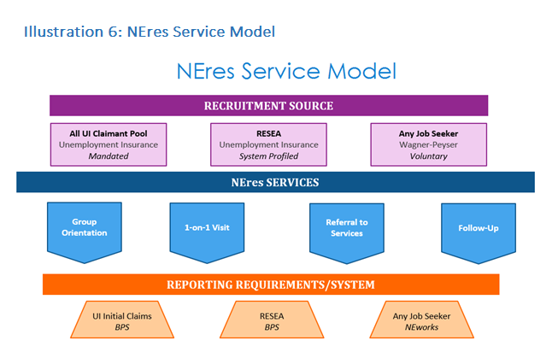

This service model identifies the following information:

1. Recruitment Source: indicates the identification of each NEres participant through one of three avenues (All UI Claimant Pool; RESEA; Voluntary Jobseeker) based on their association with the targeted populations to be served.
2. NEres Services: Regardless of population or recruitment sources, every NEres participant receives the same set of services, in the same order.
   1. Group Orientation
   2. 1-on-1 Visit
   3. Referral to Services
   4. Follow-up
3. Reporting Requirements/System: The model also shows that individuals will maintain their funding source identity for federal and state reporting requirements as well as individual program integrity and compliance.

#### Menu of Services

NEres combines the required services of the federally funded Re-Employment Services and Eligibility Assessment (RESEA) program, along with the jobseeker requirements for regular Unemployment Insurance (UI) compensation. Based on the requirements for each specific program, NEres offers a set of universal services and meets the strictest program criteria of RESEA in order to ensure compliance with all federal and state program requirements. The identified program services required by each separate program and their relation to the universal services provided via NEres, are demonstrated in Illustration 7 and outlined below.

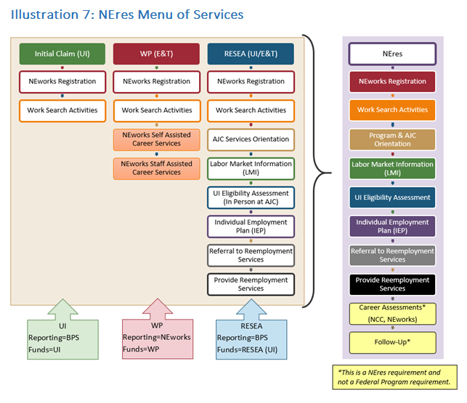

1. Initial Claim (UI): NEworks Registration; Work Search Activities.
2. WP (Employment & Training): NEworks Registration; Work Search Activities; NEworks Self Assisted Career Services (optional); NEworks Staff Assisted Career Services (optional).
3. RESEA (UI/E&T): NEworks Registration; Work Search Requirements; AJC Services Orientation; Labor Market Information (LMI); UI Eligibility Assessment (in person at AJC); Individual Employment Plan (IEP); Referral to Reemployment/Training Services; Provide Reemployment Services.
4. NEres: NEworks Registration; Work Search Requirements; Program & AJC Orientation; Labor Market Information (LMI); UI Eligibility Assessment; Individual Employment Plan (IEP); Referral to Reemployment/Training Services; Provide Reemployment Services; Career Assessments* (Nebraska Career Connections, NEworks); Follow-Up*

*This is a NEres requirement and not a Federal Program Requirement.

#### Program Requirements

NEres has four services that comprise the criteria necessary to meet re-employment program requirements. These services are shown in Illustration 8 and outlined below.

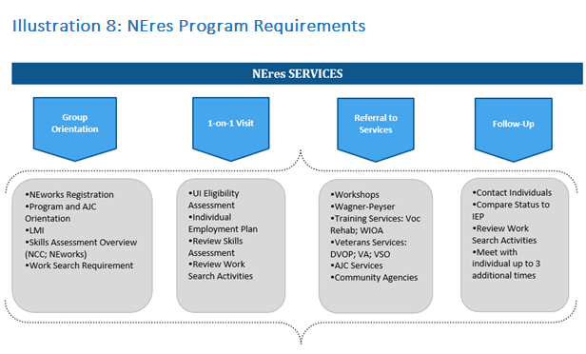

1. Group Orientation
2. 1-on-1 Visit
3. Referral to Services
4. Follow-Up

Each service of the NEres program has a defined set of criteria that are provided to assist the customer in meeting their re-employment needs and program requirements. The individual criteria that are part of each NEres service are:

1. Group Orientation: NEworks Registration; Program and AJC Orientation; LMI; Skills Assessment Overview (Nebraska Career Connections and NEworks); Work Search Requirement.
2. 1-on-1 Visit: UI Eligibility Assessment; Individual Employment Plan; Review Skills Assessment; Review Work Search Activities.
3. Referral to Services: Workshops; Wagner-Peyser; Training Services-Vocational Rehabilitation, WIOA Title I, etc.; Veteran Services-DVOP, VA, VSO, etc.; AJC Services; Community Agencies.
4. Follow-Up: Contact individuals; Compare status to IEP; Review Work Search Activities; Meet with individual up to 3 additional times.

#### Participant Compliance

The following populations are required to participate in NEres:

* + 1. All initial non-exempt UI claimants
    2. Re-Employment Services and Eligibility Assessment (RESEA) profiled individuals

Failure to comply with NEres program requirements may result in suspension of benefits until the NEres program requirements are met.

NEres also welcomes voluntary jobseekers to participate in the program and receive resources to assist them in their job search to advance their employment or achieve re-employment. Voluntary jobseekers are not mandated to participate and receive no sanctions for failure to comply with program requirements. Voluntary jobseeker participants receive the same menu of NEres services and are included in federal reporting for the Wagner-Peyser program.

#### Benefitting Fund Sources

Per the NEres Service Model shown previously, NEres maintains each participant’s association with the program that originally identified them as a part of the NEres program:

* + 1. Unemployment Insurance (UI)
    2. Re-Employment Services and Eligibility Assessment (RESEA)
    3. Wagner-Peyser (voluntary jobseekers)

Individual program identity is necessary for data integrity and federal reporting purposes. The provision of universal services maximizes agency resources and eliminates duplication of services, while maintaining individual program integrity. NEworks, the state’s reporting and case management information system, has the necessary capabilities to track individuals and their services, while maintaining their association with the appropriate and necessary reporting system.

#### Reemployment Opportunities

NEres provide tools and resources for individuals to increase their re-employment options via successful job matching. Through NEres, quality job matches are initiated by:

* + 1. Work Search Activities
    2. Job Referrals
    3. Virtual Recruiter Notifications

These preliminary steps to a successful job match provide NEres participants the opportunity to explore viable employment options that match their Knowledge, Skills and Abilities (KSA). Employment opportunities that are refined and based on participant KSAs will lead to greater success in re-employment for individuals.

#### NEres Service Delivery and Locations

NEres staff is headquartered at primary NEres locations across the state and facilitate the group workshop, one-on-one visit, referral to services and follow-up services in person or face-to-face via video conferencing. NEres service regions are based on Nebraska’s previous regions for implementation of the Extended Services Program (ESP), which was utilized to assist with the administration of Extended Unemployment Compensation (EUC) benefits. The state is divided into six regions, each composed of various counties that revolve around primary service locations. Customers are directed to the appropriate NEres location based on their home county.

### Support of UI Claimants

Describe how the State will use W-P funds to support UI claimants, and the communication between W-P and UI, as appropriate, including the following:

#### *Labor exchange Services*

Coordination of and provision of labor exchange services for UI claimants as required by the Wagner-Peyser Act;

Wagner-Peyser funds support UI claimants through the regular and ongoing provision of Employment Services throughout the workforce system. Employment Services communicates with UI on a regular basis to discuss the provision and recording of reemployment services for UI customers and to assess current practices for opportunities for improvement. Communication between UI and Employment Services occurs via technology, phone, and in-person meetings. UI Supervisors and staff are included in Employment Services training, both as participants and trainers, in order to communicate necessary and relevant strategies for provision of reemployment services to shared customers.

Nebraska Department of Labor has a contract with Geographic Solutions Inc. (GSI) for the NEworks Virtual One Stop (VOS) module system used for Employment Services, including labor exchange services. In October 2013, NDOL purchased GSI’s Re-Employment Exchange (REX) Module which allows a single sign-on for customers who utilize services through both the NEworks and Unemployment Insurance systems. In Jan 2014, NDOL transferred hosting services from the Nebraska Office of Chief Information Officer (OCIO) to GSI and added a Mobile Application module. In order to successfully implement the program design of NEres, NDOL purchased the Scheduler & Attendance Tracking Module from GSI, which:

* + 1. Interfaces with the VOS, REX, Mobile App and Benefit Payment System (BPS).
    2. Provides the functionality to schedule and track program participants per the correct fund source.

The software helps maintain eligibility of benefits for UI claimants not yet employed, by providing eligibility data to the UI system. This module also allows NEres to schedule and track unemployment claimants who are required to attend an orientation and one-on-one meeting at the beginning of their unemployment claim to get them back to work sooner. This technology will replace an outdated scheduling system.

In addition to NEworks, the state’s integrated Management Information System (MIS), Employment Services utilizes additional forms of technology to disseminate information and communicate with customers, including UI claimants. Social media, virtual services and user friendly mobile applications allow customers to have 24/7 access to services and communication tools intended to support employment opportunities for individuals in Nebraska. These same tools allow program staff to follow-up and maintain contact with participants and ensure employment services, and reemployment services for UI claimants, are being utilized in an effective manner to promote and encourage re-employment and career opportunities that match the jobseeker’s Knowledge, Skills and Abilities (KSAs).

Employment Services supports UI customers in Job Search and Placement Assistance by providing significant staff assistance with the job search process; including, but not limited to, evaluation of customers’ abilities, job search approach, advisement on alternative methods of job search techniques, and assistance with company and industry research. Additionally, Employment Services supplements application assistance by offering resume assistance, both 1-on-1 and via group workshops. Resume assistance provides jobseekers with a quality resume that can accompany their employment applications. Cover letters and other employment related correspondence are also provided, and are tailored to the needs of each customer based on their employment goals and work experience.

NEworks offers customers a powerful and robust system to search for job openings. From quick job searches to advanced searches, NEworks features a host of options to view and apply for job openings across the state. The state’s public labor exchange provides job search and employment assistance opportunities that can be self-assisted (by the customer) or staff-assisted. The web-based system means these services are available for customers to access directly 24/7, and at their convenience. The on-line labor exchange provides the opportunity and convenience for customers to look for employment opportunities that meet their needs. It also allows staff and employers to view jobseeker resumes and work history, and create job referrals based on the candidate’s abilities. A Virtual Recruiter offered through NEworks is another job-matching tool that provides customers with direct information about employment opportunities that match their interests and abilities.

#### *Registration of UI claimants*

Registration of UI claimants with the State's employment service if required by State law;

NEworks is used as the single sign-on system for Employment Services and UI customers. Employment Services staff work directly with UI customers in the One-Stop Centers or via phone to provide registration assistance on the NEworks system.

NEworks is a web-based system that can be accessed 24/7 anywhere internet connection is available. Computers available in the Resource Room in the One-Stop Centers provide direct customer access to NEworks, along with staff assistance if necessary. Employment Services staff have recognized that some customers are deficient in computer literacy skills. To assist customers in overcoming this barrier, Employment Services coordinates with local literacy groups, education institutions and Community Based Organizations (CBOs) to provide computer literacy assistance either in the local One-Stop Centers or at other locations in the community.

Employment Services also conducts NEworks Workshops to assist customers in registering for work and navigating the labor exchange system. Employment Services workshops include, but are not limited to:

* + 1. NEworks Registration
    2. Resumes Workshops
    3. Job Search Workshops
    4. Labor Market Information

#### *Work Test*

Administration of the work test for the State unemployment compensation system, including making eligibility assessments (for referral to UI adjudication, if needed), and providing job finding and placement services for UI claimants; and

Nebraska’s Employment Services, One Stop Centers and UI division collaborate to provide seamless reemployment services through the NEres program. The NEres program includes initial eligibility assessments as well as additional reemployment services. Each NEres customer receives a group orientation and then a subsequent individual appointment.

Within the individual appointment, the NEres staff conducts the following core activities:

* + 1. Eligibility Review (for UI claimants)
    2. Development of an Individual Employment Plan (IEP)
    3. Provision of Labor Market Information (LMI)
    4. Reemployment Services
    5. Referral to Training
    6. Job Search and Placement Assistance

Employment Services provides these direct services to UI customers, and coordinates with the UI program to outline expectations and needs related to eligibility assessments. Employment Services staff are trained by UI on Eligibility Issues and the communication process with UI to inform them of potential issues. Identified Eligibility Issues are documented and communicated with UI in a timely fashion, in order for UI to follow up accordingly.

#### *Training and education programs and resources*

Provision of referrals to and application assistance for training and education programs and resources.

Employment Services conducts assessments of customers to determine their Knowledge, Skills and Abilities. Assessments may include an initial assessment, either formal or informal needs assessment based on first direct contact with the customer to determine their needs and appropriate services. It may also include an Interest/Aptitude and Skills Assessment, which involves the administration of a formal assessment to measure the possession of, interested in or ability to acquire job skills of knowledge. Examples of Interest/Aptitude and Skills Assessments include: Nebraska Career Connections; NEworks Skills Analyzer; O*NET Online; My Next Move; Career One Stop; My Skills My Future; CASAS; etc.

Based on customer conversations, interviews and assessments, Employment Services staff makes the appropriate referral to training and education programs that may assist the customer with necessary upskills in order to be competitive in their reemployment journey. Referral to training and education programs is based on customer need and circumstances. These referrals are documented in NEworks in order to track progress of partnership development and use of community resources. Employment Services staff also provide assistance if additional it is needed by the customer to complete reference or application materials, These situations occur on a case by case basis, and are prompted by the customer.

Sharing of training and education program information and materials is a key strategy in order for Employment Services to make appropriate referrals for customers. Employment Services staff communicates with their education partners to determine current program opportunities and possible requirements of customers in order to participate. This information allows referrals to be based on information that directly affects and benefits the customer.

### Agricultural Outreach Plan (AOP).

Each State agency must develop an AOP every four years as part of the Unified or Combined State Plan required under sections 102 or 103 of WIOA. The AOP must include--

#### *Assessment of Need*

Provide an assessment of the unique needs of farmworkers in the area based on past and projected agricultural and farmworker activity in the State. Such needs may include but are not limited to: employment, training, and housing.

Agriculture data from prior and current program years continue to be the foundation of this program plan to provide Wagner-Peyser funded services and activities to the agricultural community under the One-Stop Delivery System. Proteus reports that the needs of MSFWs are housing and food. Housing is a challenge in rural areas of Nebraska, particularly for farmworkers with limited income and who require affordable housing. The expedited SNAP benefits process is promising, however, some of our migrant farmworkers are not in the same place week-to-week. In addition to those basic needs, Nebraska MSFWs also require language acquisition skills and technical skills. Both of these needs significantly impact the end goal of job placement for the MSFW population. In addition to language acquisition, Nebraska’s farmworkers’ needs center around skill attainment which can be assisted with training assistance and the need for permanent employment opportunities that match their available skill set. A cultural connection and sense of belonging is a common need for farmworkers. The limited availability of similar individuals settling in Nebraska communities can be offset with community engagement and education opportunities. Education beyond technical skill training is also a need. Basic literacy training is a common need among the farmworker population, many of whom have limited reading and writing ability in their native languages as well as English.

##### Assessment of agriculture activity

An assessment of the agricultural activity in the State means: 1) identifying the top five labor-intensive crops, the months of heavy activity, and the geographic area of prime activity; 2) Summarize the agricultural employers’ needs in the State (i.e. are they predominantly hiring local or foreign workers, are they expressing that there is a scarcity in the agricultural workforce); and 3) Identifying any economic, natural, or other factors that are affecting agriculture in the State or any projected factors that will affect agriculture in the State.

1. Identifying the top five labor-intensive crops, the months of heavy activity, and the geographic area of prime activity

| Crops | Months of Activity | Geographic Area |
| --- | --- | --- |
| Alfalfa | June - October | Central and Western Nebraska |
| Corn | June - October | Statewide |
| Oats for Grain | June - October | Central and Western Nebraska |
| Sorghum for Grain | June - October | Central and Western Nebraska |
| Soybeans | June - October | Statewide |

1. Summarize the agricultural employers’ needs in the state (i.e., are they predominantly hiring local or foreign workers, are they expressing that there is a scarcity in the agricultural workforce)
2. Nebraska’s agricultural employers are expressing a need for more agricultural workers. While there is still a need for some handwork in the fields, the majority of Nebraska’s agricultural employers’ labor need is for agricultural equipment operators, including operating combines and tractors, transporting fertilizer, and hauling grain to the storage facility. During the peak season, in 2017, there were 189 H2A workers. Each year the number of employers requesting H2A workers increases. Identifying any economic, natural, or other factors that are affecting agriculture in the state or any project factors that will affect agriculture in the state

Several factors are impacting agriculture in Nebraska, including mechanization, herbicide resistant weeds, and increases in fruit and vegetable production.

Automation and changes in planting techniques and weed control have drastically reduced the need for migrant and seasonal farm workers in some areas of the state for crops like sugar beets and potatoes which have traditionally required handwork. Row planting for some crops has been replaced by the drilling method of planting which provides closer spacing of the plants and makes the application of chemicals to control weeds more effective thereby reducing the need for hand weeding and hoeing efforts. However, Proteus and Nebraska Extension Educators have expressed that some weeds are now proving resistant to herbicides, which has increased the need for hand hoeing of weeds in some parts of the state.

According to the Nebraska Department of Agriculture, the number of Nebraska’s fruit and vegetable growers has increased over the past decade from 78 in 2000 to more than 600 in recent years. Most produce growers remain small family farm operations, and it is difficult to estimate how many employ seasonal workers who are not family members.

##### Assessment of unique needs

An assessment of the unique needs of farmworkers means summarizing Migrant and Seasonal Farm Worker (MSFW) characteristics (including if they are predominantly from certain countries, what language(s) they speak, the approximate number of MSFWs in the State during peak season and during low season, and whether they tend to be migrant, seasonal, or year-round farmworkers). This information must take into account data supplied by WIOA Sec. 167 National Farmworker Jobs Program (NFJP) grantees, other MSFW organizations, employer organizations, and State and/or Federal agency data sources such as the U.S. Department of Agriculture and the U.S. Department of Labor (DOL) Employment and Training Administration.

Most migrant farmworkers in Nebraska are from Texas, Mexico, Guatemala, Peru, Thailand, Nepal, and South Africa. Migrant and Seasonal Farm Workers are predominantly from Latin American countries, with most of the individuals coming from Mexico. The primary language spoken by migrant farmworkers is Spanish.

According to Nebraska’s H2A Program Coordinator, there were 183 H2A workers during the 2017 peak season. Proteus estimates that there are approximately 1000 *migrant* farmworkers in Nebraska through the peak season and 250 migrant farmworkers during the low season. According to the 2012 Agricultural Census, agricultural employers employed 788 migrant farmworkers in Nebraska.

Estimating the number of seasonal farmworkers proves far more difficult in a state where agricultural employment still accounts for twenty-five percent of employment opportunities. According to the 2012 Agricultural Census, agricultural employers reported employing 30,832 workers for less than 150 days. Most likely, there is significant duplication in this count; it’s almost guaranteed that both migrant and seasonal farmworkers were employed by more than one agricultural employer. There are only 86 seasonal farmworkers registered in NEworks.

The common populations for MSFWs are seasonal and year-round farmworkers, with migrant workers making up a smaller portion of MSFW in the state.

The peak season for MSFW in the state is May through October annually, with low seasons occurring on the late fall through early spring (November - April).

#### *Outreach Activities*

The local offices outreach activities must be designed to meet the needs of MSFWs in the State and to locate and contact MSFWs who are not being reached through normal intake activities. Describe the State agency's proposed strategies for:

Contacting Farmworkers

Contacting farmworkers who are not being reached by the normal intake activities conducted by the employment service offices.

Employment Services data mines information in NEworks to identify MSFW individual and pro-actively reach out to them to offer and promote permanent employment opportunities. Employment Services also partners with the Nebraska’s NFJP grantee for the MSFW program to provide information and conduct workshops for their MSFW customers.

Other outreach efforts include, but are not limited to

* + 1. Identifying community organizations that may come into contact with MSFW’s:
       - Churches with Spanish mass
       - Migrant Head Start
       - Libraries
       - Community Based Organizations
       - Service Agencies
       - Proteus
       - Legal Aid
    2. Identifying businesses that may come into contact with MSFW’s: ethnic markets, laundromats, restaurants, motels, salons etc.

Available resources for the MSFW outreach include a Migrant & Seasonal Farm Workers booklet and Migrant and Seasonal Farmworkers Information Bulletin. In addition to these state administered materials, AJCs and NDOL Locations and outreach staff provide local information and resources targeted to the MSFW population. Outreach workers encourage migrant and seasonal farmworkers to go to the nearest AJC or NDOL Location to receive services. If the migrant and seasonal farmworkers cannot or do not wish to access services at the Center, the outreach worker provides onsite aid in the preparation of applications, assistance in obtaining referral to specific employment opportunities, guidance in the preparation of complaints, referral to supportive services, and help in making appointments and arranging transportation. In all instances where appropriate, bilingual staff is available to conduct outreach activities.

##### Technical Assistance to Outreach Workers

Providing technical assistance to outreach workers. Technical assistance must include trainings, conferences, additional resources, and increased collaboration with other organizations on topics such as one-stop center services (i.e. availability of referrals to training, supportive services, and career services, as well as specific employment opportunities), the employment service complaint system, information on the other organizations serving MSFWs in the area, and a basic summary of farmworker rights, including their rights with respect to the terms and conditions of employment.

Technical Assistance will be provided through an in-person training, prior to the beginning of the peak season, and through regularly scheduled Technical Assistance conference calls and video conferences with local ES staff during the peak MSFW season. MSFW partners will be invited to the in-person training, including: Proteus, Migrant Education, and Legal Aid. Training topics will include the Complaint System, farmworker rights, best practices for outreach, and the Agricultural Recruitment System.

Technical Assistance calls through the season will refresh outreach workers’ knowledge about the complaint system, supportive services, and partner programs, and serve as an opportunity for outreach workers to ask questions and share best practices.

The final TA call at the end of the season recaps success stories and opportunities identified for the following year. Resources are provided to ES staff for them to incorporate into their MSFW outreach efforts.

##### Outreach Worker Training and Awareness

Increasing outreach worker training and awareness across core programs including the Unemployment Insurance (UI) program and the training on identification of UI eligibility issues.

ES staff partner on a regular basis with the UI program in order to serve customers in an informative manner about potential services available and/or eligibility issues. This same knowledge is leveraged by staff when outreaching to and serving MSFWs.

The UI program is integrated into mandatory annual training for ES staff. UI Supervisors prepare and conduct training to educate ES staff to listen for and identify potential UI eligibility issues. ES staff are also trained on the process to report potential issues to UI on an Eligibility Review Form (ERF), a document that identifies the potential eligibility issue. Written guidance for the ERF is developed in partnership with and reviewed by UI. The guidance is included in program manuals for staff. Referrals of potential issues are provided to UI staff for adjudication. The referral process involves emailing the ERF to UI staff to identify and adjudicate the potential issue.

ES staff work directly with the NFJP grantee, Proteus, to find and reach MSFW populations in order to directly share information about Employment Services, including the ES complaint system. ES partners with local and regional advocacy groups, such as Nebraska Appleseed Center for Law in the Public Interest and Legal Aid of Nebraska, to share and disseminate information to farmworkers about their rights.

MSFW Outreach staff seek out advocacy groups and partners when promoting ES services to MSFW populations. During this partnership development, Outreach staff will request printed and/or electronic materials to share with other partners and promote to MSFWs directly, in order to better inform them of services and agencies intended to serve and assist MSFWs.

##### Professional Development for Merit Staff Outreach Workers

Providing State merit staff outreach workers professional development activities to ensure they are able to provide high quality services to both jobseekers and employers.

Employment Services conducts monthly Technical Assistance video conferences with ES staff to provided tools and resources to equip staff to determine and meet the needs of jobseeker and employer customers. In addition to monthly TA conference calls, there are regular in-service training opportunities conducted throughout the year to provide new or updated information and best practices. The ES program is constantly looking for innovative ways to train staff and provide them new resources.

Coordination with NFJP Grantees

Coordinating outreach efforts with NFJP grantees as well as with public and private community service agencies and MSFW groups.

Employment Services partners across the state with Proteus, the NFJP grantee. Proteus is co-located in some AJC and NDOL Locations and has access to services available across the state, even when they do not have a physical location in an AJC or NDOL Location. ES and Proteus staff partner together at the Administrative, Management and Staff levels, designing partnership opportunities that are appropriate for each community or region, based on the available MSFW population to serve and resources.

Concentrated outreach is undertaken during the peak periods of migrant and seasonal farm workers’ activity, traditionally April through June. The outreach workers, in coordination with Proteus Inc., the WIA 167 National Farmworker Jobs Program grantee, maintain a record of outreach activities that includes the names of individuals. These records are especially utilized when an application is taken, referral to a job is made, or a complaint is documented. This data is retained and preserved through the NEworks data system. This data system allows the Agency to track the number of migrant and seasonal agricultural workers contacted, any follow-up contacts that are made, and the types of services provided. This information is provided to USDOL’s Employment and Training Administration (ETA) in the quarterly "Services to Migrant and Seasonal Farmworker Reports" (Form 5148, LEARS Reporting System).

To assist in outreach, NDOL has developed a brochure showing the services that are available and other services that are most needed by migrant and seasonal farm workers. The brochure has been produced in Spanish and English. The brochure is an important resource, both for direct outreach and for connecting to other agencies within or without the AJC or NDOL Location involved in serving the migrant and seasonal population through outreach activities. The three most important resource partners for migrant and seasonal farmworkers in Nebraska are the Department of Education migrant program, the migrant health programs, and Proteus Inc., which is the State’s Workforce Investment Act Section 167 agency. Coordination among these partners will continue to be of special importance to the Wagner-Peyser funded programs. There is no Wagner-Peyser funding level per se set-aside for the proposed outreach activities. However, all outreach activities conducted will be paid for by Wagner-Peyser funds.

#### *Services provided through the one-stop delivery system.*

Services provided to farmworkers and agricultural employers through the one-stop delivery system.

Describe the State agency's proposed strategies for:

##### Employment and Training Services

Providing the full range of employment and training services to the agricultural community, both farmworkers and agricultural employers, through the one-stop delivery system. This includes:

1. How career and training services required under WIOA Title I will be provided to MSFWs through the one-stop centers;
2. How the State serves agricultural employers and how it intends to improve such services.

**Career and Training Services**. Migrant seasonal farmworkers outreach activities are primarily coordinated through Nebraska’s One-Stop Delivery System. A dedicated ES staff person from each region of the state has been assigned the responsibility to conduct outreach to employers and to migrant and seasonal farmworkers in their surrounding areas of service. Utilization of the common case management system by WIOA Title I and ES programs is a key strategy in providing MSFW populations with WIOA Title I services. Utilizing the same case management system greatly improves the communication, enrollment and referral process, and allows management staff to review populations being served with an EEO summary report that details participant profiles, including: age; gender; household location; ethnicity; education level; employment status; MSFW status; etc.

Career and training services provided by AJC and NDOL Locations include: Job Search Assistance; Job Referral; Placement Assistance for Jobseekers; Reemployment Services to unemployment insurance claimants; Recruitment services to employers with job openings. Outreach efforts include an explanation of the full menu of services available from the local AJC or NDOL Location as well as specific employment opportunities that are currently available. Support for education and training is provided through the NFJP grantee. The State Workforce Development Boards in coordination with local Workforce Development Boards provide funding recommendations, assistance and guidance on methods of allowing AJC customers to be competitive in a regional and global economy. AJC and NDOL Locations provide MSFWs with referrals to local education institutions for GED, ESL and technical skills training.

**Serving Agricultural Employers**. Services to agricultural employers includes, but is not limited to:

NEworks: NEworks is a self-service tool for jobseekers and employers. Employers may use the web-based, integrated system of NEworks to post their job openings, either through employer-direct entry or through any AJC or Department of Labor office. Employers may also search active resumes, and contact potential employees 24 hours a day, 7 days a week.

Federal Bonding Program: Program allows employers to request fidelity insurance at no-cost when considering “at risk” and “not bondable” jobseekers otherwise eligible.

Foreign Labor Certification: Program provides information and processes required forms to employers before they can bring foreign workers in the U.S.

The H2A Coordinator follows the directives issued by the Chicago National Processing Center (for labor certification) in clearing H2A job orders in neighboring states and labor supply states, in coordination with the State Monitor Advocate.

Labor Market Information for Business: Program provides information about local economy, and changes in labor market.

##### Complaint System

Marketing the employment service complaint system to farmworkers and other farmworker advocacy groups.

Outreach also involves the provision of information on the ES Complaint System and a summary of farm worker rights with respect to employment. The ES Complaint System will be marketed to farmworkers, MSFW partners, and farmworker advocacy groups, including Legal Aid of Nebraska and Nebraska Appleseed.

##### Agricultural Recruitment System

Marketing the Agricultural Recruitment System to agricultural employers and how it intends to improve such publicity.

Outreach staff focuses on employer recruitment and services in addition to individual MSFWs. Employer outreach leverages H2A services and housing inspection staff to identify and communicate with employers about the Agricultural Recruitment System and employer services available to them through ES. Opportunities for publicity are limited due to financial restrictions and limited funds. Increased efforts for data mining will be used to access and reach out to more agricultural employers with a limited cost.

#### *Other Requirements*

##### Collaboration

Describe any collaborative agreements the state workforce agency (SWA) has with other MSFW service providers including NFJP grantees and other service providers. Describe how the SWA intends to build upon/increase collaboration with existing partners and in establishing new partners over the next four years (including any approximate timelines for establishing agreements or building upon existing agreements).

There are no existing cooperative agreements between NDOL and with public and private community service agencies. It is anticipated that there will be cooperation on an informal basis with service agencies, such as Nebraska Appleseed and Legal Aid of Nebraska. Development of a cooperative agreement will begin during PY2016.

The Monitor Advocate oversees the Wagner-Peyser program outreach to agricultural employers and migrant and seasonal farm workers. The State’s Monitor Advocate (SMA) position is currently held in NDOL’s Office of General Counsel. The Monitor Advocate coordinates responsibilities with the H2A Coordinator in NDOL’s Foreign Labor Certification (FLC) program, and this coordination will remain critical as the state transitioned to the new H2A rule that re-engineers the process by which employers obtain an H2A labor certification. The change from an attestation-based application process to one requiring more investigations and findings by the SWA has warranted enhanced outreach and referral services to migrant workers through the Interstate Clearance System.

The SMA will partner with the H2A Coordinator to provide training, as needed, to One-Stop Career Center staff on activities such as Housing Inspections and the Employment Services (ES) Complaint System, in order to improve delivery of services to the migrant population. The SMA’s duties include the conducting of annual field visits to AJCs and significant NDOL Locations in the state, and reporting any findings resulting from those visits.

Future collaborative efforts will include ongoing communication between ES and the NFJP grantee at the local AJC and statewide program levels. Both ES and the NFJP grantee are members of the state’s Nebraska Partner Council and collaborate to provide services to MSFW populations. The Nebraska Partner Council meets throughout the year to discuss partnership opportunities and efforts to serve target populations, including MSFWs. At the local level, ES managers coordinate partner meetings with local one-stop partners and service providers, including the NFJP grantee, to share information on MSFW populations and conduct targeted outreach. Both formal and informal meetings are conducted with the NFJP grantee to discuss and continue collaboration efforts. Development of local MOUs will formalize partnership efforts between ES and all one-stop system partners, including the NFJP grantee. The MOUs will describe how efforts are coordinated among partners, the method for identifying MSFWs and the process for referrals of MSFWs.

##### Review and Public Comment.

In developing the AOP, the SWA must solicit information and suggestions from NFJP grantees, other appropriate MSFW groups, public agencies, agricultural employer organizations, and other interested organizations. In addition, at least 45 calendar days before submitting its final AOP, the SWA must provide a proposed plan to NFJP grantees, public agencies, agricultural employer organizations, and other organizations expressing an interest and allow at least 30 days for review and comment. The SWA must: 1) Consider any comments received in formulating its final proposed AOP; 2) Inform all commenting parties in writing whether their comments have been incorporated and, if not, the reasons therefore; and 3) Transmit the comments and recommendations received and its responses with the submission of the AOP. The AOP must include a statement confirming NFJP grantees, other appropriate MSFW groups, public agencies, agricultural employer organizations and other interested employer organizations have been given an opportunity to comment on the AOP. Include the list of organizations from which information and suggestions were solicited, any comments received, and responses to those comments.

The Agricultural Outreach Plan was submitted for comment through the public posting of the WIOA State Plan during the public comment period. Informed parties included: All Nebraska Department of Labor (NDOL) American Job Centers and NDOL Locations in Nebraska; Legal Aid of Nebraska; Nebraska Department of Education (including Migrant Education Program); Proteus, Inc. (NFJP Grantee). No public comments were received regarding the AOP section of the WIOA State Plan.

##### Data Assessment.

Review the previous four years Wagner-Peyser data reports on performance. Note whether the State has been meeting its goals to provide MSFWs quantitatively proportionate services as compared to non-MSFWs. If it has not met these goals, explain why the State believes such goals were not met and how the State intends to improve its provision of services in order to meet such goals.

* + 1. PY2011 No - Did not meet MSFW goals for Wagner-Peyser services.
    2. PY2012 Yes - Met MSFW goals for Wagner-Peyser services.
    3. PY2013 Yes - Met MSFW goals for Wagner-Peyser services.
    4. PY2014 No - Did not meet MSFW goals for Wagner-Peyser services.

The State showed success in meeting the goals when there were higher numbers of MSFWs recruited for services. The limited number of available MSFWs in 2014 negatively affected the state’s Wager-Peyser services for these individuals. In order to meet these goals consistently moving forward, the State is working with the NFJP partner for targeted co-enrollment of services and to create programs that leverage Employment Services while working with the NFJP grantee. Targeted Technical Assistance and Best Practices will also be utilized to meet the goals for MSFW in Wagner-Peyser.

Assessment of Progress

The plan must include an explanation of what was achieved based on the previous AOP, what was not achieved and an explanation as to why the State believes the goals were not achieved, and how the State intends to remedy the gaps of achievement in the coming year.

Based on the previous AOP, increased services and outreach efforts for MSFWs was provided. The State increased in the hiring of multi-lingual staff for offices across the State to provide greater access to AJC and affiliate sites. The State did not continuously meet its goal of contacting and serving at least 100 MSFWs each year. While the State met the goal most years, it did not meet the goal in PY2014. This is believed to be due to the reduced number of MSFW in the State. The State is increasing and revitalizing efforts with the NFJP grantee and other MSFW partners to identify and outreach to MSFWs.

##### State Monitor Advocate

The plan must contain a statement confirming the State Monitor Advocate has reviewed and approved the AOP.

The State Monitor Advocate reviewed and approved the AOP.

### Wagner-Peyser Assurances

The State Plan must include assurances that:

1. The Wagner-Peyser Employment Service is co-located with one-stop centers or a plan and timeline has been developed to comply with this requirement within a reasonable amount of time. (sec 121(e)(3)); **Yes**
2. The State agency is complying with the requirements under 20 CFR 653.111 (State agency staffing requirements) if the State has significant MSFW one-stop centers; **Yes**
3. If a State Workforce Development Board, department, or agency administers State laws for vocational rehabilitation of persons with disabilities, that board, department, or agency cooperates with the agency that administers Wagner-Peyser services, Adult and Dislocated Worker programs and Youth Programs under Title I; and **Yes**
4. State agency merit-based public employees provide Wagner-Peyser Act-funded labor exchange activities in accordance with Department of Labor regulations. **Yes**

## Program-Specific Requirements for Adult Education and Family Literacy Act Programs

The State Plan must include a description of the following as it pertains to Adult Education and Literacy programs under Title II, the Adult Education and Family Literacy Act (AEFLA).

### Aligning of Content Standards

Describe how the eligible agency will, by July 1, 2016, align its content standards for adult education with State-adopted challenging academic content standards, as adopted under section 1111(b)(1) of the Elementary and Secondary Education Act of 1965, as amended (20 U.S.C. 6311(b)(1)).

Nebraska Adult Education will create and update Adult Education content standards as necessary to maintain alignment with State-adopted academic content standards as approved by the Nebraska Board of Education. Nebraska Adult Education will also create and update English Language Proficiency Standards and College and Career Ready standards to align with approved State standards.

Local program providers of Adult Education under Title II will be required to utilize the updated standards in their respective programs during the delivery of instruction and to help prepare students for transition to postsecondary education and training or employment. Professional Development will be provided to ensure that all Adult Education staff is adequately prepared for the instruction of these standards. This will be an ongoing, multi-year project. Appropriate workgroups will be formed to assist in the monitoring and implementation of updated standards.

### Local Activities

Describe how the State will, using the considerations specified in section 231(e) of WIOA, fund each eligible provider to establish or operate programs that provide the adult education and literacy activities, including programs that provide such activities concurrently. The Unified or Combined State Plan must include at a minimum the scope, content, and organization of local activities.

#### Adult Education and Literacy Activities (Section 203 of WIOA)

* + 1. Adult education;
    2. Literacy;
    3. Workplace adult education and literacy activities;
    4. Family literacy activities;
    5. English language acquisition activities;
    6. Integrated English literacy and civics education;
    7. Workforce preparation activities; or
    8. Integrated education and training that—
       - Provides adult education and literacy activities, concurrently and contextually with both, workforce preparation activities, and workforce training for a specific occupation or occupational cluster, and
       - Is for the purpose of educational and career advancement.

Nebraska Adult Education will award funding to local providers based on their responsiveness to regional needs, the serving of individuals in need of adult education and literacy activities including those who have low literacy skills and those who are English language learners. Consideration for funding will also be made based on the ability of the local program provider to serve eligible individuals with disabilities and the past effectiveness of the local provider in improving the educational functioning level of eligible individuals and ability to meet State-adjusted levels of performance for primary indicators of performance. The State will also consider alignment of Adult Education program services with the goals of the local plan and one-stop partners.

Local program providers will be required to operate programs that provide adult education and literacy activities concurrently across the community or geographic area identified in the proposal and in compliance with the considerations specified in Section 231(e) of WIOA.

Local program providers must show they are of sufficient intensity and quality and utilize instructional practices based on rigorous research and include the essential components of reading instruction. Local providers must also demonstrate effectiveness in delivering adult education program services concurrently with workforce preparation activities and, when feasible, workforce training for specific occupations or industries.

The Nebraska Adult Education program serves eligible individuals identified in WIOA, Section 203(4) as an individual–

1. who has attained 16 years of age;
2. who is not enrolled or required to be enrolled in secondary school under State law; and
3. who–
   1. is basic skills deficient;
   2. does not have a secondary school diploma or its recognized equivalent, and has not achieved an equivalent level of education; and/or
   3. is an English language learner.

Instruction includes:

* Basic skills improvement;
* Literacy skills;
* English language acquisition;
* Integrated English Literacy and Civics Education (IELCE);
* Workforce preparation activities;
* Integrated Education and Training (IET);
* Academic skills leading to a high school equivalency credential or diploma;
* Transition to post–secondary education/training and/or employment;
* Instruction that my include the following:
  + Math;
  + Reading;
  + Writing;
  + Science;
  + Social Studies;
  + Language Arts;
  + Civics;
  + Use of Technology

##### Practitioners and Providers

As defined in Section 203(5) of WIOA, the term “eligible provider” means an organization that has demonstrated effectiveness in providing adult education and literacy activities that may include:

1. a local educational agency;
2. a community-based organization or faith-based organization;
3. a volunteer literacy organization;
4. an institution of higher education;
5. a public or private nonprofit agency;
6. a library;
7. a public housing authority;
8. a nonprofit institution that is not described in any of subparagraphs (A) through and has the ability to provide adult education and literacy activities to eligible individuals;
9. a consortium or coalition of the agencies, organizations, institutions, libraries, or authorities described in any of subparagraphs (A) through (H); and
10. a partnership between an employer and an entity described in any of subparagraphs (A) through (I).

As designated in Section 232 of WIOA, each eligible provider desiring a grant or contract from Nebraska Department of Education for Adult Education shall submit an application containing such information and assurances as the Nebraska Department of Education may require, including:

1. a description of how funds awarded under this title will be spent consistent with the requirements of this title;
2. a description of any cooperative arrangements the eligible provider has with other agencies, institutions, or organizations for the delivery of adult education and literacy activities;
3. a description of how the eligible provider will provide services in alignment with the local plan under section 108, including how such provider will promote concurrent enrollment in programs and activities under Title I, as appropriate;
4. a description of how the eligible provider will meet the State adjusted levels of performance described in section 116(b)(3), including how such provider will collect data to report on such performance indicators;
5. a description of how the eligible provider will fulfill one–stop partner responsibilities as described in section 121(b)(1)(A), as appropriate;
6. a description of how the eligible provider will provide services in a manner that meets the needs of eligible individuals; and
7. information that addresses the considerations described under section 231(e), as applicable.

Section 231(c) requires that each eligible agency receiving funds under this title shall ensure that all eligible providers have direct and equitable access to apply for grants or contracts under this section; and the same grant or contract announcement process and application process is used for all eligible providers in the State or outlying area.

The Nebraska Department of Education ensures that all eligible providers have direct and equitable access to apply for grants under the Adult Education and Family Literacy Act (Title II) of the Workforce Investment and Opportunity Act. The same grant announcement and application process is used for all eligible providers statewide. All applicants follow a detailed request for proposal, and each proposal is evaluated by a team of evaluators and State Adult Education staff.

The considerations for funding will follow Section 231(e) of WIOA; other considerations identified in the local plan under section 108 as determined by the regional Workforce Boards; and other considerations as determined by Nebraska Adult Education in accomplishing the intent of WIOA.

Multi–year grants will be awarded to eligible agencies on a competitive basis.

In those programs that provide family literacy services, AE funds can be used only for those activities specifically offered for the adult parent(s) who are eligible for Adult Education services. Other sources of funding will be required to fund activities involving children. (Pertains to Special Rule directly below.)

#### Special Rule

Each eligible agency awarding a grant or contract under this section shall not use any funds made available under this title for adult education and literacy activities for the purpose of supporting or providing programs, services, or activities for individuals who are under the age of 16 and are enrolled or required to be enrolled in secondary school under State law, except that such agency may use such funds for such purpose if such programs, services, or activities are related to family literacy activities. In providing family literacy activities under this title, an eligible provider shall attempt to coordinate with programs and services that are not assisted under this title prior to using funds for adult education and literacy activities under this title for activities other than activities for eligible individuals.

### Corrections Education and other Education of Institutionalized Individuals

Describe how the State will establish and operate programs under section 225 of WIOA for corrections education and education of other institutionalized individuals, including how it will fund, in accordance with the requirements of Title II, subtitle C, any of the following academic programs for:

1. Adult education and literacy activities;
2. Special education, as determined by the eligible agency;
3. Secondary school credit;
4. Integrated education and training;
5. Career pathways;
6. Concurrent enrollment;
7. Peer tutoring; and
8. Transition to re-entry initiatives and other post release services with the goal of reducing recidivism.

Each eligible agency using funds provided under Programs for Corrections Education and Other Institutionalized Individuals to carry out a program for criminal offenders within a correctional institution must give priority to serving individuals who are likely to leave the correctional institution within 5 years of participation in the program.

The Nebraska Department of Education, pursuant to Section 222 of WIOA, shall use not less than 82.5 percent of the grant funds to award grants and contracts under Section 231 and to carry out Section 225, not more than 20 percent of such amount shall be made available.

Adult education and literacy activities are provided at both the local and state levels of Corrections to include Career Pathways. Through interactions and partnerships with local and state correctional facilities, priority will be given to students in incarceration who are likely to leave the correctional facility within 5 years of participation in the program.

All other academic programs listed below are provided only at the state correctional facilities and are funded with other state and/or federal funding:

* + special education, as determined by the eligible agency;
  + secondary school credit;
  + Integrated Education and Training (IET);
  + concurrent enrollment
  + peer tutoring
  + transition to re–entry initiatives and other post release services with the goal of reducing recidivism

The policies, procedures, and activities for providing instructional services to this clientele are the same as those for regular programs of instruction for adults. In addition, programs will be encouraged to use guidance and supportive services where possible and to provide education and training through cooperative efforts with providers in correctional and other institutionalized settings. The Nebraska Department of Education will offer a competitive RFP process designed specifically for Corrections Education.

The same application and review processes will be used for Section 225 as are used for Section 231 applicants.

### Integrated English Literacy and Civics Education Program

#### *Establishment and operation*

Describe how the State will establish and operate Integrated English Literacy and Civics Education programs under Section 243 of WIOA, for English language learners who are adults, including professionals with degrees and credentials in their native countries.

All English Language Learners (ELL), served under Section 243 of WIOA in Nebraska Adult Education, will receive instruction in English language acquisition with a primary focus on English oral communication improvement as well as reading, writing and comprehension skills in English and mathematics. ELLs will also receive instruction on the rights and responsibilities of citizenship and civic participation and may include workforce training. This includes those ELL learners who are professionals with degrees or credentials in their own countries. All new grant recipient(s) of Section 243 funding will be required to incorporate Civics and Citizenship instruction into their curriculum.

Each program that receives funding under this section shall be designed to:

1. prepare adults who are English language learners for, and place such adults in, unsubsidized employment in in-demand industries and occupations that lead to economic self-sufficiency; and

2. integrate with the local workforce development system and its functions to carry out the activities of the program

The English language acquisition program will be required to assist English language learners improve their competence in reading, writing, speaking, and comprehension of the English language that may lead to the attainment of a high school diploma or its equivalent and transition to postsecondary education and training or employment.

The Nebraska Department of Education will offer a competitive RFP process designed specifically for Integrated English Literacy and Civics. Funding under this title will be awarded based upon the criteria for evaluation of a program’s application contained in Section 231(e) of WIOA and other criteria determined through state applications for Nebraska Adult Education.

The Nebraska Department of Education recognizes the importance of integrating English Literacy and Civics education services, including workplace readiness skills, with other agencies and institutions within the state. Collaborative efforts will be made with such agencies as Department of Labor, Vocational Rehabilitation (VR), Nebraska Commission for the Blind and Visually Impaired (NCBVI), Department of Health and Human Services (DHHS), and other partnering agencies. Local programs will use guidance from the Nebraska Department of Education, Workforce Development Boards, and local advisory committees and in close association with other training providers, to establish and operate an Integrated English Literacy and Civics education program. This cooperation leads to program improvements through which to serve students.

Other partnerships come from agency, business, and industry representatives serving on local advisory committees and program administrators taking an active role by participating on other agency committees. In addition, local program representatives are appointed to the regional Workforce Development Boards. These efforts will increase collaboration, raise awareness, and educate business and industry leaders about the benefits of workplace literacy, English Literacy, and Civics education. To carry out English Literacy and Civics instruction, eligible agencies will collaborate where possible, and avoid duplication of efforts in order to maximize the impact of the activities.

As a strong supportive partner in the American Job Center, Adult Education will provide basic skills instruction and specific workplace readiness skills. This will enable the target population to obtain the skills necessary for successful employment. It is anticipated that, where feasible, Adult Education will provide on–site instruction and/or referral information to programs with a direct linkage. All of these activities help to build strong local programs that benefit the lives of students.

Nebraska Adult Education is committed to the development and implementation of programs and services through new and promising assessment tools and strategies that are based on scientifically valid research and the identification of barriers and needs of students. Adult English language learners will have the support necessary to achieve competence in Reading, Writing, Math, oral communication, digital literacy, comprehension of the English language, and Career Pathways.

#### *Funding*

Describe how the State will fund, in accordance with the requirements of title II, subtitle C, Integrated English Literacy and Civics Education services and how the funds will be used for those services.

The same application and review processes and procedures will be used for Sections 225, 231, and 243 grant awards. This includes the items designated in Section 232 (Local Application) in WIOA, as well as Section 231(e), and other considerations designated in Section 108. All local applications may also contain requests for information needed by the Nebraska Department of Education, Adult Education section.

It is required that each grant recipient that receives funding under Section 243 shall utilize these funds to:

1. Prepare adults who are English language learners for, and place such adults in, unsubsidized employment in high–demand industries and occupations that lead to economic self–sufficiency; and
2. Integrate with the local workforce development system and its functions to carry out the activities of the program.

State Leadership

#### *Funding*

Describe how the State will use the funds to carry out the required State Leadership activities under section 223 of WIOA.

Nebraska Adult Education shall make available funds under section 222(a)(2) for State Leadership activities to develop or enhance the services that Adult Education and other WIOA core partners provide to eligible participants in the program. State staff will continuously monitor and evaluate both the required and permissible activities needed to fulfill the requisites of Section 223 of WIOA. Not more than 12.5 percent of the grant funds will be used to carry out State Leadership activities under Section 223.

##### Required Activities

###### Career Pathways

Career Pathways activities in Nebraska Adult Education are vital to successful transition of students to postsecondary education and training or employment. Ongoing training of all program staff include; updated intake and assessment of students education and employment goals, personalized orientation and career exploration, employability skills improvement and college and career readiness.

As the State Career Pathways activities progress, a stronger focus on student transition to postsecondary education and training or employment will include improved collaboration with WIOA partners and services and will include referrals to the American Job Centers and partner programs through various linkages, to include the common intake form, data sharing and a more efficient referral process.

Upon determination of additional barriers, other partner programs such as Vocational Rehabilitation and Department of Health and Human Services will be consulted to provide support service training(s).

As WIOA partners continue to work collaboratively and cooperatively to align services for program participants, State Leadership funds will be used to build capacity through training activities that include cross training and development of concurrent service delivery. Local program providers will be provided with ongoing professional development and learning opportunities to build stronger more efficient and resourceful partnerships that build successful Career Pathway models for program participants.

###### Professional Development Programs

To accomplish the required objectives of Section 223 of WIOA, Nebraska Adult Education proposes to establish a leadership workgroup to assist the State Office in the development and implementation of high quality professional development programs to improve instruction in areas designated in Section 231(b) which include incorporating the essential components of reading instruction as they relate to adult learners, instruction related to the specific needs of adult learners, instruction provided by volunteers and dissemination of information about models and promising practices.

The leadership workgroup will study and recommend specific trainings to be offered and staff from the core partner programs will be invited to attend and participate in various trainings that are offered through Adult Education. Additional consideration for professional development activities will be given as they are needed or discovered.

###### Technical Assistance

The part–time nature of the Nebraska Adult Education program will require technical assistance for all levels of staff on a continuous and progressive basis.

Technical assistance to eligible program providers and WIOA partners will include, but not be limited to:

* + The development and dissemination of instructional and programmatic practices in reading, writing, speaking, mathematics, English language acquisition, digital literacy, distance education, and staff development;
  + The role of eligible providers as a one–stop partner to provide access to training, employment, and education; and
  + Assistance in the use of technology including staff development programs.

An ongoing evaluation process will be established to determine the technical assistance needs and competencies of Adult Education staff and specific trainings will be developed based on the results of the evaluations. Training will be provided in a variety of formats to include both face-to-face trainings and the use of technology.

###### Monitoring and Evaluation of Programs

The monitoring and evaluation of the quality of, and the improvement in, adult education and literacy activities are essential to program improvement and attainment of the performance standards.

Monitoring and evaluation tools will continuously be revised to address the goals of WIOA, and in particular, for the Adult Education program and its required activities in relation to the core partners. In addition, the dissemination of information about models and proven or promising practices within the State, and from other states, will be paramount to success.

Professional development activities will be routinely evaluated by participants, program directors, and state staff. Due to the wide geographic area of the state, an increased request and need for regional trainings, webinars, distance learning for Adult Education staff, and other modes of technology-delivered training will be offered. It is essential that participant evaluations validate the use of these methods vs. face-to-face trainings. Local programs can apply for State Leadership funds to provide training that is needed or requested by its own program staff, such as improving reading instruction or providing technology instruction to their teachers.

In addition, the state office, and local program directors, will evaluate the effectiveness of professional development by analyzing local program performance and teacher effectiveness. Performance data for individual programs, classes, and instructors is available and can accurately provide outcomes and identify areas of improvement.

Continuous communication with local program directors will allow for insight on the success of specific initiatives for teacher improvement, resulting in increased student performance as well as student and teacher retention.

The State office will also increase the monitoring and evaluation of distance education programs to ensure that adequate training is being offered in the use of technology-based education models.

The annual Adult Education Conference will continuously evolve to include sessions dedicated to successful monitoring and evaluation of Adult Education programs and activities and will include the monitoring and evaluation of WIOA partnerships and collaborations.

#### *Use of funding*

Describe how the State will use the funds to carry out permissible State Leadership Activities under section 223 of WIOA, if applicable.

**Permissible Activities**

With the exclusion of the regional resource centers, the following permissible activities are currently implemented components of State Leadership activities and the trainings provided through Nebraska Adult Education and will occasionally include WIOA partners.

1. **Support of technology and distance education applications.**
2. **Development and dissemination of curriculum including the essential components of reading instruction.**
3. **Development and continued improvement of Career Pathways.**
4. **Ongoing assistance to eligible local program providers in developing programs to measure progress under this title.**
5. **Development and implementation of a system to promote student transition from Adult Education to postsecondary education and training or employment.**
6. **Development of activities to promote workplace adult education and literacy.**
7. **Identify and disseminate curriculum frameworks for adult education.**
8. **Development and implementation of pilot strategies for improving teacher quality.**
9. **Development of strategies to meet the needs of adult learners with learning disabilities.**
10. **Development of outreach strategies to instructors, students, and employers.**
11. **Collaboration and partnering between eligible agencies.**

### Assessing Quality

Describe how the eligible agency will assess the quality of providers of adult education and literacy activities under title II and take actions to improve such quality, including providing the activities described in section 223(a)(1)(B) of WIOA.

The monitoring and evaluation of the quality of and the improvement in, adult education and literacy activities is essential to program improvement and the attainment of the performance standards, which are determined annually for the core programs and for the State under WIOA.

Adequate and relevant professional development activities affect all areas of Nebraska Adult Education. The quality of professional developed in many areas, including the essential components of reading instruction, instruction related to specific needs of the adult learner, instruction by both paid instructors and volunteers and dissemination of promising practices are assessed for quality in the following ways:

* Review and monitoring of local program data submitted monthly.
* Routine communication with local program directors with topics that include professional development activities offered at the state, regional and local levels, new program initiatives pertaining to WIOA, sharing of instructional strategies, new curriculum and content standard alignment.
* Review of quarterly local program reports that include program performance, program achievements, partnering and collaborative efforts with WIOA partners, local professional development and training opportunities.
* Desk monitoring of local programs that include a review of fiscal claims, performance reports, NRS data information, student EFL movement and retention and compliance with assessment policies.
* Administration of both program improvement and corrective action plans for local program providers.
* On-site evaluation and monitoring visits.
* Local program visitation and technical assistance visits as needed.
* Participation in state-sponsored professional development activities by local program providers.
* Improvement in reading scores.
* Improved teacher and volunteer retention.
* The introduction of new instructional strategies and methods in the classroom.
* Monitoring of student retention.
* Monitoring of local program budgets, program operation, and compliance.

The monitoring and evaluation documents will be revised to address the goals of WIOA, and in particular, for the Adult Education program and its newly required activities in relation to the core partners. In addition, the dissemination of information about models and promising practices within the State and from other states will take place.

The primary emphasis of evaluation will be to assess the effectiveness at both the state and local level, in achieving continuous improvement of Adult Education and literacy activities, teacher quality, and overall program performance. Data will be both quantitative and qualitative to evaluate the progress and continuous improvement of program activities.

Nebraska’s Adult Information Management System (AIMS) meets Federal reporting requirements for data reporting. Through this data tool, the quality performance of local programs will be assessed on the core performance levels required for WIOA partners and the additional assessment of academics established by the Office of Career Technical and Adult Education. Further, the data in AIMS will be utilized to analyze local and state performance, determine the cause of area(s) of weakness, and develop strategies for improvement in future program years. Professional development and technical assistance activities will be coordinated to ensure training and support for program improvements correlate with the program needs. Programs that fail to improve will develop a program improvement plan and may be placed on corrective action or receive a sanction of program funding.

The State Office holds regular meetings with the Adult Education program directors. This includes monthly conference calls and biannual face–to–face director meetings for local program administrators to share their programs’ challenges as well as successes. These meetings serve as an opportunity to share new policies, best practices, and network with Adult Education colleagues.

**Teacher Effectiveness:**

Nebraska Adult Education program will continue to update monitoring tools for evaluating the effectiveness of teachers in the local programs. This will include instruments for goal setting and review, a survey of professional development needs and general understanding of program goals and performance requirements. The teacher effectiveness evaluation will be rooted in best practices and current research, such as those developed by OCTAE and the American Institutes for Research. A list of teacher competencies, toolkits of technical assistance resources and teacher induction models to assist efforts to retain, support, and develop highly effective adult educators will be available to local programs.

Local programs will be expected to meet program and performance requirements set forth by OCTAE, the State Adult Education Office and as designated in the local provider’s grant proposal, grant award document and assurances and certifications. Meeting performance standards and timely submission of student data, claims, and reports, along with desk audits, monitoring visits, and program evaluations are essential to the quality of an Adult Education program and its staff members.

On site monitoring visits, technical assistance visits, program improvement plans and corrective action plans will be utilized for local Adult Education programs that demonstrate non-compliance with state and federal policies and for programs in need of performance improvement.

To assist in achieving maximum performance by all staff in all parts of the Adult Education program, regular and continuing professional development is essential. In addition, the Indicators of Program Quality will be updated and implemented.

### Certifications

States must provide written and signed certifications that

1. The plan is submitted by the State agency that is eligible to submit the plan. **Yes**
2. The State agency has authority under State law to perform the functions of the State under the program. **Yes**
3. The State legally may carry out each provision of the plan. **Yes**
4. All provisions of the plan are consistent with State law. **Yes**
5. A State officer, specified by title in the certification, has authority under State law to receive, hold, and disburse Federal funds made available under the plan. **Yes**
6. The State officer who is submitting the plan, specified by the title in the certification, has authority to submit the plan. **Yes**
7. The agency that is submitting the plan has adopted or otherwise formally approved the plan. **Yes**
8. The plan is the basis for State operation and administration of the program. **Yes**

Certification Regarding Lobbying

Certification for Contracts, Grants, Loans, and Cooperative Agreements

The undersigned certifies, to the best of his or her knowledge and belief, that:

1. No Federal appropriated funds have been paid or will be paid, by or on behalf of the undersigned, to any person for influencing or attempting to influence an officer or employee of an agency, a Member of Congress, an officer or employee of Congress, or an employee of a Member of Congress in connection with the awarding of any Federal contract, the making of any Federal grant, the making of any Federal loan, the entering into of any cooperative agreement, and the extension, continuation, renewal, amendment, or modification of any Federal contract, grant, loan, or cooperative agreement.
2. If any funds other than Federal appropriated funds have been paid or will be paid to any person for influencing or attempting to influence an officer or employee of any agency, a Member of Congress, an officer or employee of Congress, or an employee of a Member of Congress in connection with this Federal contract, grant, loan, or cooperative agreement, the undersigned shall complete and submit Standard Form-LLL, ''Disclosure of Lobbying Activities,'' in accordance with its instructions.
3. The undersigned shall require that the language of this certification be included in the award documents for all subawards at all tiers (including subcontracts, subgrants, and contracts under grants, loans, and cooperative agreements) and that all subrecipients shall certify and disclose accordingly. This certification is a material representation of fact upon which reliance was placed when this transaction was made or entered into. Submission of this certification is a prerequisite for making or entering into this transaction imposed by section 1352, title 31, U.S. Code. Any person who fails to file the required certification shall be subject to a civil penalty of not less than $10,000 and not more than $100,000 for each such failure.

### Statement for Loan Guarantees and Loan Insurance

The undersigned states, to the best of his or her knowledge and belief, that:

If any funds have been paid or will be paid to any person for influencing or attempting to influence an officer **or** employee of any agency, a Member of Congress, an officer or employee of Congress, or an employee of a Member of Congress in connection with this commitment providing for the United States to insure or guarantee a loan, the undersigned shall complete and submit Standard Form-LLL, ''Disclosure of Lobbying Activities,'' in accordance with its instructions. Submission of this statement is a prerequisite for making or entering into this transaction imposed by section 1352, title 31, U.S. Code. Any person who fails to file the required statement shall be subject to a civil penalty of not less than $10,000 and not more than $100,000 for each such failure.

Applicant’s Organization

* **Nebraska Department of Education**

Full Name of Authorized Representative

* **Matthew L. Blomstedt, Ph.D.**

Title of Authorized Representative

* **Commissioner of Education**

SF LLL Form – Disclosure of Lobbying Activities (only if applicable) (http://www2.ed.gov/fund/grant/apply/appforms/appforms.html). If applicable, please print, sign, and email to OCTAE_MAT@ed.gov

### Assurances

The State Plan must include assurances that:

1. The eligible agency will expend funds appropriated to carry out title II of the Workforce Innovation and Opportunity Act (WIOA) only in a manner consistent with fiscal requirements under section 241(a) of WIOA (regarding supplement and not supplant provisions). **Yes**
2. The eligible agency will ensure that there is at least one eligible provider serving each local area, as defined in section 3(32) of WIOA. **Yes**
3. The eligible agency will not use any funds made available under title II of WIOA for the purpose of supporting or providing programs, services, or activities for individuals who are not “eligible individuals” within the meaning of section 203(4) of WIOA, unless it is providing programs, services or activities related to family literacy activities, as defined in section 203(9) of WIOA **Yes**
4. The Integrated English Literacy and Civics Education program under section 243(a) of WIOA will be delivered in combination with integrated education and training activities; **Yes**
5. The Integrated English Literacy and Civics Education program under section 243(a) of WIOA will be designed to (1) prepare adults who are English language learners for, and place such adults in, unsubsidized employment in in-demand industries and occupations that lead to economic self-sufficiency and (2) integrate with the local workforce development system and its functions to carry out the activities of the program; and **Yes**
6. Using funds made available under title II of WIOA to carry out a program for criminal offenders within a correctional institution, the eligible agency will give priority to serving individuals who are likely to leave the correctional institution within five years of participation in the program. **Yes**

## Program-Specific Requirements for Vocational Rehabilitation (Nebraska VR)

The Vocational Rehabilitation (VR) Services Portion of the Unified or Combined State Plan* must include the following descriptions and estimates, as required by section 101(a) of the Rehabilitation Act of 1973, as amended by WIOA:

__________

* Sec. 102(b)(D)(iii) of WIOA

### Input of State Rehabilitation Council (Nebraska VR)

All agencies, except for those that are independent consumer-controlled commissions, must describe the following:

#### *State Rehabilitation Council*

input provided by the State Rehabilitation Council, including input and recommendations on the VR services portion of the Unified or Combined State Plan, recommendations from the Council's report, the review and analysis of consumer satisfaction, and other Council reports that may have been developed as part of the Council’s functions; (Nebraska VR)

The State Rehabilitation Council (SRC) is made up of individuals from across the state that have an interest in working with Nebraska VR to ensure that the needs of Nebraskans who experience a disability are being met in the most effective and efficient manner possible. Council members review, analyze and advise Nebraska VR regarding the agency’s performance. They also help develop, agree to, and review the agency’s goals and priorities. The SRC developed the following mission statement: “The State Rehabilitation Council recommends and advises Nebraska VR for the purpose of ensuring quality employment services for Nebraskans with disabilities.” This report covers SRC meetings and recommendations from October, 2013 through September, 2015.

The Council is composed of 3 subcommittees: Client Services, Employment and Transition. Each SRC member selects a subcommittee to participate in based on their interests and background. These committees provide the Council members the opportunity to focus and provide feedback on topics relevant to their individual group.

* The Client Services Committee provided feedback on client satisfaction surveys, services to VR clients and recommended cultural awareness training and technical assistance on materials and outreach strategies directed toward Nebraskans who are deaf and hard of hearing and the Latino populations. The Client Services Committee formed the subcommittee, Consumer Input Committee, as another avenue to gather feedback and recommendations. The Consumer Input Committee consists of past and present clients of Nebraska VR. This year the Consumer Input Committee reviewed: 1) Discover the Job that Works for You booklet section Individualized Plan for Employment (IPE) Important Information for You, 2) Application: section Understanding Your Rights as an Applicant, 3) Marketing: Magnet Promotional Item Survey and Nebraska VR bus advertisements, and 4) MyVR Survey.
* The Employment Committee selected the Entrepreneur of Distinction Annual Award winners, discussed and provided feedback on VR job placement services, job seeking training, Certificate Programs and Project Search.
* The Transition Committee focused on policies and procedures relating to high school aged clients and families including discussions on pre-employment transition services as defined in WIOA.

##### SRC Input

The VR Director provided information on the Workforce Innovation and Opportunity Act (WIOA) and the State Plan process. The SRC discussed and provided input on the long-term vision and goals of the State Plan. The SRC was in support of the comments developed and submitted by Nebraska VR on the WIOA draft regulations.

SRC members provided input on many issues including: educating the public about VR, marketing materials and brochures, and internal and external agency websites, VR’s internal data dashboard that displays information on client expenditures, placement by primary occupation, plans, eligibilities and outcomes by individual counselors, teams, and statewide. The VR and SRC websites were updated and redesigned to be compatible with mobile devices and compliant with Section 508.

The SRC provided input on client engagement initiatives, i.e., MyVR, an on-line application to enhance communication with clients, a tool to increase client engagement by providing greater access to their VR counselor and their case information. In addition, the SRC reviewed and supported the 30-day client contact standard which is the minimum amount of time that a client should be contacted.

The SRC unanimously supported the continuation of FedEx days and the creative ideas that are generated by VR staff. FedEx days was enacted several years ago to provide VR staff the opportunity to share and create ideas to improve Nebraska VR. FedEx days provides time for VR employees to work on problem solving for the agency, i.e., the Lincoln VR Office purposed and eventually developed a tool to assist with job placement giving staff the ability to search their caseloads by employment goal when working with employers.

Specific input was obtained from SRC members at the regularly scheduled meeting on October 10, 2017. The VR Director summarized the funding of Nebraska VR and reviewed the Order of Selection as discussed at prior council meetings. The VR Director summarized the state/federal match that is utilized for VR funding and why Nebraska VR is now facing a situation where adequate resources are not available to meet the needs of all individuals requiring VR services. The VR Director discussed the four biggest costs of VR: case services, staff, indirect costs and rent costs and the impact of resource decisions for each area. The VR Director stated VR needs to go into an Order of Selection to meet budget needs. Council members discussed the need to go into an Order of Selection. The VR Director reviewed the three priority categories of an Order of Selection. The VR Director shared the priority categories as follows:

* Priority Group 1- individuals with severe physical or mental impairment resulting in a rating of very low in two or more functional areas. Functional areas include: mobility, communication, interpersonal skills, self care, self-direction, work tolerance and work skills.
* Priority group 2 -an individual with severe physical or mental impairment resulting in a very low rating in one functional area.
* Priority group 3- all eligible individuals.

The VR Director then discussed the administration of the Order of Selection. The VR Director shared they are currently gathering information to determine which priority groups will need to be closed. As part of the State Plan process it can be set that if an individual comes to VR stating they will lose employment unless they receive services and that can be verified, they can be considered a top priority and pulled off the wait list. The VR Director suggested Nebraska VR choose that option as we do not want individuals losing jobs; sharing it is easier to keep individuals employed than to find new employment. The VR Director stated that in terms of administration they will monitor expenditures and revenue and every month a committee will review the agency’s revenues and expenditures and determine how many individuals might be pulled off the list to receive services. Members discussed council support of the necessity for an Order of Selection. The VR Director reported the Order of Selection will go into effect as soon as approval is received from RSA. VR has instated an immediate hiring freeze and will be eliminating as much discretionary spending as possible to maintain funds for case services. The VR Director shared that students in pre-employment transition services who are not currently receiving VR services will be placed on a waiting list for VR services if they apply for and are determined eligible for VR services. They will continue to receive pre-employment transition services. The VR Director reviewed the administration of Order of Selection including, fiscal forecasting, cost containment, staff resource assessment, SRC consultation, policy review, and a state plan hearing followed by setting a start date. The VR Assistant Director stated if VR is not able to serve a client due to Order of Selection, the core partners can assist those individuals. The VR Director discussed no cost services staff can offer individuals as well as referral options.

Chris Gaspari moved to support VR’s proposal to RSA for an Order of Selection, Gayle Hahn seconded the motion. There were no objections to the motion. The motion carried by unanimous consent.

#### *Designated State Unit*

The Designated State unit's response to the Council’s input and recommendations; and (Nebraska VR)

##### SRC ****Recommendations****

* + 1. The SRC supported VR’s efforts to improve engagement of individuals in the VR Process through the Meet You Where You Are initiative, a rapid engagement model, and stressed the importance of using surveys to gauge how Nebraska VR is meeting client needs. Therefore, client satisfaction surveys were revised to get more detail as to why jobs ended.
    2. The SRC provided feedback and supported combining the VR Adult and Transition workbooks that explore client interests, assets, work history and employment needs used to develop the Individualized Plan for Employment. The SRC recommended adding Benefit Analysis to the booklet.
    3. The SRC provided feedback and suggestions to make the VR Transition pamphlets more user-friendly language by eliminating VR terminology.
    4. The SRC suggested that VR explore opportunities to increase the number of Native Americans with disabilities being served. With the only Vocational Rehabilitation Services Project for American Indians with Disabilities in Nebraska in Nebraska no longer funded, VR will approach other eligible tribes and organizations to apply for AIVR grants.

The agency agreed with all the input and recommendations and will take or has taken necessary action to implement.

##### SRC Annual Events

Entrepreneur of Distinction Awards: The SRC selected and recognized Nebraska VR clients who were successful in their self-employment ventures. The SRC held the award ceremony during October to coincide with Disability Awareness Month and the quarterly SRC meeting. This allowed more SRC members to also attend the ceremony. The Nebraska Commissioner of Education recognized the following Entrepreneur of Distinction award winners:

* + 1. Charlene Potter of Rosewood Environmental Art in Omaha is an artist who paints and sculpts.
    2. Lee Krumm of Midwest Auto Salvage in Lincoln salvages auto parts.
    3. Dan Hromus of Prairie Pride Poultry in York provides healthy, farm fresh eggs to consumers.

The Alumni Entrepreneur of Distinction Award winners recognizes previous winners who have successfully maintained their business for at least 3 years:

* + 1. Jessica Goeden of Healthy Paws in Norfolk has a pet-grooming business.
    2. Nathan Chandler of 40 Nights Photography in Lincoln is a photojournalist.

VR Awareness Activity for Legislators: SRC Member Brad Meurrens, Disability Rights Nebraska, provided training to the SRC on strategies and techniques to educate State Legislators on employment and vocational rehabilitation services. The SRC members put what they learned into immediate action when visiting State Senators or aides.

#### *Explanations*

The designated State unit’s explanations for rejecting any of the Council’s input or recommendations. (Nebraska VR)

The agency did not reject any of the SRC’s input or recommendations.

### Request for Waiver of Statewideness (Nebraska VR)

When requesting a waiver of the statewideness requirement, the designated State unit must identify the types of services to be provided by the program on a non-statewide basis. The waiver request must also include written assurances that:

#### *Non-Federal share of costs*

A local public agency will provide the non-Federal share of costs associated with the services to be provided in accordance with the waiver request; (Nebraska VR)

Nebraska VR is not requesting a Waiver of Statewideness.

#### *Proposed Service*

The designated State unit will approve each proposed service before it is put into effect; and (Nebraska VR)

Not applicable

#### *All State Plan Requirements will Apply (Nebraska VR)*

Requirements of the VR services portion of the Unified or Combined State Plan will apply to the services approved under the waiver.

Not applicable

### Cooperative Agreements with Agencies not carrying out Activities under the Statewide Workforce Development System. (Nebraska VR)

Describe interagency cooperation with and utilization of the services and facilities of agencies and programs that are not carrying out activities through the statewide workforce development system with respect to:

#### *Federal, State, and Local Agencies and Programs; (Nebraska VR)*

Nebraska VR seeks to work cooperatively with numerous other state and local agencies and programs. Collaborative efforts are manifested through coordinated committees throughout the state with Nebraska VR state office and local field staff actively participating. Examples of the committees Nebraska VR serves on includes, but are not limited to, Nebraska Planning Council on Developmental Disabilities, State Advisory Council on Mental Health Services, Nebraska Special Education Advisory Council Standing Committees on 1) Autism Spectrum Disorders, 2) Out of Home Placements (OHP), 3) Transition, 4) Deaf and Hard of Hearing, 5) Nebraska Youth Leadership Council, Nebraska Brain Injury Advisory Council, Local Community Resource Committees**,** Madonna Community Advisory Council, Assistive Technology Partnership (ATP) Advisory Council, Alternative Finance Loan Advisory Council, Nebraska Children’s Commission Juvenile Services Committee, Protection and Advocacy for Individuals with Mental Illness Advisory Council, Prevention Partnership with the Nebraska Children and Families Foundation, and local Chambers of Commerce, etc.

Nebraska VR maintains interagency agreements with Nebraska Health and Human Services, Nebraska Commission for the Blind and Visually Impaired, and the Veterans Administration-Vocational Rehabilitation and Employment Program for purposes of providing an understood and coordinated effort to achieve employment goals for persons with disabilities.

Nebraska VR maintains written agreements with the following programs to coordinate efforts and services to assist persons with disabilities to achieve employment success. These following agencies represent various locations throughout the state and serve individuals experiencing a variety of disabilities such as severe and persistent mental illness, developmental disability, brain injury, learning disability, autism spectrum disorders, and those experiencing multiple disabilities.

Liberty Centre Services Employment Program, Cirrus House, Inc., Goodwill Industries of Greater Nebraska, Goodwill of the Great Plains, Vocational Development Center Inc., Community Options Individual and Family Services, Mental Health Association of Nebraska, Community Alliance Rehabilitation Services, Mosaic, Douglas County Correctional Services, Developmental Services of Nebraska, Vital Services, Employment Works, Inc., Region V Services, Resources for Human Development, Inc. Integrated Life Choices, Eastern Nebraska Community Office of Retardation, Rainbow Center, Turley Employment Services, Ability Building Services, Easter Seals Nebraska, Abilities Fund, North Star Services, North Platte Opportunity Center, Black Hills Workshop and Training Center, Ollie Webb Center, Inc. and The Autism Center of Nebraska.

Project Search agreements are maintained with these business and high schools:

**Businesses:** Cabela’s, Walmart Distribution Center, Embassy Suites Downtown Omaha, Embassy Suites La Vista and Embassy Suites Lincoln, PayPal, Valmont Industries, Faith Regional Hospital, St. Francis Hospital, Mercy Medical Center, Mary Lanning Health Care, St. Elizabeth’s Hospital, Children’s Hospital, Columbus Community Hospital, Monroe Meyer Institute, Nebraska Medicine, York Health Care and Good Samaritan Hospital.

**Schools:** Bellevue Public School, Columbus Public Schools, Kearney Public Schools, Lincoln Public Schools, Madonna School, Millard Public Schools, Norfolk Public Schools, North Platte Public Schools, Omaha Nations Public Schools, Omaha Public Schools, Papillion LaVista School District, Westside Community Schools, Winnebago Public Schools, Norris Public Schools, Waverly Public Schools, York Public Schools and Educational Service Units 1, 2, 6, 7 & 9.

To maximize limited resources and assist individuals to access other programs which can provide needed services essential to individuals achieving employment, Nebraska VR works cooperatively with and utilizes numerous services and facilities within the state. These services and facilities include Centers for Independent Living, the Parent Information and Training Center, Apprenticeship Program, schools, Educational Service Units and employers.

#### *State Programs Carried Out Under Section 4 of the Assistive Technology Act of 1998; (Nebraska VR)*

Nebraska VR provides a grant to the Assistive Technology Partnership (ATP) to offer rehabilitation technology assessment, assistive technology use services, rehabilitation engineering, and rehabilitation technology repair services to clients throughout the VR process. ATP and VR have established policies and procedures for these services. ATP staff are co-located in most of the Nebraska VR field offices.

Nebraska VR contracts with Easter Seals Nebraska for benefits analysis, post successful employment outcome follow-up, and conducts our client satisfaction survey.

#### *Programs carried out by the Under Secretary for Rural Development of the United States Department of Agriculture; (Nebraska VR)*

Nebraska VR works cooperatively with and utilizes Rural Economic Area Partnerships, and other programs carried out by the Under Secretary for Rural Development of the United States Department of Agriculture, when these programs and resources are available to local communities for economic development, and to the extent such cooperation and utilization is permissible under the Rehabilitation Act, as amended.

#### *Noneducational agencies serving out-of-school youth; and (Nebraska VR)*

With respect to non-educational agencies serving out-of-school youth many of the programs listed above serve this population.

#### *State use contracting programs. (Nebraska VR)*

The State of Nebraska does not have a state use contracting program.

### Coordination with Education Officials (Nebraska VR)

Describe:

#### *DSU's plans (Nebraska VR)*

The designated State unit's plans, policies, and procedures for coordination with education officials to facilitate the transition of students with disabilities from school to the receipt of VR services, including pre-employment transition services, as well as procedures for the timely development and approval of individualized plans for employment for the students.

The Office of Special Education, under the Nebraska Department of the Education, is responsible for the provision of a free and appropriate public education. Nebraska VR is the adult service agency responsible for providing vocational rehabilitation services. There is a current interagency agreement to facilitate the transition of students receiving special education services which will be revised when final regulations are issued.

Nebraska has a strong tradition of local control with over 250 local school districts offering secondary education. Most districts are small, enrolling fewer than 100 secondary students, and having less than 10 students with disabilities. Nebraska has VR Specialists assigned to each of the Nebraska high schools partnering and collaborating with school staff in providing transition services including pre-employment transition services. Nebraska VR’s policies and procedures are consistent with the Act’s timely expectation for the development and approval of individualized plans for employment for all students.

#### *Information on the formal interagency agreement with the State educational agency with respect to: (Nebraska VR)*

##### Transition of students with disabilities

Consultation and technical assistance to assist educational agencies in planning for the transition of students with disabilities from school to post-school activities, including VR services; (Nebraska VR)

Once final regulations are issued, the agreement with the Nebraska Department of Education will be revised to outline the consultation and technical assistance needed to assist local educational agencies and Educational Service Units in planning for Pre-Employment Transition Services and the transition of students with disabilities from school to post-school activities, including employment, postsecondary education, vocational rehabilitation services, or services from an appropriate adult service agency.

##### Transition Planning

Transition planning by personnel of the designated State agency and educational agency that facilitates the development and implementation of their individualized education programs; (Nebraska VR)

Transition partnership planning occurs with schools, Educational Service Units, and VR at the local level. This planning promotes a coordinated effort between the local school, ESU, and the local VR Office. The planning process identifies the nature and scope of services the local VR Office will provide in coordination with the efforts of the school and/or ESU. The process addresses the schedule of events and activities, expected outcomes, and a process to evaluate the effectiveness of the partnership. Nebraska VR will develop local interagency agreements with school districts and Educational Service Units to address the coordination of the provision of Pre-Employment Transition Services (PETS) to students with disabilities and the joint responsibilities of each agency in providing and paying for PETS and transition services.

##### Roles and Responsibilities

Roles and responsibilities, including financial responsibilities, of each agency, including provisions for determining State lead agencies and qualified personnel responsible for transition services; (Nebraska VR)

Once final regulations are issued, VR and the Nebraska Department of Education intend to refine the respective roles and fiscal responsibilities in the provision of transition services including pre-employment transition services. VR has worked closely with the Special Education Office, i.e., providing cross-training to schools, Educational Service Units, and VR staff about the provisions to WIOA pertinent to transition services, and jointly developed a Transition Planning Guide for use by school staff, agency staff, parents, and students to help guide the transition process.

##### Outreach

Procedures for outreach to and identification of students with disabilities who need transition services. (Nebraska VR)

Outreach and identification efforts are directed to special education, vocational education, guidance counseling, school nursing, and school personnel having knowledge of students with disabilities, including those not receiving special education services. In addition outreach efforts are made to students with disabilities and their parents.

Following are examples of transition services outreach and collaboration:

* + 1. Nebraska VR serves on the Nebraska Department of Education’s Special Education Advisory Council Committees on 1) Autism Spectrum Disorders, 2) Out of Home Placements (OHP) Committee, 3) Transition, 4) Deaf and Hard of Hearing, 5) Youth Leadership Council. These committees meet throughout the year to share information, identify issues, and coordinate secondary education and transition services for students with disabilities.
    2. Nebraska VR and the Nebraska Department of Education-Special Education co-funds a Youth Leadership Facilitator and a Nebraska Youth Leadership Council.
    3. Serving on the statewide Nebraska Youth Leadership Council provides an opportunity for youth with disabilities to develop leadership skills and promote self-advocacy. The Council works with youth and organizations across the state to promote the Council’s goals and activities and the maintenance of regional councils. There are five regional councils across the state and each council meets four times throughout the year and all councils come together for a statewide meeting in the summer. Council members reach out to students and youth with disabilities as well as to community members to highlight and promote awareness of disability rights issues.
    4. Nebraska VR provides financial support and consultation for five regional Transition Youth Conferences for students, aged 16-21, hosted at local community college sites. The conferences focus on employment, postsecondary educational opportunities, self-advocacy, utilizing community supports, and assistive technology. The students are exposed to a variety of interactive and informative discussions and activities to prepare for learning, working, and navigating as a young adult in the real world.
    5. In an interagency collaborative effort, Nebraska VR partnered with Department of Education-Special Education, ESUs, Disability Service Offices at Institutes for Higher Education, and PTI Nebraska to participate in a Capacity Building Institute hosted by the National Secondary Transition Technical Assistance Center. Work has continued at a local level to develop a tool, which will help professionals, parents and students answer critical questions about the coordination of services and access to resources surrounding the five core PETS activities.
    6. Nebraska VR is providing financial support to the Department of Education - Career Education to provide training to guidance counselors and special education staff regarding the Career Pathway Advancement Project (CPAP) grant. The Career Education office will educate high school staff regarding the training and employment opportunities for students when referred to Nebraska VR Career Pathway Recruiters. Local school staff will also be made aware of the grant by VR staff that work with transition students within the high schools. This will encourage referrals to Nebraska VR for students interested in career pathway advancement.
    7. The Assistive Technology Partnership/Education receives funding from Nebraska VR for the AT Education Specialists to focus on transition youth and coordinate services with Nebraska VR offices. The Education Specialists host technology conferences, participate in self-advocacy workshops, provide AT demonstrations and individualized services and AT recommendations to transition youth across the state.
    8. Nebraska VR supports 17 Project SEARCH sites across the state. Consistent with the national model, Project SEARCH is a partnership between Nebraska VR, a business, area school systems, the Commission for the Blind and Visually Impaired, Assistive Technology Partnership, and Division of Developmental Disabilities. The one year school-to-work program is business led and takes place entirely in the workplace. The experience includes a combination of classroom instruction, career exploration, and hands-on training through worksite rotations. While completing the rotations, the students have the opportunity to gain transferable skills, practice self-advocacy and demonstrate work readiness. Nebraska’s Project SEARCH programs are hosted in a variety of businesses including hotels, hospitals, retail and distribution.

### Cooperative Agreements with Private Nonprofit Organizations (Nebraska VR)

(Formerly known as Attachment 4.8(b)(3)). Describe the manner in which the designated State agency establishes cooperative agreements with private non-profit VR service providers.

Nebraska VR has written procedures for establishing written agreements with service providers, including private nonprofit vocational rehabilitation service providers. These procedures emphasize the role of local VR offices in identifying needs for specific vocational rehabilitation services responsive to the needs of persons with significant disabilities in their areas. They also emphasize the role of local VR and community rehabilitation staff in monitoring the agreements, including usage and effectiveness of services.

Background screening is required for all individual providers with written agreements who provide job coaching, independent living skills exploration and training, supported employment, and self-employment consultation. Providers who employ individuals who deliver services requiring background screening must furnish written assurances that those employees have not been convicted of a felony or misdemeanor involving neglect and/or abuse of a child or vulnerable adult before the written agreement is approved.

Currently, Nebraska VR does not have any formal Cooperative Agreements that utilize state and local dollars for matching federal funds.

### Arrangements and Cooperative Agreements for the Provision of Supported Employment Services (Nebraska VR)

(Formerly known as Attachment 4.8(b)(4)). Describe the designated State agency’s efforts to identify and make arrangements, including entering into cooperative agreements, with other State agencies and other appropriate entities in order to provide supported employment services and extended employment services, as applicable, to individuals with the most significant disabilities, including youth with the most significant disabilities.

On the state level, Nebraska VR works collaboratively with the Nebraska Department of Health and Human Services Divisions of Developmental Disabilities Services and Behavioral Health Services to coordinate the system of service delivery for supported employment services. While the funding models for supported employment services in these two systems are different, both models contain performance-based provisions.

The Health and Human Services Division of Developmental Disabilities has expanded supported employment opportunities through its Community Supports Program (CSP). This program option allows clients and their families to hire private individuals, not associated with any agency, to serve as a job coach to help the individual achieve a supported employment outcome. Nebraska VR developed policies to support this effort and to financially participate in this innovative supported employment option.

The Autism Center of Nebraska has successfully provide supported employment and job coaching for individuals with Autism Spectrum Disorders under a performance-based contract. The Autism Center self-funds extended services.

At the local level**,** Nebraska VR enters into written agreements for the provision of supported employment services with financial assistance provided by Nebraska VR. These agreements are used with public or private non-profit community rehabilitation programs and private for-profit entities providing supported employment services. Nebraska VR maintains written procedures for entering into these agreements.

Each agreement describes the time-limited services that will be provided to eligible persons with the most significant disabilities using funds from Nebraska VR prior to the transition to extended services.

Cooperating organizations must assure the availability of the minimum extended services of (1) twice monthly monitoring at the work site of each individual to assess job stability and (2) based on that assessment, coordination or provision of specific services needed to maintain job stability. If off-site monitoring is determined to be appropriate, then each month, there must be two contacts with the employed person and, if the person has disclosed their impairment to their employer, one contact with the employer each month. These mandatory extended monitoring services apply to all agreements.

### Coordination with Employers (Nebraska VR)

(Formerly known as Attachment 4.8(b)(5)). Describe how the designated State unit will work with employers to identify competitive integrated employment and career exploration opportunities in order to facilitate the provision of:

#### *VR services; and (Nebraska VR)*

In Nebraska, coordination with employers is essential to creating competitive integrated employment and exploration opportunities. In an effort to increase the partnerships Nebraska VR has with employers, the following activities have been implemented:

**“Meet You Where You Are” Model**

Nebraska VR has engaged in a dual customer approach to the provision of employment-related services for many years as embodied in its mission statement, “We help people with disabilities prepare for, obtain, and maintain employment while helping businesses recruit, train, and retain employees with disabilities.” This has led to a job-driven approach in Nebraska VR’s development of customized training programs such as Project SEARCH, Certificate Programs, and On the Job Evaluation and Training sites. Nebraska VR recently extended the job-driven emphasis with the implementation of a “Meet You Where You Are” model that includes a rapid engagement (Progressive Employment) focus engaging individuals in an element of work as quickly as possible. VR staff are actively involved in the recruitment and support of businesses to partner with VR on rapid engagement activities.

**Business Account Managers and Placement Specialists**

Nebraska VR created three new positions during the spring of 2015. The primary responsibility of these new Business Account Managers (BAMs) is fostering relationships with current and prospective business partners. As the BAMs meet with employers, the focus is not only on current hiring needs but also on exploration of opportunities that may eventually lead a client to employment. These coordinated exploration opportunities include but are not limited to: On the Job Evaluation (OJE), mock interviews, and company tours. Over time, Nebraska VR will consider increasing the number of BAMs available in the state.

Nebraska VR Placement Specialists are available across the state to assist individuals with disabilities find and keep jobs. The Placement Specialists work with clients and businesses to ensure appropriate supports are available for job seeking and job retention.

Placement Specialists and BAMs enter business information into an electronic Employer Contact application. This application is accessible to all Nebraska VR staff. It not only provides the agency with “business memory,” it also allows Nebraska VR to track employer contacts and the variety of career exploration activities each business is willing to complete.

Nebraska VR’s Talent Bank is another resource available to staff. The Talent Bank can graphically display aggregate information from the case management system by client job goal. This allows teams to strategically target employers by sectors in response to the number of job goals presented.

As the BAMs and Placement Specialists are meeting with employers, anecdotal labor market information is gathered. Employers are sharing current hiring needs with VR staff. The use of anecdotal and real time labor market information is an important component of Nebraska VR’s work to support businesses.

**Career Pathway Advancement Project**

Nebraska VR is a recent recipient of a Career Pathway grant. The Career Pathway Advancement Project represents the next evolution of vocational rehabilitation by proactively improving the likelihood of economic self-sufficiency for individuals with disabilities, including youth with disabilities. The project will build off of existing Department of Labor career pathways initiatives in Information Technology, Manufacturing, Transportation, Distribution and Logistics. It will expand partnerships with other agencies including Easter Seals Nebraska, Assistive Technology Partnership, Nebraska Department of Education (NDE) Career Education and the Institute for Community Inclusion. Ultimately the project will allow VR eligible individuals over the course of the project to access career pathway partnerships with businesses and educational institutions. A proven Upskill/Backfill business model will be used to create opportunities for former VR eligible individuals to advance their careers and open up new opportunities for other VR eligible individuals.

**Customized Employment**

Impending changes in Section 511 of WIOA and Nebraska’s experience in working with individuals with significant disabilities, lead to the conclusion that an emphasis on Customized Employment can increase the opportunities for successful employment and expanded partnerships with employers. In order for Nebraska VR to be successful in the implementation of Customized Employment services for individuals with significant disabilities, Nebraska is receiving intensive technical assistance and training from the Institute for Community Inclusion (ICI) in the following areas: 1) strategies to increase employer awareness and acceptance of a Customized Employment approach and 2) training to VR staff at all levels to develop the necessary skills, knowledge and buy-in to the Customized Employment approach and to work with businesses to negotiate customized employment opportunities.

**ADA and Section 503 Training**

There are a variety of opportunities available for Nebraska VR to present ADA and Section 503 information to businesses. Nebraska VR maintains membership with fourteen Chambers of Commerce across the state. VR staff have presented at ADA conferences and hosted National Disability Employment Awareness Month forums.

**NET and TAP**

Nebraska’s Program Director for Employment Services is a National Employment Team (NET) contact. Nebraska’s NET contact receives timely information about national job openings and partnerships and participates in face-to-face business meetings. Nebraska VR staff receive information/training specific to the Talent Acquisition Portal (TAP) and its benefits are shared with businesses.

#### *Transition Services*

Transition services, including pre-employment transition services, for students and youth with disabilities. (Nebraska VR)

**Work Based Learning Experiences**

Many of the activities highlighted under (1) VR Services also enhance Nebraska VR’s transition services, including pre-employment transition services. For example, as the Business Account Managers are working with employers, opportunities for students and youth are also explored. These work-based learning opportunities may include informational interviews, job shadows, company tours, On-the-Job Evaluation and Training, internships, and placement assistance.

**Certificate Programs**

For the past several years, Nebraska VR has developed and maintained Certificate Programs. These Certificate Programs provide hands-on training for students and youth with disabilities (adult VR clients may also enroll). The specialized training results from a partnership with local Nebraska VR service offices, three to five core business partners in the area, a community college and local schools. Students take classes, tour businesses and either work part-time or participate in an internship with employer partners. The programs are business-driven, short term, real life trainings that teach both technical hard skills and soft skills. Each training opportunity gives the students an opportunity to acquire the skills that they need to pursue in-demand jobs and careers. To date, the Certificate Programs offered include: Electrician Helper, Welding, Auto Mechanic Helper, Construction, HVAC Helper, Para-educator, and Community Health Worker. Nebraska VR will explore increasing the number of Certificate Programs available in the state.

**Project SEARCH and Business Advisory Councils**

There are currently 17 Project SEARCH sites in Nebraska. Consistent with the national model, Project SEARCH is a partnership between Nebraska VR, a business, area school systems, the Commission for the Blind and Visually Impaired, Assistive Technology Partnership, and Division of Developmental Disabilities. The one year school-to-work program is business led and takes place entirely in the workplace. The experience includes a combination of classroom instruction, career exploration, and hands-on training through worksite rotations. While completing the rotations, the students have the opportunity to gain transferable skills, practice self-advocacy, and demonstrate work readiness. Nebraska’s Project SEARCH programs are hosted in a variety of businesses including hotels, hospitals, retail and distribution.

There are currently two Project SEARCH Business Advisory Councils (BAC) in Nebraska. The goal of the BAC is to broaden the program across a variety of industries, provide individuals with disabilities access to the resources they need to be successfully employed in a wide-range of fields and serve as a platform to further educate business professionals about the benefits of employing individuals with disabilities. The measurable goal is 100% employment of Project SEARCH intern participants. Between the two Nebraska BACs there are more than thirty businesses involved. Nebraska VR will consider increasing the number of Project SEARCH sites available in the state and will also consider the expansion of BACs.

### Interagency Cooperation (Nebraska VR)

Describe how the designated State unit will collaborate with the State agency responsible for administering each of the following programs to develop opportunities for competitive integrated employment, to the greatest extent practicable:

#### *The State Medicaid plan under title XIX of the Social Security Act; (Nebraska VR)*

Attachment 4.16-A of the State of Nebraska State Plan Under Title XIX of the Social Security Act defines the relationship between the state health and vocational rehabilitation agencies and grantees under Title V of the Social Security Act and their respective functions. The attachment addresses reciprocal referrals, liaison staff, confidentiality of information, funding and limitations, exchange of service reports and reviews.

#### *Services for individuals with developmental disabilities*

The State agency responsible for providing services for individuals with developmental disabilities; and (Nebraska VR)

Nebraska VR (VR) and the Nebraska Health and Human Services (DHHS), Division of Developmental Disabilities (DD) continue to co-fund milestone outcome payments for individuals with intellectual disabilities. VR maintains Service Agreements with DD approved community-based service providers.

VR and DD have not had an opportunity to meet and begin planning on the respective sections of WIOA that related to competitive integrated employment and competitive-integrated supported employment for individuals with intellectual disabilities. This delay is the result of a change in the Nebraska governorship, changes in the Nebraska Department of Health and Human Services agency directorship and division directors particularly with DD which has yet to select a permanent director. An initial conversation with the DHHS Director found a willingness to work with VR on the WIOA related initiatives and in particular, services to individuals with intellectual disabilities prior to age 21.

#### *Mental health services*

The State agency responsible for providing mental health services. (Nebraska VR)

Nebraska VR (VR) and Nebraska Health and Human Services, Division of Behavioral Health Services (DBH) have developed a Memorandum of Understanding to provide braided funding for an outcome-based milestone system of supported employment for individuals with significant behavioral health disabilities. The negotiating team consisted of the Directors of VR and DBH along with their respective Program Managers and Fiscal Administrators. The tools used to arrive at the model included: reviews of the fidelity models, a signed agreement for sharing information on mutual clients, VR contract costs and the payments to supported employment providers from the six Behavioral Health Regions who receive their funding from the Division of Behavioral Health.

During this negotiating period, internal VR case reviews were performed on clients receiving supported employment services and program reviews were performed on the supported employment providers to assess the types of services being performed and their effectiveness. After consulting with other states including Maryland, Missouri, Kansas, Oklahoma and Indiana on milestone payment systems a braided funding system was developed. VR pays for three of the four milestones and DBH pays for one of the four milestones and all of the long-term supports. The implementation process included a pilot program to track the flow of payments, training for both VR staff and for providers. The Division of Behavioral Health instituted a “Supported Employment Payment Protocol Manual — Milestones and Payment for Services”. VR changed its Program Manual to reflect all of the changes. The new payment system was implemented starting October 1, 2014.

Regular communication is the key to keeping the model moving forward. VR case reviews and supported employment provider program reviews were conducted again during the summer of 2015. A report was written and overall recommendations were made for program improvement. DBH conducts fiscal audits and provider reviews.

VR teams have a designated liaison meeting at least monthly with the supported employment providers. The VR Program Manager and VR Office Directors meet quarterly with the supported employment providers.

### Comprehensive System of Personnel Development; Data System on Personnel and Personnel Development (Nebraska VR)

(Formerly known as Attachment 4.10)). Describe the designated State agency's procedures and activities to establish and maintain a comprehensive system of personnel development designed to ensure an adequate supply of qualified State rehabilitation professional and paraprofessional personnel for the designated State unit, including the following:

#### *Data System on Personnel and Personnel Development (Nebraska VR)*

##### Qualified Personnel Needs. (Nebraska VR)

Describe the development and maintenance of a system for collecting and analyzing on an annual basis data on qualified personnel needs with respect to:

###### *Personnel and Individuals Served*

The number of personnel who are employed by the State agency in the provision of VR services in relation to the number of individuals served, broken down by personnel category; (Nebraska VR)

Nebraska VR (VR) maintains a system for collecting and analyzing data on qualified personnel needs which includes: the number of personnel currently employed by VR by personnel category, the number of positions currently available to VR by personnel category, and projections of the number of personnel who will be needed in 5 years by personnel category. The table summarizes this information for direct service personnel as of September 30, 2015:

*Direct Service Personnel Employees*

|  | Rehab Specialist | Service Specialist | Associates |
| --- | --- | --- | --- |
| Direct Service Personnel Employed | 51.68 | 52.8 | 38.375 |
| Personnel to Client Ratio after IPE | 1:131 | 1:129 | 1:177 |
| Personnel to Clients Ratio All Clients | 1:185 | 1:217 | 1:296 |
| Projected Staffing Requirements *(All vacancies filled)* | 54.68 | 61.8 | 39.938 |
| Current Vacancies | 3 | 9 | 1.563 |
| Projected Replacement Needs (5 year total) | 40 | 35 | 20 |

*Non-Direct Service Personnel Employed*

|  |  |  |  |  |  |
| --- | --- | --- | --- | --- | --- |
|  | Senior Administrator | Program Directors Office Directors | Information Technology | Program Specialists Administrative Specialists Administrative Associates | Office Associates |
| Non-Direct Service Personnel Employed | 1 | 22 | 7 | 9.6 | 1.13 |
| Projected Staffing Requirements | 1 | 22 | 9 | 10 | 1.13 |
| Current Vacancies | 0 | 0 | 2 | 0 | 0 |
| Project Replacements (5 year total) | 0 | 3 | 2 | 1 | .565 |

###### *Personnel needs by category*

The number of personnel currently needed by the State agency to provide VR services, broken down by personnel category; and (Nebraska VR)

See the two tables above.

###### *projections of the number of personnel, broken down by personnel category, who will be needed by the State agency to provide VR services in 5 years based on projections of the number of individuals to be served, including individuals with significant disabilities, the number of personnel expected to retire or leave the field, and other relevant factors. (Nebraska VR)*

See the two tables above.

##### Personnel Development (Nebraska VR)

Describe the development and maintenance of a system for collecting and analyzing on an annual basis data on personnel development with respect to:

###### *VR Professionals - Institutions*

A list of the institutions of higher education in the State that are preparing VR professionals, by type of program; (Nebraska VR)

There are no institutions of higher education in Nebraska receiving funds under Title III of the Rehabilitation Act to prepare vocational rehabilitation professionals in the disciplines designated in the Act.

With the proposed changes in CSPD requirements and hiring Bachelor’s with paid and unpaid disability-related experience and Masters in other disability-related disciplines, requesting enrollment statistics from Nebraska postsecondary institutions’ current bachelor and master’s candidates in a number of disability and business/employment related disciplines is neither feasible nor helpful. Consequently, there is no personnel development data system on potential graduates.

###### *VR Professionals - Enrollment*

The number of students enrolled at each of those institutions, broken down by type of program; and (Nebraska VR)

Not applicable

###### *VR Professionals - Graduation*

the number of students who graduated during the prior year from each of these institutions with certification or licensure, or with the credentials for certification or licensure, broken down by the personnel category for which they have received, or have the credentials to receive, certification or licensure. (Nebraska VR)

Not applicable

#### *Plan for Recruitment, Preparation and Retention of Qualified Personnel (Nebraska VR)*

Describe the development and implementation of a plan to address the current and projected needs for qualified personnel including, the coordination and facilitation of efforts between the designated State unit and institutions of higher education and professional associations to recruit, prepare, and retain personnel who are qualified, including personnel from minority backgrounds and personnel who are individuals with disabilities.

There is a projected need to replace an average of 19-24 VR service delivery staff annually due to resignations and retirements over the next 5 years. With the passage of the Workforce Innovation and Opportunity Act and pending final regulations, it is difficult to predict the impact on personnel levels. The dual customer focus of serving both individuals with a disability and employers along with a heightened emphasis on providing pre-employment transition services to students with a disability and serving youth with a disability may have an impact on how staff are deployed, staffing levels, or a combination of both.

##### Recruitment

The ability of Nebraska VR to recruit qualified specialists continues to be impaired by the absence of:

1. a federal traineeship support for a long-term rehabilitation training program in Nebraska,
2. the inadequate regional supply of qualified applicants with an obligation to the public vocational rehabilitation program, and
3. pending changes to 361.18 (c) (1) (ii) in the Act may somewhat change Nebraska VR’s strategy for recruiting personnel having a 21st century understanding of the evolving labor force and needs of individuals with disabilities.

As previously stated, there are no institutions of higher education in Nebraska receiving funds under the Rehabilitation Act to prepare vocational rehabilitation professionals in the disciplines designated in the Act; however, Nebraska VR has had staff enrolled in programs located in other states.

Emporia State University attended one day of the FY2015 Nebraska VR State Training Conference to recruit Nebraska VR employees to the RC48 Online Masters Program. As a result, 7 employees enrolled in their program. Other staff have attended rehabilitation related programs with Drake University.

Nebraska Department of Education and Nebraska VR policy provide options to VR staff to request time or financial assistance for postsecondary education. Nebraska VR has provided non-paid internships to graduate and undergraduate students. Our most recent internship was Spring 2015 to a University of Wisconsin-Stout graduate student who was hired upon completion of the internship.

Qualified rehabilitation and service specialists are actively recruited from the Nebraska higher education institutions listed below as well as rehabilitation education programs located primarily in the Midwest. The agency supplements the distribution of Rehabilitation and Service Specialists’ vacancy postings by the State Personnel Office by sending announcements directly to the following counseling programs.

In Nebraska, there are two programs accredited by the Council for Accreditation of Counseling and Related Educational Programs (CACREP). They are the University of Nebraska at Kearney and the University of Nebraska at Omaha. Both programs offer an M.A. in Community Counseling.

* University of Nebraska at Kearney - Community Counseling
* University of Nebraska at Omaha - Community Counseling and School Counseling

There are 6 institutions of higher education, accredited by the Higher Learning Commission of the North Central Association of Colleges and Schools that offer an M.A. in Counseling, Clinical Counseling, or Community Counseling. Because these are generic counseling programs, the agency must conduct a transcript analysis to determine which applicants meet the Professional Counseling certification criteria.

* University of Nebraska Lincoln
* Creighton University
* Bellevue University
* Chadron State College
* Doane College
* Wayne State College

The following are rehabilitation education programs in adjacent and other Midwest states that the agency sends specialist vacancy announcements.

##### Master’s Rehabilitation Programs

* Adler School of Professional Psychology
* Drake University
* East Central University
* Emporia State University
* Langston University
* Maryville University of St. Louis
* Minnesota State University, Mankato
* St. Cloud State University
* University of Illinois Urbana
* The University of Iowa
* University of Northern Colorado
* University of North Dakota
* University of Wisconsin - Stout

##### Undergraduate Rehabilitation Programs

* East Central University
* Emporia State University
* Southern Illinois University - Carbondale
* University of North Dakota
* University of Wisconsin - Stout

The agency annually participates in the Fall and Spring Career Fairs at the University of Nebraska Lincoln (UNL). This career fair, while held at UNL, is attended by students from most of the colleges in Nebraska. In addition, the agency also participates in Nebraska small college career fairs.

There is active recruitment of qualified personnel with disabilities and those from racial and ethnic minority. Our vacancy postings are listed with the Nebraska Latino-American Commission, the Ponca Tribe of Nebraska, the Urban League of Nebraska, the Nebraska State Independent Living Council, five Nebraska Centers for Independent Living, and the Center for Independent Living in Council Bluffs, Iowa. In addition, an increased salary differential is offered to individuals who are bilingual or fluent in Spanish or American Sign Language (ASL). The agency currently has 16 minority staff. While we do have a number of staff with a reported or observed disability, we do not officially collect this information.

##### Retention

The Director conducts video conversations with all new staff during the first month, fifth month (6-month probationary positions), and in the seventh month on the job (1 year probationary positions). The video conversations are an opportunity to:

* become acquainted with each new staff member and his/her background,
* provide an opportunity for a new staff member to ask questions and provide feedback,
* assess how a new staff member is progressing in his/her training,
* determine if a new staff member is finding his/her job to be what they expected and is consistent with how the job was presented, and
* demonstrate the agency’s interest in his/her success.

The Director offers an opportunity to staff for face-to-face, one-on-one interviews. This is an opportunity for all staff to provide personal feedback on specific policies and procedures and to discuss their role on their team and in the agency. In addition, staff have an opportunity to anonymously post questions about policy, rumors, or any concern a staff member has to the Director on an internal website.

Nebraska VR offers staff flexible work schedule options which include, but are not limited to a 4 day workweek (10 hour workdays) and compressed workweek (four 9 hour workdays and one 4 hour workday). In some cases, the agency has approved a staff person moving to a part-time schedule. This option provides a measure of autonomy to staff in balancing work and family.

On-line exit interviews are offered to staff exiting the agency. The goal of the interview is to assess why people leave, look for trends, and to learn if there was anything the agency could have done to retain them.

#### *Personnel Standards (Nebraska VR)*

Describe the State agency's policies and procedures for the establishment and maintenance of personnel standards consistent with section 101(a)(7)(B) and 34 CFR 361.18(c) to ensure that designated State unit professional and paraprofessional personnel are adequately trained and prepared, including:

##### National or State-approved or -recognized certification, licensing, registration

Standards that are consistent with any national or State-approved or -recognized certification, licensing, registration, or other comparable requirements that apply to the profession or discipline in which such personnel are providing VR services; and (Nebraska VR)

Nebraska VR employs staff in 13 self-directed teams throughout the state to provide direct services and supports including financial assistance to help pay for the cost of services that are responsive to the unique needs and circumstances of each person with significant disabilities served.

During FY 2003, Nebraska VR implemented the new "VR Service Specialist" personnel classification. This position was created as the result of a Nebraska Department of Education position classification study based on job analyses of current job incumbents. The study found that the direct service work performed by Nebraska VR staff fell into three distinct classes of personnel instead of the two that existed. It was recommended that VR create a VR Service Specialist position classification located between the VR Associates and VR Rehabilitation Specialists positions comprised of job duties taken from the other two classifications.

**VR Associate and VR Senior Associate positions**

VR Associates provide direct support to teams serving persons with disabilities seeking employment. Their responsibilities include: monitoring persons with disabilities engaged in agreed on vocational rehabilitation plans, arranging and coordinating team activities, arranging and coordinating transportation, maintaining individual service record, and arranging financial assistance necessary to obtain agreed on goods and services from community providers.

*Associate academic degree standards*

There are no national or state approved or state-recognized standards applicable to the associate position. The highest entry-level academic degree required for comparable work in State Personnel requirements is the high school diploma. All currently employed associates meet or exceed this standard.

**VR Service Specialist and VR Senior Service Specialist positions**

VR Service Specialists provide direct support to persons with disabilities seeking employment. Their responsibilities include: conducting orientation to Social Security benefits and benefits analysis, providing personal management training, social skills training, job placement assistance, job seeking skills training and other instruction of persons with disabilities using standardized curricula and instructional methods, and providing information about the purpose, nature, and scope of vocational rehabilitation services to persons with disabilities, service providers, and the general public.

*VR Service Specialist academic degree standards*

There are no national or state approved or state-recognized standards applicable to the VR Service Specialist. The highest entry-level academic degree required for comparable work in State Personnel requirements is the baccalaureate degree. All currently employed VR Service Specialists meet this standard.

**VR Rehabilitation Specialist and VR Senior Rehabilitation Specialist positions**

VR Rehabilitation Specialists make determinations and provide specialized direct services to persons with disabilities pursuing employment goals. Their responsibilities include: eligibility, Individualized Plan for Employment (IPE) and amendment approval, IPE progress, and employment outcome determinations, community assessment, career counseling, disability awareness counseling, personal adjustment counseling, rehabilitation engineering, independent living skill training, personal management training, social skills training, job placement assistance, and job retention assistance. These activities generally require independent complex decision-making and problem-solving based on extensive knowledge of disability, human behavior, the world of work, and the community.

To comply with the previous CSPD requirements prior to WIOA, Nebraska VR elected in 1983 to use the coursework requirements for a Nebraska Certified Professional Counselor under the Nebraska Uniform Credentials Act. (Neb. Rev. Stat. §38-2132). Note that while Nebraska VR uses this academic coursework criteria for hiring, the certification applies only to individuals providing mental health counseling and who identify themselves as a Certified Professional Counselors. Nebraska VR neither requires staff to obtain the credential nor holds its staff out to be Certified Professional Counselors.

Once final regulations are issued around the CSPD standards, Nebraska VR intends to work with the Nebraska Department of Education Human Resources Office to combine the current two VR Rehabilitation Specialist classifications with the two VR Service Specialist classifications to create a four-step classification career ladder for VR Rehabilitation Specialists. The subsequent classifications are expected to be VR Rehabilitation Specialist I, II, III, and IV. Newly hired Specialists would enter the classification career ladder step commensurate with meeting the minimum education and experience requirements for either VR Rehabilitation Specialist I (BA) or VR Rehabilitation Specialist III (MA) and then progress up the career ladder based on time in grade, academic degree attainment and satisfactory performance. This career ladder has the potential of being a retention strategy to address a common comment on exit interviews on the lack of upward mobility within the agency.

##### Education and experience requirements

the establishment and maintenance of education and experience requirements, in accordance with section 101(a)(7)(B)(ii) of the Rehabilitation Act, to ensure that the personnel have a 21st century understanding of the evolving labor force and the needs of individuals with disabilities. (Nebraska VR)

A 21st century understanding of the evolving labor force begins with an awareness that the workforce will continue to grow and reflect the increasing diversity of America. While increasing numbers of individuals with disabilities will be entering the labor force, such individuals currently remain a largely untapped labor source. Women’s employment rates will rise while the employment rates for men will decline slightly. The percentage of individuals from minority groups entering the workforce will also grow.

The workforce will become increasing urban and the manufacturing sector will slowly decline while the service-producing sector will grow as will e-commerce. Technology and globalization will continue to shape the labor force and require a workforce with highly technical skills. How quickly graduate rehabilitation programs will revise curriculum to prepare graduates in a 21st understanding of the evolving labor force remains to be seen. Consequently Nebraska VR must provide staff with timely training on Nebraska labor market information and trends, career pathways, the world of work and career connections in order to equipping VR staff with the knowledge to counsel individuals with disabilities in their pursuit of work and career and provide effective employment services. The outreach and partnership efforts of our Business Account Managers with Nebraska businesses will be also be critical to understanding their respective labor needs in order for VR to prepare, train and offer skilled applicants with disabilities.

#### *Staff Development. (Nebraska VR)*

Describe the State agency's policies, procedures, and activities to ensure that, consistent with section 101(a)(7)(C) of the Rehabilitation Act, all personnel employed by the designated State unit receive appropriate and adequate training in terms of:

##### System of staff development (Nebraska VR)

a system of staff development for professionals and paraprofessionals within the designated State unit, particularly with respect to assessment, vocational counseling, job placement, and rehabilitation technology, including training implemented in coordination with entities carrying out State programs under section 4 of the Assistive Technology Act of 1998; and

Each team assesses the current knowledge, skill, and ability of the team and its members, and identifies the personnel development activities necessary to enable the team and its members to achieve their strategic and performance goals. These team level assessments are analyzed and integrated with a) statewide training needs identified by Program Directors in their specialty area, b) training needed to implement new innovative services, and c) needs indicated by objective program performance measures. The following summarizes significant staff development needs identified from these assessments.

Analysis of the assessments indicates the need for a long-term staff development strategy. In the absence of a long-term strategy, staff development becomes a series of one-time responses to immediate needs. A Program Director has been designated with the responsibility to work with the VR Leadership Council in the development of a long-term strategy.

For staff development purposes, the organizational knowledge and skill base is made up of the three major domains: Disabilities, Service Delivery Processes and Team Services. These domains are critical knowledge and skills shared by all team members. To effectively communicate among themselves, team members must possess knowledge of client disabilities and the way in which these impact the client, employment, and the provision of services. Every team member of the organization must understand the VR provided team services and possess knowledge of the service delivery system.

**Organizational Knowledge and Skill Domains and Sub-domains**

* **Disabilities (team-based)**
  + Spinal cord disorders
  + Psychosis
  + Anxiety & personality disorders
  + Autism Spectrum Disorders
  + Alcohol & Drug
  + Musculoskeletal
  + Cognitive disabilities
  + Endocrine & immune system disorders
  + Central nervous system
  + Circulatory & respiratory
  + Amputations
  + Hearing impairments
  + Acquired Brain Injury
  + Learning Disabilities
  + Intellectual Disabilities
* **Service Delivery Processes**
  + VR Implementation Process
  + Motivational Interviewing
  + QE2 Training
* **Team Services**
  + Assessment/Vocational Evaluation
  + Benefits Orientation
  + Counseling
  + Placement
  + Rehabilitation technology
  + Independent living

##### Acquisition and dissemination of significant knowledge (Nebraska VR)

Procedures for the acquisition and dissemination of significant knowledge from research and other sources to designated State unit professionals and paraprofessionals.

1. **New staff training.** There is an anticipated need for Nebraska VR to replace an average of 19- 24 staff annually due to resignations and retirements over the next 5 years. Until recently this turnover has primarily occurred among direct line staff. For the last three years, the agency experienced significant turnover among its administrative and management staff due to retirement. New hires through growth are a possibility given the emphasis of Title IV to serve businesses and to increase level of services to youth and students with a disability.

Nebraska does not have a Council on Rehabilitation Education (CORE) accredited, Rehabilitation Services Administration (RSA) assisted, graduate level rehabilitation education program preparing persons for practice in a rehabilitation discipline of counseling, evaluation or administration. In-migration of qualified personnel to fill vacant positions averages only about 1-2 per year. Consequently, newly hired VR Rehabilitation Specialists, VR Service Specialists, and VR Associates must be provided with intensive initial post-hire training to assure they possess critical performance related vocational rehabilitation knowledge and skills.

LINK is the State of Nebraska’s online Human Capital Management program that will assist the state with Sourcing and Recruiting, Learning and Development, Employee Performance Management, On-Boarding & Benefits Enrollment, Succession Planning and Compensation Management. The component supporting Learning and Development will be the Employment Development Center (EDC). EDC is an employee’s “one-stop shop” for learning, employee performance management, and employee and employer succession planning. The State of Nebraska continues to make enhancements to LINK and Nebraska VR continues to explore ways to best utilize this system.

The agency continues to explore different ways of utilizing videoconferencing, podcasts, or streaming videos as a way to deliver timely training to new staff. Using media technology would allow the training to be accessed when most relevant to each new staff member. On-line training through Elsevier, Inc. is being implemented to support training new and existing staff on career planning, working with employers, and job placement activities.

1. **Training in team services.** There is a need for on-going training to enhance the ability of VR Rehabilitation Specialists, VR Service Specialists, and VR Associates to provide direct services and supports. Staff turnover also requires training new staff to provide the quality team services expected by the program.

Specific types of team services provided directly by our staff include: community-based assessment, career counseling, vocational evaluation, disability awareness counseling, personal adjustment counseling, independent living skill training, personal management training, social skills training, job placement assistance, and job retention assistance. Also included are: Social Security benefits orientation, job seeking skills training and other instruction of persons with disabilities, monitoring persons with disabilities engaged in agreed on rehabilitation plans, providing information, arranging, coordinating, and scheduling team activities, arranging, coordinating, scheduling, and providing transportation, developing, preparing, and maintaining individual service records, and arranging financial assistance to procure agreed on goods and services. Motivational interviewing training has been provided to current staff. New staff will receive the same training. This training is expected to enhance the staff’s delivery of team services.

1. **Individual training.** Probationary and annual performance reviews include identifying individual training and development needs. Staff request to attend training not provided or sponsored by Nebraska VR will be approved based on what was identified in their performance review.
2. **Technology use training.** Training needs assessments show a broad and diverse range of training needs related to integrating technology into everyday service delivery in order to improve productivity, efficiency, and timeliness of services. Primary focus of the training has been and will continue to be on the use of iPads in case management and associated applications.
3. **Social Media.** This training will focus on the appropriate use of social media as an outreach strategy with clients, businesses, and the public.

**System of personnel development**

* + - 1. New staff training will be provided to an estimated 19-24 new staff annually. This responds to the identified need to develop fundamental vocational rehabilitation knowledge and skill related to job performance in newly hired staff.
  1. New employee training classes include the following:
     1. VR Implementation Training (4 days)
     2. QE2- Case Management System (1 day)
     3. Motivational Interviewing (5 days)
        1. Training in the functional aspects of disabilities, service delivery and team services will occur at the local office level utilizing workshops, distance learning, podcasts, and continuing education.
        2. The EDC through LINK will be used to identify areas of individual development and performance improvement. The EDC responds to individual needs as well as organizational needs of succession planning, leadership development, and capacity building.
        3. Acquisition and dissemination of significant knowledge from research and other sources to staff ensures access to new knowledge and learning in the field of vocational rehabilitation. The system of staff development must provide for the on-going renewal and updating of the entire organizational knowledge and skill base, requiring a long-range training plan.

#### *Personnel to Address Individual Communication Needs (Nebraska VR)*

Describe how the designated State unit has personnel or obtains the services of other individuals who are able to communicate in appropriate modes of communication with or in the native language of applicants or eligible individuals who have limited English speaking ability.

Nebraska VR, to the maximum extent possible, recruits and hires qualified personnel who are able to communicate in the native languages of applicants and recipients with limited English speaking ability. An increased salary differential is offered to individuals who are bilingual or fluent in American Sign Language (ASL). Interpreter services for persons with limited English speaking ability are obtained from agencies, vendors, ethnic organizations and advocacy groups. Nebraska VR has staff with sign language skills and staff fluent in a foreign language.

Deaf Services Unlimited and LanguageLine Services, Inc. are contracted with to provide on-demand and prior arranged interpreting services via video or phone. Deaf Services Unlimited provides video remote interpreting (VRI) and CART service while LanguageLine Services, Inc. provides VRI for sign language and video remote or phone interpreting for foreign languages. These remote services are provided when in-person interpreting services are not available. The State of Nebraska has recently passed legislation requiring the use of only licensed sign language interpreters and licensed VRI businesses in Nebraska.

#### *Coordination of Personnel Development under the Individuals with Disabilities Education Act (Nebraska VR)*

As appropriate, describe the procedures and activities to coordinate the designated State unit's comprehensive system of personnel development with personnel development under the Individuals with Disabilities Education Act.

Nebraska VR coordinates with the Comprehensive System of Personnel Development under the Individuals with Disabilities Education Act (IDEA) by: (1) exchanging needs assessment findings in areas or topics of mutual concern, (2) exchanging schedules of training and personnel development activities, and (3) joint development of training programs of mutual concern and priority, and joint funding of trainer costs for conducting joint training, when appropriate.

### Statewide Assessment (Nebraska VR)

(Formerly known as Attachment 4.11(a)).

#### *Needs assessment*

Provide an assessment of the rehabilitation needs of individuals with disabilities residing within the State, particularly the VR services needs of those: (Nebraska VR)

##### Most significant disabilities

With the most significant disabilities, including their need for supported employment services; (Nebraska VR)

The Comprehensive Statewide Assessment was conducted between October 1, 2013 and August 30, 2015 for Federal Fiscal Years 2016, 2017, and 2018. During this assessment period, the Workforce Innovation and Opportunities Act was passed July 2014 and proposed regulations issued April 2015. Final regulations are expected in the spring of 2016.

The State Rehabilitation Council (SRC) held 8 meetings during the assessment period. At each meeting, the SRC was apprised of and provided input on the assessment data, agency’s activities, performance data, consumer satisfaction survey results, client issues addressed by the Client Assistance Program, agency’s response to SRC recommendations and partnership updates including presentations by some of the partners. The SRC was updated on WIOA from its introduction, passage and the input Nebraska VR provided on the proposed regulations.

While the assessment is intended to help the VR agency establish it goals, strategies and priorities in addressing the rehabilitation needs of Nebraska’s with disabilities in the next three fiscal years, the pending provisions of WIOA and the Rehabilitation Act will have the greater impact on the Nebraska VR program’s goal and strategies.

###### Individuals with the most significant disabilities

Major service needs include —

* ***Impact and challenge from changing demographics in serving individuals with the most significant disabilities.*** *Nebraska continues to see a declining rural population. 59.95% of the state’s population reside within 5 of the 93 counties. T*he agency must continue to look at how best to allocate staff resources throughout the state and adequately serve both population sets. As noted in the previous comprehensive assessment community resources and employment opportunities seem to follow the population shift. Individuals with serious mental health impairments continue to be the largest disability category being served by Nebraska VR.
* ***Challenge of locating, accessing and coordinating needed community services and supports.*** Consistent with prior comprehensive assessment of rehabilitation needs, individuals with the most significant work disabilities continue to have complex needs, complicated by poverty. Social services and support networks, both governmental and non-profit, have not been able to maintain much less increase service levels to meet these needs. The new governor and the legislature will be evaluating the previous trend of moving social services from local community offices to area call centers which has resulted in service access issues. However, Nebraska VR intends to maintain its strategic office locations across the state and travel to all counties.
* ***Access to supported employment extended supports for students with developmental disabilities desiring to exit high school at an age appropriate time.*** Extended supports are still not available for individuals with developmental disabilities under age 21 delaying their access to supported employment services. With the mandate to expend half of Title VI funds on youth with disabilities, Nebraska VR has approached and will continue to approach the Nebraska Department of Health and Human Services on strategies that will address that service delay. With a recent change in the governorship and newly hired administrators, Nebraska Department of Health and Human Services, the discussions have only just begun.
* ***Skill training services provided in integrated competitive employment and community settings.*** Many individuals with cognitive disabilities struggle with traditional postsecondary classroom and/or segregated training programs. In addition to On-The-Job Training services, Certificate Programs and Project Search sites have proven to be another successful alternative for adults and students to achieve employment without pursuing postsecondary training. The collaboration between businesses and community colleges in the Certificate Programs and business and high schools in the Project Search programs results in individuals with cognitive and other impairments acquiring the desired work skills and jobs. Postsecondary training continues to be the highest expenditure category among the VR services as individuals choose careers and professions that require certificates and degrees. VR staff provides occupational information and Nebraska Labor Market data on demand occupations so clients can make an informed decision on their vocational goal.
* **Rehabilitation technology services to accommodate functional limitations.** Nebraska VR continues a strong ongoing partnership with the Nebraska Assistive Technology Partnership (ATP) that allows Nebraska VR to offer up-to-date and effective rehabilitation technology service to our clients throughout the VR process. In FY 2014, 478 clients were referred to and received services from ATP through our grant to the ATP program. The identification of solutions through a technology transfer approach has provided individuals with significant disabilities expanded opportunities for employment as reflected in our program’s increase in successful employment outcomes. ATP staff are co-located in most of the VR services offices which facilitates this effective collaboration.
* ***Transportation for employment and independence***. Nebraska’s 88 rural counties lack transportation resources that limit the opportunities for employment and independence among persons with significant work disabilities. Resources for addressing this need vary by community and for the most part transportation services are viewed as likely areas for budget cuts. Private and non-profit transportation resources also struggle with maintaining service levels essential to the elderly and persons with significant disabilities even in the more populous counties and cities. An emerging trend among students and youths with disabilities is the lack of interest in obtaining a driver’s license which contributes to the issue of transportation.

##### Minorities

Who are minorities; (Nebraska VR)

The state’s population growth has continued to be primarily among minority racial and ethnic groups. The growth has occurred in the more populous Nebraska cities and counties. The Hispanic or Latino (of any race) population grew by 77% since the 2000 census and numbers 167,405, which is 9.2% of the state’s population. It is estimated that by 2020, the Hispanic population in Nebraska will reach 242,531 and represent 12.5% of the state’s population.

The Asian, non-Hispanic, population grew by 47% and represents 1.8% of the state’s population based on the 2010 census and is projected to be the third fast-growing minority group in the state. The Black and African American population grew by 20.9% and represent 4.5% of the state’s population. The White, non-Hispanic, population only increased by 0.4%.

Refugee Resettlement in Nebraska from 2000 to 2010, the most recently reported data, totaled 5,414 from 37 different countries.

Nebraska VR has met or exceeded the Standard/Indicator 2.1 six of the last seven years. Still, there is a need for Nebraska VR to be more effective in its outreach and marketing to diverse populations to improve minority referrals. While there are foreign language interpreters in the state, Nebraska VR has written agreements with two providers to provide phone and video remote foreign language services. These services can be pre-arranged or on-demand.

Nebraska VR will be working more closely with the Adult Education and Family Literacy programs which serve minority and refugee populations.

##### Unserved or underserved

Who have been unserved or underserved by the VR program; (Nebraska VR)

SSDI and/or SSI recipients may be an underserved population by virtue of the fact that Nebraska VR’s percentage of clients receiving SSDI and/or SSI is below the national and agency mean. However, SSA data indicates that the state’s percentage of individual’s age 18 - 64 on SSDI or SSI on the basis of a disability is also below the national average.

As previously mentioned, youth with intellectual disabilities who exit or would like to exit school at an age appropriate time are unserved until they reach the age of 21 and can then receive Developmental Disabilities services and supports. With the proposed WIOA regulations, Nebraska VR intends to approach the HHS-Developmental Disabilities program with a plan to serve these youth prior to age 21.

Strides have continued to be made in using screening tools and specialized vocational assessments to identify Nebraska VR clients with brain injury and other cognitive disorders in order to better align services and supports required to achieve employment. The identification and use of assistive technology options have also proven to be beneficial to individuals with a brain injury.

Nebraska VR received a TBI Implementation Partnership Grant from the Health Resources and Services Administration in June 2014. The purpose of the 4-year grant is to increase access to rehabilitation and community-based services for individuals with brain injury. Nebraska VR is the lead agency for brain injury in the state and collaborates with several other state agencies and programs to carry out grant-funded activities. While progress has been made, information collected is a part of this grant finds that there are still service gaps and resources that exist for this population.

Nebraska VR is also active in promoting services to individuals with Autism Spectrum Disorders, a disability population that continues to grow nationally and is now the fourth largest impairment group in Nebraska schools. Nebraska VR staff have attended the National Autism Leadership Summit, joined the State Autism Collaborative, trained vocational evaluators in best practices for vocational assessment for individuals experiencing autism spectrum disorders, and have presented at the ASD Network Conference. Supported employment services to individuals with autism spectrum disorders have proven to be quite successful providing impetus to expand those services.

##### Served through other components of the statewide workforce development system

Who have been served through other components of the statewide workforce development system; and (Nebraska VR)

With the implementation of WIOA, it is expected that there will be a significant reversal of the decline in referrals to the VR program in recent years under the former workforce investment system. The major contributing factor was the move to on-line registration and on-line services at the One Stop Centers that was not adequately identifying applicants who had disabilities. The collaboration that has occurred among the core partners since the passage of WIOA has already resulted in a greater awareness of each core partners program and opportunities for reciprocal referrals and service coordination. Work is currently underway on the development of a common intake.

Nebraska VR staff will continue to serve on the new regional workforce boards which will now have a larger business representation. It is important that VR staff are aware of and promote among its clients, the jobs-driven, work-based learning, career pathways and industry sector initiatives put forth by the workforce development system.

##### Youth and students with disabilities

Who are youth with disabilities and students with disabilities, including, as appropriate, their need for pre-employment transition services or other transition services. (Nebraska VR)

The Nebraska Department of Education Statewide Count of Special Education Students by Impairment shows the four largest impairment groups continue to be Specific Learning Disability, Other Health Impaired, Intellectual Disabilities and Autism. While Nebraska has one of the highest 4 year high school graduation rates in the country (89.68%) and 6 year graduation rates (91.1%), there is still concern for those students who have dropped out of school or who graduate but do not make a successful transition to employment and independence and become involved within the Juvenile Justice system or dependent on public assistance. The provision of pre-employment transition services will hopefully lead to a more successful transition for all students and youth with a disability into employment and adult life.

Nebraska Department of Education Special Education Data by Impairment shows a three-year increase in the number of students identified as experiencing Autism. This identification is an educational diagnosis rather than a medically verified diagnosis. Regardless, individuals with Autism Spectrum Disorders experience difficulty in employment due to their social and communication skills and their repetitive and restricted behaviors and interests.

Nebraska VR has a significant presence in the high schools across the state assessing and counseling, attending IEPs and working with the schools and other community partners. This provides a foundation for developing and offering a wide range of Pre-Employment Transition Services.

On average, 35.4% of clients served by Nebraska VR are age 21 or younger when applying for VR services.

#### *Establish, develop, or improve community rehabilitation programs*

Identify the need to establish, develop, or improve community rehabilitation programs within the State; and (Nebraska VR)

Particular emphasis will be focused on establishing and developing supported employment services for youth exiting high school prior to age 21 and expanding supported employment services for individuals with autism spectrum disorders or acquired brain injuries.

Strides have been made in developing and improving evidence-based, flexible vocational skill training, behavior management, and rehabilitation technology services and supports to be provided in natural environments, including integrated competitive employment sites.

#### *Transition career services and pre-employment transition services*

Include an assessment of the needs of individuals with disabilities for transition career services and pre-employment transition services, and the extent to which such services are coordinated with transition services provided under the Individuals with Disabilities Education Act. (Nebraska VR)

See (j)(1)(E) above

### Annual Estimates (Nebraska VR)

(Formerly known as Attachment 4.11(b)). Describe:

#### *The number of individuals in the State who are eligible for services; (Nebraska VR)*

The 2014 Annual Disability Statistics Compendium published by the Rehabilitation Research and Training Center on Disability Statistics and Demographics estimates of number of Nebraskans with a disability of any age in 2013 at 205,354. For the age range of 18 - 64 the estimate is 99,698 which represents 8.9% of the population for that age range. This places the State of Nebraska in the lowest prevalence range of 7.9% to 9.1%. By comparison, the other prevalence ranges are 9.1% to 10.5%, 10.5% to 12.6% and 12.7% to 18.1.The report estimates 45,352 individuals with a disability in the 18 - 64 year age range are working in some capacity with approximately 12,064 of those individuals working full-time.

When also considering students and youth with a disability under the age of 18 and individuals over the age of 64 with a disability, the upper range of the number of individuals with a disability of working age falls between 118,500 to 123,700. Best guesstimate of the potential number of Nebraskans with disabilities who want to work and are eligible for services is 75,000 to 83,000. In reality, only 7 to 7.5% of the potential number of Nebraskans with disabilities will apply for VR services in FY 2017.

#### *The number of eligible individuals who will receive services under: (Nebraska VR)*

##### VR Program; (Nebraska VR)

**Title 1, Part B**

The estimate of eligible individuals who will receive services with funds provided by Title I, Part B during FY 2017 is between 6,326 and 7,015. The estimate of case service expenditures for FY 2017 is between $6,750,000 and $7,250,000.

##### Supported Employment Program; and (Nebraska VR)

**Title VI, Part B**

The number of individuals expected to receive supported employment services in FY2017 is expected to be between 758 and 875. This includes all individuals receiving supported employment services regardless of the funding source. Based on the last two years’ expenditures, Nebraska VR will spend over $1,000,000 for supported employment services which greatly exceed the Title VI grant of $270,000.

##### Each priority category

If under an order of selection; (Nebraska VR)

#### *Eligible individuals not receiving services*

The number of individuals who are eligible for VR services, but are not receiving such services due to an order of selection; and (Nebraska VR)

Under the Order of Selection, Nebraska VR will continue to provide services to all individuals who are already receiving services under an approved Individualized Plan for Employment (IPE) prior to final approval of the Order of Selection by RSA and implementation by Nebraska VR. The projected number of individuals not receiving services and the estimated cost for services (projected savings) is:

* Category 2: 1,158 individuals, with 475 individuals projected to require cost services at an average cost of $1,739 with a projected savings of $826,090.
* Category 3: 581 individuals, with 233 individuals projected to require cost services at an average cost of $1,739 with a projected savings of $405,219.

Total projected savings: $1,231,309.

#### *Cost of services eligible individuals not receiving services*

The cost of services for the number of individuals estimated to be eligible for services. If under an order of selection, identify the cost of services for each priority category. (Nebraska VR)

*Projected New Cases FY 18*

Category 1: 2,131 individuals, with 886 individuals projected to require cost services at an average cost of $1,739 for a projected total of $1,461,539.

Category 2: 24 individuals projected to require cost services at an average cost of $1,739 for a projected total of $41,739.

Category 3: 10 individuals projected to require cost services at an average cost of $1,739 for a projected total of $17,391.

| *Category 1* | Projected Number of Individuals | Projected Expenditures |
| --- | --- | --- |
| FY14 | 43 | $109,039 |
| FY15 | 90 | $169,947 |
| FY16 | 233 | $489,105 |
| FY17 | 685 | $1,586,451 |
| Total Category 1 | 1051 | $2,354,542 |

| *Category 2* | Projected Number of Individuals | Projected Expenditures |
| --- | --- | --- |
| FY14 | 32 | $60,827 |
| FY15 | 60 | $102,321 |
| FY16 | 94 | $159,638 |
| FY17 | 251 | $385,073 |
| Total Category 2 | 437 | $707,859 |

| *Category 3* | Projected Number of Individuals | Projected Expenditures |
| --- | --- | --- |
| FY14 | 45 | $85,959 |
| FY15 | 91 | $155,733 |
| FY16 | 161 | $229,665 |
| FY17 | 187 | $290,302 |
| Total Category 3 | 484 | $761,659 |

| Total All Categories | 1972 | $3,824,060 |
| --- | --- | --- |

The total projected number of individuals to be served in FY 18 is 2,165 new cases and 1,972 carryover cases for a total of 4,137 individuals requiring $5,344,729 in case service expenditures.

### State Goals and Priorities (Nebraska VR)

The designated State unit must:

#### *Jointly developed (Nebraska VR)*

Identify if the goals and priorities were jointly developed and agreed to by the State VR agency and the State Rehabilitation Council, if the State has a Council, and jointly agreed to any revisions.

Nebraska VR’s State Goals and Priorities have been aligned to the strategic vision of Nebraska for its Workforce Development System. The vision maintains a shared focus on seamlessly providing services to jobseekers, including individuals with disabilities, at all stages of employment and providing a trained and qualified workforce for businesses. The following aligned goals incorporate input from the State Rehabilitation Council provided during the August 2015 Council meeting.

#### *Goals and priorities*

Identify the goals and priorities in carrying out the VR and Supported Employment programs. (Nebraska VR)

##### Improve the communication between core partner programs and other key stakeholders to ensure coordinated and seamless services.

*Continue participation on the Nebraska Partners Council.* The Partner Council represents program stakeholders in Nebraska’s Workforce Delivery System model. The Nebraska Partner Council works to strengthen cross agency partnerships that focus on workforce solutions to ensure subpopulations are being afforded quality work opportunities and employers have a diverse and ready workforce. The Council is dedicated in finding employer identified skill gap solutions, resource solutions, work readiness solutions, and innovative workforce solutions while ensuring the needs of subpopulations are well represented. Members include the Nebraska Department of Education, Department of Labor, Department of Economic Development, Job Corps, Proteus (Migrant Seasonal Farmer), Indian Center, Department of Health and Human Services, Career Technical Education, Nebraska Community College Association, Adult Basic Education, Senior Community Services Program, Unemployment Insurance, Office of Employment and Training, Vocational Rehabilitation and Temporary Assistance for Needy Families. The Director of Nebraska VR will serve as the Chair of the Council beginning January 1, 2016.

*Continue to develop the interface for a common intake and reporting system and a process for sharing of information as necessary.* Initial discussions have begun but are dependent on further guidance from RSA and DOL.

*Increase the retention rate of VR staff to ensure the availability and participation of qualified rehabilitation counselors, evaluators and placement specialists enhancing the likelihood of coordinated and seamless services and improving communication by preserving established cross partner relationships.* The agency will develop strategies to provide for a competitive salary for all positions, training to develop and maintain knowledge and skills, and flexibility to enhance autonomy as much as possible within a state agency environment.

##### Increase the workforce participation of individuals with disabilities through the provision of services and supports to prepare them for careers.

*Maintain a high quality of service as measured by the rehabilitation rate and other VR program standards and indicators.* Nebraska VR has maintained a rehab rate of over 66% the last two fiscal years. Until the final rules and regulations are issued, the agency will utilize the former VR standards and indicators to evaluate its success in maintaining or improving the quality of services.

Increase the engagement of individuals with disabilities by employing motivational interviewing strategies, implementation of the Meet You Where You Are rapid engagement model, and the integration of technology, including MyVR and other social media.

Motivational Interviewing: Nebraska VR is committed to integrating motivational interviewing as a strategy to help consumers determine if they are ready to make decisions about the next steps to getting a job and as a strategy to keep consumers engaged in the process. This is a consumer-centered directive counseling approach to assist consumers to recognize and reduce barriers to change. Motivational interviewing has been shown to increase consumer motivation and promote more active participation in services.

Meet You Where You Are: MYWYA is a major initiative of Nebraska VR that captures how the agency intends to provide services to all individuals with disabilities who come to VR for services. The initiative respects that each individual comes with a different set of experiences, skills, knowledge and interests and uses that information to determine, in collaboration with the individual, what services are of most benefit. Instead of the traditional linear process, the agency aligns the strengths of the VR team and other resources in a way that recognizes the uniqueness of each individual and assists with achieving their employment goals in a timely manner. Rapid Engagement, based on Vermont’s Progressive Employment model, is a tool or strategy, as an element of the MYWYA model that seeks to connect an individual with a business in the community as soon as possible. This could be a mock interview, an individual tour, volunteer work, an on the job evaluation or on the job training. Rapid Engagement allows an individual to gain exposure to the world of work, acquire work experience, and creates an opportunity for the employer to get to know the individual without an obligation to hire. Rapid Engagement can also be a potential placement strategy as an employer may ultimately find the individual to be a good fit for their business.

MyVR and Social Media: Nebraska VR will continue to promote the use of MyVR, a consumer side social media-type application that allows for enhanced communication and engagement with staff and client access to selected case management information. MyVR was developed and piloted in partnership with ICI-UMass’ Learning Collaborative under the auspices of the NIDILRR funded RTAC on VR Program Management. Nebraska VR will maintain its presence in other social media arenas such as LinkedIn, Facebook, and Twitter.

*Increase the participation of Native Americans in VR services*. The State Rehabilitation Council suggested that the agency explore opportunities to collaborate with any existing American Indian VR programs in Nebraska to increase the number of Native Americans with disabilities being served. The one existing program in Nebraska is no longer funded. The agency will identify possible partnerships to encourage other eligible tribes/organizations to apply for an AIVR grant as available.

*Collaborate with Workforce Development core partners on the development and availability of soft skills training for all individuals.* The core partners will explore the possibility of joint soft skills training. The potential collaboration could reduce duplication and increase the availability of training opportunities across the state.

##### Strengthen the alignment between education, training, and employer workforce needs.

*Maintain the Business Account Manager model and consider expansion to other areas of the state.* Nebraska VR has hired Business Account Managers (BAM) in Omaha, Norfolk, and Kearney to establish relationships with businesses, trade associations, business, and human resources organizations to identify staffing patterns, skill requirements, support needs, training preferences, etc., to be an effective representative to Nebraska VR teams on behalf of businesses. The BAMs will seek out opportunities to establish work-based learning partnerships, OJE/OJTs, apprenticeships, and internships with businesses. These positions take a jobs driven approach in aligning the education and training requirements of businesses with the qualifications of VR eligible clients to better meet the workforce needs of employers.

*Maintain and expand the number of certificate programs that serve as an entry-level training program into an established career pathway.* Certificate Programs offer hands-on training programs for students and adults with disabilities. This opportunity results from a partnership with local Nebraska VR service offices, three to five core business partners in the area, a community college, and local schools. The businesses have common interests in the types of skills and abilities they need to fill job vacancies. Together, the businesses work to identify exactly what they need in job candidates qualified to fill job vacancies. They can fit their hiring and retention needs with the opportunity to design a curriculum. The training includes soft skills training keying in on the basics of being on time and dependable. Work place communication skills are included. Students take classes, tour business, and either work part-time or participate in an internship with employer partners. The agency will look to expand partnerships across the state as well as beyond the current areas of auto tech, HVAC, welding, electrician and community health worker.

*Collect information on the business/employer level of satisfaction with VR services and programs*. Nebraska VR will reinstitute an employer satisfaction survey to provide feedback on business-focused initiatives. This will be revised at the issuance of federal guidance on the final employer measures under WIOA.

##### Provide coordinated services that lead to gainful employment and the likelihood of economic self-sufficiency.

*Move more individuals to economic self-sufficiency through the implementation of the Career Pathways Advancement Project.* The CPAP is funded under a grant from RSA and uses an “Upskill/Backfill” model to train individuals in emerging and growing industry sectors. Career Pathway Recruiters will contact 1,200 former VR clients now working in targeted industry sectors such as information technology, manufacturing, transportation, distribution and logistics, to inform them of an opportunity to receive additional training and education to advance their careers. The grant will provide the necessary financial assistance to allow individuals with disabilities to participate in an established career pathway initiative in collaboration with the Nebraska Department of Labor, several postsecondary educational institutions, and businesses. Approximately 50-60 individuals will move up the career pathway by upgrading their skills and knowledge, creating opportunities for other individuals with disabilities to backfill the vacant positions. Individuals with disabilities will be more likely to be economically self-sufficient as they advance upward in their career pathway in the targeted high demand sectors.

*Increase our capacity to provide customized employment services and options to consumers and employers.* Nebraska VR is one of the states selected to receive technical assistance under the JD-VR TAC. The impending changes in Section 511 of WIOA, and the agency’s experience in working with individuals with significant disabilities, point to an increased emphasis on Customized Employment. In order for Nebraska VR to be successful in the implementation of Customized Employment services for individuals with significant disabilities, there are two areas of need for intensive technical assistance and training to be provided: 1) strategies to increase employer awareness and acceptance of a Customized Employment approach; and 2) training to VR staff at all levels to develop the necessary skills, knowledge and buy-in to the Customized Employment approach and to work with businesses to negotiate customized employment opportunities. The JD-VR TAC will work with Nebraska VR to increase our capacity to provide customized employment services through the provision of training and technical assistance. The expected outcomes are:

* + 1. An increase in the number and type of businesses adopting a customized employment approach and establishing a CE job for an individual with a significant disability.
    2. An increase in the number of individuals with a significant disability, especially individuals with an intellectual or developmental disability, participating in competitive integrated employment.
    3. An increase in the quality of employment (as determined by the salary, benefits, number of hours worked, etc.).

*Maintain and increase the number of Project Search sites in Nebraska.* Project SEARCH is a partnership between Nebraska VR, a business, area school systems, the Commission for the Blind and Visually Impaired, Assistive Technology Partnership, and Division of Developmental Disabilities. This one year school-to-work program is business led and takes place entirely in the workplace. The experience includes a combination of classroom instruction, career exploration, and hands-on training through worksite rotations. The goal upon program completion and graduation is to utilize skills acquired during the internship for gainful employment and greater opportunity for economic self-sufficiency. Nebraska has established 17 Project Search sites and will seek to expand the number of sites during the next year.

#### *Basis for goals and priorities*

Ensure that the goals and priorities are based on an analysis of the following areas: (Nebraska VR)

See 3A, 3B, and 3C.

##### Comprehensive statewide assessment

The most recent comprehensive statewide assessment, including any updates; (Nebraska VR)

The above goals and priorities are consistent with the most recent statewide comprehensive assessment as previously described.

##### The performance accountability measures

The State's performance under the performance accountability measures of section 116 of WIOA; and (Nebraska VR)

The State’s performance under the performance accountability measures of section 116 of WIOA have yet to be established.

##### Operation and effectiveness

Other available information on the operation and effectiveness of the VR program, including any reports received from the State Rehabilitation Council and finding and recommendations from monitoring activities conducted under section 107. (Nebraska VR)

The State Rehabilitation Council and Nebraska VR work in collaboration to conduct consumer satisfaction surveys via a contract with Easter Seals Nebraska. This survey will continue and will be reviewed to make revisions as necessary based on the final rules and regulations, including any pertinent standards and indicators under the performance measures. The evaluation and report of progress in Section (p) illustrates the effectiveness of the Nebraska VR program.

### Order of Selection (Nebraska VR)

Describe:

#### *Order of selection*

Whether the designated State unit will implement and order of selection. If so, describe: (Nebraska VR)

##### Selecting eligible individuals

The order to be followed in selecting eligible individuals to be provided VR services. (Nebraska VR)

###### *The order to be served*

Individuals applying for services in FY 2018 will be assessed and their eligibility determined along with their priority category. Eligible client’s names will be placed on a waiting list if assigned to a closed priority category. When financial resources are available, first priority will be given to clients determined most significantly disabled, second priority to those determined significantly disabled and third priority to those determined non-significantly disabled. Rationale for priority category placement will appear in the client’s case file.

Each client will be notified in writing of all the priority categories, his/her assignment to a priority category, if priority category is open or closed, an individual’s priority assignment can be re-evaluated when new or additional information becomes available affecting the individual’s functional limitation, his/her right to appeal the category assignment through informal or formal review and of the availability of assistance from the Client Assistance Program.

Clients who do not meet the Order of Selection criteria for receiving VR services will be provided:

1. VR information and guidance (which may include counseling and referral for job placement) using appropriate modes of communication to assist them in preparing for, securing, retaining/regaining or advancing in employment.
2. Referred to other appropriate Federal and State programs, including programs carried out by other components of the Statewide Workforce Investment System, best suited to address the specific employment needs of the individual along with information identifying a specific point of contact within the agency.

All funding arrangements for providing services shall be consistent with the Order of Selection. If any funding arrangements are inconsistent with the Order of Selection, Nebraska VR shall renegotiate these funding arrangements so they are consistent with the Order of Selection.

Staff training on Order of Selection was completed during the week of October 30, 2017 and will be reviewed in six months.

Overview of the training includes:

Procedure for processing applications:

1. Upon receipt of referral, specialist meets with applicant to complete application and inform them about Order of Selection.
2. Specialist will input data and application date; and determine eligibility within 60 days from the date of application.
3. After eligibility determinations are made, clients will be assigned to an Order of Selection priority category based on their functional limitations and need for VR services over an extended period of time.
4. Client’s name will be put on a waiting list if placed in a closed priority category. Priority Group letter will be sent to all new clients.

Procedure for putting clients on the waitlist:

1. For each closed priority category, clients will be put on the waiting list based upon application date.
2. Administrative Office will be responsible to maintain the waiting list.

Procedure for taking clients off the waiting list:

1. Administrative Office will determine when to open or close a priority category based upon Nebraska VR’s financial and personnel resources. One priority category will be opened at a time to clear the waiting list for that priority category before opening the next priority category.
2. A waiting list will be generated each month and based on the availability of resources, the Administrative Office will determine approximately how many clients will be taken off the waiting list for the recently opened priority category based on the date the individual applied for services.
3. Clients will be notified by letter from the Administrative Office their names are coming off the waiting list with a copy of the letter being sent to their specialist.
4. The specialist will contact the client.
5. Specialists will complete the IPE within 90 days from the date the client was taken off the waiting list.

###### *Pre-Employment Transition Services*

* Students who are considered “potentially eligible” for VR services will receive pre-employment transition services regardless of the Order of Selection, and are served when a signed Pre-employment Transition Consent and Release is in place.
* Students with disabilities who apply for VR services and who began receiving pre-employment transition services prior to applying for and being determined eligible, will continue to have access to pre-employment transition services even if their priority group closed.
* (Cannot receive any individualized VR services until priority group is being served and they come off the waiting list)
* Any student with a disability that has applied for VR services who is not yet participating in pre-employment transition services when the eligibility determination is made, and who is placed in a closed priority group will be served when funding is sufficient, by the date the application is signed by the client. (Cannot receive pre-employment transition services)
* Any student with a disability who is determined eligible for VR services and placed in an open priority group can receive the full range of services offered though VR, including pre-employment transition services and individualized VR services.

##### Justification for the order. (Nebraska VR)

Required 15% for Pre-Employment Transition Services

The Workforce Innovation and Opportunity Act (WIOA) of 2014 mandated State VR Agencies to set aside 15% of VR funds each year (approximately $2.5 million) for Pre-Employment Transition Services. This new fiscal requirement placed an additional burden on expenditures in all other areas of operating the VR Program. The 15% required for Pre-ETS expenditures are:

* + FFY 2015: $230,731
  + FFY 2016: $2,538,994
  + FFY 2017: $2,376,036

2. Reduction in Federal Funds

The amount of federal funds received by Nebraska VR since 2015 has decreased, as shown below. In federal fiscal year 2017 Nebraska VR was not re-allotted federal funds at the non-Federal match level. Nebraska VR requested $8,597,761 in federal reallotment funds and received $907,866 (an amount that did not even fully match the required non-Federal match for FY 17). Our projected FY 2018 Title I federal grant funds of $15,346,609 and matching non-federal funds of approximately $4,690,697 (MOE) for basic vocational rehabilitation services will not be sufficient to cover the cost of services mandated under WIOA and required to be provided to individuals who are eligible for planned services.

* FFY 2015 $17,139,610
* FFY 2016 $16,926,628
* FFY 2017 $15,840,244

3. Increase in Referrals for Services and Increase in Personnel to Meet the Need

Since federal fiscal year 2015, Nebraska VR has experienced an increase in referrals to the program.

* + FFY 2015 4,306
  + FFY 2016 7,262
  + FFY 2017 11,319

In order to serve the increased number of individuals coming into the program and an increased emphasis on business relations, and due to Nebraska VR providing pre-employment transition services and vocational rehabilitation services by Nebraska VR staff, personnel were added to handle the increasing demand. Personnel costs have increased as follows:

* + FFY 2015: $11,826,917
  + FFY 2016: $12,590,458
  + FFY 2017: $13,604,800

Note: In addition to implementing an Order of Selection and closing two priority categories, Nebraska VR will reduce personnel costs through a hiring freeze and not replacing positions that become vacant over the next year. Additional savings will come from a freeze or reduction on other administrative costs. The total projected savings for personnel and administrative cost reductions is $2,521,239. Total projected reductions, including $1,231,309 projected savings by closing priority categories 2 and 3 and personnel and administrative reductions is $3,752,548.

4. Reduction in Carryover Funds Available

To date, Nebraska VR has been able to cover the increase in expenditures with its Federal and State appropriation and by utilizing carryover funds from the previous fiscal year. However, as expenditures increased, federal funds decreased, and funds were shifted to cover the required 15% of Pre-Employment Transition Services, the amount of carryover funds for planned services has been reduced.

* FFY 2015 $4,163,646
* FFY 2016 $2,622,004
* FFY 2017 $2,303,037

At the close of FFY 2017, Nebraska VR estimates any remaining FFY 2017 carryover funds ($2,303,037) will be restricted to meet the 15 percent Pre-Employment Transition Services reserve and would not be available for general services.

5. Increase in Nebraska Department of Education Indirect Cost Rate

NDE has received a new Indirect Cost Rate Agreement effective July 1, 2017 with the U.S. Department of Education.  The agreement is for the period July 1, 2017 through June 30, 2020.  The new unrestricted Indirect Cost Rate is 13%. This is approximately a 50% increase from the previous indirect cost rate and is estimated to increase the charge to Nebraska VR by $558,000 in FFY 2018.

Nebraska’s combined available funds in FY2018 are projected to be only $22,067,730 million. Projected expenditures of $25,800,00 (at last year’s pace) would leave a deficit of approximately $3,732,270. As a result, Nebraska VR will be unable to provide the full range of services to all eligible individuals for FFY 2018 and needs to implement an Order of Selection as soon as possible for the continuation of services to all individuals currently under an IPE and receiving services.

##### Service and outcome goals. (Nebraska VR)

In the implementation of the Order of Selection, Nebraska VR will continue to provide services to all individuals who are already receiving services under an approved Individualized Plan for Employment (IPE) and any open priority categories. Statewide, Nebraska VR’s total projected number of individuals to be served in FY 18 is 2,165 new cases and 1,972 carryover cases for a total of 4,137 individuals requiring $5,344,729 in case service expenditures.

The following table depicts the number of new cases for FY 13 through FY 18 to date for Priority Categories 1, 2, and 3. The table reflects the number of cases expected to have an expenditure in the year of eligibility and subsequent years of service. Less than half of new cases have an expenditure the first year and even fewer the second year and substantially less after that. The table was used to formulate the projections for the number of individuals to be served and the projected case service expenditures for FY 18 (under the first section of this amendment on the first page).

Table 1

|  |  |  |  |  |  |  |  |  |  |  |  |  |  |
| --- | --- | --- | --- | --- | --- | --- | --- | --- | --- | --- | --- | --- | --- |
| Priority 1 | | | | | | | | | | | | | |
|  |  | FY 2013 Payments | | FY 2014 Payments | | FY 2015 Payments | | FY 2016 Payments | | FY 2017 Payments | | FY 2018 Payments | |
|  | New Cases | Count | Spending | Count | Spending | Count | Spending | Count | Spending | Count | Spending | Count | Spending |
| FY 2013 | 1639 | 515 | $525,960 | 425 | $467,167 | 190 | $353,385 | 75 | $132,711 | 38 | $96,211 | 0 | $0 |
| FY 2014 | 1881 |  |  | 621 | $591,028 | 644 | $1,438,786 | 205 | $351,388 | 85 | $160,549 | 6 | $8,210 |
| FY 2015 | 2129 |  |  |  |  | 894 | $1,691,422 | 676 | $1,919,837 | 217 | $454,794 | 10 | $5,265 |
| FY 2016 | 2327 |  |  |  |  |  |  | 940 | $1,778,343 | 727 | $1,683,142 | 22 | $12,867 |
| FY 2017 | 2131 |  |  |  |  |  |  |  |  | 886 | $1,461,539 | 65 | $135,288 |
| FY 2018 | 60 |  |  |  |  |  |  |  |  |  |  | 4 | $1,120 |
|  |  |  |  |  |  |  |  |  |  |  | $3,856,235 |  |  |
| Priority 2 | | | | | | | | | | | | | |
|  |  | FY 2013 Payments | | FY 2014 Payments | | FY 2015 Payments | | FY 2016 Payments | | FY 2017 Payments | | FY 2018 Payments | |
|  | New Cases | Count | Spending | Count | Spending | Count | Spending | Count | Spending | Count | Spending | Count | Spending |
| FY 2013 | 1383 | 502 | $501,012 | 332 | $416,735 | 97 | $170,022 | 51 | $96,137 | 29 | $74,633 | 2 | $2,236 |
| FY 2014 | 1431 |  |  | 464 | $437,598 | 347 | $576,316 | 133 | $191,869 | 56 | $85,812 | 2 | $1,244 |
| FY 2015 | 1739 |  |  |  |  | 691 | $526,717 | 491 | $697,422 | 142 | $241,176 | 10 | $4,471 |
| FY 2016 | 1531 |  |  |  |  |  |  | 614 | $682,026 | 325 | $497,758 | 21 | $7,048 |
| FY 2017 | 1158 |  |  |  |  |  |  |  |  | 475 | $661,224 | 39 | $134,916 |
| FY 2018 | 24 |  |  |  |  |  |  |  |  |  |  | 2 | $230.45 |
|  |  |  |  |  |  |  |  |  |  |  |  |  |  |
| Priority 3 | | | | | | | | | | | | | |
|  |  | FY 2013 Payments | | FY 2014 Payments | | FY 2015 Payments | | FY 2016 Payments | | FY 2017 Payments | | FY 2018 Payments | |
|  | New Cases | Count | Spending | Count | Spending | Count | Spending | Count | Spending | Count | Spending | Count | Spending |
| FY 2013 | 1553 | 503 | $434,447 | 370 | $472,520 | 162 | $251,355 | 91 | $155,255 | 45 | $85,959 | 6 | $5,102 |
| FY 2014 | 1525 |  |  | 448 | $334,703 | 344 | $505,701 | 176 | $259,001 | 91 | $155,733 | 3 | $1,488 |
| FY 2015 | 1269 |  |  |  |  | 375 | $336,670 | 298 | $386,698 | 176 | $250,697 | 8 | $2,767 |
| FY 2016 | 1015 |  |  |  |  |  |  | 340 | $372,211 | 273 | $423,616 | 13 | $8,433 |
| FY 2017 | 581 |  |  |  |  |  |  |  |  | 233 | $272,399 | 20 | $12,565 |
| FY 2018 | 7 |  |  |  |  |  |  |  |  |  |  | 3 | $5,403 |
|  |  |  |  |  |  |  | Average cost of services per individual (FY 17): | | | | $1,739.14 |  |  |

##### Timelines for goals

The time within which these goals may be achieved for individuals in each priority category within the order. (Nebraska VR)

Timeline to achieve goals

|  |  |  |
| --- | --- | --- |
| **Application to close successful** | **FY 16** | **FY 17** |
| Priority 1 | 441 | 453 |
| Priority 2 | 463 | 557 |
| Priority 3 | 619 | 655 |
| **Application to close unsuccessful (days)** | **FY 16** | **FY 17** |
| Priority Category 1 | 341 | 416 |
| Priority Category 2 | 368 | 417 |
| Priority Category 3 | 495 | 600 |
| **Plan to close successful (days)** | **FY 16** | **FY 17** |
| Priority Category 1 | 356 | 362 |
| Priority Category 2 | 390 | 470 |
| Priority Category 3 | 476 | 522 |
| **Plan to close unsuccessful (days)** | **FY 16** | **FY 17** |
| Priority Category 1 | 432 | 501 |
| Priority Category 2 | 502 | 487 |
| Priority Category 3 | 487 | 607 |

The average number of days relative to services and closure supports the finding that most expenditures occur within the first two years after application and determination of eligibility.

##### Selection of individuals with the most significant disabilities

How individuals with the most significant disabilities are selected for services before all other individuals with disabilities; and (Nebraska VR)

Nebraska VR anticipates it will be necessary to close one or more priority categories under the Order of Selection. All current clients will be notified in writing of all the priority categories, his/her assignment to a priority category, if priority category is open or closed, individual’s priority assignment can be re-evaluated when new or additional information becomes available affecting the individual’s functional limitation, his/her right to appeal the category assignment through informal or formal review and of the availability of assistance from the Client Assistance Program.

New clients determined eligible and current clients not under an IPE who are assigned to a closed priority category at the time of implementation of the Order of Selection will be placed on a waiting list until the resources are available to provide the full range of services. However, services will continue for all clients who are already receiving services under an approved Individualized Plan for Employment prior to the implementation of the Order of Selection.

* Priority Category 1 (Individuals with Most Significant Disabilities) will be served first;
* Priority Category 2 (Individuals with Significant Disabilities) will be served second; and
* Priority Category 3 (Individuals with Non-Significant Disabilities) will be served third.

Descriptions of Priority categories:

* Priority Category 1: Clients determined to have a most significant disability. These are clients with severe physical or mental impairments that seriously limit two (2) or more functional capacities and who require multiple services over an extended period of time.
* Priority Category 2: Clients determined to have a significant disability. These are clients with severe physical or mental impairments that seriously limit one (1) or more functional capacities and who require multiple VR services over an extended period of time.
* Priority Category 3: Clients determined to have a non-significant disability. All other VR eligible clients.

Significance of disability and Priority Group are determined after reviewing the client’s medical records, assessment reports, and determining the client’s ability to complete work related tasks. These work-related tasks are categorized into 7 functional capacity areas:

* Communication
* Mobility
* Self-direction
* Work tolerance
* Interpersonal skills
* Self-care
* Work skills

The Order of Selection shall not be based on any other factors, including:

* Any duration of residency requirement, provided the individual is present in the State;
* Type of disability;
* Age, gender, race, color or national origin;
* Source of referral;
* Type of expected employment outcome;
* The need for specific services or anticipated cost of services required by an individual; or
* The income level of an individual or an individual’s family.

#### *Specific services or equipment*

If the designated State unit has elected to serve eligible individuals, regardless of any established order of selection, who require specific services or equipment to maintain employment. (Nebraska VR)

*Exceptions to Policy on Order of Selection:*

Nebraska VR elects to serve individuals who require specific services or equipment to maintain employment regardless of their priority category. Priority will be given to individuals currently working but would almost certainly lose his or her current job if not provided specific services or equipment in the very near future that would enable him or her to retain that employment.

1. An IPE can be developed and the services required can be provided immediately.
2. VR services can only be provided to maintain the current employment.
3. The client is not eligible for post-employment services.
4. The case record must document communication from the employer stating the employee is at immediate risk of losing their job.
5. The client is not required to disclose the disability to the employer.
6. The client requires only specific services or equipment that will keep the client in his/her current job.

**Note 1:** This exemption does not apply to those losing jobs because the employer is going out of business, eliminating the job, or for other business-related decisions.

**Note 2:** This exemption does not apply to clients who are underemployed or seeking to maximize their employment.

**Note 3:** This exemption does not apply to those who are seeking to change employer.

### Goals and Plans for Distribution of title VI Funds. (Nebraska VR)

#### *Goals and priorities for funds received under section 603*

Specify the State's goals and priorities for funds received under section 603 of the Rehabilitation Act for the provision of supported employment services. (Nebraska VR)

Nebraska VR has for the last few years allocated the funds received under section 603 to providing supported employment services to persons with the most significant behavioral health disabilities. Additionally, the program’s expenditures for supported employment services to this population are supplemented by section 110 funds. With the funds under 603(d) to be expended on youth with the most significant disabilities, additional 110 funds will be needed to continue the service level for persons with significant behavioral health disabilities. The funds received under Title VI, 603 will continue to be distributed in the form of contractual payments for the costs of supported employment services provided to eligible persons with the most significant behavioral health disabilities.

#### *Activities to be conducted, with funds reserved pursuant to section 603(d)*

Describe the activities to be conducted, with funds reserved pursuant to section 603(d), for youth with the most significant disabilities, including: (Nebraska VR)

##### The provision of extended services for a period not to exceed 4 years; and (Nebraska VR)

Nebraska VR has a written agreement with the state’s Division of Behavioral Health Services that promotes evidence-based supported employment services to individuals with behavioral health disabilities. Written contracts have been established with a qualified provider in each of the state’s six regions. These contracts identify the need for supported employment, the specific evidence-based supported employment services available from the provider leading to competitive integrated employment which may include transitional employment, and their negotiated projected outcomes. The Division of Behavioral Health Services also provides funds for supported employment and extended services.

Nebraska VR and the Division of Development Disabilities have a written agreement to co-fund milestone outcome payments for individuals with intellectual disabilities.

For individuals with autism spectrum disorders who do not qualify for behavioral health or developmental disability services and funding, Nebraska has a separate written agreement with the Autism Center of Nebraska. For individuals with acquired brain injury who do not qualify for behavioral health or developmental disability services, there are two separate written agreements.

Youth with the most significant disabilities are served by these providers subject to any age requirements.

##### How the State will leverage other public and private funds to increase resources for extended services and expanded supported employment opportunities for youth with the most significant disabilities. (Nebraska VR)

**Goals**

*Behavioral Health*

To maintain or increase the number of persons with a most significant behavioral health disability served through providers using an evidence-based model of supported employment services.

* Number served in FY 2016: 600 - 693

To meet or increase the number of persons with a most significant behavioral health disability who achieve a successful competitive integrated employment outcome through providers using an evidence-based model of supported employment services.

* Number of successful employment outcomes in FY 2016 - 230

*Autism Spectrum Disorder*

To maintain or increase the number of persons with a most significant autism spectrum disorder disability served through a provider using an evidence-based model of supported employment services.

* Number served in FY 2016: 80 - 92

To meet or increase the number of persons with a most significant autism spectrum disorder disability who achieve a successful competitive integrated employment outcome through a provider using an evidence-based model of supported employment services.

* Number of successful employment outcomes in FY 2016 - 60

*Acquired Brain Injury*

To maintain or increase the number of persons with a most significant acquired brain injury disability served through providers using an evidence-based model of supported employment services.

* Number served in FY 2016: 20 - 23

To meet or increase the number of persons with a most significant acquired brain injury disability who achieve a successful competitive integrated employment outcome through providers using an evidence-based model of supported employment services.

* Number of successful employment outcomes in FY 2016 - 14

*Intellectual Disabilities*

To maintain or increase the number of persons with a most significant intellectual disabilities served through providers using an evidence-based model of supported employment services.

* Number served in FY 2016: 60 - 69

To meet or increase the number of persons with a most significant intellectual disabilities who achieve a successful competitive integrated employment outcome through providers using an evidence-based model of supported employment services.

* Number of successful employment outcomes in FY 2016 - 58

*Youth with the Most Significant Disabilities*

Most of the providers of supported employment services in Nebraska also serve youth with a disability. The major challenge will be increasing the capacity of these providers to serve youth with disabilities exiting high school prior to age 21.

Nebraska VR anticipates that all of the 50% of funds received under section 603(d) for youth with a significant disability will be used to fund both supported employment services and the necessary extended services for youth with intellectual disabilities, autism spectrum disorders and brain injuries acquired as youth. It is also anticipated that Nebraska VR will need to supplement these supported employment services with section 110 funds especially to fund up to four years of extended services.

* + 1. To serve 80 to 100 youth with the most significant disabilities in FY 2016 using an evidence-based model supported employment services.
    2. To achieve 40 - 60 successful competitive integrated employment outcomes for youth with significant disabilities in FY 2016 using an evidence-based model of supported employment services.

### State's Strategies (Nebraska VR)

Describe the required strategies and how the agency will use these strategies to achieve its goals and priorities, support innovation and expansion activities, and overcome any barriers to accessing the VR and the Supported Employment programs (See sections 101(a)(15)(D) and (18)(B) of the Rehabilitation Act and section 427 of the General Education Provisions Act (GEPA)):

#### *The methods to be used to expand and improve services to individuals with disabilities. (Nebraska VR)*

* + 1. Continue to provide motivational interviewing training with new and existing staff on how to use this engagement strategy throughout the VR process.
    2. Fully implement the Meet You Were You Are model of Rapid Engagement.
    3. Use MyVR and Social Media strategies to increase opportunities for communication between staff and clients.

#### *How a broad range of assistive technology services and devices will be provided to individuals with disabilities at each stage of the rehabilitation process and on a statewide basis. (Nebraska VR)*

The agency contracts with the Nebraska Assistive Technology Partnership (ATP) to provide rehabilitation engineering and assistive technology services to agency consumers at all stages of the rehabilitation process. Consumers are referred to ATP by Nebraska VR staff for all assistive technology assessments, funding coordination and assistive technology solutions. ATP offices are located throughout the state and in some cities are co-located with the VR office. Based on referral data available at the writing of this plan, the VR agency is expected to make approximately 450 - 500 referrals to ATP annually.

#### *The outreach procedures that will be used to identify and serve individuals with disabilities who are minorities, including those with the most significant disabilities, as well as those who have been unserved or underserved by the VR program. (Nebraska VR)*

Each team develops an outreach plan. As part of the plan, consideration is given on how to target minority populations. In addition our presence in all Nebraska high schools assists in reaching all racial and ethnic minority groups as they occur naturally in schools.

* + 1. Continue to work with El Centro de las Américas on technical assistance.
    2. Continue to run feature articles in the Nebraska Mundo Latino Newspapers.
    3. Continue the priority of hiring bilingual staff. Increased pay is available for staff who are bilingual.
    4. Establish and maintain service agreements with qualified foreign language interpreters and utilize phone and video remote foreign language interpreting when on-site interpreting is not available.
    5. Continue to translate agency audio/visual media, brochures and forms in other languages.
    6. Continue to serve individuals with disabilities with a Deferred Action for Childhood Arrivals (DACA).
    7. Attend community cultural events to promote VR services.

#### *The methods to be used to improve and expand VR services for students with disabilities, including the coordination of services designed to facilitate the transition of such students from school to postsecondary life (including the receipt of VR services, postsecondary education, employment, and pre-employment transition services). (Nebraska VR)*

* + 1. Maintain the statewide and 5 regional Youth Leadership Councils that provide students with opportunities to develop leadership skills. Seek input on suggestions from a youth perspective on the 5 core Pre-Employment Transition Services activities.
    2. Continue to financially support the 5 regional Transition Youth Conferences.
    3. Develop, revise and disseminate publications on PETS and Transition Services for both youth and students with a disability and their families.
    4. Maintain existing Project Search sites and develop additional sites in response to requests from schools and/or employers.
    5. Maintain existing Certificate Programs and develop additional programs based on local labor market needs.
    6. Continue VR representation on the Special Education Advisory Council (SEAC) subcommittees.
    7. Continue to serve on the Nebraska Transition Advisory Committee and the Transition Practitioner’s Committee.
    8. Develop agreements with local LEAs for provision of Pre-Employment Transition Services (PETS) and Transition Services.

#### *If applicable, plans for establishing, developing, or improving community rehabilitation programs within the State. (Nebraska VR)*

Counseling, placement, and evaluation services are provided by Nebraska VR staff. The performance-based agreements with supported employment providers previously described serve to improve the supported employment services and contribute to the quality and quantity of competitive, integrated supported employment outcomes.

#### *Strategies to improve the performance of the State with respect to the performance accountability measures under section 116 of WIOA. (Nebraska VR)*

* + 1. Develop strategies in coordination with the appropriate core partners and participating Combined State Plan program partners once benchmarks are established.
    2. Implement the technical assistance and training on customized employment with VR staff and providers. Technical assistance will be provided by the Job-Driven VR Technical Assistance Center.

#### *Strategies for assisting other components of the statewide workforce development system in assisting individuals with disabilities. (Nebraska VR)*

* + 1. Continue participation on the Nebraska Partners Council to strengthen cross agency partnerships that focus on workforce solutions.
    2. Dovetail with the Nebraska Department of Labor’s established career pathways initiatives through our Career Pathways Advancement Project.

#### *How the agency's strategies will be used to: (Nebraska VR)*

##### Achieve goals and priorities by the State, consistent with the comprehensive needs assessment; (Nebraska VR)

The agency’s strategies are fully explained in the State Goals and Priorities section.

##### Support innovation and expansion activities; and (Nebraska VR)

The transition youth conferences and the Youth Leadership Council are innovation and expansion activities that focus on students who are potentially eligible or are under an IEP or Section 504 Plan. The Youth Leadership Council members reach out to other students who can benefit from VR services and serve as role models for transitioning from school to work. Transition youth conferences provide opportunities for career exploration and development of work soft skills including independent living skills. The number of youth conferences and the number of youth attending continue to increase due to additional support from VR.

The State Rehabilitation Council provides input and guidance on VR’s innovative approaches to service delivery including the Meet You Were You Are service delivery model, the use of motivational interviewing techniques, and the expanded use of social media to engage consumers (MyVR). Members also provide direction on strategies to reach underserved and unserved through expanded and innovative marketing strategies.

The Grants Management position facilitates the development and implementation of innovative community and agency partnerships, i.e., the Assistive Technology Partnership, the use of community rehabilitation providers for supported employment (expanded autism services, acquired brain injury, intellectual/developmental disabilities, and behavioral health). The position assisted in the development of a braided milestone funding payment system — an innovative approach to collaborative funding for behavioral health supported employment services. The position will be instrumental in the exploration of this payment system for other providers of supported employment services especially in collaboration with intellectual/developmental disability community providers.

##### Overcome identified barriers relating to equitable access to and participation of individuals with disabilities in the State VR Services Program and the State Supported Employment Services Program. (Nebraska VR)

The proactive strategies listed above are expected to address identified barriers such as locating, accessing, and coordinating needed community services and supports expanding work-based training opportunities throughout the entire state. Nebraska VR remains committed to serving individuals with disabilities in their local communities. To be successful this includes establishing partnerships and collaborations with local businesses, local community resources, schools, and other programs.

### Evaluation and Reports of Progress: VR and Supported Employment Goals (Nebraska VR)

Describe:

#### *An evaluation of the extent to which the VR program goals described in the approved VR services portion of the Unified or Combined State Plan for the most recently completed program year were achieved. The evaluation must: (Nebraska VR)*

##### Identify the strategies that contributed to the achievement of the goals. (Nebraska VR)

The following represents Nebraska VR’s evaluation and report of progress on the agency’s FY 2014 State Goals and Priorities.

**(A) Identify the strategies that contributed to the achievement of the goals —**

**Increase the Rehabilitation Rate (Goal of 65%)**

In FY 2014, we:

1. Conducted quarterly reviews with management staff to review progress on Standards & Indicators including the rehabilitation rate.
2. Continued Project Search training programs with 8 hospitals, a warehouse distribution center, and 3 hotels. Added Project Search training programs with a manufacturer, payment processing center, and another hospital. Students in these programs achieved a 75% employment rate. Since the first site in 2009, 206 students with disabilities have participated in Project Search.
3. Represented Nebraska as point of contact on The National Employment Team (NET). Pursued developing partnerships with employers identified through The NET.
4. Continued to contract with the Abilities Fund to provide all necessary services for clients with a self-employment goal.
5. Continued outcome-based supported employment services for individuals with behavioral health, acquired brain injury, autism spectrum disorders and intellectual disabilities.
6. Expanded Certificate Training Programs to a total of 13 sites based on local employer needs in conjunction with community colleges and high schools. The rehab rate for FY2014 was 57%.
7. The statewide rehab rate for FY2014 was 66.32% which exceeded VR’s goal and the federal standard.

**Increase the quality and timeliness of services**

In FY 2014, we:

1. Continued a state-imposed standard of 55 days for job search and placement.
2. Continued to monitor the placement requirements that have been developed.
3. Continued to have placement staff marketing with employers to identify specific job openings.
4. Provided monthly labor market information specifically addressing each team’s local labor market.
5. Provided additional training through monthly lunch-time video conferencing to all placement staff in the areas of: 503 Compliance, How to Find Labor Market Information on the Department of Labor Website, Effective Resumes, Employer Panel on Effective Interviewing, and Working with Clients Who Have Criminal Backgrounds.
6. Utilized iPads to enhance timely VR service delivery.
7. Average consumer wage was $11.09 in FY 2014, an increase from FY 2013’s Average Consumer Wage of $10.51.
8. The amount of time that a client was in employment services for FY2014 was 70.86 days.
9. QE2 on-line case management system continues to be revised to enhance utilization.
10. Continue statewide implementation of MyVR, a computer-based client communication application, to enhance timeliness of communication between staff and clients.

**Improve client satisfaction and engagement**

In FY 2014, we:

1. Continued the employment outcome survey conducted at the time of the 90-day employment monitoring follow-up. Client satisfaction was 92.75% in FY2014.
2. Reported survey results are tabulated by the Client Assistance Program (CAP) and provided to the State Rehabilitation Council (SRC) at each of the meetings throughout the year.
3. Provided management staff the ability to review the results of client satisfaction surveys in order to address any team issues in a timely fashion.
4. Continued quarterly reports from the CAP on the type of client concerns and CAP’s recommendations to Nebraska VR leadership.
5. Continued the Consumer Input Committee as a part of the SRC to provide direct client input on program marketing materials and marketing strategies.
6. Continued quarterly agency ombudsman reports to SRC.
7. Continued the use of LinkedIn and Facebook as communication strategies to enhance client engagement.
8. Provided another statewide training through Technical Assistance and Continuing Education (TACE) and follow-up support on motivational interviewing to improve client satisfaction and engagement.

**Develop effective community partnerships**

In FY 2014 we:

1. Continued to collaborate and provide funding for Nebraska Career Connections through the Nebraska Department of Education, Department of Labor, Nebraska Public Power District, and Partnerships for Innovation.
2. Continued and added Project Search partnerships involving high schools and businesses. Continued to explore and promote partnership opportunities with other community businesses and schools.
3. Continued the supported employment program for individuals with severe and persistent mental illness, acquired brain injury, autism spectrum disorders and intellectual disabilities through an outcome-based payment process.
4. Continued and added Certificate Programs across the state.

##### Describe the factors that impeded the achievement of the goals and priorities. (Nebraska VR)

1. Staff turnover affects timeliness of services due to the amount of time to orient and train staff to be fully functional.
2. Small rural population over a large geographic area creates issues with timeliness and availability of services.
3. The growing number of non-English speaking individuals with disabilities and the lack of availability of interpreters results in delays of services.

#### *An evaluation of the extent to which the Supported Employment program goals described in the Supported Employment Supplement for the most recent program year were achieved. The evaluation must: (Nebraska VR)*

##### Identify the strategies that contributed to the achievement of the goals. (Nebraska VR)

1. Maintained supported employment partnerships for mental health in all 6 regions of the state.
2. Piloted a revised supported employment milestones and payment system to demonstrate the viability to providers.
3. Finalized a protocol manual in collaboration with the Division of Behavioral Health following the pilot.
4. Utilized Title I funds to supplement Title VI, Part B funds to adequately address the mental health supported employment service needs in the State of Nebraska.
5. Served 672 behavioral health supported employment cases.

##### Describe the factors that impeded the achievement of the goals and priorities. (Nebraska VR)

1. A change in leadership and direction within the Division of Behavioral Health delayed the implementation of the final protocol.
2. The supported employment providers were hesitant to accept the new milestones and payment process.

#### *The VR program's performance on the performance accountability indicators under section 116 of WIOA. (Nebraska VR)*

Since the performance accountability indicators were not in effect in FY2014, the following is a summary of the program’s performance utilizing Standards & Indicators and RSA reporting data.

The agency met all of the performance Standards & Indicators in FY 2014.

* **Applied for Services**
  + FY2009 — 5,013
  + FY2010 — 5,069
  + FY2011 — 4,812
  + FY2012 — 5,246
  + FY2013 — 5,677
  + FY2014 — 5,558
* **Eligible for Services**
  + FY2009 — 4,429
  + FY2010 — 4,513
  + FY2011 — 4,237
  + FY2012 — 4,439
  + FY2013 — 5,407
  + FY2014 — 5080
* **Started Services**
  + FY2009 — 2,710
  + FY2010 — 2,955
  + FY2011 — 2,877
  + FY2012 — 2,845
  + FY2013 — 3,314
  + FY2014 — 3,168
* **Received Services**
  + FY2009 — 6,018
  + FY2010 — 6,397
  + FY2011 — 6,519
  + FY2012 — 6,364
  + FY2013 — 6,745
  + FY2014 — 6,789
* **Successfully Employed**
  + FY2009 — 1,568
  + FY2010 — 1,677
  + FY2011 — 1,799
  + FY2012 — 1,806
  + FY2013 — 1,887
  + FY2014 — 2,014
* **Supported Employment Outcomes**
  + FY2009 — 201
  + FY2010 — 212
  + FY2011 — 270
  + FY2012 — 275
  + FY2013 — 325
  + FY2014 — 317
* **SE Mental Health Partnership Outcomes\***
  + FY2009 — 179
  + FY2010 — 173
  + FY2011 — 218
  + FY2012 — 222
  + FY2013 — 212
  + FY2014 — 224 \**SE Mental Health Partnership Outcomes are a subset of the Supported Employment Outcomes*
* **SE Autism Outcomes**
  + FY 2014 - 33 \**SE Autism Outcomes are a subset of all Supported Employment Outcomes*
* **SE Acquired Brain Injury Outcomes**
  + FY 2014 - 11 \**SE Acquired Brain Injury Outcomes are a subset of the Supported Employment Outcomes*
* **SE Intellectual Disability Outcomes**
* FY 2014 - 49 \**SE Intellectual Disability Outcomes are a subset of the Supported Employment Outcomes*

#### *How the funds reserved for innovation and expansion (I&E) activities were utilized. (Nebraska VR)*

I & E funding for FY2014 totaling $122,474.21 was used to support the following:

1. State Rehabilitation Council ($4,876.35)
2. Transition Program ($49,948.98) and the Youth Leadership Council ($17,080.96) — $67,029.94
3. Grants & Contracts Specialist ($50,567.92)

The agency has pursued outside funding for the development of innovative activities, such as MyVR and Employer On-Demand Side Strategies (Certificate Program) supported by grants from the Institute for Community Inclusion.

### Quality, Scope, and Extent of Supported Employment Services. (Nebraska VR)

Include the following:

#### *The quality, scope, and extent of supported employment services to be provided to individuals with the most significant disabilities, including youth with the most significant disabilities. (Nebraska VR)*

**Quality of supported employment services**

All services provided will be of high quality, as judged by prevailing professional standards and such legal standards as may apply. Persons licensed, certified, or registered in accordance with the laws of the State of Nebraska to perform the services will render these services or, if the service is not regulated by the State, by persons who are able to demonstrate they are qualified by reason of education, training, and experience to perform the services.

**Scope of supported employment services**

The services made available by Nebraska VR using Title VI and Title I funds are limited to those initial services resulting in stable job performance in an integrated competitive work setting. These may include, as appropriate to individual needs:

1. An assessment of the need for supported employment services is supplementary to and provided after an assessment of eligibility and rehabilitation needs has been determined that a person is eligible for services and is a person with a most significant disability.
2. Development and placement in competitive integrated employment includes customized employment services for the maximum number of hours possible consistent with the person’s unique strengths, resources, priorities, concerns, abilities, and capabilities.
3. Intensive on-the-job skills training and other training provided by skilled job trainers, co-workers, and other qualified persons is based on a systematic analysis of the work to be performed, and a systematic analysis of the employer’s performance expectations and requirements. It is conducted in accordance with a written plan identifying the methods of teaching, instruction, and behavior management necessary to enable the individual to acquire skills and master the work to be performed, to regulate behavior in accordance with the employer’s requirements and expectations, and achieve stable job performance. The training provides for a systematic reduction of intensive teaching, instruction, and behavior management methods to the lowest intervention level necessary to maintain stable job performance.
4. Other vocational rehabilitation services that are needed to achieve and maintain job stability include, but are not limited to —
   1. Interpreter services for individuals with hearing impairments to permit communication between the individual and the skilled job trainer.
   2. Occupational licenses and permits required by federal, state, and local law to perform an occupation.
   3. Occupational tools and equipment required by the employer but not routinely provided to new employees.
   4. Rehabilitation technology services including adaptations and modifications of the workplace.
   5. Work clothing and uniforms required by the employer but not routinely provided to new employees, and safety shoes and other articles of clothing necessary to permit safe performance on the job.
   6. Transportation from place of residence to the work site and return until the person can pay for the cost from earnings.
   7. Benefits planning to ensure an understanding of work incentives and earnings reporting requirements.
   8. Customized employment services to enhance the likelihood of competitive, integrated employment for individuals with significant disabilities.
5. Follow-up services, including regular contact with the employer, the individual with a most significant disability, the individual’s parents, guardian or other representative, in order to reinforce and stabilize the job placement.
6. On-going monitoring services from the time of job placement until the transition to extended services from one or more extended services providers. These services include, at a minimum, the assessment of employment stability and, based on that assessment, the coordination or provision of specific services needed to maintain employment stability.

**Extent of supported employment services**

1. Assessment of rehabilitation need for supported employment services are made available to the extent necessary to determine the nature and scope of services to be provided under an Individualized Plan for Employment (IPE) to achieve supported employment or to determine on the basis of clear evidence that an employment outcome cannot be achieved
2. Job development including customized employment and placement services are provided to the extent necessary to place the individual into competitive integrated employment consistent with client’s informed choice.
3. Intensive on-the-job and other training services are provided to the person to the extent necessary to achieve stable job performance, or to determine on the basis of clear evidence this cannot be achieved. Services are provided for a maximum of 24 cumulative months, or for youth with a disability (16-24) utilizing Title VI funds up to 48 cumulative months unless a longer period is provided in the IPE of the person.
4. Other services are made available to the extent necessary to support the individual achieving a successful competitive integrated outcome.
5. Follow-up services are provided to the individual to the extent necessary to assure that job stability has occurred, or to determine on the basis of clear evidence that job stability cannot be achieved.
6. On-going monitoring services are provided, at a minimum, twice monthly at the work site to assess employment stability and, based on that assessment, to coordinate or provide specific services needed to maintain employment stability. If off-site monitoring is determined to be appropriate, and is included in the person’s IPE, it must, at a minimum, include two meetings with the person and one contact with the employer each month.

#### *The timing of transition to extended services. (Nebraska VR)*

Nebraska VR transitions the person to extended services provided by other public agencies, nonprofit agencies or organizations, employers, natural supports, or other entities no later than 24 cumulative months or 48 cumulative months for youth with a disability after placement in supported employment (unless a longer period is established in the IPE), provided that—

* + 1. the person has made substantial progress toward their hours per week goal in the IPE,
    2. the individual is stabilized on the job, and
    3. extended services will be available and provided without a hiatus in services.

### Certifications (Nebraska VR)

Name of designated State agency or designated State unit, as appropriate

* **Nebraska Division of Rehabilitation Services**

Name of designated State agency

* **Nebraska Department of Education**

Full Name of Authorized Representative

* **Mark A. Schultz**

Title of Authorized Representative

* **Deputy Commissioner/Director**

States must provide written and signed certifications that:

1. The **designated State agency or designated State unit (as appropriate) listed above** is authorized to submit the VR services portion of the Unified or Combined State Plan under title 1 of the Rehabilitation Act of 1973 (Rehabilitation Act), as amended by WIOA*, and its supplement under title VI of the Rehabilitation Act.** **Yes**
2. As a condition for the receipt of Federal funds under title I of the Rehabilitation Act for the provision of VR services, the **designated State agency listed above** agrees to operate and administer the State VR Services Program in accordance with the VR services portion of the Unified or Combined State Plan, the Rehabilitation Act, and all applicable regulations, policies, and procedures established by the Secretary of Education. Funds made available under section 111 of the Rehabilitation Act are used solely for the provision of VR services and the administration of the VR services portion of the Unified or Combined State Plan; **Yes**
3. As a condition for the receipt of Federal funds under title VI of the Rehabilitation Act for supported employment services, the designated State agency agrees to operate and administer the State Supported Employment Services Program in accordance with the supplement to the VR services portion of the Unified or Combined State Plan,* the Rehabilitation Act, and all applicable regulations, policies, and procedures established by the Secretary of Education. Funds made available under title VI are used solely for the provision of supported employment services and the administration of the supplement to the VR services portion of the Unified or Combined State Plan;** **Yes**
4. The designated State agency and/or the designated State unit has the authority under State law to perform the functions of the State regarding the VR services portion of the Unified or Combined State Plan and its supplement; **Yes**
5. The State legally may carry out each provision of the VR services portion of the Unified or Combined State Plan and its supplement. **Yes**
6. All provisions of the VR services portion of the Unified or Combined State Plan and its supplement are consistent with State law. **Yes**
7. The **Authorized Representative listed above** has the authority under State law to receive, hold, and disburse Federal funds made available under the VR services portion of the Unified or Combined State Plan and its supplement; **Yes**
8. The **Authorized Representative listed above** has the authority to submit the VR services portion of the Unified or Combined State Plan and the supplement for Supported Employment services; **Yes**
9. The agency that submits the VR services portion of the Unified or Combined State Plan and its supplement has adopted or otherwise formally approved the plan and its supplement. **Yes**

Footnotes (Nebraska VR)

__________

**Certification 1 Footnotes**

* Public Law 113-128.

** Unless otherwise stated, "Rehabilitation Act" means the Rehabilitation Act of 1973, as amended by WIOA, signed into law on July 22, 2014.

**Certification 2 Footnotes**

* All references in this plan to "designated State agency" or to "the State agency" relate to the agency identified in this paragraph.

** No funds under title 1 of the Rehabilitation Act may be awarded without an approved VR services portion of the Unified or Combined State Plan in accordance with section 101(a) of the Rehabilitation Act.

*** Applicable regulations, in part, include the Education Department General Administrative Regulations (EDGAR) in 34 CFR parts 76,77,79,81, and 82; 2 CFR part 200 as adopted by 2 CFR part 3485; and the State VR Services Program regulations.

**Certification 3 Footnotes**

* No funds under title VI of the Rehabilitation Act may be awarded without an approved supplement to the VR services portion of the Unified or Combined State Plan in accordance with section 606(a) of the Rehabilitation Act.

** Applicable regulations, in part, include the citations in *** under Certification 2 footnotes

**Additional Comments on the Certifications from the State (Nebraska VR)**

**None**

### Certification Regarding Lobbying — Vocational Rehabilitation (Nebraska VR)

Certification for Contracts, Grants, Loans, and Cooperative Agreements – The undersigned certifies, to the best of his or her knowledge and belief, that:

1. No Federal appropriated funds have been paid or will be paid, by or on behalf of the undersigned, to any person for influencing or attempting to influence an officer or employee of an agency, a Member of Congress, an officer or employee of Congress, or an employee of a Member of Congress in connection with the awarding of any Federal contract, the making of any Federal grant, the making of any Federal loan, the entering into of any cooperative agreement, and the extension, continuation, renewal, amendment, or modification of any Federal contract, grant, loan, or cooperative agreement.
2. If any funds other than Federal appropriated funds have been paid or will be paid to any person for influencing or attempting to influence an officer or employee of any agency, a Member of Congress, an officer or employee of Congress, or an employee of a Member of Congress in connection with this Federal contract, grant, loan, or cooperative agreement, the undersigned shall complete and submit Standard Form-LLL, ''Disclosure of Lobbying Activities,'' in accordance with its instructions.
3. The undersigned shall require that the language of this certification be included in the award documents for all subawards at all tiers (including subcontracts, subgrants, and contracts under grants, loans, and cooperative agreements) and that all subrecipients shall certify and disclose accordingly. This certification is a material representation of fact upon which reliance was placed when this transaction was made or entered into. Submission of this certification is a prerequisite for making or entering into this transaction imposed by section 1352, title 31, U.S. Code. Any person who fails to file the required certification shall be subject to a civil penalty of not less than $10,000 and not more than $100,000 for each such failure.

**Statement for Loan Guarantees and Loan Insurance (Nebraska VR)**

The undersigned states, to the best of his or her knowledge and belief, that:

If any funds have been paid or will be paid to any person for influencing or attempting to influence an officer or employee of any agency, a Member of Congress, an officer or employee of Congress, or an employee of a Member of Congress in connection with this commitment providing for the United States to insure or guarantee a loan, the undersigned shall complete and submit Standard Form-LLL, ''Disclosure of Lobbying Activities,'' in accordance with its instructions. Submission of this statement is a prerequisite for making or entering into this transaction imposed by section 1352, title 31, U.S. Code. Any person who fails to file the required statement shall be subject to a civil penalty of not less than $10,000 and not more than $100,000 for each such failure.

Applicant’s Organization

* **Nebraska Division of Rehabilitation Services**

Full Name of Authorized Representative

* **Mark A. Schultz**

Title of Authorized Representative

* **Deputy Commissioner/Director**

SF LLL Form – Disclosure of Lobbying Activities (only if applicable) (http://www2.ed.gov/fund/grant/apply/appforms/appforms.html). If applicable, please print, sign, and email to MAT_OCTAE@ed.gov.

### Certification Regarding Lobbying — Supported Employment (Nebraska VR)

Certification for Contracts, Grants, Loans, and Cooperative Agreements – The undersigned certifies, to the best of his or her knowledge and belief, that:

1. No Federal appropriated funds have been paid or will be paid, by or on behalf of the undersigned, to any person for influencing or attempting to influence an officer or employee of an agency, a Member of Congress, an officer or employee of Congress, or an employee of a Member of Congress in connection with the awarding of any Federal contract, the making of any Federal grant, the making of any Federal loan, the entering into of any cooperative agreement, and the extension, continuation, renewal, amendment, or modification of any Federal contract, grant, loan, or cooperative agreement.
2. If any funds other than Federal appropriated funds have been paid or will be paid to any person for influencing or attempting to influence an officer or employee of any agency, a Member of Congress, an officer or employee of Congress, or an employee of a Member of Congress in connection with this Federal contract, grant, loan, or cooperative agreement, the undersigned shall complete and submit Standard Form-LLL, ''Disclosure of Lobbying Activities,'' in accordance with its instructions.
3. The undersigned shall require that the language of this certification be included in the award documents for all subawards at all tiers (including subcontracts, subgrants, and contracts under grants, loans, and cooperative agreements) and that all subrecipients shall certify and disclose accordingly. This certification is a material representation of fact upon which reliance was placed when this transaction was made or entered into. Submission of this certification is a prerequisite for making or entering into this transaction imposed by section 1352, title 31, U.S. Code. Any person who fails to file the required certification shall be subject to a civil penalty of not less than $10,000 and not more than $100,000 for each such failure.

**Statement for Loan Guarantees and Loan Insurance (Nebraska VR)**

The undersigned states, to the best of his or her knowledge and belief, that:

If any funds have been paid or will be paid to any person for influencing or attempting to influence an officer or employee of any agency, a Member of Congress, an officer or employee of Congress, or an employee of a Member of Congress in connection with this commitment providing for the United States to insure or guarantee a loan, the undersigned shall complete and submit Standard Form-LLL, ''Disclosure of Lobbying Activities,'' in accordance with its instructions. Submission of this statement is a prerequisite for making or entering into this transaction imposed by section 1352, title 31, U.S. Code. Any person who fails to file the required statement shall be subject to a civil penalty of not less than $10,000 and not more than $100,000 for each such failure.

Applicant’s Organization

* **Nebraska Division of Rehabilitation Services**

Full Name of Authorized Representative

* **Mark A. Schultz**

Title of Authorized Representative

* **Deputy Commissioner/Director**

SF LLL Form – Disclosure of Lobbying Activities (only if applicable) (http://www2.ed.gov/fund/grant/apply/appforms/appforms.html).

### Assurances (Nebraska VR)

The designated State agency or designated State unit, as appropriate and identified in the State certifications included with this VR services portion of the Unified or Combined State Plan and its supplement, through signature of the authorized individual, assures the Commissioner of the Rehabilitation Services Administration (RSA), that it will comply with all of the requirements of the VR services portion of the Unified or Combined State Plan and its supplement, as set forth in sections 101(a) and 606 of the Rehabilitation Act. The individual authorized to submit the VR services portion of the Unified or Combined State Plan and its supplement makes the following assurances:

**The State Plan must provide assurances that:**

#### Public Comment on Policies and Procedures: (Nebraska VR)

The designated State agency assures it will comply with all statutory and regulatory requirements for public participation in the VR Services Portion of the Unified or Combined State Plan, as required by section 101(a)(16)(A) of the Rehabilitation Act.

#### Submission of the VR services portion of the Unified or Combined State Plan and Its Supplement: (Nebraska VR)

The designated State unit assures it will comply with all requirements pertaining to the submission and revisions of the VR services portion of the Unified or Combined State Plan and its supplement for the State Supported Employment Services program, as required by sections 101(a)(1), (22), (23), and 606(a) of the Rehabilitation Act; section 102 of WIOA in the case of the submission of a unified plan; section 103 of WIOA in the case of a submission of a Combined State Plan; 34 CFR 76.140.

#### Administration of the VR services portion of the Unified or Combined State Plan: (Nebraska VR)

The designated State agency or designated State unit, as appropriate, assures it will comply with the requirements related to:

1. **the establishment of the designated State agency and designated State unit, as required by section 101(a)(2) of the Rehabilitation Act. (Nebraska VR)**
2. **the establishment of either a State independent commission or State Rehabilitation Council, as required by section 101(a)(21) of the Rehabilitation Act. (Nebraska VR)**

The designated State agency or designated State unit, as applicable: **(B) has established a State Rehabilitation Council**

1. **consultations regarding the administration of the VR services portion of the Unified or Combined State Plan, in accordance with section 101(a)(16)(B) of the Rehabilitation Act. (Nebraska VR)**
2. **the financial participation by the State, or if the State so elects, by the State and local agencies, to provide the amount of the non-Federal share of the cost of carrying out the VR program in accordance with section 101(a)(3). (Nebraska VR)**
3. **the local administration of the VR services portion of the Unified or Combined State Plan, in accordance with section 101(a)(2)(A) of the Rehabilitation Act. (Nebraska VR)**

The designated State agency allows for the local administration of VR funds **No**

1. **the shared funding and administration of joint programs, in accordance with section 101(a)(2)(A)(ii) of the Rehabilitation Act. (Nebraska VR)**

The designated State agency allows for the shared funding and administration of joint programs: **No**

1. **statewideness and waivers of statewideness requirements, as set forth in section 101(a)(4) of the Rehabilitation Act. (Nebraska VR)**

Is the designated State agency requesting or maintaining a waiver of statewideness for one or more services provided under the VR services portion of the Unified or Combined State Plan? See Section 2 of this VR services portion of the Unified or Combined State Plan. **No**

1. **the descriptions for cooperation, collaboration, and coordination, as required by sections 101(a)(11) and (24)(B); and 606(b) of the Rehabilitation Act. (Nebraska VR)**
2. **all required methods of administration, as required by section 101(a)(6) of the Rehabilitation Act. (Nebraska VR)**
3. **the requirements for the comprehensive system of personnel development, as set forth in section 101(a)(7) of the Rehabilitation Act. (Nebraska VR)**
4. **the compilation and submission to the Commissioner of statewide assessments, estimates, State goals and priorities, strategies, and progress reports, as appropriate, and as required by sections 101(a)(15), 105(c)(2), and 606(b)(8) of the Rehabilitation Act. (Nebraska VR)**
5. **the reservation and use of a portion of the funds allotted to the State under section 110 of the Rehabilitation Act for the development and implementation of innovative approaches to expand and improve the provision of VR services to individuals with disabilities, particularly individuals with the most significant disabilities. (Nebraska VR)**
6. **the submission of reports as required by section 101(a)(10) of the Rehabilitation Act. (Nebraska VR)**

#### Administration of the Provision of VR Services: (Nebraska VR)

The designated State agency, or designated State unit, as appropriate, assures that it will:

1. **comply with all requirements regarding information and referral services in accordance with sections 101(a)(5)(D) and (20) of the Rehabilitation Act. (Nebraska VR)**
2. **impose no duration of residence requirement as part of determining an individual’s eligibility for VR services or that excludes from services under the plan any individual who is present in the State in accordance with section 101(a)(12) of the Rehabilitation Act. (Nebraska VR)**
3. **provide the full range of services listed in section 103(a) of the Rehabilitation Act as appropriate, to all eligible individuals with disabilities in the State who apply for services in accordance with section 101(a)(5) of the Rehabilitation Act? (Nebraska VR)**

Agency will provide the full range of services described above. **No**

1. **determine whether comparable services and benefits are available to the individual in accordance with section 101(a)(8) of the Rehabilitation Act. (Nebraska VR)**
2. **comply with the requirements for the development of an individualized plan for employment in accordance with section 102(b) of the Rehabilitation Act. (Nebraska VR)**
3. **comply with requirements regarding the provisions of informed choice for all applicants and eligible individuals in accordance with section 102(d) of the Rehabilitation Act. (Nebraska VR)**
4. **provide vocational rehabilitation services to American Indians who are individuals with disabilities residing in the State, in accordance with section 101(a)(13) of the Rehabilitation Act. (Nebraska VR)**
5. **comply with the requirements for the conduct of semiannual or annual reviews, as appropriate, for individuals employed either in an extended employment setting in a community rehabilitation program or any other employment under section 14(c) of the Fair Labor Standards Act of 1938, as required by section 101(a)(14) of the Rehabilitation Act. (Nebraska VR)**
6. **meet the requirements in sections 101(a)(17) and 103(b)(2) of the Rehabilitation Act if the State elects to construct, under special circumstances, facilities for community rehabilitation programs (Nebraska VR)**
7. **with respect to students with disabilities, the State,** 
   * 1. **has developed and will implement,**

* **strategies to address the needs identified in the assessments; and**
* **strategies to achieve the goals and priorities identified by the State, to improve and expand vocational rehabilitation services for students with disabilities on a statewide basis; and**
  + 1. **has developed and will implement strategies to provide pre-employment transition services (sections 101(a)(15) and 101(a)(25)).**

#### Program Administration for the Supported Employment Title VI Supplement:

1. **The designated State unit assures that it will include in the VR services portion of the Unified or Combined State Plan all information required by section 606 of the Rehabilitation Act. (Nebraska VR)**
2. **The designated State agency assures that it will submit reports in such form and in accordance with such procedures as the Commissioner may require and collects the information required by section 101(a)(10) of the Rehabilitation Act separately for individuals receiving supported employment services under title I and individuals receiving supported employment services under title VI of the Rehabilitation Act. (Nebraska VR)**
3. **The designated state unit will coordinate activities with any other State agency that is functioning as an employment network under the Ticket to Work and Self-Sufficiency program under Section 1148 of the Social Security Act. (Nebraska VR)**

#### Financial Administration of the Supported Employment Program:

1. **The designated State agency assures that it will expend no more than 2.5 percent of the State’s allotment under title VI for administrative costs of carrying out this program; and, the designated State agency or agencies will provide, directly or indirectly through public or private entities, non-Federal contributions in an amount that is not less than 10 percent of the costs of carrying out supported employment services provided to youth with the most significant disabilities with the funds reserved for such purpose under section 603(d) of the Rehabilitation Act, in accordance with section 606(b)(7)(G) and (H) of the Rehabilitation Act. (Nebraska VR)**
2. **The designated State agency assures that it will use funds made available under title VI of the Rehabilitation Act only to provide supported employment services to individuals with the most significant disabilities, including extended services to youth with the most significant disabilities, who are eligible to receive such services; and, that such funds are used only to supplement and not supplant the funds provided under Title I of the Rehabilitation Act, when providing supported employment services specified in the individualized plan for employment, in accordance with section 606(b)(7)(A) and (D), of the Rehabilitation Act. (Nebraska VR)**

#### Provision of Supported Employment Services: (Nebraska VR)

1. **The designated State agency assures that it will provide supported employment services as defined in section 7(39) of the Rehabilitation Act. (Nebraska VR)**
2. **The designated State agency assures that:**
3. **the comprehensive assessment of individuals with significant disabilities conducted under section 102(b)(1) of the Rehabilitation Act and funded under title I of the Rehabilitation Act includes consideration of supported employment as an appropriate employment outcome, in accordance with the requirements of section 606(b)(7)(B) of the Rehabilitation Act**
4. **an individualized plan for employment that meets the requirements of section 102(b) of the Rehabilitation Act , which is developed and updated with title I funds, in accordance with sections 102(b)(3)(F) and 606(b)(6)(C) and (E) of the Rehabilitation Act.**

**Additional Comments on the Assurances from the State (Nebraska VR)**

**None**

## Program-Specific Requirements for Vocational Rehabilitation (Nebraska Commission for the Blind and Visually Impaired [NCBVI])

The Vocational Rehabilitation (VR) Services Portion of the Unified or Combined State Plan* must include the following descriptions and estimates, as required by section 101(a) of the Rehabilitation Act of 1973, as amended by WIOA:

__________

* Sec. 102(b)(D)(iii) of WIOA

### Input of State Rehabilitation Council (NCBVI)

All agencies, except for those that are independent consumer-controlled commissions, must describe the following:

#### *Input provided by the State Rehabilitation Council, including input and recommendations on the VR services portion of the Unified or Combined State Plan, recommendations from the Council's report, the review and analysis of consumer satisfaction, and other Council reports that may have been developed as part of the Council’s functions; (NCBVI)*

The Nebraska Commission for the Blind and Visually Impaired (NCBVI) is a consumer–controlled agency. Since it is governed by a Board of consumers, there is no State Rehabilitation Council.

#### *The Designated State unit's response to the Council’s input and recommendations; and (NCBVI)*

Not applicable

#### *The designated State unit’s explanations for rejecting any of the Council’s input or recommendations. (NCBVI)*

Not applicable

### Request for Waiver of Statewideness (NCBVI)

When requesting a waiver of the statewideness requirement, the designated State unit must identify the types of services to be provided by the program on a non-statewide basis. The waiver request must also include written assurances that:

#### *A local public agency will provide the non-Federal share of costs associated with the services to be provided in accordance with the waiver request; (NCBVI)*

All services provided by NCBVI are statewide. There is no request for a waiver.

#### *The designated State unit will approve each proposed service before it is put into effect; and (NCBVI)*

Not applicable

#### *All State plan requirements will apply (NCBVI)*

Requirements of the VR services portion of the Unified or Combined State Plan will apply to the services approved under the waiver.

Not applicable

### Cooperative Agreements with Agencies not carrying out Activities under the Statewide Workforce Development System. (NCBVI)

Describe interagency cooperation with and utilization of the services and facilities of agencies and programs that are not carrying out activities through the statewide workforce development system with respect to:

#### *Federal, State, and local agencies and programs; (NCBVI)*

Nebraska Commission for the Blind and Visually Impaired (NCBVI) works across the state of Nebraska to establish interagency cooperation with, and utilization of the services of all relevant entities, including entities which are not within the Workforce Development System. NCBVI administrative personnel communicate and cooperate with representatives of the statewide or corporate level of such entities. Counseling and other staff of our District and area rehabilitation offices do so in their areas. There are no State Use Contracting programs in Nebraska.

In each office, NCBVI staff members identify and network with a wide range of professionals in both the public and the private sectors. Doing so serves multiple purposes. NCBVI’s VR professionals become well–versed in the resources and opportunities available to blind consumers across Nebraska. They are able to make NCBVI services known to those same entities, to educate them about the tremendous resource available to them from blind and visually impaired community members. In some cases, NCBVI Counselors participate with local Chambers of Commerce, Lions Clubs, Rotary Clubs, Commissions or Area Agencies on Aging, Community Networking Councils, and related organizations.

The United States Rural Development Agency (RDA) administers programs related to self–employment, business opportunities, housing, and other community economic development activities. NCBVI collaborates by providing information to counseling staff about the RDA programs which might benefit their clients. NCBVI VR Counselors also provide information to RDA representatives about efforts to assist blind and visually impaired Nebraskans to access funds available for developing self–employment and business opportunities.

NCBVI works to assure that all the programs of the RDA in Nebraska are made available to clients. We also are available to provide training about NCBVI services, and about blindness, to RDA personnel. With this training they are able to provide reciprocal referrals to persons participating in their programs who might be eligible for services from NCBVI. NCBVI offices are located in six locations; NCBVI staff work in all communities across the State of Nebraska. Agency staff members go to where the referrals and clients live, to provide the rehabilitation services specific to each individual. In each area and statewide, they work with local, state, and regional resources available. These include, but are not limited to small business, women’s and minority business initiatives, community commercial, recreational and educational programs, religious entities (churches, synagogues, mosques), and private or public organizations are available and relevant to helping blind Nebraskans achieve their employment goals.

#### *State programs carried out under section 4 of the Assistive Technology Act of 1998; (NCBVI)*

NCBVI provides Assistive technology services throughout the state of Nebraska to blind and visually impaired consumers. Under the leadership of the NCBVI Technology Program Manager, the Commission’s three technology specialists provide assessment, consultative support, and training on mainstream and access technology products. The specialists participate in trainings and research to discover technology solutions and provide consumers the ability to weigh the pros and cons of specific technologies to support their informed choice. Furthermore, NCBVI collaborates with Assistive Technology Partnership throughout the state in field offices and is active on the ATP Advisory Board.

#### *Programs carried out by the Under Secretary for Rural Development of the United States Department of Agriculture; (NCBVI)*

The United States Rural Development Agency (RDA) administers programs related to self–employment, business opportunities, housing, and other community economic development activities. NCBVI collaborates by providing information to counseling staff about the RDA programs which might benefit their clients. NCBVI VR Counselors also provide information to RDA representatives about efforts to assist blind and visually impaired Nebraskans to access funds available for developing self–employment and business opportunities.

#### *Noneducational agencies serving out-of-school youth; and (NCBVI)*

NCBVI programs partner with non–educational agencies serving out–of–school youth through many of the programs listed above.

#### *State use contracting programs. (NCBVI)*

The State Use Contracting program is not applicable to NCBVI.

### Coordination with Education Officials (NCBVI)

Describe:

#### *DSU's plans (NCBVI)*

The designated State unit's plans, policies, and procedures for coordination with education officials to facilitate the transition of students with disabilities from school to the receipt of VR services, including pre-employment transition services, as well as procedures for the timely development and approval of individualized plans for employment for the students.

Consistent with requirements of the Workforce Investment and Opportunities Act, NCBVI coordinates with entities within the WIOA system, including teachers of the visually impaired and education officials, to facilitate the transition of students with disabilities from school to the vocational rehabilitation service system. We have developed a number of strategies to address the seamless transition from school to work for blind students. The most formal is a Cooperative Agreement, signed and updated periodically.

#### *Information on the formal interagency agreement with the State educational agency with respect to: (NCBVI)*

##### Consultation and technical assistance to assist educational agencies in planning for the transition of students with disabilities from school to post-school activities, including VR services; (NCBVI)

The agreement delineates the responsibilities of NCBVI, the Nebraska Department of Education (NDE) Special Populations Division, the Nebraska Center for the Education of Children who are Blind or Visually Impaired (NCECBVI), and school districts and Educational Service Units across Nebraska.

##### Transition planning by personnel of the designated State agency and educational agency that facilitates the development and implementation of their individualized education programs; (NCBVI)

Specifically, included in the agreement are provisions for consultations and technical assistance, transition planning, coordinating the IEP and the IPE for roles and responsibilities amongst key individuals, and financial responsibilities, and procedures for outreach. The purpose is to coordinate and promote the cooperation of the programs and services available to students who are blind, deaf–blind and visually impaired during the transition process.

##### Roles and responsibilities, including financial responsibilities, of each agency, including provisions for determining State lead agencies and qualified personnel responsible for transition services; (NCBVI)

NDE is responsible for assuring that a free, appropriate public education, in accordance with federal and state laws, rules and regulations, to children with disabilities from date of diagnosis to age 21 or graduation. Local school districts and Educational Service Units operate under the structure of NDE and are responsible to fund the education of children with disabilities who are in that particular district. This may include direct provision of educational services in the district itself or at NCECBVI. Ongoing communication amongst NCBVI, educators, parents, and students, are an important strength to the overall transition efforts in Nebraska. NCBVI counselors and administrators will continue a process of educating educators and service providers about the services we provide to children who are blind. Students of NCECBVI and those attending school in their local school districts also have the opportunity to participate in specialized NCBVI programs for children and youth. We invite educators to also attend and observe our programs for students. NCBVI youth programs are offered each year. In all NCBVI Transition Programs our participants are exposed to successful adult blind role models. The impact of the events is clear in terms of self–confidence, blindness skills, and elevated expectations. We can see qualitatively that many if not most adults who have attended such programs in previous years, are active, competent members of the workforce and their communities. NCBVI recently acquired a data management system which will enable us to track results quantitatively as well. Project Independence (PI) is a five day summer program for pre–transition age students. PI provides counseling on attitudes about blindness, self–esteem building, recreational and social experiences. It enables students to develop and to utilize relevant skills in conjunction with the discussions and activities. The opportunity to be with other blind and visually impaired children is a vital factor to the success of the program participants. Winnerfest retreats are offered twice per school year, from Thursday evening through Saturday noon. Transition aged students from across the state participate in the opportunity for fellowship with blind and visually impaired peers. The curriculum focuses on personal achievement, goal setting, and communication skills. Through videos, role play activities and group discussion, young people explore a variety of topics relative to their everyday lives and to their career aspirations. Participants have the opportunity to learn from and with each other about how to be competent and successful in all aspects of their lives. WAGES (Work and Gain Experience in the Summer) is a summer employment program for students as they approach high school graduation. WAGES provides students with work experience, peer interaction, and the opportunity to enhance pre–employment and independent living skills. Participants are trained in job–readiness skills, perform actual jobs with businesses in the community, and practice the behaviors needed to maintain employment. WAGES also enhances entities within the workforce system, particularly those participating employers who learn the value of employees who are blind or visually impaired. In FFY 2018, fifteen percent (15%) of VR funds and fifty percent (50%) of supported employment funds are committed to the provision of pre–employment transition services to blind and visually impaired students and youth in transition between 14 and up to but not including 22 years of age. To that end, a Transition Service Specialist was hired in September 2015 to strengthen the partnership with educational institutions statewide with the objective of making a smooth transition from school to adult life and the world of work possible for more blind and visually impaired students and youth. NCBVI staff members work with local Workforce Investment Boards and Youth Councils to inform them of the program and to develop the job opportunities for the young blind participants.

##### Procedures for outreach to and identification of students with disabilities who need transition services. (NCBVI)

The Transition Service Specialist continues to work on a statewide basis to enhance communication between NCBVI, educators at all levels, and families with children identified as having a visual disability. These efforts include meetings with local Educational Service Units and school districts, together with the NCBVI Technology Program Manager and Specialists, and local VR Staff to further reach out and identify students with visual disabilities who need transition services. He also meets regularly with NCBVI Supervisors to assure that the outreach efforts are consistent in all NCBVI field offices.

### Cooperative Agreements with Private Nonprofit Organizations (NCBVI)

(Formerly known as Attachment 4.8(b)(3)). Describe the manner in which the designated State agency establishes cooperative agreements with private non-profit VR service providers.

Most private non–profit vocational rehabilitation service providers in Nebraska do not specifically serve persons who are blind or visually impaired; however, Nebraska Commission for the Blind and Visually Impaired (NCBVI) works cooperatively with community rehabilitation programs when the needs and interests of mutual clients dictate. The Vision Resource Coalition, a collaborative project initiated in 2013, developed public informational materials regarding a wide range of services and resources available to blind and visually impaired consumers. Coalition partners include NCBVI, Radio Talking Book of Nebraska (RTBN), Nebraska Library Commission and Talking Book and Braille Services, Lions Clubs, Nebraska Academy of Eye Physicians and Surgeons and others. The Coalition conducts an annual Resource Fair featuring programs, services, and resources of interest to blind and visually impaired consumers across the state of, Nebraska. Coalition and NCBVI materials are also shared at annual state conventions of the Nebraska Academy of Eye Surgeons, Ophthalmologists, and Optometrists. NCBVI also partners with the Nebraska Foundation for Visually Impaired Children in the provision of assistive technology for blind and visually impaired children under 14 years of age on an ongoing basis.

### Arrangements and Cooperative Agreements for the Provision of Supported Employment Services (NCBVI)

(Formerly known as Attachment 4.8(b)(4)). Describe the designated State agency’s efforts to identify and make arrangements, including entering into cooperative agreements, with other State agencies and other appropriate entities in order to provide supported employment services and extended employment services, as applicable, to individuals with the most significant disabilities, including youth with the most significant disabilities.

Nebraska Commission for the Blind and Visually Impaired (NCBVI) enters into cooperative agreements with other state agencies and providers of supported employment when specific clients are identified as candidates for those services. The agreements are based on a model utilized for the purpose of providing supported employment, including the assurance of long term services. NCBVI’s Deputy Director of Services has lead responsibility for Supported Employment. He is the point of contact for the Nebraska Department of Health and Human Services–Division of Developmental Disabilities (NDHHS–DDD). NCBVI Field Supervisors and Vocational Rehabilitation Counselors typically identify providers of supported employment services and make the necessary contractual arrangements. Each blind and visually impaired individual with a developmental disability has a case service coordinator employed by the NDHHS–DDD. The case service coordinator is responsible for leading a multi–disciplinary team in the development of an Individualized Service Plan (ISP) for mutual clients served by NCBVI and NDHHS–DDD. When supported employment services are involved, NCBVI provides incentive payments at specific intervals (start of job search, start of employment, maintenance, and start of long-term employment. This arrangement is in accordance with the “milestones” model used by Nebraska VR General to serve clients shared with NDHHS–DDD. NCBVI is currently contracting for supported employment services on behalf of blind persons provided by the Autism Center of Nebraska. NCBVI collaborated with the Department of Education, Special Education and Vocational Rehabilitation (Nebraska VR Services) in the development of policies and procedures more clearly delineating the responsibilities of the different agencies and institutions involved and the scope and nature of services available to younger persons with disabilities in transition from school. The Collaborative Agreement between NCBVI, Department of Education – Special Populations, and the Nebraska Center for the Education of Children who are Blind or Visually Impaired, applies to persons who are likely to require supported employment or extended services in the future, as well as those students without this need.

### Coordination with Employers (NCBVI)

(Formerly known as Attachment 4.8(b)(5)). Describe how the designated State unit will work with employers to identify competitive integrated employment and career exploration opportunities in order to facilitate the provision of:

#### *VR services; and (NCBVI)*

The business community is a key customer for vocational rehabilitation. NCBVI professionals in all six offices have active approaches to reaching out to employers in their areas of coverage. NCBVI professionals are engaged with the American Job Centers (AJC) and the WIOA state and local boards. In the metropolitan area of Omaha, NCBVI co-locates one part-time VR Counselors at the local AJC.

VR Counselors and Supervisors are members of employer groups, or business networking organizations, as available in each area. These include local Chambers of Commerce, and other entities established for businesses to connect in a meaningful way.

Employers and Human Resource personnel of companies are invited to tour the Nebraska Center for the Blind. This gives them a chance to learn about the potential capability of blind persons as potential employees and to dispel misconceptions held by many people about blindness.

VR professionals, including Counselors and Technology Specialists in particular are available to spend time at companies to assess the positions or openings, to identify if any accommodations might be needed and to provide information about the various technologies and adaptations that can facilitate employing blind and visually impaired persons in most every occupation.

Information is also provided about the resources available – some directly from NCBVI, such as paying for technology, or from external sources, such as tax supports or benefits to the employer as a result of hiring a person with a disability.

#### *Transition services, including pre-employment transition services, for students and youth with disabilities. (NCBVI)*

Transition services, including pre–employment transition services for students and youth with disabilities are key to life–long successful employment of persons with disabilities. NCBVI has a strong emphasis on building the skills and abilities of blind and visually impaired youth, so that they will be successful. The Work and Gain Experience in the Summer (WAGES) program is an example already in place, others will likely be developed pursuant to pre-employment transitions services requirements in WIOA. WAGES first focuses on identifying employers who will hire young clients for a nearly full–time job during the summer. Employers involved are encouraged to consider the youth as any employee, with high expectations for performance. NCBVI provides salaries to the clients and consultation and technology to the employers. This and other such programs are effective in the career success of the young clients; they are also instrumental in enabling employers to have direct experience with the benefits of hiring people who are blind. This promotes more opportunities for VR clients of all ages to achieve full–time integrated employment.

### Interagency Cooperation (NCBVI)

Describe how the designated State unit will collaborate with the State agency responsible for administering each of the following programs to develop opportunities for competitive integrated employment, to the greatest extent practicable:

#### *The State Medicaid plan under title XIX of the Social Security Act; (NCBVI)*

NCBVI is very much focused upon clients achieving competitive integrated employment, to the greatest extent practicable. The agency will explore potentials for cooperation and collaboration with the State Medicaid plan under title XIX of the Social Security Act.

#### *The State agency responsible for providing services for individuals with developmental disabilities; and (NCBVI)*

NCBVI collaborates with the Nebraska Department of Health and Human Services–Division of Developmental Disabilities services (NDHHS–DDD) to identify potential clients, coordinate service plans and share funding for those individuals in the System who are described as blind and visually impaired.

#### *The State agency responsible for providing mental health services. (NCBVI)*

Representatives of NCBVI and the Nebraska Department of Health and Human Services–Division of Behavioral Health (NDHHS–DBH) have met to discuss how our two agencies can work together to promote competitive integrated employment opportunities on behalf of blind and visually impaired people with behavioral health conditions. Services include a method for providing supported employment services similar to the milestone approach used by Nebraska VR General. Other mental health services are provided statewide by various entities. NCBVI personnel in each office cooperate with those providers to ensure that mutual clients, or persons who may need both VR and mental health services, will be adequately and appropriately served.

### Comprehensive System of Personnel Development; Data System on Personnel and Personnel Development (NCBVI)

(Formerly known as Attachment 4.10)). Describe the designated State agency's procedures and activities to establish and maintain a comprehensive system of personnel development designed to ensure an adequate supply of qualified State rehabilitation professional and paraprofessional personnel for the designated State unit, including the following:

#### *Data System on Personnel and Personnel Development (NCBVI)*

##### Qualified Personnel Needs. (NCBVI)

Describe the development and maintenance of a system for collecting and analyzing on an annual basis data on qualified personnel needs with respect to:

###### *The number of personnel who are employed by the State agency in the provision of VR services in relation to the number of individuals served, broken down by personnel category; (NCBVI)*

NCBVI staffing complement totals forty-seven point eighty eight (47.88) FTEs; forty-five (45) full-time staff persons and four (4) permanent part-time staff persons. NCBVI personnel include ten (10) vocational rehabilitation (VR) counselors; three Field supervisors and one Center supervisor; thirteen (13) rehabilitation teachers (orientation counselors); six (6) program specialists (three in technology, one in older blind services, one in transition services, and one is in Nebraska Business Enterprises); two (2) Program Managers (one in Technology and one in Nebraska Business Enterprises); and eight (8) vocational rehabilitation technicians. There are also seven (7) administrative/business personnel including one (1) executive director, one (1) deputy director, one (1) business manager, three (3) Administrative Assistants, and one (1) Staff Assistant (Nebraska Business Enterprises). The Nebraska Business Enterprises (NBE) program consists of a Team including one (1) Program Manager, one (1) Program Specialist, one (1) Staff Assistant, and part of the time of the VR Deputy Director and two people in the Business Office. All NCBVI Vocational Rehabilitation Counselors meet the state standard by having achieved the status of Certified Vocational Rehabilitation Counselor for the Blind (CVRCB). Fourteen (14) staff members hold graduate degrees of a Masters or higher, including one Ph.D. and one J.D. These positions are all included in the total agency staffing, mentioned above.

###### *The number of personnel currently needed by the State agency to provide VR services, broken down by personnel category; and (NCBVI)*

We project the total number of persons receiving vocational rehabilitation services (all statuses, from applicant through full services) during FY 2018 to total 560. The ratio of applicants and eligible individuals served to Vocational Rehabilitation Counselors will be 56 to 1. The current staffing level enables NCBVI to provide core services to customers. Generally, the number of individuals served each year does not change a great deal.

###### *projections of the number of personnel, broken down by personnel category, who will be needed by the State agency to provide VR services in 5 years based on projections of the number of individuals to be served, including individuals with significant disabilities, the number of personnel expected to retire or leave the field, and other relevant factors. (NCBVI)*

When numbers of referrals increase, we work to find ways to effectively streamline our processes to enable us to continue meeting customer needs. Budgetary considerations and state regulations which limit personnel per agency prevent us from changing our staffing to any great extent. We do, of course, monitor services to assure that all core services are provided and that all active Individualized Plans for Employment are carried out in full. Policy and procedures are in place to implement Order of Selection should it ever be imminent. As stated, though, to date we are able to manage the number of personnel who will be needed by the Commission to provide vocational rehabilitation services to all eligible individuals. During the next five years, we project that the number of individuals served including those with significant disabilities, will neither increase nor decrease significantly from the current level. Over the past year, one (1) Executive Director, one (1) Deputy Director, one (1) Orientation Counselor, and two (2) Vocational Rehabilitation Technicians (support staff) resigned. Other vacancies projected during the next five years, based on potential retirement age and age of the individual, include: one (1) Business Manager, one (1) Vocational Rehabilitation Counselor, one (1) Program Specialist, one (1) Technology Specialist, two (2) Orientation Counselors, and one (1) vocational rehabilitation technician (support staff). The plan is to consider the needs of the agency as people retire. When any vacancy occurs, we assess client needs statewide, to determine whether to change the staffing patterns. We may decide to move any vacant position to a different location in the State or to put the resources toward a different position. Row Job Title Total positions Current vacancies Projected vacancies over the next 5 years 1 Vocational Rehabilitation Counselors 10 0 1 2 Vocational Rehabilitation Technicians 8 2 2 3 Orientation Counselors (Rehab Teachers) thirteen 1 3 4 Program Managers (Technology, Nebraska Business Enterprises) 2 0 0 5 Program Specialists (Technology, Transition, OIB, Nebraska Business Enterprises) 6 0 1 6 Vocational Rehabilitation Supervisors 4 1 0 7 Deputy Director 1 0 0 8 Business, Personnel, Other 4 0 1 8 Executive Director 1 0 0.

##### Personnel Development (NCBVI)

Describe the development and maintenance of a system for collecting and analyzing on an annual basis data on personnel development with respect to:

###### *A list of the institutions of higher education in the State that are preparing VR professionals, by type of program; (NCBVI)*

There are no institutions of higher education in Nebraska that are preparing vocational rehabilitation professionals. The State law mandating standards for Certified Vocational Rehabilitation Counselor for the Blind (CVRCB) enables NCBVI to hire, train and maintain qualified staff. This is especially important because there are no postsecondary degree programs in Rehabilitation Counseling within Nebraska. It is extremely rare that our job candidates have a CRC, and rarely do applicants have a Master’s or Bachelor’s Degree in Rehabilitation Counseling specifically. There are no institutions of higher education in Nebraska receiving funds under Title III of the Rehabilitation Act, to prepare vocational rehabilitation professionals in the disciplines designated in the Act [29 USC 771(b)(1)(B)].

###### *The number of students enrolled at each of those institutions, broken down by type of program; and (NCBVI)*

* Institutions 0
* Students enrolled 0
* Employees sponsored by agency and/or RSA 0
* Graduates sponsored by agency and/or RSA Graduates from the previous year 0

###### *The number of students who graduated during the prior year from each of these institutions with certification or licensure, or with the credentials for certification or licensure, broken down by the personnel category for which they have received, or have the credentials to receive, certification or licensure. (NCBVI)*

As stated above, there are no institutions of higher education in Nebraska receiving funds under Title III of the Rehabilitation Act, to prepare vocational rehabilitation professionals in the disciplines designated in the Act [29 USC 771(b)(1)(B)]. Nor are there any colleges or universities offering academic programs in vocational rehabilitation at the Baccalaureate or Graduate degree levels. Therefore, there is no coordination or facilitation of recruitment, preparation or retention efforts between NCBVI and colleges or universities within Nebraska. There are, however, some such graduate programs in the Midwest. NCBVI has contacted the university placement offices of nine institutions. All have indicated that they will post any job openings that we transmit to them.

#### *Plan for Recruitment, Preparation and Retention of Qualified Personnel (NCBVI)*

Describe the development and implementation of a plan to address the current and projected needs for qualified personnel including, the coordination and facilitation of efforts between the designated State unit and institutions of higher education and professional associations to recruit, prepare, and retain personnel who are qualified, including personnel from minority backgrounds and personnel who are individuals with disabilities.

Currently, there are vacancies for a Supervisor of the Nebraska Center for the Blind and an Orientation Counselor and no vacancies for pre–existing vocational rehabilitation personnel at NCBVI. When vacancies occur within our VR positions, NCBVI recruits through local and statewide newspapers, State of Nebraska Personnel services, consumer organizations of blind persons, University graduate programs beyond our immediate geographic area, and related list–serves. As stated above, there are no institutions of higher education in Nebraska receiving funds under Title III of the Rehabilitation Act, to prepare vocational rehabilitation professionals in the disciplines designated in the Act [29 USC 771(b)(1)(B)]. Nor are there any colleges or universities offering academic programs in vocational rehabilitation at the Baccalaureate or Graduate degree levels. Therefore, there is no coordination or facilitation of recruitment, preparation or retention efforts between the Commission and colleges or universities within Nebraska. There are, however, some such graduate programs in the Midwest. NCBVI has contacted the university placement offices of nine institutions. All have indicated that they will post any job openings that we transmit to them. During 2014, we began to do this on a routine basis. The goal is to recruit recent graduates to apply for open positions with NCBVI in the future. Non–Discriminatory Plan NCBVI always strives to be non–discriminatory in hiring, retention, and promotion of staff from minority backgrounds and with disabilities. To recruit qualified personnel including those from minority backgrounds and those with disabilities, NCBVI follows federal Affirmative Action guidelines. We recruit via national consumer groups of blind individuals. To prepare and retain all personnel, including those from minority backgrounds and those with disabilities, the initial training and the ongoing training plan are individualized according to each person’s specific training needs and also encompasses training issues that will maximize the agency’s effectiveness and efficiency.

#### *Personnel Standards (NCBVI)*

Describe the State agency's policies and procedures for the establishment and maintenance of personnel standards consistent with section 101(a)(7)(B) and 34 CFR 361.18(c) to ensure that designated State unit professional and paraprofessional personnel are adequately trained and prepared, including:

##### Standards that are consistent with any national or State-approved or -recognized certification, licensing, registration, or other comparable requirements that apply to the profession or discipline in which such personnel are providing VR services; and (NCBVI)

Nebraska statute requires a State Certification for Vocational Rehabilitation Counselors for the Blind. This law is the highest standard in Nebraska for the discipline of rehabilitation counseling for the blind. All NCBVI Vocational Rehabilitation Counselors meet the state standard by having achieved the status of Certified Vocational Rehabilitation Counselor for the Blind. Fourteen staff members also hold degrees of a Masters or higher. Certified Vocational Rehabilitation Counselor for the Blind (CVRCB) is defined as a person who is certified to practice vocational rehabilitation counseling for blind persons and holds a certificate issued by NCBVI. Vocational rehabilitation counseling for the blind is defined as the process implemented by a person who operates a comprehensive and coordinated program designed to assist blind persons to gain or maintain remunerative employment, to enlarge economic opportunities for blind persons, to increase the available occupational range and diversity for blind persons, and to stimulate other efforts that aid blind persons in becoming self–supporting. The qualifications to be a certified vocational rehabilitation counselor for the blind in Nebraska are: (a) to have a bachelor’s degree from an appropriate educational program approved by the NCBVI Executive Director; (b) to have completed six hundred (600) hours of immersion training under sleep shades (for persons with any functional vision) at the Nebraska Center for the Blind (operated by NCBVI); and (c) to have completed appropriate continued education training credits as approved by the NCBVI Executive Director. The plan for training newly hired personnel who do not meet the established standards is as follows. New hires for VR Counselor positions must have the bachelor’s degree (a) before hire. Training in the immersion setting (b), begins on the first day of the second week of employment. It continues for 600 hours of their employment, that is roughly four (4) months of work time. The time period allowed is sometimes extended if there are interruptions to the training, such as leave needed for illness, vacation, or sometimes meetings that must be attended, etc. The continuing education credits (c) are accrued over time and are reviewed every three years to qualify for certification renewal. Intensive systematic immersion training of six hundred (600) hours is provided by NCBVI for all newly hired counselors, followed by three months of training specific to the individual’s new position. This training provides an orientation to the agency understanding of blindness and the strategy of service delivery that grows out of that understanding. The training includes reading and discussion of many articles and documents in the blindness field, and skills training in non–visual techniques and technologies through hands–on experiences. To a lesser degree, paraprofessional or support personnel also receive intensive pre–service training in the office where they will be working at the start of their employment.

##### The establishment and maintenance of education and experience requirements, in accordance with section 101(a)(7)(B)(ii) of the Rehabilitation Act, to ensure that the personnel have a 21st century understanding of the evolving labor force and the needs of individuals with disabilities. (NCBVI)

Following Center Training, newly hired rehabilitation personnel continue with two to three months of on–the–job training activities for specific job duties including agency policies and procedures, accessing local resources, sensitivity training, social security, vocational counseling techniques, consumer group information, etc. The topics covered include a wide range of policies and procedures, counseling techniques, teaching modalities, etc. Each Certified Vocational Rehabilitation Counselor for the Blind shall, in the period since his or her certificate was issued or last renewed, complete continuing competency requirements as set forth by NCBVI under the Executive Director’s approval. Annually, each employee and supervisor review performance and plan for individualized training. The goals include activities to enhance abilities in blindness skills, to refresh and deepen understanding of philosophical concepts, to expand professional knowledge within the field of rehabilitation counseling for the blind, and opportunities for training specific to rehabilitation counseling for specific positions. Discussions of philosophical issues are held in local offices and by the Administrative Team in Central office. Employees are also encouraged to spend time with other staff to learn new practices and to stimulate ongoing improvement.

#### *Staff Development. (NCBVI)*

Describe the State agency's policies, procedures, and activities to ensure that, consistent with section 101(a)(7)(C) of the Rehabilitation Act, all personnel employed by the designated State unit receive appropriate and adequate training in terms of:

##### System of staff development (NCBVI)

a system of staff development for professionals and paraprofessionals within the designated State unit, particularly with respect to assessment, vocational counseling, job placement, and rehabilitation technology, including training implemented in coordination with entities carrying out State programs under section 4 of the Assistive Technology Act of 1998; and

Supervisors have provided data regarding their subordinates’ education, including degrees held. As mentioned above, the CVRCB Certification requirement is a Bachelor’s degree approved by the Executive Director, and 600 hours of intensive training at the NCBVI Nebraska Center for the Blind. We encourage VR Counselors to pursue additional academic work. NCBVI has six offices across the State of Nebraska. Some of these locales are many hours away from colleges or universities with graduate programs relevant to this endeavor. Distance learning is an option for some parts of a degree program, but may not fulfill all requirements for such a program. Many activities are conducted in the team setting. This enables mentoring of staff less experienced by those with more expertise in a particular area. Individual staff members may also schedule time with others to expand their own knowledge, skills and experience in areas needing to be strengthened. One example that is proving to be highly productive is training in Motivational Interviewing (MI). The Nebraska Center for the Blind and each district have each scheduled sessions with MI trainers, to develop, expand, and fine tune the MI skills of NCBVI Counselors. These skills helped counselors build more positive working relationships with clients towards the achievement of individualized service goals and objectives. NCBVI coordinates efforts with institutions of higher education, organized consumer groups and professional associations to recruit, prepare, and retain qualified personnel, including personnel from minority backgrounds, and personnel who are individuals with disabilities. Continuing efforts ensure that all personnel are adequately trained and prepared to meet standards that are based on the highest requirements in the State and to become certified in accordance with State Law. NCBVI also works to ensure the availability of personnel internally (or from external resources) who are, to the maximum extent feasible, trained to communicate in the native language or mode of communication of an applicant or eligible individual. Ongoing staff development activities will ensure that all NCBVI personnel receive appropriate and adequate training. Funds from several segments of the NCBVI budget are committed to developing personnel, including funding training from the Nebraska Center for the Blind, as well as tuition and related expenses for expanding the capacities of NCBVI staff. Ongoing training is made available to all staff on relevant and timely topics. Retaining qualified personnel is particularly important because of the investment we make with the intensive Center Training as well as our willingness to reimburse tuition for course work. Topics of focused training sessions may include, but are not limited to:

1. laws and regulations, including the Rehabilitation Act, Randolph–Sheppard, the Workforce Innovation and Opportunity Act, Americans with Disabilities Act, Individuals with Disabilities Education Act, and others,
2. methods to help clients of all ages achieve successful employment in high–quality positions with benefits and opportunities for advancement,
3. using data to measure the success of concentrated efforts for achieving goals of high quality employment outcomes,
4. providing effective services to transition–aged persons who are blind or visually impaired, including approaches to outreach and service delivery;
5. ways to work effectively with the increasing number of older individuals who are losing vision but still want or need to be a part of the workforce,
6. serving persons with multiple disabilities, especially deaf–blindness,
7. assistive technology, including non–visual and low vision options,
8. maximizing effectiveness in the group training or counseling setting,
9. Social Security information, including benefits counseling and PASS plan development,
10. supported employment,
11. workplace policies,
12. positive philosophical understandings of blindness,
13. diversity awareness and sensitivity training, especially to working with people from poverty, and
14. additional relevant issues, e.g. transportation, crisis management, etc.

The long–range plan for ongoing development of staff is based upon needs identified by our annual processes for comprehensive statewide needs assessment. The plan is updated and kept current with ideas or issues identified from ongoing client satisfaction surveys, employee requests for additional training on specific topics, and internal data collection from the NCBVI data management system.

##### Acquisition and dissemination of significant knowledge (NCBVI)

Procedures for the acquisition and dissemination of significant knowledge from research and other sources to designated State unit professionals and paraprofessionals.

Significant knowledge from research and other sources is disseminated to staff members; thus ensuring access to new knowledge and learning in the field of vocational rehabilitation. The system of staff development provides for on–going renewal and enhancing of the individual and the agency’s organizational knowledge and expertise.

#### *Personnel to Address Individual Communication Needs (NCBVI)*

Describe how the designated State unit has personnel or obtains the services of other individuals who are able to communicate in appropriate modes of communication with or in the native language of applicants or eligible individuals who have limited English speaking ability.

NCBVI has several employees across the State of Nebraska with bilingual skills in English and Spanish. Independent contracts are established as needed to obtain services from individuals who are able to communicate in the native language of applicants or clients who have limited English speaking ability or in appropriate modes of communication. Contracts have included, but are not limited to American Sign Language, including Tactile Signing for Deaf–Blind individuals, Spanish, French, Turkish, Arabic, Vietnamese, Burmese, Kareni, Swahili and others according to the needs of applicants and eligible individuals.

#### *Coordination of Personnel Development under the Individuals with Disabilities Education Act (NCBVI)*

As appropriate, describe the procedures and activities to coordinate the designated State unit's comprehensive system of personnel development with personnel development under the Individuals with Disabilities Education Act.

NCBVI coordinates with the Comprehensive System of Personnel Development under the Individuals with Disabilities Education Act (IDEA) in several ways. NCBVI and a team of educators and other stakeholders established a Protocol for educators and NCBVI counselors, for providing high quality services to blind and visually impaired children and youth in Nebraska. The handbook is titled Opening Doors: A Transition Guide. This tool serves as a vehicle for educating parents and families, service providers, educators, and others about the best way for children from birth through transition age, to obtain the education and rehabilitation services that will move them into adulthood successfully. NCBVI provides information to educators and to VR personnel about training opportunities relevant to personnel development in the fields of both education and vocational rehabilitation. A series of personnel training sessions relating to the handbook were held in a coordinated effort between NCBVI and personnel covered by IDEA. In FFY 2014 and 2015, NCBVI Counselors continued to provide the tool, and instructions as needed, statewide to educators, parents, and other persons involved with educating blind and visually impaired school students within Nebraska. Additional joint personnel development efforts will be held when specific issues of mutual concern are identified. For example, teachers of blind children from the public school system provide presentations to NCBVI at Staff Meetings. At the NCBVI Annual State Staff Meeting in 2013, a speaker from Nebraska Department of Education/Special Populations gave a presentation on the IEP process and the role of VR Counselors in that process, working with educators, families and students. NCBVI staff members provide presentations at training sessions of the school system, university and college classes, and other opportunities which arise. We will continue to explore ways to assure success in education and quality employment. One avenue will be collaborating with the WinAHEAD organization (Western Iowa and Nebraska Association on Higher Education and Disabilities). On an ongoing basis, the primary emphasis will be individual communication between NCBVI counselors and parents, teachers and others in the education system.

### Statewide Assessment (NCBVI)

(Formerly known as Attachment 4.11(a)).

#### *Provide an assessment of the rehabilitation needs of individuals with disabilities residing within the State, particularly the VR services needs of those: (NCBVI)*

##### With the most significant disabilities, including their need for supported employment services; (NCBVI)

Nebraska Commission for the Blind and Visually Impaired (NCBVI) is the Designated State Agency responsible under State law for operating the vocational rehabilitation program for the blind in Nebraska. A governing board, the majority of whom are persons who are blind or visually impaired, appointed by the Governor of the State of Nebraska serves to assure the agency is consumer–controlled. NCBVI undertakes to review and analyze the effectiveness of services and consumer satisfaction with services provided by the Commission, vocational rehabilitation services provided by other state, public and private entities, and employment outcomes achieved by eligible individuals receiving vocational rehabilitation services from NCBVI, to assure high quality, career track employment outcomes, with health and other employment benefits, wages comparable to state wages for non–disabled persons, and equity for persons of minority status. Formal Comprehensive Statewide Needs Assessment (CSNA) During FFY 2013, NCBVI established a contract with the National Research and Training Center on Blindness and Low Vision (NRTC), Mississippi State University Research Unit for a formal Comprehensive Statewide Needs Assessment to cover the period of 2011 through 2013. The assessment included surveys of blind clients closed either in status 26 or 28, members of NCBVI staff, and employers who have had experience with NCBVI staff and clients. Semi–structured interviews were conducted with other key informants. In addition, existing data from various sources was analyzed, such as the RSA–911 data for NCBVI, American Community Survey data, and Bureau of Labor Statistics labor and economic forecasts. Data gathering began in March 2013 and continued through August 2013. Analysis was conducted primarily during the final quarter of Fiscal year 2013. The full report was provided to NCBVI early in fiscal year 2014. We had hoped to contract with MSU for a triennial assessment again in the upcoming period. The next Statewide Assessment will cover the period of FY 2015 through FY 2017. Unfortunately, MSU is not available to conduct the needs assessment. A search for another surveyor is underway. NCBVI worked to understand and assess the study’s results. Steps are being taken to move forward on the recommendations of the Comprehensive Statewide Needs Assessment. Serving consumers with the most significant and multiple disabilities is a need that grows in complexity and numbers. The agency will work to increase staff members’ expertise in a variety of disabilities, including deaf–blindness, brain injury, and others. In addition, it is important to partner with other entities specializing in serving persons with specific disabilities other than blindness. There is a need to increase competitive employment outcomes for clients with multiple disabilities. Caseloads were reviewed to identify clients with multiple disabilities and strategies were developed to more effectively provide the services needed by those individuals.

##### Who are minorities; (NCBVI)

The population of Nebraska is not tremendously diverse in terms of race and ethnicity, but diversity has been increasing. The agency works to assure that contacts are made to minority populations in every area of the State. The CSNA results show that there is a need to analyze the work being done. It is important to make meaningful contacts with diverse populations, to effectively reach persons who might be eligible for agency services. Materials are being revised to have different languages available, including print, online, and video productions for public use. A translation tool was added in 2014 to the agency website, allowing the user to read all content in a wide range of language options. There is a need to increase the proportions of people served from minority populations who achieve competitive employment outcomes. The efforts to date have focused on increasing outreach to all Nebraskans. This effort will continue, along with examination of barriers that inhibit successful outcomes. Efforts statewide assure that regardless of race or ethnicity, quality services are provided at referral, application, and throughout the VR process.

##### Who have been unserved or underserved by the VR program; (NCBVI)

Several data sources indicated that services to consumers with multiple disabilities need improvement. According to the RSA–911 analyses, consumers with multiple disabilities were competitively employed at a significantly lower rate after receiving services than other consumers. In the consumer survey, respondents who had multiple disabilities reported a greater need for services in many areas compared to those with blindness or visual impairment only. In terms of services for which a need remained after the completion of their rehabilitation program, respondents with multiple disabilities had similar or higher remaining needs in all areas. They reported a higher remaining need (compared to those without multiple disabilities) in 47.4% (n=9) of the services asked about. Almost all staff (94.7%) indicated that improving services to consumers with multiple disabilities was a moderate or critical need. This item had the fewest number of people who did not consider it a need (only one staff person rated this as limited or no need). Four of the eight key informants identified persons with multiple disabilities as a group that was unserved or underserved by NCBVI. One key informant mentioned that counselors tended to not have knowledge about other disabilities, and there was a need for them to have this knowledge in order to serve this group appropriately. In terms of suggestions by participants about how to better serve this population and meet their needs, four key informants indicated that it is important for NCBVI to partner with other agencies or organizations that have some expertise with the additional disabilities of this group. Three staff members mentioned that additional training or professional development about other disabilities was needed, and two staff members suggested partnering with other professionals or organizations that have expertise with other disabilities.

##### Who have been served through other components of the statewide workforce development system; and (NCBVI)

Assistance related to employment is another identified need. The needs can be broken into three major areas: career exploration and guidance, searching for and obtaining employment, and working with employers on accommodations and other on–the–job requirements. More specifically, the needs include help with finding a job, finding job leads or contacting employers, working with employers on job accommodations, completing applications, exploring career options, and developing clients’ skills for seeking and obtaining competitive employment. The world of work and life in general require increasing needs for technology related skills and equipment. The highest focus of need from consumer surveys was in this area. Training in access technology is an area of high need, according to the assessment. This is consistent with our ongoing needs assessment with consumers statewide, described below, which we conduct every year. Employers surveyed also indicated that assistance with technology will help them to hire and retain employees with vision impairments. The Technology Team, led by a Program Manager, works to enhance their own expertise, to train other staff, to provide opportunities for training consumers, and to identify additional opportunities available from external resources. Another area identified is the importance of partnering with other organizations, agencies, groups, etc. In particular, other components of the statewide workforce development system are key entities with whom to partner. Much is done and will continue to be done throughout the state. Staff members in each geographic area are encouraged to engage in networking opportunities with businesses in their locale. We engage with the Local Workforce Boards in all parts of the State. This helps to assure that we do have knowledge of and interaction with other components of the workforce system statewide. When staff members learn of new entities, or ones that have not worked with NCBVI in the past, the information is shared with other staff and consumers who need it. This agency is strongest when collaborating with and learning from people and groups that may have resources beyond its own. With the exception of Omaha and Lincoln metropolitan areas, most of the state is rural. There are small and medium–sized towns sprinkled across the state. Still it is critical that we work to ensure our ability to achieve competitive employment outcomes for clients living in rural Nebraska. NCBVI data show that the rates of acceptance for services and competitive employment are actually slightly better for rural–based clients than for urban. However, there may be a perception amongst individuals who feel isolated and unable to connect with employment, leading to a sense that this is an unmet need. It is also not unusual for VR Counselors in the rural areas to be frustrated by limited employment opportunities for their clients. The fact that this need emerged as critical in the survey reinforces the need to strengthen networking efforts, outreach to potential clients and employers, and building skills among agency staff to make sure that all areas of the state are served fully, including rural, urban, and metropolitan.

##### Who are youth with disabilities and students with disabilities, including, as appropriate, their need for pre-employment transition services or other transition services. (NCBVI)

NCBVI is committed to the provision of rehabilitation services to blind and visually impaired children and youth and their families as early as possible in the child’s development. Special programs such as Project Independence for children between the ages of five and fourteen stress the importance of self–confidence and independence using the alternative skills of blindness. Programs for blind and visually impaired teens such as WAGES (Work and Gain Experience in the Summer) and Winnerfest provide valuable work experiences and opportunities for developing interpersonal skills needed for success in later life. Other programs such as technology fairs and the College Workshop also help blind and visually impaired students make the transition to life after high school. In the coming year, NCBVI will increase efforts promoting more job opportunities for blind and visually impaired youth in their home communities throughout the school year. In September 2015, NCBVI hired a Transition Services Specialist to strengthen the relationship between NCBVI and schools statewide on behalf of blind and visually impaired youth. Fifteen percent (15%) of funds allocated to NCBVI for vocational rehabilitation services are dedicated to providing pre–employment transition services to blind and visually impaired students between the ages of 14 and up to but not including 22; 50 percent (50%) of funds for supported employment services are committed to providing pre–employment transition services to blind and visually impaired youth in the same age group. Increasing the number of blind and visually impaired youth in transition achieving their individual employment goals is a major objective for NCBVI in FY 2016. Transition–aged clients are encouraged to elevate their expectations for personal achievement. This can translate to higher education, often delaying their ultimate employment. It may take more years to reach that goal, but when they do, it will be in a career that will pay well, have benefits, and the chance for promotions. All 28 closures, including Transition clients who were closed unsuccessful from active services, are studied for more effective intervention methodologies. We will determine if there are differences between those who choose to continue their education and those who do not. We also will explore any commonalities among cases closed unsuccessfully. There may be strategies which can be used to improve the employment outcomes and the resulting rehab rate.

#### *Identify the need to establish, develop, or improve community rehabilitation programs within the State; and (NCBVI)*

For the effort to establish, develop or improve community rehabilitation programs (CRPs), NCBVI collaborates with a wide range of community partners statewide, working together to develop and improve services. Job coaching to Supported/Customized Employment clients is provided through contracts with community rehabilitation programs. Agency staff members also work with CRPs and independent living centers to assure that services are coordinated and meeting the needs of Nebraskans with disabilities, especially those who are blind or visually impaired along with multiple disabilities. NCBVI partners with community rehabilitation programs (Martin Luther Homes, Quality Living) and other entities. In addition to services specific to individuals, collaboration on other projects occurs as the need and opportunity arise. The activities enable NCBVI to inform many persons about the services available to individuals who are blind, thus expanding opportunities to those who are, or who may become, eligible for services of the Vocational Rehabilitation or the Supported Employment program. The agency website is updated continuously and provides information to the public about available services and resources, avenues to apply for services, and ask questions, and so forth. Work is being done to enhance a social media presence with information and updates about NCBVI events, activities, and services. The agency collaborates with the Nebraska Department of Health and Human Services–Division of Developmental Disabilities services (NDHHS–DDD) to identify potential clients, coordinate service plans and share funding for those individuals in the System who are described as blind and visually impaired. Efforts have been initiated to establish a similar relationship with the Department of Health and Human Services–Division of Behavioral Health (NDHHS–DBH) on behalf of blind and visually impaired clients with behavioral health issues. For the most part, job coaching to SE clients is provided through contracts with community rehabilitation programs. DDD provides ongoing funding for the job supports. Contracts with CRPs and coordination for services all serve to expand, develop and improve such programs across the State of Nebraska. Part of the Comprehensive Statewide Needs Assessment gathered information regarding this question, from the staff survey and the key informant interviews. One item on the staff survey addressed this, and staff did not consider establishing or developing CRPs within the state to be an important need. This was the lowest rated item for staff in terms of need, with 64.7% indicating there was limited or no need to do this. Four of the key informants indicated they did not know or preferred not to provide an answer about this need. One informant did not see a need to establish CRPs, while another commented on the fact that there are no other organizations in the state which can provide blindness rehabilitation services. Only one key informant felt there is a need to establish additional CRPs, although this was from the perspective of providing a source of employment for consumers rather than from the perspective of providing rehabilitation services to consumers. Overall, the results would indicate that most do not consider the establishment or development of CRPs to be an important need for blind consumers in Nebraska. The only information that supports a need is that two key informants thought that there is a need for other service options (beyond NCBVI providing all services). The fact that NCBVI currently partners with community programs to identify and to address consumer needs may be the reason that developing further such programs is not seen as a high–level need.

#### *Include an assessment of the needs of individuals with disabilities for transition career services and pre-employment transition services, and the extent to which such services are coordinated with transition services provided under the Individuals with Disabilities Education Act. (NCBVI)*

With the increased emphasis on pre–employment youth, students and programming to enhance their skills in the areas of job readiness, community based integration skills and exploration of potential pathways in both college and/or job settings, NCBVI has adopted several new strategies designed to assess both the needs of our staff and clients with regard to the transition process. NCBVI has engaged in a survey and programmatic initiative with Dr. Gary Meers, to implement his internationally recognized transition model in ways suited to NCBVI and WIOA. This process involves the assessment of various stakeholders to gauge their present level of transition knowledge and then create new curriculums or methods that staff and students can use together to increase internships or employment opportunities, especially in after–school, non–traditional settings, rural areas and with multiply–disabled youth, all of which are strengths of the model. In addition, NCBVI attends Stakeholder meetings at NCECBVI, the statewide program for blind and visually impaired youth, meetings of the transition practitioners committees, and various district meetings of teachers of the visually impaired, in an effort to assess the needs of students and teachers and to offer our expertise in meeting these needs. One unique aspect of this effort is a strategic plan to connect schools districts and every education service unit in Nebraska to cement the notion that NCBVI provides the rehabilitation services for youth with visual impairments and blindness. These connections will help to assess the extent that youth may not yet know of vocational rehabilitation services for the blind in Nebraska. These efforts will enhance discovery and anecdotal assessed needs for increased programming for blind and visually impaired youth in school systems who now offer career academies. Programs and districts, such as the one in Lincoln Public Schools, are now shifting to new pathways of learning, which are career–based opportunities for students as opposed to the traditional classroom learning model. Initial Meetings have been held and proposals are being drafted to submit to Lincoln Public Schools to support staffing at these career academies so the needs of youth can be addressed, to enable them to perform in these new and exciting aspects of education in our state.

### Annual Estimates (NCBVI)

(Formerly known as Attachment 4.11(b)). Describe:

#### *The number of individuals in the State who are eligible for services; (NCBVI)*

NCBVI projects the total number of persons served by vocational rehabilitation (all statuses, from applicant through full services) during FY 2018 to total 560. The ratio of applicants and eligible individuals served to VR counselors will be 56 to 1. The current staffing level enables NCBVI to provide core services to customers. Generally, the number of individuals served each year does not change a great deal. When numbers of referrals increase, the agency identifies ways to effectively streamline processes to enable the staff to continue meeting customer needs. Budgetary considerations and state regulations that limit personnel per agency prevent us from changing our staffing to any great extent. Services are monitored to assure that all core services are provided and that all active Individualized Plans for Employment are carried out in full. Policy and procedures are in place to implement Order of Selection should it ever be imminent. As stated, though, to date there are adequate personnel to provide vocational rehabilitation services to all eligible individuals.

#### *The number of eligible individuals who will receive services under: (NCBVI)*

##### The VR Program; (NCBVI)

560

##### The Supported Employment Program; and (NCBVI)

75

##### Each priority category, if under an order of selection; (NCBVI)

Not applicable

#### *The number of individuals who are eligible for VR services, but are not receiving such services due to an order of selection; and (NCBVI)*

Not applicable

#### *The cost of services for the number of individuals estimated to be eligible for services. If under an order of selection, identify the cost of services for each priority category. (NCBVI)*

Not applicable

### State Goals and Priorities (NCBVI)

The designated State unit must:

#### *Identify if the goals and priorities were jointly developed (NCBVI)*

Identify if the goals and priorities were jointly developed and agreed to by the State VR agency and the State Rehabilitation Council, if the State has a Council, and jointly agreed to any revisions.

Nebraska Commission for the Blind and Visually Impaired (NCBVI) is an independent, consumer–controlled Commission. As such, it does not have a State Rehabilitation Council. A Board of Commissioners governs NCBVI, the majority of whom must be blind consumers. Up until three years ago, all Commissioners appointed by the Governor of the State of Nebraska have been individuals who are blind or visually impaired. One Commissioner is the parent of a blind young adult. The Board of Commissioners works together with the agency Executive Director to develop and agree to annual goals and priorities.

#### *Identify the goals and priorities in carrying out the VR and Supported Employment programs. (NCBVI)*

The mission of NCBVI is “Empowering Blind Individuals, Promoting Opportunities, and Building Belief in the Blind.” The agency’s primary priority is to enable persons who are blind and visually impaired, including those who also have multiple disabilities, to achieve their individual goals for competitive integrated employment (including supported employment). The secondary priority is to enable persons who are blind and visually impaired, including those who also have multiple disabilities, to achieve their individual goals to live independently, and to be full participants in their communities. With both priorities, agency personnel work with clients to elevate their personal goals beyond what they might have expected a blind person to be able to achieve. As people learn to understand blindness and learn to utilize the alternative skills of blindness, they develop self–confidence and determination to establish personal goals that embody elevated expectations for themselves and for their future. 1. Increase the number and percentage of clients achieving competitive integrated employment outcomes. 2. Increase the rehabilitation rate for transition aged clients achieving competitive integrated employment outcomes. 3. Improve the quality assurance system.

#### *Ensure that the goals and priorities are based on an analysis of the following areas: (NCBVI)*

##### The most recent comprehensive statewide assessment, including any updates; (NCBVI)

NCBVI goals are based on factors identified through analysis of the comprehensive statewide assessments, both the contracted research project and the ongoing public forums, and results of federal RSA Monitoring and oversight.

##### The State's performance under the performance accountability measures of section 116 of WIOA; and (NCBVI)

Of the two options to be used to report on the effectiveness in serving employer performance measure. NCBVI performance will be based on the performance accountability measures of section 116 of WIOA. Of the three options for reporting on the effectiveness in serving employers performance measure, NCBVI will use 1) retention with the same employer – this approach captures the percentage of participants who exit and are employed with the same employer in the second and fourth quarters after exit (states must use wage records to identify whether a participant’s employer wage record indicates the same establishment identifier, such as a federal employer identification number or state tax ID), and 2) repeat business customers (percentage of repeat employers using services within the previous three years; this approach tracks the percentage of employers who receive services that use core services more than once).

##### Other available information on the operation and effectiveness of the VR program, including any reports received from the State Rehabilitation Council and finding and recommendations from monitoring activities conducted under section 107. (NCBVI)

NCBVI goals are based on factors identified through analysis of the comprehensive statewide assessments, both the contracted research project and the ongoing public forums, and results of federal RSA Monitoring and oversight. The operation and effectiveness of the VR–B program is reviewed by the NCBVI Board of Commissioners at quarterly meetings, reviews of reports to federal and state entities, and follow–up from previous RSA Monitoring activities and reports.

### Order of Selection (NCBVI)

Describe:

#### *Whether the designated State unit will implement and order of selection. If so, describe: (NCBVI)*

##### The order to be followed in selecting eligible individuals to be provided VR services. (NCBVI)

NCBVI is not under an Order of Selection. Policy and procedures are in place to implement Order of Selection should it ever be imminent. It is not expected that an Order of Selection will be required during FFY 2018.

##### The justification for the order. (NCBVI)

Not applicable

##### The service and outcome goals. (NCBVI)

Not applicable

##### The time within which these goals may be achieved for individuals in each priority category within the order. (NCBVI)

Not applicable

##### How individuals with the most significant disabilities are selected for services before all other individuals with disabilities; and (NCBVI)

Not applicable

#### *If the designated State unit has elected to serve eligible individuals, regardless of any established order of selection, who require specific services or equipment to maintain employment. (NCBVI)*

Not applicable

### Goals and Plans for Distribution of title VI Funds. (NCBVI)

#### *Specify the State's goals and priorities for funds received under section 603 of the Rehabilitation Act for the provision of supported employment services. (NCBVI)*

The primary goal for the Supported Employment (SE) program of NCBVI is to develop appropriate individualized SE placements for blind and visually impaired persons with developmental disabilities. It is also the goal of NCBVI’s SE program to develop appropriate individualized SE placements for blind and visually impaired persons with significant secondary disabilities including brain injury, mental illness, hearing impairment, or other multiple disabilities occurring after consumers have reached the age of 21.

#### *Describe the activities to be conducted, with funds reserved pursuant to section 603(d), for youth with the most significant disabilities, including: (NCBVI)*

##### The provision of extended services for a period not to exceed 4 years; and (NCBVI)

Each blind and visually impaired individual with a developmental disability has a case service coordinator employed by the Nebraska Department of Health and Human Services, Division of Developmental Disabilities (NDHH–DDD). The case service coordinator is responsible for developing an Individualized Service Plan (ISP) for mutual clients served by NCBVI and DDD. When supported employment services are involved, NCBVI provides incentive payments at specific intervals (start of job search, start of employment, stabilization, maintenance, and start of long-term support.). This arrangement is in accordance with the “milestones” model used by Nebraska VR General to serve clients shared with NDHHS–DDD. NCBVI representatives met with a meeting of supervisors of local field office coordinated by NHHS–DDD in November 2012 to explain how the milestone model applies to clients served by NCBVI as well as Nebraska VR General. Since then, NCBVI administrators, supervisors, and counselors continue to meet and build closer working relationships with NHHS–DDD at the state and local levels. NCBVI has also reached out to Nebraska Department of Health and Human Services-Division of Behavioral Health (NDHHS-DBH) and to the Autism Center of Nebraska to create a mechanism for providing supported employment services to blind and visually impaired clients with mental health conditions and autism. Continued training regarding Supported Employment Services is provided to NCBVI Counselors statewide. The total funds projected for FY 2018 is expected to be $30,000. At least 50% will be allocated to blind and visually impaired students in the pre-employment transition services categories.

##### How the State will leverage other public and private funds to increase resources for extended services and expanded supported employment opportunities for youth with the most significant disabilities. (NCBVI)

Concerted efforts will assure efficiency so that the limited funding will be as effective as possible. As appropriate, additional funding will be available from Title I funds. SE services were provided to 63 clients in FY 2017; it is feasible that the number served in 2018 will be 75. Overall, NCBVI Management staff work to implement creative strategies to most effectively utilize Supported employment funds to maximize the benefit for those individuals in the program’s target population. Project SEARCH is a joint effort between NCBVI, Nebraska VR General, school districts, hospitals and other businesses in several communities. Project SEARCH is not specifically supported employment, but it is designed to benefit people with developmental disabilities in transition. Additional Project SEARCH programs were added during the past year. These partnerships between NCBVI, VR, schools and businesses are expanding. New projects include a major hotel and hospitals. Outreach to transition aged persons with multiple disabilities will enable us to identify youth who are appropriate for this opportunity and to provide the vocational preparation and experience that will serve them well into adulthood.

### State's Strategies (NCBVI)

Describe the required strategies and how the agency will use these strategies to achieve its goals and priorities, support innovation and expansion activities, and overcome any barriers to accessing the VR and the Supported Employment programs (See sections 101(a)(15)(D) and (18)(B) of the Rehabilitation Act and section 427 of the General Education Provisions Act (GEPA)):

#### *The methods to be used to expand and improve services to individuals with disabilities. (NCBVI)*

Nebraska Commission for the Blind and Visually Impaired (NCBVI) works to increase the number and percentage of clients achieving competitive integrated employment outcomes; increase the rehabilitation rate for transition aged clients achieving competitive integrated employment outcomes; and to improve the quality assurance system. NCBVI utilizes strategies identified in the text above and in WIOA to achieve these goals and priorities, to support innovation and expansion activities, and to overcome barriers to accessing NCBVI’s vocational rehabilitation and supported employment programs. There are six physical offices throughout the State of Nebraska, to reach blind and visually impaired persons in their home communities. Vocational Rehabilitation staff travel their catchment areas to meet with referrals and clients, to educate the general public, including employers, and to reach out to individuals who may need our services.

#### *How a broad range of assistive technology services and devices will be provided to individuals with disabilities at each stage of the rehabilitation process and on a statewide basis. (NCBVI)*

NCBVI provides assistive technology services throughout the state of Nebraska to blind and visually impaired consumers. NCBVI’s team of three technology specialists, under the lead of a Technology Program Manager, provides assessment, consultative support, and training on mainstream and access technology products. The specialists participate in trainings and research to discover technology solutions and provide consumers the ability to weigh the pros and cons of specific technologies to support their informed choice. Technology training is provided in the NCBVI Center for the Blind. We also contract with third parties to make software accessible and with others to provide training when additional consultation is needed. NCBVI collaborates with the Assistive Technology Partnership (ATP) throughout the state in field offices.

#### *The outreach procedures that will be used to identify and serve individuals with disabilities who are minorities, including those with the most significant disabilities, as well as those who have been unserved or underserved by the VR program. (NCBVI)*

Through the leadership of the NCBVI Deputy Director of Services and three district Supervisors, Counselors in each District and Office work to identify and serve blind and visually impaired individuals who are of minority backgrounds, have the most significant disabilities, and those who have been unserved or underserved by NCBVI. Direct contact is made with organizations and populations in each area of the state, to assure that the availability of services is made known to all who might be eligible.

#### *The methods to be used to improve and expand VR services for students with disabilities, including the coordination of services designed to facilitate the transition of such students from school to postsecondary life (including the receipt of VR services, postsecondary education, employment, and pre-employment transition services). (NCBVI)*

There is an increasing emphasis upon providing effective services to the transition population, particularly pre–employment transition eligible persons. From the RSA perspective, as well as this agency, it is crucial to increase successful outcomes for clients who begin rehabilitation services from the age of 14 through age 24. NCBVI closely reviews all transition cases closed without achieving employment outcomes. Through this process, approaches and services are analyzed, to determine how successes for transition clients can be increased. At the same time, case reviews are conducted on all transition cases closed that did achieve employment outcomes. The level and types of services provided and the success achieved are examined based upon benchmarks established by RSA and WIOA common measures.

#### *If applicable, plans for establishing, developing, or improving community rehabilitation programs within the State. (NCBVI)*

Workshops are provided in various locations around Nebraska to spotlight the capabilities of blind individuals. The agency partners with other agencies, consumer organizations, communities, and groups; including Disability Rights Nebraska, Nebraska Assistive Technology Partnership (ATP), the Statewide Independent Living Council, Workforce Development Councils, educational entities, hospitals, multi–cultural centers, community rehabilitation programs (Goodwill, Martin Luther Homes, Quality Living), and a wide range of other entities.

#### *Strategies to improve the performance of the State with respect to the performance accountability measures under section 116 of WIOA. (NCBVI)*

Data collected for performance accountability measures under §116 of WIOA have not yet been analyzed. The system of Standards and Indicators established by RSA had been the primary benchmark used to measure the extent to which program goals were achieved and as a result, the effectiveness of the overall program. NCBVI successfully achieved performance levels required by the US Department of Education/Rehabilitation Services Administration (RSA) official Standards and Indicators.

#### *Strategies for assisting other components of the statewide workforce development system in assisting individuals with disabilities. (NCBVI)*

Various activities enable NCBVI to inform other components of the statewide workforce development system about the services available to individuals who are blind, thus expanding opportunities to those who are, or who may become, eligible for services of the Vocational Rehabilitation or the Supported Employment program. At the Statewide level, NCBVI is actively engaged with the WIOA Core Partners efforts; in local workforce areas, NCBVI staff collaborate with other components of the workforce system to assure there is knowledge of and access to providing services to persons who are blind or visually impaired. The agency website is updated continuously and provides information to the public about available services and resources, avenues to apply for services, and ask questions, and so forth. In 2018, the employment conferences for clients will continue as long as available funds and resources allow. The conferences are an effective approach to expand and improve efforts to secure high quality employment outcomes for job ready consumers and to enable pre–employment services clients to gain skills and resources for achieving employment. Included in the conferences are motivational speakers, sessions on resume writing, interviewing and related skills, technology demonstrations, mock interviews with local business people, and a job fair with local businesses present. Employers have an opportunity to meet blind job candidates in a setting conducive to exploring the options for both blind consumers and for business representatives. Clients learn and practice many skills necessary to succeed in the world of work. Instructional videos developed and produced by NCBVI are now being used by clients, for self–study on blindness skills, between appointments with Rehabilitation Counselors and Teachers.

#### *How the agency's strategies will be used to: (NCBVI)*

##### Achieve goals and priorities by the State, consistent with the comprehensive needs assessment; (NCBVI)

Over the past several years, staff training included intervention strategies promoting greater effectiveness working with people with Traumatic Brain Injury, Deaf–Blindness, autism, and other significant disabilities. These activities will enable more blind consumers to obtain employment and to be full participants in their families and communities. Every year, NCBVI conducts comprehensive, statewide assessments on an ongoing basis. Throughout each year, NCBVI holds public forums to elicit opinions and comments from consumers regarding the services currently being provided and the needs of consumers that are not being addressed. In some cases, the forums are conducted jointly with other providers (e.g. the general vocational rehabilitation agency, centers for independent living, education, health and human services, etc.). Other forums are conducted as a part of our presentations to statewide meetings of consumer or peer support groups of the blind: National Federation of the Blind of Nebraska, American Council of the Blind of Nebraska, Nebraska Association of the Blind, and others. The NCBVI Board of Commissioners also holds quarterly public meetings during which they encourage consumers and interested persons to make comments and suggestions. In addition to the ongoing work to hear from the public about services and needs, we have the results of the formal Comprehensive Statewide Needs Assessment, completed in FFY 2014. The results are consistent with our less formal, ongoing assessments, validating the information that is received from both approaches.

Consumers are informed that the current NCBVI State Plan is posted on the website and is otherwise available to anyone requesting a copy in any format. The forums serve as focus groups to solicit consumer input. The event locations and logistics are scheduled to best elicit input from and ideas about the needs of persons with the most significant disabilities, disabled individuals of minority or ethnic background, areas that may be underserved, and those who may be served by other entities such as the Nebraska Workforce System or other partner entities. The following strategies work toward achieving the third goal (Improve the quality assurance system): each fiscal year, a percentage of Title I funds are used to develop and implement innovative approaches to expand and improve services. Since 2009, Innovation and Expansion funds were used to maintain the data management system, eForce, to manage data systematically. Beginning in November 2016, training in the operation of a new, more sophisticated data management system, AWARE, was provided to NCBVI personnel with the system going live on July 1, 2017.

##### Support innovation and expansion activities; and (NCBVI)

A combination of Title I Innovation and Expansion and Social Security reimbursement funds will be used to cover the subscription fee for the operation and maintenance of AWARE, the data management system used by NCBVI. Work with the data management system will address all goals. Data management will enable NCBVI to analyze the effectiveness of all parts of the system. These can then be used the data based results to add value to overall efforts of the agency, achieve established goals, and to identify future needs and challenges.

##### Overcome identified barriers relating to equitable access to and participation of individuals with disabilities in the State VR Services Program and the State Supported Employment Services Program. (NCBVI)

Partnering with other organizations throughout Nebraska and the nation is crucial to assuring equitable access to and participation of individuals who are blind and visually impaired in the State VR and SE services programs. Resources external to NCBVI can help to address areas and issues of potential barriers. Partnering with other agencies, components of the statewide workforce system, consumer organizations and experts expands the capacities of NCBVI and of those other entities. It is a viable way to better serve hard to reach consumers and to improve services with limited funding. Particularly in rural areas, collaboration improves outreach and services to those living in less–populated communities.

### Evaluation and Reports of Progress: VR and Supported Employment Goals (NCBVI)

Describe:

#### *An evaluation of the extent to which the VR program goals described in the approved VR services portion of the Unified or Combined State Plan for the most recently completed program year were achieved. The evaluation must: (NCBVI)*

##### Identify the strategies that contributed to the achievement of the goals. (NCBVI)

###### Mission

The mission of NCBVI is “Empowering Blind Individuals, Promoting Opportunities, and Building Belief in the Blind.” NCBVI’s primary priority is to enable persons who are blind and visually impaired, including those with multiple disabilities (i.e., hearing impairment, brain injury, mental illness) to achieve their individual goals for competitive integrated employment (including supported employment). A secondary priority is to enable persons who are blind and visually impaired, including those who also have multiple disabilities, to achieve their individual goals to live independently and to be full participants in their home communities. Particular emphasis is given to the provision of pre–employment transition services to blind students ages 14 years and up to but not including age 22.

###### Goals

NCBVI’s goals are based on factors identified through analysis of comprehensive statewide assessments, the contracted research projects, and ongoing public forums. 2016 State Plan program goals for NCBVI are extensions of the goals identified on the 2014 State Plan:

1. Increase the number and percentage of clients achieving full–time (31+ hours per week) competitive employment outcomes.

Forty-six (46) VR clients were closed in Status 26 during FY 2017 indicating that employment goals were achieved, compared to sixty-seven (67) in FY 2016. In FY 2017, 58.7% of cases closed in Status 26 achieved full–time employment, compared to 58.27% achieving full–time employment in FY 2016. Our goal specifically focused on employment with more than 31 hours per week. The goal of increasing the percentage of status 26 closures achieving full–time employment in FY 2017 was not met; neither was the goal of increasing the number of status 26 closures achieving full–time employment in FY 2017.

1. Increase the ratio of average hourly earnings of clients who become employed compared to average earnings in the state.

The average hourly wage of cases closed in status 26 during FY 2017 was $15.72. Using the Department of Labor (DOL) estimates for the average overall hourly wage for Nebraska in the third quarter of 2017 ($21.89), the ratio of average hourly wage of cases closed in status 26 with DOL estimates is .72. The average hourly wage of cases closed in status 26 during FY 2016 was $14.69. Using DOL estimates for the average hourly wage for Nebraska in the third quarter of 2016 ($20.93), the ratio of average hourly wage of cases closed in status 26 with DOL estimates of the average overall hourly wage in Nebraska is .70. Goal number 2 was met.

1. Increase the rehabilitation rate for transition aged clients in FY2015 over the previous fiscal year.

The rehabilitation rate for transition–aged clients in FY 2015 was 45.45%; in FY 2014, it was 28.57%. Goal 3 was met. The rehabilitation rate for youth in transition in FY 2017 and 2016 respectfully was 30.4 % and 55.2%. NCBVI is committed to the provision of rehabilitation services to blind and visually impaired children and youth and their families as early as possible in the child’s development. Special programs such as Project Independence for children between the ages of five and fourteen stress the importance of self–confidence and independence using the alternative skills of blindness. Programs for blind and visually impaired teens such as WAGES (Work and Gain Experience in the Summer) and Winnerfest provide valuable work experiences and opportunities for developing interpersonal skills needed for success in later life. Other programs such as technology fairs and the College Workshop also help blind and visually impaired students make the transition to life after high school. In the coming year, NCBVI will increase efforts promoting more job opportunities for blind and visually impaired youth in their home communities throughout the school year.

In September 2015, NCBVI hired a Transition Services Specialist to strengthen the relationship between NCBVI and schools statewide on behalf of blind and visually impaired students. Fifteen percent (15%) of funds allocated to NCBVI for vocational rehabilitation services are dedicated to providing pre–employment transition services to blind and visually impaired youth between the ages of 14 and up to but not including 22; 50 percent (50%) of funds for supported employment services are committed to providing pre–employment transition services to blind and visually impaired youth in the same age group. Increasing the number of blind and visually impaired youth in transition achieving their individual employment goals is a major objective for NCBVI in FY 2016. Transition–aged clients are encouraged to elevate their expectations for personal achievement. This can translate to higher education, often delaying their ultimate employment. It may take more years to reach that goal, but when they do, it will be in a career that will pay well, have benefits, and the chance for promotions. We are in the process of examining all 28 closures, including those for Transition clients. We will determine if there is any difference between those who choose to continue their education and those who do not. We also will explore any commonalities among cases closed unsuccessfully. There may be strategies which can be used to improve the employment outcomes and the resulting rehab rate.

1. Improve the quality assurance system.

On July 1, 2017, NCBVI launched AWARE, a client database management system, to replace eForce the previous system. AWARE will be more comprehensive and effective on all levels of the process, such as establishing electronic reminders of service deadlines; ways for staff to communicate with each other about client needs and case service activities; mechanisms for administrators to review work that is done, accomplishments made, and to assess gaps in either the data management system itself or the agency’s service delivery system. As there is more time using the new system, NCBVI will be better able to track effectiveness of programs and in other ways, assure that high quality services are provided to accomplish successful outcomes for clients.

To achieve the goals and priorities of achieving high–quality successful employment for clients, NCBVI is using many approaches. Each situation is individualized, thus the strategies and solutions for each client is unique. This approach is productive in many ways. It helps each individual client to clarify personal goals and then to achieve those goals. It helps to model for the individual that throughout life, one can accomplish new things by thinking creatively and having the confidence to try new approaches. It also helps rehabilitation staff by reinforcing creative, individualized thinking, which in turn stimulates creative thinking for the next client who walks in the door.

Clients are encouraged to examine whether, if not for blindness, he or she would still be in the workforce. If so, counselors help individuals to understand blindness and to raise personal expectations and aspirations. This process often leads to employment goals for individuals who otherwise would not have believed that they could be successful in the job market as a blind or visually impaired person.

NCBVI has developed workshops for clients that give a jump–start toward competitive employment. They also serve to educate business people about the features and benefits involved with hiring blind job candidates, the capabilities of blind individuals, and technology related to blind persons in the workplace. These events have been highly effective in the short term and are expected to garner additional benefits over time.

During FY 2015, NCBVI entered into a contract with Abilities Fund, a private non–profit organization specializing in training for people with disabilities in preparation for self–employment. Unfortunately, this partnership terminated in June 2017 because of health problems; however, it is expected that the experience NCBVI counselors gained from their work with Abilities Fund will continue to expand self–employment options for more blind and visually impaired consumers. The upturn in the national economy over the past couple of years has created a more favorable labor market; however, there are still pressures which make getting a job more difficult for individuals who are blind or visually impaired. It is hoped that the overall economic situation in Nebraska and across the country will continue to improve during 2018.

##### Describe the factors that impeded the achievement of the goals and priorities. (NCBVI)

###### Evaluation of Program Effectiveness

Every year, NCBVI evaluates the effectiveness of its vocational rehabilitation program in several different ways; using data and input from Rehabilitation Services Administration (RSA), employers, consumers and the general public, staff members, the Client Assistance Program, and private or other public entities with whom the agency collaborates. Most important, service recipients are asked for their evaluation of services provided at several stages of their program.

The needs of Nebraskans who are blind or have visual impairments are identified on a statewide basis through public forums and meetings, surveys of clients after completion of Center training, after case closure, and changes at statuses 18 and 20. There is ongoing communication with the NCBVI Governing Board of Commissioners (four of five of whom are blind) and the agency’s accessible website. Work continues with the resultant feedback, to best address identified needs and to modify procedures for the future. The public forums held throughout the year continue to confirm and reinforce findings of that formalized needs assessment.

###### Statewide Needs Assessment

In 2013, NCBVI initiated a contract for a statewide needs assessment with the National Research and Training Center on Blindness and Low Vision (NRTC), Mississippi State University Research Unit. The assessment includes surveys of blind clients who were closed either in status 26 or 28, members of NCBVI staff, and employers who have had experience with NCBVI staff and clients. Semi–structured interviews were conducted with other key informants. In addition, existing data from various sources were analyzed, such as the RSA–911 data for NCBVI, American Community Survey data, and Bureau of Labor Statistics labor and economic forecasts. Some of the more important research findings of the statewide needs assessment issued in FY 2014 were as follows:

###### Services to Consumers with Multiple Disabilities

Several data sources indicated that services to consumers with multiple disabilities need improvement. According to the RSA–911 analyses, consumers with multiple disabilities were competitively employed at a significantly lower rate after receiving services than other consumers. In the consumer survey, respondents who had multiple disabilities reported a greater need for services in many areas compared to those with blindness or visual impairment only. In terms of services for which a need remained after the completion of their rehabilitation program, respondents with multiple disabilities had similar or higher remaining needs in all areas. They reported a higher remaining need (compared to those without multiple disabilities) in 47.4% (n=9) of the services asked about. Almost all staff (94.7%) indicated that improving services to consumers with multiple disabilities was a moderate or critical need. This item had the fewest number of people who did not consider it a need (only one staff person rated this as limited or no need). Four of the eight key informants identified persons with multiple disabilities as a group that was unserved or underserved by NCBVI. One key informant mentioned that counselors tended to not have knowledge about other disabilities, and there was a need for them to have this knowledge in order to serve this group appropriately.

In terms of suggestions by participants about how to better serve this population and meet their needs, four key informants indicated that it is important for NCBVI to partner with other agencies or organizations that have some expertise with the additional disabilities of this group. Three staff members mentioned that additional training or professional development about other disabilities was needed, and two staff members suggested partnering with other professionals or organizations that have expertise with other disabilities.

###### Services to minorities

Several data sources also indicated that services to minorities could be improved. In RSA–911 analyses, there were significant differences by race/ethnicity in both acceptance rates and competitive employment. Whites were significantly more likely than other races/ethnicities to be accepted to receive services and also to be closed with competitive employment.

Specifically, Whites were competitively employed at a rate of nearly double the rate for African Americans (51.2% and 25.9%, respectively). Competitive employment rates were also lower for Hispanics (33.3%) and for American Indians (10%). The majority (57.9%) of staff respondents indicated that services to consumers with diverse racial or ethnic backgrounds was a critical (31.6%) or moderate (26.3%) need for improvement.

Across multiple data sources, there were indications that improvement of services to non–English speaking individuals is needed. Those of Hispanic origin were under–represented in percentages who received services by NCBVI compared to the percentages of their population in the state. Key informants and staff respondents indicated that there are various barriers associated with serving non–English speaking consumers. These issues included cultural barriers, language or communication issues, and outreach concerns. Improving the availability of materials for non–English speaking consumers was indicated as either a critical or moderate need by 73.7% of staff respondents. Staff and key informants suggested that the use of local translators can create a perceived threat to confidentiality among non–English speaking consumers, especially in small communities. One recommendation provided was to contract with non–local translators by phone when possible. Another respondent suggested that specific steps need to be taken beyond what is outlined in the Minority Outreach Plan. Suggested actions to potentially improve services include making all materials and outreach brochures available in Spanish and reaching out to communities to learn about cultural issues that may discourage individuals from contacting the Commission.

###### Employment–related Assistance

Employment–related assistance was another area of need identified by several data sources. This was one of the most common rehabilitation needs identified by key informants, for all people who are blind or visually impaired and for those with the most significant disabilities. Consumers indicated a remaining need, after receipt of services, for many employment–related services. The services included assistance with finding a job (39.3% reported still needing help in this area), finding job leads or contacting employers (38.5%), assistance working with employer to provide accommodations (34.8%), filling out a job application (33.3%), exploring career options (26.7%), support from counselor to raise career expectations (24%), improving interview skills (21.4%), and guidance in developing a resume (11.8%). More than one quarter of the consumer respondents (28.2%) indicated that they did not achieve their employment goal. However, it is relevant to note that when reporting on barriers experienced to employment, the top five barriers identified are not things that can be directly influenced by the agency.

Several items on the staff survey addressed employment–related services. The two items that were identified as having the greatest needs were Improving placement services by developing and strengthening relationships with employers and community organizations and improving services that enable consumers to learn more about career options (both identified by 84.2% of staff as a moderate or critical need). Also considered a moderate or critical need by most staff were improving job placement services to help clients find or maintain employment (78.9%) and improving training for consumers on job seeking skills (68.4%). Some suggestions related to improving services in these areas were: doing more on–the–job training, use of professionals to help with career exploration, use of career assessments, providing more opportunities for bringing employers and job–ready consumers together, all staff being involved in networking with employers, and having one staff person in each district specialize in placement activities.

###### Assistive technology

Training in assistive technology, including computer assistive technology, was the highest area of need reported by consumers in their survey. After completing their rehabilitation programs, a number of consumers reported a remaining need for training in this area. Of the people who reported that they initially needed the service, 20.8% (n=11) for assistive technology and 14.8% (n=8) for computer assistive technology reported still needing the service after completion of their programs. Four of the seven consumers who indicated a remaining need after services (to the open–ended question) indicated a need in this area. In addition, 33.3% of employers who completed the survey indicated that providing assistance with assistive technology would help them in hiring or retaining people who are blind or visually impaired, and two key informants identified assistive technology as an important rehabilitation need.

Most staff also considered items associated with improving assistive technology to be important needs. Improving the assistive technology training to consumers was rated the second highest in terms of critical need (36.8% of staff rated as critical and 42.1% rated it as a moderate need). A large majority of staff (84.2%) also believed that offering more in–service training for staff who provide assistive technology to consumers and providing more assistive technology support to employers were moderate or critical needs. Staff provided several suggestions for improving services related to assistive technology. Several recommended additional, ongoing training in use of assistive technology for all staff (not just the tech staff). Two suggested group training classes for consumers. One suggested that better teamwork was needed between VR/OC counselors and technology staff.

###### Partnering with Other Organizations

Across multiple data sources, many respondents suggested that several needs could be addressed by partnering with other agencies and organizations. According to respondents, collaboration with resources external to NCBVI has the potential to address several issues, particularly those related to expertise and funding constraints. Staff members and key informants suggested partnering with other agencies, consumer groups, and experts to improve service to those with multiple disabilities by providing staff training, learning from successful organizations, and sharing costs and caseloads. Specifically, some individuals suggested partnering with experts in mental health, memory loss, and brain injury associations.

Respondents suggested that partnering with organizations would also improve services to other special populations such as the older blind, transition age youth, non–English speaking consumers, and those living in rural areas. For example, key informants suggested that NCBVI could better serve older blind consumers, by reaching out to senior centers, community centers, the Department of Aging, and state independent living centers. Respondents also suggested that partnerships should be established with schools and educators beginning as early as pre–school, with direct communication with TVIs, which would develop better relationships to later serve transition–age youth.

In addition to these partnerships, some respondents noted the benefits of strengthening partnerships with community organizations, non–employment related agencies (such as housing, transportation, and Medicaid), advocacy groups, the Nebraska Partner Council, and low vision clinics. Most respondents suggested that partnering with other organizations is a viable way to better serve hard to reach consumers and to improve services with limited funding. Some respondents suggested that partnering with agencies in rural areas, or hiring paraprofessionals, would improve outreach and services to those living in those communities. Collaboration with other agencies was also suggested as one way to improve services to non–English speaking consumers by learning how cultural and language barriers are being addressed by other community agencies. While most respondents were in favor of improving and developing partnerships, one individual cautioned that “sometimes too many agencies working together can create delays and miscommunication.”

###### Services for Consumers in Rural Areas

A large majority of staff indicated that enhancing services in rural areas was either a moderate (47.4%) or critical (42.1%) need, making it the most critical area for improvement of all items on the staff survey. In addition, one key informant stated that reaching consumers in rural areas is a problem. However, analyses with RSA–911 data did not indicate a significant difference in acceptance rates or competitive employment rates based on rurality. Though not significantly different, highest acceptance and competitive employment rates were among those living in rural areas (86.8% and 50% respectively), while those living in urban areas had the lowest acceptance and competitive employment rates (75.2% and 45.3% respectively). To evaluate whether people living in rural areas might be underserved (under–represented), percentages of consumers served in rural, urban, and metro areas were compared to percentages for the entire population of the state, and no differences were found.

Despite lack of evidence from secondary data sources (RSA–911 and state population data), staff and one key informant perceived services to consumers in rural areas to be an important area needing improvement. A variety of suggestions for improving services to consumers in rural areas included increasing outreach efforts in these areas, increasing presence by providing more counselors and visits to clients in those areas, promoting self–employment, and partnering with other agencies or contracting with professionals within rural communities.

NCBVI has studied and assessed these research findings in conjunction with other methods for gathering data in the establishment of priorities for improving VR services to blind and visually impaired individuals and in the consideration of future practice and policy.

As noted above, NCBVI will be switching to a new, more comprehensive client data management system. This will enable us to achieve our goal to improved quality assurance with a systematic assessment of progress of all aspects of service delivery. The system will be customized to our environment and fine–tuned to provide the data–analysis components which we will find most useful in the future.

Work to implement a new database management system will address all four goals and enable NCBVI to analyze the effectiveness of all parts of the client services system. We can then use the data based results to add value to our overall efforts, achieve established goals, and to identify future needs and challenges.

#### *An evaluation of the extent to which the Supported Employment program goals described in the Supported Employment Supplement for the most recent program year were achieved. The evaluation must: (NCBVI)*

##### Identify the strategies that contributed to the achievement of the goals. (NCBVI)

The primary goal for the SE Program is to develop supported employment opportunities for persons who experience a significant secondary disability (i.e., developmental disability, acquired brain injury, mental illness, or other significant disability limiting a person’s ability to maintain competitive employment without ongoing support).

An agreement with the Nebraska Health and Human Services System provides the expertise and resources, including ongoing support, to develop and sustain individualized services. Each individual with a developmental disability has a case manager service coordinator, employed by the Nebraska Health and Human Services, Division of Developmental Disabilities (NHHS–DDD). The case service coordinator is responsible for developing an Individual Service Plan (ISP) for each client. When supported employment services are involved, NCBVI provides incentive payments at specific intervals (start of job search, start of employment, stabilization, maintenance, and start of long-term support.). This arrangement is in accordance with the “milestones” model used by Nebraska VR General to serve mutual clients interested in supported employment services shared with NDHHS–DDD.

Blind and visually impaired individuals with mental health issues, acquired brain injury, or other significant disabilities with onset of disability occurring after the age of 21 may also be candidates for SE services , and NCBVI is exploring ways to expand SE opportunities with these individuals through partnerships with relevant state agencies and non–profit SE service providers.

NCBVI works to enhance the potential to achieve employment outcomes in cases that often require maximizing resources and creativity. SE funds are utilized for training of clients who are Deaf–Blind or have other multiple disabilities. As appropriate, some clients are referred to the Helen Keller National Center (HKNC) for intensive training, not available in Nebraska. In recent years, there have been more Deaf–Blind individuals who have personal goals to become employed, who qualify for Supported Employment and for whom Supported Employment is indicated. In addition to the actual job coaching and ongoing supports, it is crucial for such individuals to enhance their capabilities for productive lives.

##### Describe the factors that impeded the achievement of the goals and priorities. (NCBVI)

As outreach efforts are made to behavioral health agencies, resistance has been encountered to working with NCBVI. We believe that this is due in part to a general lack of understanding about NCBVI being the entity responsible for funding Supported Employment services for the blind. That is, that NCBVI is the same as Nebraska VR General in this regard. We believe that ignorance and lack of information about blindness also contributes to the hesitation experienced by other human service professionals unfamiliar with blind people. Personnel from the Nebraska Mental Health Association met with Lincoln district counselors and toured the Nebraska Center for the Blind in 2016, and it is hoped that this will lead to more interaction between our two agencies. To that end, efforts to educate behavioral health and other human service professionals will continue.

#### *The VR program's performance on the performance accountability indicators under section 116 of WIOA. (NCBVI)*

Analysis of performance accountability indicators under section 116 of WIOA have not yet been completed. To date, the RSA Standards and Indicators have served as the performance measure by which the VR programs are judged. The most current reporting of achievement on Standards and Indicators gives the following results. Standard 1.1 Change in number of employment outcomes – must be greater than or equal to zero. NCBVI: Plus 68. Passed. Standard 1.2 Percent employed – must be greater than or equal to 68.9%. NCBVI: 58.66%. Not passed. Standard 1.3 Employed competitively – % must be greater than or equal to 35.40%. NCBVI: 98.10%. Passed. Standard 1.4 Significant Disabilities achieving competitive employment outcomes – must be greater than or equal to 89%. NCBVI: 100%. Passed. Standard 1.5 Average hourly earnings – ratio must be greater than or equal to .59. NCBVI: 0.819. Passed. Standard 1.6 Self Support – % must be greater than or equal to 30.40%. NCBVI 33.01%. Passed Primary Indicators 1.3 through 1.5 – must pass 2 out of 3. Passed all three. Number of indicators 1.1 through 1.5 – must pass 4 of the 6. Passed five of the six. Standard 2.1 Minority ratio – must be greater than or equal to .80, except for low incidence populations where number served are less than N=100. Not applicable

#### *How the funds reserved for innovation and expansion (I&E) activities were utilized. (NCBVI)*

In FY 2017, NCBVI utilized I&E funds to install AWARE, a data management system produced by Alliance Enterprises, to replace eForce, the old, outmoded system.

### Quality, Scope, and Extent of Supported Employment Services. (NCBVI)

Include the following:

#### *The quality, scope, and extent of supported employment services to be provided to individuals with the most significant disabilities, including youth with the most significant disabilities. (NCBVI)*

Supported Employment (SE) is an employment option available to individuals with the most significant disabilities receiving services from NCBVI. An individual with the most significant disability is defined in rule (Title 192 Nebraska Administrative Code, Chapter 1) as an individual with a severe visual impairment or combination of visual, physical, or mental impairments which profoundly limits one or more functional capacities (such as mobility, communication, self–care, self–direction, interpersonal skills, work tolerance, or work skills) in terms of an employment outcome; and an individual whose vocational rehabilitation can be expected to require extensive or intensive SE services.

NCBVI provides financial support of SE services using Title IV Subtitle G funds only if the placement is expected to meet the following conditions:

1. The placement is community–based.
2. The consumer is integrated into the workforce with other non–disabled individuals.
3. The consumer earns minimum wage or better.
4. The need for ongoing support is expected to continue indefinitely.

NCBVI works in partnership with the Department of Health and Human Services–Division of Developmental Disabilities (NDHHS–DDD) in the provision of SE services to blind and visually impaired individuals with developmental disabilities. Each individual with a developmental disability has a case service coordinator, employed by NDHHS–DDD. The case service coordinator is responsible for developing an Individualized Service Plan (ISP_) for each client. When supported employment services are involved, NCBVI provides incentive payments at specific intervals (start of job search, start of employment, stabilization, maintenance, and start of long-term support.). This arrangement is in accordance with the “milestones” model used by Nebraska VR General to serve mutual SE clients shared with NDHHS–DDD.

NCBVI collaborated with the Department of Education, Special Education and Vocational Rehabilitation in the development of policies and procedures more clearly delineating the responsibilities of the different agencies and institutions involved and the scope and nature of services available to younger persons with disabilities in transition from school. The Collaborative Agreement between NCBVI, Department of Education/Special Populations, and the Nebraska Center for the Education of Children who are Blind or Visually Impaired, applies to persons who are likely to require supported employment in the future, as well as those students without this need. Particular emphasis is placed on the provision of pre-employment transition services for blind and visually impaired students in need of SE services between the ages of 14 and up to but not including the age of 22.

Collaborative working relationships with state agencies and service providers are currently being explored to extend SE service opportunities to blind and visually impaired consumers with acquired brain injury, mental health conditions, autism, or other significant secondary disabilities. These agencies or service providers include The Nebraska Department of Behavioral Health, the Nebraska Mental Health Association, and Autism Center of Nebraska.

A small number of blind and visually impaired consumers with significant, non–developmental secondary disabilities occurring after age 21 might benefit from SE services. Generally, however, if the individual has a secondary disability other than a significant behavioral health condition or autism, there may not be a source of ongoing financial support for SE services extending beyond the time allowed for NCBVI support. In such cases, the Deputy Director of Services and the immediate supervisor of field services works with the NCBVI Counselor involved to identify possible resources for the ongoing support, such as developing a PASS (Plan to Achieve Self Sufficiency) or personal resources. The Deputy Director also provides statewide training and information to NCBVI personnel regarding the SE program.

NCBVI has service contracts with a number of providers in the Nebraska Developmental Disabilities system and with private providers of job coaching and related services. Contracts are developed on behalf of individuals with the most significant disabilities with both private and public providers who are actively seeking suitable work placements for them in integrated settings. The total amount of Title IV Subtitle G funds that we project to expend in FY 2016 is $30,000. We expect to provide SE services to approximately 75 clients in FY 2018.

#### *The timing of transition to extended services. (NCBVI)*

NCBVI Supported Employment clients are transitioned to extended services provided by other public agencies, non–profit organizations, employers, natural supports or other entities after no longer than 24 months, or 48 months for blind or visually impaired youth after placement in Supported Employment, unless a longer period is set forth in the IPE. The transition to extended services is based upon a) substantial progress made toward hours per week goal in the IPE, b) the client is stabilized on the job, and c) that extended services will be available and provided without a break in services.

### Certifications (NCBVI)

Name of designated State agency or designated State unit, as appropriate

* **Nebraska Commission for the Blind and Visually Impaired**

Name of designated State agency

* **Nebraska Commission for the Blind and Visually Impaired**

Full Name of Authorized Representative

* **Carlos Servan**

Title of Authorized Representative

* **Executive Director**

States must provide written and signed certifications that:

1. The **designated State agency or designated State unit (as appropriate) listed above** is authorized to submit the VR services portion of the Unified or Combined State Plan under title 1 of the Rehabilitation Act of 1973 (Rehabilitation Act), as amended by WIOA*, and its supplement under title VI of the Rehabilitation Act.** **Yes**
2. As a condition for the receipt of Federal funds under title I of the Rehabilitation Act for the provision of VR services, the **designated State agency listed above** agrees to operate and administer the State VR Services Program in accordance with the VR services portion of the Unified or Combined State Plan, the Rehabilitation Act, and all applicable regulations, policies, and procedures established by the Secretary of Education. Funds made available under section 111 of the Rehabilitation Act are used solely for the provision of VR services and the administration of the VR services portion of the Unified or Combined State Plan; **Yes**
3. As a condition for the receipt of Federal funds under title VI of the Rehabilitation Act for supported employment services, the designated State agency agrees to operate and administer the State Supported Employment Services Program in accordance with the supplement to the VR services portion of the Unified or Combined State Plan*, the Rehabilitation Act, and all applicable regulations, policies, and procedures established by the Secretary of Education. Funds made available under title VI are used solely for the provision of supported employment services and the administration of the supplement to the VR services portion of the Unified or Combined State Plan;** **Yes**
4. The designated State agency and/or the designated State unit has the authority under State law to perform the functions of the State regarding the VR services portion of the Unified or Combined State Plan and its supplement; **Yes**
5. The State legally may carry out each provision of the VR services portion of the Unified or Combined State Plan and its supplement. **Yes**
6. All provisions of the VR services portion of the Unified or Combined State Plan and its supplement are consistent with State law. **Yes**
7. The **Authorized Representative listed above** has the authority under State law to receive, hold, and disburse Federal funds made available under the VR services portion of the Unified or Combined State Plan and its supplement;. **Yes**
8. The **Authorized Representative listed above** has the authority to submit the VR services portion of the Unified or Combined State Plan and the supplement for Supported Employment services. **Yes**
9. The agency that submits the VR services portion of the Unified or Combined State Plan and its supplement has adopted or otherwise formally approved the plan and its supplement. **Yes**

**Footnotes (NCBVI)**

__________

**Certification 1 Footnotes**

* Public Law 113-128.

** Unless otherwise stated, "Rehabilitation Act" means the Rehabilitation Act of 1973, as amended by WIOA, signed into law on July 22, 2014.

**Certification 2 Footnotes**

* All references in this plan to "designated State agency" or to "the State agency" relate to the agency identified in this paragraph.

** No funds under title 1 of the Rehabilitation Act may be awarded without an approved VR services portion of the Unified or Combined State Plan in accordance with section 101(a) of the Rehabilitation Act.

*** Applicable regulations, in part, include the Education Department General Administrative Regulations (EDGAR) in 34 CFR parts 76,77,79,81, and 82; 2 CFR part 200 as adopted by 2 CFR part 3485; and the State VR Services Program regulations.

**Certification 3 Footnotes**

* No funds under title VI of the Rehabilitation Act may be awarded without an approved supplement to the VR services portion of the Unified or Combined State Plan in accordance with section 606(a) of the Rehabilitation Act.

** Applicable regulations, in part, include the citations in *** under Certification 2 footnotes

**Additional Comments on the Certifications from the State (NCBVI)**

**None**

### Certification Regarding Lobbying — Vocational Rehabilitation (NCBVI)

Certification for Contracts, Grants, Loans, and Cooperative Agreements – The undersigned certifies, to the best of his or her knowledge and belief, that:

1. No Federal appropriated funds have been paid or will be paid, by or on behalf of the undersigned, to any person for influencing or attempting to influence an officer or employee of an agency, a Member of Congress, an officer or employee of Congress, or an employee of a Member of Congress in connection with the awarding of any Federal contract, the making of any Federal grant, the making of any Federal loan, the entering into of any cooperative agreement, and the extension, continuation, renewal, amendment, or modification of any Federal contract, grant, loan, or cooperative agreement.
2. If any funds other than Federal appropriated funds have been paid or will be paid to any person for influencing or attempting to influence an officer or employee of any agency, a Member of Congress, an officer or employee of Congress, or an employee of a Member of Congress in connection with this Federal contract, grant, loan, or cooperative agreement, the undersigned shall complete and submit Standard Form-LLL, ''Disclosure of Lobbying Activities,'' in accordance with its instructions.
3. The undersigned shall require that the language of this certification be included in the award documents for all subawards at all tiers (including subcontracts, subgrants, and contracts under grants, loans, and cooperative agreements) and that all subrecipients shall certify and disclose accordingly. This certification is a material representation of fact upon which reliance was placed when this transaction was made or entered into. Submission of this certification is a prerequisite for making or entering into this transaction imposed by section 1352, title 31, U.S. Code. Any person who fails to file the required certification shall be subject to a civil penalty of not less than $10,000 and not more than $100,000 for each such failure.

**Statement for Loan Guarantees and Loan Insurance (NCBVI)**

The undersigned states, to the best of his or her knowledge and belief, that:

If any funds have been paid or will be paid to any person for influencing or attempting to influence an officer or employee of any agency, a Member of Congress, an officer or employee of Congress, or an employee of a Member of Congress in connection with this commitment providing for the United States to insure or guarantee a loan, the undersigned shall complete and submit Standard Form-LLL, ''Disclosure of Lobbying Activities,'' in accordance with its instructions. Submission of this statement is a prerequisite for making or entering into this transaction imposed by section 1352, title 31, U.S. Code. Any person who fails to file the required statement shall be subject to a civil penalty of not less than $10,000 and not more than $100,000 for each such failure.

Applicant’s Organization

* **Nebraska Commission for the Blind and Visually Impaired**

Full Name of Authorized Representative

* **Carlos Servan**

Title of Authorized Representative

* **Executive Director**

SF LLL Form – Disclosure of Lobbying Activities (only if applicable) (http://www2.ed.gov/fund/grant/apply/appforms/appforms.html). If applicable, please print, sign, and email to MAT_OCTAE@ed.gov

### Certification Regarding Lobbying — Supported Employment (NCBVI)

Certification for Contracts, Grants, Loans, and Cooperative Agreements – The undersigned certifies, to the best of his or her knowledge and belief, that:

1. No Federal appropriated funds have been paid or will be paid, by or on behalf of the undersigned, to any person for influencing or attempting to influence an officer or employee of an agency, a Member of Congress, an officer or employee of Congress, or an employee of a Member of Congress in connection with the awarding of any Federal contract, the making of any Federal grant, the making of any Federal loan, the entering into of any cooperative agreement, and the extension, continuation, renewal, amendment, or modification of any Federal contract, grant, loan, or cooperative agreement.
2. If any funds other than Federal appropriated funds have been paid or will be paid to any person for influencing or attempting to influence an officer or employee of any agency, a Member of Congress, an officer or employee of Congress, or an employee of a Member of Congress in connection with this Federal contract, grant, loan, or cooperative agreement, the undersigned shall complete and submit Standard Form-LLL, ''Disclosure of Lobbying Activities,'' in accordance with its instructions.
3. The undersigned shall require that the language of this certification be included in the award documents for all subawards at all tiers (including subcontracts, subgrants, and contracts under grants, loans, and cooperative agreements) and that all subrecipients shall certify and disclose accordingly. This certification is a material representation of fact upon which reliance was placed when this transaction was made or entered into. Submission of this certification is a prerequisite for making or entering into this transaction imposed by section 1352, title 31, U.S. Code. Any person who fails to file the required certification shall be subject to a civil penalty of not less than $10,000 and not more than $100,000 for each such failure.

**Statement for Loan Guarantees and Loan Insurance (NCBVI)**

The undersigned states, to the best of his or her knowledge and belief, that:

If any funds have been paid or will be paid to any person for influencing or attempting to influence an officer or employee of any agency, a Member of Congress, an officer or employee of Congress, or an employee of a Member of Congress in connection with this commitment providing for the United States to insure or guarantee a loan, the undersigned shall complete and submit Standard Form-LLL, ''Disclosure of Lobbying Activities,'' in accordance with its instructions. Submission of this statement is a prerequisite for making or entering into this transaction imposed by section 1352, title 31, U.S. Code. Any person who fails to file the required statement shall be subject to a civil penalty of not less than $10,000 and not more than $100,000 for each such failure.

Applicant’s Organization

* **Nebraska Commission for the Blind and Visually Impaired**

Full Name of Authorized Representative

* **Dr. Pearl Van Zandt**

Title of Authorized Representative

* **Executive Director**

SF LLL Form – Disclosure of Lobbying Activities (only if applicable) (http://www2.ed.gov/fund/grant/apply/appforms/appforms.html).

### Assurances (NCBVI)

The designated State agency or designated State unit, as appropriate and identified in the State certifications included with this VR services portion of the Unified or Combined State Plan and its supplement, through signature of the authorized individual, assures the Commissioner of the Rehabilitation Services Administration (RSA), that it will comply with all of the requirements of the VR services portion of the Unified or Combined State Plan and its supplement, as set forth in sections 101(a) and 606 of the Rehabilitation Act. The individual authorized to submit the VR services portion of the Unified or Combined State Plan and its supplement makes the following assurances:

**The State Plan must provide assurances that:**

#### Public Comment on Policies and Procedures: (NCBVI)

The designated State agency assures it will comply with all statutory and regulatory requirements for public participation in the VR Services Portion of the Unified or Combined State Plan, as required by section 101(a)(16)(A) of the Rehabilitation Act.

#### Submission of the VR services portion of the Unified or Combined State Plan and Its Supplement: (NCBVI)

The designated State unit assures it will comply with all requirements pertaining to the submission and revisions of the VR services portion of the Unified or Combined State Plan and its supplement for the State Supported Employment Services program, as required by sections 101(a)(1), (22), (23), and 606(a) of the Rehabilitation Act; section 102 of WIOA in the case of the submission of a unified plan; section 103 of WIOA in the case of a submission of a Combined State Plan; 34 CFR 76.140.

#### Administration of the VR services portion of the Unified or Combined State Plan: (NCBVI)

The designated State agency or designated State unit, as appropriate, assures it will comply with the requirements related to:

* 1. **the establishment of the designated State agency and designated State unit, as required by section 101(a)(2) of the Rehabilitation Act. (NCBVI)**
  2. **b. the establishment of either a State independent commission or State Rehabilitation Council, as required by section 101(a)(21) of the Rehabilitation Act. (NCBVI)**

The designated State agency or designated State unit, as applicable: **(A) is an independent State commission**

* 1. **consultations regarding the administration of the VR services portion of the Unified or Combined State Plan, in accordance with section 101(a)(16)(B) of the Rehabilitation Act. (NCBVI)**
  2. **the financial participation by the State, or if the State so elects, by the State and local agencies, to provide the amount of the non-Federal share of the cost of carrying out the VR program in accordance with section 101(a)(3). (NCBVI)**
  3. **the local administration of the VR services portion of the Unified or Combined State Plan, in accordance with section 101(a)(2)(A) of the Rehabilitation Act. (NCBVI)**

The designated State agency allows for the local administration of VR funds **No**

* 1. **the shared funding and administration of joint programs, in accordance with section 101(a)(2)(A)(ii) of the Rehabilitation Act. (NCBVI)**

The designated State agency allows for the shared funding and administration of joint programs **No**

* 1. **statewideness and waivers of statewideness requirements, as set forth in section 101(a)(4) of the Rehabilitation Act. (NCBVI)**

Is the designated State agency requesting or maintaining a waiver of statewideness for one or more services provided under the VR services portion of the Unified or Combined State Plan? See Section 2 of this VR services portion of the Unified or Combined State Plan **No**

* 1. **the descriptions for cooperation, collaboration, and coordination, as required by sections 101(a)(11) and (24)(B); and 606(b) of the Rehabilitation Act. (NCBVI)**
  2. **all required methods of administration, as required by section 101(a)(6) of the Rehabilitation Act. (NCBVI)**
  3. **the requirements for the comprehensive system of personnel development, as set forth in section 101(a)(7) of the Rehabilitation Act. (NCBVI)**
  4. **the compilation and submission to the Commissioner of statewide assessments, estimates, State goals and priorities, strategies, and progress reports, as appropriate, and as required by sections 101(a)(15), 105(c)(2), and 606(b)(8) of the Rehabilitation Act. (NCBVI)**
  5. **the reservation and use of a portion of the funds allotted to the State under section 110 of the Rehabilitation Act for the development and implementation of innovative approaches to expand and improve the provision of VR services to individuals with disabilities, particularly individuals with the most significant disabilities. (NCBVI)**
  6. **the submission of reports as required by section 101(a)(10) of the Rehabilitation Act. (NCBVI)**

#### Administration of the Provision of VR Services: (NCBVI)

The designated State agency, or designated State unit, as appropriate, assures that it will:

1. **comply with all requirements regarding information and referral services in accordance with sections 101(a)(5)(D) and (20) of the Rehabilitation Act. (NCBVI)**
2. **impose no duration of residence requirement as part of determining an individual’s eligibility for VR services or that excludes from services under the plan any individual who is present in the State in accordance with section 101(a)(12) of the Rehabilitation Act. (NCBVI)**
3. **provide the full range of services listed in section 103(a) of the Rehabilitation Act as appropriate, to all eligible individuals with disabilities in the State who apply for services in accordance with section 101(a)(5) of the Rehabilitation Act? (NCBVI)**

Agency will provide the full range of services described above **Yes**

1. **determine whether comparable services and benefits are available to the individual in accordance with section 101(a)(8) of the Rehabilitation Act. (NCBVI)**
2. **comply with the requirements for the development of an individualized plan for employment in accordance with section 102(b) of the Rehabilitation Act. (NCBVI)**
3. **comply with requirements regarding the provisions of informed choice for all applicants and eligible individuals in accordance with section 102(d) of the Rehabilitation Act. (NCBVI)**
4. **provide vocational rehabilitation services to American Indians who are individuals with disabilities residing in the State, in accordance with section 101(a)(13) of the Rehabilitation Act. (NCBVI)**
5. **comply with the requirements for the conduct of semiannual or annual reviews, as appropriate, for individuals employed either in an extended employment setting in a community rehabilitation program or any other employment under section 14(c) of the Fair Labor Standards Act of 1938, as required by section 101(a)(14) of the Rehabilitation Act. (NCBVI)**
6. **meet the requirements in sections 101(a)(17) and 103(b)(2) of the Rehabilitation Act if the State elects to construct, under special circumstances, facilities for community rehabilitation programs (NCBVI)**
7. **with respect to students with disabilities, the State,**
8. **has developed and will implement,**
   1. **strategies to address the needs identified in the assessments; and**
   2. **strategies to achieve the goals and priorities identified by the State, to improve and expand vocational rehabilitation services for students with disabilities on a statewide basis; and**
9. **has developed and will implement strategies to provide pre-employment transition services (sections 101(a)(15) and 101(a)(25)).**

#### Program Administration for the Supported Employment Title VI Supplement: (NCBVI)

1. **The designated State unit assures that it will include in the VR services portion of the Unified or Combined State Plan all information required by section 606 of the Rehabilitation Act. (NCBVI)**
2. **The designated State agency assures that it will submit reports in such form and in accordance with such procedures as the Commissioner may require and collects the information required by section 101(a)(10) of the Rehabilitation Act separately for individuals receiving supported employment services under title I and individuals receiving supported employment services under title VI of the Rehabilitation Act. (NCBVI)**
3. **The designated state unit will coordinate activities with any other State agency that is functioning as an employment network under the Ticket to Work and Self-Sufficiency program under Section 1148 of the Social Security Act. (NCBVI)**

#### Financial Administration of the Supported Employment Program: (NCBVI)

1. **The designated State agency assures that it will expend no more than 2.5 percent of the State’s allotment under title VI for administrative costs of carrying out this program; and, the designated State agency or agencies will provide, directly or indirectly through public or private entities, non-Federal contributions in an amount that is not less than 10 percent of the costs of carrying out supported employment services provided to youth with the most significant disabilities with the funds reserved for such purpose under section 603(d) of the Rehabilitation Act, in accordance with section 606(b)(7)(G) and (H) of the Rehabilitation Act. (NCBVI)**
2. **The designated State agency assures that it will use funds made available under title VI of the Rehabilitation Act only to provide supported employment services to individuals with the most significant disabilities, including extended services to youth with the most significant disabilities, who are eligible to receive such services; and, that such funds are used only to supplement and not supplant the funds provided under Title I of the Rehabilitation Act, when providing supported employment services specified in the individualized plan for employment, in accordance with section 606(b)(7)(A) and (D), of the Rehabilitation Act. (NCBVI)**

#### Provision of Supported Employment Services: (NCBVI)

1. **The designated State agency assures that it will provide supported employment services as defined in section 7(39) of the Rehabilitation Act. (NCBVI)**
2. **The designated State agency assures that:**
3. **the comprehensive assessment of individuals with significant disabilities conducted under section 102(b)(1) of the Rehabilitation Act and funded under title I of the Rehabilitation Act includes consideration of supported employment as an appropriate employment outcome, in accordance with the requirements of section 606(b)(7)(B) of the Rehabilitation Act**
4. **an individualized plan for employment that meets the requirements of section 102(b) of the Rehabilitation Act , which is developed and updated with title I funds, in accordance with sections 102(b)(3)(F) and 606(b)(6)(C) and (E) of the Rehabilitation Act.**

**Additional Comments on the Assurances from the State (NCBVI)**

**None**

# Program-Specific Requirements for Combined State Plan Partner Programs

States choosing to submit a Combined State Plan must provide information concerning the six core programs—the Adult Program, Dislocated Worker Program, Youth Program, Wagner-Peyser Act Program, Adult Education and Family Literacy Act Program, and the Vocational Rehabilitation Program— and also submit relevant information for any of the eleven partner programs it includes in its Combined State Plan. When a State includes a Combined State Plan partner program in its Combined State Plan, it need not submit a separate plan or application for that particular program*.\** If included, Combined State Plan partner programs are subject to the “common planning elements” in Sections II and III of that document, where specified, as well as the program-specific requirements for that program (available on www.regulations.gov for public comment). The requirements that a State must address for any of the partner programs it includes in its Combined State Plan are provided in this separate supplemental document. The Departments are not seeking comments on these program-specific requirements, which exist under separate OMB control numbers and do not represent requirements under WIOA. For further details on this overall collection, access the Federal eRulemaking Portal at http://www.regulations.gov by selecting Docket ID number ETA-2015-0006.

__________

* States that elect to include employment and training activities carried out under the Community Services Block Grant (CSBG) Act (42 U.S.C. 9901 et seq.) under a Combined State Plan would submit all other required elements of a complete CSBG State Plan directly to the Federal agency that administers the program*.* Similarly, States that elect to include employment and training activities carried by the Department of Housing and Urban Development and programs authorized under section 6(d)(4) and 6(o) of the Food and Nutrition Act of 2008 that are included would submit all other required elements of a complete State Plan for those programs directly to the Federal agency that administers the program*.*

## Temporary Assistance for Needy Families (TANF)

States that include TANF in the Combined State Plan must outline how the State will meet the requirements of section 402 of the Social Security Act including how it will:

### Service in all Political Subdivisions

Conduct a program designed to serve all political subdivisions in the State (not necessarily in a uniform manner) that provides assistance to needy families with (or expecting) children and provides parents with job preparation, work, and support services to enable them to leave the program, specifically cash assistance, and become self-sufficient (section 402(a)(1)(A)(i) of the Social Security Act).

Nebraska will continue to serve families who are Nebraska residents and:

* Are composed of either one or two parents; or
* Specified relatives, conservator, or guardian; and
* Who are expecting their first child to be born within the next 90 days; or
* Who care for children under the age of 18; or
* Up to age 19 if still in secondary school or participating in Employment First after dropping out of school; and
* Whose family’s income and resources meet the current means test.

Nebraska will operate a statewide program which provides temporary financial assistance for needy families with minor children and a mandatory work program known as the Employment First Program.

### Employment First

Require a parent or caretaker receiving assistance to engage in work (defined by the State) once the State determines the parent or caretaker is ready to engage in work, or once he or she has received 24 months of assistance, whichever is earlier, consistent with the child care exception at 407(e)(2) (section 402(a)(1)(A)(ii) of the Social Security Act)

EMPLOYMENT FIRST PARTICIPATION Nebraska has adopted the federal definition of work–eligible individuals. All individuals who are defined as a work–eligible individual are required to participate in the Employment First program.

Once a family applies for ADC cash assistance, all work–eligible individuals, unless they otherwise qualify for an exemption from Employment First, are referred to the Employment First program at the time of the intake interview. The work–eligible individual is required to complete an Employment First Self–Sufficiency Contract within five days of the referral and immediately engage in approved work activities.

Dependent children age 15 or younger (including an emancipated minor) and dependent children age 16, 17, or 18 who are full–time students regularly attending an elementary or secondary school or a dependent child age 16 or 17 who is a full–time student and regularly attending college, are not required to participate in the Employment First program.

### Orientation Assessment; Self-Sufficiency Contract

Ensure that parents and caretakers receiving assistance engage in work in accordance with section 407 (section 402(a)(1)(A)(iii) of the Social Security Act)

ORIENTATION ASSESSMENT/SELF-SUFFICIENCY CONTRACT. The orientation is done as an introduction to the Employment First program and the comprehensive assets assessment. The orientation highlights the responsibilities that the client will be expected to fulfill if s/he becomes eligible for ADC cash assistance. The orientation also provides the participant with detailed information on all Employment First requirements, program expectations, participation options, services, and time limits. An assessment will be completed with each participant. The purpose of the assessment is to gather and organize information about the participant’s skills, aptitudes, strengths, interests, goals, prior work experience, family circumstances and employability. The assessment is an ongoing process. Reassessment occurs when a participant’s circumstances change, when s/he is not able to continue forward movement in the activities included in his/her Self-Sufficiency Contract, or at any time the case manager and/or the participant determines it is necessary.

Based on the results of the assessment, an individualized Self-Sufficiency Contract, which incorporates a detailed Service Plan, will be developed. The Contract will stress urgent action toward economic independence. It will outline and define both DHHS’ responsibility and the family’s responsibility. The Contract will be used as a flexible tool. If the participant is not achieving progress in his/her Contract, it will be evaluated and changed accordingly.

#### WORK ACTIVITIES

Nebraska’s approved work activities are:

1. Core activities:
   1. Unsubsidized Employment;
   2. Subsidized Private or Public Sector Employment;
   3. Work Experience;
   4. On-the-Job Training;
   5. Job Search/Job Readiness;
   6. Community Service;
   7. Vocational Training;
   8. Providing Child Care Services to an Individual Who is Participating in a Community Service Program; and
   9. Postsecondary Education.
2. Non-Core activities:
   1. Job Skills Training Directly Related to Employment;
   2. Education Directly Related to Employment; and
   3. Satisfactory Attendance at Secondary School or in a Course of Study Leading to a Certificate of General Equivalence.

#### SUPPORTIVE SERVICES

Supportive services will be provided to the extent determined necessary to permit the individual to participate in any Employment First approved work activity, including the administrative process of orientation, assessment, self-sufficiency planning, and Self-Sufficiency Contract development, if no other source is available. Case management and necessary supportive services may be provided for the duration of the client’s participation in all Employment First approved work activities and, if needed, after the loss of eligibility for ADC cash assistance due to earned income, and if the individual was either cooperating with or participating in Employment First at the time:

1. Extended Employment First supportive can be provided for up to three months for all approved work activities included in his/her Self-Sufficiency Contract; and 2. Transitional Employment First supportive services can be provided for up to six months if the supportive services are determined as necessary and critical for maintaining and/or retaining their employment.

The supportive services include, but are not limited to transportation, education/training related expenses, relocation assistance, work-related expenses, and medical-related services.

#### SANCTIONS

Non-cooperation with the program requirements will result in the following sanctions:

* ADC cash assistance will be reduced by $50 for each dependent child who fails to attend school if the student’s parent has not taken reasonable steps to encourage the child to remain in school.
* Non-cooperation with Child Support Enforcement will result in a 25 percent reduction in the ADC cash payment and the removal of the sanctioned individual’s needs from the medical unit.
* Refusal to apply for potential income will result in the suspension or closure of the ADC case.
* Failure of a needy caretaker relative, guardian, or conservator to participate in the Employment First program results in the removal of the individual’s needs from the ADC unit. The sanction will last until the failure to participate ceases.
* Failure of a dependent child age 16, 17, or 18 to attend school without participating in any other Employment First approved work activity results in removal of the child’s needs from the ADC unit. The sanction will last until the failure to participate ceases.
* If the parent(s) fails to participate in the Employment First program, the result is the loss of ADC cash assistance for the entire family. The length of this sanction is:
  + The first sanction will last one month or until the failure to cooperate ceases, whichever is longer.
  + The second sanction will last for three months or until the failure to cooperate ceases, whichever is longer.
  + The third and subsequent sanctions will last for 12 months or until the failure to cooperate ceases, whichever is longer.

### Privacy

Take such reasonable steps as the State deems necessary to restrict the use and disclosure of information about individuals and families receiving assistance under the program attributable to funds provided by the Federal Government (section 402(a)(1)(A)(iv) of the Social Security Act)

#### CONFIDENTIALITY

All information regarding individuals and families will remain confidential and available only for the purposes of the effective administration of the program and to other federal or state agencies as appropriate. All employees are trained in the need to maintain the confidentiality of information. All DHHS staff must complete HIPAA and SSA confidentiality training and all contractors must agree to and sign HIPAA Business Associates Agreements and SSA Access Agreements.

Access to DHHS’ computer system N–FOCUS is defined by a security role that is attached to a person’s ID, and access to information is defined and limited by job responsibilities. A personal logon ID cannot be issued until the individual completes a state developed orientation course. The orientation includes a review of data privacy and ethics as they pertain to client information.

All DHHS staff, contractors, temporary workers, and business partners are aware of the Information Technology (IT) Policies, Procedures, and Safeguards implemented by DHHS and understand their roles and responsibilities in insuring DHHS IT resources are secure and protected. There are two sections to the Security Awareness Training. The first section "Information Technology Computer User Security Awareness" must be completed by any individual who uses a DHHS computer. The second section "IRS Federal Tax Information Appropriate Use and Disclosure" must be completed by every DHHS staff person that accesses IRS Federal Tax Information in the N–FOCUS data system.

### Pregnancies

Establish goals and take action to prevent and reduce out-of-wedlock pregnancies, with special emphasis on teenage pregnancies (section 402(a)(1)(A)(v) of the Social Security Act)

#### OUT OF WEDLOCK BIRTHS

##### Nebraska Reproductive Health

Nebraska Reproductive Health is a Federal Grantee administering the statewide Title X Family Planning Program. Title X delegate clinics provide reproductive health education and comprehensive medical services that are an integral part of prevention and good health. Nebraska Reproductive Health:

* Promotes responsible behavior, the well–being of families and healthy babies.
* Reduces mother and infant death, unintended pregnancies, child abuse and sexually transmitted diseases.
* Allows timing of pregnancies when couples are in the best position to care for new children.

Eleven delegate clinics provide services to people, both female and male, regardless of income, marital status, age, national origin, or residence.

Services at delegate sites are confidential and provided in a setting that preserves and protects the privacy and rights of each person. Medical services include:

* Physical exams
* Cervical cancer screening
* Breast cancer screening
* STD testing and treatment
* High blood pressure screening
* Anemia screening
* Pregnancy testing
* Contraceptive methods
* Referrals and links to community resources

Education services include:

* Reproductive and preventative health
* Self–breast and testicular exams
* Contraceptive methods
* STD/HIV risks
* Infertility information

##### Abstinence Education

As a result of the Patient Protection and Affordable Care Act of 2010, P.L. 111–148, Nebraska is receiving federal funds to provide a state Abstinence Education Program for youth through community–based projects statewide as defined by Section 510(b)(2) of the Social Security Act. A state plan for implementing the program was approved December 20, 2010 by HHS, Administration for Children and Families, Family and Youth Services Bureau. The state plan can be found on the DHHS website at: http://dhhs.ne.gov/publichealth/Pages/lifespanhealth_adolescenthealth_abstinenceeducationprogram.aspx Positive Alternatives A pilot program that began as a grant in 2005 has continued with service contracts executed for two–year periods. The current contractor, in place as of May 1, 2010, is Nebraska Children’s Home Society. Their program.

### Statutory Rape Education Program

Conduct a program designed to reach State and local law enforcement officials, the education system, and relevant counseling services, that provides education and training on the problem of statutory rape so that teenage pregnancy prevention programs may be expanded to include men (section 402(a)(1)(A)(vi) of the Social Security Act)

#### STATE RAPE EDUCATION PROGRAM

The Nebraska Law Enforcement Training Center, the Nebraska State Patrol, and the Omaha Police Department are the three entities responsible for providing training to Nebraska’s law enforcement officials on the problem of statutory rape. In addition, DHHS contracts with the Nebraska Domestic Violence Sexual Assault Coalition to provide training and technical assistance to local rape crisis centers as well as local police departments upon request regarding statutory rape.

Nebraska Revised Statutes 28–317 to 321, Crimes and Punishments, does not distinguish between genders. The State Rape Education Program serves all genders equally without distinction. The educational services provided are the same for both genders statewide.

The Nebraska Domestic Violence Sexual Assault Coalition supports the Nebraska Step Up Speak Out Program. This program provides an educational curriculum designed for youth and young adults in grades 6 -12 regarding dating violence, sexual assault and harassment. The program also provides poster campaign material, public service announcements and public speakers.

### EBT and Access to Cash Assistance

Implement policies and procedures as necessary to prevent access to assistance provided under the State program funded under this part through any electronic fund transaction in an automated teller machine or point-of-sale device located in a place described in section 408(a)(12), including a plan to ensure that recipients of the assistance have adequate access to their cash assistance (section 402(a)(1)(A)(vii) of the Social Security Act)

Nebraska uses the US Bank ReliaCard for TANF benefits. The ReliaCard Visa is a prepaid debit card, offered to DHHS grant recipients, clients and individual service providers who wish to receive their benefits electronically. This No–Cost or Low–Cost payment method is a great alternative to paper checks and direct deposit because it is fast, secure, convenient and easy.

* Fast & Efficient – You won’t have to wait for the mail to arrive and have no risk of lost or stolen checks. Your money is automatically deposited to your card account.
* Safe & Secure – No need to carry large amounts of cash. Cardholders can get cash from many retailers, over 1 million Visa/Plus branded Automated Teller Machines (ATMs) and any bank or credit union accepting Visa.
* Convenient – Over 20 million merchants nationwide and more internationally, accept the ReliaCard. It can be used to make purchases everywhere Visa debit cards are accepted, including grocery stores, gas stations and restaurants.
* Easy – No existing bank account, credit approval or minimum balance is required.

#### TANF EBT RESTRICTIONS P. L. 112–96 (Middle Class Tax Relief and Job Creation Act of 2012)

Nebraska has reached agreement with U. S. Bank, the vendor for our electronic benefit card to restrict access to automated teller machines or point–of–sale devices in casinos, gaming establishments, liquor stores, and retail establishments which provide adult–oriented entertainment. The restrictions will be placed based on vendor codes for these establishments and thus recipients of assistance will be able to access their benefits at any teller machine or point–of–sale device at other locations. Nebraska recipients of TANF assistance are not charged fees for use of their electronic benefit cards at any device.

### Nebraska ReliaCard

Ensure that recipients of assistance provided under the State program funded under this part have the ability to use or withdraw assistance with minimal fees or charges, including an opportunity to access assistance with no fee or charges, and are provided information on applicable fees and surcharges that apply to electronic fund transactions involving the assistance, and that such information is made publicly available (section 402(a)(1)(A)(viii) of the Social Security Act)

The ReliaCard Visa is a No-Cost or Low-Cost payment method for DHHS cash grant recipients and individual service providers. It is fast, secure, convenient, and efficient and most services are free. The following services are free with the Nebraska ReliaCard. FREE SERVICES WITH RELIACARD Online Customer Service Live Customer Service Representative Automated Interactive Voice Response Standard Card Replacement Account Maintenance Teller Cash Withdrawal ATM Withdrawals at U.S. Bank or MoneyPass® ATM 1st ATM use per month for non-U.S. Bank or non-MoneyPass ATM Optional service to receive e-mail, text alert or mobile phone alert to notify account holder of deposit, address change, funds added, low balance and/or zero/negative balance. Bill Pay

### Services for Relocating Families

Indicate whether it intends to treat families moving from another State differently from other families under the program, and if so how (section 402(a)(1)(B)(i) of the Social Security Act)

Nebraska will continue to serve families moving to Nebraska under the same program regulations as are applied to other Nebraska families.

### Services for Non-Citizens

Indicate whether it intends to provide assistance to non-citizens, and if so include an overview of the assistance (section 402(a)(1)(B)(ii) of the Social Security Act)

Nebraska will continue to serve qualified aliens as defined in section 431 of the Personal Responsibility and Work Opportunity Reconciliation Act of 1996 (PRWORA), as amended, under the same program regulations as are applied to other Nebraska families.

### Eligibility and Benefits

Set forth objective criteria for the delivery of benefits and the determination of eligibility and for fair and equitable treatment, including an explanation of how it will provide opportunities for recipients who have been adversely affected to be heard in a State administrative or appeal process (section 402(a)(1)(B)(iii) of the Social Security Act)

#### ELIGIBILITY FOR TANF

Nebraska’s TANF cash assistance program is called Aid to Dependent Children (ADC). Eligibility is limited to needy families with dependent children or parent(s) with an unborn child in the final trimester. A needy family is defined as a family consisting of children who are living in the home of a relative, guardian, or conservator, unless removed from that home by judicial determination and whose income and resources are below the standards which are applied on a statewide basis.

Usually the child shares the same household with the parent, relative, guardian or conservator. However, a home is considered to exist as long as the parent or relative exercise responsibility for the care and control of the child, even though circumstances may require the temporary absence of either from the customary family setting. Allowable absences include:

1. A child receiving medical care or education which requires the child to live away from the home.
2. A child out of the home for a visit not to exceed three months.
3. Emergency situations that deprive the child of a parent, relative, guardian, or conservator’s care (may not continue beyond three months except in case of extended hospitalization).

If the child is living with a relative, the relative must be a father, mother, grandfather, grandmother, brother, sister, stepfather, stepmother, stepbrother, stepsister, uncle, aunt, first cousin, second cousin, nephew, or niece. These relatives may be half blood, related by adoption, or from a preceding generation. A child may also live with the spouse of any persons previously named even after death or divorce has terminated the marriage. The child may also live with a court appointed guardian or conservator.

The needs of the parent(s), needy caretaker relative, guardian or conservator may be included in the ADC financial payment. To be eligible they shall:

1. Assign support rights to DHHS;
2. Cooperate with the Child Support Enforcement Unit;
3. Live with the child in a place of residence they maintain;
4. Be in need, as determined by assistance requirements and standards;
5. Cooperate in developing and completing a Self–Sufficiency Contract;
6. Not be eligible for the Aid to the Aged, Blind and Disabled (AABD) medical assistance program.

If there is more than one child in the household of a non–relative, all children for whom assistance is requested must be included in a single grant unit and budgeted accordingly. Deprivation of parental support or care is not an eligibility requirement. Unmarried parents living together as a family shall be considered a family unit when paternity for the child(ren) has been acknowledged or established. When unmarried parents are living as a family and one parent is ineligible, the ineligible parent and his/her child(ren) are not included in the ADC unit. If otherwise financially eligible, the other parent and his/her children may continue to receive ADC cash assistance. Eligibility for ADC cash assistance must be redetermined every six months. A family will be eligible for financial assistance and services if:

1. The family’s countable income is under the standards in effect on July 1, 2013, adjusted biennially using the Consumer Price Index (CPI) for the previous two years; and
2. Countable resources do not exceed $4,000 for a single individual and $6,000 for two or more.

Any person convicted in federal or state court of having fraudulently misrepresented his/her residence in order to obtain assistance in two or more states is ineligible for ADC cash assistance for 10 years from the date of conviction.

An individual is ineligible for ADC cash assistance during any period in which the individual is:

1. Fleeing to avoid prosecution or custody or confinement after conviction for a crime or attempt to commit a crime that is a felony under the law of the place from which the individual is fleeing; or
2. Violating a condition of federal or state probation or parole.

An individual who commits any offense after August 22, 1996, which is classified as a felony and which has as an element the possession, use, or distribution of a controlled substance and is convicted under federal or state law after August 22, 1996, is permanently ineligible to be included in the ADC cash assistance unit.

As a condition of eligibility for ADC cash assistance, a client determined to be a work–eligible individual and subject to Employment First participation must complete his/her Employment First Self–Sufficiency Contract before the family can be determined eligible to receive ADC cash assistance. If a client does not cooperate in developing and completing an Employment First Self–Sufficiency Contract, the family is ineligible for ADC cash assistance.

##### BENEFITS

Effective September 1, 2015 the maximum amount of ADC cash assistance provided will be fifty-five percent (55%) of the ADC Standard of Need based on the number of eligible members in the unit. ADC cash assistance eligibility is determined in two steps, the first step is determining initial eligibility during the application process. If the unit is found eligible during step one, the second step is determining the units grant amount or ongoing grant eligibility. Once a unit is found eligible during step one, they are not again subjected to step one unless a financially responsible adult is being added to the unit.

1. Determining eligibility during the initial application process, or, when adding a financially responsible individual to an existing ADC unit, consists of the following steps:

1. Calculate total gross earned income;
2. Subtract 20 percent of total gross earned income;
3. Subtract child care expense paid out-of-pocket;
4. The result after step C is the net (countable) earned income.
5. Compare the result of step D to the appropriate standard of need;
6. If the result of step D is less than the appropriate standard of need, proceed to #2. If the result of step D is greater than or equal to the standard of need, proceed to step G.
7. If during the initial application process, deny the application. If when adding a financially responsible individual to an existing ADC unit, determine eligibility for transitional benefits.
8. Determining ongoing eligibility will consist of the following steps:
9. Calculate total gross earned income;
10. Subtract 50 percent of total gross earned income;
11. Subtract child care expense paid out-of-pocket;
12. The result of step C is the net (countable) earned income.
13. Subtract the net (countable) earned income from the appropriate Standard of Need;
14. F. Compare the result of step E to the appropriate payment standard and show lower amount;
15. Subtract unearned income from the amount shown in step F;
16. The result of step G is the amount of the grant.

ADC cash assistance is time limited for families that include an adult or minor parent who meets the federal definition of a work–eligible individual. Families subject to the time limit may receive an ADC cash payment for which they are eligible for a total of 60 months in a lifetime. The 60–month lifetime limit begins with the first month the family is determined to be eligible for and receives ADC cash assistance.

Child care assistance may be available at no cost to families receiving ADC cash assistance or whose gross earned and unearned income is at or below 100 percent of the Federal Poverty Level. Families whose incomes are above the current income standard for the full Child Care Subsidy program may be eligible for a partial subsidy if their gross earned and unearned income is at or below 185 percent of the Federal Poverty Level. Families must show a need for receiving Child Care Subsidy, such as, but not limited to; job search, employment, education, training, incapacitated parent, and need to obtain medical care.

#### TRANSITIONAL BENEFITS

An ADC case may receive up to five transitional cash payments, each payment being equal to one fifth of the ADC Payment Standard for the family’s size at the time the family becomes ineligible for an ADC cash payment if:

1. The unit lost eligibility for an ADC cash payment because of increased earnings or increased hours of employment of the parent or needy caretaker relative or guardian or conservator.
2. The unit meets the requirements to qualify for Transitional Medical Assistance.
3. The unit must have lost eligibility for an ADC cash payment in the month immediately preceding the first month of eligibility for the transitional cash payment.
4. In order to continue to receive transitional cash payments for the full five–month period, the family must meet the following requirements:
   1. The family’s earned income cannot exceed 185 percent of the Federal Poverty Level for the family’s size;
   2. The parent or needy caretaker relative or guardian or conservator must be employed;
   3. The family continues to reside in the State of Nebraska;
   4. The family must continue to include a dependent child; and
   5. The family must remain ineligible to receive an ADC cash payment.

Transitional cash payments will be funded with state dollars only. The state general funds used for transitional cash payments will apply towards Nebraska’s Maintenance–of–Effort requirement. This additional cash benefit was created effective October 1, 2007.

A family whose income upon redetermination exceeds 130 percent of the Federal Poverty Level becomes eligible for Transitional Child Care. A family whose income exceeds 130 percent of the Federal Poverty Level may receive Transitional Child Care for up to 24 consecutive months or until the family’s income exceeds 185 percent of the Federal Poverty Level, whichever comes first. If the income of a family receiving Transitional Child Care falls to or below 130 percent of the Federal Poverty Level, Transitional Child Care ends and the Department will redetermine the family’s eligibility for other types of Child Care Subsidy.

#### APPEALS/MEDIATION

Every applicant for or recipient of assistance or services provided through DHHS has the right to appeal to the Director of DHHS for a fair hearing on any action or inaction with regard to the assistance or services. The request for a fair hearing must be filed in writing within 90 days following the date the notice of adverse action is mailed. If an applicant wishes to appeal due to inaction, s/he must request a fair hearing within 90 days of the date the application was signed. Requests for a fair hearing filed within ten days following the date the notice of adverse action is mailed will stay the adverse action until a fair hearing decision is rendered.

Employment First participants have the right to independent mediation if the participant is unhappy with a case manager’s action or inaction; or when DHHS has determined that the participant has not complied with the terms of the Self–Sufficiency Contract; or the participant contends that DHHS has not fulfilled its terms of the Self–Sufficiency Contract. The request for mediation must be requested within 90 days following the date the notice of adverse action is mailed. Requests for mediation requested within ten days following the date the notice of adverse action is mailed will stay the adverse action until a decision is reached through mediation. If the individual is unhappy with a case manager’s action or inaction, the individual has 30 days from the date of the case manager’s action or inaction or the date the individual became aware of the case manager’s action or inaction to request mediation.

#### SAFETY AND IN-HOME SERVICES

DHHS will use TANF funds to support an array services to assist needy families with children so that children can be cared for in their own homes by DHHS, Division of Children and Family Services (CFS) staff. The services provided meet the first and fourth statutory purposes of TANF (as specified at §260.20(a) and (d) of this chapter):

The eligibility criteria will be needs based as indicated by the family’s program eligibility status for Aid to Dependent Children (ADC), Supplemental Nutrition Assistance Program (SNAP), SSI or Medicaid. Medicaid eligibility will be based on parent income and not state ward status of an identified child.

The target population is identified through the assessment of maltreatment reports of abuse or neglect by CFS staff. The target population is families whose child or children (ages 0 through 18) are involved in a proceeding in the juvenile court system and placed in the custody of DHHS (court involved) or whose families are in need of support services to safely care for their children in their own home (non-court involved).

Nebraska uses Structured Decision Making (SDM) for the assessment of reports of maltreatment. SDM is a set of evidence based assessment tools utilized to provide structure for gathering information at critical case management decision points. SDM increases the consistency and validity of decisions related to child safety, targeting resources to families at high risk of future maltreatment, supporting decisions for using out-of-home care and determining case closure. SDM also can be used to aggregate assessment and decision data to inform agency monitoring, planning and budgeting. The goals of the model are to reduce subsequent harm to children including re-referral, repeat maltreatment (in-home and out-of-home), and to reduce the time to permanency for children served by the DCFS.

##### *Description of services*

The array of services include:

1. In-Home Safety Service is a rapid response, home-based intervention service delivered by trained professionals to manage identified safety threats in order to safely maintain the child in the family home. Trained professionals shall intervene if safety of the child(ren) is compromised. Trained professionals shall provide training, modeling, and coaching to the parent or caretaker when necessary to facilitate the child remaining safely placed in the family home.
2. Intensive Family Preservation (IFP) Service is defined as intensive crisis intervention, therapeutic intervention and life skills education for the target population identified below provided in the home or at a location identified in the service referral. This service is designed to strengthen the family system, improve family functioning, increase access to community resources, assist in accessing informal and formal supports to preserve the family unit. This service is designed to create sustainable change in the family unit by focusing on interventions that build on family strengths in order to eliminate safety threats and/or reduce the risk of child maltreatment. This service must be delivered in the family home or their community, available 24 hours a day, 7 days a week, including holidays and weekends. This service must include multiple face-to-face direct contacts and indirect contacts (e.g. telephone calls, e-mail) with the family each week.
3. Family Support Service is defined as the provision of face to face assistance, coaching, teaching, role modeling, and the supervision of visits when applicable by a trained professional in the family home or community based setting. Family Support Service promotes family well-being and enhances the protective factors i.e., knowledge of parenting and child development, resilience, social connections, concrete supports, and social and emotional competence.
4. Agency Supported Respite Care is defined as the temporary care and supervision of youth referred by DHHS that is provided in a licensed foster home during an urgent or pre-planned situation. The Contractor shall communicate all known information about the child to the respite care family. The Contractor will also provide input to planning processes i.e. Family Team Meetings, Independent Living Plans and preparation of Case Plans and Court Reports when requested by DHHS. The Contractor will provide any information requested by DHHS necessary to complete reports required by any applicable Federal or State law and regulation. The Contractor shall be in compliance with all DHHS policy and regulation, to include regulation and licensure established by the Division of Public Health. The Contractor shall be responsible for transporting children in respite care to their home school, activities, and services that are located within a 25-mile radius from the foster care home. Activities and services are expected to include visits with the child’s family members, behavioral health appointments, medical appointments, and extra-curricular activities.
5. Drug Testing and Lab Confirmation Service is defined as a point of collection test by a trained employee in which specimens such as urine, saliva, and breath are used to determine a positive or negative drug test result. Collection of a urine specimen will be conducted through line of sight observation of the client by a trained employee of the same gender. Drug testing includes the collection of a sweat specimen obtained through the use of a patch. A refusal by the client is defined as the client choosing not to provide a specimen to the Contractor at a designated time and place. All refusals must be reported to the DHHS case manager or supervisor by the end of the next business day, unless otherwise noted in the service referral. A no show by the client is defined as the client not being present to provide a specimen to the Contractor at the designated time and place. All no shows must be reported to the DHHS case manager or supervisor by the end of the next business day, unless otherwise noted in the service referral. Laboratory test confirmation is defined as screening the collected specimen by a laboratory to detect the presence of a specific drug(s) or substance(s) and the concentration of the drug(s) or substance(s) as identified and requested in the Service Referral. Laboratory test confirmation includes the written verification of the results. The Contractor’s drug testing protocol and policy shall be consistent with the Substance Abuse and Mental Health Services Administration (SAMHSA). The Contractor’s drug testing protocol, policy, and rates shall be submitted to each Service Area Contract Liaison where the service will be provided.
6. Family Peer Support services are time limited and designed for the caregiver of a youth with a severe emotional disturbance or substance use disorder, and who has experienced behavioral/emotional challenges in the home, school, and/or community. Services utilize a parent peer coaching model to facilitate system navigation, accessing community resources and other benefits, engaging with formal and informal supports to ensure that the elements of the family plan for the youth and family are planned for and progress towards goals and objectives occur. Services are designed to increase capacity and skills to prevent/stabilize crisis within the family, caregiver, or prevent out of home placement of the youth.

### Elder Care

Indicate whether the State intends to assist individuals to train for, seek, and maintain employment (Section 402(a)(1)(B)(v) of the Social Security Act)—

#### *Providing direct care in a long-term care facility (as such terms are defined under section 1397j of this title); or*

#### *In other occupations related to elder care, high-demand occupations, or occupations expected to experience labor shortages as, determined appropriate by the State for which the State identifies an unmet need for service personnel, and, if so, shall include an overview of such assistance.*

#### ELDER CARE

Nebraska assists Employment First participants to train for, seek, and maintain employment providing direct care in long–term care facilities, and in other occupations related to elder care determined appropriate by the State for which the State identifies an unmet need for service personnel.

To help communities address the growing need for personnel in the eldercare and healthcare fields, where possible, the Employment First program will partner with community organizations, schools and businesses in developing and funding community responsive customized training for certified nursing assistants (CNA) and certified medication aides (CMA). Nebraska promotes and funds CNA and CMA training, for which state and federal financial aid is not available. Job skills training and vocational training in eldercare and healthcare occupations are approved work activities under the Employment First program.

### MOE-funded Services

Provide for all MOE-funded services the following information: the name of the program benefit or service, and the financial eligibility criteria that families must meet in order to receive that benefit or service. In addition, for TANF MOE-funded services (co-mingled or segregated MOE) describe the program benefit provided to eligible families (SSP services do not have to include a description but the Department of Health and Human Services encourages it) (§263.2(b)(3) & §263.2(c) preamble pages 17826-7)

#### SOLELY STATE–FUNDED PROGRAM FOR SPECIFIED EXEMPTIONS

Nebraska has implemented a solely–state funded program for families receiving ADC cash assistance where the adult or minor parent qualifies for one of the specified exemptions. To allow for more flexibility in serving these families, this program is not funded with federal TANF funds. Cash assistance provided to these families will be funded with state dollars only. The state general funds used for cash assistance for this program will not count toward Nebraska’s TANF maintenance–of–effort requirement and therefore are not subject to any federal TANF requirements. This program was created effective October 1, 2006.

This solely state–funded program allows Nebraska to exempt from the work participation requirements and federal time limits those families where the adult or minor parent is incapacitated with a medically determinable physical, mental or emotional impairment or who has significant barriers to participation in approved work activities. Nebraska will provide the services necessary to help these individuals overcome and/or remove the barriers preventing them from effectively engaging in approved work activities and attaining the maximum level of economic independence possible for their families through work.

The following individuals are exempt from participating in Employment First and are exempt from the state and federal time limit for the length of time they qualify for the exemption:

1. A person who: a. Has an illness or injury serious enough to temporarily prevent entry into employment or participating in another Employment First component activity for up to three months; b. Is incapacitated with a medically determinable physical or mental impairment which, by itself or in conjunction with age, prevents the individual from engaging in employment or participating in another Employment First component activity and which is expected to exist for a continuous period of at least three months.
2. A person age 65 or older.
3. A parent who is needed in the home on a continuous basis to provide care for a disabled family member living in the home who does not attend school on a full–time basis and no other appropriate member of the household is available to provide the needed care.
4. A victim of domestic violence and where participation in Employment First approved work activities would make it more difficult for the individual to escape violence, or unfairly penalize the individual, or would put the individual at risk of further domestic violence.
5. A single custodial parent who is unable to participate because s/he cannot obtain child care for his/her child age five or younger for one or more of the following reasons:
   1. Unavailability of appropriate child care within a reasonable distance from the client’s home or work site;
   2. Unavailability or unsuitability of informal child care by a relative or under other arrangements; or
   3. Unavailability of appropriate and affordable formal child care arrangements.

Two–parent families are allowed the same exemptions as are single–parent families, but will remain in the solely state–funded program for two–parent families. If both parents in a two–parent family qualify for an exemption, the family will be exempt from the state time limit for the length of time both parents qualify for an exemption.

#### SEPARATE STATE PROGRAM FOR SPECIFIED EXEMPTIONS

Nebraska has implemented a separate state program for single–parent families receiving ADC cash assistance where the adult or minor parent qualifies for one of the specified exemptions. ADC cash assistance provided to these families will be funded with state dollars only. The state general funds used to support this separate state program will apply towards Nebraska’s Maintenance–of–Effort requirement. This program was created effective October 1, 2006.

The following individuals are exempt from participating in Employment First and are exempt from the state and federal time limit for the length of time they qualify for the exemption:

1. A pregnant woman beginning the first of the month before the month of the mother’s due date.
2. A parent or needy caretaker relative, guardian or conservator of a child under the age of 12 weeks. This exemption can be extended if a written statement from the attending physician states that the parent requires additional post-partum recovery time, or special medical conditions of the child require the presence of at least one parent or needy caretaker relative, guardian, or conservator.

Nebraska will continue to report on all TANF families and separate state funded families in the quarterly TANF data report (ACF–199) as required.

#### SEPARATE STATE PROGRAM FOR POST–SECONDARY EDUCATION

Nebraska has implemented a separate state program for single–parent families where the adult or minor parent is participating in an approved post–secondary education component activity. ADC cash assistance provided to these families will be funded with state dollars only. The state general funds used to support this separate state program will apply towards Nebraska’s Maintenance–of–Effort requirement. This separate state program took effect November 1, 2004.

Nebraska’s Section 1115 waivers allowed the State to count post–secondary education as an approved work activity. With the loss of the Section 1115 waivers, Nebraska’s post–secondary education component activity became inconsistent with approved federal work activities. Post–secondary education is specified as an allowable activity under the Nebraska Welfare Reform Act. By creating this separate state program Nebraska will be able to continue post–secondary education as an allowable work activity.

Nebraska will continue to report on all TANF families and separate state funded families in the quarterly TANF data report (ACF–199) as required.

#### NEBRASKA’S MAINTENANCE–OF–EFFORT QUALIFYING EXPENDITURES

To receive full federal TANF funding, Nebraska must have qualifying state expenditures to meet at least 75% of the 1995 level of expenditures. Effective October 1, 2007, Nebraska’s TANF Maintenance–of–Effort (MOE) requirement is $28,375,365 at the 75% level and $30,267,056 at the 80% level.

The following are the qualifying state expenditures for Nebraska’s TANF Maintenance–of–Effort requirement beginning FFY 2006, with the exception of Nebraska’s Earned Income Tax Credit which began qualifying as a TANF Maintenance–of–Effort expenditure for FFY 2007:

##### Cash Assistance

Nebraska’s Aid to Dependent Children (ADC) program provides cash assistance to low–income families with minor children to help to meet their basic needs. This program is funded with both TANF federal funds and state general funds. Eligibility is based on the same criteria for TANF cash assistance as found on pages 4 – 6, ELIGIBILITY FOR TANF.

##### Emergency Assistance to Needy Families with Children (EA)

Nebraska’s Emergency Assistance program provides financial assistance and/or services to or on behalf of a needy child(ren) and any other members of the household to meet needs that have been caused by an emergency situation when the needs cannot be met because of destitution. The program provides a means to deal with financial situations that are threatening the health or wellbeing of an eligible child and family. Emergency Assistance benefits must be used to help return the family to a stable environment that they will be able to maintain. The Emergency Assistance program is funded with state general funds only. Emergency Assistance may be provided to a needy child and any other member of the household in which the child is living only if:

* 1. The child is age 18 or younger (a pregnant woman with no other children may be eligible);
  2. The child is currently living with one or both parents, or is temporarily absent from their home and within six months before the month in which assistance is required, was living with a specified relative* or a legally appointed guardian or conservator** in a place of residence maintained as their own home;
  3. Members of the household must be legally residing in the United States;
  4. The household meets relevant income eligibility requirements. The family’s gross monthly income must not exceed 185 percent of Nebraska’s ADC Standard of Need for the family size; and e. The destitution or need did not arise because the child (if age 16 or older and not in school) or the relative responsible for support and care refused without good cause to accept employment or training for employment or quit a job without good cause. However, if the child or family member refused without good cause to accept employment or training for employment or quit a job without good cause, but the emergency was not caused by this action, the family is still eligible for EA.

* A specified relative is defined as a relative with whom a child must be living or have been living within six months prior to the month in which EA is requested. A specified relative includes a child’s father, mother, grandfather, grandmother, brother, sister, stepfather, stepmother, stepbrother, stepsister, uncle, aunt, first cousin, second cousin, nephew or niece are specified relatives. These relatives may be half-blood relation, related by adoption, or from a preceding generation as denoted by prefixes of grand, great, great–great, or great–great–great. A child may also live with the spouse of any persons previously named even after the marriage has been terminated by death or divorce.

** Under Nebraska law, a guardian has the same powers, rights and duties that a parent has respecting his or her minor child and a conservator has all powers which he or she could exercise if not under a disability (Nebraska Revised Statutes §§30–2628 and 30–2637).

##### Employment Assistance

Nebraska’s Employment First program provides education, training, employment preparation activities, and supportive services along with other activities and services to recipients of ADC cash assistance. The Employment First program is designed to move families, who are receiving ADC cash assistance, quickly into employment so that they may become economically independent. In order to promote job advancement and job retention, supportive services may be provided after the loss of eligibility for ADC cash assistance due to earned income: a. Extended supportive services: Supportive services determined necessary to participate in all approved Employment First activities included in a participant’s Self–Sufficiency Contract may be provided for up to three months, if needed, after the loss of eligibility for ADC cash assistance due to earned income. b. Transitional supportive services: Supportive services determined necessary and critical for job retention may be provided for up to six months, if needed, after the loss of eligibility for ADC cash assistance due to earned income.

##### Administrative Expenses

Nebraska expends funds to administer Nebraska’s assistance programs. These administrative costs support staff and necessary overhead. These qualifying state expenditures are developed through our Cost Allocation Plan.

##### Information Systems Expenses

Nebraska expends funds to provide information systems to provide needed information to staff regarding eligibility, client activities, cash payments and services for families receiving assistance. These qualifying state expenditures are developed through our Cost Allocation Plan.

##### Child Care Assistance

Nebraska’s Child Care Subsidy program subsidizes child care costs for eligible families. Child Care Subsidy may be available at no cost to families receiving ADC cash assistance or whose gross earned and unearned income is at or below 100 percent of the Federal Poverty Level. Families whose incomes are above the current income standard for the full subsidy may be eligible for a partial subsidy if their gross earned and unearned income is at or below 185 percent of the Federal Poverty Level. Families must also show a need for receiving a child care subsidy, such as, but not limited to, job search, employment, education, training, incapacitated parent, and need to obtain medical care.

##### Tribal TANF Programs

Nebraska provides a fair and equitable share of state Maintenance–of–Effort funds to Nebraska Tribes in support of their federally approved Tribal TANF programs. DHHS specifies that the state Maintenance–of–Effort funds provided to the Tribes be used for Tribal cash payments to eligible families. Eligibility is defined in their Tribal Family Assistance Plan (TFAP). DHHS requires the reporting of the use of these funds and the number of families served with these funds.

##### Nebraska Earned Income Tax Credit (EITC)

Most states levy state income taxes, but the tax burden on low–income families varies significantly depending on where they live. A growing number of states offset this burden with state earned income tax credits and/or state child and dependent care tax credits. These credits are typically based on provisions in the federal income tax code, but states make all decisions regarding eligibility and benefit levels.

To be eligible to claim the Nebraska EITC the individual must:

* Be a resident of the State of Nebraska, and
* Be eligible for and claim the federal EITC on their federal tax return.

This tax credit is now refundable, which means it will first be used to lower or eliminate any state income tax s/he might owe and if the credit is larger than what s/he owes in state tax the amount will be refunded.

Income eligibility criteria Income eligibility rules same as federal EITC Yes (2009) Income limit for 1–parent family with 2 qualifying children $40,295/year (2009)

Benefit level Refundable credit available Yes (2009) Percent of federal EITC 10% (2009) Max benefit for family with 2 qualifying children $503/year (2009)

##### Nebraska Child and Dependent Care Tax Credit: The Child and Dependent Care Tax Credit is a tax benefit that helps families pay for the child care they need in order to work or look for work. The credit is also available to families that must pay for the care of a spouse or an adult dependent who is incapable of caring for himself or herself. Nebraska is counting only the refundable portion of the Nebraska Child and Dependent Care Tax Credit as a qualifying state expenditure for Nebraska’s TANF Maintenance–of–Effort requirement.

Income eligibility criteria Income eligibility rules same as for federal credit Yes (2008) Income limit for family with 2 or more qualifying children No limit (2008)

Eligible expenses Child care expenses eligible by same rules as federal credit Yes (2008)

Benefit level Refundable credit available Yes (2008) Benefit structure Credit of 25–100% of federal credit, depending on income (2008) Max benefit for family with 2 qualifying children $2,100/year (2008)

##### Lifespan Respite Subsidy Program for Children: DHHS, Office of Home and Community–Based Services offers respite service to caregivers who need a temporary break from care giving so they can come back refreshed and ready to provide good care again. Respite service pays someone to come into the home, take care of a child with disabilities or special needs, and give the primary caregiver a temporary break. This would include adult children caring for siblings with disabilities or special needs and parents of children with disabilities or special needs.

This program pays for respite services (someone to come into the home to care for a child with a disability or special needs to give the primary caregiver a temporary break). It is for people who are not receiving the service from another government program.

Caregivers who need a temporary break from providing care to persons of any age with special needs. Examples of special needs are developmental and physical limitations, emotional or behavioral disorders, chronic illness, Alzheimer’s disease and related health concerns, or persons at risk of abuse and neglect.

Eligibility is based on income guidelines. However, if you have expenses directly related to the disability, these can usually be subtracted from the counted income. The person applying must have a caregiver. The program will provide up to $125 per client each month

The Lifespan Respite Subsidy Program serves clients whose monthly, adjusted gross income is at or below 312% of the Federal Poverty Guidelines. If eligible, the program will provide a payment for respite services up to $125 per client per month and up to an additional $1,000 per eligibility year for exceptional circumstances, including crisis respite for those who qualify. Benefits may be saved for use up to three months.

### TANF Certifications

States that include TANF in the Combined State Plan must provide a certification by the chief executive officer of that State that during the fiscal year, the State will:

Operate a child support enforcement program under the State Plan approved under part D. (section 402(a)(2) of the Social Security Act) **Yes**

Operate a foster care and adoption assistance program under the State Plan approved under part E, and that the State will take such actions as are necessary to ensure that children receiving assistance under such part are eligible for medical assistance under The Unified or Combined State Plan under title XIX (section 402(a)(3) of the Social Security Act). **Yes**

Specify which State agency or agencies will administer and supervise the program referred to in paragraph (1) for the fiscal year, which shall include assurances that local governments and private sector organizations (section 402(a)(4) of the Social Security Act)—have been consulted regarding the plan and design of welfare services in the State so that services are provided in a manner appropriate to local populations; **Yes**

Specify which State agency or agencies will administer and supervise the program referred to in paragraph (1) for the fiscal year, which shall include assurances that local governments and private sector organizations (section 402(a)(4) of the Social Security Act)—have had at least 45 days to submit comments on the plan and the design of such services **Yes**

Provide each member of an Indian tribe, who is domiciled in the State and is not eligible for assistance under a tribal family assistance plan approved under section 412, with equitable access to assistance under the State program funded under this part attributable to funds provided by the Federal Government (section 402(a)(5) of the Social Security Act). **Yes**

Establish and enforce standards and procedures to ensure against program fraud and abuse, including standards and procedures concerning nepotism, conflicts of interest among individuals responsible for the administration and supervision of the State program, kickbacks, and the use of political patronage (section 402(a)(6) of the Social Security Act). **Yes**

(optional) Establish and Enforcing standards and procedures to (section 402(a)(7) of the Social Security Act).— screen and identify individuals receiving assistance under this part with a history of domestic violence while maintaining the confidentiality of such individuals; **Yes**

(optional) Establish and Enforcing standards and procedures to (section 402(a)(7) of the Social Security Act).— refer such individuals to counseling and supportive services; **Yes**

(optional) Establish and Enforcing standards and procedures to (section 402(a)(7) of the Social Security Act).—waive, pursuant to a determination of good cause, other program requirements such as time limits (for so long as necessary) for individuals receiving assistance, residency requirements, child support cooperation requirements, and family cap provisions, in cases where compliance with such requirements would make it more difficult for individuals receiving assistance under this part to escape domestic violence or unfairly penalize such individuals who are or have been victimized by such violence, or individuals who are at risk of further domestic violence **Yes**

## Trade Adjustment Assistance (TAA)

TAA State Planning Requirements

There are no program-specific state planning requirements for TAA. If the state includes TAA in a Combined State Plan, the state must incorporate TAA in its responses to the common planning elements in sections II, III, IV, and V of the WIOA State Plan requirements instrument.

### *TAA Program*

Nebraska will deliver the Trade Adjustment Assistance program to serve individuals who have lost their jobs due to increased foreign imports or shifts in productions to foreign markets. The TAA program is currently operating under the Trade Adjustment Assistance Reauthorization Act of 2015 which also authorizes the operation of the 2002 Program, the 2009 Program and the 2011 Program.

Services provided by Nebraska’s Trade program include, but are not limited to:

1. Employment and case management services
2. Basic and individualized career services
3. Training/TRA
4. Co-enrollment and referral to partner programs
5. Wage subsidy for reemployed older workers
6. Job search allowances
7. Relocation allowances
8. HCTC tax credit

Nebraska will continue to increase TAA program participation by actively researching layoffs/closures with trade indicators and providing supporting documentation when filing trade petitions to increase the probability of certification. Nebraska will continue to grow outreach efforts for trade eligible individuals by utilizing print media, social media, and mailings for notification as well as conducting individual outreach.

Growing partnerships

Nebraska’s TAA program is dedicated to growing strong partnerships to better serve the needs of Trade affected individuals. These efforts will include partnering with TAACCT grant recipients in the state and co-enrolling trade eligible individuals in WIOA to fully leverage available resources as quickly as possible in serving adversely affected workers. TAA will also continue to partner closely with the Office of Unemployment Insurance (UI) to deliver Trade Readjustment Assistance (TRA) benefits to ensure appropriate TRA funding is available to those enrolled in full-time training.

Use of TAA Funding for Infrastructure and Shared Costs

Describe how the State will use TAA funding for infrastructure, other shared costs, and the promotion of the development of integrated intake, case management and reporting systems.

The Trade program is a required partner in each of Nebraska’s four American Job Centers and a Memoranda of Understanding is in place with each of the one-stops detailing the available TAA program services and delivery method along with a funding agreement for infrastructure and additional costs of one-stop center operations. TAA program data is managed in NEworks along with Wagner Peyser, JVSG, Adult, Dislocated Worker, and Youth programs allowing comprehensive case management, co-enrollment, shared assessments, and integrated program referrals. Nebraska is in the early planning stages for development of a common intake with core partners which will further broaden integrated service delivery and reporting among workforce partners including TAA.

Except for States covered by the regulatory exemption 20 CFR 618.890 (c) or to perform noninherently governmental functions, States must engage only State government personnel to perform TAA-funded functions undertaken to carry out the TAA program, and must apply to such personnel the standards for a merit system of personnel administration applicable to personnel covered under 5 CFR part 900, subpart F. (20 CFR 618.890)

In compliance with Title 20, CFR 618, the TAA program is delivered by State of Nebraska merit staff.

### Trade Adjustment Assistance (TAA) Program Assurances

* 1. The State Plan must include assurances that on an annual basis, the CSA will execute TAA Cooperative Financial Agreements and UI Funding Agreements for each fiscal year during the four-year State planning cycle.  **Yes**

Has the state incorporated TAA into the sections indicated above? **Yes**

## Jobs for Veterans’ State Grants

The Jobs for Veterans’ State Grants (JVSG) are mandatory, formula-based staffing grants to (including DC, PR, VI and Guam). The JVSG is funded annually in accordance with a funding formula defined in the statute (38 U.S.C. 4102A (c) (2) (B) and regulation and operates on a fiscal year (not program year) basis, however, performance metrics are collected and reported (VETS-200 Series Reports) quarterly (using four “rolling quarters”) on a Program Year basis (as with the ETA-9002 Series). Currently, VETS JVSG operates on a five-year (FY 2015-2019), multi-year grant approval cycle modified and funded annually.

In accordance with 38 U.S.C. § 4102A(b)(5) and § 4102A(c), the Assistant Secretary for Veterans' Employment and Training (ASVET) makes grant funds available for use in each State to support Disabled Veterans' Outreach Program (DVOP) specialists and Local Veterans' Employment Representatives (LVER) staff. As a condition to receive funding, 38 U.S.C. § 4102A(c)(2) requires States to submit an application for a grant that contains a State Plan narrative, which includes:

### Employment, Training, and Job Placement Services

How the State intends to provide employment, training and job placement services to Veterans and eligible persons under the JVSG

#### Partnerships

DVOPs and LVERs have formed strong partnerships with other AJC programs to integrate Veteran services and to promote employment, training, and placement opportunities for Veterans throughout the areas of the state. This includes integration with other state and federal agencies. This integration ensures that qualified Veterans can be simultaneously enrolled with other partner programs such as Wagner-Peyser, Trade Adjustment Assistance (TAA), Workforce Innovation and Opportunities Act (WIOA), and Vocational and Rehabilitation Employment Program (VR&E).

Lincoln and Omaha DVOP staff currently attend U.S. Department of Veterans Affairs Chapter 31 VR&E orientation sessions hosted in these metro VA offices. Omaha staff partners with Offutt Airman & Family Readiness staff with two significant Veteran focused job fairs each year hosted in the spring and fall.

In collaboration with the Nebraska National Guard (NENG), Wagner-Peyser staff routinely attend unit demobilization and reintegration trainings to assist eligible Veterans with employment and training services. These events, known as “Yellow Ribbon Events” provide staff an opportunity to promote Veteran services to newly separated Veterans. DVOPs work with Wagner-Peyser staff to inform and education them on relevant information to promote and share. NDOL conducts training sessions to present job search, resume, and interviewing skills workshops to NENG members during weekend unit trainings and other appropriate occasions. NDOL will develop, implement, and offer new and updated informational sessions during NENG weekend training sessions as needed.

State VR has developed a Traumatic Brain Injury (TBI) Task Force and facilitates education and trainings for those providing services to this unique population. NDOL is working to ensure that all DVOP and LVER staff has the opportunity to attend these informational sessions. Traumatic Brain Injury Task Force awareness and resource emails are distributed to DVOP and LVER staff to allow them to get a better understanding of the program and its resources. This allows the DVOP and LVER staff to address the employment barriers created by TBIs.

NDOL continues to develop and refine the relationship with the Veterans Association (VA) Regional Office with regard to assisting and monitoring Chapter 31 Veterans. In Nebraska, the state Intensive Services Coordinator (ISC) provides Chapter 31 referrals from VR&E Counselors to DVOP staff across the state. Upon receipt of the referral, DVOP staff members provide initial Labor Market Information (LMI) or employment services. Initial LMI is provided to help the Vocational Rehabilitation Counselor (VRC) and the veteran choose suitable occupation and training choices leading to self-sufficiency. DVOPs, with assistance from LVER staff, provide employment and placement services near the completion of the veteran’s Chapter 31 training

#### Outreach

The JVSG Program Coordinator also supports the Hiring our Heroes (HOH) job fairs conducted periodically by the US Chamber of Commerce in order to help Veterans, transitioning service members, and military spouses find meaningful employment opportunities.

The majority of state and county correctional facilities are located in or near the Lincoln and Omaha AJCs and NDOL office locations. Local DVOPs provide outreach, employment, and training information to incarcerated Veterans at several correctional facilities located in these areas. DVOP outreach at these facilities is scheduled as needed when Veterans are identified within the incarcerated population. Eligible incarcerated Veterans, who are approved for work release, are referred to DVOPs for job development and other placement activities to provide optimal support as the incarcerated Veteran transitions to life outside the correctional institution.

The preponderance of homeless Veterans are located in the two metropolitan service delivery areas of Omaha and Lincoln, which also have the greatest number of support agencies available to provide assistance. However, regardless of location, when a homeless Veteran is identified, the DVOP will commence and coordinate support activities with local shelters and health organizations to provide for basic subsistence needs and referral to job training activities or agencies. If job ready, DVOPs provide job placement/referral activities and initiate contact with public housing and social service agencies to provide often needed support services when transitioning to employment.

All DVOP and LVER staff members have the responsibility to expand partnerships and coordination with other resource and community agencies in their locations in order to locate and assist the various Veteran groups and provide additional services. LVER staff will work with industry employers and employer associations to identify the skills needed for in-demand careers. If applicable, LVERs will provide information on military skill identifiers and military occupational specialties that possess similar skills and experiences, but may be unknown to employers due to differences in military/civilian terminologies. LVER staff will work with additional agencies including Nebraska State Vocational Rehabilitation, local County Veteran Service Offices, Vet Centers, satellite VA clinics, homeless shelters, and NENG units, etc., to develop the in-demand skills that have been identified. LVERs will keep DVOPs well informed of the in-demand jobs and related job training opportunities. DVOPs will present information on services and opportunities in high-demand, high-skill, and high-wage (H3) occupations while conducting career counseling. DVOPs will assist Veterans and eligible spouses in making decisions based on individual needs in conjunction with the projected labor market information.

NDOL has partnered with the state Apprenticeship program to assist with the screening and assessment for the local electrical workers and steamfitters unions. Additionally, NDOL has developed a dedicated Veteran’s services web page outlining available resources. Through this web page, Veterans and military personnel can access a current NDOL office directory with all appropriate location and contact information. The web page includes information regarding priority of service, job search services and location sites, job fair information, and links to other Veteran service organizations, federal employment information, and state and federal benefit information.

Due to the isolated nature of the Native American communities living on tribal lands in largely unpopulated rural areas of Nebraska, specific outreach plans for Native American Veterans have not been developed.

Success regarding services to Veterans will be monitored and assessed through existing report mechanisms. This includes quarterly reports and reports located within NEworks. These reports currently provide information on employment and training activities on Veterans with SBE’s and the targeted population at a state, regional or local perspective.

### DVOP Specialists and LVER Staff Roles and Responsibilities

The duties assigned to DVOP specialists and LVER staff by the State; specifically implementing DVOP and LVER duties or roles and responsibilities as outlined in 38 U.S.C. § 4103A and 4104. These duties must be consistent with current guidance;

DVOP Staff: Nebraska’s current staffing model is predominantly a DVOP model. All DVOPs are state merit staff and assigned to a Nebraska Department of Labor location or American Job Center. DVOPs are integrated into the one-stop delivery system and are well versed in the process of developing and maintaining strong relationships with other service providers and program partners to promote employment, training, and placement services for Veterans. NDOL conducts numerous public relations activities to ensure the general public is aware of the services available to Veterans. This includes the use of informational pamphlets, webpages, and social media posts containing information about the employment services offered by DVOPs and LVERs.

DVOPs will provide or coordinate the full range of employment and training services to eligible Veterans in accordance with the VPL 03-14 Change 2 & VPL 04-14. The intent is to serve Veterans and eligible spouses with the following Significant Barriers to Employment (SBE) or within the following target population(s):

* A special disabled or disabled Veteran
* Homeless
* A recently-separated service member, who at any point in the previous 12 months has been unemployed for 27 or more weeks
* An offender who is currently incarcerated or released from incarceration
* Lacks a high school diploma or equivalent certificate
* Low-income
* Veterans or Transitioning Service Members between the ages of 18-24
* TSMs identified as in need of intensive services
* Members of the armed forces who are wounded, ill, or injured and receiving treatment in a Military Treatment Facility (MTF) or Warrior Transition Unit (WTU)
* The spouse or other family caregivers of such wounded, ill, or injured members

These Veterans may be identified and referred through other partner or program staff such as WIOA, Trade Adjustment Assistance (TAA), Unemployment Insurance, Department of Health and Human Services, Vocational Rehabilitation, Veteran County Service officers, among others. Regardless of the referral source, the provision of direct services provided by DVOP staff to Veterans with a SBE may include, but are not limited to:

* Initial and/or in-depth assessment
* Intensive services as defined in VPL 07-10
* Case management activities and established case files
* Individual Employment Plans (IEP)
* Provision of Labor Market Information
* Referral to supportive service programs and resources
* Co-enrollment (shared case management responsibility) with other agency, state or partner staff
* Job search assistance
* Job developments
* Individual or group career counseling

DVOP staff will also place emphasis on outreach activities and partnerships with other NDOL partners and programs within their local communities to locate those Veterans who may benefit from more intensive services. The DVOPs will provide technical assistance or guidance as needed to community-based organizations and assist other NDOL staff in carrying out their responsibilities to serve Veterans.

All VR&E referrals/Chapter 31 Veterans will be disseminated to DVOP staff. The referral process will be coordinated through the State ISC. VR&E counselors will outline needed services for the Veteran that may include the need for labor market information, assessments, and job placement services. DVOP staff will case manage and track those Veterans deemed “job ready” or who are within 90 days of completing their Individual Written Rehabilitation Plan (IWRP). DVOP staff will be required to maintain regular communication with the Veteran and provide monthly updates to the VR&E counselors regarding the Veteran’s progress. VR&E activities and Chapter 31 Veteran updates will also be included in monthly and quarterly reports disseminated to Nebraska’s DVET.

#### DVOP Responsibilities and Job Functions

DVOP Responsibilities and Job Functions include, but are not limited to:

1. Outreach
   1. Provide outreach services to the entire service area; including surrounding towns outside of the NDOL Location
   2. Actively recruit eligible Veterans and spouses through consistent and on-going efforts. These efforts include:
      * Partnering with Wagner-Peyser to data mine in NEworks to make referrals to DVOPs
      * Developing and expanding partnerships with agencies that serve Veterans
      * Communicating with Veteran service staff from other Veteran programs (Nebraska Veteran Affairs, County Veteran Service Officer (VSO), etc.)
      * Partnering with community colleges, state colleges, universities and other educational institutions to obtain Veteran referrals
   3. Review newly registered reports in NEworks and partner Wagner-Peyser to receive Veteran referrals
   4. Maintain beneficial relationships with area VSOs, VFWs, American Legions, Local Armory, Salvation Army, Rescue Mission; Goodwill; National Guard and Reserve; Community foundations; Chamber of Commerce’s and such within the communities.
2. Service Delivery
   1. Recruit, enroll and maintain an active caseload that corresponds to the staffing matrix:
      * 1.0 FTE = minimum of 40 qualifying/eligible Veterans.
   2. Provide all Veterans on the caseload with intensive services at least once every 30 days.
   3. Provide case management and intensive services for no more than 6 months per Veteran.
   4. Maintain an active caseload that accurately reflects the Veterans being provided intensive services.
   5. Remove Veterans from case management at the conclusion of intensive services.
   6. Request an extension to provide intensive services beyond 6 months.
   7. Continuously evaluate the intensive services provided to Veterans to determine if sufficient progress is being made and how the Veteran is benefitting from the intensive services provided.
3. Priority of Service
   1. Inform and educate NDOL staff and partner programs of Priority of Service and changes in policy.
4. Program Knowledge
   1. Be informed of changes in Veteran related policies and programs, and share relevant information with staff and management.
   2. Attend National Veterans Training Institute (NVTI) training.
   3. Participate in Vets Technical Assistance activities, webinars and trainings.
5. Reports
   1. Provide input and information to the Manager for the quarterly Veteran reports for the local office. Completion and submission of this report is the manager’s responsibility, but it is completed with input from the DVOP.

#### Management Responsibilities to Support DVOPs

MANAGEMENT Responsibilities to support DVOPs include, but are not limited to:

The Manager is responsible for the workload and production level of the DVOP. To ensure that that the DVOP is working productively and meeting the goals of the VETS program, the Manager will:

1. Meet on a regular basis with the DVOP to discuss the following:
2. Outreach and enrollment efforts.
3. Any obstacles that are preventing the DVOP from meeting expectations.
4. Enrollments and services provided since the previous meeting will be reviewed.
5. The Manager will identify DVOP strengths shown and opportunities for improvement.
6. Issues, questions and concerns will be discussed.
7. Review all new enrollments to ensure data integrity and program eligibility are met.
8. Determine the need for and request technical assistance from the Veteran Program Coordinator.
9. Assist in coordinating necessary NEworks Training and Technical Assistance to be provided via the Manager, NDOL Administration, and/or the Veterans Program Coordinator.
10. Assist in coordinating National Veterans Training Institute (NVTI) training.
11. Monitor DVOP progress using NEworks reports.
12. Run and share appropriate NEworks reports, including Enrolled Individual reports and Services Provided Individual reports, to inform the DVOP of progress and identify areas of concern.
13. Conduct Quality Control (i.e. monitoring, data integrity, oversight, etc.) to ensure that program guidelines, rules and expectations are followed.

LVER Staff: Nebraska will support four (3.0 FTE) LVER positions in this next fiscal year; each with specific duties and responsibilities.

#### JVSG Program Coordinator

One LVER (0.5 FTE) will be assigned to the State Administrative office and will serve as the state JVSG Program Coordinator. Primary duties for the JVSG Program Coordinator will be to provide technical assistance to DVOPs and LVERs regarding NDOL and USDOL guidance, policies, and mandates on services to Veterans. This position will also be responsible for all quarterly and annual reporting requirements as defined in the JVSG grant. This LVER will also assist in coordinating staff attendance at Veteran-focused job fairs, Nebraska National Guard demobilization activities in their assigned areas, and compile the Quarterly Managers Report on Services to Veterans, VR&E Quarterly Report, and JVSG Quarterly Report.

#### Omaha LVER

One LVER is assigned to the Omaha AJC and NDOL Omaha location. As the Omaha metro area serves up to 60% of Nebraska’s employment and training customers and the majority of the state’s job seeking Veteran population, Omaha is the only locale with a defined Veterans unit consisting of three DVOP and one LVER staff. This unit receives and serves the majority of Chapter 31 referrals in Nebraska.

#### Virtual Services Unit (VSU) LVER

The remaining two (1.5 FTE) LVER position will function within the Virtual Service Unit. The LVER functioning in this position will primarily provide virtual support to employers utilizing the NEworks system. This role will provide statewide LVER functions while working with both DVOPs and employers throughout Nebraska to assist in placing Veterans in quality employment and filling employer’s needs.

The VSU LVER will serve as the Veterans’ services liaison on a statewide basis to promote job and training opportunities on behalf of Veterans within the workforce system. The LVER will also establish and maintain regular employer contacts to develop educational, promotional and employment opportunities for Veterans.

The outlined duties do not preclude the overarching LVER responsibility to ensure that Veterans are provided the full range of labor exchange services to meet their employment and training needs. The LVER shall be available to provide guidance and/or technical assistance to NDOL staff regarding the identification and referral of those Veterans who may benefit from more intensive services provided either by DVOP staff or other partner resources.

LVER staff will also conduct employer outreach either independently or through the coordinated efforts of the AJCs and NDOL locations. Through contacts within the employer community, LVER staff work to develop employment and job training opportunities, apprenticeship, and other on-the-job (OJT) training positions to benefit the Veteran community.

VSU LVER Responsibilities and Job Functions include, but are not limited to:

LVER staff promote available resources, programs, and work to develop or expand the network of community and employer groups for the purpose of opening all avenues of assistance and job opportunities to these Veterans.

1. On a weekly basis, team members will:
   1. Conduct Employer Outreach
      1. Contact employers for job postings. Explain the benefits of posting on NEworks;
      2. Provide information on self-service job postings;
      3. Explain to the benefits of job development and hiring Veterans. Federal contractors will be informed of their responsibility to recruit and retain qualified Veterans;
      4. Promotional calls will include calls placed to unions, apprenticeship programs, and business organizations to promote the benefits of hiring Veterans.
   2. Provide Job Order Assistance/Follow-Up
      1. Job Order Assistance will take place during “Promotional” and “Follow-Up” calls with employers;
      2. Staff will promote self-service job posting for employers.
   3. Perform Customized Recruiting
   4. Contact DVOP and Wagner-Peyser staff throughout the state to find Veterans who are job ready and qualified for available positions.
2. On a monthly basis, the LVER will:
   1. Conduct speaking engagement(s) to a community business organization or union on the benefits of hiring qualified Veterans
      1. Speaking engagements will be to groups where five or more employers are expected to be present;
      2. Speaking engagement will focus on the benefits of hiring Veterans
      3. Employers attending the speaking engagements will be followed up within two business days
   2. Plan and/or participate in career fairs/hiring events within a 90 mile radius of Lincoln
      1. Coordination between the LVER and the partner programs will take place to coordinate each staffs’ roles in the event
      2. LVER will engage employers in conversation about the benefits of hiring Veterans.
      3. LVER will partner with Wagner-Peyser to promote services offered to jobseekers
      4. Interested jobseekers will be followed up within 2 business days of the event to review the Veteran’s job skills, abilities, goals, and any limitations
      5. Labor market information and vocational guidance will be reviewed with the jobseeker

### Integration of DVOP Specialists and LVER Staff

The manner in which DVOP specialists and LVER staff are integrated into the State’s employment service delivery system or one-stop delivery system partner network;

The Nebraska Department of Labor currently hosts 1 American Job Center (AJC) and 14 NDOL locations across the state. NDOL will locate 9.5 grant funded DVOPs in Scottsbluff, North Platte, Grand Island, Beatrice, Norfolk, Columbus, Omaha and Lincoln and 3 LVERs between Lincoln and Omaha as identified in Map 4 and in Table 1 below.

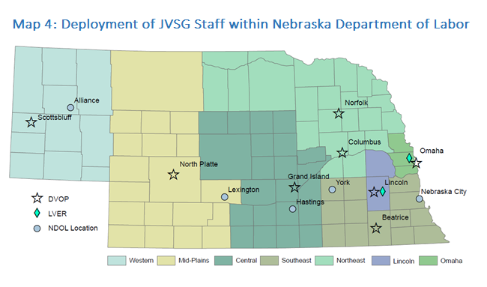

*Table 1: Deployment of JVSG Staff within Nebraska Department of Labor*

| Region | Program | Number of Staff | Number of Counties |
| --- | --- | --- | --- |
| Western | DVOP | 1.0 | 11 |
| Mid-Plains | DVOP | 0.5 | 19 |
| Central | DVOP | 1.0 | 22 |
| Southeast | DVOP | 1.0 | 13 |
| Northeast | DVOP | 2.0 | 23 |
| Lincoln | DVOP | 1.0 | 2 |
| Omaha | DVOP | 3.0 | 3 |
| Omaha | LVER | 1.0 | 3 (same as DVOP) |
| VSU | LVER | 1.5 | Statewide |
| Administration | LVER | 0.5 | Program Support |

In the Omaha area, three DVOPs provide services from the Omaha American Job Center (operated by Heartland Workforce Solutions, serving the same three counties). Two LVER staff will operate from the Virtual Service Unit and a LVER Supervisor will be located at the Omaha American Job Center location. The JVSG Program Coordinator will operate as a LVER from the NDOL administrative location in Lincoln.

NDOL will work to fill any DVOP or LVER vacancies as expeditiously as possible. When notified of a potential opening or staff intent to vacate a position, managers will seek approval or authorization from senior management to hire as soon as possible. This may include filling vacant positions with temporary or interim positions. Additionally, NDOL makes every attempt to satisfy the requirement in 38 U.S.C. 4102A(c)(8), stating that all newly assigned DVOP and LVER staff will receive training from the National Veterans’ Training Institute within 18 months of assignment. Nebraska will do this by scheduling mandated courses at the time the DVOP/LVER has successfully completed their initial three months.

### Incentive Award Program

The Incentive Award program implemented using the 1% grant allocation set aside for this purpose, as applicable;

The JVSG Program utilizes the monetary incentive awards program authorized under VPL 02-07 to recognize employees and offices that provide exceptional service to Veterans and eligible persons. Per guidance, 1% of the JVSG funding may be used for Veterans Performance Incentive Awards.

The objective of the program is to encourage our staff to be more attuned to the needs of our veterans and to motivate them to provide outstanding service. A second and equally important objective is to ensure there is improvement to the overall system of providing services to veterans.

There will be a total of 5 annual awards; 4 individual awards and 1 office award. Entries are not restricted to JVSG staff.

Awards will occur annually on the following timeline:

* June 30th – Submission deadline (We Reserve right to adjust deadline based on NASWA Veterans Conference Dates)
* July 15th – Announcement of recipients
* August 10th – All allocated funds via Purchase Request submitted to NDOL Procurement
* September 30th* - Obligated (encumbered) via Procurement
* December 31st*- Funds expended

* Any funds not obligated by 9/30 or expended by 12/31 will be forfeited.

The Veteran Program Coordinator, Employment & Training Administrator, and the Director of the Office of Employment & Training will function as the selection committee for these awards.

**Submissions**

Submissions for an individual may include anything that showcases going above and beyond to serve veterans. Awards to offices should be reserved for instances where most, if not all, office staff contribute to providing or improving employment and training services to veterans. Each individual office may submit one office application. Activities must have taken place during the current program year, which runs July 1– June 30. Examples include, but are not limited to:

* Exemplary success story showcasing substantial assistance with overcoming SBE(s) leading to successful job placement or development
* Developing and sharing a best practice that has greatly benefited veterans, possibly on the TA call
* Standing up a new program or initiative that promotes employment or training opportunities for Veterans
* Really anything that substantially moves the needle in a positive way enabling a veteran or veterans to achieve meaningful employment

**Individual Awards**

Four individual awardees will receive paid admission to the annual NASWA Veterans Conference including, including normal state travel expenses.

* If an individual is unavailable to attend the conference, they may receive an award that is approved by the state, is of personal benefit to the recipient, and ultimately of benefit to the veterans they serve. Staff would still receive, if conferred, any individual monetary award.

**Office Award**

One office will receive a minimum of $1,000 to be used as they see fit, within the guidelines of VPL 2-7, to better enable the office to serve veterans.

### Populations of Veterans to be served

The populations of Veterans to be served, including any additional populations designated by the Secretary as eligible for services, and any additional populations specifically targeted by the State Workforce Agency for services from one-stop delivery system partners (e.g., Native American Veterans; Veterans in remote rural counties or parishes);

In accordance with Veteran Program Letter (VPL) 03-14 Change 2, VPL 04-14, and VPL 08-14 Nebraska is placing emphasis on service to Veterans in need of basic and individualized career services. In order to easily identify Veterans most in need, all American Job Centers (AJCs) & NDOL offices will conduct “first point of contact” initial assessments. Veterans are afforded the opportunity to voluntarily disclose information that allows AJC & NDOL staff to determine if there is a need for individualized career services. If there is a need, the Veteran is referred to a DVOP to deliver individualized career services per the guidelines established in Veterans Program Letter (VPL) 07-10, VPL 03-14 Change 2, VPL 04-14, VPL 08-14, and VPL 03-14 change 1. DVOP staff will serve those with Significant Barriers to Employment (SBE) as defined by VPL 03-13 and target populations as defined by VPL 04-14 and VPL 08-14 listed below:

* A special disabled or disabled Veteran, as those terms are defined in 38 U.S.C § 4211(1) and (3); Special disabled and disabled Veterans are those:
  + who are entitled to compensation (or who but for the receipt of military retired pay would be entitled to compensation) under laws administered by the Secretary of Veterans’ Affairs; or,
  + were discharged or released from active duty because of a service-connected disability;
* Homeless, as defined in Section 103(a) of the Stewart B. McKinney Homeless Assistance Act (42 U.S.C. 11302(a));
* A recently-separated service member, as defined in 38 U.S.C § 4211(6), who at any point in the previous 12 months has been unemployed for 27 or more weeks;
* TSMs identified as in need of intensive services who:
  + does not meet career readiness standards receiving a "warm handover" from commander or as documented on form DD-2958; or
  + who was released from active duty because of a service-connected disability;
* An offender, as defined by WIOA Sec. 3 (38)1, who is currently incarcerated or who has been released from incarceration;
* Lacking a high school diploma or equivalent certificate; or
* Low-income (as defined by WIOA at Sec. 3(36)).
* Veterans and Transitioning Service Members between the ages of 18-24;
* Members of the armed forces who are wounded, ill, or injured and receiving treatment in a Military Treatment Facility (MTF) or Warrior Transition Unit (WTU); or,
* The spouse or other family caregivers of such wounded, ill, or injured members

In addition to Veterans assessed at “first point of contact,” DVOPs routinely receive referrals from other agencies working with Veterans with disabilities such as State Vocational Rehabilitation (VR), VA Vocational Rehabilitation (VR&E), and Nebraska’s Vets Centers. For Veterans not identified at “first point of contact,” Wagner-Peyser staff will search NEworks, Nebraska’s management information system, for new Veteran registrations and refer Veterans to the DVOPs as appropriate.

Nebraska hosts three AJCs. These are located in Grand Island, Lincoln, and Omaha. The NDOL operates the AJC in Grand Island, but does not operate the AJCs in Omaha and Lincoln; instead NDOL acts as a partner to offer DVOP services. The encouraged referral process between partner program and DVOP staff is:

The documented referral process between partner program and DVOP staff is:

#### Wagner-Peyser and DVOP Referral Process

1. Jobseekers are identified by either directly contacting an NDOL Location (walk-in, phone, email) or via data mining of NEworks (State’s labor exchange system).
2. Veteran or Eligible Spouse status is determined.
   1. No, not a Veteran or Eligible Spouse, then serve as Wagner-Peyser
   2. Yes a Veteran or Eligible Spouse, then determine if have Significant Barrier to Employment (SBE) or Target Population
      1. No, does not have SBE/Target Population, then serve as Wagner-Peyser with Priority of Service
      2. Yes, does have SBE/Target Population, then staff referral to DVOP services

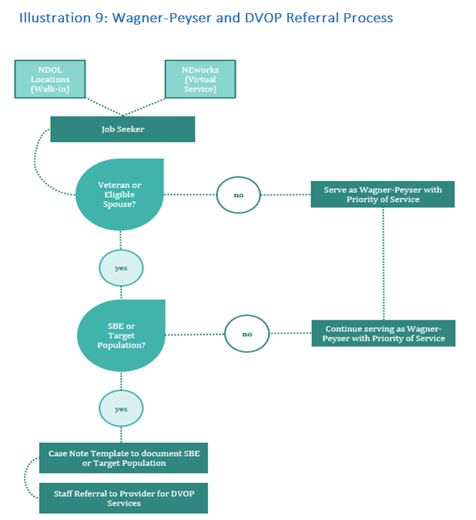

#### Omaha and Lincoln American Job Center Referral Process for DVOP Services

1. Jobseekers are identified by directly contacting an AJC (walk-in, phone, email).
2. Veteran or Eligible Spouse status is determined via screening devices by Omaha and Lincoln American Job Center staff.
3. No, not a Veteran or Eligible Spouse, then referred to AJC Appropriate Partner.
4. Yes a Veteran or Eligible Spouse, then determine if have Significant Barrier to Employment (SBE) or Target Population:
   * 1. No, does not have SBE/Target Population, then referred to AJC Appropriate Partner.
     2. Yes, does have SBE/Target Population, then referral to DVOP services.
5. DVOP makes referral in NEworks to Partner Programs if necessary
6. Veterans overcome barriers to employment.
7. DVOP works with LVER or Wagner-Peyser staff to find employment for Veterans
8. DVOP work with Veteran to provide individualized career services if still necessary.

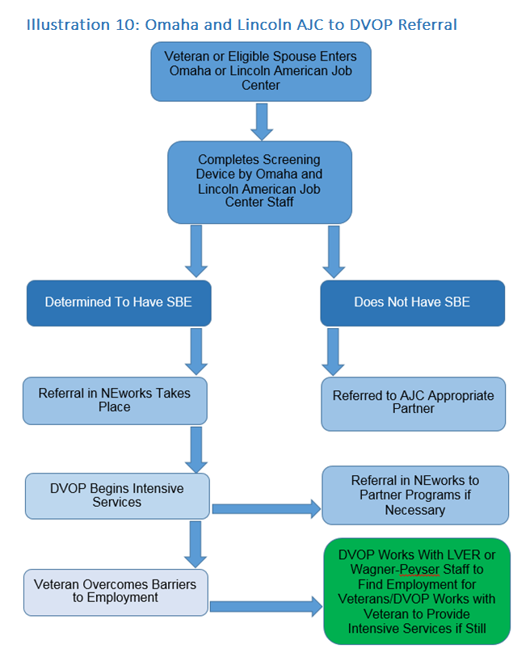

DVOPs in Nebraska deliver basic and individualized career services to Veterans with Significant Barriers to Employment (SBE) and qualified spouses. These services include but are not limited to: resume preparation, education on proper work/interview attire, education on interviewing skills, job search assistance, job coaching, assistance finding housing, and referrals to supportive services offered by other Federal, State, and non-profit organizations.

NEworks provides self-service options to resources and website links that Veterans and eligible spouses can access from their residence or any accessible public computer. NEworks provides Veterans access to a vast range of job opportunities from corporate job posting boards and external job search engine websites that are imported into NEworks on a daily basis.

As prescribed by the VR&E counselor, Chapter 31 Veterans may receive a wide range of services to include: labor market information, assessment, career guidance, and counseling. DVOPs provide case management services as needed, especially for those in need of placement services or other services to become “job ready”. Case management services include the development of an Individual Employment Plan (IEP), in-depth assessments, and regularly scheduled communication or follow-up until the Veteran no longer requires DVOP services or the VR&E counselor closes the Veteran’s file.

### Priority of Service to Covered Persons

How the State implements and monitors the administration of priority of service to covered persons;

Priority of Service (POS) to Veterans has been incorporated into all local WIOA plans and a specific Veterans Priority Provisions policy has been developed for all AJCs and NDOL locations. . Priority of service means that a Veteran or an eligible spouse either receives access to a service earlier in time than a non-covered person, or if the resource is limited, the Veteran or eligible spouse receives access to the service instead of or before the non-covered person.

When accessing a NDOL location, Veterans and eligible spouses are made aware of their right to priority of service through well-advertised and conspicuous signage. Identification of such Veterans or covered persons will be made by “first point of contact” initial assessment as well as referrals from other partner or program staff. NDOL will maintain POS signage promoting priority of service in all NDOL locations. NDOL will also maintain updated Veteran focused brochures or pamphlets outlining POS and other employment and training services available for Veterans through the NDOL locations.

Veterans and eligible spouses referred to other DOL programs will receive priority over non-Veterans in terms of eligibility determination and enrollment. For workforce programs that operate or deliver services to the public as a whole without targeting specific groups, Veterans and eligible spouses will receive priority of service over all other program participants. For example, the primary universal access services are the basic career services delivered through the AJC system under the Wagner-Peyser, WIOA, and all other NDOL E&T programs. Veteran populations targeted for special consideration in accordance with VPL 03-14 as well as Chapter 31 Veterans will receive priority for DVOP individualized career services.

Priority of service is further supported through the state labor exchange system, NEworks, which automatically matches qualified applicants to available jobs. When a job search is run against any job opening, a list of qualified jobseekers is created. All eligible Veterans are placed at the top of the list and will be notified of job openings before non-Veterans. NDOL staff are responsible for reviewing job orders for qualified eligible Veterans and making referrals.

Priority of Service will be monitored through existing report mechanisms such as quarterly and federal reporting and NEworks reports. These reports provide information at a state, regional, or local perspective through which the percentage or ratio of service delivery of Veterans to non-Veterans may be compared. NDOL administrative and managerial staff will be responsible for conducting and tracking the monitoring efforts. As with the quarterly reports submitted to the DVET, the Veterans Program Coordinator will also conduct monthly monitoring of the service delivery systems through case file reviews. These enhanced monitoring efforts will ensure ALL NDOL programs are within federal regulations, as well as promote continuous quality assurance.

### Provision and Measurement of Services

How the State provides or intends to provide and measure, through both the DVOP and one-stop delivery system partner staff:

#### *Job and job training individualized career services,*

The State will provide Job and Job Training individualized career services by providing 1-on-1 services to Veterans with SBEs and other eligible persons. These 1-on-1 services will center on formal and informal assessments to determine the skills, strengths and barriers faced by the participant.

An Individual Employment Plan (IEP) will outline the identified barriers and plan to overcome these barriers to gain sustainable employment. The IEP will be developed in coordination with the participant to ensure greater success through their agreement and “buy-in” of the plan. Additional services will be provided based on the needs of the individual. Referrals to service provider is a key aspect of ensuring a participant receives individualized services. Program staff will follow up with service provider referrals to determine the success and benefit to the customer of such referrals.

Coordination with partner programs that have Job Training funds is key to the successful upskilling of Veterans. Co-enrollment and leveraging of resources will allow Veterans to receive the greatest amount of services. Communication between partners will occur on a formal and informal basis to allow continual support of Veterans through job training programs. Release of Information documentation will be collected when necessary, in order to allow this communication to occur between the programs and not require the Veteran to repeatedly provide the same information multiple times to partnering programs.

#### *Employment placement services, and*

Employment placement services will be leveraged through the Wagner-Peyser program, including the NEworks website and Employment Service staff. Veterans will be shown the benefits of job search, posting a resume, setting up a Virtual Recruiter, and other self-service options within NEworks to maximize the opportunities for employment.

In addition to self-service options, participants will receive the benefits of Employment Service staff. Employment Service staff will provide Veterans with priority of service when they make job referrals for job postings within NEworks.

LVER and DVOP staff will coordinate with Employment Services (business services and jobseeker services) staff to promote qualified Veterans as part of the hiring pool in Nebraska. New served Veterans will have the opportunity to leverage their recently obtained employment skills to work for employers in their community.

NDOL staff also conduct outreach to Federal Contractors to offer assistance with meeting the requirements of Office of Federal Contract Compliance Programs (OFCCP). This assistance includes recruitment and referral of qualified Veterans for their job openings, as well as promoting job development opportunities with employers.

#### *Job-driven training and subsequent placement service program for eligible Veterans and eligible persons;*

Job-driven training and placement services are coordinated with job training providers and other service and training providers in each region. Veterans are provided Labor Market Information (LMI) from a variety of sources, in including: the NEworks website; Career One-Stop resource; H3 website (h3.ne.gov) which provides information on High Wage, High Skill, High Demand jobs at a local, regional and statewide level in Nebraska. This LMI provides insight on the current and growing opportunities available to Veterans and other jobseekers. Veterans are counseled with this information to determine in-demand opportunities and job-driven trainings that may assist them in achieving these employment goals.

Veterans are referred to one-stop partners with job training funds to assist the Veterans in receiving the job-driven training. Veterans are also referred to other financial assistance providers, such as Financial Aid Offices, the GI Bill, EducationQuest Foundation (a non-profit organization with a mission to improve access to higher education in Nebraska), as well as other local resources.

Placement services are leveraged between DVOPs and the partnering programs, such as WIOA, Wagner-Peyser, Vocational Rehabilitation, etc. The program staff that have served the Veteran or other eligible person, communicate with each other to maximize placement services to achieve the greatest possible outcome of sustainable employment.

The items above are measured through:

* + 1. Federal reporting of the Veterans Entered Employment Rate (EER)
    2. Referrals to Service Provider through the NEworks system
    3. File reviews for quality of services provided and IEPs developed

This information can be quantified and assessed for quality programing. Areas for improvement will be identified and staff training for program improvement will conducted.

### Hire Dates and Mandatory Training Completion Dates

The hire date along with mandatory training completion dates for all DVOP specialists and LVER staff; and

Staff hire dates and mandatory training completion dates for NDOL’s DVOP staff are listed below:

* Dave Alder, hire date 12/16/2013, mandatory training completion date 6/3/2014
* Arthur Davis, hire date 8/12/1996, mandatory training completion date 8/30/2011
* Sandy Grigg, hire date 3/3/1997, mandatory training completion date 3/6/2001
* Joshua Hanson, hire date 8/22/2016, mandatory training completion date n/a
* Dave Rangeloff, hire date 8/1/1996, mandatory training completion date 5/1/2001
* Nina Rogers, hire date 12/26/2009, mandatory training completion date 11/22/2014
* Andrew Strasburg, hire date 10/3/2016, mandatory training completion date 9/15/2017
* Alan Trook, hire date 1/12/2015, mandatory training completion date 7/31/2015
* Joshua Whited, hire date: 8/11/2014, mandatory training completion date 6/5/2015
* Riley Wilson, hire date: 10/2/2017, mandatory training completion date n/a

Staff hire dates and mandatory training completion dates for NDOL’s LVER staff are listed below:

* Roxana Aviles, hire date: 7/10/2017, mandatory training completion n/a
* Terry Eklund, hire date: 11/3/2014, mandatory training completion 12/4/2015

*Note: State of Nebraska hire date may not align with start date as DVOP or LVER.

Additional NVTI training is made available to DVOP and LVER staff as schedules allow. NVTI Training is prioritized for new hires in order to be compliant with training mandates.

### Additional Information

Such additional information as the Secretary may require.

Not applicable.

## Unemployment Insurance (UI)

The Unemployment Insurance (UI) program requires a State Quality Service Plan (SQSP) on a 2-year planning cycle that is a condition of receipt of administrative funding to administer the program. The SQSP is the State’s UI performance management and planning process that allows for an exchange of information between Federal and State partners to enhance the UI program’s ability to reflect their joint commitment to performance excellence and client-centered services. A formal two-year SQSP is submitted biennially. On the off years, States may be required to modify the SQSP with additional corrective action plans and narrative if they are failing any new performance measures, and they are required to provide updated budget documents, certifications, and assurances. ETA Handbook No. 336, 18th Edition provides detailed guidance for the preparation and submittal of the SQSP and supplemental guidance is provided in an annual UIPL, issued as UIPL 21-14 for the FY 2015 SQSP. The Social Security Act (SSA) sections 302 and 303 authorize the Secretary of Labor to provide funds to administer the UI program and govern the expenditure of those funds. States that choose the option to include UI in a WIOA Combined State Plan will be required to submit their SQSP through the Combined State Plan process. The SQSP must be prepared in accordance to the instructions in ET Handbook 336, 18th Edition and there are no changes to the established SQSP cycle if a State chose to submit their SQSP through the Combined State Plan process.

### Contents of a complete UI SQSP package

A complete UI SQSP package includes the following documents, as described in Chapter 1, ETA Handbook 336, 18th Edition:

#### *Transmittal Letter*

A cover letter to the appropriate Regional Office (RO) transmitting all the required SQSP documents.

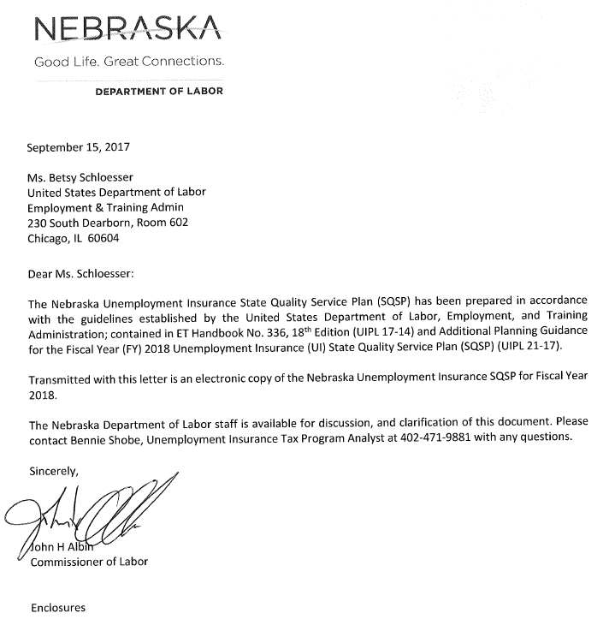

#### *Budget Worksheets/Forms*

Budget worksheets/forms and plan for program administration based on projected allocations received from the Federal partner. These forms include Worksheet UI-1 and SF 424, SF 424A and SF 424B. The SF 424A is only required if the State vary the quarterly distribution of base claims activity staff years.

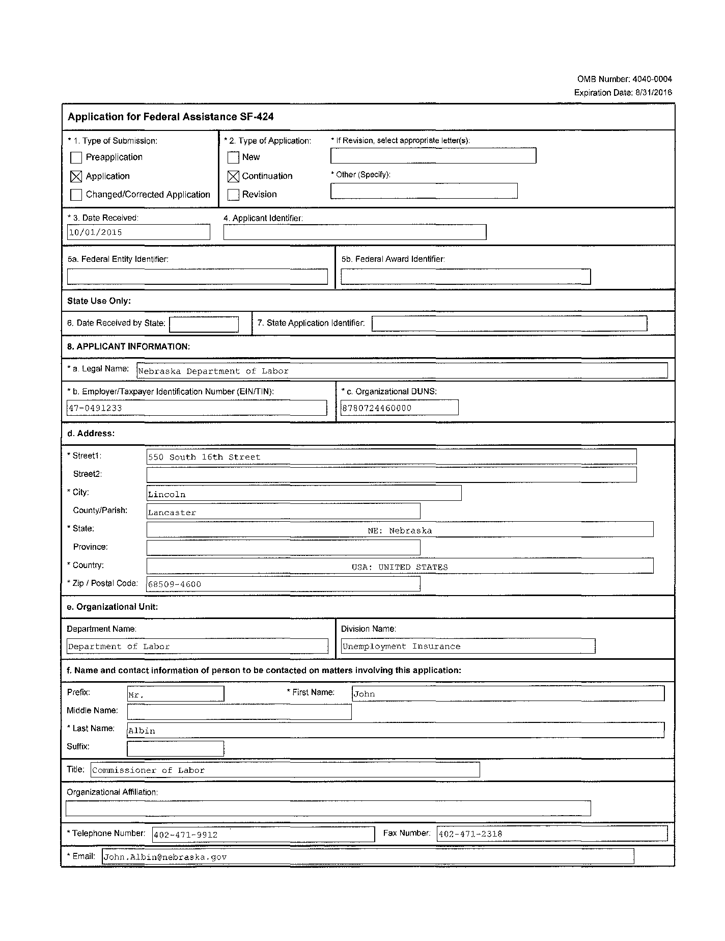



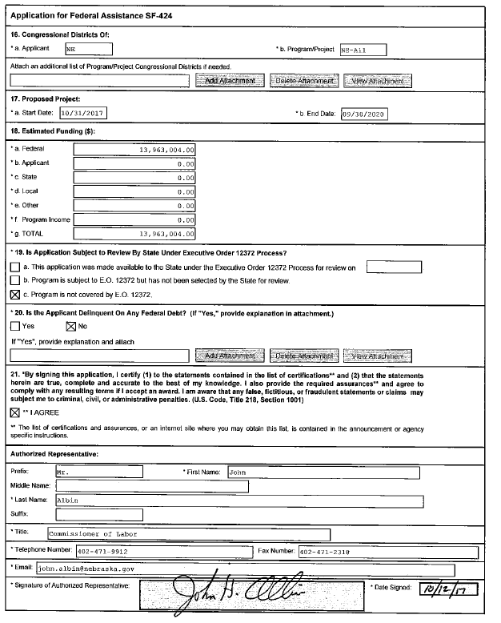

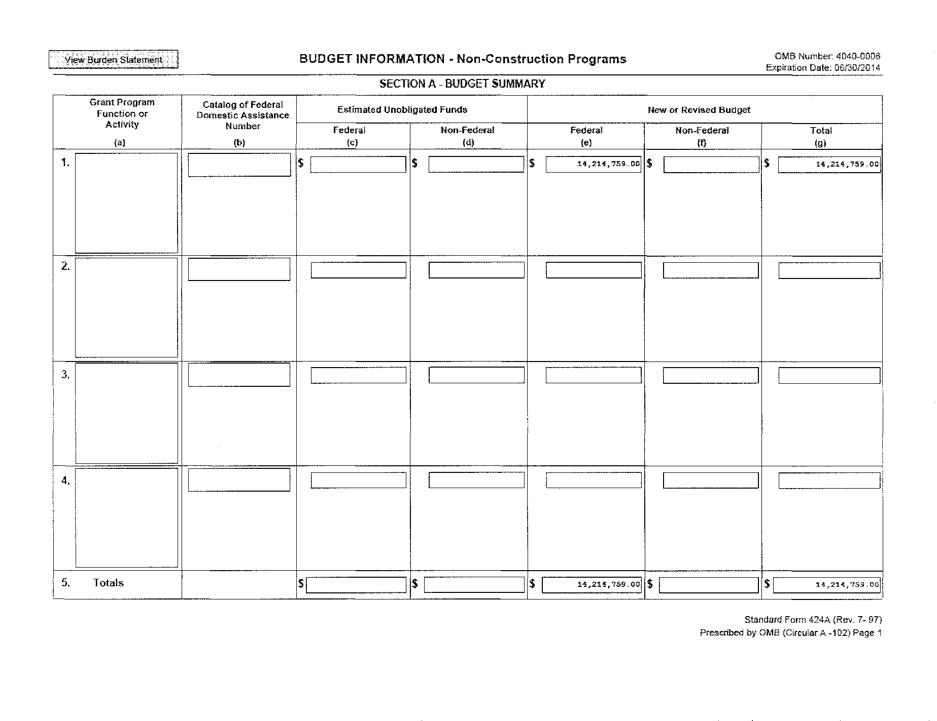

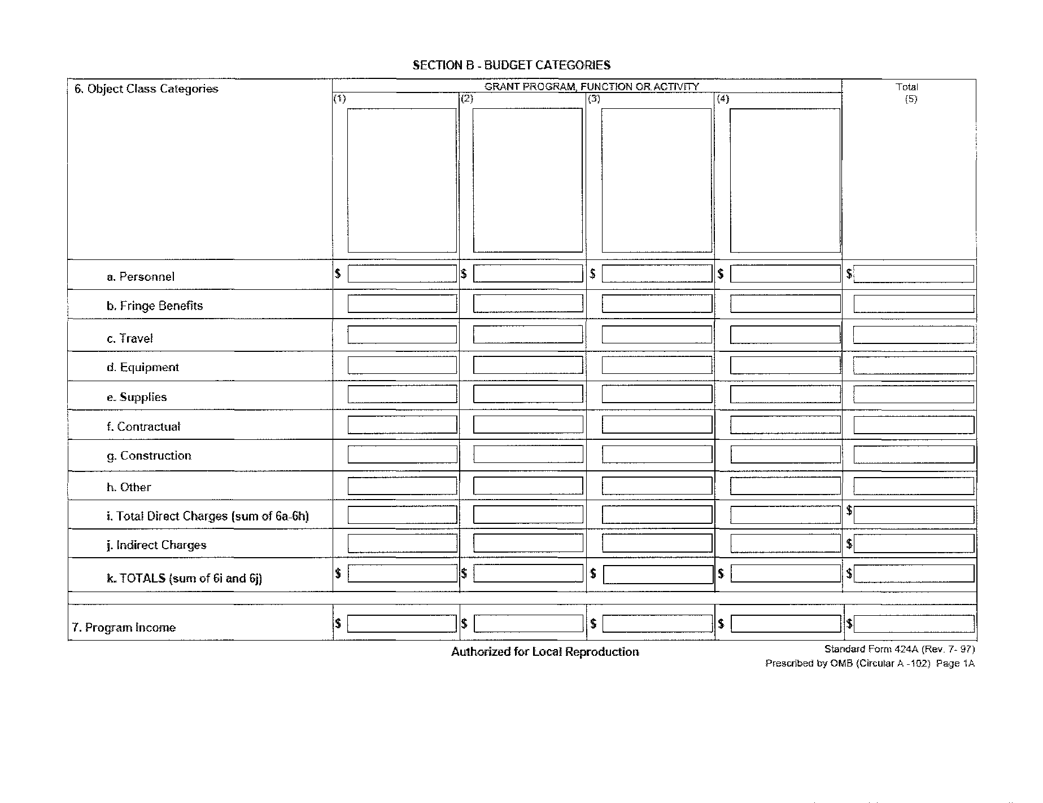

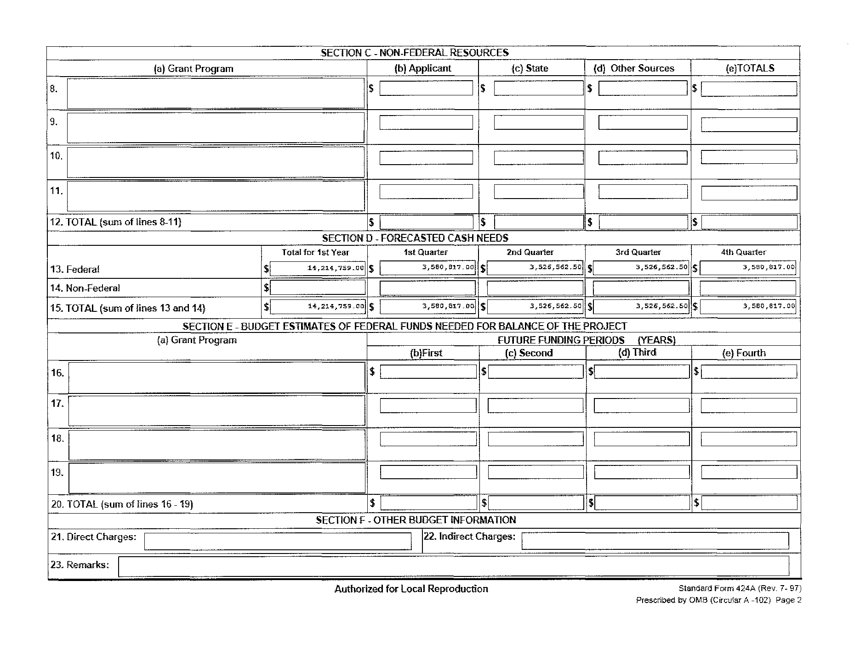

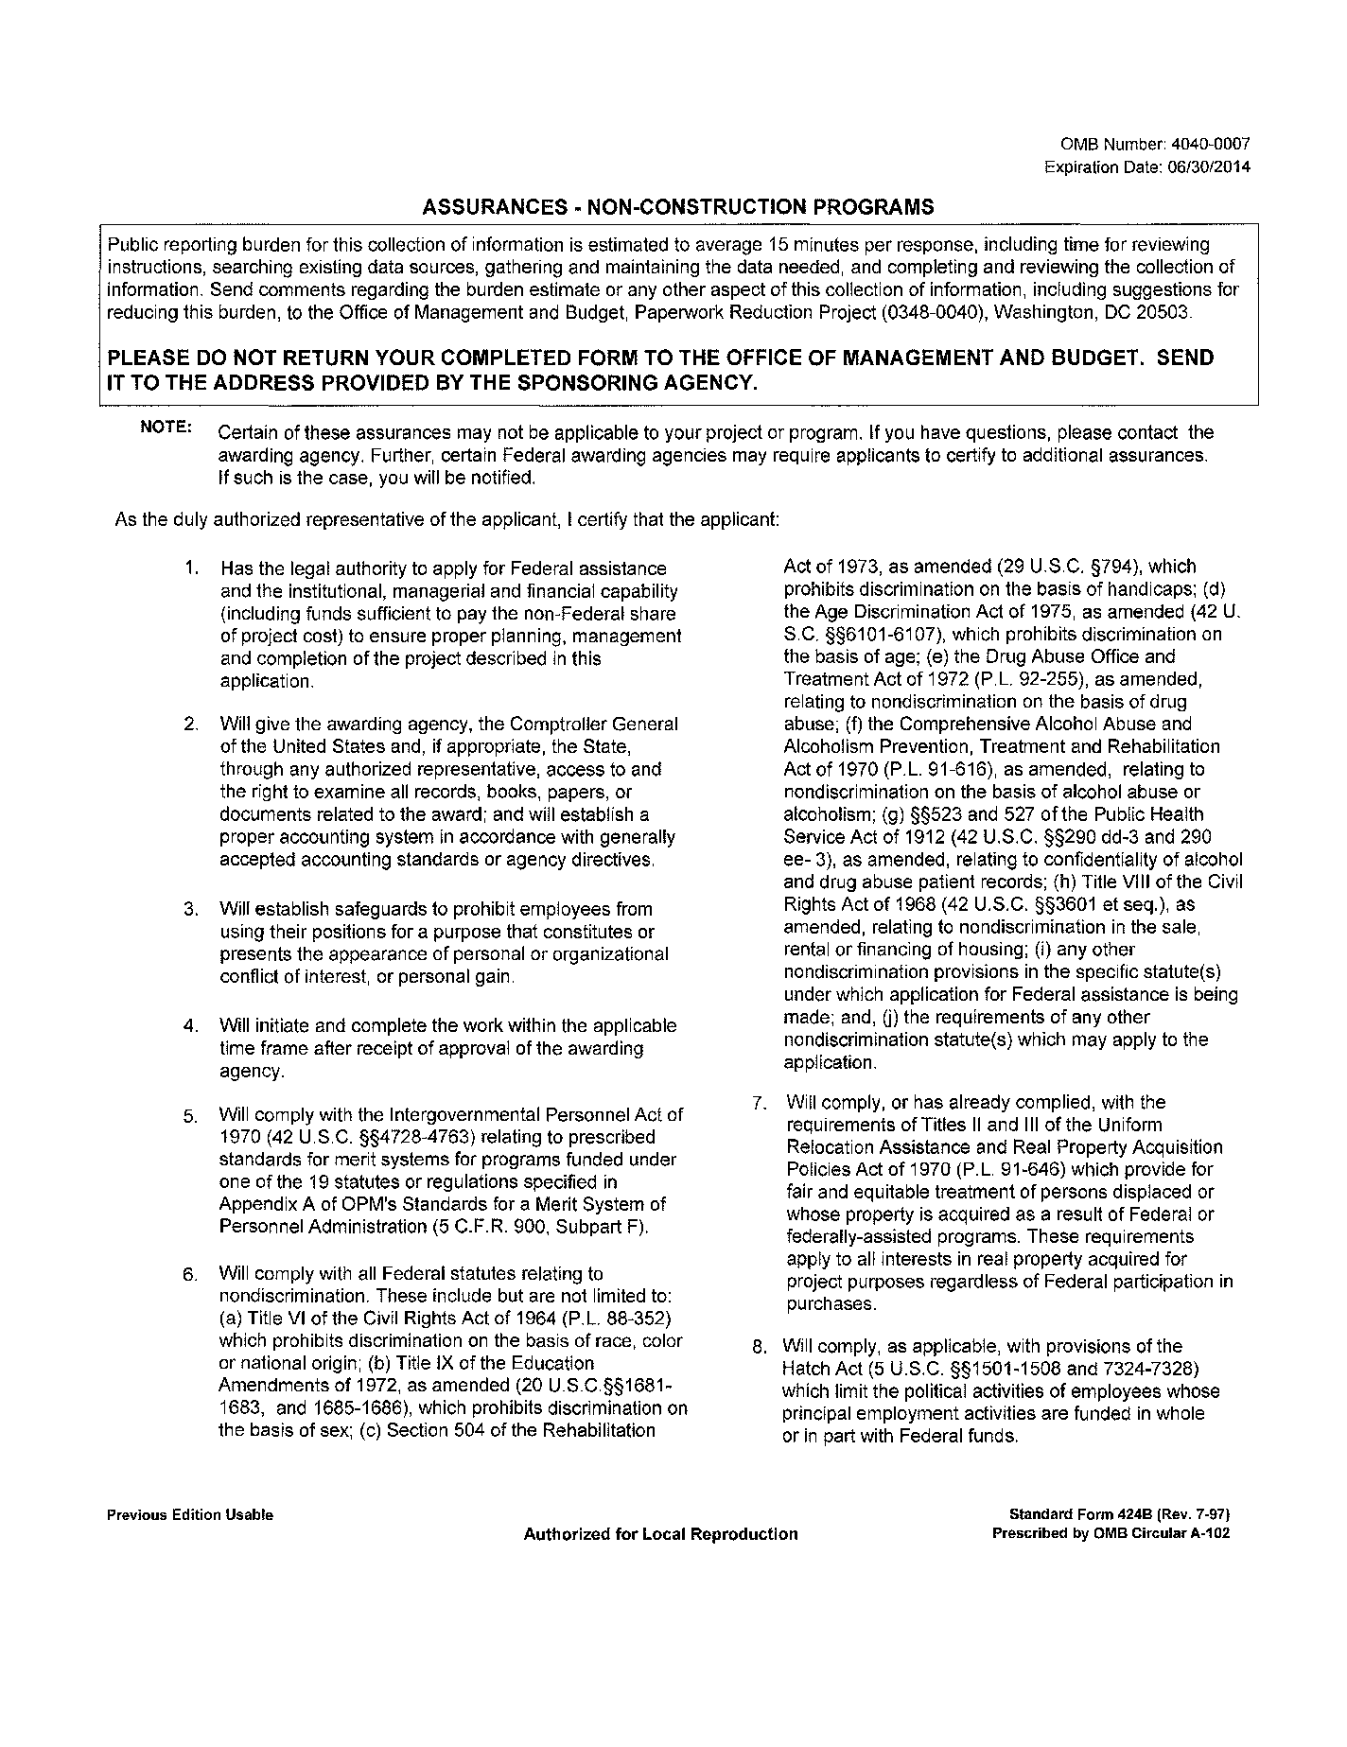

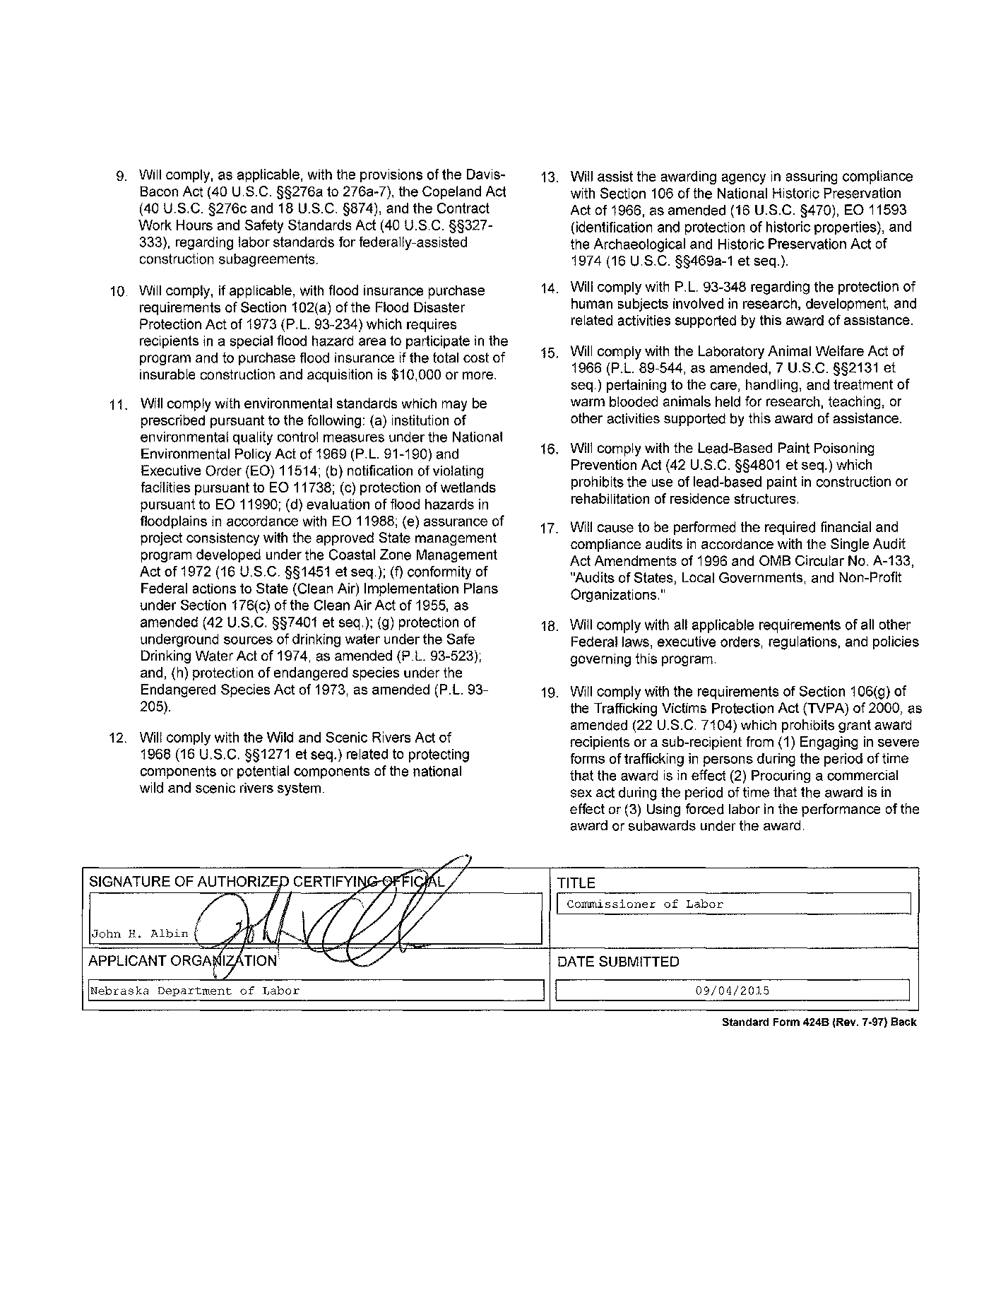

#### *The State Plan Narrative*

The State Plan Narrative is a vital element of the SQSP that provides a vehicle for sharing with the Federal partner State-specific efforts that affect the administration of the UI Program. The State Plan Narrative allows the State to describe in a single narrative: a) State performance in comparison to the Government Performance Review Act goals; b) actions planned to correct deficiencies regarding UI programs, UI program reviews and reporting requirements; and c) results of customer satisfaction surveys (optional).

##### A – Overview

In FY 2017 the UI Program experienced continued decreases in benefit payment workloads from prior years. Nebraska has made processing benefit claims accurately and timely a priority along with a continued focus on improvement in all performance measures. Over the next two fiscal years, UI Modernization will offer automated improvements to many of the UI Program functions. Modernization will also afford opportunities for additional training all UI Benefit staff.

The UI Tax system continued development of the Tax Management System (TMS) and UIConnect to implement the Treasury Offset Program (TOP) and State Income Tax Intercept (SITI). Implementation of TOP for Tax was successfully completed in early 2016. The SITI program became active in the spring of 2017. Along with TOP and SITI, UI Tax staff completed the development of the business and technical requirements for a Short Time Compensation (STC) program—workshare—in Nebraska. That program was implemented in October of 2016.

In recent years, Nebraska has focused UI Program integrity efforts on decreasing improper payments resulting from Employment Services Registration, Work Search Issues, and Separations. Nebraska requires claimants to use a Single Sign-On solution integrating the Agency’s Employment and Training (E&T) and UI computer systems. All workers filing an unemployment claim are required to register with Employment and Training prior to filing an initial claim, virtually eliminating Employment Services registration errors. The registration requirement lead to a marked decline, improper payments attributable to registration.

While these numbers indicate some progress has been made toward restoring the public trust in UI, Nebraska recognizes there is still more work to be done. Preliminary BAM statistics indicate Nebraska has experienced an increase in Benefit Year Earnings (BYE) improper payments. A Corrective Action Plan (CAP) is included in this SQSP for BYE and the measure is addressed as well in the Integrity Action Plan. Nebraska expects to see a decrease in the rate of improper payments as new IT functionality and procedural controls are implemented in FY 2018.

UIConnect, Nebraska’s employer portal, allows employers to register for a UI Account, file and pay UI Combined Tax and Wage reports, file UI Benefits separations, Appeals and Benefit Payment Audits. A majority of Nebraska employers file UI Combined Tax Reports electronically using UIConnect or Bulk filing, or by paper. For the second quarter 2017, 52,167 combined tax reports (88%) were filed electronically of which 30,519 (58%) were filed via UIConnect. Approximately 93% of payments were received electronically and 98.29% of wage items.

Nebraska recognizes the importance of maintaining a solvent trust fund. An array system has been used since CY 2006 to determine employer combined tax rates. The trust fund balance dropped below the solvency range for the CY 2010. The trust fund balance returned to solvent range for CY 2012 and above the solvency range for CY 2013 through present. This has allowed the expected yield to repeatedly fall below prior year benefit payments. Nebraska maintains one of the highest solvency rates in the nation, posting an AHCM of 1.76 in 2017.

##### B – Federal Emphasis and GPRA Performance Goals

###### *Improving State Capacity to Administer and Operate the UI Program Effectively*

During FY 2017 Nebraska experienced a reduction in workload levels consistent with a TUR stabilized around 3% and an IUR under 1%. This has given the state an opportunity to update system processes and technologies that were delayed during previous years. In preparation for the increased workloads resulting from anticipated economic downturns in the future, the UI Benefits program has renewed focus on leveraging technology in expanding public access to the program.

Nebraska maintains an online initial claim filing rate of 76.4% and online weekly claim rate of 93.1%. While alternative accessibility options have always been available to UI claimants, Nebraska continues to explore and implement new strategies strengthening public access to benefits, including revamped web materials. Planned FY 2017 technological revisions to the Nebraska Claims Center IVR will allow increased information accessibility 24/7. The web portal, UI Connect, designed for the filing of tax reports and the payment therein continues to increase in employer usage. The UI programs are able to alert employers of any program changes immediately by use of the message board on UI Connect. This has become a fast, efficient way of connecting with the employer community as soon as they log on to the system. The portal continues to grow and develop enhancements that allow employers more access to actual employer data such as benefit charges, ability to appeal determinations, report fraud, and contact local resources for further clarification.

Increased staff turnover over the past few years has emphasized the importance of strengthening training efforts. Nebraska recognizes the importance of maintaining and nurturing a knowledgeable UI staff as senior staff begin to retire. A renewed emphasis on training began in FY 2016 with the full implementation of REX in November, 2015, regulatory reform, and other technology solutions.

###### *Improving Prevention, Detection, and Recovery of UI Improper Payments*

Nebraska continues to review and revise procedures and technology solutions to improve UI Improper Payments prevention, detection, and recovery. With the successful deployment of the Benefits Investigation Tracking System (BITS) and implementation of a predictive analytics tool, Nebraska has laid the technological groundwork to focus on prevention. Efforts in FY 2017 will expand the scope of these tools to enhance the prevention of overpayments, particularly in the area of identity theft. Details of these efforts are included in the Integrity Action Plan. Detection improvements will be primarily focused on increasing staff awareness, focusing on techniques for identifying potential overpayments with increased cross-matching, online training tools, and auditing. The Treasury Offset Program (TOP) and State Income Tax Intercept (SITI) proved valuable for the ongoing recovery of eligible debts. Procedurally, the Agency revised policies allowing State Income Tax Intercept efforts to broaden resulting in increased recovery. Additionally, Nebraska provides claimants an online payment portal providing an electronic payment method for claimants with overpayment collections due.

***Improving Program Performance Nationally***

The Department continued to invest in technology and staff, deploying several projects in an effort to meet performance standards. The Field Audit—total wages changed measure reached Acceptable Levels of Performance (ALP) during FY 2017. Program performance continues to be a priority in Nebraska in efforts to continue meeting performance targets.

###### *Addressing Worker Misclassification*

Meeting all the criteria of UIPL 30-10 continues to be a challenge for Nebraska. Utilizing the resources of the IRS 1099 Extract File and the NAICS Codes of problematic industries, Nebraska has been successful in locating misclassified workers. This process also provides the opportunity of educating the employer community regarding correct classification of workers.

The misclassified worker information is shared with the IRS through the QETP (Questionable Employment Tax Practices) program. Nebraska is one of twenty-nine states that shares information through this process. The misclassified information is also shared with other state enforcement agencies so that all phases of worker misclassification are addressed.

As a “small state” in terms of liable employers, 60,026, and the fact that 80 percent of the liable employers have less than ten workers, we are challenged to meet the second criteria of UIPL 30-10 which is the Percent of Total Wage Change from Audit. Nebraska has embraced the challenge to meet the second audit measure by aggressively following potential fraud complaints regarding employers and claimants raised by other agency departments and the web based fraud line. Nebraska will continue to use the 1099 Extract file in FY 2018 to identify Nebraska employers who have issued 1099’s but have no liable UI number. We are optimistic that the findings will be beneficial to the agency.

###### *GPRA Performance Goals*

Making Timely Benefit Payments: Target – 87%; Nebraska Performance – 92.6%

During FY 2015 and FY 2016 the GPRA performance has been met with Nebraska meeting the 87% target in fifteen of the last sixteen months through July, 2016. In recognition of this sustained performance, Nebraska was relieved of “Marginally At-Risk” status by USDOL in July, 2016. Nebraska continues to exceed first payment targets.

Detection of Overpayments: Target – 54.2%; Nebraska Performance 48.38%

Nebraska continues to focus on goals to meet this measure. In FY 2016, the BPCU rolled out a new Benefits Investigations Tracking System (BITS) for identity theft and fraud prevention and Benefits Audit Tracking System (BATS), integrating the Benefits Payment System with auditing functions. The new technology solution will also have increased cross-matching capabilities as the Agency brings in more data from external sources for analysis.

Establish Tax Accounts Promptly: Target – 70%; Nebraska Performance – 95.1%

Prompt status determinations continue to be a priority in Nebraska.

Facilitate the Reemployment of Claimants: Target – 74%; Nebraska Performance – 73.7%

Nebraska continues to be provided Reemployment Services through American Job Centers located across the state. During FY 2017 Nebraska reached an Acceptable Levels of Performance (ALP). Work continues to increase employment levels for claimants and reduce the number of benefit weeks experienced by offering jobseekers an individualized reemployment plan.

##### C - Program Review Deficiencies

Not applicable

##### D – Program Deficiencies

Not applicable

##### E – Reporting Deficiencies

Not applicable

##### F – Customer Service Surveys

Not applicable

##### G – Other

Not applicable

In accordance with ET Handbook 336, 18th Edition, Change 2, NDOL instituted plans or measures to comply with SQSP Assurance requirements, as follows:

##### Assurance H – Assurance of Contingency Planning

Background - Utilizing 2010 SBR funds, NDOL contracted with a CIP-certified IT consulting company to update and test the UI IT contingency plan according to the NIST SP 800-34 standard. The project was completed in November 2011, and the contingency plan was updated to document processes and procedures to recover and protect the UI data, assets and facilities in the event of a disaster. The 2010 SBR funds were also used to procure hardware and software for implementation of a UI IT disaster recovery (DR) cold site at the University of Nebraska Medical Center (UNMC) in Omaha, NE, situated 50 miles away from our primary data center. Implementation of the DR site was completed in September 2012, and the contingency plan was updated and tested to include the addition of the disaster recovery site. In 2012, NDOL contracted services for an Independent Verification & Validation (IV&V) of the UI IT contingency plan, which was completed December 1, 2012. The UI IT contingency plan is updated uniformly with changes in the UI IT environment, but at least annually so as to be in a ready state for use immediately upon notification.

NDOL conducted table top DR exercises on November 16, 2012 and put the structure in place to review, update, and test the UI IT Contingency Plan annually to ensure availability of critical assets and overall operational readiness for unexpected disruptions. NDOL had an unplanned test of the UI IT Contingency plan on April 23, 2013 due to a 2-hour power outage. The incident was fully documented and outcomes included action to be taken for improvement. On June 29, 2017, NDOL moved the UI IT DR site to DOTcomm, a collaboration between the City of Omaha and Douglas County, NE to serve the information technology needs of those entities. The robust government data center also serves as the DR site for the State of NE data center, including NDOL. NDOL procedures include Table Top DR, Functional and Full-Scale tests, which are scheduled in compliance with IRS Publication 1075 and NIST requirements, and strengthen the agency’s ability to recover in the event of an emergency or system disruption.

NDOL also conducts scheduled inspections of the state Data Center, off-site storage and disaster recovery site annually, in compliance with IRS Publication 1075 and NIST requirements to ensure security protocols are in place for the protection of information and information systems.

In January of 2017, NDOL IT began a consolidation of services with the Office of the Chief Information Officer (OCIO). These actions are designed to reduce duplication of service, reduce response time and increase efficiencies. Additionally, NDOL IT and OCIO are conducting a complete review of the agency’s IT systems including off-site storage and disaster recovery.

##### Assurance J - Assurance of Automated Information Systems Security

Background - Over the last nine (9) years, NDOL completed several initiatives that have been valuable to the security needs of the agency. The first initiative, Strategic Technical Architecture Roadmap, STAR – V2.0 provided a point-in-time assessment of the current level of technical maturity and recommendations on how to achieve a future state technical architecture. Other initiatives, iSecure 2004 and subsequent iSecure 2007 IT Security Risk Self-Assessment, used the security section of STAR as a springboard to perform the high level analysis and review of the security environment of the agency.

Utilizing 2010 SBR funds, NDOL contracted with an independent, CIP-certified firm to conduct an update of iSecure 2007. iSecure 2011 was completed on November 10, 2011, including documented policies and procedures, along with recommendations for addressing deficiencies and security management effectiveness. The iSecure Assessment is in accordance with the FIPS 200/NIST SP 800-53 and NIST SP 800-53A security guidelines.

In February 2012, NDOL hired an independent consultant to facilitate the process of conducting the NIST Self-Assessment and completing the System Security Plan (SSP). The self-assessment identified additional controls, policies and procedures to be addressed in NDOL’s Plan of Action and Milestones (POA&M) documentation. The SSP documents each control and responsible parties. This ongoing process documents all corrective actions identified during internal inspections and security assessments and assigns a risk category to each so the most critical are addressed immediately, with measured progress towards resolving all defined gaps or findings. NDOL uses security and risk assessments as a best practice to ensure that appropriate levels of controls exist, they are being managed, and they are compliant with all federal and state laws or statutes.

NDOL performs ongoing monitoring of all UI systems in accordance with documented policies and procedures from the iSecure 2011 update. All documentation is reviewed and updated at a minimum annually. Every three years, NDOL conducts a formal independent UI IT security risk assessment ensuring vulnerability management and policy compliance. Under UIPL 13-14, NDOL applied for SBR funds to complete iSecure 2014, the security risk assessment for 2014, aligning with our three-year requirement.

NDOL uses security tools. The Veracode tool identifies software vulnerabilities across UI systems. This tool helps to prevent threat posed by hackers who are targeting software vulnerabilities to gain access to critical data. NDOL conducted a series of scans on UI systems, which provide categorized analytics to improve performance. NDOL uses the outcomes to mitigate application risk at the code level. NDOL’s system security plan clearly defines procedures and timelines for conducting scans for risk management and audit compliance. The LogRhythm tool collects a complete set of data from the IT environment for processing and analysis of relevant information from multiple dimensions, allowing NDOL to perform real time threat management. Logs are reviewed continually to detect and respond to breaches and threats. Microsoft System Center Configuration Manager is used for remote control, patch management, software distribution, operating system deployment, network access protection, and hardware and software inventory capabilities.

NDOL’s security team meets monthly to review the POA&M and discuss security-related projects or activities. Changing technology requires conscientious and steady assessment of the System Security plan. In strict compliance with legislation, regulations and other applicable requirements, NDOL is committed to compliance with NIST SP 800-53 Recommended Security Controls for Federal Information Systems and Organizations.

NDOL’s security and risk assessment policy addresses purpose, scope, roles, responsibilities, management commitment, coordination among agency entities, and compliance; and procedures to facilitate the implementation of the risk assessment policy and associated risk assessment controls. The policy is reviewed and updated every three years; procedures at least annually.

The Agency Security Officer and infrastructure staff who support IT security have utilized SBR or program funds to further train staff in NIST security and privacy controls for the protection of information and information systems.

In January of 2017, NDOL IT began a consolidation of services with the Office of the Chief Information Officer (OCIO). These actions are designed to reduce duplication of service, reduce response time and increase efficiencies. Additionally, NDOL IT and OCIO are conducting a complete review of the agency’s IT Contingency Plan, System Security Plan and conducting a system wide Risk Assessment.

#### *Corrective Action Plans (CAPs)*

Corrective Action Plans (CAPs): CAPs are expected as a part of the SQSP when State’s annual performance does not meet the established criteria for core measures, Secretary’s Standards, UI program, assurances, and other program deficiencies identified in the annual SQSP guidance provided by the Department. The CAP must list both specific milestones for key corrective actions or improvement activities, and the completion date for each milestone.

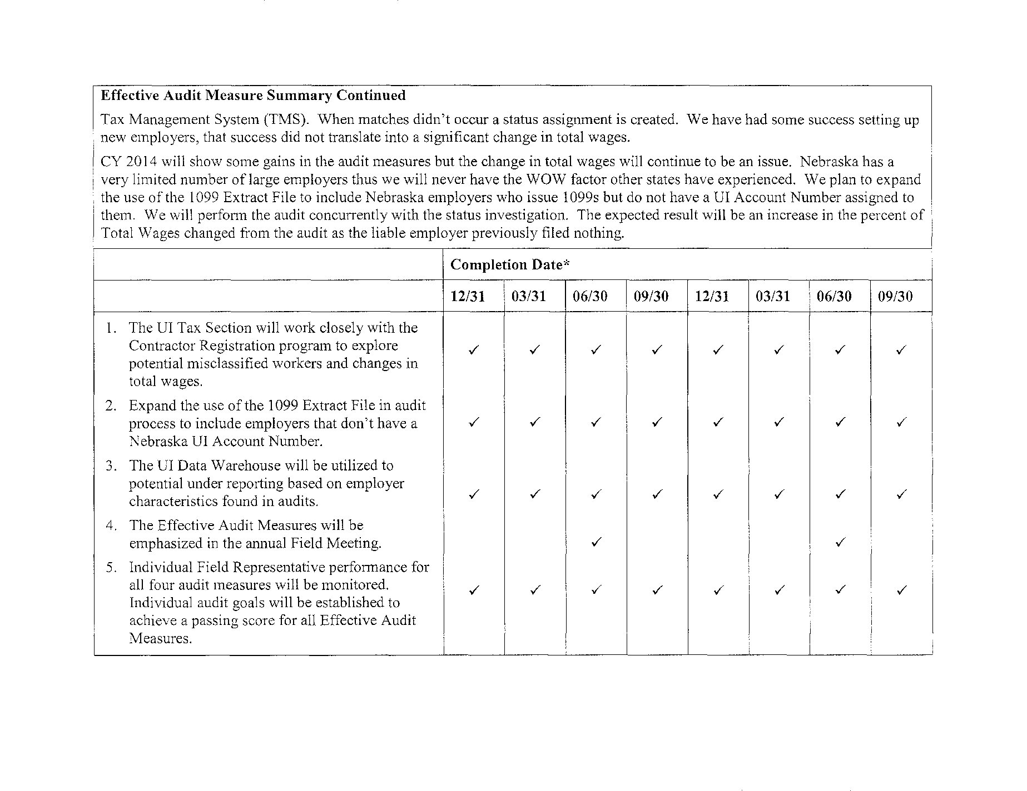

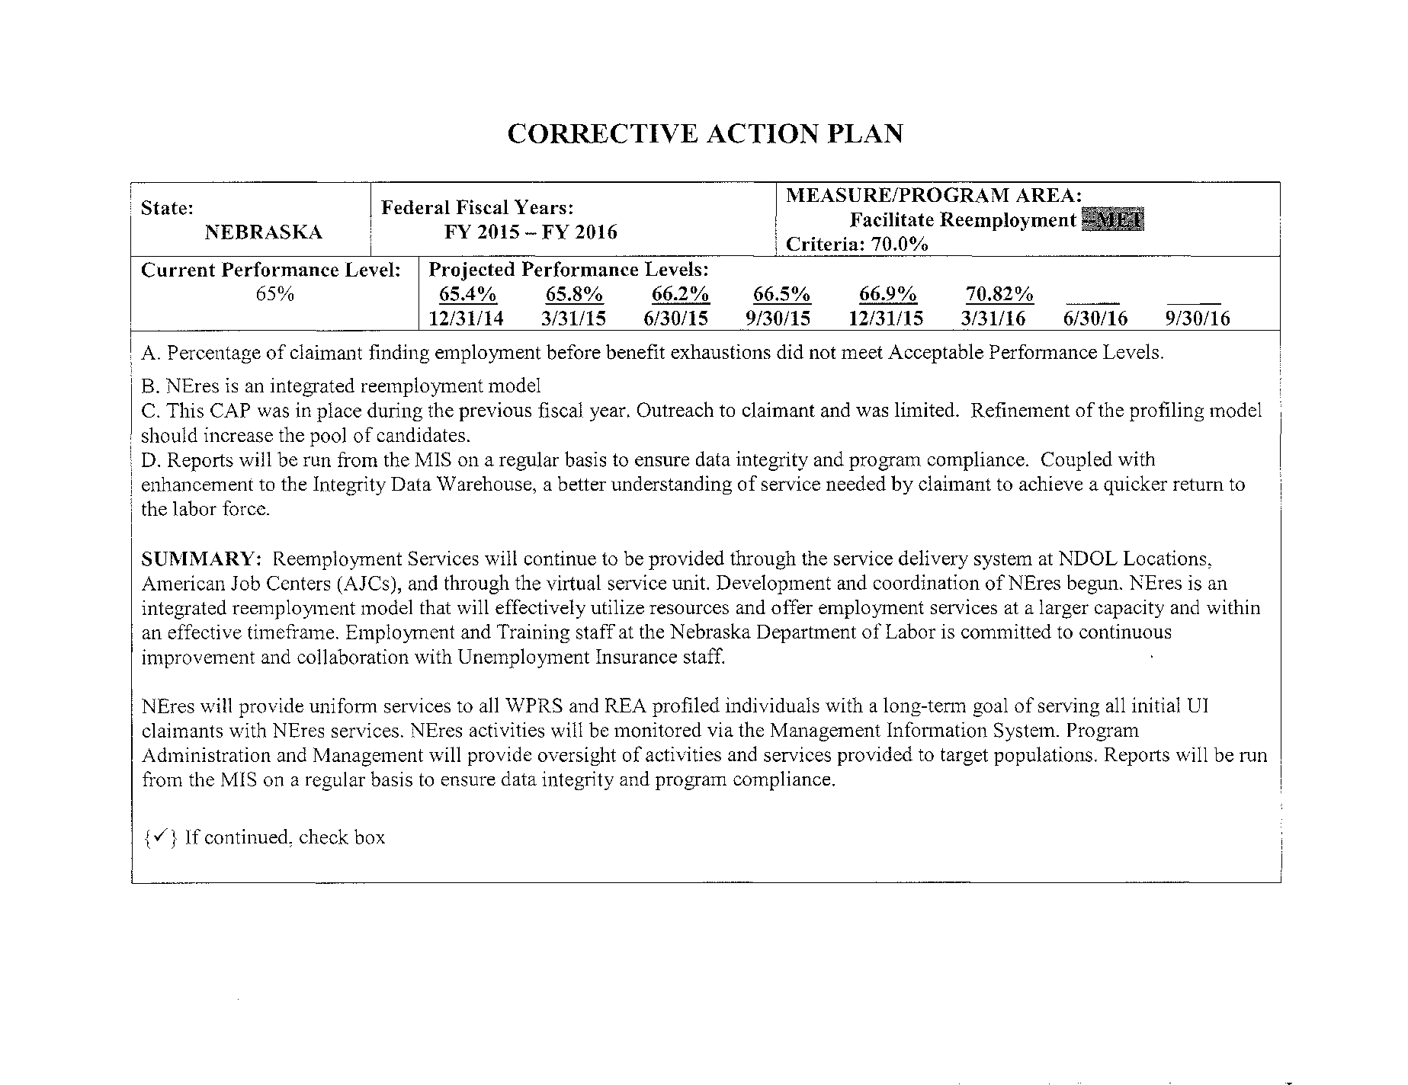

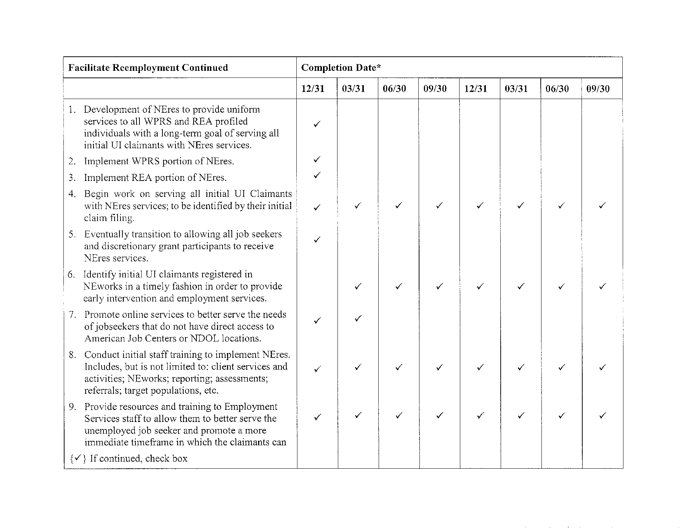

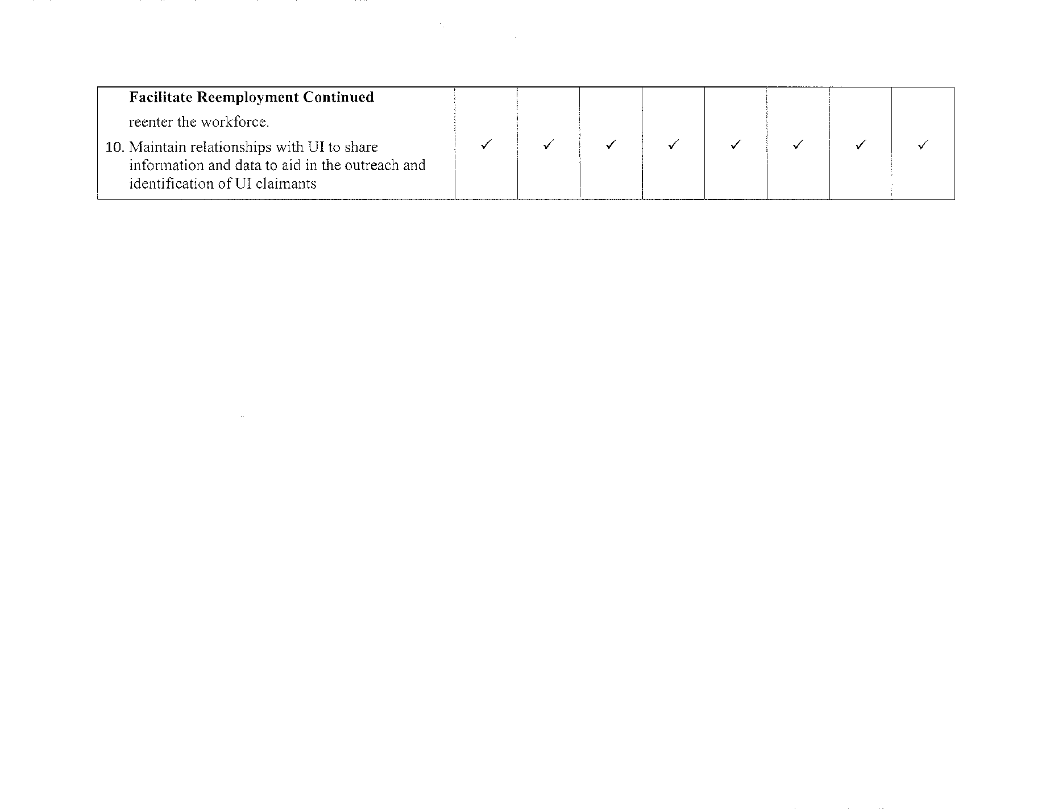

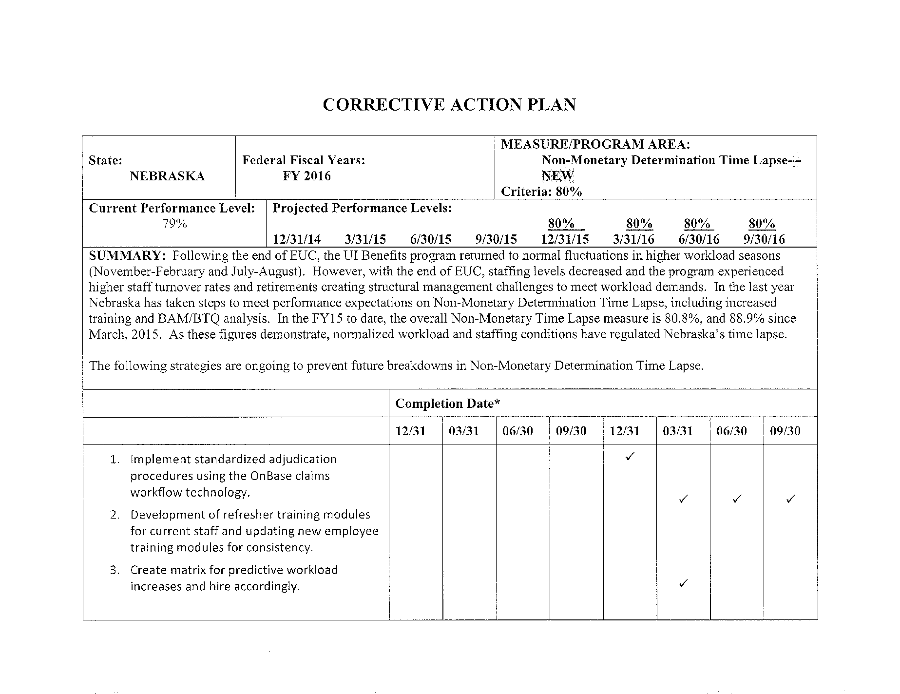

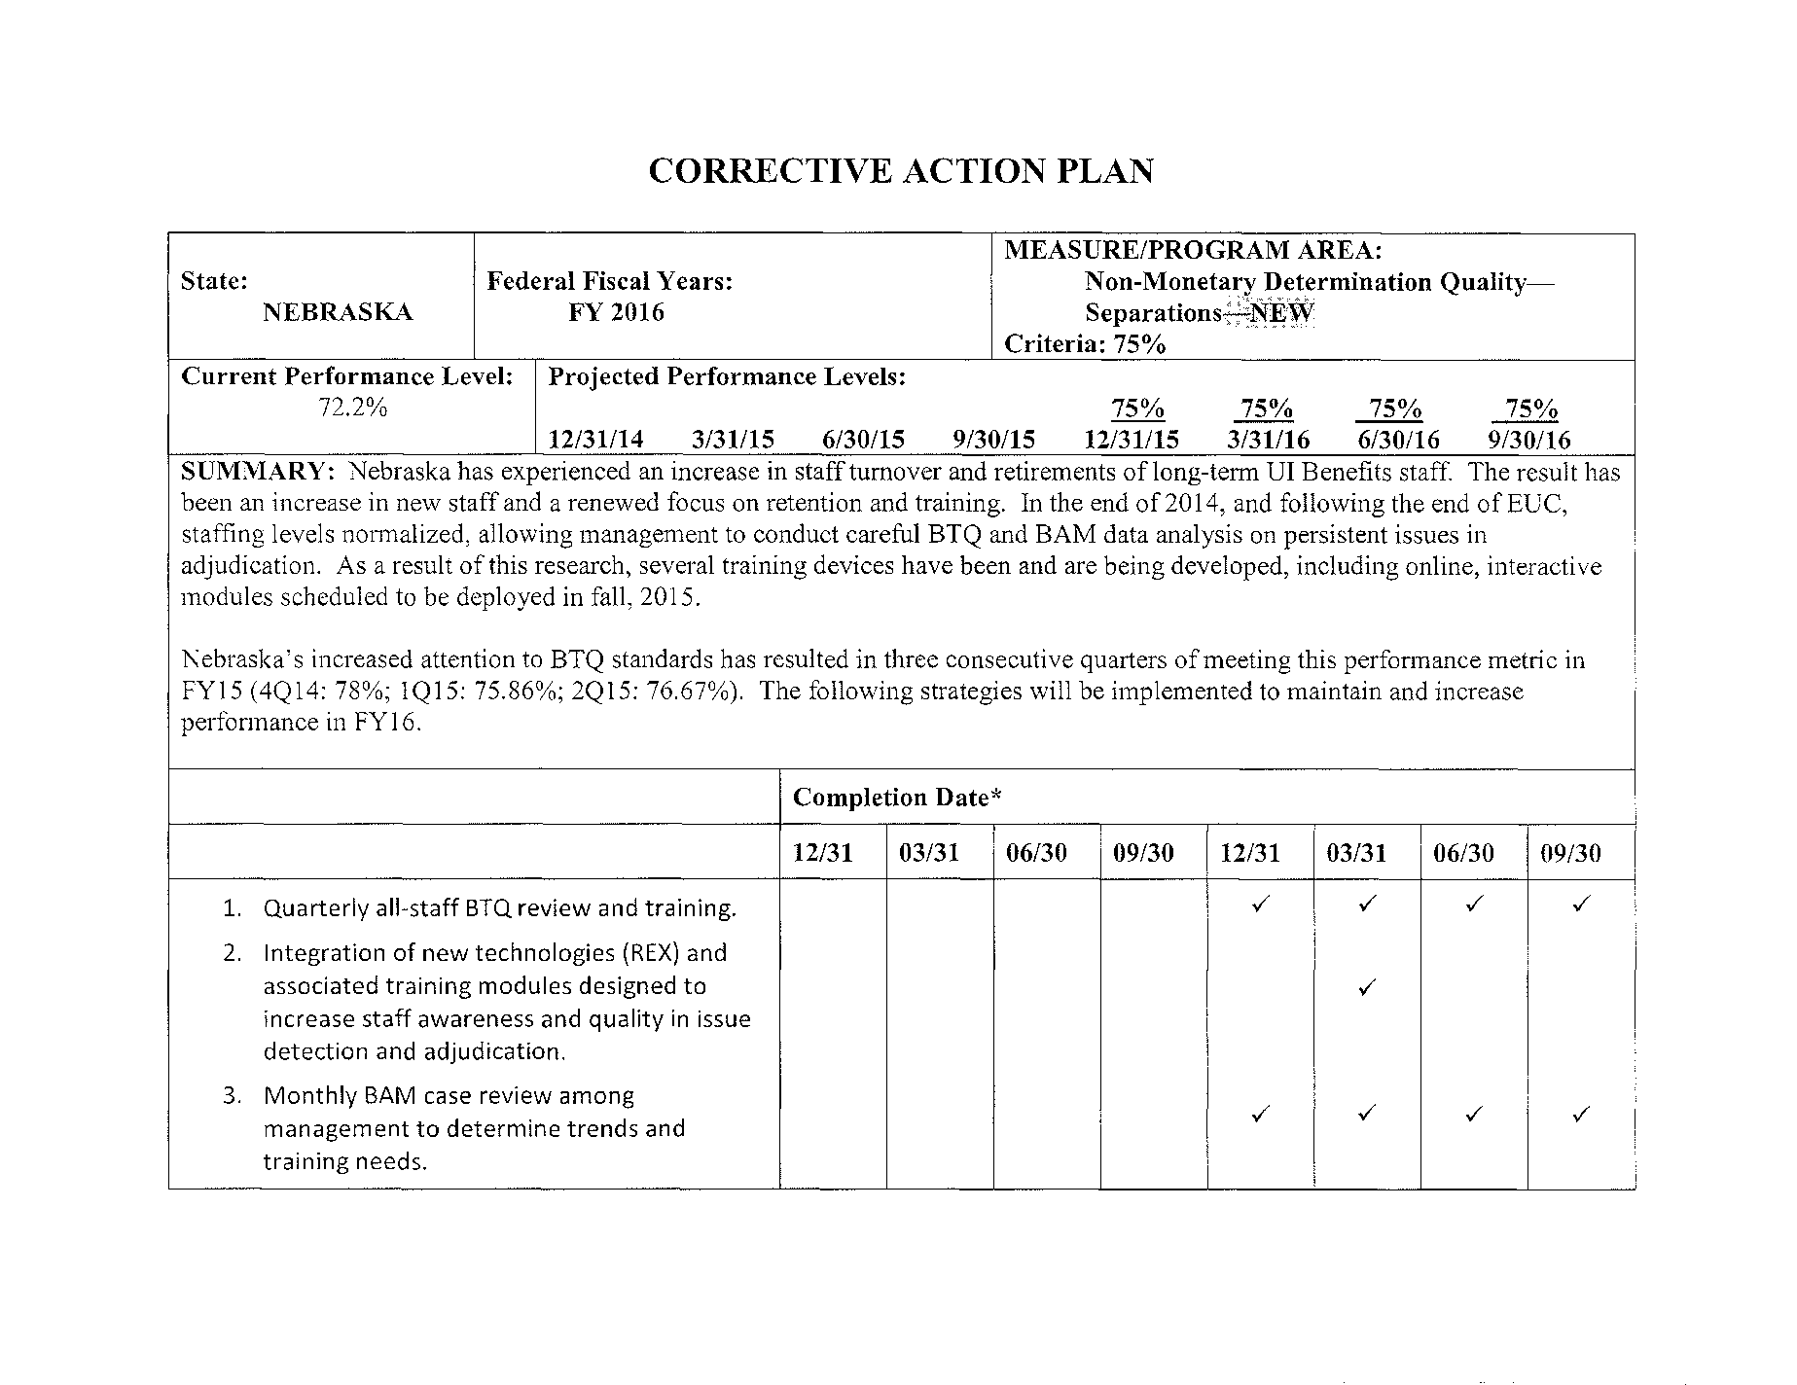

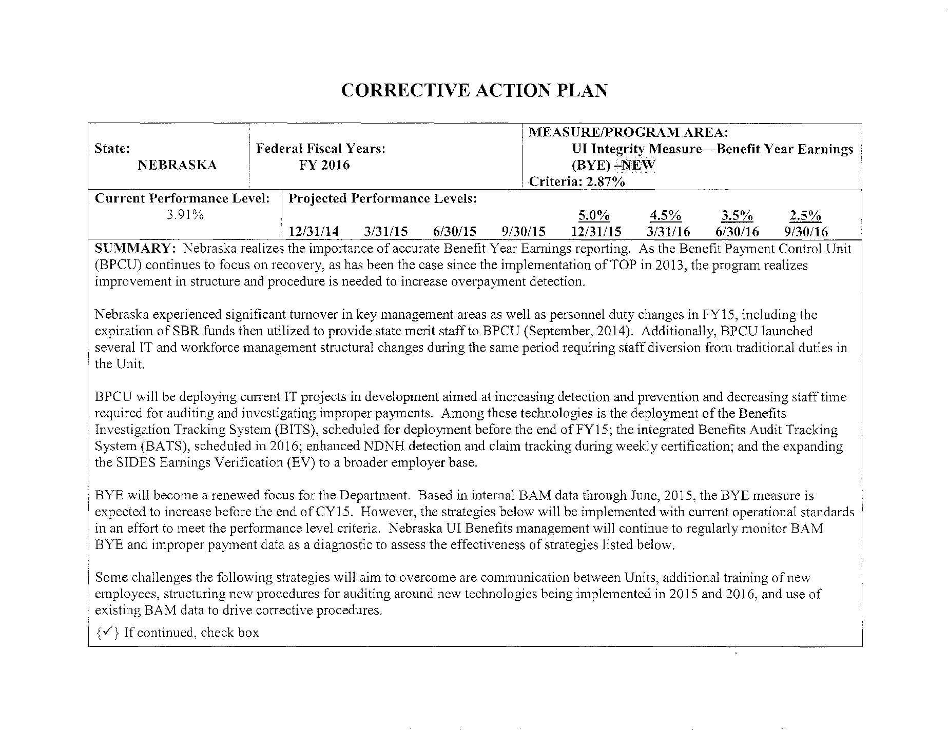

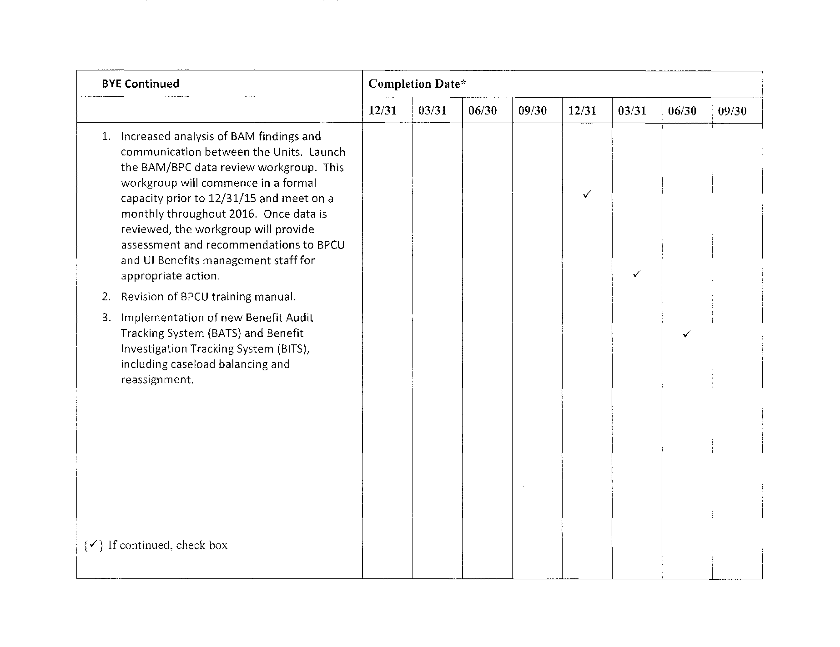

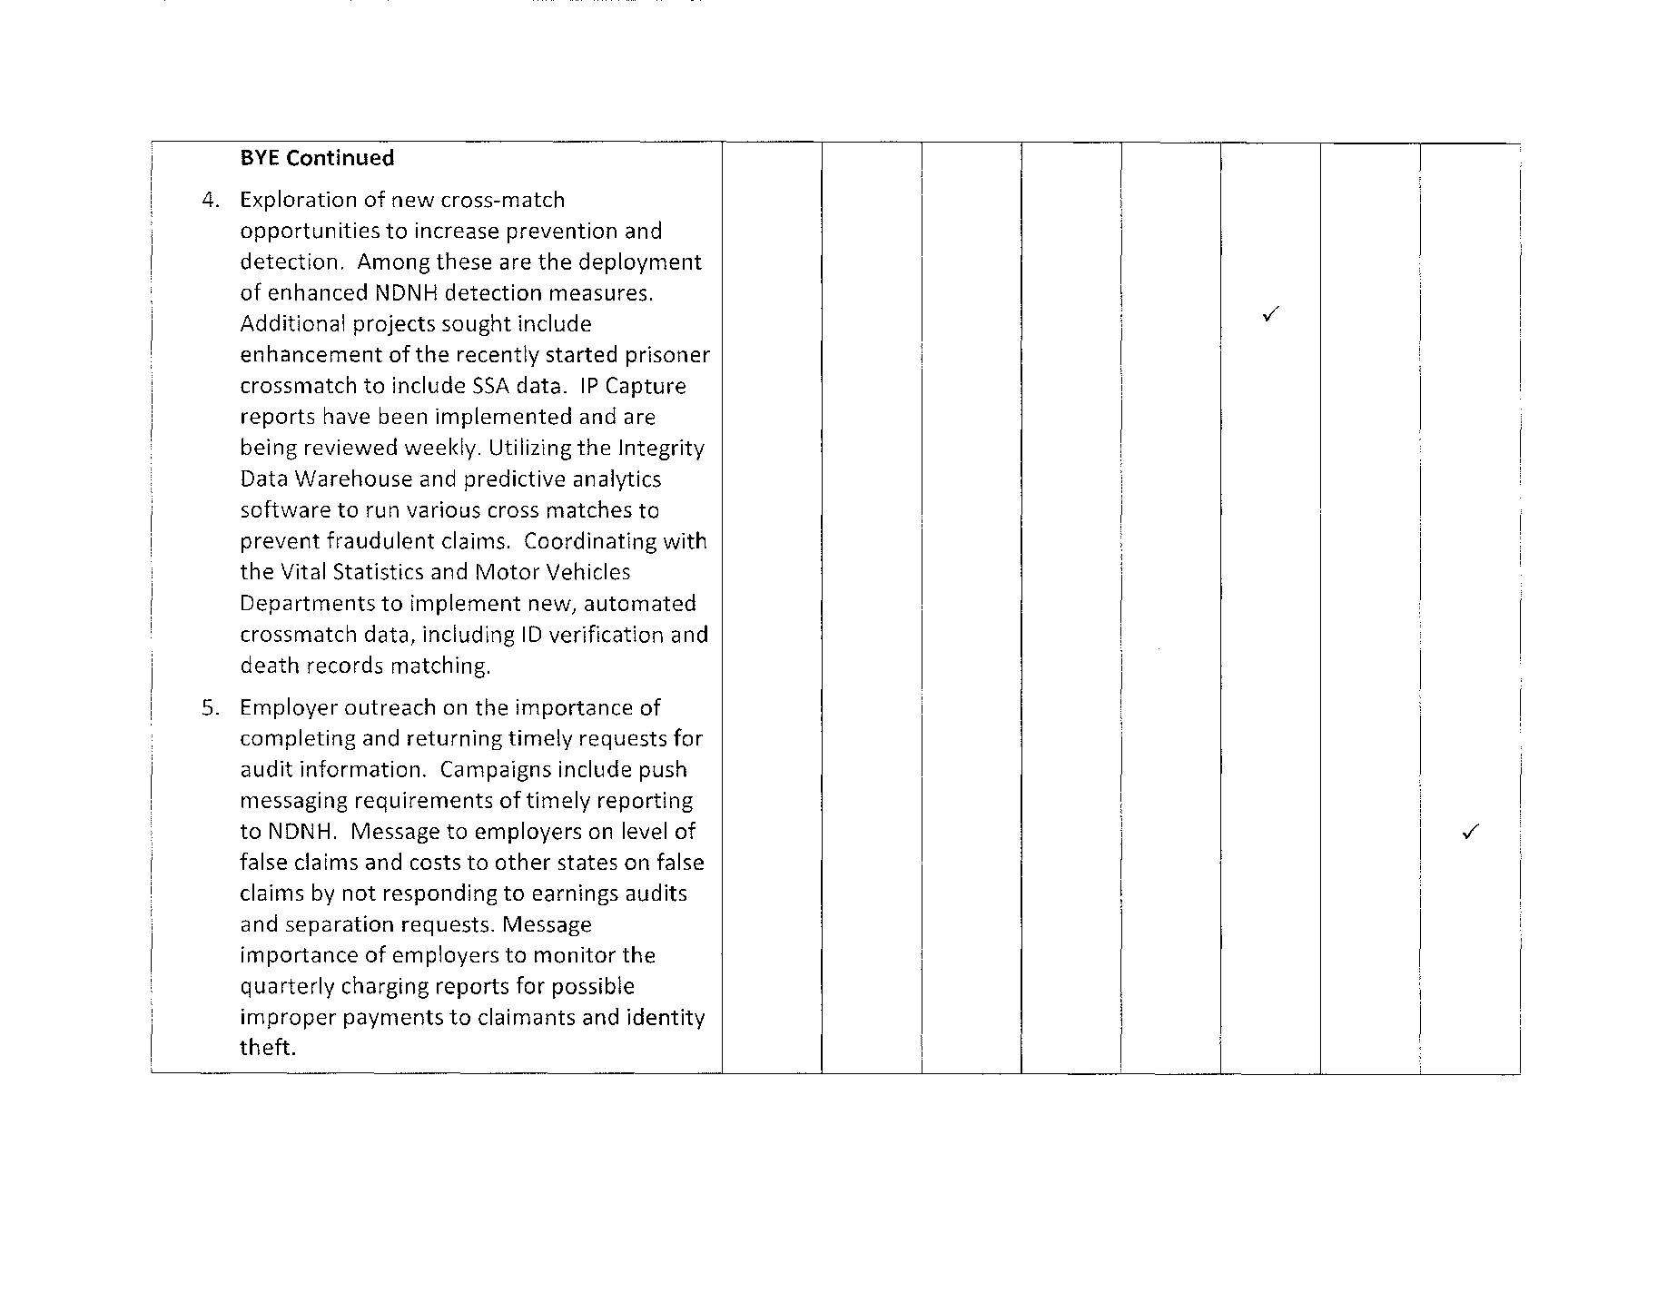

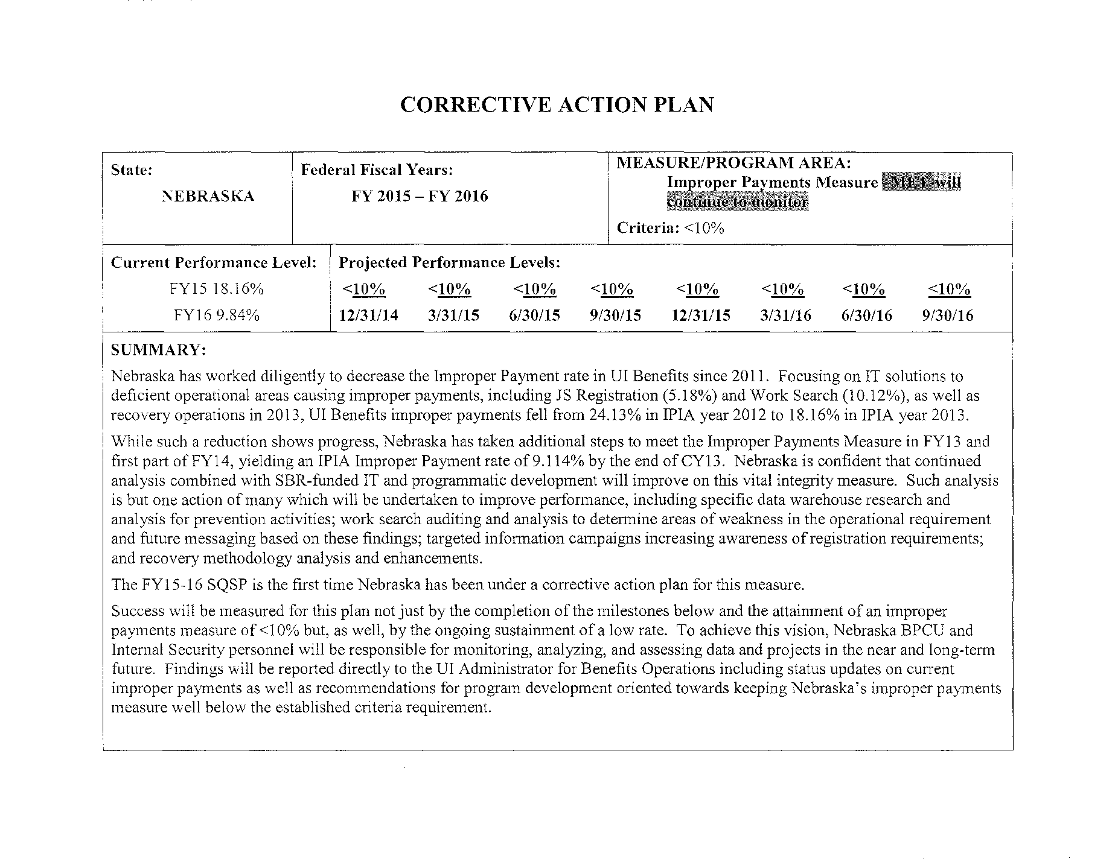

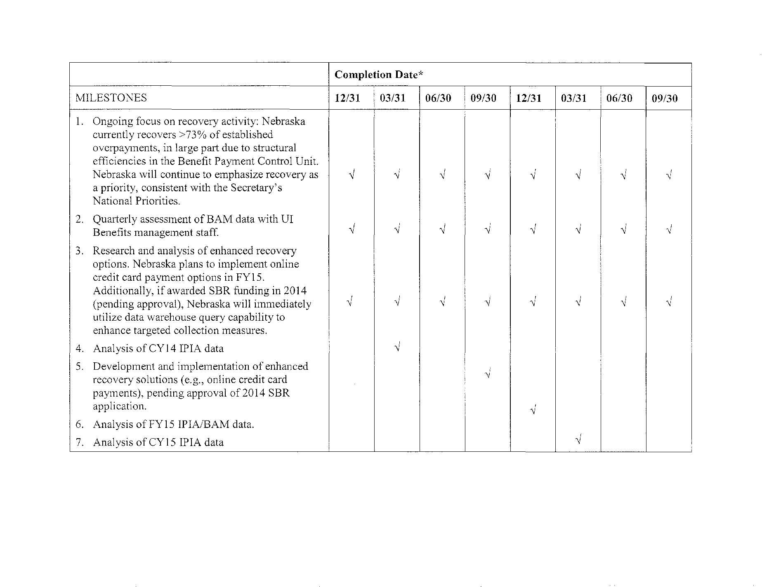

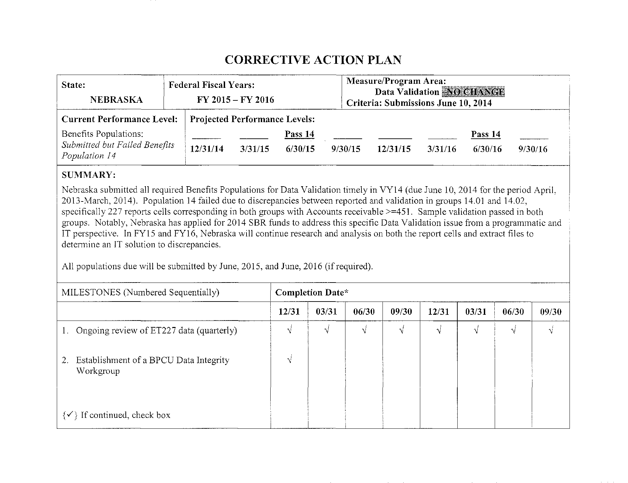

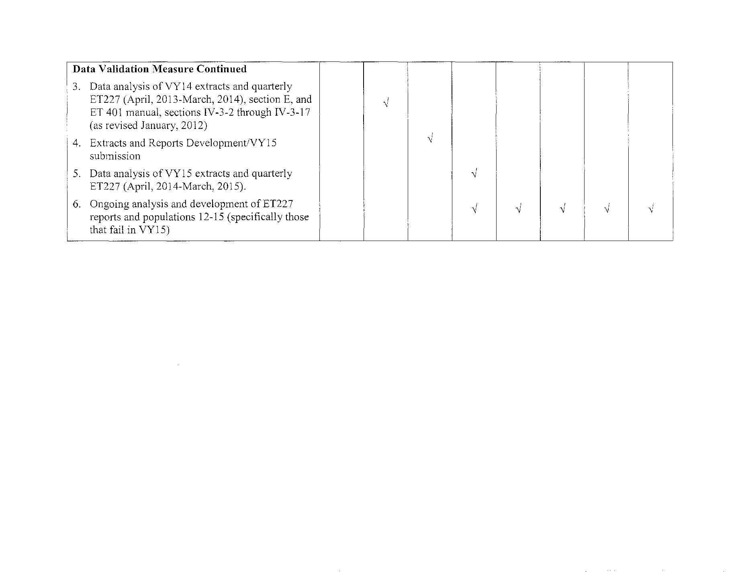

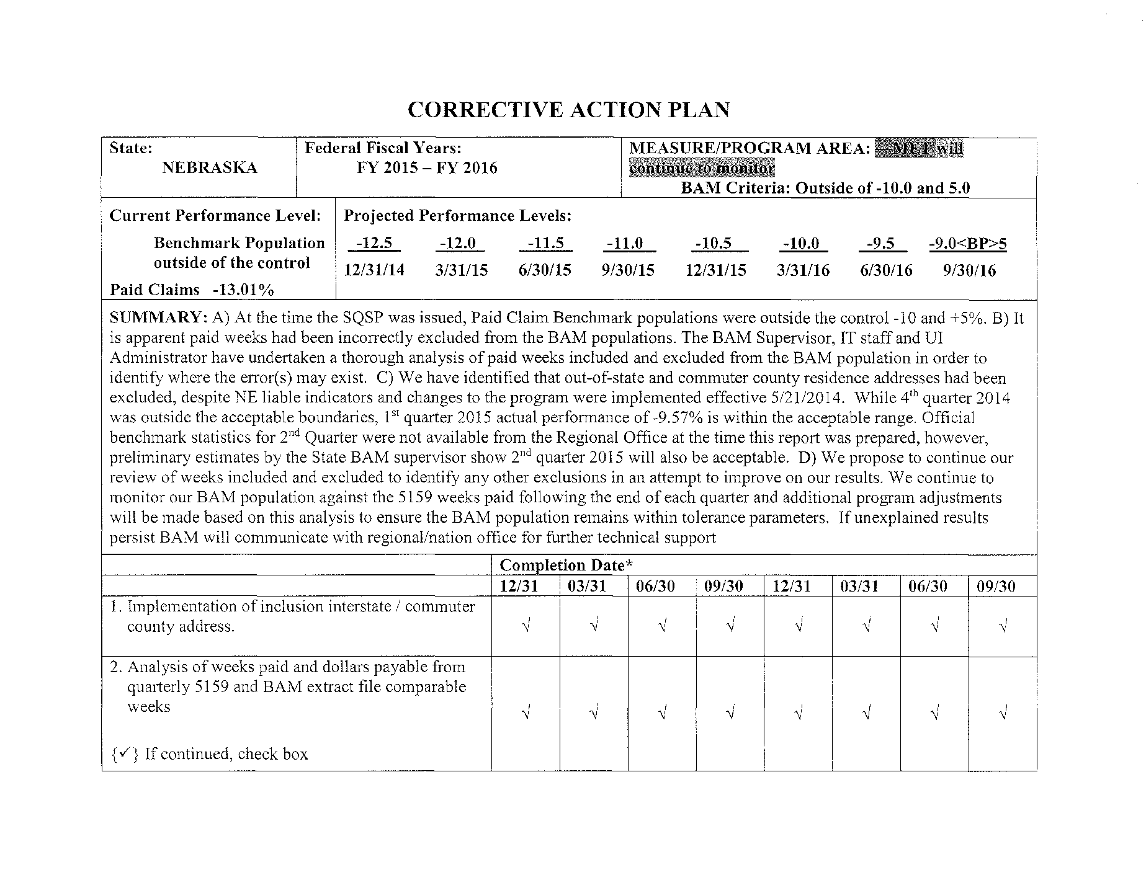

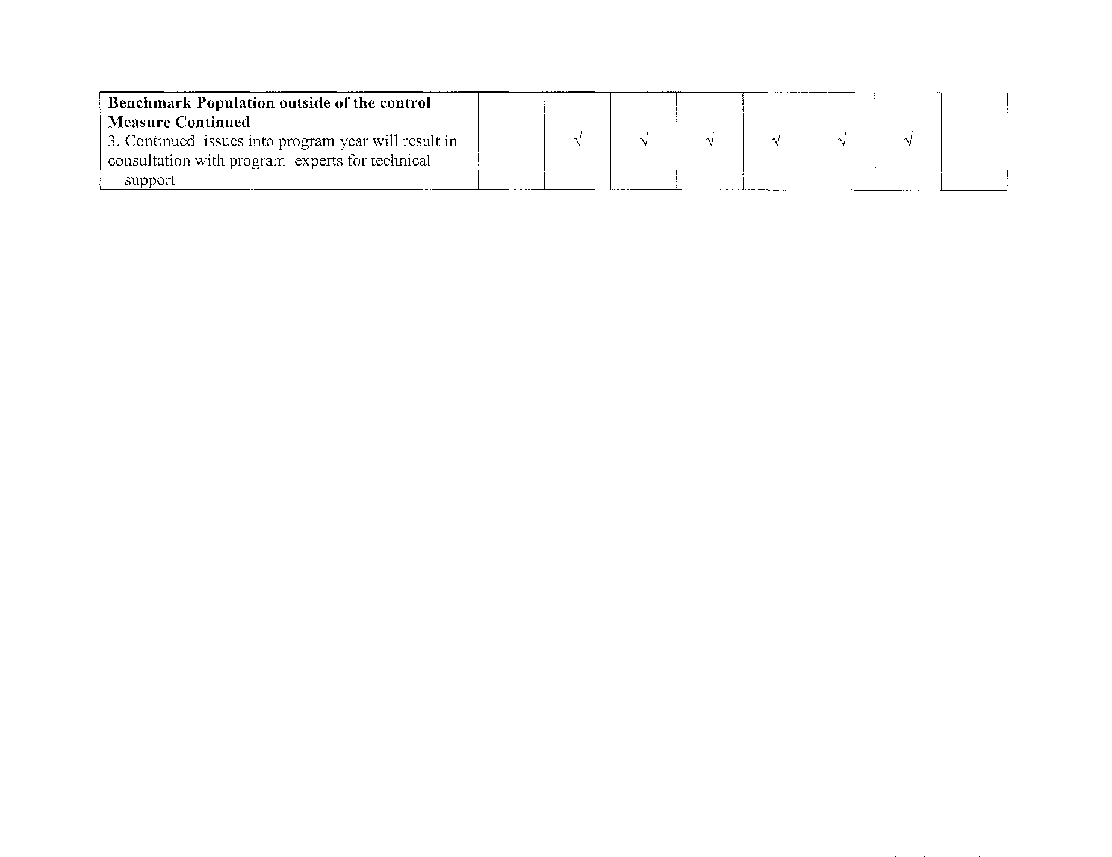

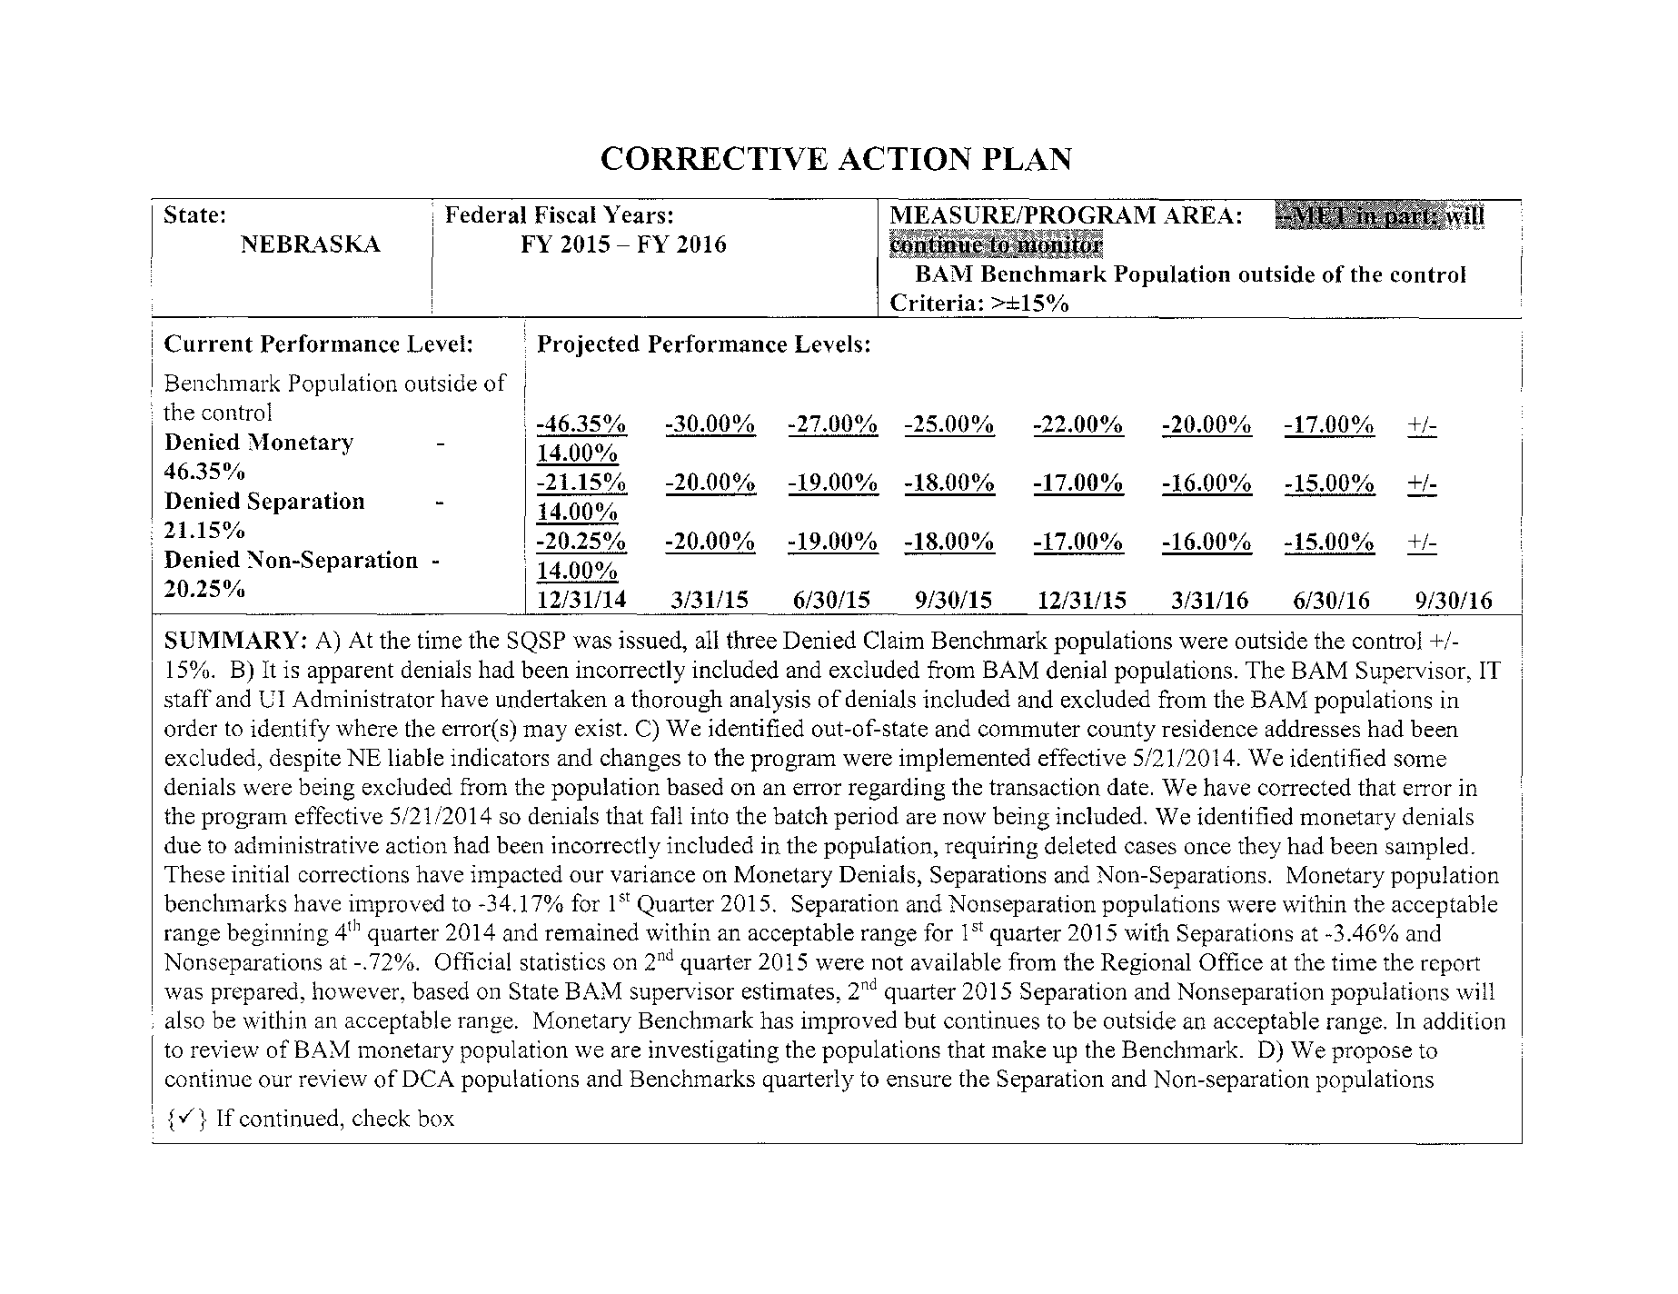

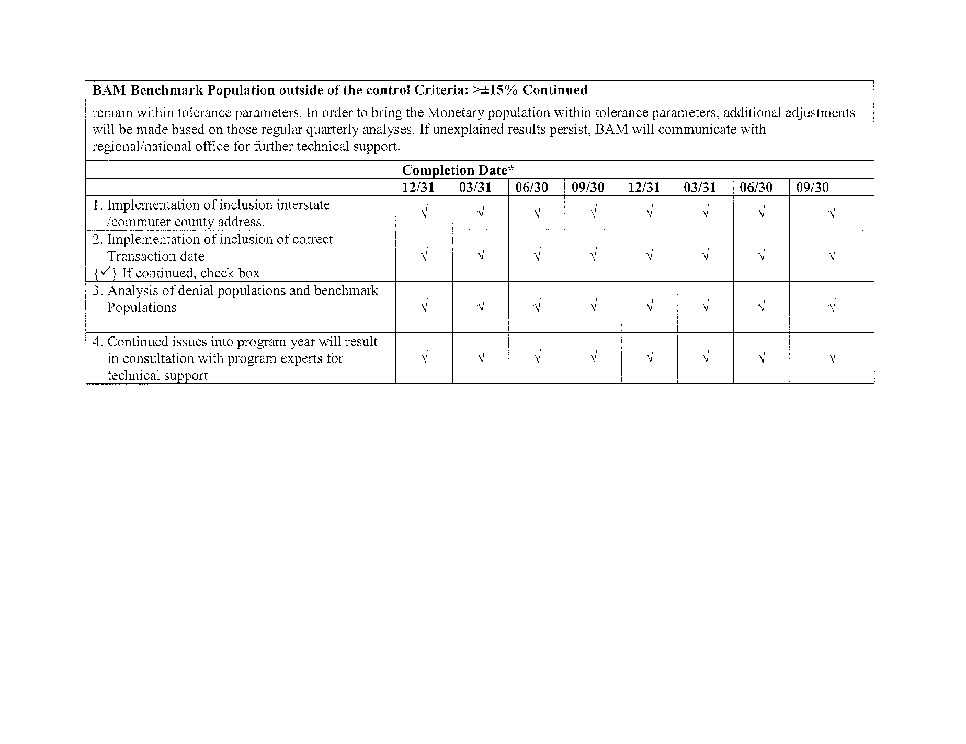

#### *UI Program Integrity Action Plan (UI IAP)*

The UI IAP outlines the strategies the State will undertake during the planning period regarding the prevention reduction and recovery of UI improper payments.

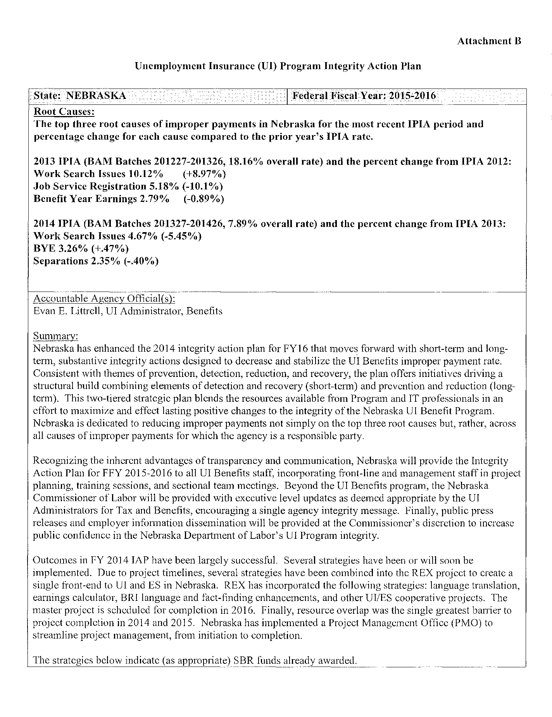

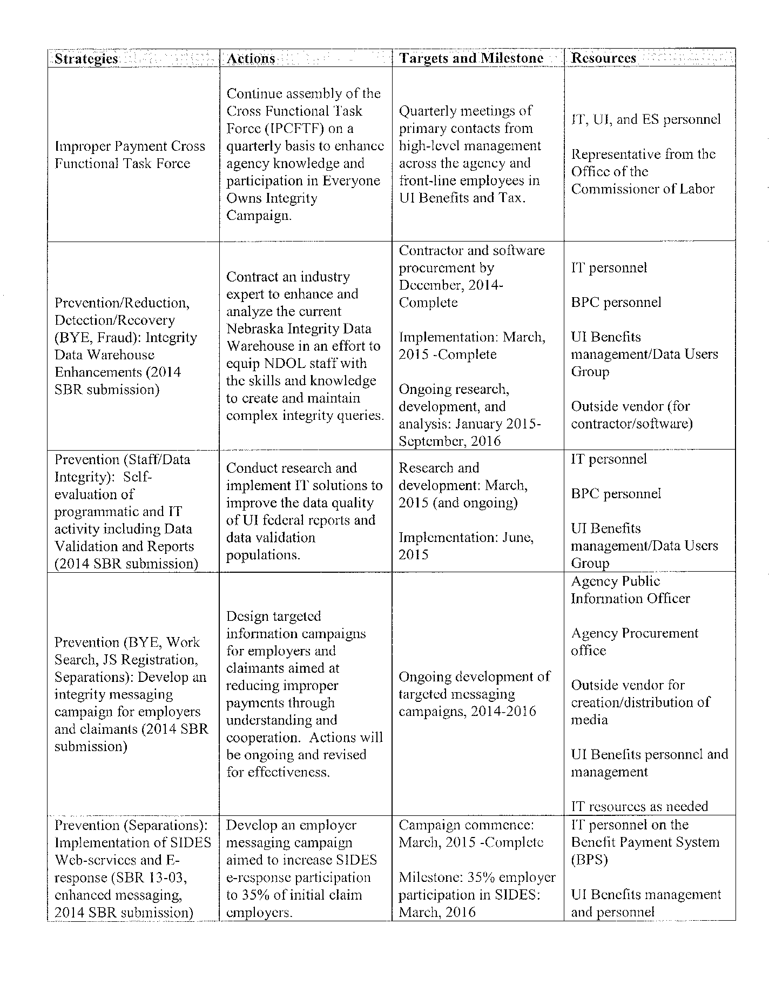

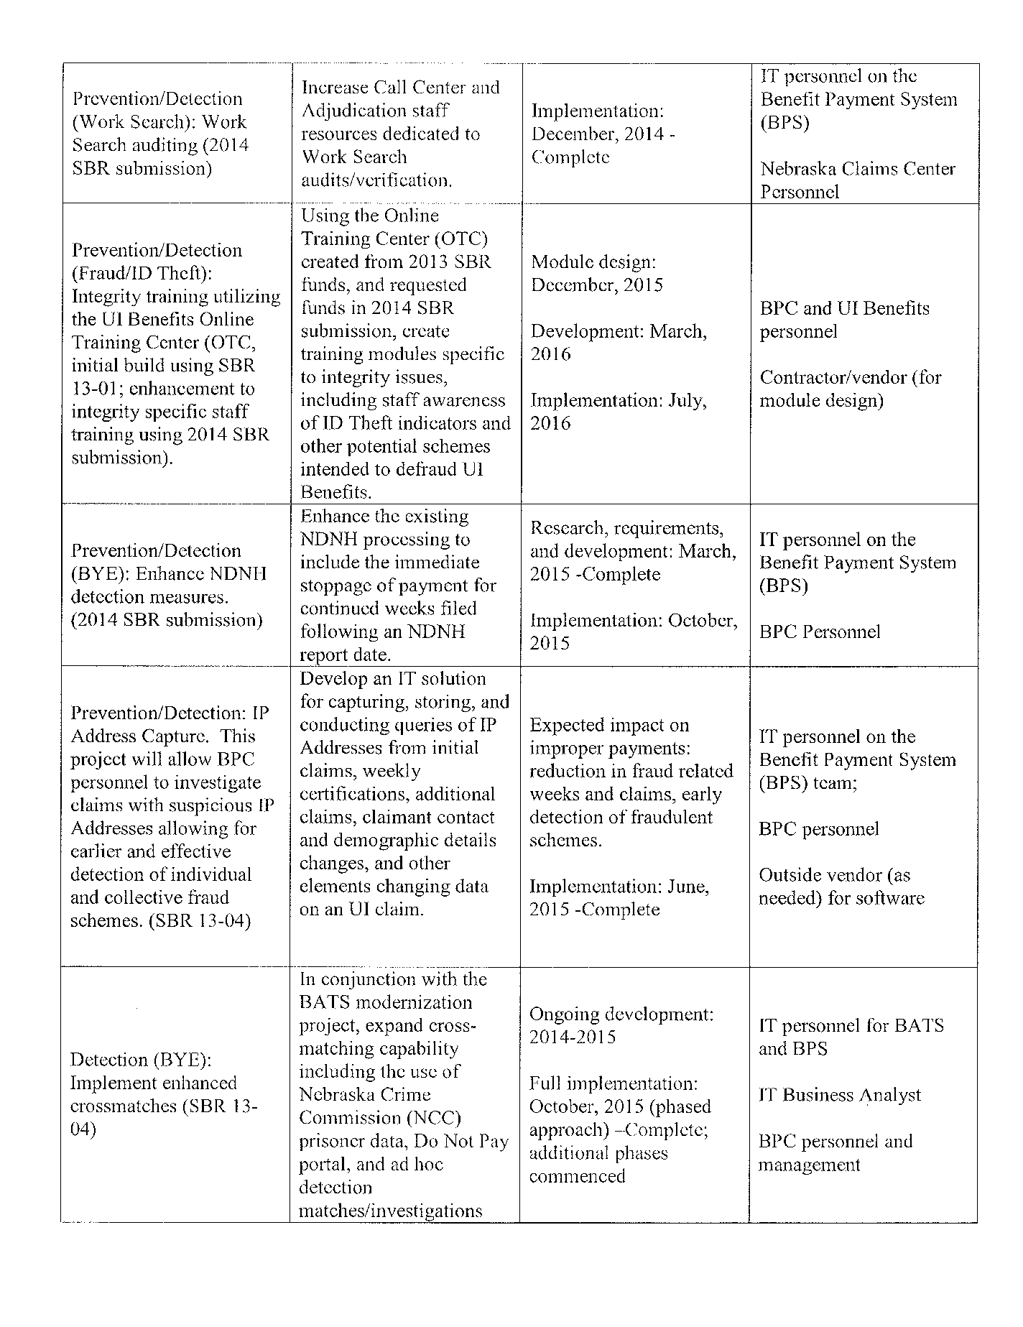

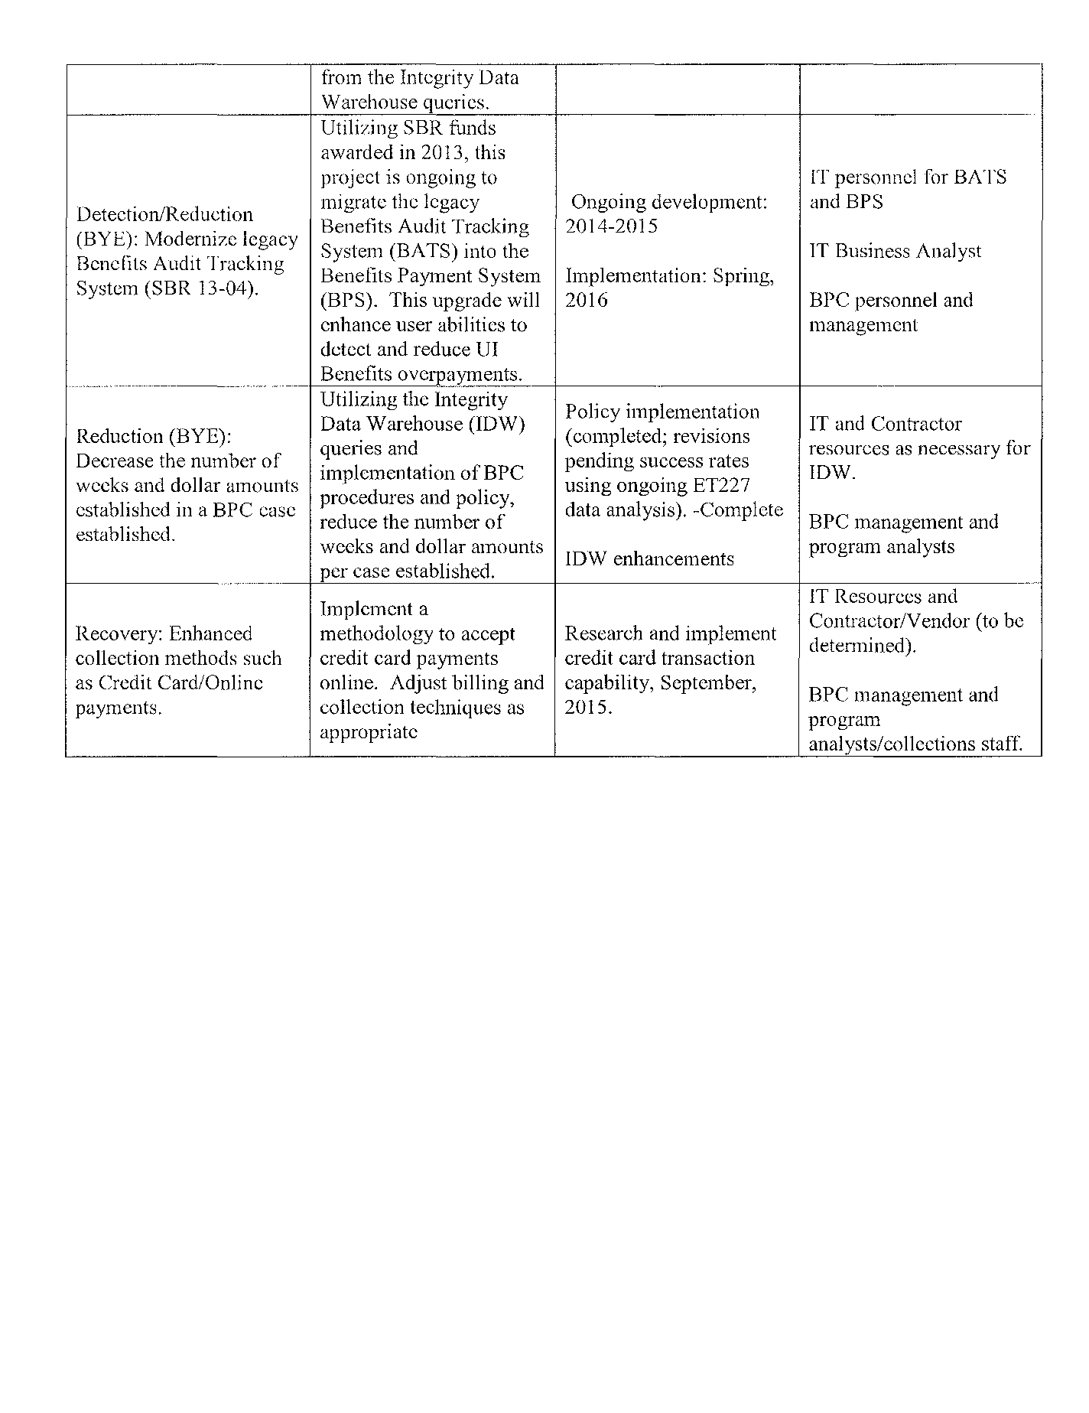

#### *Organizational Chart*

The organization chart must conform to the requirement for delivery of service through public employment offices, or such other designated providers as the Secretary may authorize; show the State's configuration from the Governor of the State down to the point of Employment Service and UI customer service delivery; and provide sufficient detail to show each organizational unit involved and the title of the unit manager.

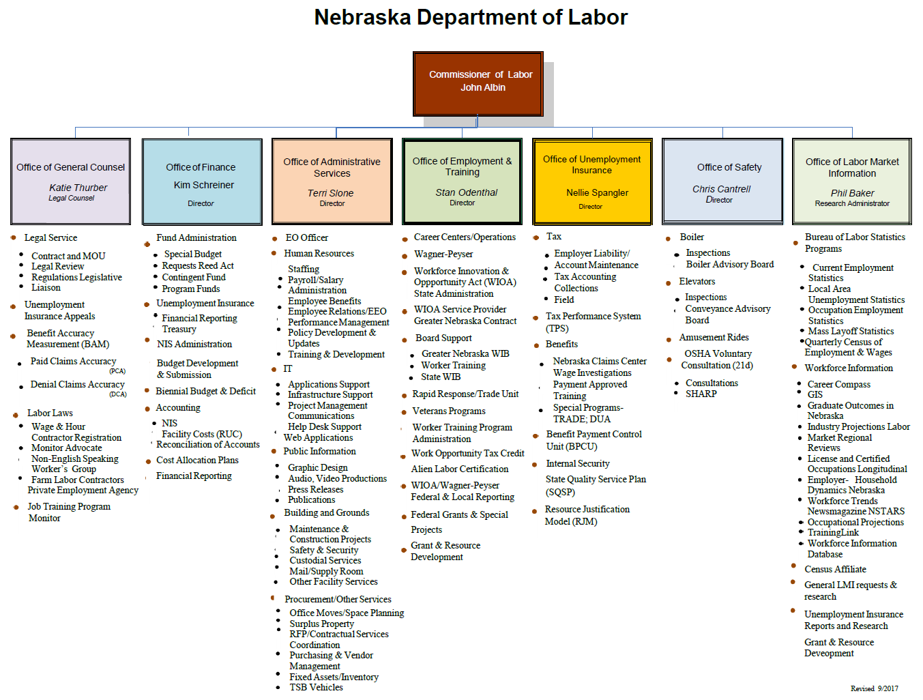

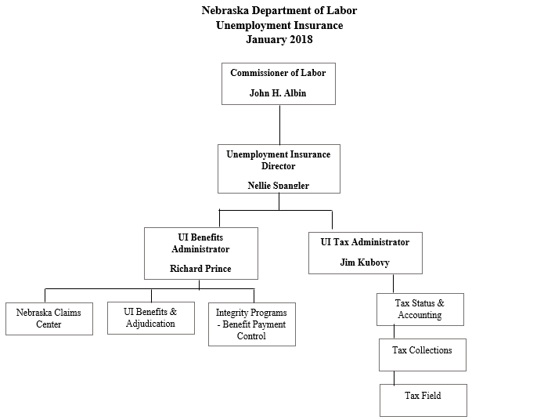

#### *SQSP Signature Page*

The State administrator must sign and date the SQSP Signature Page. By signing the Signature Page, the State administrator certifies that the State will comply with all the assurances and activities contained in the SQSP guidelines.

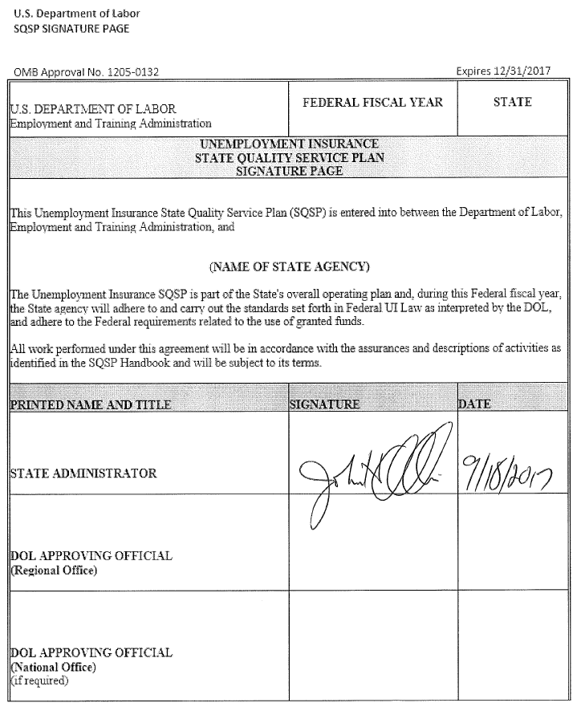

### Requirements for States electing to include UI in the Combined State Plan

States that elect to include UI in the Combined State Plan must:

#### *Submit an SQSP in the following manner depending on their timing in the SQSP cycle:*

1. If a State is in the first year of their 2-year cycle, a complete SQSP package must be submitted.  A complete SQSP package will include the Transmittal Letter, Budget Worksheets/Forms, State Plan Narrative, CAPs (including the milestones and the completion date for each milestone), the UI IAP, Organizational Chart, and the SQSP Signature Page.  One of the key goals for the UI program is to ensure that claimants are able to successfully return to work.  As such, the SQSP State Plan Narrative must provide a discussion of the plan coordination with other WIOA Combined Plan programs to ensure a coordinated effort and integrated service delivery.
2. If a State is in the second year of the 2-year cycle, the State is required to submit the most recently approved complete SQSP package with a modification that must include the Transmittal Letter, Budget Worksheets/Forms, Organizational Chart, and the SQSP Signature page.  The modification may also include CAPs for new identified performance deficiencies, and any required modifications to existing CAPs.  The CAP must list both specific milestones for key corrective actions or improvement activities, and the completion date for each milestone.

#### *Submit the required off-year SQSP components as a modification to the Combined State Plan on the same cycle as the regular SQSP process which must be approved by September 30th each year.*

## Senior Community Service Employment Program (SCSEP)

At minimum, in the SCSEP stand-alone submission and the SCSEP portion of the Combined State Plan, States should comprehensively cover the following elements.

### Economic Projections and Impact

States must:

#### *Discuss long-term projections for jobs in industries and occupations in the State that may provide employment opportunities for older workers. (20 CFR 641.302(d))(May alternatively be discussed in the economic analysis section of strategic plan.)*

The long-term projections for jobs in industries and occupations in Nebraska that may provide employment opportunities for older workers is discussed in the economic analysis section of the strategic plan portion of Nebraska’s Combined State Plan.

#### *Discuss how the long-term job projections discussed in the economic analysis section of strategic plan relate to the types of unsubsidized jobs for which SCSEP participants will be trained and the types of skill training to be provided. (20 CFR 641.302(d))*

The State Department of Labor data offers the state’s top 10 occupations that have above average job prospects. Occupations addressing our aging population’s long term care support needs are prominently featured.

*2014 – 2024 Occupational Projections Top 10 Most Annual Openings for Postsecondary Non-degree Award Education Level with Entry Wages from the Occupational Employment Statistics Survey*

| SOC Code | Standard Occupation Classification (SOC) Title | Average Annual Openings | Entry Wage |
| --- | --- | --- | --- |
| 29-2061 | Licensed Practical and Licensed Vocational Nurses | 293 | $16.37 |
| 31-1014 | Nursing Assistants | 459 | $10.47 |
| 31-9092 | Medical Assistants | 147 | $11.90 |
| 39-5012 | Hairdressers, Hairstylists, and Cosmetologists | 142 | $8.32 |
| 47-2111 | Electricians | 155 | $14.37 |
| 47-2152 | Plumbers, Pipefitters, and Steamfitters | 132 | $15.93 |
| 51-4041 | Machinists | 144 | $12.93 |
| 51-4121 | Welders, Cutters, Solderers, and Brazers | 153 | $13.15 |
| 53-3032 | Heavy and Tractor-Trailer Truck Drivers | 920 | $14.40 |
| 53-3033 | Light Truck or Delivery Services Drivers | 105 | $9.45 |

Source*: Nebraska Department of Labor, Office of Labor Market Information 2014 – 2024 Long Term Occupational Projections and the Occupational Employment Statistics Survey updated to third quarter 2017*

The State Department of Labor notes that the most common job vacancies are for Health, Transportation and Material Moving occupations. Some of the most common job vacancies, such as medical and dental assistant, match the interest of some women over 55 years of age seeking employment. The Senior Community Service Employment Program’s (SCSEP) host agencies provide the location and the skills training to support participants’ development of job skills for meeting their goal of locating a position in the workforce. Currently, office work, food service, and retail are the most common types of training opportunities offered through Nebraska’s host agencies. Nebraska SCSEP will work towards aligning the training with the top job openings in the state.

Host agency training may need further supplementation by SCSEP the subgrantee and the Workforce Innovation and Opportunity Act (WIOA) partners to provide local employers with job-ready employees. The office jobs currently available require a working knowledge of computers. This technological experience is often underdeveloped in persons over 55 years of age. Computer skill-building classes are offered to participants of SCSEP through a job-certified training developed by the Greater Omaha Local Workforce Development Board and by the subgrantee. Nebraska will apply for a training waiver in PY 2018 for an intensive computer training curriculum. Digital literacy and technology competencies will help advance participants’ computer, communication and customer service skills. These skills are transferrable across a broad spectrum of high-growth occupations and industries. A Customer Service and Support Training component which is part of the National Retail Federations will focus on meeting customer needs, establishing clarity and continuous improvement. Participants whose Individual Employment Plan (IEP) and assessment results align with the top occupations projected for growth will be enrolled in the computer literacy program. Knowledge and skills gained through the digital literacy program are transferrable across a broad range of industries and occupations including the high demand occupations and those with the most annual openings listed above. As current participants exit, Nebraska SCSEP will try to enroll new participants whose employment goals and assessment results support placement in healthcare and personal service occupations listed above. New host agencies in these occupations will be recruited and OJE opportunities will be explored in the top occupations listed above.

#### *Discuss current and projected employment opportunities in the State (such as by providing information available under §15 of the Wagner-Peyser Act (29 U.S.C. 491-2) by occupation), and the types of skills possessed by eligible individuals. (20 CFR 641.325(c))*

The current and projected employment opportunities in Nebraska and the types of training possessed by eligible individuals is discussed in the economic analysis section of the strategic plan portion of Nebraska’s Combined State Plan.

### Service Delivery and Coordination

States must:

#### *Provide a description of actions to coordinate SCSEP with other programs*

This may alternatively be discussed in the State strategies section of the strategic plan, but regardless of placement in document, must include:

##### Actions to coordinate activities of SCSEP grantees with WIOA title I programs, including plans for using the WIOA one-stop delivery system and its partners to serve individuals aged 55 and older. (20 CFR 641.302(g), 641.325(e))

The development of Nebraska’s Senior Community Employment Program State Plan, as a chapter of the Combined State Plan, involved the insight and participation of a variety of interested persons and groups. This planning process involved multiple steps and opportunities for various opinions to impact the plan. A brief summary includes:

1. State Title V Agency developed the framework and initial draft of the State Plan. State SCSEP coordinator attended focus group meetings held by the workforce development agency to gather input on the combined state plan.
2. Nebraska’s Title V program includes National Able Network which operates in 77 counties. National Able Network recruits, locates community service training and helps program participants locate unsubsidized jobs.
3. State Department of Labor and workforce development partners provide job-search and work-skills development. The Department of Labor collaborates with the Departments of Economic Development and Education to develop a strategic approach to developing a local workforce with the skills needed for current jobs as well as future opportunities. The Department of Labor provides a wide variety of support services for jobseekers. Their workforce development activities include job-training for adults. Some SCSEP participants receive additional training through this program.
4. Workforce development partners are regional agencies which work with schools, employers and other training partners to provide necessary skills training for persons seeking employment. Nebraska’s Senior Community Service Employment Program is an active partner in the WIOA’s One Stop Centers/American Job Centers. Some SCSEP participants also benefit from training opportunities available through the WIOA’s adult training programs.
5. Area Agencies on Aging provide a wide variety of support services to help persons over 60 years of age live independently within their communities. SCSEP participants often have significant constraints limiting their ability to find and keep a job. Addressing factors such as affordable housing, transportation and caregiver support are necessary also. Their familiarity with community supports makes Area Agencies on Aging important partners for Nebraska’s Senior Community Service Employment Programs.
6. Community service organizations provide training to SCSEP participants. These organizations range from senior service organizations, such as senior centers, to community services including schools and hospitals.
7. Nebraska’s Combined State Plan was posted on the Nebraska Department Health & Human Services web site dhhs.ne.gov/aging and published for comment by the Nebraska Department of Labor.

Nebraska is a vast geographic area of 76,358 square miles which means that technology is critical in coordinating services among programs and in providing services to employers and jobseekers. To enhance coordination and communication, SCSEP will partner in the Combined State Plan to utilize a single case management and Management Information System. This technology is called NEworks. NEworks is a powerful online labor exchange system that integrates workforce services with jobseeker and employer candidate recruitment.

Nebraska has a NEworks Mobile APP available for jobseekers to view jobs located near them with the “Job Nearby” feature, search for jobs by company, job title, and location, save their favorite jobs, share jobs via email, Facebook, or Twitter and access Nebraska’ most comprehensive resource for full-time and part-time jobs.

The SCSEP program will work with the workforce development partners in developing sector strategies that will focus on industries that are essential to the economic vitality of the state’s regions and support the businesses and offer employment opportunities to Nebraskans 55 and over who are structurally unemployed with barriers to employment such as low income, homeless, and other disadvantaged populations.

SCSEP subgrantee(s) will continue to work with the Nebraska Department of Labor (NDOL) One-Stop delivery system to prepare participants for in-demand industries and occupations. Nebraska hosts a website, H3.ne.gov that utilizes “real time” job postings and jobseeker information from NEworks, Nebraska’s job search system, to list Todays’ Hot Jobs that are updated weekly. The Nebraska Departments of Labor, Economic Development and Education collaborated on this initiative to provide educators, economic developers, students and their parents, community leaders and jobseekers information on the states’ high skill, high wage and high demand occupations. Today’s Hot Jobs are defined as High Wage, High Demand and High Skill (H3). High wage is determined when an occupation has wages at or above the median. High demand is determined by the number of annual openings, the net change in employment, and the growth rate for the specific occupation. High Skill is defined as occupations which require some form of training and education beyond high school. All three factors must be present to be an H3 Occupation.

Career Pathways is a strategy that will support Nebraska’s vision and goals for workforce development. In 2008, the Nebraska Department of Education/Career Technical Education adopted and implemented the National Career Pathway Model developed by the Office of Vocational and Adult Education. The model includes six career fields: 1) Business, Marketing & Management; 2) Agriculture, Food, and Natural Resources; 3) Communication and Information Systems; 4) Human Services and Education; 5) Health Sciences and 6) Skilled and Technical Sciences. The six career fields entail several professions and jobs. Career Pathways is discussed in further detail under State Strategies in the Combined State Plan.

##### Actions to coordinate activities of SCSEP grantees with the activities to be carried out in the State under the other titles of the OAA. (20 CFR 641.302(h))

The SCSEP will coordinate with the area agencies on aging, senior centers and other community organizations on activities carried out under other titles of the Older Americans Act (OAA). Collaboration with these agencies will include recruitment of new participants, establishing host agency sites with the agencies and integrating the SCSEP with the agencies’ other services under the Older Americans Act. This includes collaborating with the Aging and Disability Resource Center (ADRC) with a SCSEP presence on the ADRC website (nebraska.networkofcare.org), collaborating with transportation services provided by the agencies for SCSEP participants that need supportive services and working with agencies that serve minorities including Native Americans under Title VI of the OAA. The aging network’s familiarity with community supports makes the Area Agencies on Aging important partners for Nebraska’s Senior Community Service Employment Program.

##### Actions to coordinate SCSEP with other private and public entities and programs that provide services to older Americans, such as community and faith-based organizations, transportation programs, and programs for those with special needs or disabilities. (20 CFR 641.302(i))

To meet the basic support needs outside of training for employment, provide training to match older worker’s employment goals, and matching older worker’s to jobs available with local employers will require coordination with a number of organizations. These organizations include human service, employment and training agencies and employers.

The inadequacy of basic supports such as housing, transportation and possible care needs of a frail spouse or parent will lower a SCSEP participant’s chances of completing training, finding and keeping a job. Human service organizations such Nebraska’s Aging & Disability Resource Centers, the Nebraska Department of Health and Human Services and Area Agencies on Aging will be central to addressing these basic support needs.

The Department of Health and Human Services (DHHS) offers a wide variety of supports to help maintain individuals within their community. Specific programs which address common support needs include the Social Services Block Grant, Disabled Persons and Family Support, Lifespan Respite and Medicaid Waivers. A sampling of possible support services includes: transportation, energy assistance, housing, telephone assistance, Supplemental Nutrition Assistance Program (SNAP, formerly known as food stamps), adult day care for caregivers and covering the Medicare premiums for eligible low-income beneficiaries. DHHS also coordinates the Ticket to Work program which encourages persons receiving Social Security Disability to rejoin the workforce. Ticket to Work also provides benefits counselors to help people understand whether participation impacts eligibility for other public benefits.

The local Area Agencies on Aging are familiar with the support needs of the elderly and are experienced in organizing community resources to address those needs. Nebraska currently has one program sub-grantee, National Able Network. National Able Network took over from Experience Works as the sub-grantee in December 2016 following a national Request for Proposal process for national grantees in 2016. National Able Network is also a national grantee whose service area covers most of Nebraska. National Able Network confers with the staff of each of the eight Area Agencies on Aging to address non-employment support needs of SCSEP trainees. The program is also participating in the development of the Nebraska’s Aging and Disability Resource Centers (ADRC). This partnership will be able to provide information to address a variety of human services as well as a referral to local agencies which provide assistance to our targeted population. The ADRC website provides linkages to a wide variety of community resources for the SCSEP participants. Coordination with ADRC will continue to enhance with the demonstration project implemented in 2016. For more information visit www.nebraska.networkofcare.org.

One significant barrier to employment is an inadequate availability of public transit. The State Unit on Aging has established a Senior Transportation Coalition with the substantial support from Nebraska Easter Seals and Nebraska AARP. Nebraska’s efforts have focused upon the development of local coordinated transportation initiatives and regional coordinated transportation systems. Interest in this initiative has come from human service, transportation providers and State agencies (Departments of Health and Human Services, Labor, Roads and the Public Service Commission) and indicates a continuing commitment to improve the availability and effectiveness of public transportation services.

Affordable housing is necessary to rebuild or maintain the economic life of program participants. Housing issues range from locating affordable housing to accessing community supports such as energy assistance and weatherization. Both Area Agencies on Aging and Community Action Programs are familiar with available affordable housing resources. Program participants are often caregivers for a parent, spouse or grandchild. Nebraska’s Lifespan Respite Program, Care Management Program and the Older Americans Act’s Caregiver Support Program assist these caregivers. The Area Agencies on Aging are partners with the Lifespan Respite Program. The Area Agencies on Aging also provide Care Management and operate Caregiver Support Programs. Additionally, the State SCSEP Coordinator serves on the Nebraska Caregiver Coalition and is a member of the Caregiver Advisory Board. This helps facilitate coordination between SCSEP and caregivers in the state.

This older worker initiative focuses by design on an economically at-risk population. As noted earlier, 95% of participants have incomes below the poverty level, 81% receive public assistance benefits and 64% are at-risk of homelessness. A functional partnership between SCSEP, local aging, housing and community service organizations is necessary to address multiple needs of the program’s participants.

The State Unit on Aging has worked with National Able Network to maintain functional partnerships within the WIOA system. Nebraska’s grantee and sub-grantee are active with the local One-Stop Centers. This includes participation on Workforce Development Boards (WDB) and their committees. The sub-grantee has current Memoranda of Understanding and Infrastructure and Cost Share Agreements with the WDBs.

The Nebraska Partner Council will continue to work together to find skill gap solutions, resource solutions, work readiness solutions and other innovative workforce solutions. The Partner Council will receive timely and valuable information from the Industry Councils and local and regional employer representatives on work and skill readiness needs. Depending on labor market demands and skill sets needed, any one or all of the partners may participate in a work readiness initiative. The Partner Council will work collaboratively to address some of Nebraska’s most challenging workforce issues identified by subpopulations. The State SCSEP Coordinator’s participation on the Partner Council will help ensure that subpopulations and minority populations are being afforded good work opportunities and employers have a diverse and ready workforce. The Partner Council has formed six (6) work groups to implement the WIOA system. These workgroups include: Continuous Improvement, Business Services, Funding Resources, Policies and Systems, Cross-training and Targeted Population Outreach. The State SCSEP Coordinator served on the Targeted Population Outreach workgroup.

##### Actions to coordinate SCSEP with other labor market and job training initiatives. (20 CFR 641.302(j))

SCSEP will coordinate with labor market and job training initiatives in the state to promote access and distribute essential information to individuals 55 and over facing barriers to employment. For those wishing to investigate training options and approved training providers, a self-service web-based tool that displays Workforce Innovation and Opportunity Act approved training programs is available on the NEworks website. Through this tool, users will be able to access the statewide list of eligible training providers and their performance information.

##### Actions the State will take to ensure that SCSEP is an active partner in the one-stop delivery system and the steps the State will take to encourage and improve coordination with the one-stop delivery system. (20 CFR 641.335)

Nebraska’s SCSEP is an active partner in the WIOA’s One Stop Centers/American Job Centers. Some SCSEP participants also benefit from training opportunities available through the WIOA’s adult training programs. SCSEP will work with the WIOA system in developing a common Intake system. SCSEP will participate in joint planning sessions with WIOA core partners in building a system approach to delivery of services. As a mandatory one-stop partner, the SCSEP grantee will continue to participate in the state and local Workforce Development Boards to work on program alignment, system building and service deliver design/coordination. Many of the sub-grantees’ offices are co-located with American Job Centers or collaborate with them. This helps strategically serve the needs of SCSEP participants in finding unsubsidized employment. SCSEP participants will have access to online resources at the American Job Centers.

The Nebraska Department of Labor provides a wide variety of support services for jobseekers. Their workforce development activities include job training for adults. Some SCEP participants receive additional training through this program. SCSEP will coordinate the development of OJEs with the Department of Labor’s OJT program to enhance job development initiatives with employers.

##### Efforts the State will make to work with local economic development offices in rural locations.

The Nebraska sub-grantee will build partnerships with local economic development offices in rural areas. This will be a critical strategy as Nebraska moves SCSEP positions from urban centers to rural areas. Local collaboration will be enhanced with the five economic development field offices as well as with the Latino Business Office in the Department of Economic Development.

#### *Describe the long-term strategy for engaging employers to develop and promote opportunities for the placement of SCSEP participants in unsubsidized employment. (20 CFR 641.302(e)) (Alternately, the State may discuss this in the State strategies section of strategic plan if submitting a Combined Plan.)*

Nebraska’s long-term strategy to engage employers to develop and promote opportunities for placement of SCSEP participants in unsubsidized employment is discussed elsewhere in this plan. NEworks and Nebraska Career Connections sites contain resources specific to employers. SCSEP will continue to expand OJE opportunities with employers for the SCSEP participants. Employer outreach will be enhanced with television and radio advertisements highlighting the value of the SCSEP.

#### *Describe the long-term strategy for serving minorities under SCSEP. (20 CFR 641.302 (c))*

Nebraska’s long-term strategy for serving minority older individuals under SCSEP will include ongoing collaboration with agencies serving the minority population such as the Latino Centers and Migrant Seasonal Farmworkers, utilizing television and radio ads in Spanish and Vietnamese and continued use of printed materials in Spanish.

#### *List needed community services and the exact places where these services are most needed. Specifically, the plan must address the needs and location(s) of those individuals most in need of community services and the groups working to meet their needs. (20 CFR 641.330)*

In the rural areas of Nebraska, community service training opportunities are limited to local schools and government agencies. Larger towns offer broader training options which include health care and a wider range of community service organizations. Lincoln and Omaha have the widest range of community service possibilities including government offices (state, federal and local governments), hospitals (local, regional and university), to cultural centers, ethnic, minority and neighborhood organizations.

A wide variety of community service organizations provide training for program participants and have the benefits of a part-time worker. Community service needs addressed through SCSEP includes educational activities, environmental quality, health care, housing, employment assistance, cultural and recreational services, as well as senior services such as nutrition sites, outreach and referral, and transportation.

The State, along with its subgrantee(s) will continue to discuss community service needs with the organizations addressing those needs. The opportunities created by a growing need in the health services area appears promising across the State. SCSEP participants will find opportunities as in-home or health facility care providers. These opportunities will require specialized skills development through classroom training offered by community colleges (with some preparation through on-line course work for persons living in remote areas) or on-the-job training for potential hospital maintenance workers or certified nurse assistants.

#### *Describe the long-term strategy to improve SCSEP services, including planned long-term changes to the design of the program within the State, and planned changes in the use of SCSEP grantees and program operators to better achieve the goals of the program. This may include recommendations to the Department as appropriate. (20 CFR 641.302(k))*

Program improvement over the next two years will increasingly focus upon growing industries, developing a closer working relationship with human service organizations, supporting employers and equitably distributing SCSEP positions across our State. Suggestions include:

1. Increase SCSEP focus upon Nebraska’s Hot Jobs. Through partnerships with other Workforce Innovation and Opportunity Act organizations develop classroom and on-the job training to address our growth industries. Long term care will be a growth industry as the Baby Boom generation increasingly needs a variety of supportive services.
2. Develop a closer working relationship between SCSEP, Ticket to Work and the Centers for Independent Living.
3. Continue relationships between SCSEP, Nebraska’s Aging Network (Aging and Disability Resource Center and Area Agencies on Aging) and the State Department of Health and Human Services to address the multiple support needs common among SCSEP participants.
4. Work with Medicaid to review program guidelines which count SCSEP training income when determining program eligibility. Current rules require interested older persons to choose between training and Medicaid.
5. Review the distribution of positions to be proportional to the eligible population of persons over 55 years of age, commuting patterns, industry concentrations and education systems (community colleges) in the newly designated economic regions in the state. Distribution within rural areas will be monitored to assure equitable distribution of SCSEP positions. Shifting positions will be accomplished gradually as participants leave this program.
6. Work with SCSEP providers to assure timely reporting of participant activity into SPARQ (US Department of Labor web-based reporting system).

#### *Describe a strategy for continuous improvement in the level of performance for SCSEP participants’ entry into unsubsidized employment, and to achieve, at a minimum, the levels specified in OAA Section 513(a)(2)(E)(ii). (20 CFR 641.302(f))*

Nebraska’s Combined State Plan includes the Senior Community Service Employment Program (SCSEP) State Plan.

The SCSEP provides training for aging workers through community service organizations (host agencies). Common training locations are provided at schools, hospitals and senior service organizations. Nebraska’s SCSEP program has a working relationship with a wide variety of community organizations. These include local non-profits, senior service organizations, senior centers and local Area Agencies on Aging. Additional partnerships have been formed with supporting employment training organizations such as One-Stops and the Workforce Development Boards and local employers. Once completed, a new partnership will also include Nebraska’s Aging and Disabilities Resources Center.

Communication is vital for Nebraska’s SCSEP. Program adjustments (due to revised regulations, processes, program performance measures or employment niches for older workers) may be required for substantial changes in program operations. These developments are discussed with Nebraska’s project sponsors during regular contacts or as needs arise.

Under SCSEP, the project sponsors receive grants to create and pay for part-time (usually 18 – 22 hours a week) community service positions for low-income persons over 55 years of age at local public or private nonprofit organizations. The program has a dual purpose to provide useful community service assignments for the enrollees while promoting transition to unsubsidized employment. Local public and private nonprofit organizations which provide training opportunities also benefit through the work completed by SCSEP enrollees.

##### Use of Funds

Each enrollee is offered on average a minimum of an 18-hour work week. Enrollees placed in part-time community service employment currently receive a wage not less than what is established by the State Minimum Wage Law and receive fringe benefits. Host agencies, private nonprofit employers, and public employers provide skill training through subsidized part-time employment in the fields of social services, recreational activities, library services, legal services, health care, education, economic development, conservation, maintenance and restoration of natural resources, community beautification, and other services within communities. A host agency must be a governmental or nonprofit, nonpartisan organization. Examples of host agencies include schools, senior centers, food banks, housing authorities, libraries, community foundations and health agencies.

##### Participant Eligibility

Eligible individuals are at least 55 years of age, and have an income not greater than 125 percent of the poverty level, or are a member of a family that receives regular cash public benefit payments. Income eligibility must be certified annually. All participants must reside within Nebraska. There is no minimum period of residency for determining eligibility. Subgrantees may not impose additional eligibility requirements beyond those imposed by federal law. The enrollment priorities for filling vacant authorized positions are as follows:

1. Veterans and qualified spouses.
2. Individuals with the greatest economic need (incomes at or below the poverty level).
3. Those 65 years of age or older.
4. Those seeking re-enrollment following termination of a job through no fault of their own due to illness or engaging in unsubsidized employment, provided that re-enrollment is sought within one year of termination.
5. Individuals with limited English proficiency.
6. Anyone with a disability.
7. Those with low employment prospects.
8. Those at-risk of homelessness.
9. Individuals that live in rural areas.

### Location and Population Served, including Equitable Distribution

States must:

#### *Describe the localities and populations for which projects of the type authorized by title V are most needed. (20 CFR 641.325 (d))*

##### Nebraska Demographics

According to the Nebraska Department of Labor, two-thirds of Nebraska’s counties are not included in a Metropolitan Statistical Area (MSA) or a Micropolitan Statistical Area (MC). According to the U.S. Department of Agriculture, Economic Research Service, in 2012, there were 49,969 farms covering 92.2% of Nebraska. Yet, according to the Bureau of Economic Analysis, only 4.2% of Nebraskans were employed in the Agriculture industry in 2016.

Twenty-eight of Nebraska’s 93 counties are either part of the Omaha, Lincoln, or Grand Island MSA, or are part of a MC. The greatest percentage of employing industries in Nebraska are Health Care and Social Assistance (14.6%), Retail Trade (11.2%), Manufacturing (10.0%), Educational Services (9.3%), Accommodation and Food Services (8%), and Finance and Insurance (5.87%). The top industries with the highest number of job openings are very similar, with Health Care and Social Assistance. (*Sources: Nebraska Department of Labor, Labor Market Information, Quarterly Census of Employment and Wages. United States Department of Agriculture, Economic Research Service, State Fact Sheets: Nebraska. Job Source: Nebraska Department of Labor Online advertised jobs data*)

According to the US Census, Nebraska’s population of those 55 years of age or above represents 464,671 individuals or 24.7% of the state’s population. According to the US Census, Nebraska’s population of those 65 years of age or above represents 270,902 individuals or 14.4% of the state’s population. The first of the baby boom generation reached 65 years of age in 2011. The population over 65 will increase dramatically over the next 15 years as baby boomers continue to age.

##### Special Populations

The Older Americans Act requires this program provide priority in enrollment for eligible individuals who are Veterans or spouses of Veterans, those with greatest economic need, individuals who are minorities, and individuals with greatest social need, individuals who failed to find employment using available WIOA services, individuals who are homeless or at-risk of homelessness and those living in rural areas.

#### *List the cities and counties where the SCSEP project will take place. Include the number of SCSEP authorized positions and indicate if and where the positions changed from the prior year.*

##### Nebraska PY 2017 Modified Positions

| **Type of Position** | **Number** |
| --- | --- |
| Federal | 191 |
| State | 51 |
| TOTAL MOD | 242 |



##### 2017 SCSEP Equitable Distribution Report

*[The Equitable Distribution (ED) State Report form 8705A shows the number of authorized positions by county as determined by the Census data and the number of enrollments by county as determined by the data in SPARQ. The state report includes all grantees that operate in a particular state. The tables in SCSEPED provide various calculations of the variance between the authorized position and the number of current enrollments by county. The table from SCSEPED.org was used to fill out the values below and to answer the two questions about the variance: What is its significance; and what, if any, actions the grantees will take to come into better compliance with the equitable distribution requirements.*

*State:*

I. Summary of Variance

|  | Number of Counties | Percent of All Counties | Average Percentage of Variance |
| --- | --- | --- | --- |
| Under-service | 39 | 54.2 | 57.7 |
| Over-service | 27 | 37.5 | 74.2 |
| Combined Total Under- and Over-service | 66 | 91.7 | 60.1 |

II. Discussion: reasons for and significance of the variance

*[Please describe any significant variance and explain the possible reasons for the variance]*

When the National Grantee (National Able Network) acquired the National Slots on February 1, 2017, the program was significantly under-enrolled on paper. Upon further investigation, it was discovered that over 20 participants enrolled in the program should have been exited prior to the transition, making the program severely under-enrolled. This, paired with the difficulty in hiring staff in the Western regions of the state, has made the program under-enrolled. It should be noted that the majority of the under-enrolled counties are just short one or two participants, not causing a significant variance on its own, but as a conglomerate. The program is generally slightly over-enrolled in the Eastern region, where the program is fully staffed. The exception to that is Douglas County, but there is a robust waiting list for that county, and we anticipate being fully enrolled there shortly.

III. Plan to improve statewide ED during program year

*[Please explain your plans to reduce the variance in your state during the program year.]*

Subgrantee, National Able Network plans to recruit and hire staff to cover the Western region of the state and assist with enrollments there, as well as employ new recruitment strategies to bolster interest for the program. National Able is in the process of working through the waiting list for Douglas County, thus coming to full enrollment shortly. The State will allow natural attrition to align ED in the counties currently over-enrolled.

IV. Attach copy of state ED table from SCSEPED.org.

*[The Equitable Distribution (ED) Grantee Table 8705B shows the number of authorized positions by county as determined by the Census data and the number of enrollments by county as determined by the data in SPARQ. The grantee report includes all states in which the grantee operates. The tables in SCSEPED.org provide various calculations of the variance between the authorized position and the number of current enrollments by county. The tables from SCSEPED.org were used to fill out the values below and to answer the two questions about the variance: What is its significance; and what, if any, actions the grantee will take to come into better compliance with the equitable distribution requirements.*

##### Grantee

I. Summary of Variance

|  | Number of Counties | Percent of All Counties | Average Percentage of Variance |
| --- | --- | --- | --- |
| Under-service | 3 | 33.3 | 10 |
| Over-service | 3 | 33.3 | 316.7 |
| Combined Total Under- and Over-service | 6 | 66.7 | 45.1 |

II. Discussion: reasons for and significance of the variance

*[Please describe any significant variance and explain the possible reasons for the variance]*

In the counties that are under-enrolled, in 2 counties the variance is just one participant and the third has a variance of 2 participants, so the variance is not significant. The state program is over-enrolled in general (66 enrollees and 51 modified slots, overenrolled by 15 participants), so it stands to reason that there are 3 counties that are over-enrolled. The over-enrollment is due to anticipating general program attrition and durational limit.

III. Plan to improve ED in your grant during program year

*[Pl ease explain your plans to reduce the variance in your grant during the program year.]*

The plan is to allow natural attrition in those areas where there is over-enrollment and continue to recruit and enroll in the areas where there is under-enrollment. New strategies will be explored to recruit participants in those hard-to-serve counties where there is under-enrollment.

#### *Describe any current slot imbalances and proposed steps to correct inequities to achieve equitable distribution.*

The grantee believes the slot imbalances are currently prevalent between rural and urban areas with most of the slots in urban areas. The subgrantee experienced difficulty in reaching full staffing capacity but is now staffed fully. This will help the grantee review and address the slot imbalance.

#### *Explain the State’s long-term strategy for achieving an equitable distribution of SCSEP positions within the State that:*

##### Moves positions from over-served to underserved locations within the State in compliance with 20 CFR 641.365.

The Nebraska Equitable Distribution (ED) Report provides a basis for determining a fair allocation of program positions with the State. This report is useful for determining where to locate new positions, fill vacant positions, or reduce positions, as necessary. The most recent Nebraska Equitable Distribution Report prepared in 2017 is provided above. The new ED, prepared in September 2017, is based on the latest Census data for distribution of the SCSEP-eligible population within each state. **The total PY 2017 allocation of positions for Nebraska was reduced from the PY 2016 level by about 8%. The PY2017 authorized positions were reduced to 51.**

##### Equitably serves both rural and urban areas.

The distribution of Nebraska’s SCSEP positions has supported the rural counties. Until the last few years Douglas County, which includes Omaha, had substantially fewer positions than were equitable. During this period, the grantee shifted a number of their positions into Douglas County. Future Equitable Distribution discussions will focus upon the adequacy of position distribution within the urban and rural counties.

##### Serves individuals afforded priority for service under 20 CFR 641.520. (20 CFR 641.302(a), 641.365, 641.520)

##### Recruitment

Enrollment priority will be given to Veterans and qualified spouses, eligible individuals having the greatest economic need and eligible individuals over 65 years of age. Nebraska’s grantee has a history of focusing their efforts upon older individuals both with incomes below the poverty level and those with greatest social need. The State SCSEP program currently provides 59% of its positions to minority individuals. Over 93% of Nebraska’s grantee’s enrollees have annual incomes below the poverty level. Eleven percent of these enrollees are Veterans. Among program participants, 58% are receiving public assistance and 63% are at risk of homelessness. Women over the age of 55 represent 64% of the total program enrollment.

##### Increasing Placements to Employment

Increasing the placement of trainees requires that a variety of support services be focused upon all SCSEP trainees as they approach job-ready status. This may be in the form of participation in job-clubs or specialized training through Workforce Development Board partners. Other approaches include trial employment or on-the-job training (OJE) with potential employers. Initiatives such as the Omaha Chamber of Commerce-Workforce Development Board (WDB) job-certified training for Mutual of Omaha and Blue Cross/Blue Shield will be utilized as they become more available. Trial employment or on-the-job training opportunities will be for a limited time with the expectation of a high rate of hiring by participating employers. This strategy will support resume development, interview skills and applying on-line for area jobs. Nebraska will utilize new strategies to reach employers and conduct job development such as distributing employer brochures, airing television and radio ads and using print media.

High growth industries in Nebraska include customer service representatives (for organizations such as Pay Pal, Sitel, Mutual of Omaha and Blue Cross/Blue Shield) and entry-level health care positions. These opportunities provide a livable wage for Nebraskans and a chance for advancement in growing organizations. Office support is another opportunity which matches the interest of many persons over the age of 55; however, all of these opportunities require a working knowledge of computers which is supported by training offered through the program. Following assessment, participants are enrolled in a 10-week computer training program as appropriate. This enhances their ability to find unsubsidized employment.

Continued success in meeting performance goals will require maintenance and further development of partnerships within Workforce Development Board and business community. Omaha’s job-certified training program will be increasingly more common throughout Nebraska. Similar efforts are necessary to fulfill the Nebraska SCSEP’s goal of providing trained workers for the State’s high growth industries.

Program participants who locate employment will continue to receive program support. This support will consist of regular follow-ups with former participants and their employers. The purpose of follow-ups is to address any issues and support these workers in their new jobs.

#### *Provide the ratio of eligible individuals in each service area to the total eligible population in the State. (20 CFR 641.325(a))*

Nebraska’s eligible population over 65 years of age based on poverty level in the state is **20,399.** The ratio of eligible individuals in each service area to the total eligible population in the state is provided in the table below.

*Table S1701: Ratio of Eligible Individuals in each service area to the total eligible population in the State*

| Nebraska Service Areas | Eligible Population | Ratio of Eligible to Eligible Population in the State |
| --- | --- | --- |
| Central | 1,762 | .077 |
| Grand Island MSA | 1,181 | .095 |
| Lincoln MSA | 2,174 | .056 |
| Mid Plains | 1,658 | .090 |
| Northeast | 3,470 | .091 |
| Omaha Consortium | 6,417 | .073 |
| Panhandle | 1,399 | .092 |
| Sandhills | 602 | .066 |
| Southeast | 1,736 | .087 |

*Source: United State Census Bureau, –2012 – 2016 American Community Survey 5-year Estimates*

#### *Provide the relative distribution of eligible individuals who:*

##### Reside in urban and rural areas within the State

According to population estimates from the Census from 2010-2014, much of the State’s population growth has been in its urban counties. More remote counties have lost population. Sarpy County, part of the Omaha MSA, has grown rapidly in the last few years. The 2010 Census notes that 35% of the Nebraska population over 60 years of age lives in rural areas. While bio-technology, internet commerce and transportation services are growing rapidly in the eastern cities, most of Nebraska is rural with an economy that is heavily farming and ranch dominated.

##### Have the greatest economic need

The term greatest economic need is defined as persons at or below the poverty level established by the US Department of Health & Human Services. Nebraska’s population over sixty years of age includes 27,618 individuals with incomes below the poverty level, and 11,904 individuals over 75 years of age with incomes below the poverty level (Source: U.S. Census Bureau, 2012-2016 American Community Survey 5-Year Estimates).

##### Are minorities

According to the U.S. Census, there were about 15,739 Native Americans living in Nebraska. Population totals for other races, according to the U.S. Census were: White: 1.7 million, Black: 88,388, Asian: 39,794, Native Hawaiian: 1,305, and Two or more Races: 43,653. There were 191,802 Hispanics or Latinos living in Nebraska. Twenty-one percent of Whites living in Nebraska who were foreign born had become naturalized citizens. This compares with 9.6% of Blacks, 27.5% of Asians, and 40.2% of Hispanics. Hispanics were the largest category of foreign born population, at 66,077, and had the lowest rate of becoming naturalized US citizens.

For Nebraska’s SCSEP, the term "minorities" includes American Indians or Alaskan Natives, Asians, Blacks or African-Americans, Hispanics or Latino Americans and Asians or Pacific Islanders. The majority of Nebraska’s African-American population lives in Omaha and Lincoln. The distribution of Nebraska’s Hispanic population is broader with a presence in many of the smaller cities such as Norfolk, Lexington and Scottsbluff. These figures are supported by Map 6 and are outlined below.

Map 6

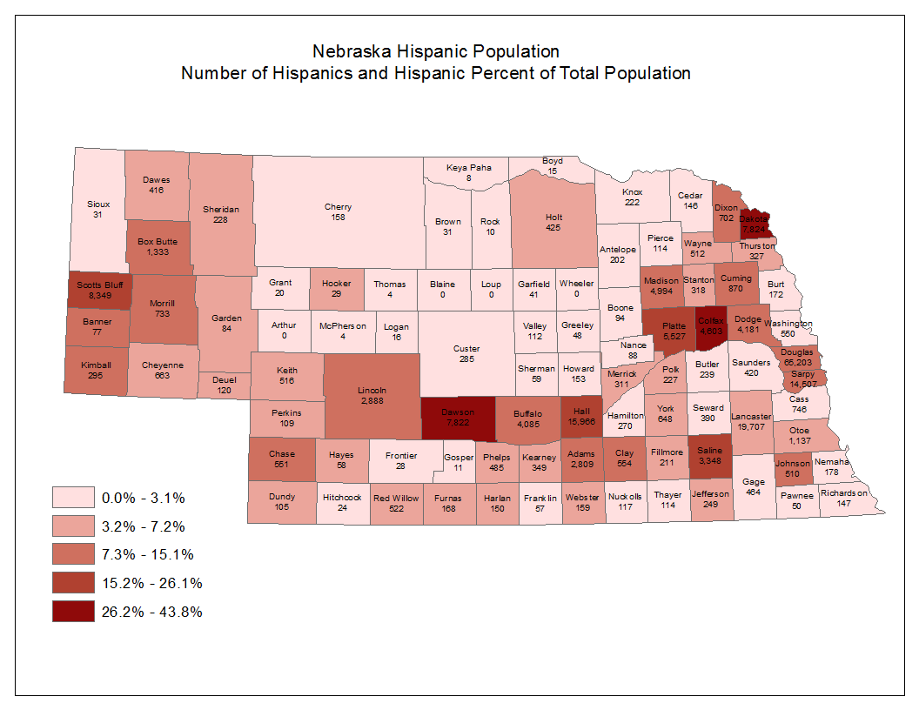

*Source: US Census Bureau*

***Nebraska Hispanic Population: Hispanic Population by County and Percentage of County Population***

| Nebraska County | Hispanic Population | Percent of Total County Population |
| --- | --- | --- |
| Hall | 13,653 | 14% - 41% |
| Scotts Bluff | 7,785 | 14% - 41% |
| Dawson | 7,746 | 14% - 41% |
| Dakota | 7,419 | 14% - 41% |
| Platte | 4,452 | 14% - 41% |
| Colfax | 4,315 | 14% - 41% |
| Saline | 2,870 | 14% - 41% |
| Morrill | 687 | 14% - 41% |
| Douglas | 57,801 | 6% - 13% |
| Lancaster | 16,685 | 6% - 13% |
| Sarpy | 11,569 | 6% - 13% |
| Madison | 4,504 | 6% - 13% |
| Dodge | 3,689 | 6% - 13% |
| Buffalo | 3,432 | 6% - 13% |
| Lincoln | 2,602 | 6% - 13% |
| Adams | 2,544 | 6% - 13% |
| Box Butte | 1,157 | 6% - 13% |
| Otoe | 902 | 6% - 13% |
| Cuming | 754 | 6% - 13% |
| Dixon | 622 | 6% - 13% |
| Cheyenne | 610 | 6% - 13% |
| Clay | 502 | 6% - 13% |
| Keith | 474 | 6% - 13% |
| Chase | 442 | 6% - 13% |
| Johnson | 435 | 6% - 13% |
| Kimball | 244 | 6% - 13% |
| Dundy | 117 | 6% - 13% |
| Cass | 608 | 2% - 5% |
| York | 555 | 2% - 5% |
| Red Willow | 462 | 2% - 5% |
| Washington | 419 | 2% - 5% |
| Saunders | 415 | 2% - 5% |
| Wayne | 401 | 2% - 5% |
| Gage | 385 | 2% - 5% |
| Phelps | 373 | 2% - 5% |
| Dawes | 306 | 2% - 5% |
| Holt | 305 | 2% - 5% |
| Stanton | 281 | 2% - 5% |
| Seward | 272 | 2% - 5% |
| Merrick | 271 | 2% - 5% |
| Kearney | 244 | 2% - 5% |
| Custer | 216 | 2% - 5% |
| Jefferson | 200 | 2% - 5% |
| Butler | 195 | 2% - 5% |
| Thurston | 190 | 2% - 5% |
| Hamilton | 181 | 2% - 5% |
| Antelope | 178 | 2% - 5% |
| Fillmore | 178 | 2% - 5% |
| Sheridan | 171 | 2% - 5% |
| Polk | 158 | 2% - 5% |
| Knox | 155 | 2% - 5% |
| Nemaha | 133 | 2% - 5% |
| Webster | 133 | 2% - 5% |
| Furnas | 132 | 2% - 5% |
| Burt | 126 | 2% - 5% |
| Cedar | 113 | 2% - 5% |
| Richardson | 112 | 2% - 5% |
| Howard | 109 | 2% - 5% |
| Nuckolls | 97 | 2% - 5% |
| Cherry | 95 | 2% - 5% |
| Perkins | 95 | 2% - 5% |
| Pierce | 93 | 2% - 5% |
| Garden | 80 | 2% - 5% |
| Valley | 79 | 2% - 5% |
| Thayer | 76 | 2% - 5% |
| Deuel | 75 | 2% - 5% |
| Boone | 65 | 2% - 5% |
| Nance | 65 | 2% - 5% |
| Sioux | 52 | 2% - 5% |
| Greeley | 51 | 2% - 5% |
| Gosper | 49 | 2% - 5% |
| Harlan | 45 | 2% - 5% |
| Hitchcock | 42 | 2% - 5% |
| Frontier | 35 | 2% - 5% |
| Pawnee | 35 | 2% - 5% |
| Boyd | 33 | 2% - 5% |
| Franklin | 33 | 2% - 5% |
| Hayes | 33 | 2% - 5% |
| Banner | 26 | 2% - 5% |
| Arthur | 19 | 2% - 5% |
| Logan | 13 | 2% - 5% |
| Loup | 13 | 2% - 5% |
| Thomas | 12 | 2% - 5% |
| Hooker | 8 | 2% - 5% |
| Grant | 7 | 2% - 5% |
| Sherman | 31 | 0% - 1% |
| Brown | 29 | 0% - 1% |
| Garfield | 15 | 0% - 1% |
| Wheeler | 6 | 0% - 1% |
| Keya Paha | 4 | 0% - 1% |
| McPherson | 2 | 0% - 1% |
| Rock | 2 | 0% - 1% |
| Blaine | 0 | 0% - 1% |

*Source: US Census Bureau*

##### Are limited English proficient.

The characteristics of the limited-English-proficient population in Nebraska is discussed in the economic analysis section of the strategic plan portion of Nebraska’s Combined State Plan.

##### Have the greatest social need. (20 CFR 641.325(b))

The term greatest social need is defined as needs caused by non-economic factors such as physical and mental disabilities, language barriers and cultural, social, or geographic isolation, including isolation brought about by racial or ethnic status. For purposes of this plan, greatest social need is defined as persons with physical and mental disabilities who are 55 years of age or older. Nebraska’s population over 55 years of age includes 138,784 persons with greatest social need (Source: U.S. Census Bureau, 2016 American Community Survey 1-Year Estimates B21007).

#### *Describe the steps taken to avoid disruptions to service for participants to the greatest extent possible, when positions are redistributed, as provided in 20 CFR 641.365; when new Census or other reliable data becomes available; or when there is over-enrollment for any other reason. (20 CFR 641.325(i), 641.302(b))*

Communication is vital for Nebraska’s SCSEP. Program adjustments may be necessary for a variety of reasons. Reasons vary from the population shift documented by a new Census to an adjustment in funds available to support this program. Modest program adjustments (such as yearly Equitable Distribution position level changes) will not have an impact on current individual enrollees. Actual program shifts would occur as participants leave the program for unsubsidized jobs or for other reasons. A decrease in program funding will also require similar action. A substantial cut in funding will require a more significant program adjustment such as a reduction in the weekly participant’s training hours. All participants will continue to receive program support during a program adjustment period. These developments are discussed with Nebraska’s project sponsors during regular contacts or as needs arise.

### SCSEP Assurances

The State Plan must include assurances that where SCSEP is included in the Combined Workforce Plan, the State has established a written policy and procedure to obtain advice and recommendations on the State Plan from:

Representatives of the State and area agencies on aging; **Yes**

State and local boards under WIOA; **Yes**

Public and private nonprofit agencies and organizations providing employment services, including each grantee operating a SCSEP project within the State, except as provided under section 506(a)(3) of OAA and 20 CFR 641.320(b); **Yes**

Social service organizations providing services to older individuals; **Yes**

Grantees under Title III of OAA; **Yes**

Affected Communities; **Yes**

Unemployed older individuals; **Yes**

Community-based organizations serving older individuals; **Yes**

Business organizations; and **Yes**

Labor organizations. **Yes**

**State Comments on SCSEP Assurances**

**None**

# Appendix 1. Performance Goals for the Core Programs

Include the State's expected levels of performance relating to the performance accountability indicators based on primary indicators of performance described in section 116(b)(2)(A) of WIOA.

**Instructions: Performance Goals for the Core Programs**

Each State submitting a Unified or Combined Plan is required to identify expected levels of performance for each of the primary indicators of performance for the first two years covered by the plan. The State is required to reach agreement with the Secretary of Labor, in conjunction with the Secretary of Education on state adjusted levels of performance for the indicators for each of the first two years of the plan.

## Table 1. Employment (Second Quarter after Exit)

| Program | PY 2018 Proposed/ Expected Level | PY 2018 Negotiated/ Adjusted Level | PY 2019 Proposed/ Expected Level | PY 2019 Negotiated/ Adjusted Level |
| --- | --- | --- | --- | --- |
| Adults | 78.00 | 78.00 | 78.00 | 78.00 |
| Dislocated Workers | 87.00 | 87.00 | 87.00 | 87.00 |
| Youth | 78.00 | 78.00 | 78.00 | 78.00 |
| Adult Education | Baseline | Baseline | Baseline | Baseline |
| Wagner-Peyser | 69.00 | 69.00 | 69.00 | 69.00 |
| Vocational Rehabilitation</ | Baseline | Baseline | Baseline | Baseline |

**User remarks on Table 1**

None

## Table 2. Employment (Fourth Quarter after Exit)

| Program | PY 2018 Proposed/ Expected Level | PY 2018 Negotiated/ Adjusted Level | PY 2019 Proposed/ Expected Level | PY 2019 Negotiated/ Adjusted Level |
| --- | --- | --- | --- | --- |
| Adults | 79.00 | 79.00 | 79.00 | 79.00 |
| Dislocated Workers | 88.00 | 88.00 | 88.00 | 88.00 |
| Youth | 77.00 | 77.00 | 77.00 | 77.00 |
| Adult Education | Baseline | Baseline | Baseline | Baseline |
| Wagner-Peyser | 73.00 | 73.00 | 73.00 | 73.00 |
| Vocational Rehabilitation | Baseline | Baseline | Baseline | Baseline |

**User remarks on Table 2**

None

## Table 3. Median Earnings (Second Quarter after Exit)

| Program | PY 2018 Proposed/ Expected Level | PY 2018 Negotiated/ Adjusted Level | PY 2019 Proposed/ Expected Level | PY 2019 Negotiated/ Adjusted Level |
| --- | --- | --- | --- | --- |
| Adults | 5,500.00 | 5,500.00 | 5,500.00 | 5,500.00 |
| Dislocated Workers | 7,200.00 | 7,200.00 | 7,200.00 | 7,200.00 |
| Youth | Baseline | Baseline | Baseline | Baseline |
| Adult Education | Baseline | Baseline | Baseline | Baseline |
| Wagner-Peyser | 5,000.00 | 5,000.00 | 5,000.00 | 5,000.00 |
| Vocational Rehabilitation | Baseline | Baseline | Baseline | Baseline |

**User remarks on Table 3**

None

## Table 4. Credential Attainment Rate

| Program | PY 2018 Proposed/ Expected Level | PY 2018 Negotiated/ Adjusted Level | PY 2019 Proposed/ Expected Level | PY 2019 Negotiated/ Adjusted Level |
| --- | --- | --- | --- | --- |
| Adults | 56.00 | 56.00 | 56.00 | 56.00 |
| Dislocated Workers | 60.00 | 60.00 | 60.00 | 60.00 |
| Youth | 68.00 | 68.00 | 68.00 | 68.00 |
| Adult Education | Baseline | Baseline | Baseline | Baseline |
| Wagner-Peyser | n/a | n/a | n/a | n/a |
| Vocational Rehabilitation | Baseline | Baseline | Baseline | Baseline |

**User remarks on Table 4**

None

## Table 5. Measurable Skill Gains

| Program | PY 2018 Proposed/ Expected Level | PY 2018 Negotiated/ Adjusted Level | PY 2019 Proposed/ Expected Level | PY 2019 Negotiated/ Adjusted Level |
| --- | --- | --- | --- | --- |
| Adults | Baseline | Baseline | Baseline | Baseline |
| Dislocated Workers | Baseline | Baseline | Baseline | Baseline |
| Youth | Baseline | Baseline | Baseline | Baseline |
| Adult Education | 35.00 | 35.00 | 36.00 | 36.00 |
| Wagner-Peyser | n/a | n/a | n/a | n/a |
| Vocational Rehabilitation | Baseline | Baseline | Baseline | Baseline |

**User remarks on Table 5**

None

## Table 6. Effectiveness in Serving Employers

| Program | PY 2018 Proposed/ Expected Level | PY 2018 Negotiated/ Adjusted Level | PY 2019 Proposed/ Expected Level | PY 2019 Negotiated/ Adjusted Level |
| --- | --- | --- | --- | --- |
| Adults | Baseline | Baseline | Baseline | Baseline |
| Dislocated Workers | Baseline | Baseline | Baseline | Baseline |
| Youth | Baseline | Baseline | Baseline | Baseline |
| Adult Education | Baseline | Baseline | Baseline | Baseline |
| Wagner-Peyser | Baseline | Baseline | Baseline | Baseline |
| Vocational Rehabilitation | Baseline | Baseline | Baseline | Baseline |

**User remarks on Table 6**

None

## Table 7. Combined Federal Partner Measures

| Program | | PY 2018 Proposed/ Expected Level | | PY 2018 Negotiated/ Adjusted Level | | PY 2019 Proposed/ Expected Level | | PY 2019 Negotiated/ Adjusted Level |
| --- | --- | --- | --- | --- | --- | --- | --- | --- |
|  |  | |  | |  | |  | |

**User remarks on Table 7**

No Federal partner

# Appendix 2. Other State Attachments (Optional)

## Limited English Proficiency (LEP) Plan

The Nebraska Department of Labor Limited English Proficiency (LEP) Plan is accessible at https://dol.nebraska.gov/EmploymentAndTraining/LCRWP/WIOA/ManualsPlansReports.

1. United States Census Bureau, “State Area Measurements and Internal Point Coordinates” under “Geography,” https://www.census.gov/geo/reference/state-area.html [accessed December 21, 2017]
2. United States Census Bureau, “QuickFacts Nebraska,” https://www.census.gov/quickfacts/fact/table/NE/PST045216 [accessed December 21, 2017]
3. Missouri Department of Economic Development, Missouri Economic Research and Information Center, “Cost of Living Data Series Third Quarter 2017,” https://www.missourieconomy.org/indicators/cost_of_living/ [accessed December 21, 2017]
4. Estimates in current dollars are not adjusted for inflation (Source: United States Department of Commerce, Bureau of Economic Analysis, “Regional Economic Accounts: Regional Definitions,” https://www.bea.gov/regional/definitions/ [accessed December 19, 2017]).
5. Real GDP (in chained dollars) by state is an inflation-adjusted measure of each state’s gross product based on national prices for the goods and services produced within the state. The real estimates of gross domestic product (GDP) by state are measured in chained (2009) dollars (Source: United States Department of Commerce, Bureau of Economic Analysis, “Regional Economic Accounts: Regional Definitions,” https://www.bea.gov/regional/definitions/ [accessed December 19, 2017]).
6. Industry totals and rollups may not be additive due to the suppression of non-disclosable industry cells.
7. Large counties are defined as those with employment of 75,000 or more as measured by 2015 annual average employment. (United States Department of Labor, Bureau of Labor Statistics, County Employment and Wages in Nebraska – Fourth Quarter 2016, https://www.bls.gov/regions/midwest/news-release/countyemploymentandwages_nebraska.htm [accessed December 27, 2017])
8. Nebraska Department of Labor, NEworks, Office of Labor Market Information, Publications, Nebraska Labor Availability Studies, https://neworks.nebraska.gov/gsipub/index.asp?docid=802 [accessed December 28, 2017]
9. United States Department of Labor, Bureau of Labor Statistics, Alternative Measures of Labor Underutilization, Nebraska – 2016, https://www.bls.gov/regions/midwest/news-release/laborunderutilization_nebraska.htm [accessed December 27, 2017]
10. The official measure of unemployment in states is derived using a statistical model that incorporates data from the CPS and other sources, and this model-based estimate can differ from the direct CPS estimate discussed here.
11. Nebraska Department of Labor, NEworks, Office of Labor Market Information, Publications, “Nebraska Economic Insight and Outlook,” https://neworks.nebraska.gov/admin/gsipub/htmlarea/uploads/EconInsight_Outlook.pdf [accessed December 28, 2017]
12. Nebraska Department of Education, “2017 Nebraska Higher Education Progress Report,” https://nebraskalegislature.gov/FloorDocs/105/PDF/Agencies/Coordinating_Commission_for_Postsecondary_Education/474_20170317-141944.pdf [accessed 28 Dec 2017]
13. United States Census Bureau, “LANGUAGE SPOKEN AT HOME 2016 American Community Survey 1-year Estimates,” https://factfinder.census.gov/faces/tableservices/jsf/pages/productview.xhtml?src=bkmk [accessed December 28, 2017]
14. Nebraska Department of Labor, “Grand Island Skills Gap Report,” https://neworks.nebraska.gov/admin/gsipub/htmlarea/uploads/GrandIslandSkillsGap2016.pdf [accessed December 28, 2017]
15. Nebraska Department of Labor, “Hastings Skills Gap Report,” https://neworks.nebraska.gov/admin/gsipub/htmlarea/uploads/HastingsSkillsGap2016.pdf [accessed December 28, 2017]
16. Nebraska Department of Labor, “Kearney Skills Gap Report,” https://neworks.nebraska.gov/admin/gsipub/htmlarea/uploads/KearneySkillsGap2016.pdf [accessed December 28, 2017]
17. Nebraska Department of Labor, “Lincoln Skills Gap Report,” https://neworks.nebraska.gov/admin/gsipub/htmlarea/uploads/LincolnSkillsGap2016.pdf [accessed December 28, 2017]
18. Nebraska Department of Labor, “Omaha Skills Gap Report,” https://neworks.nebraska.gov/admin/gsipub/htmlarea/uploads/Omaha_Skills%20Gap.pdf [accessed December 28, 2017]
19. Nebraska Department of Labor, “Scottsbluff Skills Gap Report,” https://neworks.nebraska.gov/admin/gsipub/htmlarea/uploads/Scottsbluff_Skills_Gap.pdf [accessed December 28, 2017]
20. Nebraska Department of Labor, “Southeast Skills Gap Report,” https://neworks.nebraska.gov/admin/gsipub/htmlarea/uploads/SoutheastSkillsGap2017.pdf [accessed December 28, 2017]
21. Nebraska Department of Labor, “Southwest Skills Gap Report,” https://neworks.nebraska.gov/admin/gsipub/htmlarea/uploads/SouthwestSkillsGap2016.pdf [accessed December 28, 2017]
22. Nebraska Information Technology Commission, “PSC Approves Funding for 11 Towers,” http://nitc.nebraska.gov/news/community/2017JanPSCWirelessGrants.html [accessed December 29, 2017]
23. “Individual with a barrier to employment” is defined above and in WIOA Sec. 3(24) and “other populations” is defined above.
24. 20 CFR § 679.260(a)
25. 20 CFR § 679.260(b)(1)
26. 20 CFR § 679.260(b)(2)
27. TEGL 25-13
28. TEGL 25-13
29. TEGL 25-13
30. 20 CFR § 679.260(c)
31. 20 CFR § 680.430(a)
32. 20 CFR § 680.410(d)
33. 20 CFR § 680.460(f)(5)
34. The written assurances form is provided by NDOL.
35. 20 CFR § 683.285
36. 20 CFR § 683.250(a)(4)
37. 20 CFR §§ 680.450(e) and 680.490
38. 20 CFR § 680.420
39. This is determined based on the Standard Occupational Classification (SOC) code provided by the training provider in the application submitted in NEworks, the current High Wage, High Skill, High Demand (H3) Occupations dataset posted in the Labor Market Analysis Data Download Center in NEworks, and the Nebraska Career Education Model defined and provided by the Nebraska Department of Education as it relates to career pathways.
40. 20 CFR § 680.460(f)
41. 20 CFR § 680.470(a)
42. The one-page Registered Apprenticeship sponsor and program information form is accessible at https://dol.nebraska.gov/EmploymentAndTraining/LCRWP/WIOA/ETP.
43. 20 CFR §§ 680.460(j) and 680.470(b)
44. 20 CFR § 680.460(j)
45. The written assurances form is provided by NDOL.
46. 20 CFR § 683.285
47. 29 CFR § 38.3(c)
48. 20 CFR § 680.450(g)
49. 20 CFR §§ 680.430(h) and 680.460(a)(2)
50. WIOA Sec. 134(c)(3)(E)
51. TEGL 10-09; VPL 07-09
52. TEGL 10-09; VPL 07-09
53. The Nebraska Department of Labor has authority to act on the Governor’s behalf pursuant to the Governor’s Executive Order No. 15-03.
54. 20 CFR § 679.510(b)
55. Neb. Rev. Stat. §§ 84-1407 through 84-1414
56. 20 CFR §§ 681.400
57. 20 CFR § 681.400(b)(4)
58. WIOA Section 102(b)(2)(D)(i)(V)
59. 20 CFR § 681.420(d) – (f)
60. The term *focal county* refers to the main county or counties in a region to which employees from other counties commute for work. Each region has at least one (1) focal county.
61. 20 CFR § 679.130(e)(1) and 679.370(h)(3)