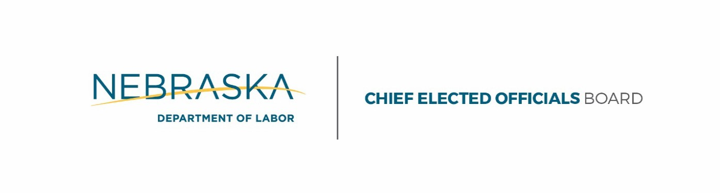
Pamela Lancaster CEOB Chair
Lisa Wilson GNWDB Chair
Agenda — June 29, 2017
JOINT EXECUTIVE COMMITTEE MEETING AND CHIEF ELECTED OFFICALS BOARD MEETING
LOCATION Kearney Public Library, 2020 1st Ave. Kearney, NE 68847 Conference Call - (888) 820 – 1398
10:00 am to 11:30 am (CST)

- Call to Order:
  - Executive Committee Lisa Wilson
  - CEOB Pamela Lancaster
- Roll Call Wendy Sieler
  - Executive Committee
  - CEOB
- Notice of Publications Wendy Sieler
- Approval of Minutes*
  - Approval of Executive Committee Minutes* Lisa Wilson
  - Approval of CEOB Minutes* Pamela Lancaster
- New Business*
  - Approval of Nebraska Department of Economic Development as the One-Stop Operator*
- Approval by Executive Committee* Lisa Wilson
- Approval by CEOB* Pamela Lancaster
- Public Comment Lisa Wilson
- Adjournment*
  - Executive Committee Meeting Adjournment* Lisa Wilson
  - CEOB Meeting Adjournment* Pamela Lancaster

*Requires a Motion and a Vote

