Motion to Appoint New Members to the Greater Nebraska Workforce Development Board
February 6, 2017
Greater Nebraska Chief Elected Officials Board

Agenda Item 4c

Background: To comply with WIOA Section 107 (b) (2), local board membership, at a minimum, must be composed of the following:

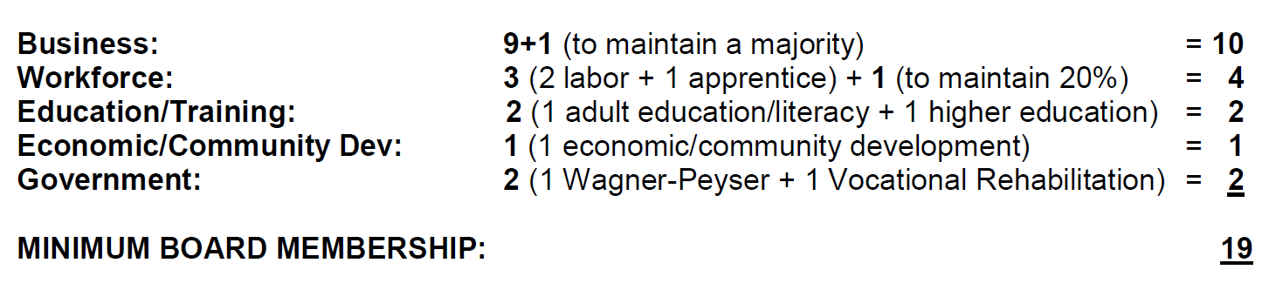

Required Membership Categories and Formula

Business: Business owners and other business executives or employers with optimum policymaking or hiring authority who represent businesses with employment opportunities that reflect employment opportunities in the local area.

An individual with “optimum policy-making authority” means an individual who can reasonably be expected to speak affirmatively on behalf of the entity he/she represents and to commit that entity to a chosen course of action

Education/Training: A representative of eligible providers administering adult education and literacy activities, and a representative of institutions of higher education providing workforce investment activities.

Position Appointments

1 Education/ Training Position
It is proposed that the Chief Elected Officials Board appoint _____________ to the Greater Nebraska Workforce Development Board (GNWBD) for a three-year term ending February 5, 2020.

1 Business Position
It is proposed that the Chief Elected Officials Board provisionally appoint _____________contingent upon endorsement by the respective Chamber of Commerce to the Greater Nebraska Workforce Development Board (GNWBD) for a three-year term ending February 5, 2020.

