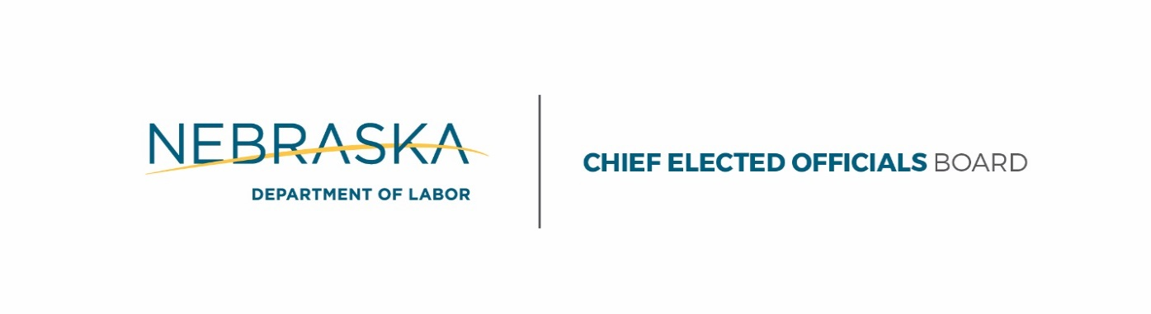

Pamela Lancaster Lisa Wilson
Chair GNWDB Chair

Agenda – Chief Elected Officials

Monday, 2/6/2017
1:30 - 2:30 p.m. (CT)
Grand Island City Library, 211 N Washington St. Grand Island, NE 68801

- Call to Order Pamela Lancaster
- Roll Call Wendy Sieler
- Notice of Publication
- Old Business Pamela Lancaster
  - Approval of Minutes
  - Request for Proposal
    - One-Stop Operator*
    - Adult & Dislocated Worker*
    - Youth*
    - Administrative Entity*
  - Board Appointments
    - Kim Schumacher*
    - Matt Gotschall*
- New Business Dylan Wren
  - Guiding Principles
  - RFP for One-Stop Operator*
- Board Member Updates Pamela Lancaster
- Public Comment
- Adjournment
*Requires a Motion & Vote
Department of Labor | ADMINISTRATIVE ENTITY
A proud partner of the American Job Center network
(402) 471-9878
ndol.greaternebraska@nebraska.gov
P.O. Box 9460, Lincoln, Nebraska 68509 An Equal Opportunity Employer | TDD 800-833-7352

dol.nebraska.gov

